Towards standardized microbial hydrogen consumption testing in the subsurface: Harmonized field sampling and enrichment approaches

Kateřina Černá^{1*}, Kristýna Fadrhonc¹, Jakub Říha¹, Petra Bombach², Sylvain Stephant³, Caroline Michel³, Laura Fablet³, Joachim Tremosa⁴, Kyle Mayers⁵, Biwen Annie An-Stepec⁵, Nicole Dopffel⁵

1 Technical University of Liberec, Institute for Nanomaterials, Advanced Technologies and Innovation, Bendlova 7, 46117 Liberec, Czechia
2 Isodetect GmbH, Deutscher Platz 5b, 04103 Leipzig, Germany
3 BRGM, 3 Avenue Claude Guillemin, 45060 Orléans Cedex 2, France
4 Geostock, 2 Rue des Martinets, 92500 Rueil-Malmaison, France
5 Norwegian Research Centre AS – NORCE, Nygårdsgaten 112, 5008 Bergen, Norway

*Corresponding author: Kateřina Černá, katerina.cerna1@tul.cz, ORCID ID: 0000-0003-3351-6372

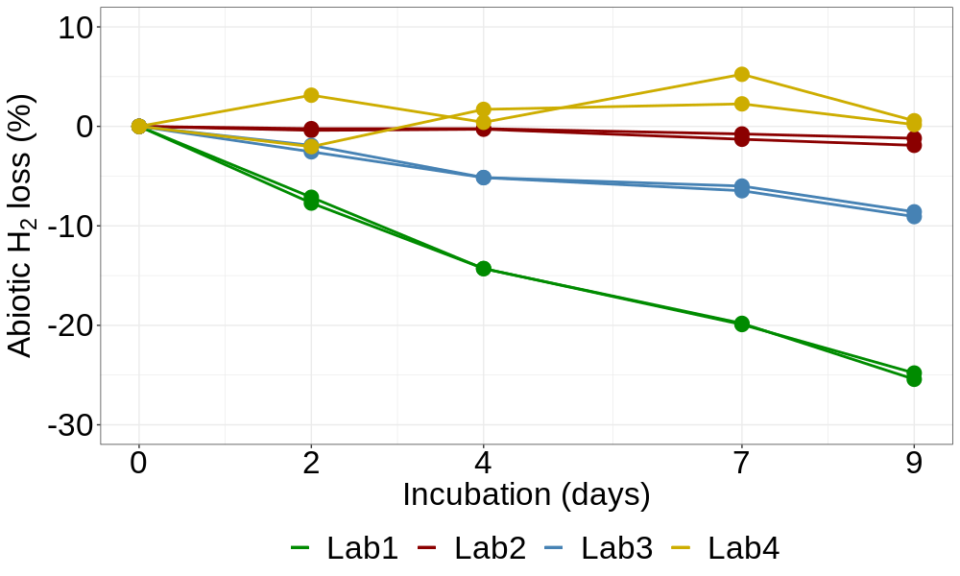
Supplementary Figure S1: Differences in abiotic H2 loss (in %) among laboratories.

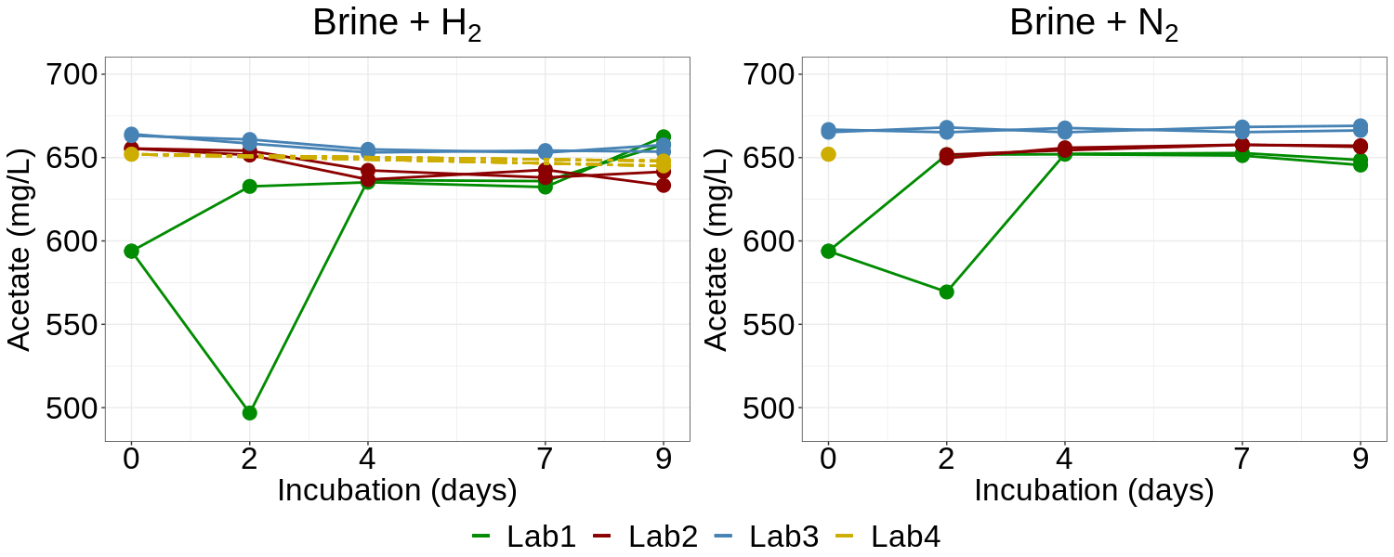Supplementary Figure S2: Acetate concentration (mg/L) in brine samples incubated with hydrogen (left) and nitrogen (right) during the experiment in respective laboratories.

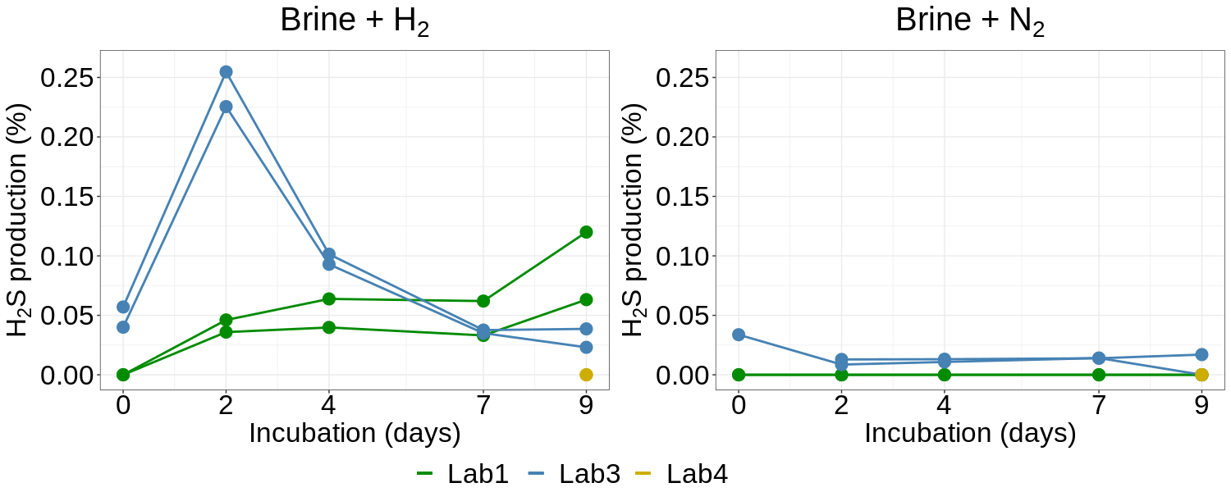
Supplementary Figure S3: Production of H2S (in %) in brine samples incubated with hydrogen (left) and nitrogen (right) during the experiment in respective laboratories.

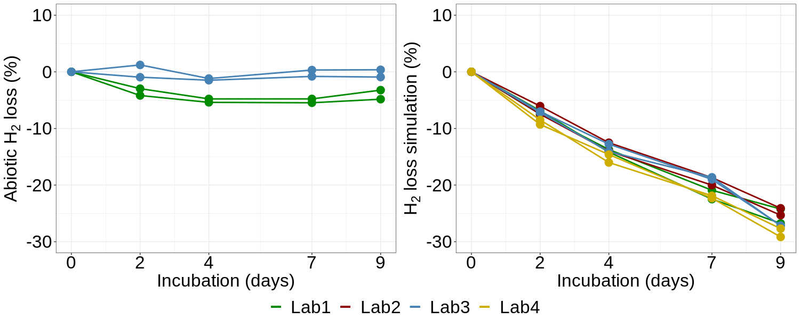
Supplementary Figure S4: Left: Abiotic H₂ loss in Lab 1 and 4 after protocol optimization. Right: Simulation of microbial H₂ consumption (in %) demonstrating consistency in hydrogen loss detection among the labs.

