Supporting Information
Size-evolving protein drug nanoparticles: A promising non-invasive strategy for retinal neovascularization by overcoming multiple ocular barriers
Xiaoling Xie^{Ʈ}, Sicheng Tang ^{ʄ}, Ruhui Yang^{Ʈ}, Jinyu Guo^{Ʈ}, Chaofan Jin ^{ʄ}, Hao Chen ^{Ʈ*}, Wenjuan Huang¶ *, and Xingjie Zan ^{Ʈ, ʄ *}
^{Ʈ} School of Ophthalmology and Optometry, Eye Hospital, School of Biomedical Engineering, Wenzhou Medical University, Wenzhou, Zhejiang Province 325035, China.
^{ʄ} Wenzhou Institute, University of Chinese Academy of Sciences, Wenzhou Key Laboratory of Perioperative Medicine, Wenzhou, Zhejiang, 325001, China
¶ Taizhou Hospital of Zhejiang Province Affiliated to Wenzhou Medical University, Linhai, 317000, China
* Corresponding author. Chenhao823@mail.eye.ac.cn (H. Chen); huangwj5388@enzemed.com (W. Huang); zanxj@ucas.ac.cn (X. Zan.)

Table of Contents

Section 1：Materials and methods 3
1.1 Material 3
1.2 Synthesis and characterization of protein nanoparticles 3
1.2.1 Synthesis of protein nanoparticles 3
1.2.2 Encapsulation rate 4
1.2.3 Characterization of protein nanoparticles 4
1.2.4 Molecular dynamics simulation 5
1.2.5 Drug Release Experiments 5
1.2.6 Protein Activity Experiments 6
1.3 In vitro experiments 6
1.3.1 Cytotoxicity experiments 6
1.3.2 In vitro anti-neovascularization evaluation 6
1.3.3 Evaluation of Penetration Effect 8
1.3.4 Evaluation of Ocular Surface Retention Effect 11
1.4 Animal Experiments 11
1.4.1 Establishment and Treatment of the Oxygen-Induced Retinal Neovascularization (OIR) Model 11
1.5 In vivo biocompatibility experiments 13
1.5.1 Slit lamp inspection 13
1.5.2 H&E Pathology sections 14
1.5.3 Corneal endothelial cells trypan blue-alizarin red staining 14
1.5.4 ERG experiments 14
1.6 Statistical Analysis. 14
Section 2：Supplementary Tables and Figures 16
Section 3: References 25

Section 1：Materials and methods

1.1 Material
Peptides Cys-Gly-Gly-Arg₉ (CG₂R₉), were obtained from Nanjing Peptide Valley Technology Co., Ltd. Avastin Injection ® (Bevacizumab, Beva) was purchased from Roche Pharmaceuticals in Shanghai. Polyvinylpyrrolidone (PVP), Zn(NO₃)₂•6H₂O, and Fluorescein isothiocyanate were purchased from Aladdin Biochemical Technology Co., Ltd. N-2-hydroxyethylpiperazine-N'-2-ethanesulfonate sodium salt (HEPES sodium) and ethylenediaminetetraacetic acid disodium salt (EDTA) were obtained from Maclean's Biochemical Technology Co., Ltd. HUVEC cells were obtained from Fenghui Biotechnology Co., Ltd., while HCEC and ARPE were obtained from the Shanghai Cell Bank of the Chinese Academy of Sciences. The in vitro recombinant 3D corneal model (BioOcullarTM RHC), BioRecovery medium, and BioGrowth medium were purchased from Guangzhou Boxi Biological Co., Ltd. The culture media used were DMEM, DMEM/F-12, and MEM. Anti-fluorescence quencher, DAPI staining solution, and Isolectin GS-IB4 were obtained from Thermo Fisher Scientific. Corning Matrigel Matrigel was purchased from Corning, while Anti-CD31 antibody [HEC7] (ab119339), Anti-VEGFA antibody [VG-1] (ab1316), and Beva Elisa Kit were obtained from Shanghai Ruiban Biological Technology Co., Ltd. The RNA Isolation Kit, qPCR-related reagents, and Goat Anti-Rabbit IgG (H+G) were purchased from Novozan. Lastly, Lyso-Tracker Red was obtained from Beyotime, while Occludin Monoclonal Antibody was obtained from Invitrogen.

1.2 Synthesis and characterization of protein nanoparticles

1.2.1 Synthesis of protein nanoparticles
To prepare the solution, combine 1 mg of Beva, 1 mg of CG₂R₉, and 2.5 mg of PVPON in 500 μL of 50 mM HEPES sodium buffer. Adjust the total volume to 1 mL with deionized water and set the pH to 8-9. Next, add 50 μL of 0.01 M Zn(NO₃)₂•6H₂O dropwise to the mixture while applying ultrasound at 4°C for 5 minutes, ensuring that the water bath temperature remains constant. During this step, the solution will transition from clear to a milky white appearance. Following this, centrifuge the mixture at 12,000 rpm for 15 minutes, discard the supernatant, and wash the particles three times with deionized water. Finally, disperse the particles in 1 mL of deionized water using ultrasound, and store the evenly dispersed solution at 4°C.

1.2.2 Encapsulation rate
Beva's Encapsulation Efficiency (EE%) and Loading Capacity (LCwt%) are calculated according to the following formula:
$$EE\%=\frac{ V_{O}l_{o}∗A_{o} − V_{o}l_{S}∗A_{S}}{Vol_{O}∗A_{O}}∗100\%$$
$$LC（wt\%）=\frac{W_{added drug}∗EE\left(\%\right)}{W_{added CG2R9}∗Yield\left(\%\right)}∗100\%$$
where$V_{O}l_{o}$ and are the volumes of the original solution and supernatant , and $A_{S}$represent the UV-vis absorbance of the original solution and Ava supernatant, and and represent the weight of the protein nanoparticles formed after the addition of Beva and CG₂R₉, respectively. The absorption peak of Beva at 280 nm was used as a quantitative measurement and the measurement was repeated in triplicate measurements.

1.2.3 Characterization of protein nanoparticles
The encapsulation efficiency of peptides and Beva in protein nanoparticles was assessed using various analytical techniques. UV-VIS spectroscopy (Perkin Elmer, Lambda 25, USA) was employed to evaluate encapsulation levels, while the zeta potential and size of the protein nanoparticles were measured at different time points using the Zetasizer Nano ZS (Malvern, UK). The morphology of the protein nanoparticles, stained with phosphotungstic acid, was characterized via transmission electron microscopy (TEM, Talos F200S FEI) was utilized to examine the molecular structure; lyophilized samples of Beva, CG₂R₉, and (CG₂R₉&Beva)@Zn were mixed with KBr powder and pressed into thin slices for scanning in the range of 4000 cm⁻¹ to 400 cm⁻¹. X-ray photoelectron spectroscopy (ESCALAB 250Xi, Thermo Fisher) was used for qualitative analysis of Zn, alongside carbon, oxygen, and nitrogen elements. The Zn²⁺ content in (CG₂R₉&Beva)@Zn was quantitatively determined using inductively coupled plasma optical emission spectrometry (ICP-OES, Agilent). Circular dichroism was performed to investigate changes in the secondary structure of the protein, with Beva concentration set at 0.25 mg/mL. The parameters for circular dichroism analysis included a temperature of 25 ℃, a scanning range of 190–250 nm, a scanning speed of 50 nm/s, and three replicates for each sample.

1.2.4 Molecular dynamics simulation
The predicted structure of the dimmer complex of Beva was solvated in a water box of 23$×$23$×$23 nm³. The CHARMM-GUI server was used to generate the configuration, topology [1-4], and parameter files with the CHARMM36m force field [5]. For the system with zinc ions, in addition to the dimmer complex of Bevacizumab and peptides, the simulation system included about 421,541 water molecules, 197 sodium, 66 zinc, and 442 chloride ions (mimicking the 25 mM NaCl and 0.75 mM ZnCl₂ present in protein buffer), totaling about 1,288,000 atoms. The cubic periodic boundary condition was used during the simulations and the van der Waals interaction was switched off from 1 to 1.2 nm. The Particle Mesh Ewald (PME) method calculated the long-range electrostatic interactions. Energy minimization was done using the steepest descent algorithm, followed by a 0.4 ns NVT (constant particle number, volume, and temperature) and a 20 ns NPT (constant particle number, pressure, and temperature) equilibration simulation by gradually decreasing force restraints from 1000 kJ mol⁻¹ nm⁻² to 400 mol⁻¹ nm⁻² (for NVT stage) and 400 kJ mol⁻¹ nm⁻² to 40 mol⁻¹ nm⁻² (for NPT stage). All force restraints were removed after the equilibration steps, and the MD simulation was performed in the NPT ensemble. The 200 ns all-atom MD simulation trajectory was performed on the dimmer complex of Bevacizumab with different peptides by using GROMACS 2021 [6] at 298 K using a time step 2 fs.

1.2.5 Drug Release Experiments
Add 3 mL of protein nanoparticles containing 6 mg of Beva into a 5 mL dialysis bag with a molecular weight cutoff of 100 kDa. Immerse the dialysis bag in a centrifuge tube filled with 37 mL of Bis-Tris buffer solution at pH 7.2. Incubate the setup in a thermostatic shaker at 37 °C and 200 rpm. At predetermined time points, remove 1 mL of the solution from the centrifuge tube and replace it with an equal volume (1 mL) of fresh buffer solution at the same pH. The collected samples were then analyzed using a BCA assay to quantify the concentration of the released drug. The cumulative release curve was constructed following a previously reported method [7].

1.2.6 Protein Activity Experiments
1.2.6.1 Changes in protein activity before and after protein nanoparticle synthesis
To evaluate the activity of the protein, 100 μL of protein nanoparticles is treated with 200 μL of EDTA solution (pH 7.4) to facilitate the complete release of Beva from the particles. The biological activity of Beva is subsequently assessed using a Beva ELISA kit, with a standard protein used as a control for comparison.
1.2.6.2 Anti-proteinase K shearing experiment
Proteinase K is a serine protease recognized for its strong cleavage activity, particularly at carboxy-terminal peptide bonds of aliphatic and aromatic amino acids. To simulate the enzymatic degradation of synthetic nanoparticles upon entering an organism, we employed proteinase K due to its widespread use and relative stability. The concentration of proteinase K used in this study was 50 μg/mL.
To evaluate the effect of proteinase K on the protein nanoparticles and free Beva, incubation was conducted at pH 7 and a temperature of 55 ℃ for 2 hours. After the incubation period, the binding capacity of each group to VEGF-A was assessed using the Beva ELISA Kit, following the protocols outlined in section 2.2.5.1.

1.3 In vitro experiments

1.3.1 Cytotoxicity experiments
Human corneal epithelial cells (HCECs) and retinal pigment epithelial cells (ARPE-19) were cultured in MEM and DMEM/F-12 media, respectively, both supplemented with 10% fetal bovine serum, 100 U/mL streptomycin, and 100 U/mL penicillin. Umbilical vein endothelial cells (HUVECs) were cultured in DMEM supplemented with the same concentrations of fetal bovine serum, streptomycin, and penicillin. All cell cultures were maintained in a 37 ℃ incubator with 5% CO2. Cytotoxicity was assessed using the CCK-8 assay, following the standard protocol provided by the kit manufacturer.

1.3.2 In vitro anti-neovascularization evaluation
1.3.2.1 Human umbilical vein endothelial cell migration assay
First, 2 × 10⁵ HUVECs were seeded into each well of a 12-well plate and incubated overnight. Once the HUVEC monolayer reached confluence, it was scraped with a sterile 200 μL pipette tip and gently washed three times with 1× PBS. Next, 1 mL of various medium formulations was added to each well, and the plates were incubated for 24 hours. Images were captured at baseline and after 24 hours using a camera, and the results were analyzed using ImageJ software. Each experiment was repeated at least three times. The mobility rate (wound closure) was calculated using the following formula:
Cell mobility (%) = (scratch width after 1-24 h/initial scratch width) ×100%
1.3.2.2 Human umbilical vein endothelial cell tubule formation experiment
A 48-well plate was coated with 150 μL of Corning Matrigel per well and incubated at 37 ℃ for 1 hour until the Matrigel fully solidified. Subsequently, 5 × 10⁴ HUVECs, along with various materials (control, Beva, Beva@Zn, and (CG₂R₉&Beva)@Zn nanoparticle formulations), were added to each well along with 150 μL of serum-free DM. The plate was then incubated for 6 hours in a 37 ℃ incubator with 5% CO2. Following incubation, images of each group were captured using an inverted microscope and analyzed using ImageJ software. Each experiment was performed in triplicate, and the data were statistically analyzed using appropriate software.
1.3.2.3 Choroidal plate germination inhibition/retraction experiment
The choroidal germination experiments were conducted under controlled conditions as described below: mouse choroidal tissue was sectioned into approximately 0.5 mm × 0.5 mm pieces and embedded in Matrigel within a 24-well plate. The explants were cultured in vitro using 10% high-glucose DMEM (10% HG-DMEM). After 48 hours of incubation at 37 ℃, vascular growth in the explants was monitored. The medium in each well was then replaced with 500 μL of a different formulation, and the vascular area was assessed after 2 days. Images were acquired using a bright-field inverted microscope.
For choroidal regression experiments, explants were cultured in HG-DMEM for 4 days to allow vessel establishment. Once vascular structures were formed, the medium in each well was replaced with the corresponding experimental group's medium. Explants were monitored on days 3 and 4. The germination area was quantified using Photoshop by converting the original grayscale image of the choroid and applying sharpening techniques. The Magic Wand tool was used to select the choroidal implant, record its pixel count, and remove it. Subsequently, the remaining buds were selected with the Wand Tool, and their total pixel count was recorded. To account for differences in initial explant size, the germination area was calculated using the following formula:
$Sprouting Area \left(\% of original\right)=\frac{\left(Final sprouted area – initial sprouted area\right)}{Total Initial Area 100\%}∗100\%$ Each experiment is repeated at least 3 times. The application software analyzes the data statistically.

1.3.3 Evaluation of Penetration Effect
1.3.3.1 Cell uptake assay (HCEC/ARPE)
HCEC and ARPE-19 cells were seeded at a density of 5 × 10⁴ cells per well in 24-well plates. After 24 hours of incubation to allow for full cell adherence, the medium was removed. Then, medium containing nanoparticles(Beva：100μg/mL) was added, and the cells were incubated for an additional 6 hours. Following this incubation, the samples were fixed, stained, and covered with a cover slip, then photographed using a laser scanning confocal microscope (LSCM). The fluorescence intensity of the images was subsequently analyzed using ImageJ software.
1.3.3.2 Lysosomal staining experiments
HCEC and ARPE-19 cells were seeded at a density of 5 × 10⁴ cells per well in 24-well plates. After 24 hours of incubation to ensure full cell adherence, the medium was removed. Next, medium containing various formulations was added, and the cells were incubated for an additional 24 hours. After 45 minutes of incubation with the Lyso-Tracker Red (1:20,000), the samples were fixed, stained with DAPI, and covered with a cover slip, then photographed using a laser scanning confocal microscope (LSCM). Colocalization analysis of fluorescence intensity across different channels was performed using ImageJ software.
1.3.3.1 Franz Diffusion Pools
We assessed the permeability of Beva and (CG₂R₉&Beva)@Zn through rabbit corneas using a diffusion pool device. The rabbit was anesthetized and subsequently sacrificed, and the fresh cornea was harvested and placed horizontally between the diffusion pools within 30 minutes, with the epithelial side facing the donor compartment. The apparatus was maintained at 37℃, and the donor side was loaded with 200 μL of Beva or (CG₂R₉&Beva)@Zn solution (containing 1 mg of Beva) in 5 mL of phosphate-buffered saline (PBS). At time points of 0.5, 1, 2, 4, and 6 hours, 1 mL of PBS was collected from the receiver chamber and replaced with an equal volume of fresh PBS. The experiment was concluded after 6 hours, and the concentration of Beva was determined based on UV absorbance (sample size ≥ 3).
1.3.3.2 Transcytosis assay
5×10⁴ HCEC cells/well and ARPE-19 cells were seeded in 24-well plates. Both HCECs and ARPE-19 cells were pretreated with 100 μg/mL (CG₂R₉&Beva)@Zn pellets for 6 hours. Following washing, the treated HCECs and ARPE-19 cells were co-cultured as the donor side with untreated HCECs and ARPE-19 cells on the recipient side in fresh medium for an additional 6 hours. Subsequently, the recipient cells were incubated with fluorescein-conjugated secondary antibodies to detect Beva in both donor and recipient cells using confocal microscopy.
1.3.3.3 In vitro recombinant 3D multilayer corneal epithelial cell penetration test
Resuscitate the in vitro recombinant 3D corneal model (BioOcullar™ RHC) in a Transwell plate using BioRecovery culture. Add 300 μL of a solution containing various formulations, ensuring a final concentration of 100 μg/mL of FITC-Beva for each group, to the inside of the Transwell plate. Subsequently, add 700 μL of medium to the outer compartment of the Transwell plate and incubate it in a cell culture incubator for 4 hours. After fixation, perform DAPI staining and seal the samples for observation and photography using a laser scanning confocal microscope (LSCM). Each group should consist of a sample size of ≥3, and fluorescence data should be analyzed using ImageJ software.
1.3.3.4 Drug Fluorescence Distribution sections
Healthy C57/6J mice were euthanized at 1, 6, and 12 hours following local eye infusion. The eyeballs were promptly excised and processed for immunofluorescence to produce fluorescent sections. Following fixation, embedding, sealing, staining, washing, and mounting, laser scanning confocal microscopy (LSCM) was employed to observe and capture images, allowing for the detection of Beva distribution in the eyeball at various time points post-administration. This experiment was conducted in triplicate.
1.3.3.5 Close connection test
Mice were euthanized 3 hours after local ocular instillation. Fresh corneas were excised and washed three times with PBS, with each wash lasting 5 minutes. Subsequently, the corneas were permeabilized with a 1% Triton X-100 solution for 30 minutes, followed by blocking with 5% BSA for 1 hour. Staining was performed using a 2 μg/mL occludin antibody at 4℃ for 12 hours. After staining, the corneas were washed three additional times with PBS for 5 minutes each. Finally, corneal imaging was conducted using laser scanning confocal microscopy (LSCM) to assess the opening of tight junctions. Each experimental group included at least 3 mice.
1.3.3.6 Permeability test of particles at different time points after synthesis
1.3.3.6.1 Particle uptake experiment in ARPE cells at different time points
ARPE-19 cells were seeded at a density of 5 × 10⁴ cells per well in 24-well plates. After 24 hours of incubation to allow for full cell adherence, the medium was removed. After synthesizing the protein nanoparticle solution, the (CG₂R₉&Beva)@Zn solution (containing 100 μg/mL Beva) was co-incubated with ARPE cells at 1h, 3h, 6h, and 12h. After drug administration, the ARPE cells were fixed and stained at 0.5 hours, then covered with a cover slip and imaged using a laser scanning confocal microscope (LSCM). The fluorescence intensity of the images was subsequently analyzed using ImageJ software.
1.3.3.6.2 Detection of Beva concentration in the mouse retina at different time points for the particles
After the synthesis of (CG₂R₉&Beva)@Zn particle solution, 5 μL of a 5 mg/mL solution was applied to the mouse corneal surface at 1h, 3h, 6h, and 12h time points. At 0.5 hours post-administration, the mice were euthanized, and fresh retinas were collected (for detailed retina collection steps, see section 2.4.1.7). The retinas were then homogenized, centrifuged to collect the supernatant, and the Beva concentration in each group of retinas was measured using the Beva ELISA kit.

1.3.4 Evaluation of Ocular Surface Retention Effect
A total of 12 SD rats were randomly assigned to four groups, with three rats in each group. After anesthesia, 20 μL of FITC-Beva, CG₂R₉+FITC-Beva, FITC-Beva@Zn, and (CG₂R₉&FITC-Beva)@Zn nanoparticles were administered to the right eye of each group. Images of the treated eyes were captured using a multi-mode optical in vivo imaging system at 0, 0.5, 1, 2, and 3 hours post-application. The fluorescence intensity of the images was subsequently analyzed statistically.

1.4 Animal Experiments

1.4.1 Establishment and Treatment of the Oxygen-Induced Retinal Neovascularization (OIR) Model
1.4.1.1 Animals
C57BL/6 pregnant mice were obtained in advance, and in vivo experiments were conducted on their neonatal C57BL/6 offspring following delivery. All animal experiments were conducted in accordance with the guidelines approved by the Animal Experimentation Center of Wenzhou Institute, University of Chinese Academy of Sciences, with the ethical approval number: WIUCAS22101301. It is crucial to prepare an adequate number of lactating female mice beforehand to facilitate timely replacements during molding, thereby preventing potential discomfort, such as pulmonary edema, caused by prolonged exposure to a high-oxygen environment.
1.4.1.2 Establishment and administration of OIR model
The study involved seven-day-old neonatal mice and lactating female mice placed in oxygen chambers at a 75% oxygen concentration. Female mice were replaced every 24 hours with pre-prepared counterparts. After 5 days, the mice were returned to a normal environment, and those meeting weight criteria for modeling were randomized into groups, with a minimum of 20 mice per group. The randomization process was blinded to the researchers to prevent bias. Treatment began on day 12, with 5 μL of formulated eye drops (containing Beva at 12.5 mg/mL) administered twice daily. Retinal neovascularization was assessed on day 17, and the resulting data were analyzed statistically.
1.4.1.3 IB4 staining
At designated time points, excise the eyeball and fix it in 4% paraformaldehyde (PFA) at room temperature for approximately 1 hour. Using microscopic forceps, remove the anterior segment and carefully separate the retina from the choroid. Cut the retina into four lobes with microscissors and store them in phosphate-buffered saline (PBS) at 4 °C. To stain retinal blood vessels, prepare an Isolectin-GS B4 staining solution (0.5% Triton X-100, 0.5% Isolectin-GS B4, and 1 mmol/L CaCl₂) and incubate the samples for 12 hours at 4 ℃. Following incubation, wash the samples and capture images using laser scanning confocal microscopy (LSCM). The areas of retinal nonperfusion and neovascularization can then be analyzed using Photoshop.
1.4.1.4 Histological examination
The mice were euthanized on day 17. the mouse eyeballs were extracted within 30 minutes and subsequently fixed overnight in a fixation solution (acetic acid/40% formaldehyde/80% acetaldehyde, v/v/v = 1:1:8) at 4 ℃. After removal of the lens, the eyeballs were dehydrated, embedded in paraffin, sectioned into 5 μm thick slices, stained with hematoxylin and eosin (H&E) and imaged using an upright microscope to statistically analyze the number of nuclei present above the inner limiting membrane.
1.4.1.5 Immunofluorescence staining
The sliced eyeballs were fixed in 4% paraformaldehyde, embedded in the OCT compound, and sectioned into 5 μm thick slices for immunostaining analysis. Before staining, the samples were pretreated with 1% Triton and 5% goat serum solutions. Following the manufacturer's protocol, VEGF antibody was utilized to detect the expression of VEGF. Imaging was conducted using a confocal microscope (A1, Nikon) after completion of the immunostaining process.
1.4.1.6 qPCR
On day 17, the mouse retina was harvested and homogenized using an automated cryo grinder at a frequency of 60 Hz for 480 seconds. The sample was then centrifuged at 13,000 rpm for 15 minutes at 4 °C to collect the supernatant. RNA was extracted using an RNA isolation kit, and complementary DNA (cDNA) was synthesized with a reverse transcription kit, following the manufacturer's instructions. Quantitative PCR (qPCR) detection was performed using primer sequences for VEGF (VEGF-f :GGCGG:CCTTCGCTTACTC,VEGF-r :GGCTGCTTCTTCCAACAATG) and CD31(CD31-f :CCCACTGAAGACGTCGAATAC,CD31-r :CACCCTCAGAACCTCACTTAAC), with β-actin serving as the housekeeping gene. Data were analyzed using the 2^{-△△ct} method and normalized to the average of the control group.
1.4.1.7 Drug Metabolism Experiments
Experiments were conducted using C57BL/6J mice. After administering 5 μL of the (CG₂R₉&Beva)@Zn protein nanoparticle solution, the eyeballs were excised, and the ocular tissues (cornea, iris, lens, retina, and sclera-choroid) were isolated. The supernatants were obtained by homogenizing the tissues with an automated cryo grinder at a frequency of 60 Hz for 480 seconds, followed by centrifugation at 13,000 rpm for 5 minutes at 4 °C. The Beva ELISA Kit was employed to determine the concentrations of Beva in various ocular tissues at different time points.

1.5 In vivo biocompatibility experiments

1.5.1 Slit lamp inspection
After confirming the absence of lesions in the anterior segment of the eye, C57BL/6J mice and SD rats were administered their respective treatment formulations. Subsequently, corneal edema and anterior chamber depth were assessed by capturing images of the anterior segment of the eyes using a slit lamp. Additionally, sodium fluorescein was employed to detect any spots or defects on the cornea.

1.5.2 H&E Pathology sections
C57BL/6J mice and SD rats were administered their respective treatment formulations for 30 days, and hematoxylin and eosin (H&E)-stained sections of their ocular tissues were prepared. The structure and inflammatory infiltration of the cornea and retina were assessed by capturing images under an upright microscope.

1.5.3 Corneal endothelial cells trypan blue-alizarin red staining
Following the administration of the respective treatment formulation to SD rats, the rats were euthanized under anesthesia. The cornea was then promptly excised and shaped into a four-leaf clover configuration. Subsequently, the cornea was stained with 0.25% trypan blue for 2 minutes, followed by three rinses with normal saline. Next, a 0.2% alizarin red stain at pH 4.2 was applied for 2 minutes, followed by three additional rinses. The morphology of the corneal endothelial cells was observed using a wet mount microscope, and the number of hexagonal endothelial cells in the same field of view was counted and statistically analyzed.

1.5.4 ERG experiments
After 5 days of dosing, the mice underwent overnight dark adaptation in a controlled dark environment. Anesthesia was induced using chloramine (50 mg/kg) and xylazine (5 mg/kg), followed by the application of topical tropicamide to dilate the pupils. Lidocaine was administered, and the electrodes of the Roland electrophysiology system were properly positioned. The negative electrode of both channels (blue) was inserted under the skin on the mouse's forehead using a needle electrode, while the positive electrode (red) was connected to the cornea of both eyes using gold ring electrodes. The common electrode (black) was placed under the skin near the mouse's tail with a needle electrode. Subsequently, light-adapted and dark-adapted 3.0 ERG retinal electrical signals were recorded, and the amplitudes of the a- and b-waves were statistically analyzed.

1.6 Statistical Analysis.
All data presented in this study are expressed as the mean ± standard error of the mean (SEM) derived from at least three independent experiments. The significance of differences between groups was assessed using one-way analysis of variance (ANOVA) followed by Tukey’s post-hoc test for multiple comparisons. For comparisons between two groups, an unpaired Student’s t-test was used. A p-value of less than 0.05 was considered statistically significant. All statistical analyses were performed using IBM SPSS Statistics version 22.0. Graphical representations of the data were generated using Origin 2021 (OriginLab, Northampton, MA, USA).

Section 2：Supplementary Tables and Figures

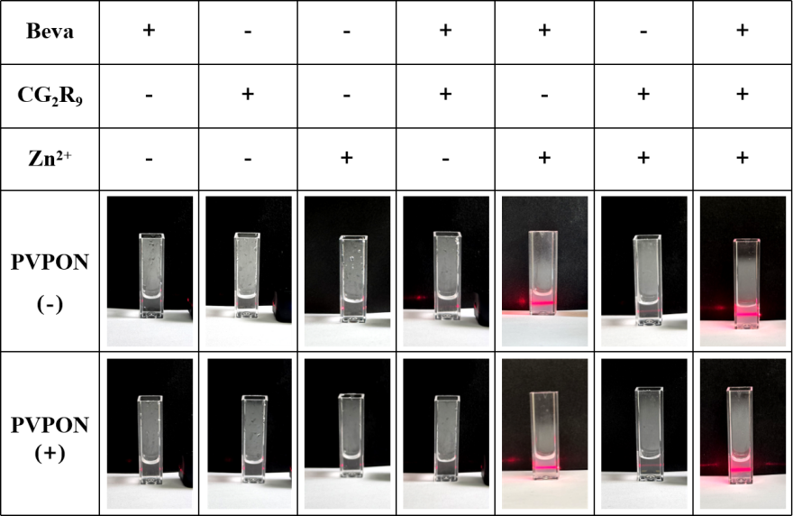
Figure S1. The solution state diagram of different materials (Beva, CG₂R₉, Zn, PVPON) after ultrasonic mixing and infrared laser pen irradiation.

Beva: Zn²⁺ | 67:2 | 67:4 | 67:6 | 67:8 | 67:10 | 67:12
Size  (nm) | - | - | 223.1±6.5 | 234.6±4.6 | 214.0±5.2 | 278.6±10.7
PDI | - | - | 0.278±0.0982 | 0.198±0.021 | 0.173±0.021 | 0.209±0.072
Zeta  (mV) | - | - | 17.7±1.2 | 18.9±2.5 | 19.2±1.2 | 19.1±2.3
EE% | 3.8±0.2 | 33.2±3.7 | 75.2±2.2 | 87.6±1.7 | 92.3±2.3 | 93.1±1.3

Table S1. Size, PDI, Zeta, and EE% of (CG₂R₉&Beva)@Zn at different mass ratios of Beva and Zn²⁺.

CG₂R₉ : Beva | 1:5 | 3:5 | 5:5 | 7:5
Size(nm) | 224.9±4.2 | 214.5±8.6 | 214.0±5.2 | 241.5±6.9
PDI | 0.131±0.023 | 0.172±0.032 | 0.173±0.021 | 0.248±0.072
Zeta(mV) | 18.7±0.9 | 19.2±1.8 | 19.2±1.2 | 20.7±1.1
EE% | 93.8±0.7 | 93.3±0.3 | 92.3±2.3 | 92.6±2.1

Table S2. Size, PDI, Zeta, and EE% of (CG₂R₉&Beva)@Zn at different mass ratios of Beva and Zn²⁺.

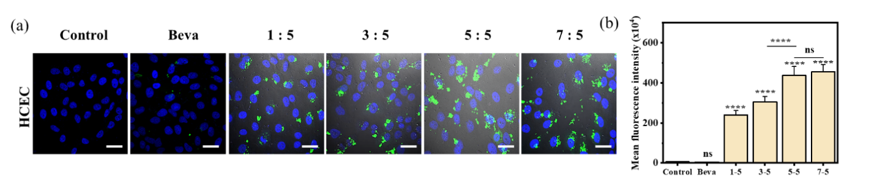
Figure S2. (a) Endocytosis results in different mass ratios of Beva and CG₂R_{9,}nuclei (blue), Beva(green),scar bar:100nm.(b) Results of the statistical analysis of the fluorescence intensity.

Figure S3. Zeta potential of Beva, CG₂R₉, Beva@Zn and (CG₂R₉&Beva)@Zn.

Figure S4. Characterization and Comparative Analysis of (CG₂R₉&Beva)@Zn Drug Delivery Systems. UV–vis absorbance of (a) F-Beva, (CG₂R₉&F-Beva)@Zn and the supernatant of (CG₂R₉&F-Beva)@Zn solutions; (b) F-CG₂R₉, (F-CG₂R₉&Beva)@Zn and the supernatant of (F-CG₂R₉&Beva)@Zn solutions.

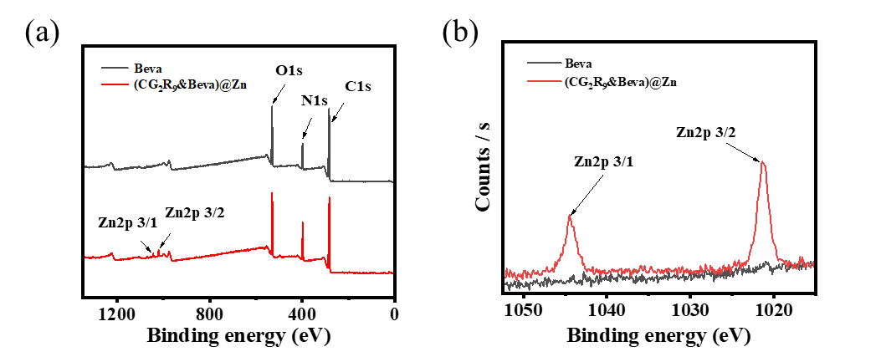
Figure S5. (a) X-ray photoelectron spectroscopy total spectra of Beva and (CG₂R₉&Beva)@Zn. (b) X-ray photoelectron spectroscopy Zn2p spectra of Beva and (CG₂R₉&Beva)@Zn.

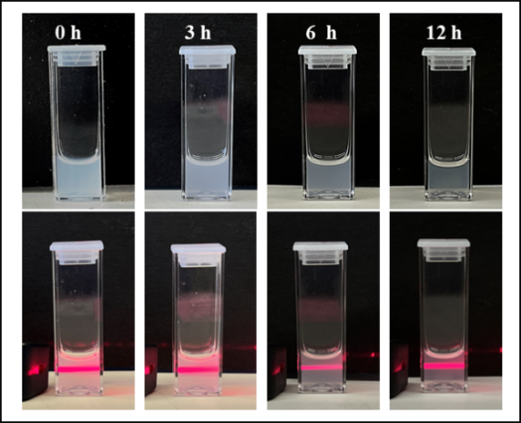

Figure S6. Photographs of the solution of the (CG₂R₉&Beva)@Zn particles at different times after synthesis. The lower rows are laser pointer irradiation images.

Time | 0h | 1h | 3h | 6h | 12h
Size(nm) | 214.0±5.2 | 190.0±9.4 | 164.0±5.2 | 106.0±6.9 | 43.8±3.2
PDI | 0.171±0.063 | 0.192±0.072 | 0.173±0.021 | 0.238±0.072 | 0.243±0.023
Zeta(mV) | 19.0±0.9 | 19.2±1.8 | 19.2±1.2 | 18.9±1.1 | 19.5±0.6
Table S3. Size，PDI, Zeta of (CG₂R₉&Beva)@Zn at 0h, 1h, 3h, 6h and 12h .

Figure S7. Particle Size Distribution of Beva@Zn at 0h, 24h, and 48h Post-Synthesis.
Beva@Zn was synthesized by adding 0.01M Zn²⁺ (50 μL) to a solution of Bevacizumab (Beva, 1 mg/mL) in the presence of PVPON (10 mg/mL) under sonication at pH 8.5.

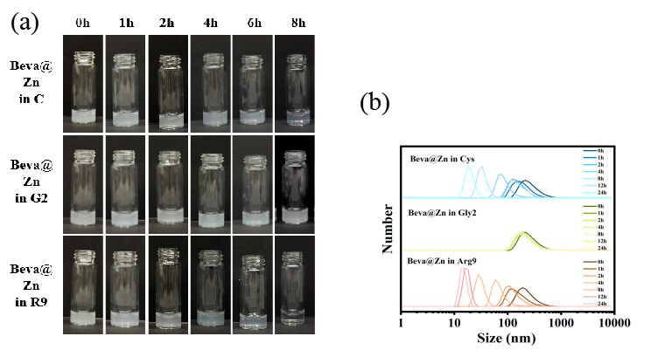
Figure S8. (a) Photographs of the solution of synthesized Beva@Zn particles in equimolar Cys (C), Gly2 (G₂) and Arg9 (R₉) solutions relative to (CG₂R₉&Beva)@Zn particles at 0h, 1h, 2h, 4h, 8h, 12h and 24h. (b) Size distribution of synthesized Beva@Zn particles in equimolar Cys,Gly2 and Arg9 solutions relative to (CG₂R₉&Beva)@Zn particles at 0h, 1h, 2h, 4h, 8h, 12h and 24h.

Peptide(C/G₂/R₉) : Initial | 1:1 | 1.5:1 | 2:1
(C&Beva)@Zn | 93.7±0.2 | 37.2±0.3 | 0
(G₂&Beva)@Zn | 93.5±0.7 | 94.3±1.3 | 94.6±1.5
(R₉&Beva)@Zn | 93.8±1.7 | 93.2±0.9 | 94.1±1.3

Table S4. Comparison of the EE% of nanoparticles formed by individual peptides (Cys [C], Gly2 [G₂], Arg9 [R₉]) at incremental stoichiometric ratios (1×, 1.5×, 2×) relative to their initial concentrations in the (CG₂R₉&Bevacizumab)@Zn formulation.

Figure S9. (a)The MD simulation results for Beva and peptides were obtained. (b)The interaction between Beva and Peptide 1 (CG₂R₉ ) was visualized as follows: The two heavy chains of Beva were represented in red and orange, while the two light chains were colored blue and green. CG₂R₉ was highlighted in violet. The residues involved in hydrogen bond formation between Beva and CG₂R₉ were depicted in licorice representation. (c) Hydrogen bonds number between CG₂R₉ and Beva. (d) (Root Mean Square Fluctuation) RMSF values of CG₂R₉ residues.

Figure S10. In vitro release profiles of Beva (a) and CG₂R₉ (b) from (CG₂R₉&Beva)@Zn particles at pH 7.2.

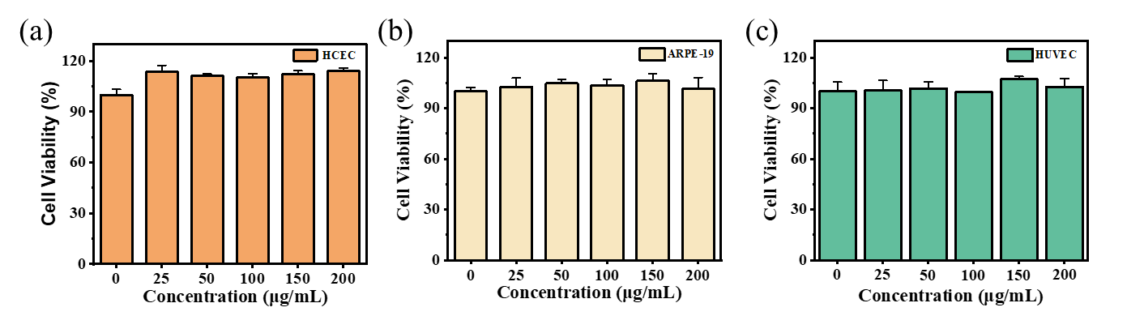
Figure S11. Viabilities of HCECs (a), ARPE-19 (b), and (HUVECs) (c) after treatment with different concentrations of (CG₂R₉&Beva)@Zn particles for 24 h.

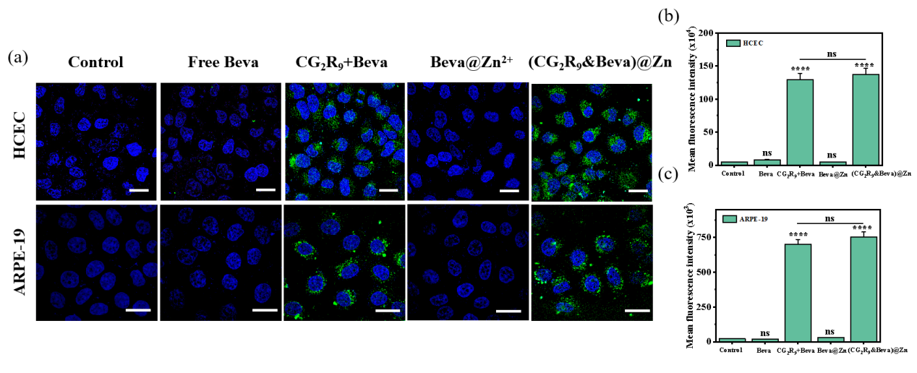

Figure S12. (a) Endocytosis of (CG₂R₉&Beva)@Zn after 3 h treatment on HCECs and ARPE-19 cells. Fluorescence statistical results of HCECs(b) and ARPE-19.Beva (green), nuclei (blue), scale bar 50 μm. (c)Results of the statistical analysis of the fluorescence intensity.
.

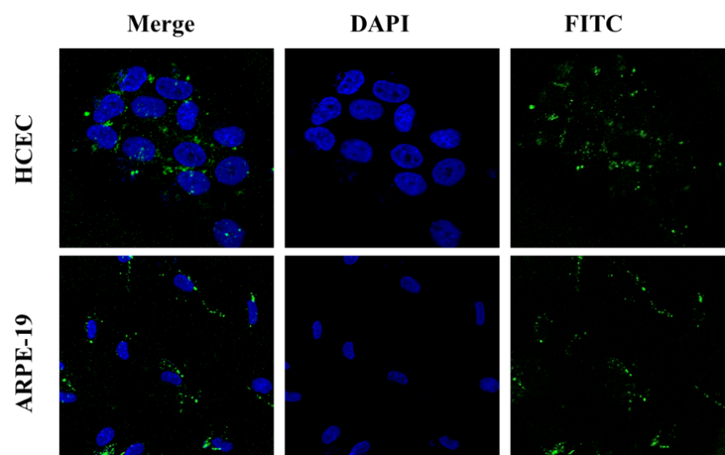
Figure S13. Fluorescence image of HCEC/ARPE cells on the recipient side after 6 h of co-incubation with donor-side cells after (CG₂R₉&Beva)@Zn treatment. Beva is labeled with fitc-labeled goat anti-human IgG. Beva (green), nuclei (blue), scale bar 50 μm.

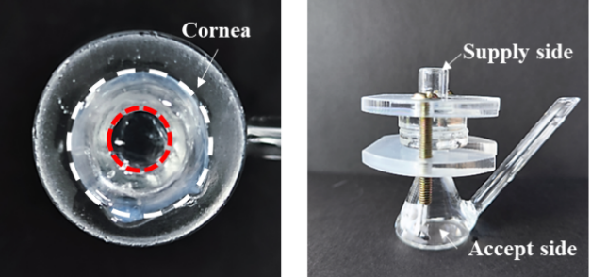
Figure S14. Schematic diagram of the Franz diffusion device.

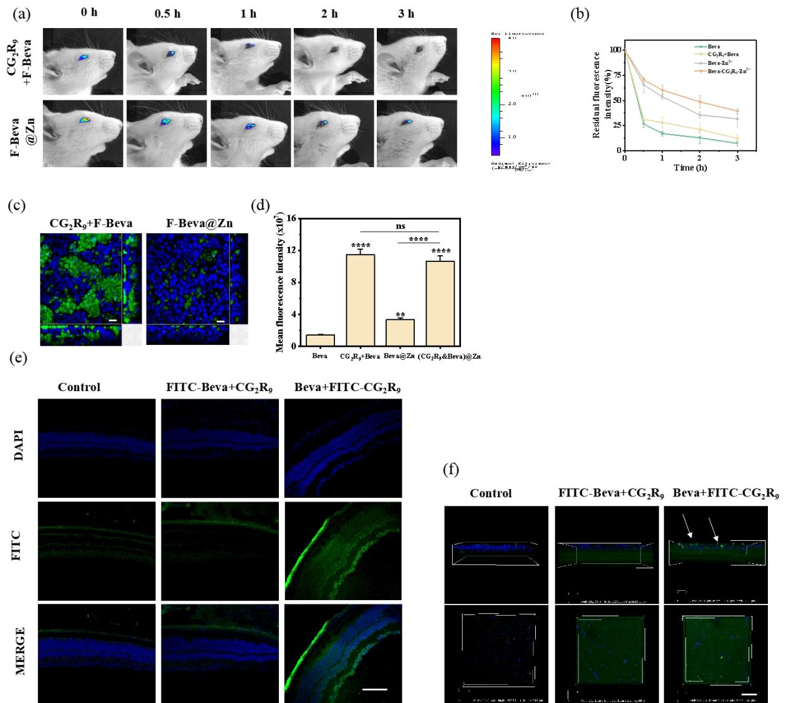

Figure S15. Evaluation of permeability and retention capacity in groups CG₂R₉+Beva and Beva@Zn. (a)In vivo fluorescence imaging of CG₂R₉+Beva and Beva@Zn at different time intervals on the ocular surface of rats. (b) Statistical analysis of fluorescence intensity of (a). (c) 3D multilayer corneal epithelial infiltration results. The xy axis, xz axis (lower side), and yz axis (right side) are shown. FITC-Beva (green), nucleus (blue), scale bar: 20 μm; (d) Statistical results of fluorescence intensity statistics of (c). (e) Fluorescent sections of the posterior segment of the mouse eye after administration in groups FITC-CG₂R₉+Beva and CG₂R₉+FITC-Beva. scale bar:100μm. (f) 3D scan images of the posterior segment of the eye of (c), white arrows indicate FITC-CG₂R₉ (Green). *: difference between the control group and the other group. *: p < 0.05; **: p < 0.01; ***: p < 0.001; ****: p < 0.0001 .The above statistical results were shared with the Beva group and (CG₂R₉&Beva)@Zn group.

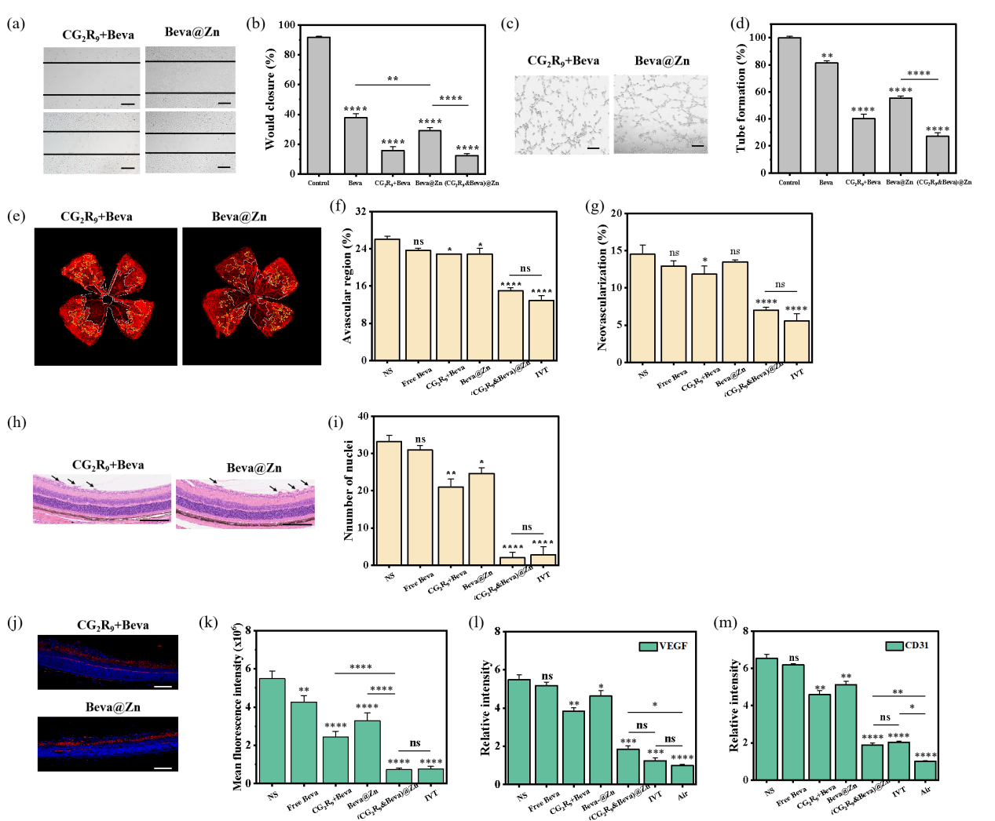
Figure S16. Anti-neovascularization effect in vitro and mouse oxygen- induced retinopathy (OIR) model in groups CG₂R₉+Beva and Beva@Zn. (a)The photographs from a wound healing assay were taken at 0 and 24 h after the generation of wounds in monolayer cultures of Huvec cells. Scale bar: 50 µm (b) Statistical results of (a). (c) Representative images of tube-like structures of Huvec cells acquired at 6 h and treated with different formulations. Scale bar: 100 µm. (d) Statistical results of (c). (e) Anti-angiogenic effect of G₂R₉+Beva and Beva@Zn in mouse OIR model. (a) Representative images of retinal neovessels for groups on day 17. The whole amount of retinas were stained with IB4. Analysis of (f) avascular areas and (g) pathological angiogenesis from the IB4-stained retinas at day 17. (h) H&E stained a section of the posterior segment of the eye for different groups. The scale bar in the H&E section is 50 μm; (i) Statistical analysis of fluorescence intensity of (h). (j) VEGF fluorescence staining images of the posterior segment of the eye at day 17 in each group VEGF (red) DAPI (blue). The scale bar is 20 μm. (k) Statistical analysis of fluorescence intensity of (j). RT-qPCR results of eyeballs (l) VEGF and (m) CD31 for each group. *: difference between the NS group and the other group. *: p < 0.05; **: p < 0.01; ***: p < 0.001; ****: p < 0.0001. The above statistical results were shared with the control group, Beva group, and Beva-CG₂R₉-Zn²⁺ group.

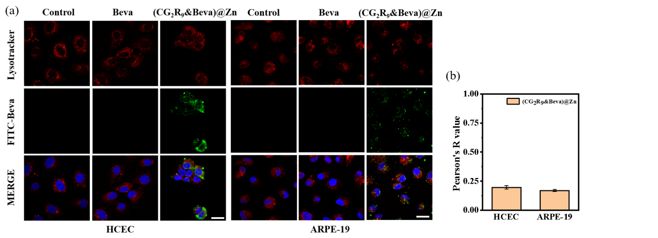

Figure S17. (a) Staining results of lysosomes (red) and Beva (green) in HCECs and ARPE-19 cells after particle treatment. (b) Colocalization analysis results of HCECs and ARPE-19 for the group (CG₂R₉&Beva)@Zn. scale bar 50 μm.

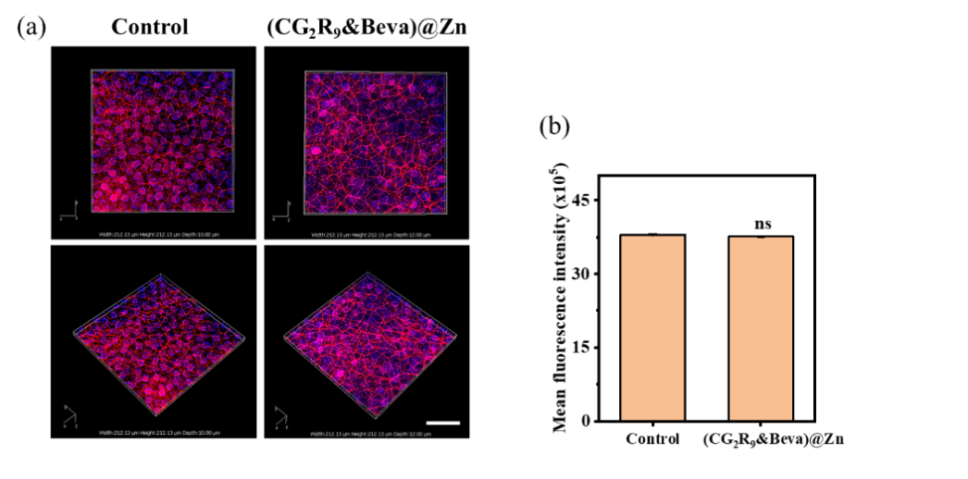

Figure S18. (a) Staining images of C57/6b mice corneal tissue Occludin tight junctions for (CG₂R₉&Beva)@Zn. Occludin (red) and DAPI (blue). Scale bar: 50μm. (b) Statistical analysis results of (a).

Section 3: References

1. Jo, S., et al., CHARMM-GUI: a web-based graphical user interface for CHARMM. J Comput Chem, 2008. 29(11): p. 1859-65.
2. Jo, S., et al., CHARMM-GUI Membrane Builder for mixed bilayers and its application to yeast membranes. Biophys J, 2009. 97(1): p. 50-8.
3. Wu, E.L., et al., CHARMM-GUI Membrane Builder toward realistic biological membrane simulations. J Comput Chem, 2014. 35(27): p. 1997-2004.
4. Lee, J., et al., CHARMM-GUI Input Generator for NAMD, GROMACS, AMBER, OpenMM, and CHARMM/OpenMM Simulations Using the CHARMM36 Additive Force Field. J Chem Theory Comput, 2016. 12(1): p. 405-13.
5. Huang, J., et al., CHARMM36m: an improved force field for folded and intrinsically disordered proteins. Nat Methods, 2017. 14(1): p. 71-73.
6. Abraham, M.J., et al., GROMACS: High performance molecular simulations through multi-level parallelism from laptops to supercomputers. SoftwareX, 2015. 1-2: p. 19-25.
7. Tang, B., et al., Decorating hexahistidine-metal assemblies with tyrosine enhances the ability of proteins to pass through corneal biobarriers. Acta Biomater, 2022. 153: p. 231-242.

