Suppplementary Figures for
iGrow: A Smart Agriculture Solution to Autonomous Greenhouse Control

Xiaoyan Cao∗† holmescaoxy@gmail.com School of Informatics, Xiamen University
Wanpeng Zhang zhangwp19@mails.tsinghua.edu.cn Tsinghua University

Shihui Guo guoshihui@xmu.edu.cn School of Informatics, Xiamen University

∗Both authors contributed equally to this research.
†Xiaoyan Cao and Dijun Luo are the corresponding authors.

Yao Yao∗

y-yao19@mails.tsinghua.edu.cn Tsinghua-Berkeley Shenzhen Institute, Tsinghua University
Zhicheng An azc19@mails.tsinghua.edu.cn Tsinghua-Berkeley Shenzhen Institute, Tsinghua University

Li Xiao xiaoli@sz.tsinghua.edu.cn Tsinghua-Berkeley Shenzhen Institute, Tsinghua University

Dijun Luo†
dijunluo@tencent.com
AI Lab, Tencent
Lanqing Li lanqingli@tencent.com AI Lab, Tencent

Zhong Zhang todzhang@tencent.com AI Lab, Tencent

Xiaoyu Cao xcao@xmu.edu.cn College of Chemistry and Chemical Engineering, Xiamen University Xiamen, China

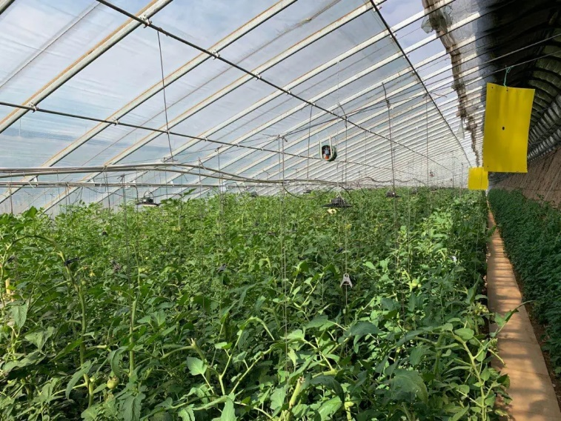
Figure S1. A greenhouse managed by iGrow in Liaoyang City, Liaoning Province, China.

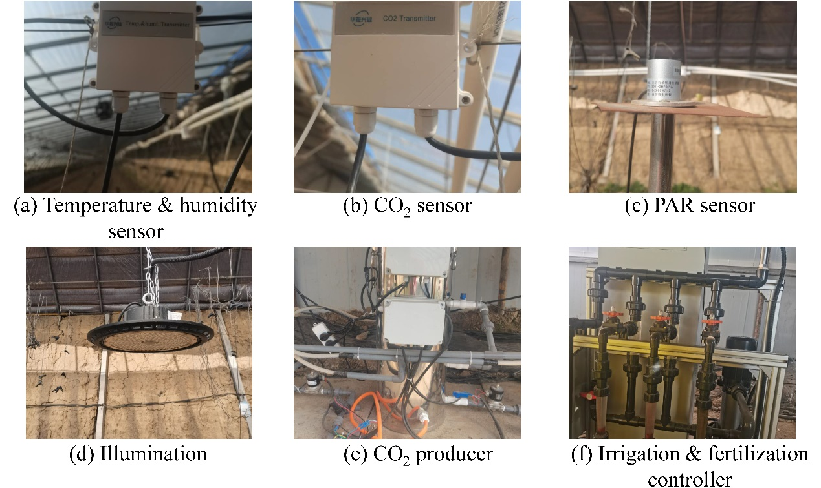
Figure S2. Some equipment of real greenhouse.

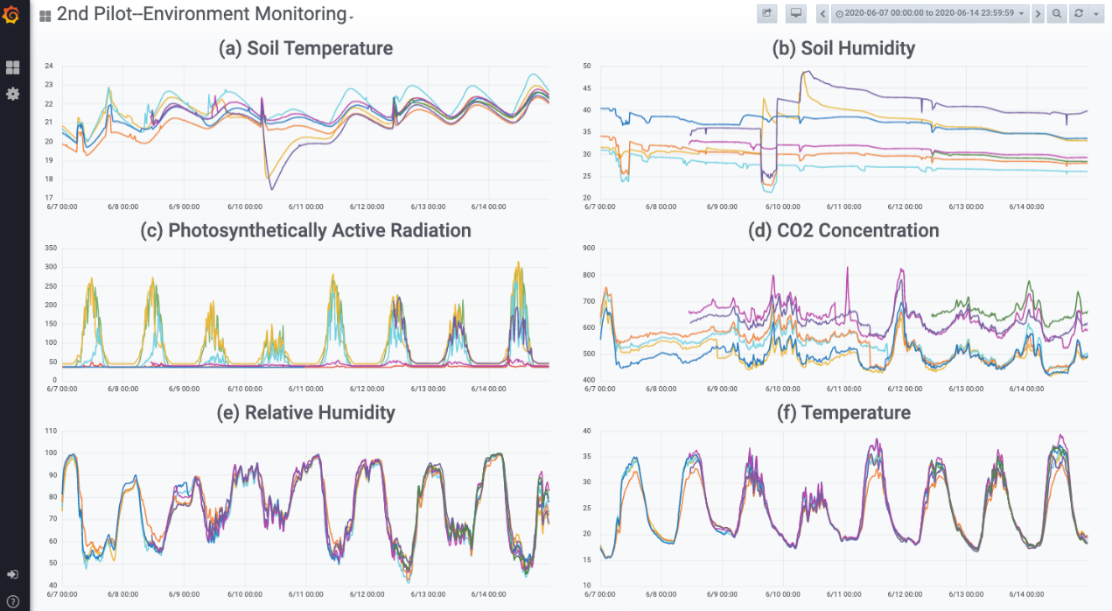
Figure S3. Visualization platform. Shows the environmental monitor situation in different greenhouse of the Liaoyang 2nd pilot. (From 2020-06-07 to 2020-06-14)

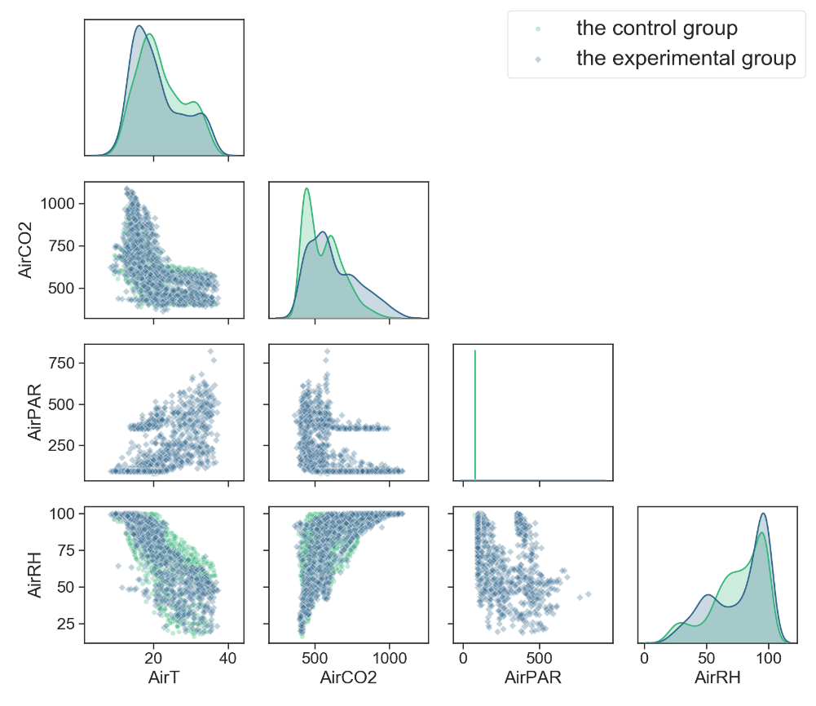
Figure S4. The relationship among AirT, AirCO2, AirPAR, and AirRH under the control strategies (the control group gh01 vs. the experimental group gh03).

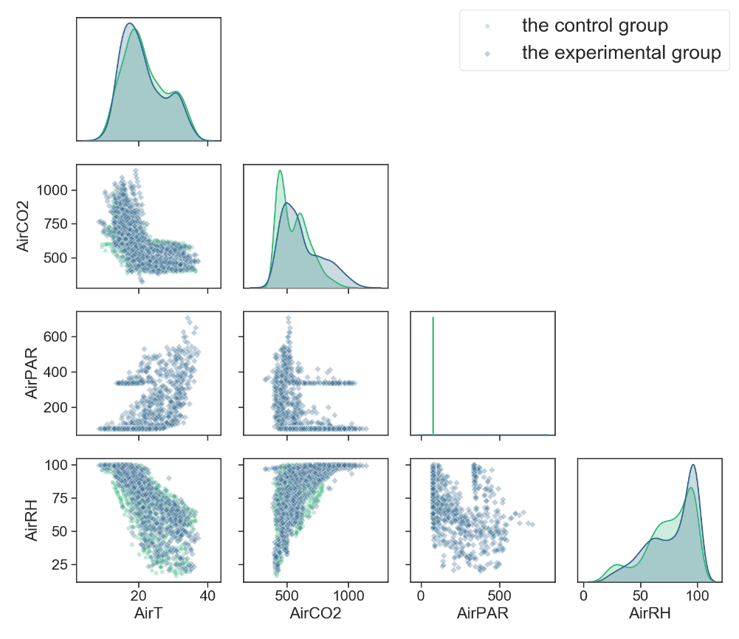
Figure S5. The relationship among AirT, AirCO2, AirPAR, and AirRH under the control strategies (the control group gh01 vs. the experimental group gh04).

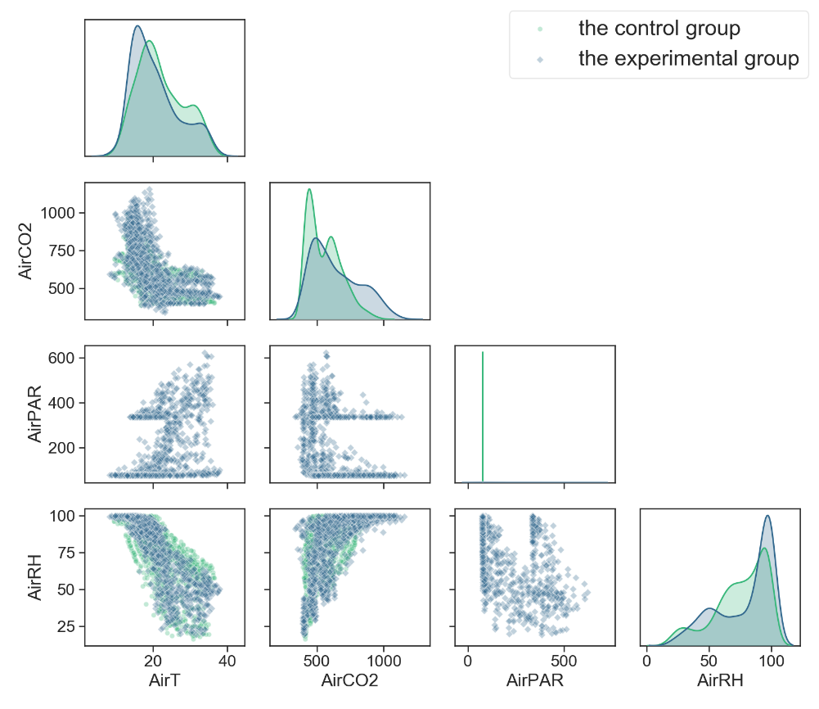
Figure S6. The relationship among AirT, AirCO2, AirPAR, and AirRH under the control strategies (the control group gh01 vs. the experimental group gh05).

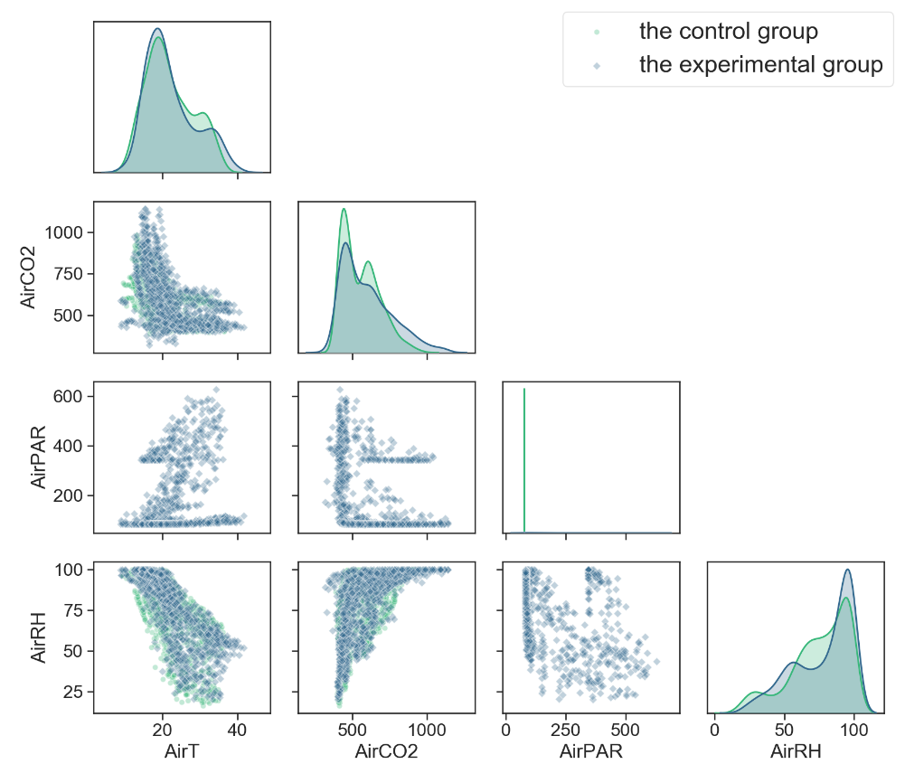
Figure S7. The relationship among AirT, AirCO2, AirPAR, and AirRH under the control strategies (the control group gh01 vs. the experimental group gh06).

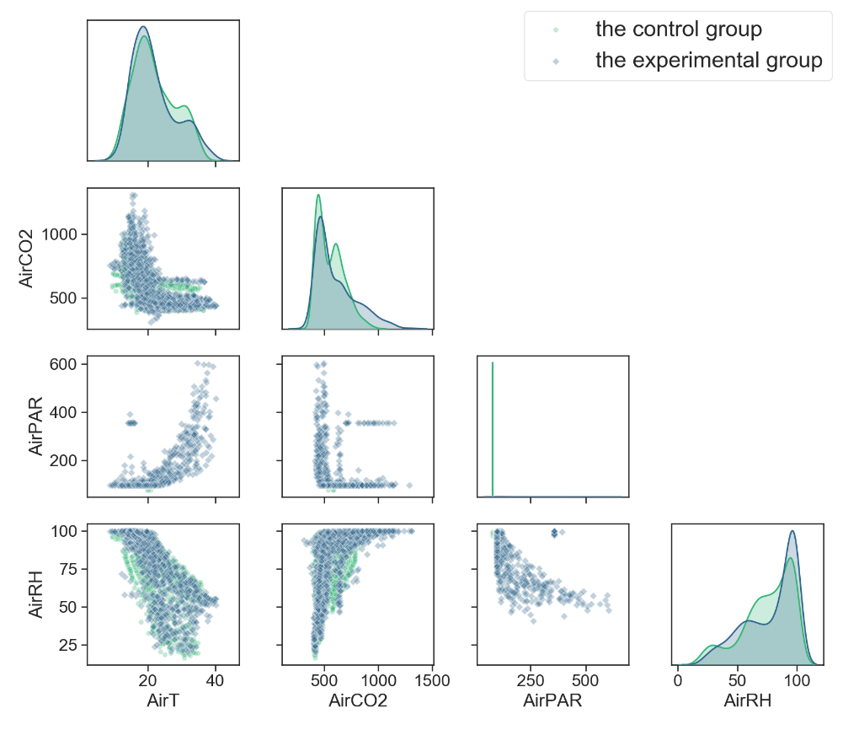
Figure S8. The relationship among AirT, AirCO2, AirPAR, and AirRH under the control strategies (the control group gh01 vs. the experimental group gh07).

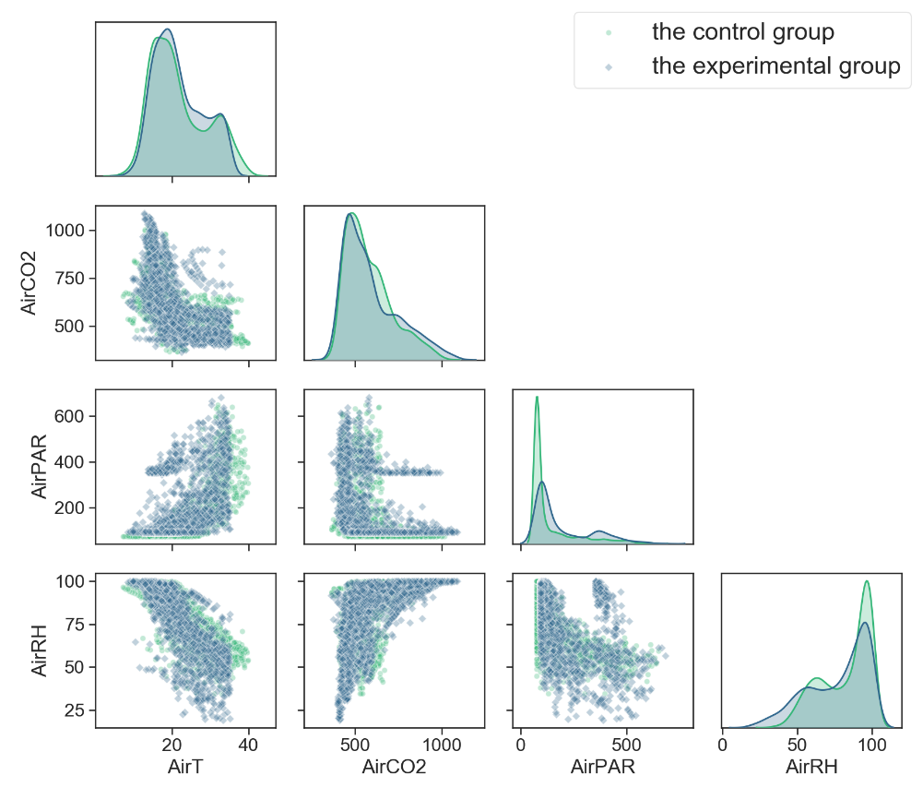
Figure S9. The relationship among AirT, AirCO2, AirPAR, and AirRH under the control strategies (the control group gh02 vs. the experimental group gh03).

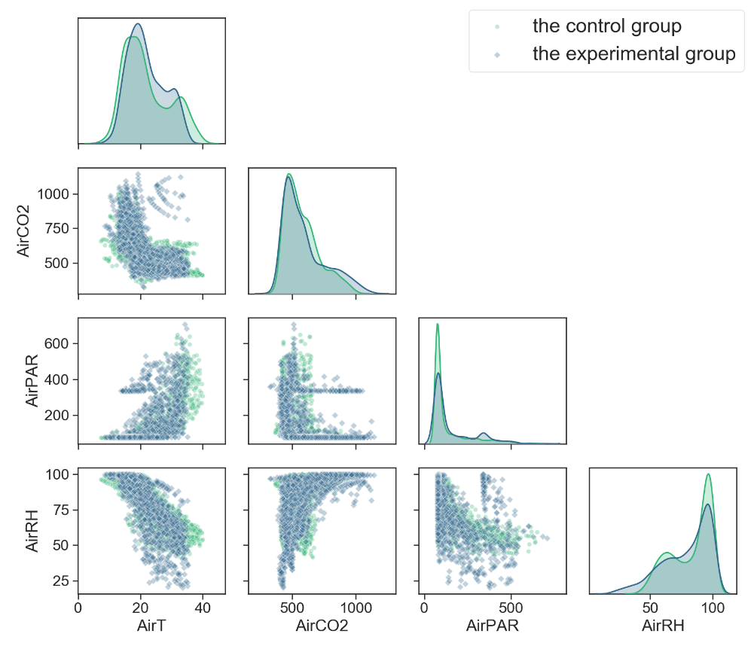
Figure S10. The relationship among AirT, AirCO2, AirPAR, and AirRH under the control strategies (the control group gh02 vs. the experimental group gh04).

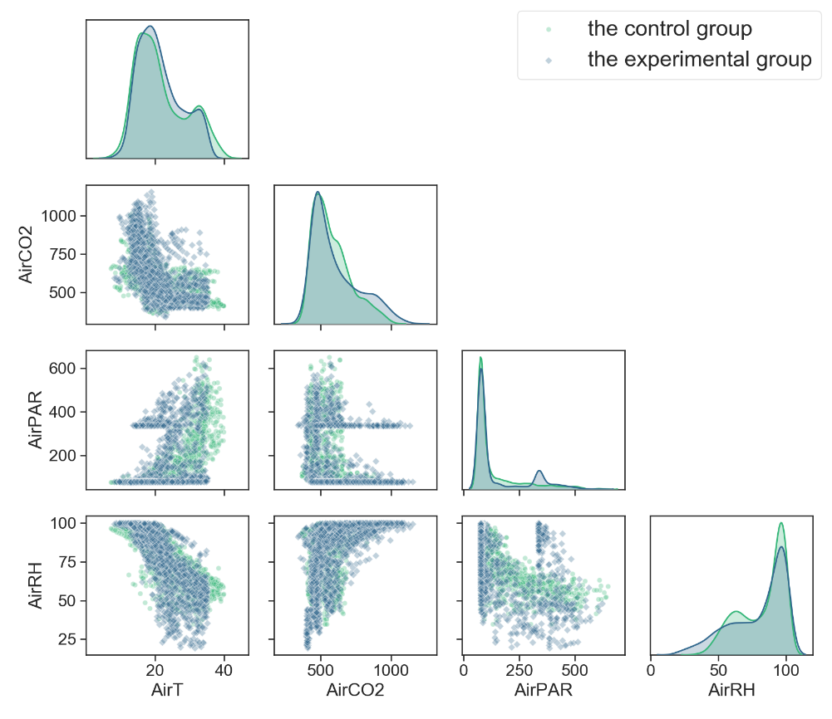
Figure S11. The relationship among AirT, AirCO2, AirPAR, and AirRH under the control strategies (the control group gh02 vs. the experimental group gh05).

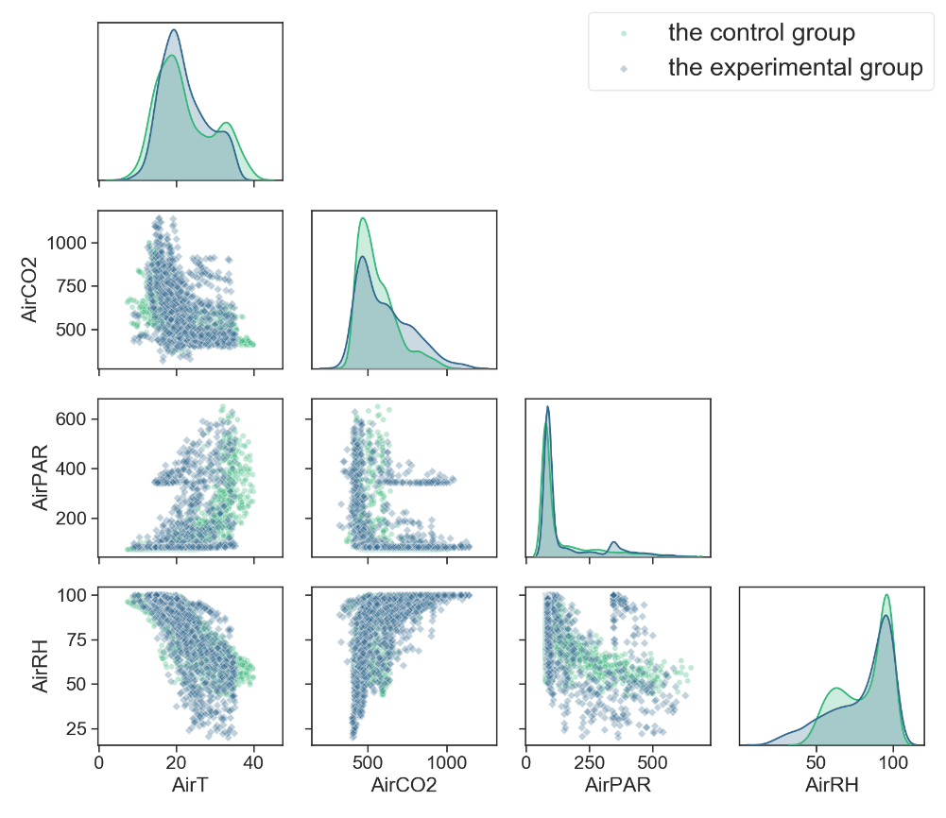
Figure S12. The relationship among AirT, AirCO2, AirPAR, and AirRH under the control strategies (the control group gh02 vs. the experimental group gh06).

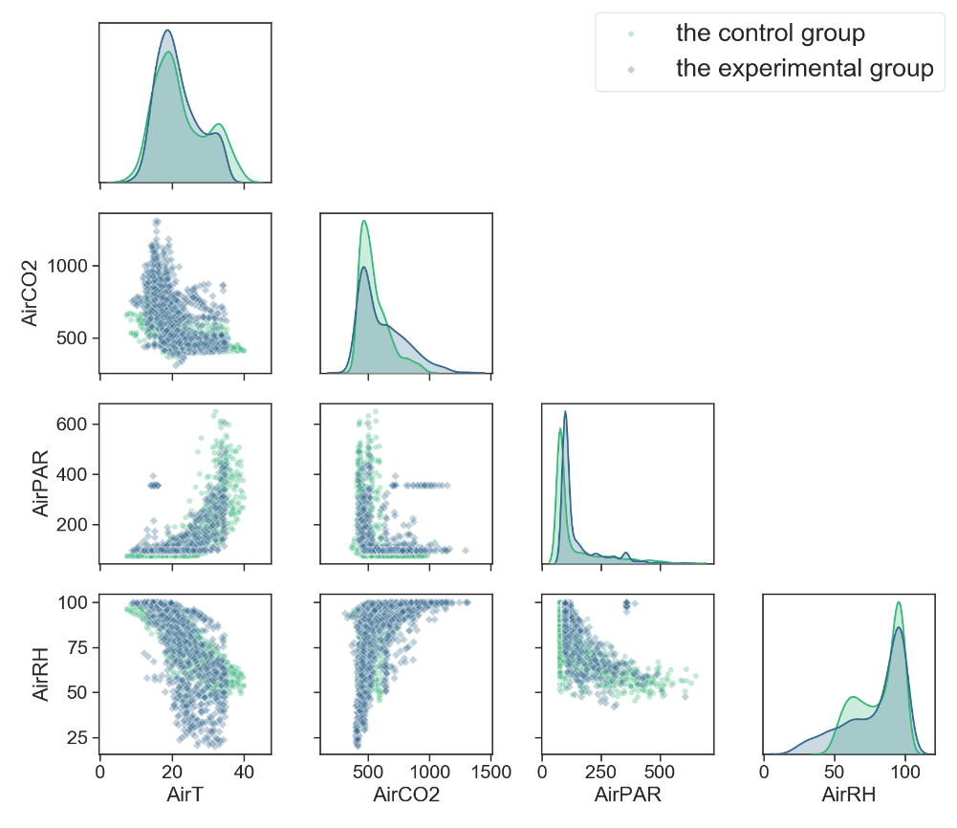
Figure S13. The relationship among AirT, AirCO2, AirPAR, and AirRH under the control strategies (the control group gh02 vs. the experimental group gh07).

