Real-time studies of plasma membrane damage trigger cell apoptosis from sulfhydryl nanoparticles to support safety assessment of nanoscale materials
Ting Wang¹*, Guanwen Qu ², Chenglong Cai^{1, 2}, Yichuan Wang³, Boru You¹, Zhewei Shuai¹, Yixin Zhang¹, Zhangqi Feng⁴, Jing Shang³
¹ State Key Laboratory of Bioelectronics, National Demonstration Centre for Experimental Biomedical Engineering Education, School of Biological Science and Medical Engineering, Southeast University, Nanjing 210096, P. R. China.
² Southeast University Jiangbei New Area Innovation Institute, Nanjing 210096, P. R. China.
³ State Key Laboratory of Natural Medicines, Department of Pharmacology, China Pharmaceutical University, Nanjing 210002, China.
⁴ School of Chemical Engineering, Nanjing University of Science and Technology, Nanjing, Jiangsu 210094, P.R. China.

Size distribution of nanopartibles and SSC analysis of C6 cells.
Dynamic laser light scattering image shown the size distribution of the nanoparticles from 50nm and 200nm nanoparticles as show in (Figure S1a).
Side scattered light (SSC) described the intracellular granularities and complexities of cells. Cells with more nanoparticles endocytosed or organelle swell would present high SSC intensities, while newly divided cells and cells with organelle damages would present relatively low SSC intensities [1]. Therefore, after being treated with 50 nm and 200 nm nanoparticles for 8 h, 16 h, and 24 h, SSC intensities of C6 cells were measured to describe the granularity and complexity changes in cells under the effects of the two kinds of nanoparticles. And to distinguish cells with high and low SSC intensities, a threshold I (the higher threshold, red line in figure S1b) and threshold II (the lower threshold, blue line in figure S1b) were set referring to the control group, and over 95% healthy cells distributed within the two thresholds. For 50 nm nanoparticles, the threshold I was set as SSC-H = 106.1, and threshold II was set as SSC-H = 105.7. For 200 nm nanoparticles, the threshold I was set as SSC-H = 106.3, and threshold II was set as SSC-H = 106.0 (Figure S1 b).
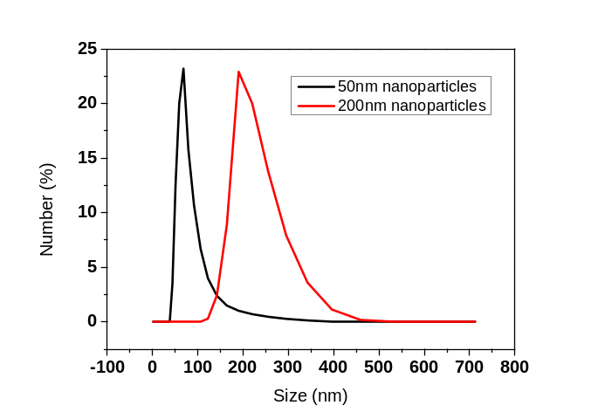
a

b
Figure S1. (a). The size distribution of 50nm and 200nm nanoparticles. (b). SSC-H maps of cells with and without 50 nm and 200 nm nanoparticle treatments. Red lines were the thresholds I distinguishing the cells with high SSC intensity. Blue lines were the thresholds II distinguishing the cells with low SSC intensities.
Sum Frequency Generation (SFG) Vibrational Spectroscopic Experiment
As a nonlinear optical process, SFG is only allowed under electric-dipole approximation in media without inversion symmetry. At surfaces or interfaces, the inversion symmetry of the bulk is broken and therefore SFG is allowed. SFG is a process in which two input beams at frequencies ω₁ and ω₂ mix in a medium and generate an output beam at the sum frequency ω = ω₁ + ω₂. For IR-visible SFG vibrational spectroscopy, ω₁, the frequency of the IR input beam, is tunable. If it is scanned over a vibrational resonance, SFG signal can be resonantly enhanced. Therefore SFG spectra can be collected by detecting SFG signals as a function of input IR frequency from surfaces and interfaces.
The supported lipid bilayers were constructed using the Langmuir-Blodgett and Langmuir Schaeffer method on CaF₂ right-angle prisms (Altos, Trabuco Canyon, CA). These prisms were soaked in toluene overnight and then sonicated in a Contrex AP solution from Decon Laboratories (King of Prussia, PA).They were then rinsed with water before being immersed in methanol for 1 h. After that, the prisms were rinsed again thoroughly with a large amount of deionized water and then cleaned in a glow discharge plasma chamber for 4 min immediately before the bilayer preparation. Substrates were tested by collecting SFG signals from their surfaces in air, and no contamination was detected. A KSV2000 LB system and ultrapure water from a Millipore system (Millipore, Bedford, MA) were usedthroughout the bilayer preparation. Aclean CaF₂ prism was attached to a sample holder via one right-angle face. The other right-angle face was perpendicularly immersed in the water inside of the Langmuir trough. Anappropriate amount of lipid chloroform solution was then gently spread onto the water surface, and the chloroform was allowed to evaporate. The lipid monolayer area was compressed by two barriers at a rate of 5 mm/min until a surface pressure of 34mN/m was reached. The prism was lifted out of the sub-phase at a rate of 1 mm/min. A monolayer of lipid on the prism was thus prepared. A reservoir was placed in a large trough slightly deeper than it so that water could cover the reservoir. The right-angle surface of the prism with the lipid monolayer was horizontally lowered to contact theother lipid monolayer deposited on the water surface (with a surface pressure of 34 mN/m) of the trough to form a lipid bilayer. After the formation of the bilayer, the extra lipidsat the air-water interface were removed using a micropipette. Water in the large trough was drained while keeping the bilayer immersed in water inside of the small reservoir so that a very small amount of m/NPswould be sufficient for the experiment. The bilayer was immersed in water throughout the entire experiment, and a small amount of water was added to the reservoir, when needed, to compensate for water evaporation during lengthy experiments.
For the m/NPs-bilayer interaction experiments, a small amount of the NP aqueous stock solution was injected into the small reservoir of 2 mL in contact with the lipid bilayer to achieve the desiredNP concentration. A magnetic micro-stirrer was used to ensure a homogeneous concentration distribution of m/NPs in the sub-phase below the bilayer. SFG spectra were then collected from the lipid bilayer with m/NPs using different polarization combinations of the input and output beams including ssp (s-polarized sum frequency signal, s-polarized visible input beam, and p-polarized IR input beam) and ppp. All the experiments were carried out at room temperature (23 °C).
In this research, to monitor how m/NPs interact with each leaflet of the lipid bilayer, bilayers with one deuterated lipid leaflet as the distal leaflet (or outer leaflet) and one hydrogenated lipid leaflet as the proximal leaflet (or inner leaflet) were constructed. SFG can be used to study two leaflets simultaneously by detecting C-D and C-H stretching signals respectively. To monitor C-H signals from m/NPs, lipid bilayers with both deuterated leaflets have also been used in the experiment. We show the molecular structure of 1,2-distearoyl(d70)–sn–glycerol-3-phosphocholine-1,1,2,2-d4-N,N,N-trimethyl-d9 (d-DSPC), 1,2-distearoyl-sn-glycero-3-phosphocholine (DSPC) and 1-palmitoyl-2-oleoyl-glycero-3-phosphocholine (POPC), all the lipids were from Avanti Polar Lipids, Alabaster were used.
The molecular structure for the lipid membrane were show as fig S1.
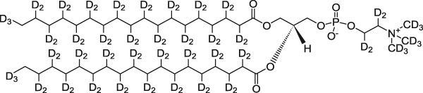
d-DSPC

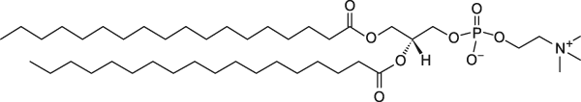
DSPC

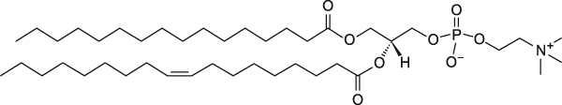
POPC
Fig S2 The molecular structure for the lipid membrane of d-DSPC, DSPC and POPC

Figure S3 showed the quantity changes of cells with high SSC intensities (SSC-H was higher than the threshold I), which indicated cells endocytosed large quantities of nanoparticles. According to the results, both 50 nm and 200 nm nanoparticle treatments could increase the SSC intensities in cells, indicating that the two kinds of nanoparticles could both be endocytosed by cells. And regarding time scale, the cell proportion with nanoparticle internalized increased within 24 h, which proved that 50 nm and 200 nm nanoparticles were continually endocytosed by cells and then accumulated in cells.

Figure S3. The proportions of cells with high SSC intensities after cells were treated with 50 nm and 200 nm nanoparticles.
Figure S4 demonstrated the quantity changes of cells with low SSC intensities (SSC intensity lower than threshold II). Low SSC intensity was derived from decreased intracellular granularities and complexities, which indicated organelle damages. According to figure S2 and S4, after treated with 50 nm nanoparticles, small amounts of cells presented low SSC intensities, but the cell proportions of low SSC intensities hardly changed from 8 h to 24 h, indicating that 50 nm nanoparticles did cause organelle damages, but the so-caused organelle damages was not strong nor deteriorate. Differently, 200 nm nanoparticles caused more cells to reflect low-intense SSC, and the cell proportions of low SSC intensities increased from 16 h to 24 h. The results suggested that 200 nm nanoparticles caused more organelle damages and these organelle damages kept worsening from 16 h to 24 h.

Figure S4. The proportions of cells with low SSC intensities after cells were treated with 50 nm and 200 nm nanoparticles.

Animal Experiments
Zebrafish eggs were co-cultured with 50 nm and 200 nm nanoparticles for 48 h, and then the zebrafish eggs were observed under SEM (Figure S5). Figure S5a presented that 50 nm nanoparticles could attach to the surface of zebrafish eggs but had little interactions with zebrafish eggs. And the zebrafish eggs hardly lost their contents after treated with 50 nm nanoparticles (figure S6b), indicating that 50 nm nanoparticles did not present strong toxicities to zebrafish embryos. Differently, 200 nm nanoparticles not only attached to the zebrafish eggs but also interacted with the egg membrane (blue circles in figure S6c). Simultaneously, the obvious shrinkage of zebrafish eggs can be found after affected by 200 nm nanoparticles and images show that they lose their contents. Results indicated that 200 nm nanoparticles harmed the zebrafish embryos potently.

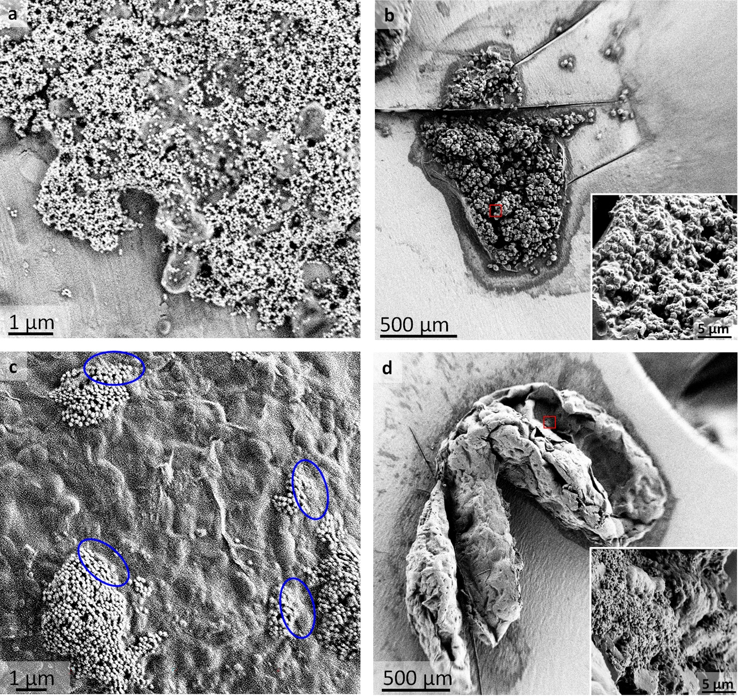
Figure S5. (a) 50 nm and (c) 200 nm sulfhydride nanoparticles on zebrafish eggs. Blue circles labeled the interactions between 200 nm nanoparticles and zebrafish egg membrane. Zebrafish eggs were cut to present their inner contents after treated with nanoparticles, (b) treated with 50 nm nanoparticles and (d) treated with 200 nm nanoparticles.

Reference
[1] C-L. Luo, Y-Q. Liu, P. Wang, C-H. Song, K-J. Wang, L-P. Dai, J-Y Zhang, H. Ye, The effect of quercetin nanoparticle on cervical cancer progression by inducing apoptosis, autophagy and anti-proliferation via JAK2 suppression. Biomed. Pharmacother. 82 (2016), 595-605. http://doi.org/ 10.1016/j.biopha.2016.05.029.

