Supplementary Materials

Supp. Figures:
Supp. Fig. 1. Boxplot of the number of days on Azithromycin for each participant by trajectory group.
Supp. Fig. 2. Generalized additive mixed model of total bacterial reads per million in nasal swab samples by days of azithromycin usage.
Supp. Fig. 3. SARS-CoV-2 Nasal Reads per million in samples ≤2 days on Azithromycin and after 4-6 days on Azithromycin shows no difference in rate of viral clearance.
Supp. Fig. 4. Number of detectably expressed MLS ARGs and percent of resistome attributed to the MLS ARG class show no significant decrease after cessation of Azithromycin.

Supplementary Tables
Supp. Table 1. Cohort demographics.

Supp. Table 2. Antibiotic usages across COVID-19 severity trajectory groups.

Supp. Table 3. Nasal swab differential gene expression analysis comparing Azithro versus No Abx groups. Legend: logFC = log(2) fold change; padj = Benjamini-Hochberg adjusted P value.
Please see accompanying data file.

Supp. Table 4. PBMC RNA-seq differential gene expression analysis comparing Azithro versus No Abx groups. Legend: logFC = log(2) fold change; padj = Benjamini-Hochberg adjusted P value. Please see accompanying data file.
 |  | Overall  (N=1164) | No Antibiotics  (n=474) | Azithro  (n=366) | Other Antibiotics  (n=324) | Overall  p-value | No vs Azithro  p-value | Other vs Azithro  p-value
Age (years), median (IQR) |  | 59.0 (20.0) | 57.0 (21.0) | 59.0 (19.0) | 62.0 (19.0) | <.001 | 0.025 | 0.000
Sex at birth | Male | 711 (61%) | 289 (61%) | 228 (62%) | 194 (60%) | 0.808 | 0.696 | 0.756
Sex at birth | Female | 453 (39%) | 185 (39%) | 138 (38%) | 130 (40%)
Race | White | 562 (48%) | 205 (43%) | 189 (52%) | 168 (52%) | 0.117 | 0.289 | 0.037
Race | Black | 259 (22%) | 125 (26%) | 75 (20%) | 59 (18%)
Race | Other | 210 (18%) | 93 (20%) | 62 (17%) | 55 (17%)
Race | Asian | 51 (4%) | 18 (4%) | 19 (5%) | 14 (4%)
Race | Multiple | 15 (1%) | 4 (1%) | 3 (1%) | 8 (2%)
Race | American Indian/Alaska Native | 14 (1%) | 7 (1%) | 4 (1%) | 3 (1%)
Race | Native Hawaiian/Pacific Islander | 11 (1%) | 6 (1%) | 3 (1%) | 2 (1%)
Race | Unknown | 42 (4%) | 16 (3%) | 11 (3%) | 15 (5%)
Hispanic ethnicity | Non-Hispanic | 753 (65%) | 320 (68%) | 218 (60%) | 215 (66%) | 0.020 | 0.008 | 0.917
Hispanic ethnicity | Hispanic | 364 (31%) | 133 (28%) | 138 (38%) | 93 (29%)
Hispanic ethnicity | Unknown | 47 (4%) | 21 (4%) | 10 (3%) | 16 (5%)
Comorbidities | None | 68 (6%) | 31 (7%) | 18 (5%) | 19 (6%) | 0.039 | 0.173 | 0.114
Comorbidities | Hypertension | 677 (58%) | 266 (56%) | 209 (57%) | 202 (62%) | 0.191 | 0.775 | 0.079
Comorbidities | Diabetes | 427 (37%) | 161 (34%) | 138 (38%) | 128 (40%) | 0.249 | 0.262 | 0.110
Comorbidities | Chronic lung disease | 235 (20%) | 86 (18%) | 67 (18%) | 82 (25%) | 0.026 | 0.952 | 0.015
Comorbidities | Asthma | 174 (15%) | 75 (16%) | 48 (13%) | 51 (16%) | 0.493 | 0.271 | 0.975
Comorbidities | Chronic cardiac disease | 315 (27%) | 140 (30%) | 77 (21%) | 98 (30%) | 0.007 | 0.005 | 0.829
Comorbidities | Chronic kidney disease | 178 (15%) | 59 (12%) | 58 (16%) | 61 (19%) | 0.046 | 0.158 | 0.013
Comorbidities | Chronic liver disease | 58 (5%) | 26 (5%) | 14 (4%) | 18 (6%) | 0.469 | 0.263 | 0.966
Comorbidities | Chronic neurological disorder | 143 (12%) | 60 (13%) | 29 (8%) | 54 (17%) | 0.002 | 0.027 | 0.112
Comorbidities | Organ Transplantation | 69 (6%) | 18 (4%) | 28 (8%) | 23 (7%) | 0.037 | 0.015 | 0.038
Comorbidities | HIV/AIDS | 21 (2%) | 9 (2%) | 3 (1%) | 9 (3%) | 0.153 | 0.191 | 0.411
Comorbidities | Malignancy | 119 (10%) | 44 (9%) | 25 (7%) | 50 (15%) | <.001 | 0.199 | 0.008
BMI Category | Underweight | 15 (1%) | 7 (1%) | 4 (1%) | 4 (1%) | <.001 | 0.209 | 0.001
BMI Category | Normal weight | 166 (14%) | 55 (12%) | 40 (11%) | 71 (22%)
BMI Category | Overweight (25.1-29.9) | 300 (26%) | 115 (24%) | 100 (27%) | 85 (26%)
BMI Category | Class 1-2 Obesity (30-39.9) | 473 (41%) | 194 (41%) | 163 (45%) | 116 (36%)
BMI Category | Class 3 Obesity (40+) | 167 (14%) | 77 (16%) | 50 (14%) | 40 (12%)
BMI Category | Missing | 43 (4%) | 26 (5%) | 9 (2%) | 8 (2%)
Level of respiratory support | Mechanically ventilated, or ECMO (OS=6) | 139 (12%) | 12 (3%) | 64 (17%) | 63 (19%) | <.001 | 0.000 | 0.000
Level of respiratory support | Non-invasive ventilation, or high flow nasal O2 (OS=5) | 212 (18%) | 62 (13%) | 89 (24%) | 61 (19%)
Level of respiratory support | Supplemental oxygen (not high flow) (OS=4) | 546 (47%) | 269 (57%) | 159 (43%) | 118 (36%)
Level of respiratory support | None (OS=3) | 266 (23%) | 131 (28%) | 54 (15%) | 81 (25%)
Level of respiratory support | Missing | 1 (0%) | 0 (0%) | 0 (0%) | 1 (0%)
Receipt of steroids |  | 793 (68%) | 273 (58%) | 291 (80%) | 229 (71%) | <.001 | 0.000 | 0.000
Length of stay (days) |  | 6.0 (8.0) | 5.0 (5.0) | 7.0 (9.0) | 8.0 (13.0) | <.001 | 0.000 | 0.000
COVID-19 severity trajectory group | 1 | 232 (20%) | 126 (27%) | 49 (13%) | 57 (18%) | <.001 | 0.000 | 0.000
COVID-19 severity trajectory group | 2 | 265 (23%) | 128 (27%) | 82 (22%) | 55 (17%)
COVID-19 severity trajectory group | 3 | 337 (29%) | 166 (35%) | 99 (27%) | 72 (22%)
COVID-19 severity trajectory group | 4 | 222 (19%) | 42 (9%) | 97 (27%) | 83 (26%)
COVID-19 severity trajectory group | 5 | 108 (9%) | 12 (3%) | 39 (11%) | 57 (18%)
Supp. Table 1. Cohort Demographics. ABX = antibiotics. CRP = C-reactive protein.
Antibiotic | Total  (n=1154) | TG1  (n=232) | TG2  (n=265) | TG3  (n=337) | TG4  (n=222) | TG5  (n=108)
Amikacin | 0.09% (1) | 0% (0) | 0% (0) | 0.3% (1) | 0% (0) | 0% (0)
Ampicillin-Sulbactam | 0.86% (10) | 0% (0) | 0.75% (2) | 0.3% (1) | 2.7% (6) | 0.93% (1)
Ampicillin | 2.06% (24) | 2.16% (5) | 0.38% (1) | 0.89% (3) | 5.86% (13) | 1.85% (2)
Azithromycin | 29.81% (347) | 20.69% (48) | 29.06% (77) | 28.19% (95) | 40.54% (90) | 34.26% (37)
Aztreonam | 0.43% (5) | 0.43% (1) | 0.38% (1) | 0% (0) | 0.9% (2) | 0.93% (1)
Cefazolin | 2.23% (26) | 1.29% (3) | 0.75% (2) | 1.19% (4) | 4.95% (11) | 5.56% (6)
Cefepime | 12.71% (148) | 3.02% (7) | 5.28% (14) | 4.45% (15) | 31.08% (69) | 39.81% (43)
Cefpodoxime | 0.43% (5) | 1.29% (3) | 0% (0) | 0.59% (2) | 0% (0) | 0% (0)
Ceftazidime | 1.72% (20) | 0% (0) | 0.38% (1) | 0.3% (1) | 4.5% (10) | 7.41% (8)
Ceftriaxone | 36.77% (428) | 30.6% (71) | 35.09% (93) | 31.16% (105) | 49.55% (110) | 45.37% (49)
Cefuroxime | 0.26% (3) | 0% (0) | 0% (0) | 0.89% (3) | 0% (0) | 0% (0)
Ciprofloxacin | 1.03% (12) | 0.43% (1) | 0.38% (1) | 1.19% (4) | 2.25% (5) | 0.93% (1)
Clindamycin | 0.17% (2) | 0% (0) | 0% (0) | 0.59% (2) | 0% (0) | 0% (0)
Daptomycin | 0.26% (3) | 0% (0) | 0% (0) | 0% (0) | 0.9% (2) | 0.93% (1)
Doxycycline | 7.13% (83) | 6.9% (16) | 9.06% (24) | 5.34% (18) | 8.11% (18) | 6.48% (7)
Ertapenem | 1.55% (18) | 0% (0) | 0.75% (2) | 0.89% (3) | 4.5% (10) | 2.78% (3)
Erythromycin | 0.34% (4) | 0.43% (1) | 0% (0) | 0% (0) | 0.9% (2) | 0.93% (1)
Gentamicin | 0.09% (1) | 0% (0) | 0% (0) | 0% (0) | 0.45% (1) | 0% (0)
Levofloxacin | 2.32% (27) | 1.29% (3) | 0.75% (2) | 2.37% (8) | 4.95% (11) | 2.78% (3)
Linezolid | 0.77% (9) | 0.43% (1) | 0% (0) | 0% (0) | 2.25% (5) | 2.78% (3)
Meropenem | 3.87% (45) | 0% (0) | 0.75% (2) | 1.19% (4) | 12.16% (27) | 11.11% (12)
Metronidazole | 3.09% (36) | 0.86% (2) | 1.13% (3) | 1.19% (4) | 7.66% (17) | 9.26% (10)
Piperacillin-Tazobactam | 9.02% (105) | 3.02% (7) | 4.91% (13) | 3.86% (13) | 20.72% (46) | 24.07% (26)
Rifampin | 0.09% (1) | 0% (0) | 0% (0) | 0% (0) | 0.45% (1) | 0% (0)
Rifaximin | 0.43% (5) | 0.43% (1) | 0% (0) | 0% (0) | 1.35% (3) | 0.93% (1)
Sulfamethoxazole-Trimethoprim | 1.55% (18) | 0.43% (1) | 0.75% (2) | 1.48% (5) | 3.6% (8) | 1.85% (2)
Tobramycin | 0.34% (4) | 0% (0) | 0% (0) | 0% (0) | 1.35% (3) | 0.93% (1)
Vancomycin | 21.22% (247) | 4.74% (11) | 11.7% (31) | 10.39% (35) | 45.5% (101) | 63.89% (69)
Other | 3.09% (36) | 1.72% (4) | 2.64% (7) | 1.78% (6) | 5.86% (13) | 5.56% (6)

Supp. Table 2. Antibiotic usages across COVID-19 severity trajectory groups (TGs).
Supplementary Figures
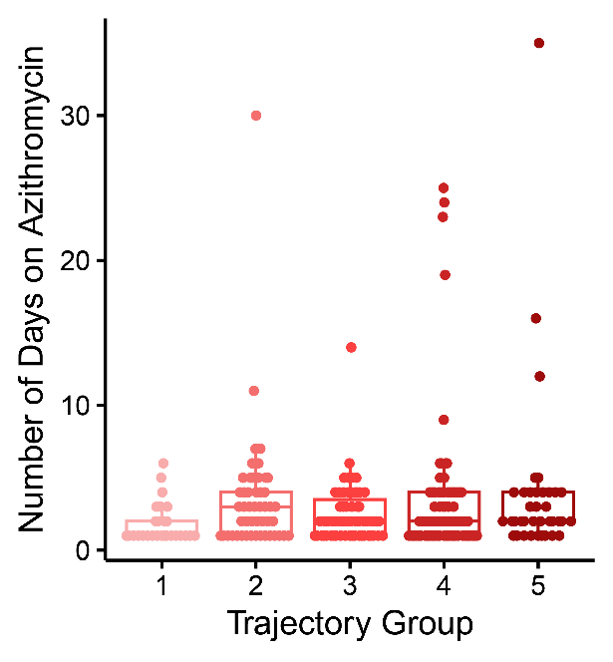
Supplementary Figure 1. Days of azithromycin exposure for each participant by COVID-19 severity trajectory group.

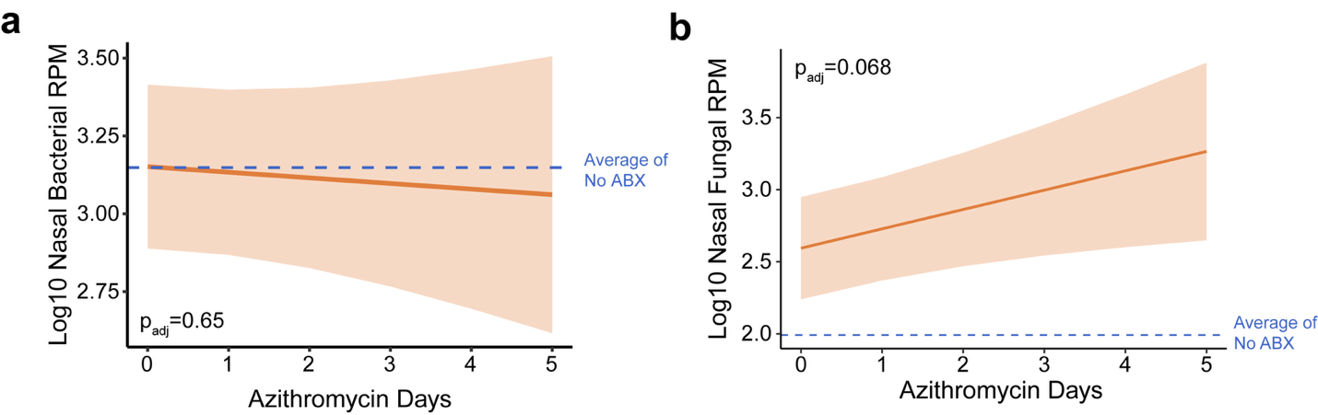

Supplementary Figure 2. Changes in upper airway bacterial and fungal abundance based on days of azithromycin exposure. a Generalized additive mixed model (GAMM) of total bacterial reads per million (RPM) in nasal swab samples by days of azithromycin usage. b Total fungal RPM in nasal swab samples by days of azithromycin usage.

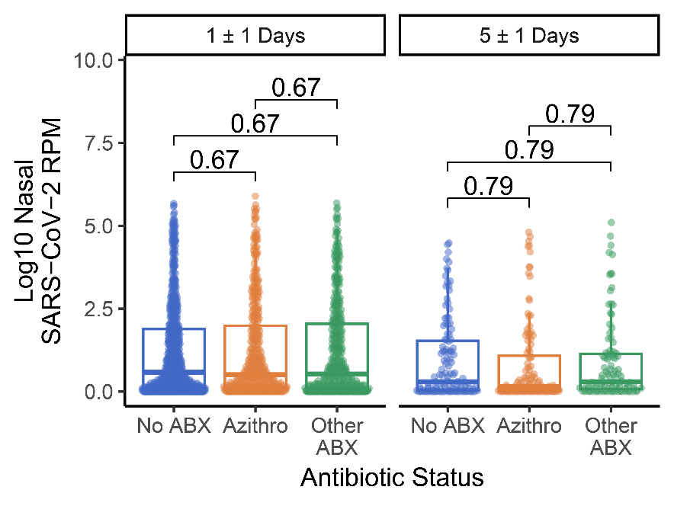
Supplementary Figure 3. SARS-CoV-2 abundance (reads per million, RPM) does not differ based on azithromycin exposure.

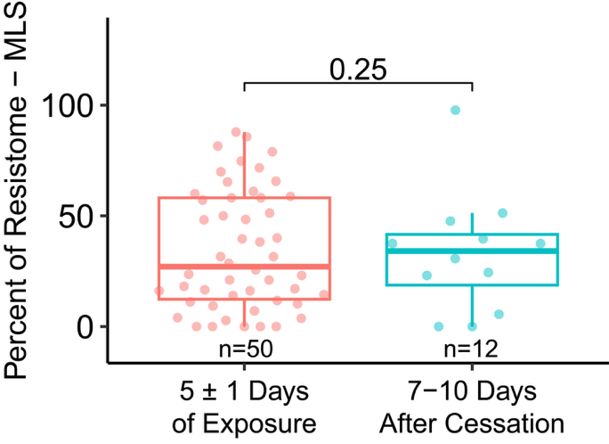
Supplementary Figure 4. Percent of resistome attributed to the MLS ARG class shows no significant decrease after cessation of azithromycin. P values shown are the result of a linear mixed-effects model. Boxplots display the median, first and third quartile, and range. Data points are randomly jittered along the x-axis for visual clarity.
# The IMPACC Network
National Institute of Allergy and Infectious Diseases, National Institute of Health, Bethesda, MD 20814, USA: Patrice M. Becker, Alison D. Augustine, Steven M. Holland, Lindsey B. Rosen, Serena Lee, Tatyana Vaysman
Clinical and Data Coordinating Center (CDCC) Precision Vaccines Program, Boston Children’s Hospital, Boston, MA 02115, USA: Al Ozonoff, Joann Diray-Arce, Jing Chen, Alvin Kho, Carly E. Milliren, Annmarie Hoch, Ana C. Chang, Kerry McEnaney, Brenda Barton, Claudia Lentucci, Maimouna D. Murphy, Mehmet Saluvan, Tanzia Shaheen, Shanshan Liu, Caitlin Syphurs, Marisa Albert, Arash Nemati Hayati, Robert Bryant, James Abraham, Sanya Thomas, Mitchell Cooney, Meagan Karoly
Benaroya Research Institute, University of Washington, Seattle, WA 98101, USA: Matthew C. Altman, Naresh Doni Jayavelu, Scott Presnell, Bernard Kohr, Tomasz Jancsyk, Azlann Arnett
La Jolla Institute for Immunology, La Jolla, CA 92037, USA: Bjoern Peters, James A. Overton, Randi Vita, Kerstin Westendorf
Knocean Inc. Toronto, ON M6P 2T3, Canada: James A. Overton
Precision Vaccines Program, Boston Children’s Hospital, Harvard Medical School, Boston, MA 02115, USA: Ofer Levy, Hanno Steen, Patrick van Zalm, Benoit Fatou, Kinga K. Smolen, Arthur Viode, Simon van Haren, Meenakshi Jha, David Stevenson, Oludare Odumade
Brigham and Women’s Hospital, Harvard Medical School, Boston, MA 02115, USA: Lindsey R. Baden, Kevin Mendez, Jessica Lasky-Su, Alexandra Tong, Rebecca Rooks, Michael Desjardins, Amy C. Sherman, Stephen R. Walsh, Xhoi Mitre, Jessica Cauley, Xiofang Li, Bethany Evans, Christina Montesano, Jose Humberto Licona, Jonathan Krauss, Nicholas C. Issa, Jun Bai Park Chang, Natalie Izaguirre
Metabolon Inc, Morrisville, NC 27560, USA: Scott R. Hutton, Greg Michelotti, Kari Wong
Prevention of Organ Failure (PROOF) Centre of Excellence, University of British Columbia, Vancouver, BC V6T 1Z3, Canada: Scott J. Tebbutt, Casey P. Shannon
Case Western Reserve University and University Hospitals of Cleveland, Cleveland, OH 44106, USA: Rafick-Pierre Sekaly, Slim Fourati, Grace A. McComsey, Paul Harris, Scott Sieg, Susan Pereira Ribeiro
Drexel University, Tower Health Hospital, Philadelphia, PA 19104, USA: Charles B. Cairns, Elias K. Haddad, Michele A. Kutzler, Mariana Bernui, Gina Cusimano, Jennifer Connors, Kyra Woloszczuk, David Joyner, Carolyn Edwards, Edward Lee, Edward Lin, Nataliya Melnyk, Debra L. Powell, James N. Kim, I. Michael Goonewardene, Brent Simmons, Cecilia M. Smith, Mark Martens, Brett Croen, Nicholas C. Semenza, Mathew R. Bell, Sara Furukawa, Renee McLin, George P. Tegos, Brandon Rogowski, Nathan Mege, Kristen Ulring, Pam Schearer, Judie Sheidy, Crystal Nagle
MyOwnMed Inc., Bethesda, MD 20817, USA: Vicki Seyfert-Margolis
Emory School of Medicine, Atlanta, GA 30322, USA: Nadine Rouphael, Steven E. Bosinger, Arun K. Boddapati, Greg K. Tharp, Kathryn L. Pellegrini, Brandi Johnson, Bernadine Panganiban, Christopher Huerta, Evan J. Anderson, Hady Samaha, Jonathan E. Sevransky, Laurel Bristow, Elizabeth Beagle, David Cowan, Sydney Hamilton, Thomas Hodder, Amer Bechnak, Andrew Cheng, Aneesh Mehta, Caroline R. Ciric, Christine Spainhour, Erin Carter, Erin M. Scherer, Jacob Usher, Kieffer Hellmeister, Laila Hussaini, Lauren Hewitt, Nina Mcnair, Susan Pereira Ribeiro, Sonia Wimalasena
Icahn School of Medicine at Mount Sinai, New York, NY 10029, USA: Ana Fernandez-Sesma, Viviana Simon, Florian Krammer, Harm Van Bakel, Seunghee Kim-Schulze, Ana Silvia Gonzalez Reiche, Jingjing Qi, Brian Lee, Juan Manuel Carreño, Gagandeep Singh, Ariel Raskin, Johnstone Tcheou, Zain Khalil, Adriana van de Guchte, Keith Farrugia, Zenab Khan, Geoffrey Kelly, Komal Srivastava, Lily Q. Eaker, Maria C. Bermúdez-González, Lubbertus C.F. Mulder, Katherine F. Beach, Miti Saksena, Deena Altman, Erna Kojic, Levy A. Sominsky, Arman Azad, Dominika Bielak, Hisaaki Kawabata, Temima Yellin, Miriam Fried, Leeba Sullivan, Sara Morris, Giulio Kleiner, Daniel Stadlbauer, Jayeeta Dutta, Hui Xie, Manishkumar Patel, Kai Nie
Immunai Inc. New York, NY 10016, USA: Adeeb Rahman
Oregon Health Sciences University, Portland, OR 97239, USA: William B. Messer, Catherine L. Hough, Sarah A.R. Siegel, Peter E. Sullivan, Zhengchun Lu, Amanda E. Brunton, Matthew Strand, Zoe L. Lyski, Felicity J. Coulter, Courtney Micheleti
Stanford University School of Medicine, Palo Alto, CA 94305, USA: Holden Maecker, Bali Pulendran, Kari C. Nadeau, Yael Rosenberg-Hasson, Michael Leipold, Natalia Sigal, Angela Rogers, Andrea Fernandes, Monali Manohar, Evan Do, Iris Chang, Alexandra S. Lee, Catherine Blish, Henna Naz Din, Jonasel Roque, Linda Geng, Maja Artandi, Mark M. Davis, Neera Ahuja, Samuel S. Yang, Sharon Chinthrajah, Thomas Hagan
David Geffen School of Medicine at the University of California Los Angeles, Los Angeles CA 90095, USA: Elaine F. Reed, Joanna Schaenman, Ramin Salehi-Rad, Adreanne M. Rivera, Harry C. Pickering, Subha Sen, David Elashoff, Dawn C. Ward, Jenny Brook, Estefania Ramires Sanchez, Megan Llamas, Claudia Perdomo, Clara E. Magyar, Jennifer Fulcher
University of California San Francisco, San Francisco, CA 94115, USA: David J. Erle, Carolyn S. Calfee, Carolyn M. Hendrickson, Kirsten N. Kangelaris, Viet Nguyen, Deanna Lee, Suzanna Chak, Rajani Ghale, Ana Gonzalez, Alejandra Jauregui, Carolyn Leroux, Luz Torres Altamirano, Ahmad Sadeed Rashid, Andrew Willmore, Prescott G. Woodruff, Matthew F. Krummel, Sidney Carrillo, Alyssa Ward, Charles R. Langelier, Ravi Patel, Michael Wilson, Ravi Dandekar, Bonny Alvarenga, Jayant Rajan, Walter Eckalbar, Andrew W. Schroeder, Gabriela K. Fragiadakis, Alexandra Tsitsiklis, Eran Mick, Yanedth Sanchez Guerrero, Christina Love, Lenka Maliskova, Michael Adkisson, Aleksandra Leligdowicz, Alexander Beagle, Arjun Rao, Austin Sigman, Bushra Samad, Cindy Curiel, Cole Shaw, Gayelan Tietje-Ulrich, Jeff Milush, Jonathan Singer, Joshua J. Vasquez, Kevin Tang, Legna Betancourt, Lekshmi Santhosh, Logan Pierce, Maria Tecero Paz, Michael Matthay, Neeta Thakur, Nicklaus Rodriguez, Nicole Sutter, Norman Jones, Pratik Sinha, Priya Prasad, Raphael Lota, Sadeed Rashid, Saurabh Asthana, Sharvari Bhide, Tasha Lea, Yumiko Abe-Jones
Yale School of Medicine, New Haven, CT 06510, USA: David A. Hafler, Ruth R. Montgomery, Albert C. Shaw, Steven H. Kleinstein, Jeremy P. Gygi, Shrikant Pawar, Anna Konstorum, Ernie Chen, Chris Cotsapas, Xiaomei Wang, Leqi Xu, Charles Dela Cruz, Akiko Iwasaki, Subhasis Mohanty, Allison Nelson, Yujiao Zhao, Shelli Farhadian, Hiromitsu Asashima, Omkar Chaudhary, Andreas Coppi, John Fournier, M. Catherine Muenker, Allison Nelson, Khadir Raddassi, Michael Rainone, William Ruff, Syim Salahuddin, Wade L. Shulz, Pavithra Vijayakumar, Haowei Wang, Esio Wunder Jr., H. Patrick Young, Albert I. Ko,
Yale School of Public Health, New Haven, CT 06510, USA: Denise Esserman, Leying Guan, Anderson Brito, Jessica Rothman, Nathan D. Grubaugh
Baylor College of Medicine and the Center for Translational Research on Inflammatory Diseases, Houston, TX 77030, USA: David B. Corry, Farrah Kheradmand, Li-Zhen Song, Ebony Nelson
Oklahoma University Health Sciences Center, Oklahoma City, OK 73104, USA: Jordan P. Metcalf, Nelson I. Agudelo Higuita, Lauren A. Sinko, J. Leland Booth, Douglas A. Drevets, Brent R. Brown
University of Arizona, Tucson AZ 85721, USA: Monica Kraft, Chris Bime, Jarrod Mosier, Heidi Erickson, Ron Schunk, Hiroki Kimura, Michelle Conway, Dave Francisco, Allyson Molzahn, Connie Cathleen Wilson, Ron Schunk, Trina Hughes, Bianca Sierra
University of Florida, Gainesville, FL 32611, USA: Mark A. Atkinson, Scott C. Brakenridge, Ricardo F. Ungaro, Brittany Roth Manning, Lyle Moldawer University of Florida, Jacksonville, FL 32218, USA: Jordan Oberhaus, Faheem W. Guirgis University of South Florida, Tampa FL 33620, USA: Brittney Borresen, Matthew L. Anderson
The University of Texas at Austin, Austin, TX 78712, USA: Lauren I. R. Ehrlich, Esther Melamed, Cole Maguire, Dennis Wylie, Justin F. Rousseau, Kerin C. Hurley, Janelle N. Geltman, Nadia Siles, Jacob E. Rogers, Pablo Guaman Tipan.

IMPACC Network Competing Interests
The Icahn School of Medicine at Mount Sinai has filed patent applications relating to SARS-CoV-2 serological assays and NDV-based SARS-CoV-2 vaccines which list Florian Krammer as co-inventor. Mount Sinai has spun out a company, Kantaro, to market serological tests for SARS-CoV-2. Florian Krammer has consulted for Merck and Pfizer (before 2020), and is currently consulting for Pfizer, Seqirus, 3rd Rock Ventures, Merck and Avimex. The Krammer laboratory is also collaborating with Pfizer on animal models of SARS-CoV-2. Viviana Simon is a co-inventor on a patent filed relating to SARS-CoV-2 serological assays (the "Serology Assays"). Ofer Levy is a named inventor on patents held by Boston Children’s Hospital relating to vaccine adjuvants and human in vitro platforms that model vaccine action. His laboratory has received research support from GlaxoSmithKline (GSK) and is a co-founder of and advisor to ARMR Sciences (formerly Ovax, Inc) that develops technologies to detect illicit substances and prevent overdose. He is a consultant to GSK and Sanofi. Charles Cairns serves as a consultant to bioMerieux and is funded for a grant from Bill & Melinda Gates Foundation. James A Overton is a consultant at Knocean Inc. Jessica Lasky-Su serves as a scientific advisor of Precion Inc. Scott R. Hutton, Greg Michelloti and Kari Wong are employees of Metabolon Inc. Vicki Seyfer- Margolis is a current employee of MyOwnMed. Nadine Rouphael reports grants or contracts with Merck, Sanofi, Pfizer, Vaccine Company, Quidel, Lilly and Immorna, and has participated on data safety monitoring boards for Moderna, Sanofi, Seqirus, Pfizer, EMMES, ICON, BARDA, Imunon, CyanVac and Micron. Nadine Rouphael has also received support for meetings/travel from Sanofi and Moderna and honoraria from Virology Education. Adeeb Rahman is a current employee of Immunai Inc. Steven Kleinstein is a consultant related to ImmPort data repository for Peraton. Nathan Grabaugh is a consultant for Tempus Labs and the National Basketball Association. Akiko Iwasaki is a consultant for 4BIO, Blue Willow Biologics, Revelar Biotherapeutics, RIGImmune, Xanadu Bio, Paratus Sciences. Monika Kraft receives research funds paid to her institution from NIH, ALA; Sanofi, Astra-Zeneca for work in asthma, serves as a consultant for Astra-Zeneca, Sanofi, Chiesi, GSK for severe asthma; is a co-founder and CMO for RaeSedo, Inc, a company created to develop peptidomimetics for treatment of inflammatory lung disease. Esther Melamed received research funding from Babson Diagnostics and honorarium from Multiple Sclerosis Association of America and has served on the advisory boards of Genentech, Horizon, Teva, and Viela Bio. Carolyn Calfee receives research funding from NIH, FDA, DOD, Roche-Genentech and Quantum Leap Healthcare Collaborative as well as consulting services for Janssen, Vasomune, Gen1e Life Sciences, NGMBio, and Cellenkos. Wade Schulz was an investigator for a research agreement, through Yale University, from the Shenzhen Center for Health Information for work to advance intelligent disease prevention and health promotion; collaborates with the National Center for Cardiovascular Diseases in Beijing; is a technical consultant to Hugo Health, a personal health information platform; cofounder of Refactor Health, an AI-augmented data management platform for health care; and has received grants from Merck and Regeneron Pharmaceutical for research related to COVID-19. Grace A McComsey received research grants from Redhill, Cognivue, Pfizer, and Genentech, and served as a research consultant for Gilead, Merck, Viiv/GSK, and Jenssen. Linda N. Geng received research funding paid to her institution from Pfizer, Inc.

