Supplementary Figures

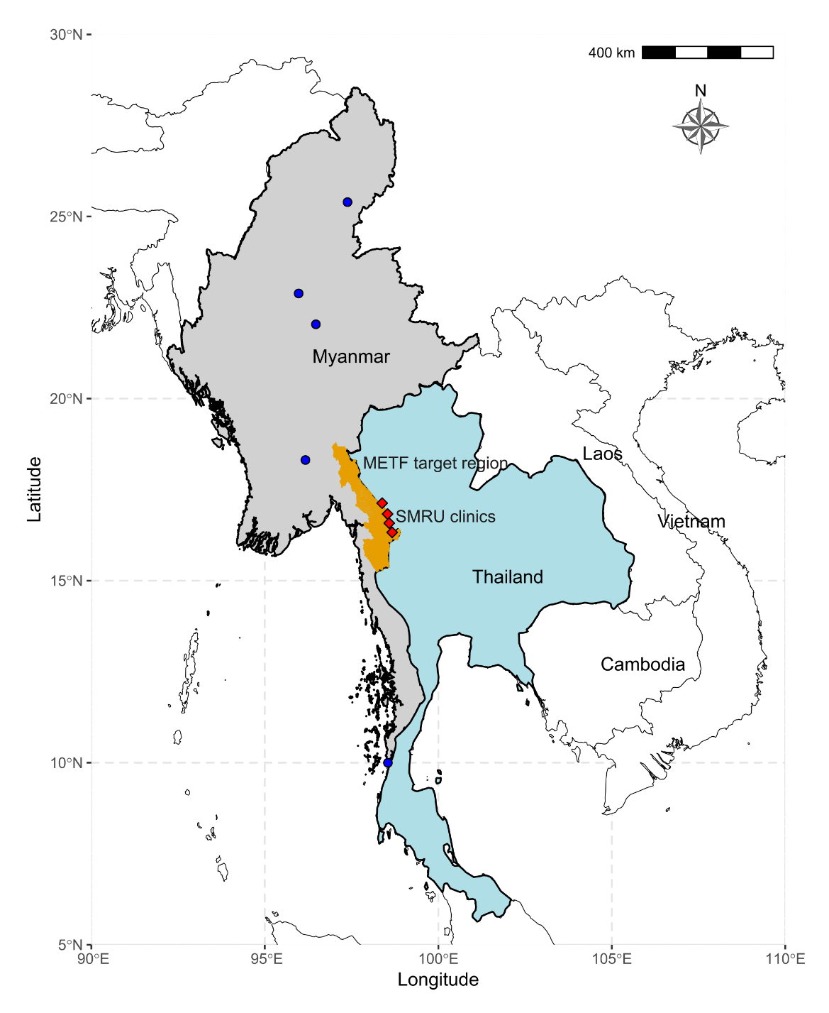

Supplementary Figure 1. Location of the Malaria Elimination Task Force (METF) project.
The METF project was performed at four townships (Myawaddy, Kawkareik, Hlaingbwe, and Hpapun) of Kayin state (orange shaded region), Myanmar. The control activities were started in 2014. The malaria clinics run by the Shoklo Malaria Research Unit (SMRU) were located along the western border of Thailand (red squares), opened since 2001. The majority of patients of SMRU clinics came from adjacent Myanmar. Blue cycles indicate other Myanmar sampling sites that were not located in Kayin state.

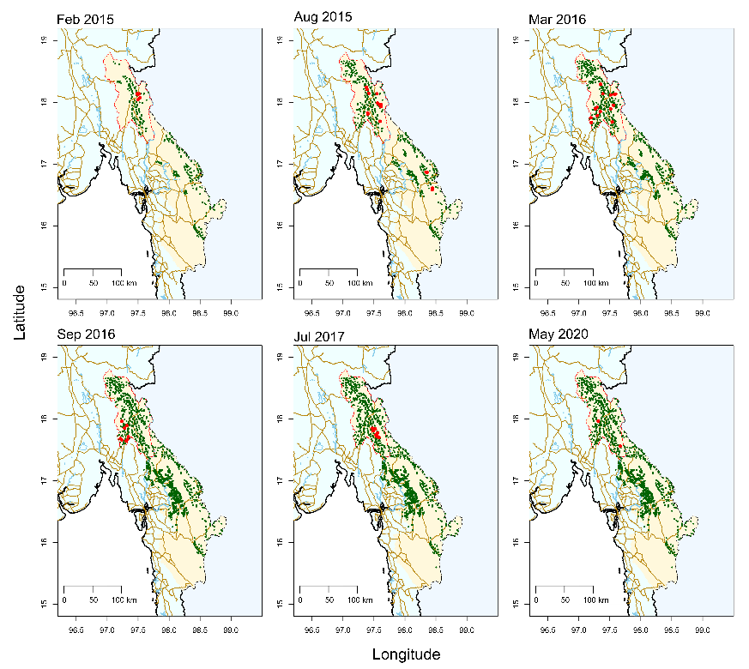
Supplementary Figure 2. Location of malaria posts and mass drug administration.
Red dots, locations where mass drug administration (MDA) was applied; green dots, location of malaria posts.

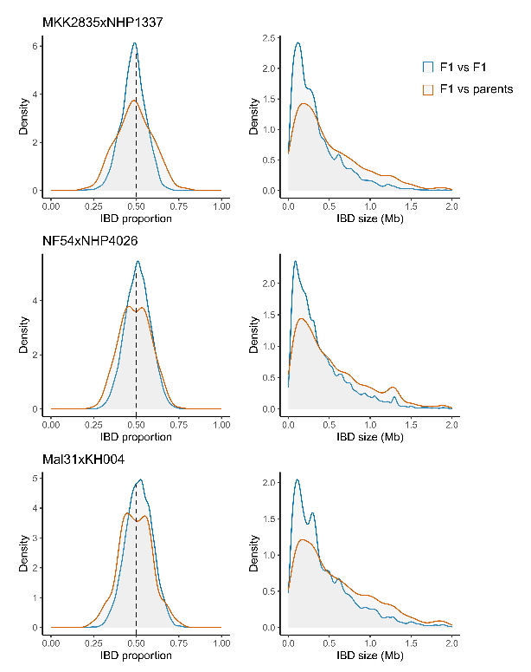

Supplementary Figure 3. IBD distribution in malaria parasite genetic crosses.
The plots show distribution of IBD proportions over the whole genome (left panels) or distribution of IBD fragment length (right panels), between any two progeny or between progeny and parents. Filtered genotypes for cloned progeny from the three crosses (MKK2835xNHP1337, NF54xNHP4026, and Mal31xKH004) are available at https://github.com/emilyli0325/P01-cloned.progeny. We used these experimental crosses to establish thresholds for investigating relatedness in field collected samples. For example, parasite pairs showing r > 0.45 was used to determine malaria family members. Raw sequencing data has been published at: MKK2835xNHP1337 (Li et al., 2019 ¹ and Button-Simons et al., 2021²), NF54xNHP4026 (Button-Simons et al., 2021², Kumar et al., 2022³ and Amambua-Ngwa at al., 2023⁴), Mal31xKH004 (Kane et al., 2024⁵).

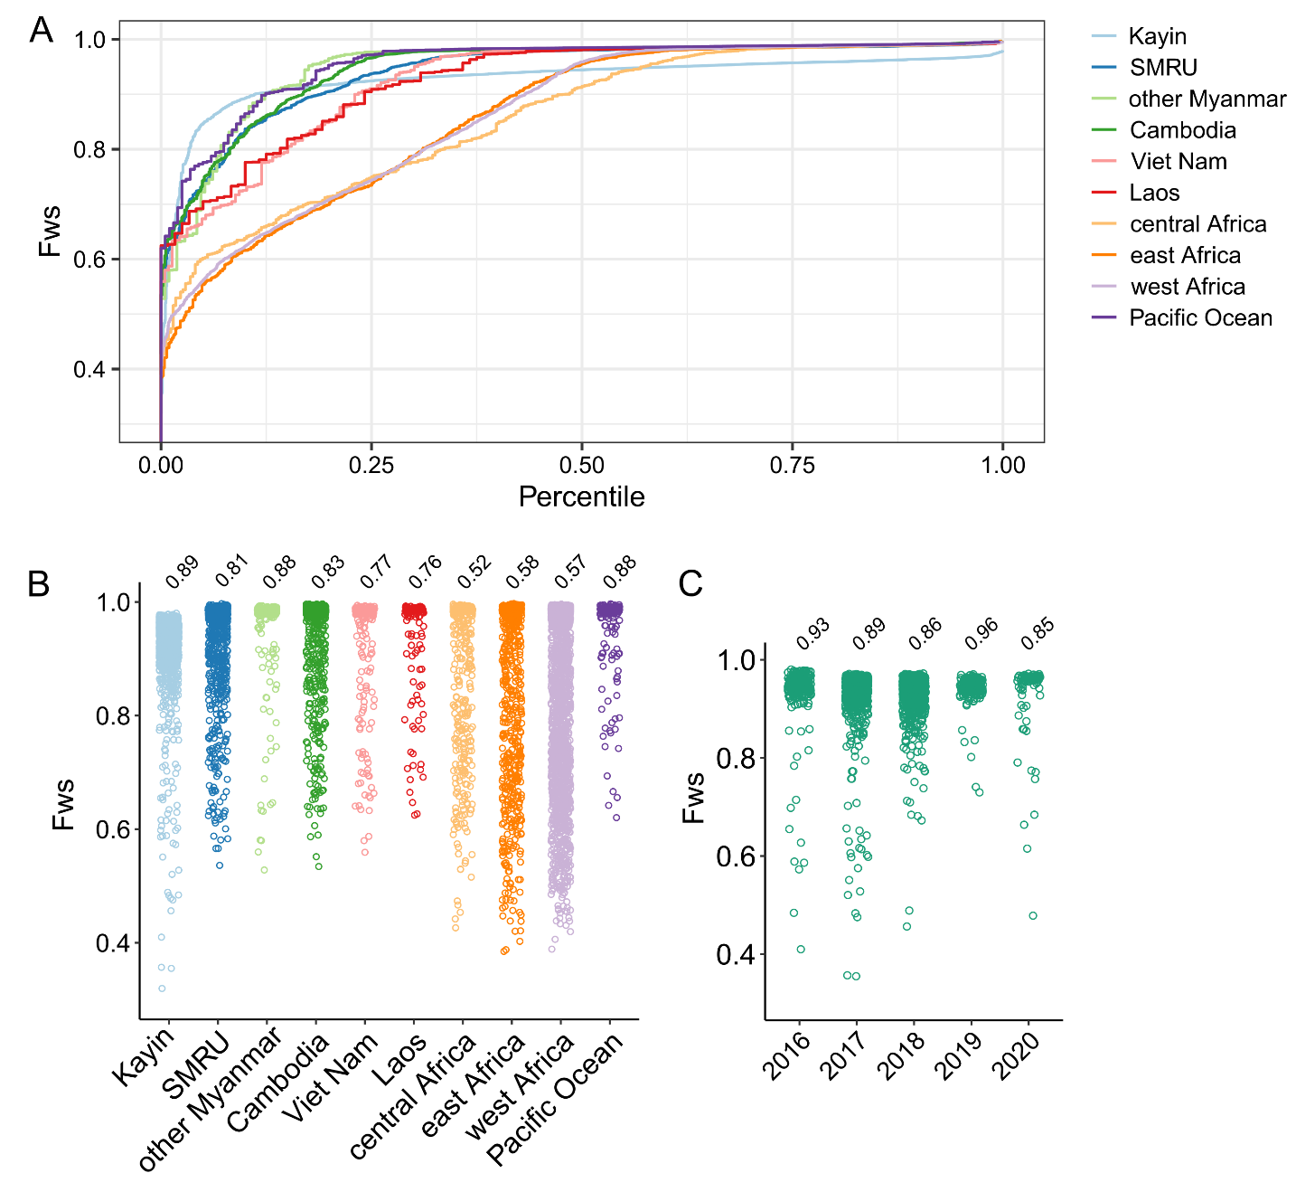

Supplementary Figure 4. Complexity of infections measured by inbreeding coefficient (F_{WS}).
(A) Cumulative plot of F_{WS} grouped by geographic origins. The curve reaches plateau at 0.9 for Kayin population, and 0.95 for other populations, which may be caused by selective whole genome amplification (sWGA) during library preparation from dried blood samples. We used F_{WS} >0.9 for Kayin population, and >0.95 for other populations as threshold for single-genotype infections. (B) F_{WS} of samples from different populations. (C) F_{WS} of Kayin samples across time. The proportion of single-genotype infections are labeled on top of each scatter plot.

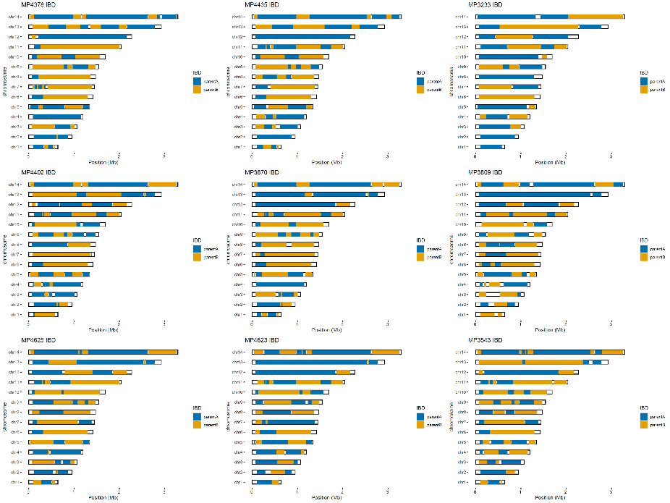

Supplementary Figure 5. Chromosome plots for estimated progeny from family 1.
We infer that the parents of family 1 are C13 (parent A, IBD cluster 13, kelch13-wildtype) and C17 (parent B, IBD cluster 17, kelch13-F446I).

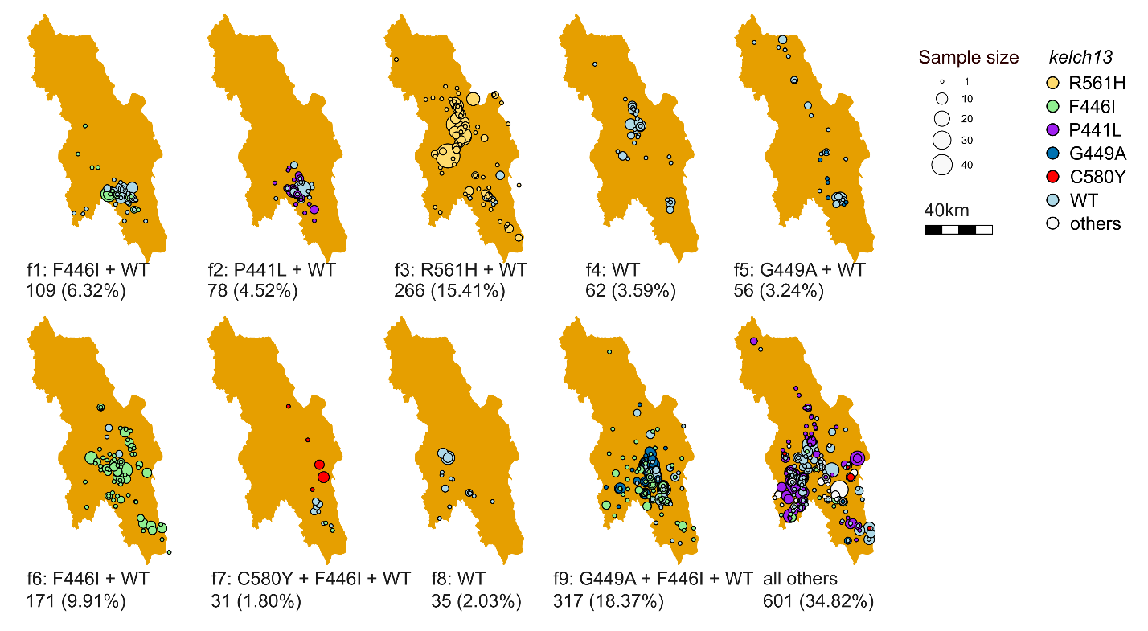
Supplementary Figure 6. Geographic distribution of closely related parasite families. Families are defined as a group of parasites that share over 45% of their genome (r ≥ 0.45).

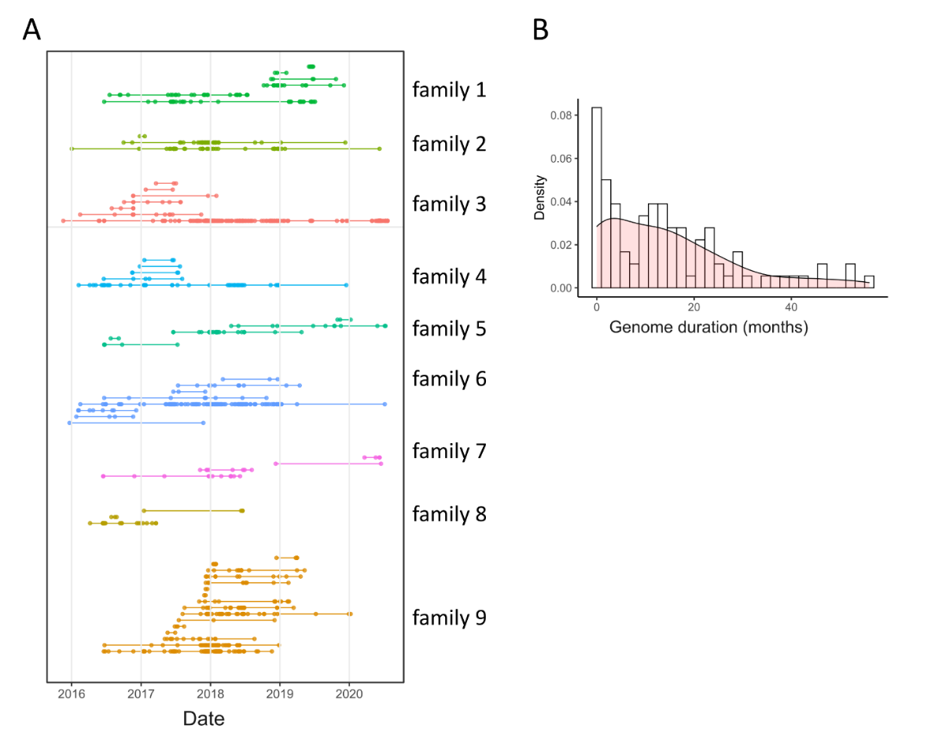

Supplementary Figure 7. Closed related parasite families and their duration.
(A) Duration of each parasite family. One dot indicates one sample, and each line indicates one unique genome. Families are defined as a group of parasites that share over 45% of their genome (r ≥ 0.45). (B) Density distribution of unique genome durations.

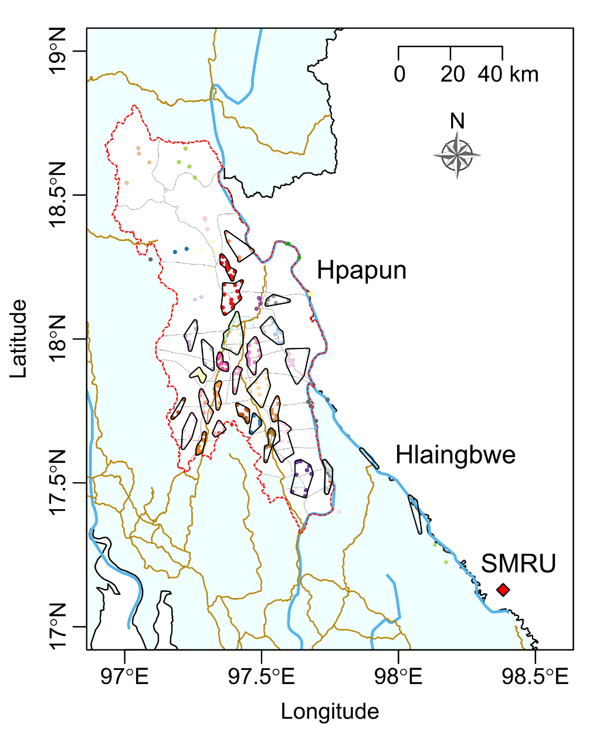
Supplementary Figure 8. Grouping of malaria posts (MPs) based on hierarchical clustering on principal components (HCPC) of geographic location.
MPs geographically close to each other, determined by HCPC analysis, were grouped together (circles) for further population relatedness analyses. This map shows the 29 HCPC-defined regions, each containing more than 10 samples collected across the entire sampling period. Dots represent locations of malaria posts from which sequenced samples were obtained.

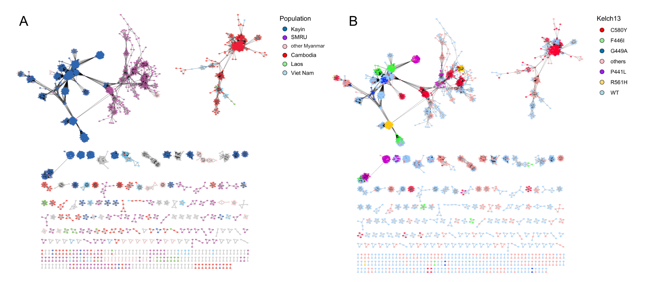

Supplementary Figure 9. Parasite connection network based on pair-wise genetic relatedness.
Networks were illustrated using Cytoscape, and were colored according to the geographical origin (A) or kelch13 alleles (B). Lines indicate connections with relatedness (r) > 0.35. There was no connection detected between east and west of Southeast Asia with r > 0.15. Closely related parasites were found between Kayin state and SMRU clinics on Thailand-Myanmar border.

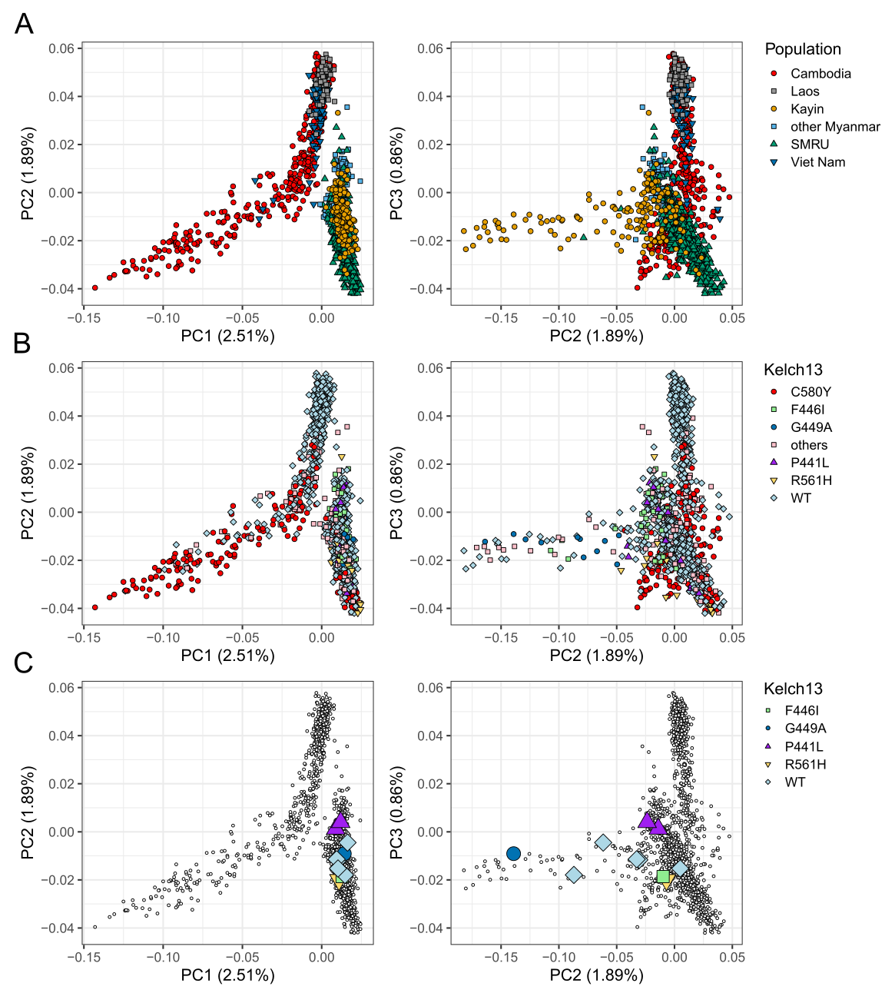
Supplementary Figure 10. Principal component analysis (PCA) comparing Southeast Asian populations.
(A, B) PCA plots of the first three component. Each point represents a sample, which was colored according to the geographical origin (A) or kelch13 alleles (B). (C) Placement of the top ten unique genomes from Kayin state in PCA plots.

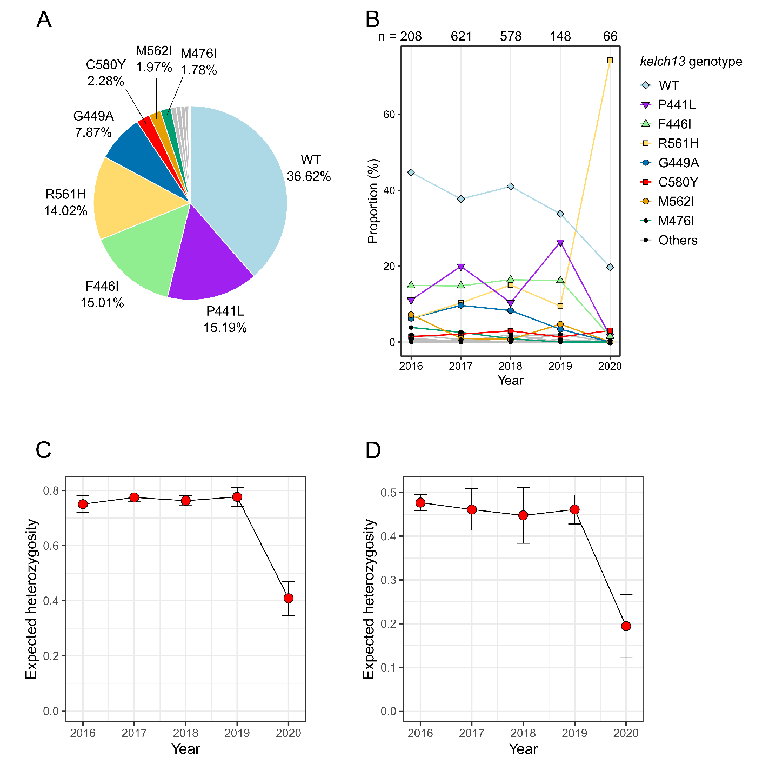

Supplementary Figure 11. Prevalence of kelch13 mutations.
(A) Percentages of kelch13 alleles in samples from Kayin State. (B) Temporal changes of kelch13 allele frequency. The number of samples in each year is labeled on top of the plot. There is a slow decrease in wild-type kelch13 alleles. An outbreak of R561H allele was detected in 2020. Colored lines, alleles with at least one year > 2%, grey lines, other alleles. (C) Expected heterozygosity of kelch13 gene across time. (D) Expected heterozygosity of kelch13 spanning region. The analysis was based on single nucleotide polymorphisms (SNPs) located 100kb up and down stream of the kelch13 gene. Only SNPs with minor allele frequency (MAF) > 0.3 in 2016 were used.

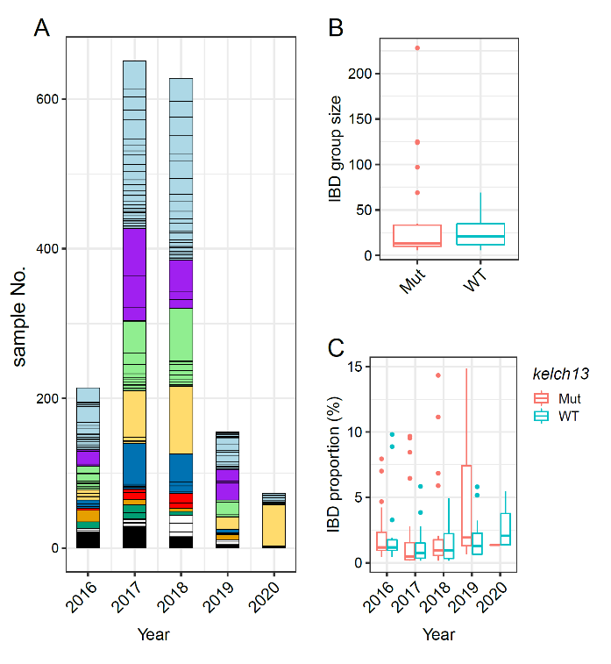
Supplementary Figure 12. Temporal changes in unique genome proportion.
(A) Sample size of parasites with different unique genome across time. Barplot was separated by IBD genome groups (unique genomes, with >90% of genome identical), colored based on kelch13 alleles; See Figure 3A for color legend of kelch13 alleles; black blocks indicate number of unique genomes. (B) Comparison of the size of IBD groups carrying kelch13 wild-type and mutant alleles. No significant difference was detected (Welch Two Sample t-test, p-value = 0.34). (C) Proportion distribution of IBD groups with wild-type and mutant alleles kelch13 alleles across time. No significant difference was detected (p-value = 0.54, 0.17, 0.37, 0.20 and 0.41 for 2016-2020, separately).

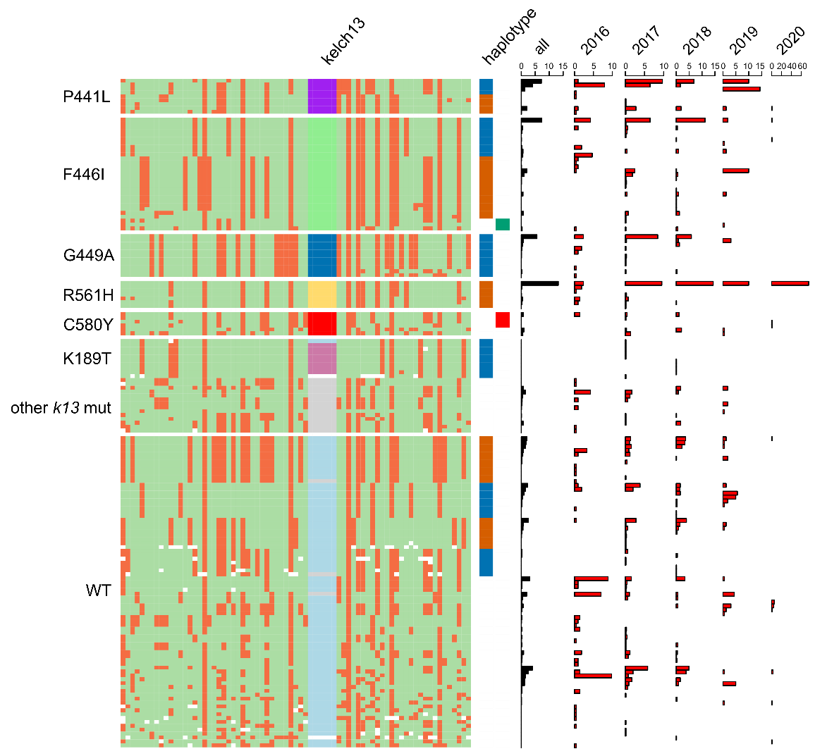
Supplementary Figure 13. Analyses of kelch13 haplotypes.
Left panel, haplotype diagram showing 100 kb upstream and down-stream of the kelch13 gene. Each column represents a SNP with minor allele frequency (MAF) ≥ 0.05 in Kayin; each row represents a unique genome; color represents genotype: reference (green), alternative (orange), and white (ungenotyped). Middle panel, kelch13 haplotypes: orange and blue blocks represent haplotypes that have high allele frequency in Kayin; green black indicates major haplotype from other Myanmar regions; and red blocks are C580Y haplotypes dominating SMRU clinics. Right panel, frequency of unique genomes from Kayin.

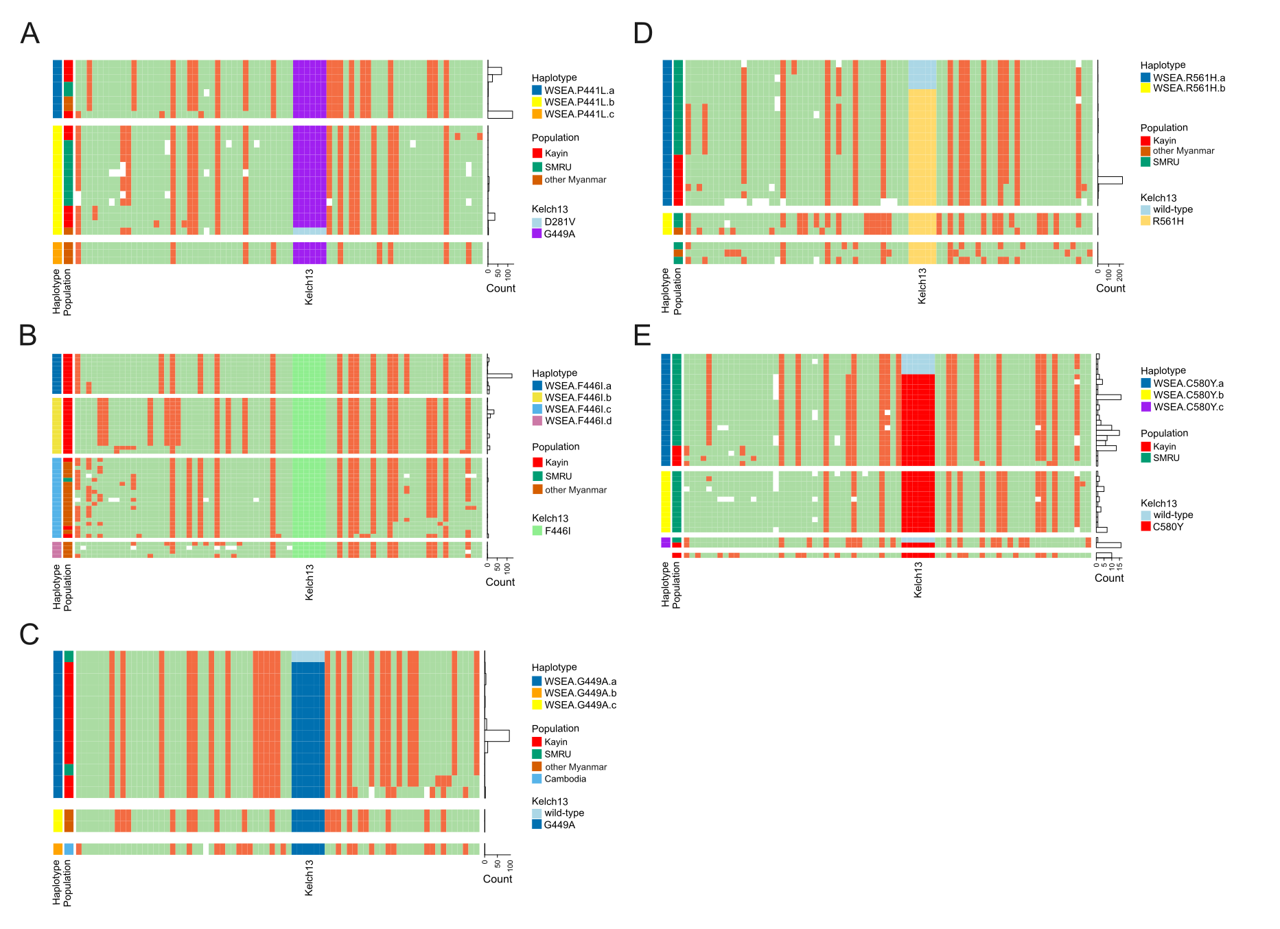

Supplementary Figure 14. Compare kelch13 haplotypes from Southeast Asia.
(A) P441L. Two kelch13 haplotypes carrying P441L mutation were detected in Kayin. Both of them have also been found either in SMRU or other Myanmar regions, despite their low allele frequency in those regions.
(B) F446I. Three F446I haplotypes were observed in Kayin. The most common two haplotypes were only found in Kayin and were at high allele frequencies (9.72% and 5.22%), suggesting that they originated locally and have not been transmitted to other locations. The third F446I haplotype was more common in north Myanmar with only few cases found in Kayin.
(C) G449A. One unique haplotype carrying G449A was detected in Kayin, and also observed in in SMRU. The same haplotype carrying wild-type kelch13 was found from SMRU in 2001, suggesting it might have originated from the SMRU region. However, we cannot locate where the G449A mutation took place.
(D) R561H. Multiple haplotypes have been found to be associated with the R561H mutation in western SE Asia, but only one of them was found in Kayin (named WSEA.R561H.a). The kelch13 wild-type version of WSEA.R561H.a haplotype was detected from SMRU in 2002 and 2004, while the kelch13-R561H on this haplotype was not detected until 2012. Comparing the wild-type and mutant WSEA.R561H.a from SMRU, the Kayin R561H haplotype has been broken down by recombination, suggesting the spread of this haplotype was not a recent event.
(E) C580Y. Four haplotypes were detected, with three of them found in Kayin. Two of the haplotypes were detected in both Kayin and SMRU, and one of them was dominant kelch13 mutant alleles in SMRU.

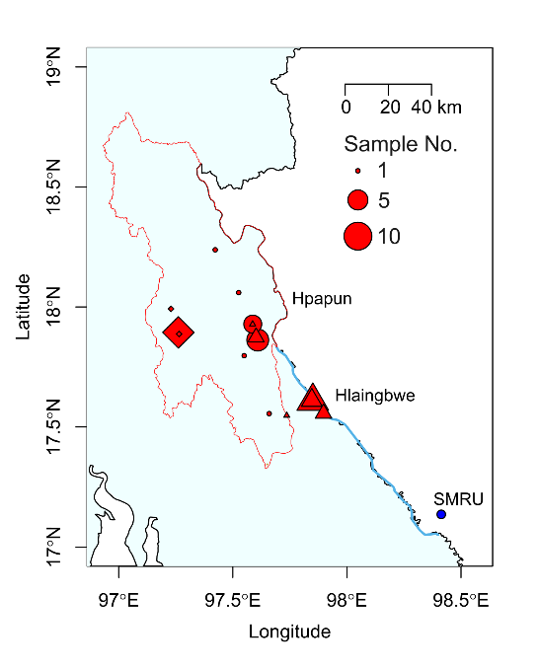
Supplementary Figure 15. Distribution of samples carrying kelch13-C580Y haplotypes in Kayin state.
Three kelch13-C580 haplotypes (represented by different shapes) were identified in Kayin state. Two haplotypes (circles and triangles) were also observed among patients attending Shoklo Malaria Research Unit (SMRU) clinics. The kelch13-C580Y allele was at highly frequency (>90%) at malaria posts in Hlaingbwe Township (located between SMRU and Hpapun Township), but less common (<10%) in Hpapun Township (outlined in red).

‘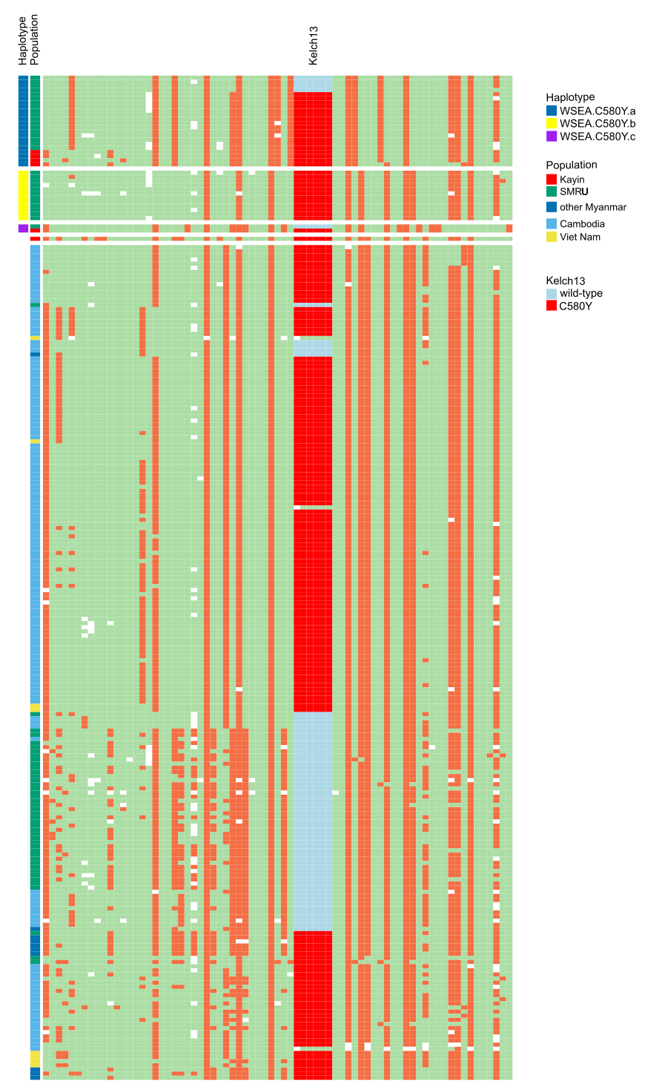

Supplementary Figure 16. Compare kelch13-C580Y haplotypes from Southeast Asia.
No kelch13-C580Y haplotype was shared between west and east southeast Asia.

Supplementary Table 1. Information of samples from Kayin state.

Supplementary Table 2. Information of samples from other Southeast Asian populations.

Supplementary Table 3. Comparison of estimated parasite population size.

