Supplementary Information
for
Decoding Nacre: Uncovering Unique Identifiers of Pearl Provenance

Dahyun Kyung^{1†}, Ruiqi Zhang^{2,3†}, Alice Zehner¹, Ali Alatawi⁴, Noora Jamsheer⁴, Adam B. Jost⁵, James C. Weaver¹, Kristin D. Bergmann⁵, Vladimir Bulovic^{2,3}, and Admir Masic^{1*}

¹Department of Civil and Environmental Engineering, Massachusetts Institute of Technology, Cambridge, MA 02139
²Department of Electrical Engineering and Computer Science, Massachusetts Institute of Technology, Cambridge, MA 02139
³Research Laboratory of Electronics (RLE), Massachusetts Institute of Technology, Cambridge, MA 02139
⁴Bahrain Institute for Pearls and Gemstones (DANAT), Manama, Kingdom of Bahrain
⁵Department of Earth, Atmospheric, and Planetary Sciences, Massachusetts Institute of Technology, Cambridge, MA 02139
† These authors contributed equally
* Corresponding authors

Method | Sorted by | Categories |  | Number of samples | Number of measurements
Raman spectroscopy | Species | Pearls | Pinctada fucata | 15 | 51
Raman spectroscopy | Species | Pearls | Pinctada maxima | 593 | 600
Raman spectroscopy | Species | Pearls | Pinctada radiata | 168 | 170
Isotope ratio mass spectrometry | Geography | Pearls | Australia (saltwater) | 19 | 37
Isotope ratio mass spectrometry | Geography | Pearls | Bahrain (saltwater) | 42 | 99
Isotope ratio mass spectrometry | Geography | Pearls | Qatar (saltwater) | 19 | 25
Isotope ratio mass spectrometry | Geography | Pearls | Japan (saltwater) | 125 | 125
Isotope ratio mass spectrometry | Geography | Pearls | Japan (freshwater) | 15 | 15
Isotope ratio mass spectrometry | Geography | Pearls | Scotland (freshwater) | 5 | 15
Isotope ratio mass spectrometry | Geography | Shells | Bahrain (aragonite) | 31 | 56
Isotope ratio mass spectrometry | Geography | Shells | Bahrain (calcite) | 31 | 56
Isotope ratio mass spectrometry | Geography | Shells | Kuwait (aragonite) | 14 | 14
Isotope ratio mass spectrometry | Geography | Shells | Qatar (aragonite) | 18 | 18
Supplementary Table 1. Analyzed samples. Summary of samples collected and investigated in this work.

Acquisition Confidence Level | Description
Confidence Level 1 | Obtained by DANAT from the source directly
Confidence Level 2 | Obtained for DANAT by a non-DANAT party, with documentation that proves origin
Confidence Level 3 | Obtained for DANAT by a trusted non-DANAT party, without paper trail evidence
Confidence Level 4 | Obtained by a third party, without paper trail evidence
Confidence Level 5 | Obtained from the market
Supplementary Table 2. DANAT confidence levels. Description of DANAT confidence levels for sample acquisition.

Species | Source Location | Acquisition Confidence Level
Pinctada radiata | Bahrain (Natural Saltwater) | Confidence Level 1
Pinctada radiata | Qatar (Natural Saltwater) | Confidence Level 1
Pinctada radiata | Kuwait (Natural Saltwater | Confidence Level 1
Pinctada maxima | North Australia (Natural Saltwater) | Confidence Level 1
Pinctada fucata | Japan, Mikimoto pearl farms (Saltwater) | Confidence Level 1
Pinctada fucata | Japan, pearl market (Saltwater) | Confidence Level 5
Margaritifera margaritifera | Scotland (Natural Freshwater) | Confidence Level 3
Unknown | Japan, pearl market (Cultured Freshwater) | Confidence Level 5
Supplementary Table 3. Sample confidence levels. DANAT confidence levels for sample species.

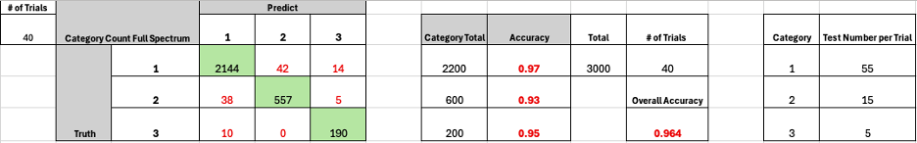Supplementary Table 4. Confusion matrix calculation for overall prediction results.

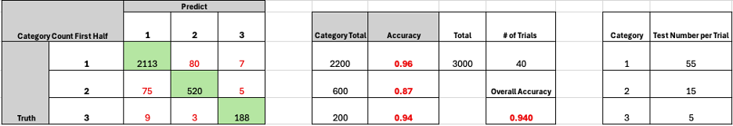Supplementary Table 5. Confusion matrix calculations for first-half input prediction results.

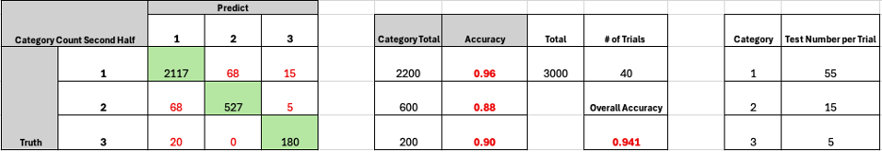Supplementary Table 6. Confusion matrix calculations for second-half input prediction results.

Location | Total number of analyzed pearls | Pearls analyzed with run parameters optimized for clumped isotope spectrometry | Pearls analyzed only with run parameters optimized for clumped isotope spectrometry
Australia | 19 | 6 | 6
Bahrain | 42 | 10 | 3
Scotland | 5 | 5 | 5
Supplementary Table 7. Pearls analyzed with run parameters optimized for clumped isotope spectrometry. The δ¹³C and δ¹⁸O values for 21 pearls (of 225 total) were obtained with a set of run parameters optimized for clumped isotope spectrometry. 14 of these pearls were only analyzed using these run parameters. The remaining 7 pearls also have data collected using the parameters explicitly detailed in the Methods.

Anchor | Number of measurements | Standard Error (‰ VPDB)
Anchor | Number of measurements | δ¹³C | δ¹⁸O
ETH-1 | 24 | 0.0045 | 0.0112
ETH-2 | 100 | 0.0067 | 0.0080
ETH-3 | 109 | 0.0051 | 0.0087
ETH-4 | 22 | 0.0046 | 0.0109
IAEA-C1 | 10 | 0.0090 | 0.0217
IAEA-C2 | 32 | 0.0051 | 0.0088
Supplementary Table 8. Standard error calculations for mass spectrometry anchors. Standard errors of anchor measurements relative to VPDB are shown here as a measure of instrument accuracy. Most measurements were calibrated only to ETH-2 and ETH-3, but measurements of samples with run parameters optimized for clumped isotope spectrometry were also calibrated to the remainder of the anchors listed in this table.

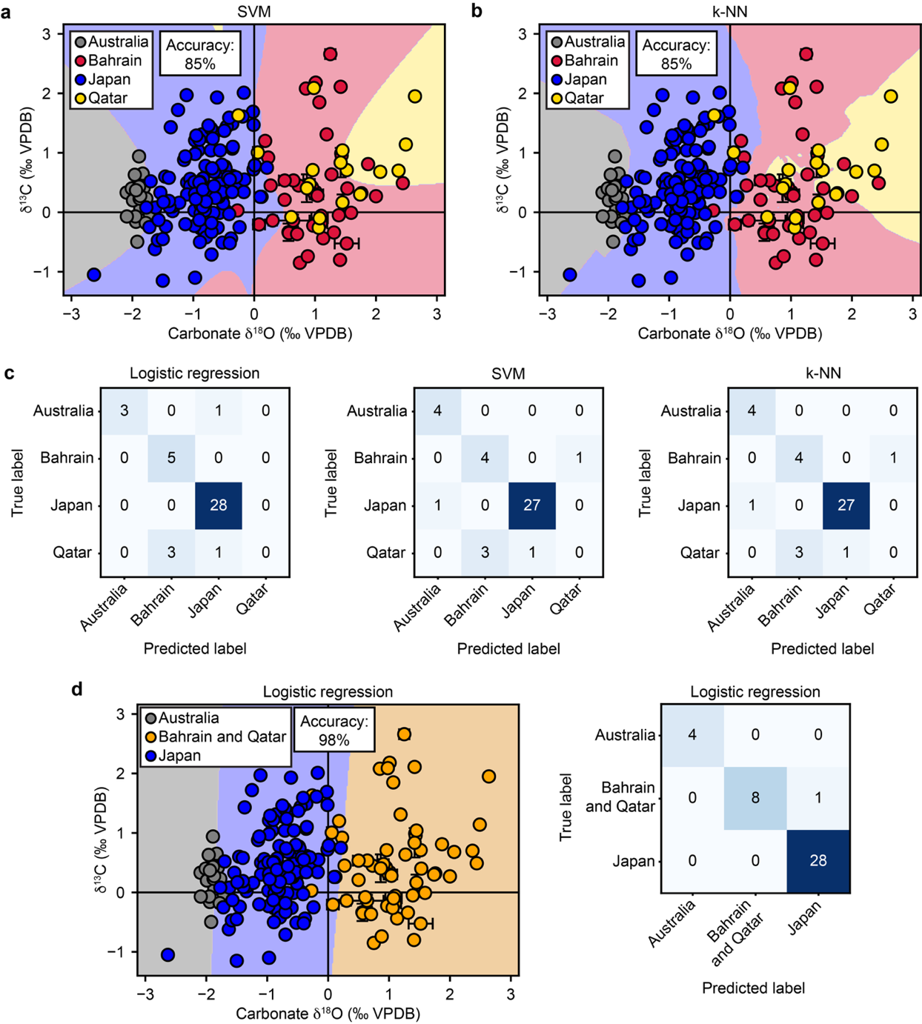
Supplementary Figure 1. Machine learning results for classifying saltwater pearl δ¹⁸O values by geographic origin. Decision boundaries for a) support vector machine (SVM) and b) k-nearest neighbors (k-NN) models are shown, both with accuracy scores of 85%. c) Confusion matrices for (left to right) logistic regression, SVM, and k-NN models are shown. Pearls from Qatar were consistently misclassified, being most commonly predicted as pearls from Bahrain. Considering the geographic proximity of Bahrain and Qatar and overlaps in isotopic composition of pearls from the two countries, d) shows the decision boundaries (left) and confusion matrix (right) of a logistic regression model that groups pearls from Bahrain and Qatar into the same class. This produces a considerably higher accuracy score of 98%. Error bars show standard deviations for samples with multiple measurements, for which plot markers show the mean δ¹³C and δ¹⁸O values. Plot marker colors correspond to source location.
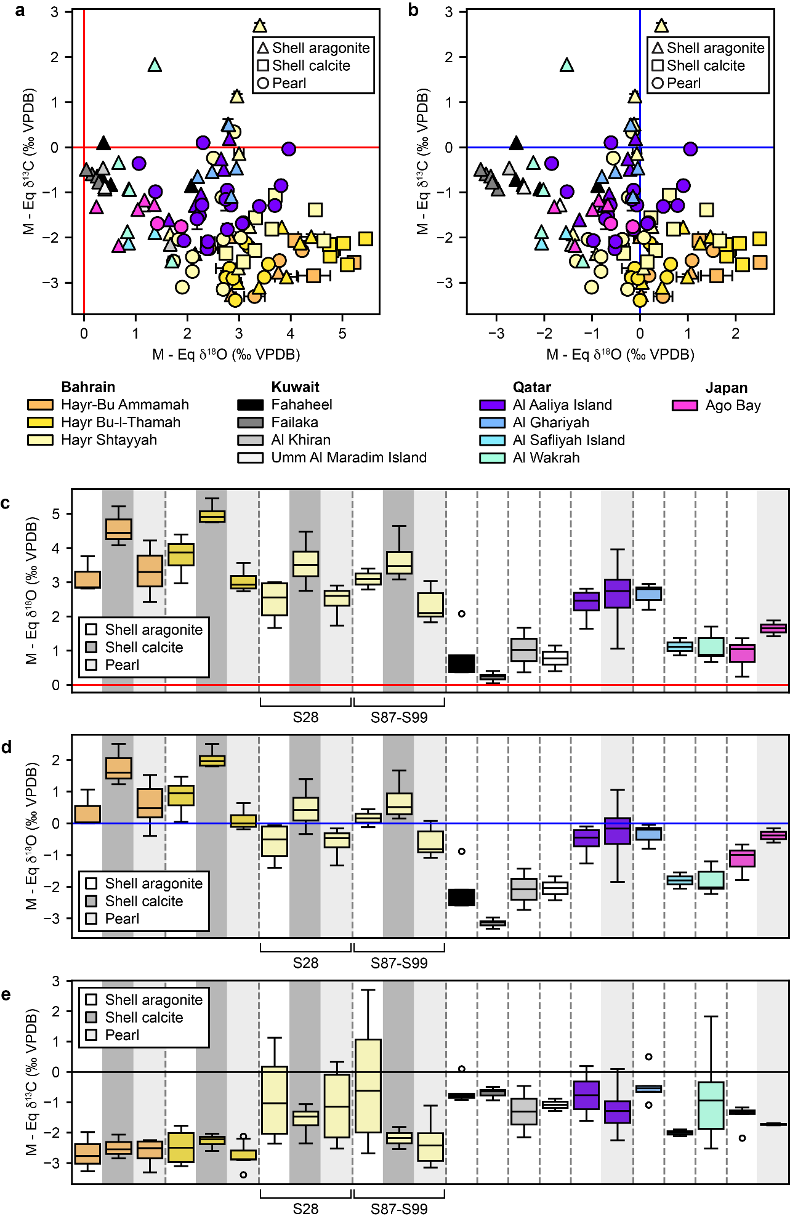
Supplementary Figure 2. Equilibrium offset estimations. Calculations isolating the offset of the pearl and shell isotopes from expected values of the same minerals formed at equilibrium, as described in Gilbert et al.¹, are presented. Seawater δ¹⁸O and δ¹³C were directly sampled from the presented locations, and temperature data were either directly measured from sampling locations or taken from the Global Ocean Physics Analysis and Forecast from E.U. Copernicus Marine Service Information². Plots of the offset of pearl and shell δ¹³C against the offset of δ¹⁸O for a) high and b) low seasonal temperatures are shown. Plot marker colors correspond to source location, with triangles representing shell aragonite, squares representing shell calcite, and circles representing pearl aragonite. Error bars show standard deviations for samples with multiple measurements, for which plot markers show the mean δ¹³C or δ¹⁸O values. Box plots of the δ¹⁸O offsets for the same samples, grouped by mineralogy and location, are also shown using c) high and d) low seasonal temperatures. e) Box plots of the δ¹³C offsets are similarly shown (δ¹³C values are not calculated to be influenced by temperature). In c) - e), samples from Hayr Shtayyah in Bahrain are subdivided into two groups, as seawater and temperature were sampled separately for the two zones (i.e., S28 and S87-S99). Boxes in box plots in c)-e) show the interquartile range and whiskers extend to the most extreme values within 1.5 times the interquartile range beyond the first and third quartiles. Black bands within the boxes represent mean values, and outliers are plotted as individual points. Dotted lines and box colors separate different source locations, and shading behind boxes show sample type (white: shell aragonite, dark gray: shell calcite, light gray: pearl aragonite).
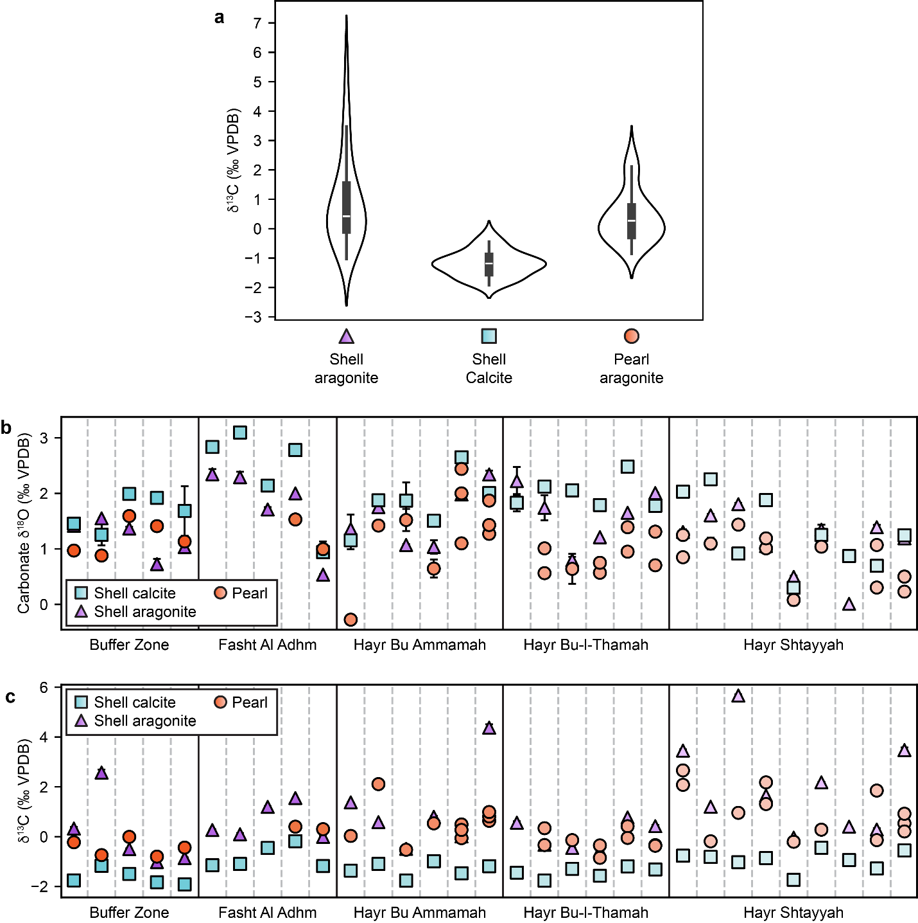

Supplementary Figure 3. Pearl and shell layer isotopic composition of oysters from Bahrain. a) Violin plots of the δ¹³C values of pearls, shell calcite, and shell aragonite from P. radiata oysters from Bahrain. Boxes in box plots show the interquartile range and whiskers extend to the most extreme values within 1.5 times the interquartile range beyond the first and third quartiles. The white bands in the boxes represent the mean values. Plots of the b) δ¹⁸O and c) δ¹³C of pearl and shell layers from individual P. radiata oysters from Bahrain. Each column separated by dotted lines in the plots corresponds to one oyster, with bolder lines separating groups of oysters from different locations in Bahrain. Dotted lines between columns separate samples from the same specimen/oyster, and solid lines and plot marker shading separate source locations. Teal squares represent shell calcite, purple triangles represent shell aragonite, and orange circles represent pearl aragonite. Error bars show standard deviations for samples with multiple measurements, for which plot markers show the mean δ¹³C or δ¹⁸O values.

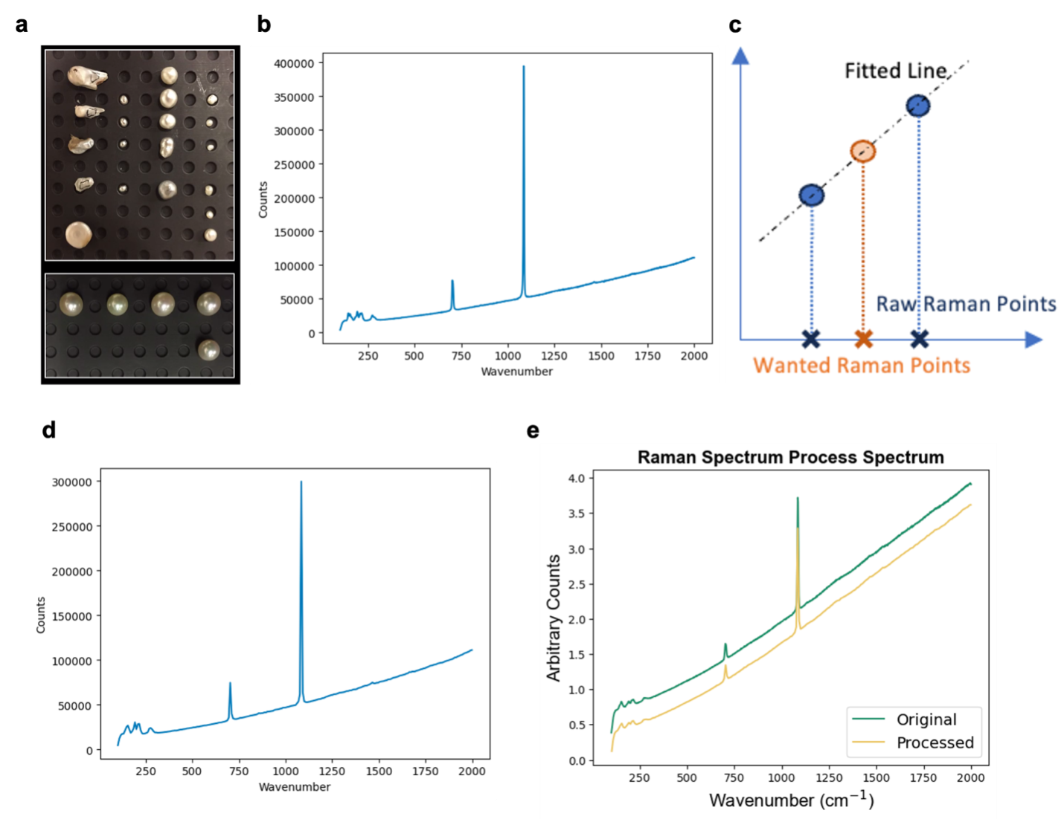
Supplementary Figure 4. Raman spectrum preprocessing procedure. a) Optical images of sample saltwater pearls for analysis by Raman spectroscopy. b) Representative as-obtained raw Raman spectrum from a P. maxima pearl. c) Linear interpolation method for generating the final spectra for SVM input. If a data point was not located in the original raw spectrum, it was linearly evaluated by its nearest two neighbors. d) Post-processed Raman spectrum after linear interpolation from the same pearl as shown in b) above. e) Collected Raman spectrum of a representative P. maxima pearl. The green curve represents the original Raman spectrum while the yellow curve represents the post-processed spectrum.
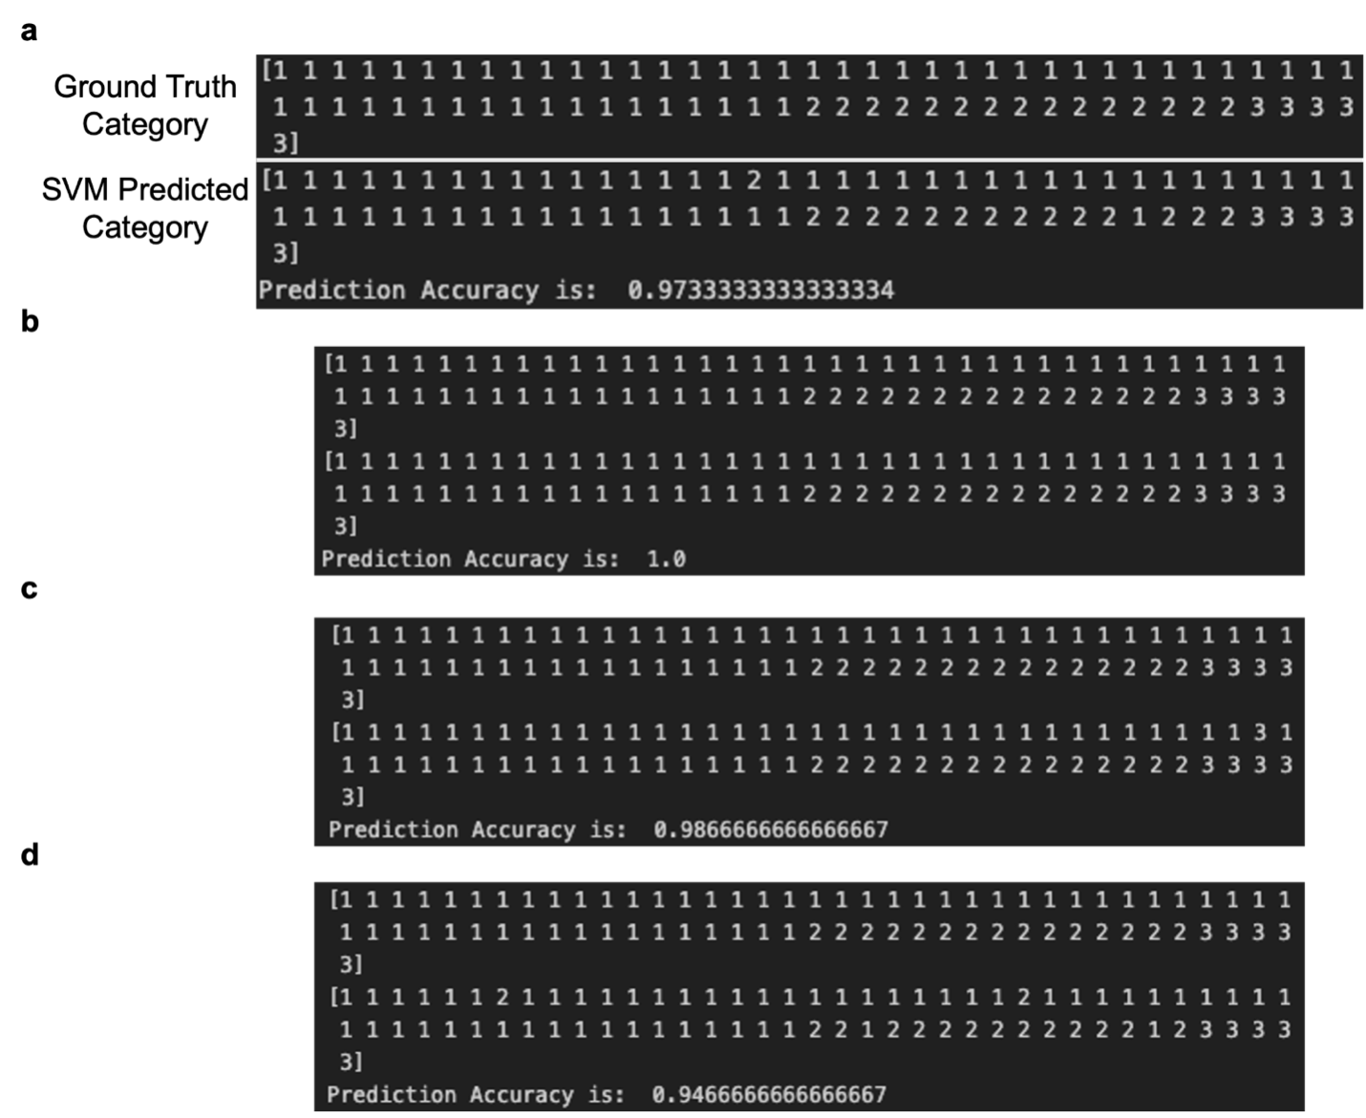
Supplementary Figure 5. Representative SVM prediction results with 75 test spectra. a) Sample set of SVM prediction results with 75 randomly selected pearls as the testing dataset. Here, numbers 1, 2, and 3 represent pearls formed by P. maxima, P. radiata, and P. fucata oysters, respectively. The first block (upper section) of numbers represents the ground truth category. The second block on the bottom represents the SVM predicted category. Numbers are one-by-one matched in sequence between each category. b)-d) Three more representative prediction results for predicting various sets of 75 selected pearls as testing datasets.
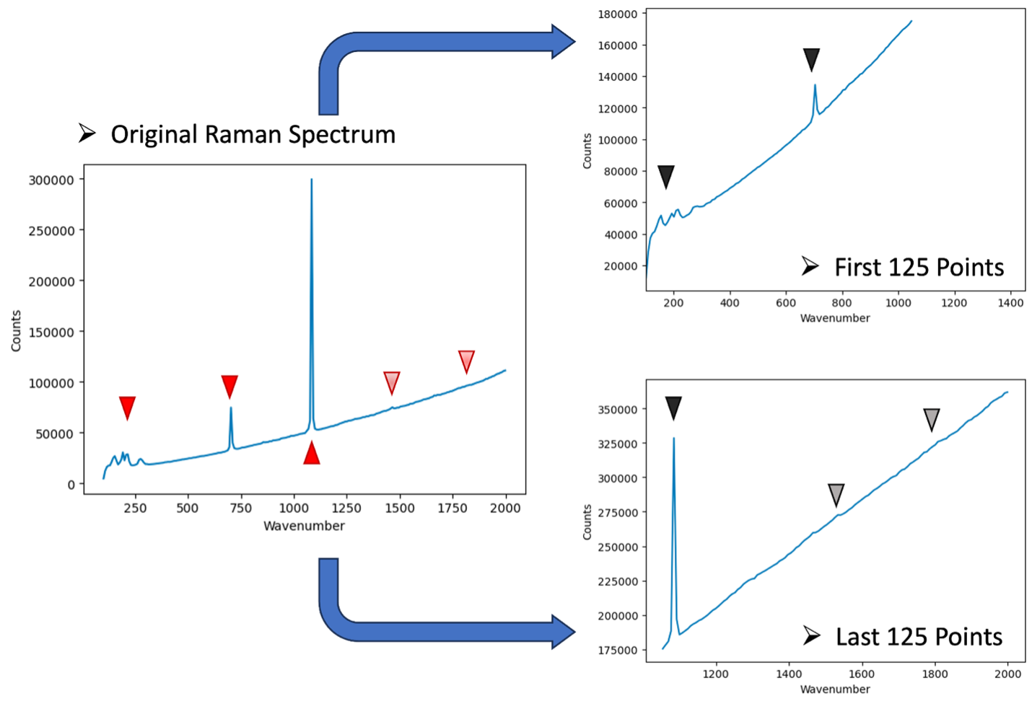
Supplementary Figure 6. Separating original Raman spectra into two half-spectra. Procedure of separating the original Raman spectra into two separate parts. The original Raman spectra had a total of 250 data points. The spectra were then separated into halves, with the first half consisting of the first 125 data points from the original spectrum and the second half consisting of the last 125 data points from the original spectrum. Main characteristic peaks are denoted with triangles.
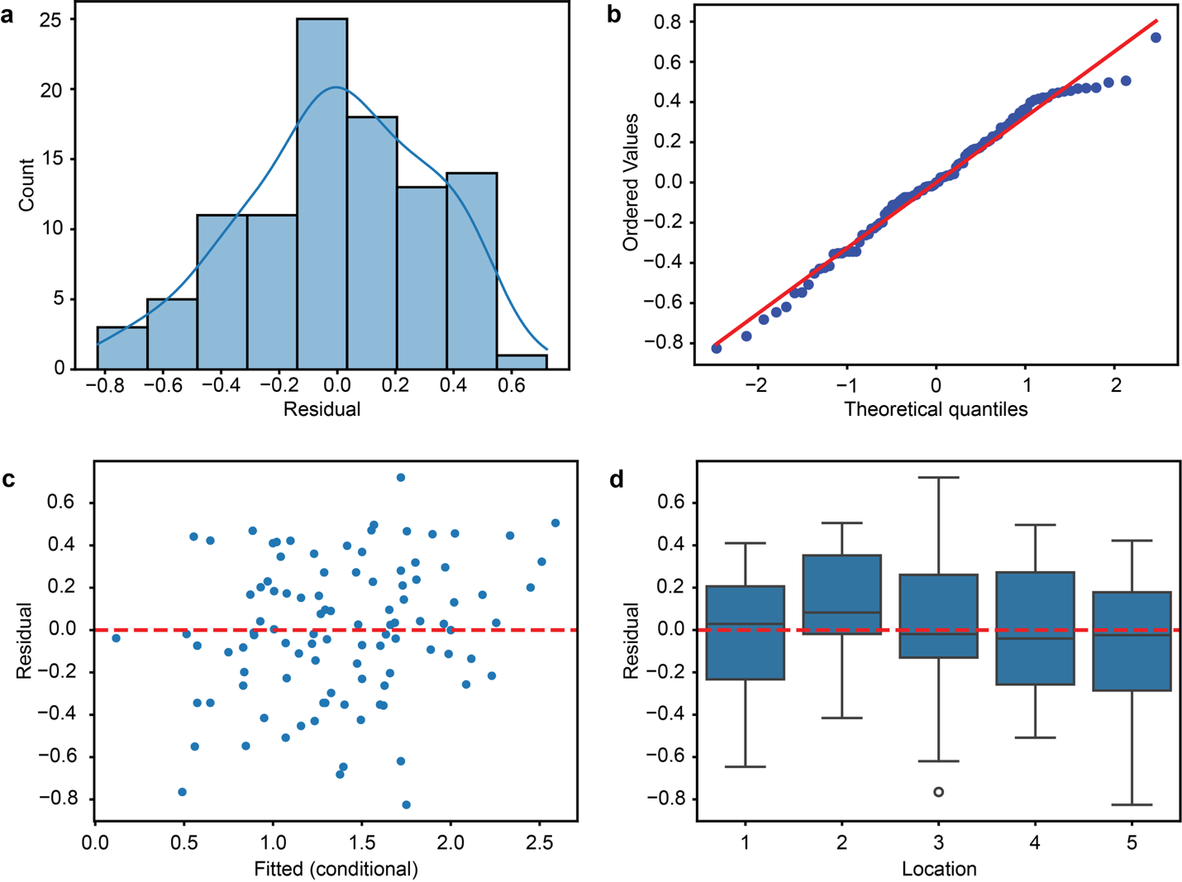
Supplementary Figure 7. Plots for assumptions of normality of residuals and homoscedasticity of variance for statistical comparisons of δ¹⁸O values from pearl and shell samples from Bahrain. a) Histogram of residuals. b) Q-Q plot of residuals. c) Residuals vs. fitted values. d) Box plot of distribution of residuals for each specific source location of samples from Bahrain. Boxes show the interquartile range and whiskers extend to the most extreme values within 1.5 times the interquartile range beyond the first and third quartiles. Black bands within the boxes represent mean values, and outliers are plotted as individual points.
Supplementary References
1. Gilbert, P. U. P. A. et al. Biomineralization: Integrating mechanism and evolutionary history. Sci. Adv. 8, eabl9653 (2022).
2. European Union-Copernicus Marine Service. Global Ocean 1/12° Physics Analysis and Forecast updated Daily. Mercator Ocean International https://doi.org/10.48670/MOI-00016 (2016).

