Supplemental Materials
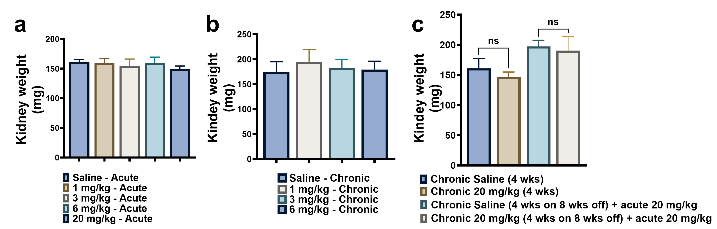

Supplemental Figure 1. No change in kidney weights after different doses of TfRMAb-EPO following acute (a), chronic (b), and chronic followed by eight-week washout and a final TfRMAb-EPO dose (c). Data are presented as mean ± SEM of n = 4-5 mice per group. Statistical significance was determined by one-way ANOVA with Holm-Sidak’s post-hoc test. ns: non-significant.

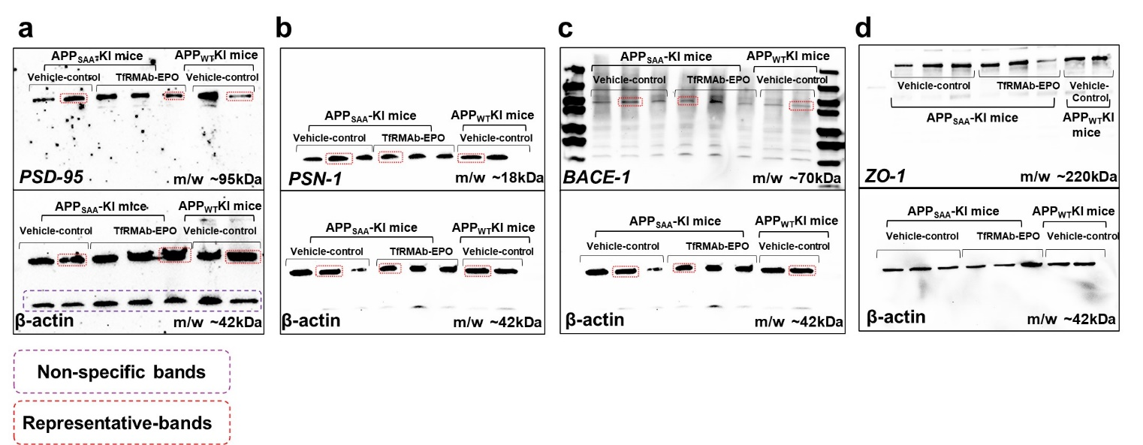
Supplemental Figure 2. Example full-gel Western blot images for proteins shown in Fig. 8 (c-e) and Supplemental Figure 5c. Bands representing the average data shown in Figure 8 are shown in the red box above.

Supplemental Figure 3. Significant decrease in the liver EPOR concentration was observed with a chronic 3 mg/kg SQ dose of TfRMAb-EPO compared to that of the acute dose. No significant change in the spleen and kidney EPOR concentrations was observed between acute and chronic doses. This data shows that decreased plasma exposure with chronic TfRMAb-EPO dosing is not associated with increased EPOR tissue expression; the latter can be a potential mechanism for tissue uptake of TfRMAb-EPO. Data are presented as mean ± SEM of n = 4-5 mice per group. Statistical significance was determined by one-way ANOVA with Holm-Sidak’s post-hoc test. *p<0.05. ns: non-significant.

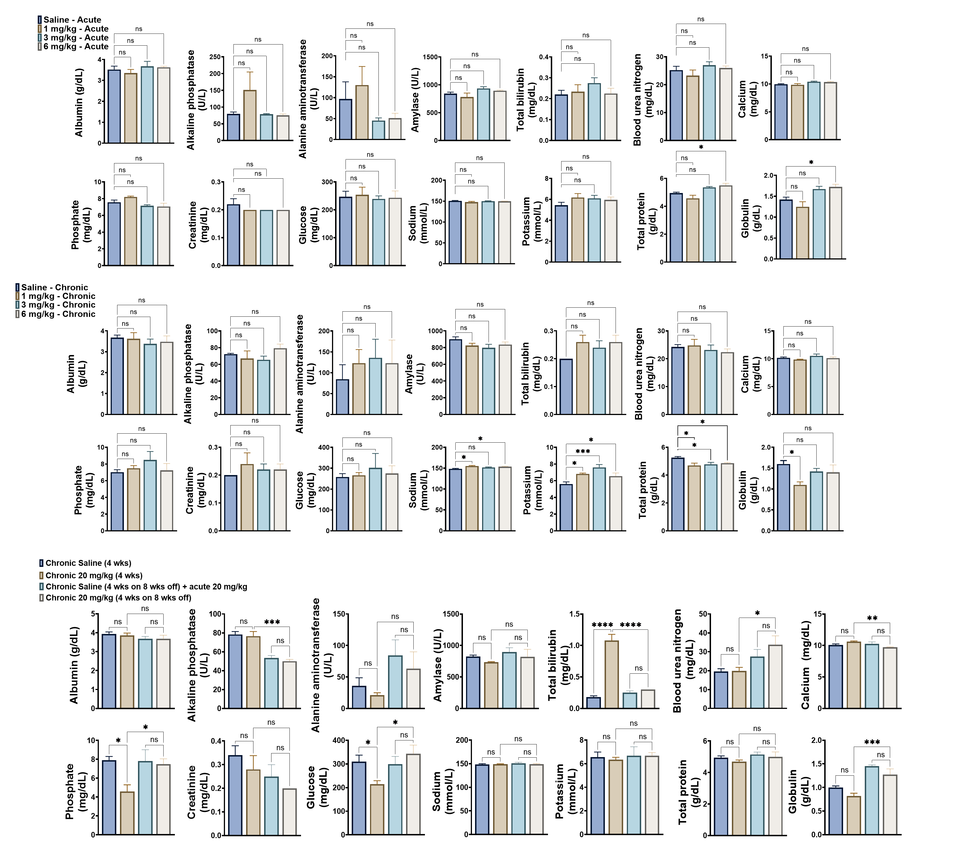
Supplemental Figure 4. Blood chemistry analysis following acute (a), chronic (b), and chronic followed by eight-week washout and a final TfRMAb-EPO dose (c). Data are presented as mean ± SEM of n = 4-5 per group. Statistical significance was determined by one-way ANOVA with Holm-Sidak’s post-hoc test. *p<0.05, **p<0.01, ***p<0.001, and ****p<0.0001.

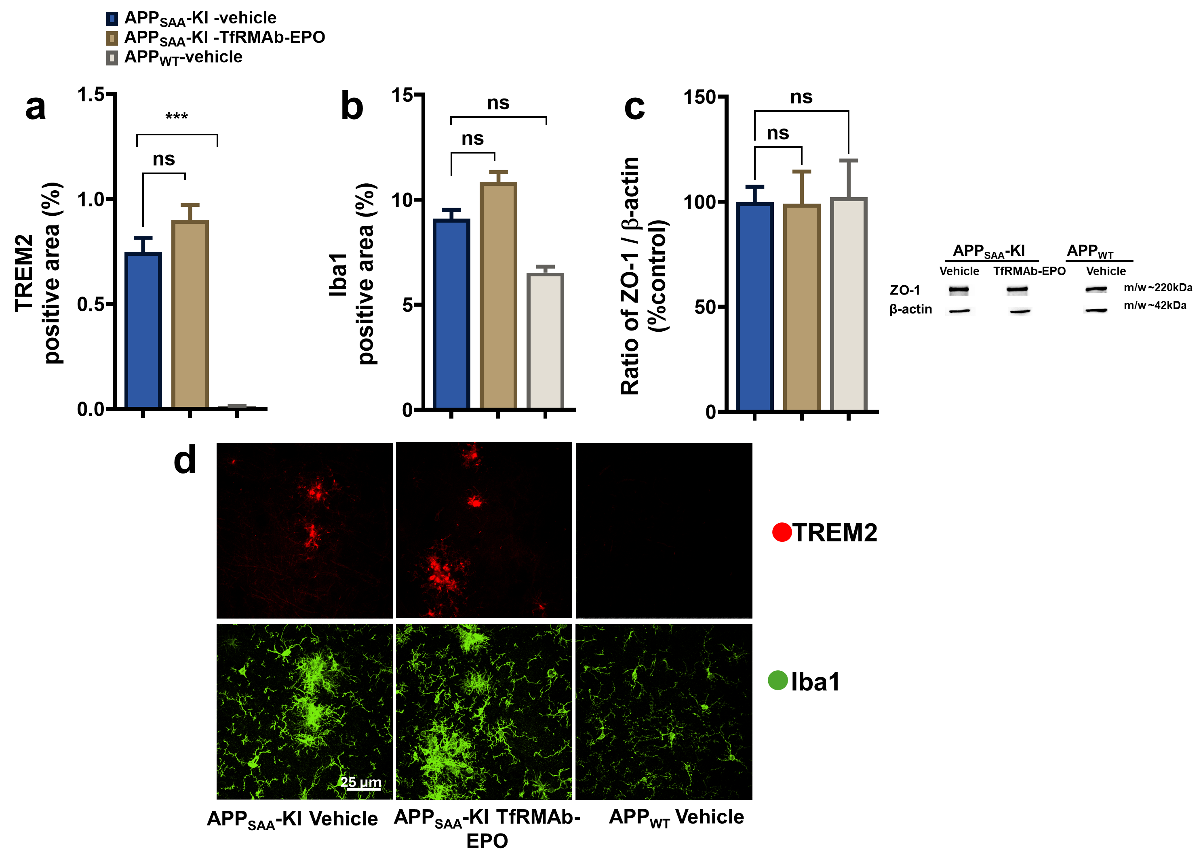
Supplemental Figure 5. TREM2- (a), Iba1- (b) positive area, and ZO-1 expression (c) between the treatment groups. The representative confocal images of TREM2 and Iba1 (d) are shown. Immunostaining data are presented as mean ± SEM of individual images analyzed from each of the TfRMAb-EPO-treated and vehicle-treated groups using the linear-mixed effect (LME) model with treatment as the fixed effect and mouse as the random effect. ***p<0.001. Western blot data are presented as mean ± SEM. n=4-6 mice per group. Statistical significance was determined by one-way ANOVA with Holm-Sidak’s post-hoc test. ns: non-significant.

