Supplementary Materials

- Development of Smell Memories Questionnaire

The methodology for constructing a research instrument suggests that combining qualitative and quantitative methods enhances the quality of intercultural research, while cognitive techniques improve the understanding of cultural thought processes ¹. Open-ended questions complement the quantitative findings in studies ², and can improve the quality of responses and engagement in extracting content on a subject, reflecting relevant characteristics of the respondents ^{3,4}. Meanwhile, closed questions may be more effective in revealing trends in plot relationships. They can also be analyzed for their importance to the respondents ⁵, which facilitates data analysis. Therefore, the questionnaire was developed to include both types of questions: open-ended questions to capture spontaneous responses about the participants' odor memories, and closed questions to identify the significance of these memories in their lives.
In the present study, the questionnaire construction was based on face-to-face interviews with subjects, identifying specific domains that characterize the smell autobiographical memories. Our research instrument aimed to access the semantic content of these memories, wherefore we also utilized prior studies on the phenomenology of memories as a source of knowledge ^{6,7}.
All participants of the questionnaire development declared to have normal olfactory functions. The UPSIT (University of Pennsylvania Smell Identification Test) (Doty et al., 1984) was used in this phase. This test was translated and validated for the Brazilian population by Fornazieri et al. (2013). All participants scored within the normative parameters for normosmia according to their age group and gender, based on the UPSIT normative tables (Fornazieri et al., 2015). These results confirmed the participants' self-reports of normal olfactory function.The participants were recruited among University’s students and staff, and the general public. Subjects consented to participate in the research by signing the Free and Informed Consent Form. This study was approved by the Human Research Ethics Committee of the Institute of Psychology of the University of São Paulo (CAAE: 72199617.1.0000.5561; Opinion number: 2.231.489), according to the National Research Ethics Commission (CONEP) and in line with CNS Resolutions no. 466/2012 and 510/2016.

  - First step
In the first step of building the research instrument, a semi-structured interview was conducted with 20 participants (14 female and 6 male; mean age=36, SD= ± 11.3) lasting approximately 30 minutes for each interview. The guiding topics of the interviews were: memories of odors associated with different periods of life, feelings, and relationships. This procedure aimed to generate data for analysis and to complement what is already known in the literature on the subject. The interviews were recorded in a tablet device (iPad) using a voice recorder app (AVR – Auto Voice Recorder). The responses from the semi-structured interviews were transcribed, and the semantic content analysis was conducted.
We analyzed the dataset containing the responses using Iramuteq software and found 62,135 occurrences. The number of word forms was 2,855, with 45.08% being hapax (terms that appear only once). The frequencies of terms associated with life periods, feelings, and relationships were analyzed to formulate the questions for the questionnaire, assuming that the most frequently mentioned forms are those most related to the participants' autobiographical memories of odors.
The main forms found were: today (f=75), childhood (f=89), adolescence (f=46), day (f=80), morning (f=49), afternoon (f=34), night (f=88), season (f=37), spring (f=15), summer (f=22), autumn (f=4), winter (f=9), weekend (f=63), vacation (f=44), travelling (f=73), parties (f=65), love (f=62), success (f=99), freedom (f=40), sophistication/chic (f=53), sensuality (f=33), spirituality (f=29), pleasure (f=37), happiness (f=19), sadness (f=43), bad memories (f=74), irritation (f=10), people (f=231), family (f=53), father (f=113), mother (f=193), children (f=50), grandparents (f=146), friends (f=43), home (f=298).
These data were organized into domains, dimensions, and categories, as shown in Figure 1. A preliminary questionnaire was developed incorporating the relevant terms for eliciting responses about odors related to autobiographical memories. The valence of feelings was classified according to the NRC emotion lexicon ⁸.
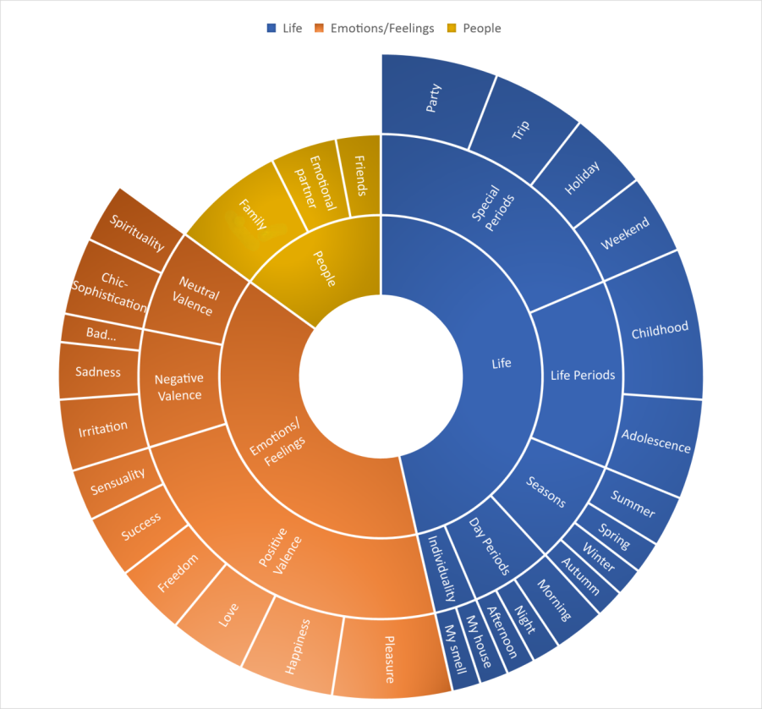
Figure 1. Graph with the domains (innermost circle), dimensions (intermediate circle), and categories (outer circle) founds in the responses to the semi-structured interviews. These categories found are present in the final questionnaire.

  - Second Step
As the final questionnaire would be completed by participants online, without the presence of a researcher, we adopted validation procedures to ensure its intelligibility. A preliminary questionnaire covering the dimensions identified in the previous phase was tested with cognitive interviews to detect issues with the instructions, design, and organization of the research instrument ⁹. The cognitive interview is useful when there is doubt about the respondents' understanding of a question's wording or how they will interpret and respond to the questionnaire ^{10,11}.
In this stage, it was conducted in person with 15 people, 9 female and 6 male, the mean age was 34 years old, SD= ± 14.2.
After completing the preliminary questionnaire using a tablet device (iPad), they answered four questions that assessed their understanding of the issues:
Was it difficult to answer any of the questions? (Understanding)
Did you need to read any of the questions more than once? (Clarity)
Did you feel that you would like to answer any of the questions in more detail? (Expression)
Did you not like any questions? (Pleasantness)
Content validity index (CVI) of a measure was calculated based on the representativeness of the measure. Subjects scored with 1 (understood perfectly), 0 (one or more questions caused doubts) and -1 (did not understand most of the questions). Rubio et al. (2003) recommend first computing the CVI for each item by counting the number of experts who rated the item as 1 and dividing that number by the total number of experts. This gives you the proportion of experts who deemed the item as content valid. The CVI for the measure is estimated by calculating the average CVI across the items. ¹³ recommends a CVI of .80 for new measures. The questionnaire score was: Understanding: CVI= 0.67; Clarity: CVI= 1; Expression: CVI= 1; Pleasantness: CVI= 1.
For the subjects who gave scores of 0 or -1, they were asked which questions they encountered comprehension problems. These questions were modified in this cognitive interview process, ensuring a score of 1 for all the questions.

  - Third Step
Content validity was evaluated by 3 judges (subject experts) who assessed the clarity, expression and relevance of each item using a three-point Likert scale for each item (-1, 0, 1). The overall assessment of the content was positive and the judges considered that each domain and dimension was covered by the set of items. Initial CVI scores was: clarity: CVI= 0,92 ; expression: CVI= 0,76; relevance: CVI= 0,64. The questions scored with CVI<0,80 were reformulated or eliminated, ensuring a score of 1 for all the questions after the discussions with the subject experts.

After the process of construction, validation and adaptation to the psychometric rules, the final version of the 34-item questionnaire was completed. This research instrument is composed of 30 open-ended and 4 closed questions on a 4-point Likert Scale and was called Smell Memories Questionnaire. Its version in English is included in table 1 in the manuscript. This questionnaire was developed to provide a semantic content dataset of AMs related to odors.

Table S1. Specificities by regions

 | SI | SI | SI | SI | SI
Form | Northeast | North | Midwest | Southeast | South
couscous | 20,3234 | -0,393 | -0,939 | -7,6827 | -5,0164
flower | 14,7244 | 0,4061 | 3,7066 | -25,285 | 1,0755
perfume | 13,8039 | 0,4942 | 4,7153 | -16,526 | -1,3061
lavender | 13,3127 | 1,0349 | -3,2466 | -2,2585 | -5,2694
wet earth | 10,8396 | 1,047 | 0,6515 | -5,8844 | -3,9908
fruit | 10,6272 | 0,8019 | -1,3416 | -7,5471 | -0,3156
food | 10,3977 | -0,4439 | 1,6979 | -13,679 | 0,779
perfume 1 | 9,766 | -0,6634 | -0,4025 | -4,6663 | -1,099
mango | 7,2246 | 3,913 | 0,746 | -7,8835 | -4,0054
acarajé | 7,0207 | 0,2643 | -1,1136 | -2,6983 | -1,3433
jackfruit | 5,1757 | -0,2393 | -2,7702 | -1,7708 | 0,4006
maniçoba | -1,1242 | 10,8993 | -0,5062 | -2,5922 | -0,6105
perfume 2 | 2,3439 | 7,8012 | -0,8408 | -4,7554 | -1,658
beer brand | -0,6082 | 6,5989 | -0,5568 | -2,8515 | 0,3632
patchouli | -3,8016 | 5,2209 | -2,2276 | 1,6789 | -1,2213
cupuaçu | -0,3359 | 4,8898 | -0,6074 | -0,8687 | -0,7326
açaí | 0,3565 | 4,7896 | 0,7016 | -4,8487 | 0,2851
clean | -0,2898 | 4,6539 | -0,6159 | -0,8225 | -0,9662
rose | 2,9857 | 4,466 | 0,2904 | -5,4413 | -0,7053
jambo | 0,3896 | 4,3416 | -0,5062 | -1,6301 | -0,6105
tobacco | -0,6915 | 3,7604 | -0,6074 | -1,3719 | 0,6961
forest | -1,7736 | 2,899 | 2,1814 | -1,5413 | -0,2417
rain | 1,4451 | 2,2636 | -0,8968 | -1,2646 | -0,7456
farm | -0,8306 | -0,4923 | 17,2814 | -4,7222 | -2,4443
pequi | 0,3663 | -0,817 | 11,931 | -4,915 | -1,595
pamonha | -1,8872 | -0,9215 | 10,6487 | -2,6299 | -0,2359
bamboo | -3,4858 | -1,1427 | 8,5433 | -0,7204 | -0,3911
cheese bread | -5,2984 | -0,9259 | 7,5185 | 0,2995 | -0,258
cappuccino | -1,0409 | -0,5897 | 5,9582 | -1,0656 | -0,4434
breath | -0,5892 | -0,5897 | 4,8862 | -1,5468 | -0,188
essence | -0,5557 | -0,5489 | 3,8388 | -1,0282 | -0,3163
popcorn | 0,2862 | -0,6244 | 3,3376 | -0,9835 | -0,5902
icecream | 0,4008 | -1,6563 | 3,1007 | -0,906 | -0,338
wet grass | -4,654 | 0,3455 | 2,365 | 0,9674 | -0,3779
night b. jasmine | -15,5134 | -3,6148 | -0,3131 | 22,4089 | -3,389
wine | -6,3418 | 0,328 | -1,0133 | 9,9425 | -2,1673
chlorine | -8,6036 | -1,4901 | -0,577 | 8,7758 | -0,2653
grandfa | -1,9202 | -1,4202 | -2,4813 | 8,0287 | -1,2635
oven | -5,4442 | -0,5926 | -1,3187 | 7,477 | -0,5005
ylang ylang | -2,3611 | -0,774 | -1,063 | 7,2954 | -1,2822
perfume 3 | -1,7904 | -0,8846 | -1,2149 | 6,8547 | -1,4654
pollution | -2,3599 | -0,8567 | -0,4265 | 6,3941 | -2,5528
tangerine | -1,9847 | -0,9583 | -1,3161 | 6,3158 | -0,8951
sea | 0,2976 | -5,9549 | -5,8528 | 5,8675 | 0,6436
manacá | -1,7989 | -0,2064 | -0,8099 | 4,244 | -0,9769
chimarrão | -2,3791 | -1,1058 | 1,8686 | -6,3715 | 10,7528
barbecue | -1,1381 | -0,3785 | 2,2366 | -6,9745 | 10,7057
wood | -0,9514 | -0,5528 | -0,7593 | -1,3686 | 6,794
sunscreen | -6,0096 | -3,6908 | -3,0261 | 4,2778 | 6,4261
pine nut | -1,6864 | -0,5528 | 0,2983 | -1,3686 | 5,6217
cigarette | -10,6633 | -1,4408 | -2,0247 | 5,6059 | 4,825
grass | -5,5348 | -0,9018 | -1,317 | 2,0302 | 4,6094
cleanliness | -1,8297 | -0,4439 | -0,6678 | -0,3815 | 4,477
bergamot | -0,6082 | -0,4054 | -0,5568 | -0,7164 | 3,8691
perfume 4 | -0,955 | 0,8746 | -0,3177 | -1,7766 | 3,6366
horse | -1,1045 | -0,6889 | -0,4864 | -0,3423 | 3,2443

Note. The 11 terms mainly associated with each region, along with their specificity indices (SI) compared to the other region indexes and indicating the odors main specifically related to Northeast (red), North (grey), Midwest (purple), Southeast (green), and South (blue). P-value<0.01 for all.

References

1. Hines, A. M. Linking qualitative and quantitative methods in cross-cultural survey research: Techniques from cognitive science. Am. J. Community Psychol. 21, 729–746 (1993).
2. Neuert, C., Meitinger, K., Behr, D. & Schonlau, M. Editorial: The Use of Open-ended Questions in Surveys. Methods, data, Anal. a J. Quant. methods Surv. Methodol. 15, 3–6 (2021).
3. Geer, J. G. Do open-ended questions measure ‘salient’ issues? Public Opin. Q. 55, 360–370 (1991).
4. Singer, E. & Couper, M. P. Some Methodological Uses of Responses to Open Questions and Other Verbatim Comments in Quantitative Surveys. Methods, Data, Anal. 11, 115–134 (2017).
5. Swyngedouw, M. The subjective cognitive and affective map of extreme right voters: using open-ended questions in exit polls. Elect. Stud. 20, 217–241 (2001).
6. Johnson, M. K., Foley, M. A., Suengas, A. G. & Raye, C. L. Phenomenal characteristics of memories for perceived and imagined autobiographical events. J. Exp. Psychol. Gen. 117, 371–376 (1988).
7. Rubin, D. C., Schrauf, R. W. & Greenberg, D. L. Belief and recollection of autobiographical memories. Mem. Cognit. 31, 887–901 (2003).
8. Mohammad, S. M. & Turney, P. . . NRC Emotion Lexicon. NRC Publ. Rec. 1–15 (2013).
9. García, A. A. Cognitive Interviews to Test and Refine Questionnaires. Public Health Nurs. 28, 444–450 (2011).
10. Wallen, G. R., Feldman, R. H. & Anliker, J. Cognitive Interviews Conducted in Spanish: A Method for Enhancing a Hispanic Infant Feeding Questionnaire. Hisp. Health Care Int. 1, 91–96 (2002).
11. Willis, G. B. Cognitive interviewing: A tool for improving questionnaire design. (Sage, 2005).
12. Rubio, D. M., Berg-Weger, M., Tebb, S. S., Lee, E. S. & Rauch, S. Objectifying content validity: Conducting a content validity study in social work research. Soc. Work Res. 27, 94–104 (2003).
13. Davis, L. L. Instrument review: Getting the most from a panel of experts. Appl. Nurs. Res. 5, 194–197 (1992).

