Supp Figure 1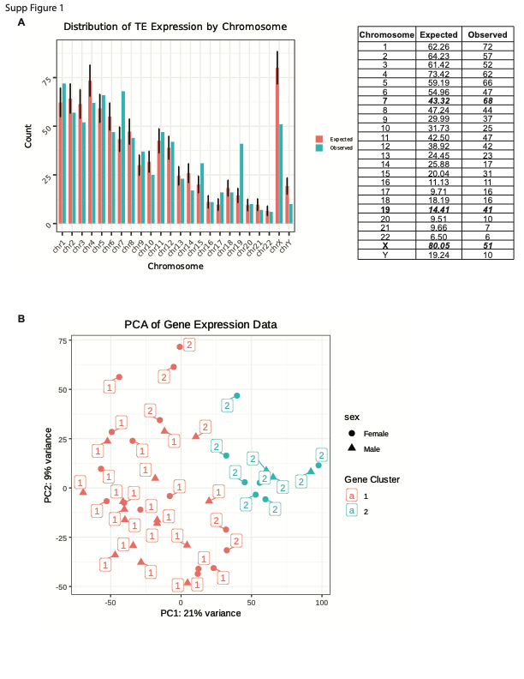
Supp Figure 2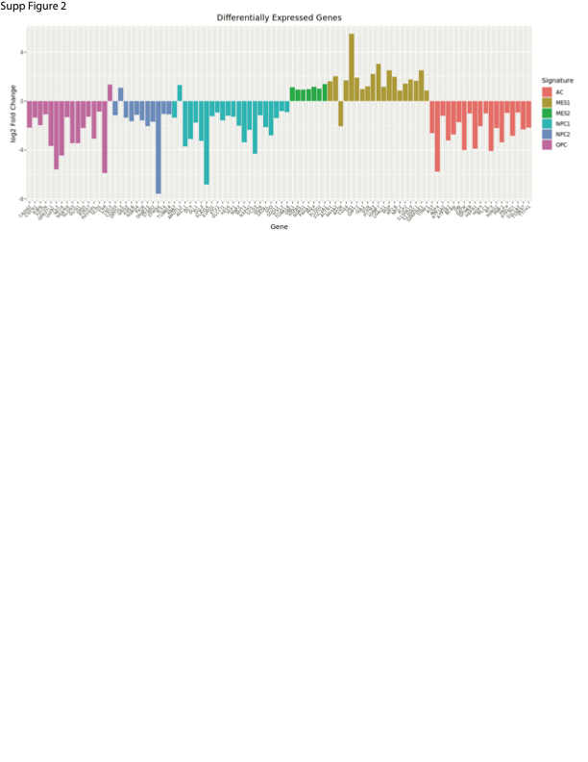
Supp Figure 3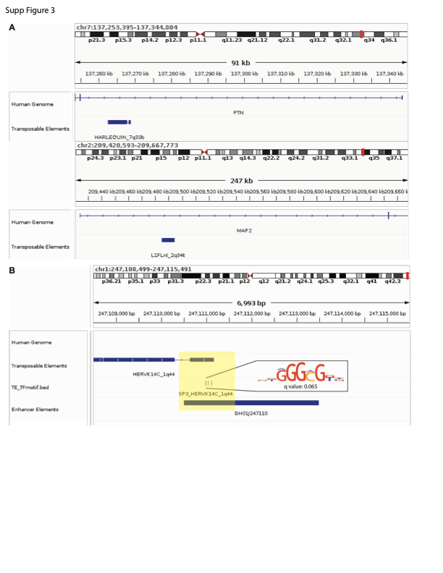
Supp Figure 4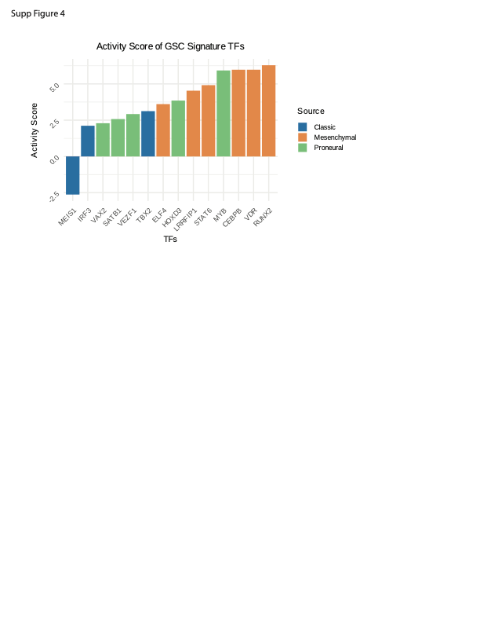
Supplemental Figure 1: (A) Distribution of expressed transposable elements (TEs) across chromosomes. Red columns show the expected distribution of expression as determined by 10,000 random simulations of expression. Blue corresponds to the observed expression. The table provides the exact values, with significantly over or under represented chromosomes bolded (p-value < 0.01) (B) PCA plot of GSC gene expression, with clusters determined by the most variably expressed genes. The labels indicate the TE cluster the sample belongs to. Although partially overlapping, the groupings of cells are different.
Supplemental Figure 2: Significantly differentially expressed genes that were identified to be drivers of glioblastoma stem cell states(49). Confirming our other results, cluster 2 has increased expression of genes related to the mesenchymal signature and decreased expression of genes related to astrocyte, oligodendrocyte precursor and neural precursor signatures.
Supplemental Figure 3: More representative screen captures from the Integrative Genomics Viewer demonstrating TE overlap with (A) genes related to epithelial to mesenchymal transition and (B) enhancer elements. GH01J247110 regulates the expression of ZNF669 and ZNF124.
Supplemental Figure 4: TFs related to glioblastoma signatures that had significant changes in their activity score between the two clusters (p-value < 0.05).

