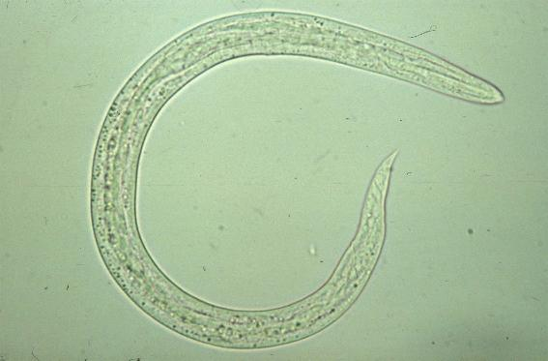
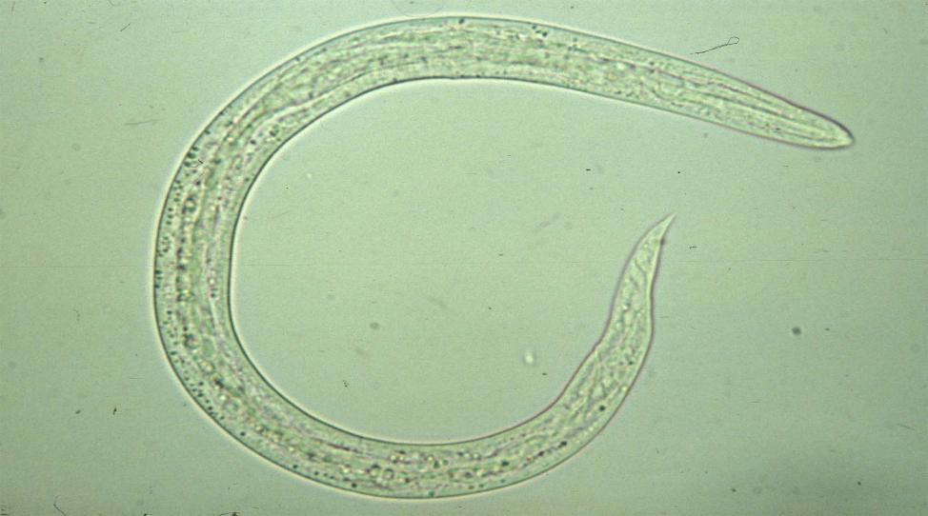
b
a

Supplementary figure 1. a: Crenosoma striatum first stage larva; b: Angiostrongylus vasorum first stage larva

