Supplementary Materials
Overexpression of cotton PLATZ transcription factors GhPLATZ01 and GhPLATZ15 improves the drought resistance of tomato
Tao Liu^{,1}, Baotang Wu^{,1}, Yao Zhang, Zhongqing Li, Yanhua Xue, Xiaoqin Ding , Zhihui Yang , Jianbo Zhu*· & Ruina Liu*
Corresponding Author:
Jianbo Zhu
Tel: 86993- 2057515, Fax: 86993-2057262, E-mail address: zhujianboshz@163.com.
Ruina Liu
E-mail address:shuilingzi123_4@126.com
¹ These authors contributed equally to this work.

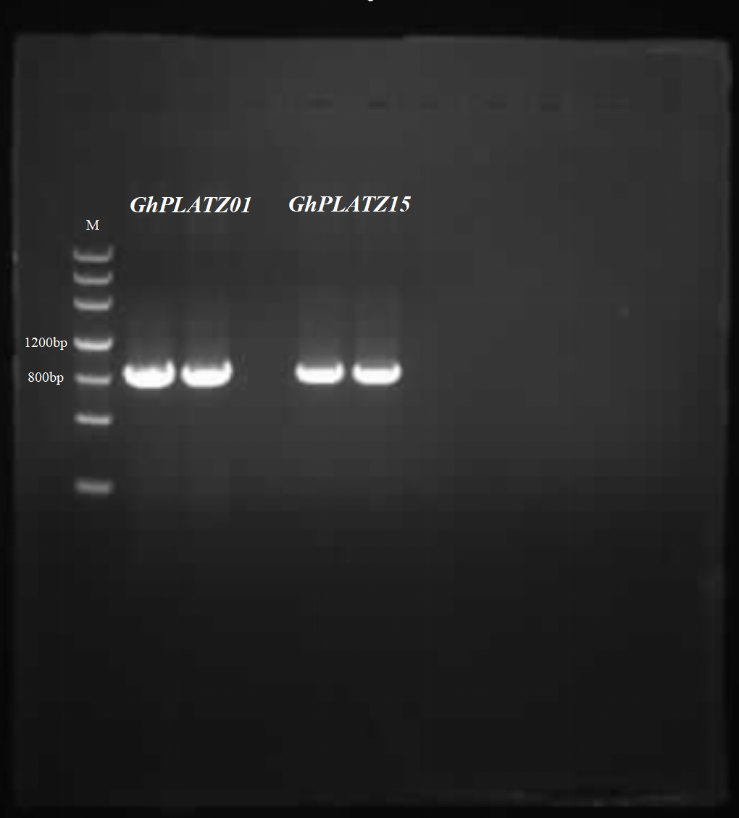
Supplementary Materials.1. Cloning of GhPLATZ01&15 gene; M: Marker3

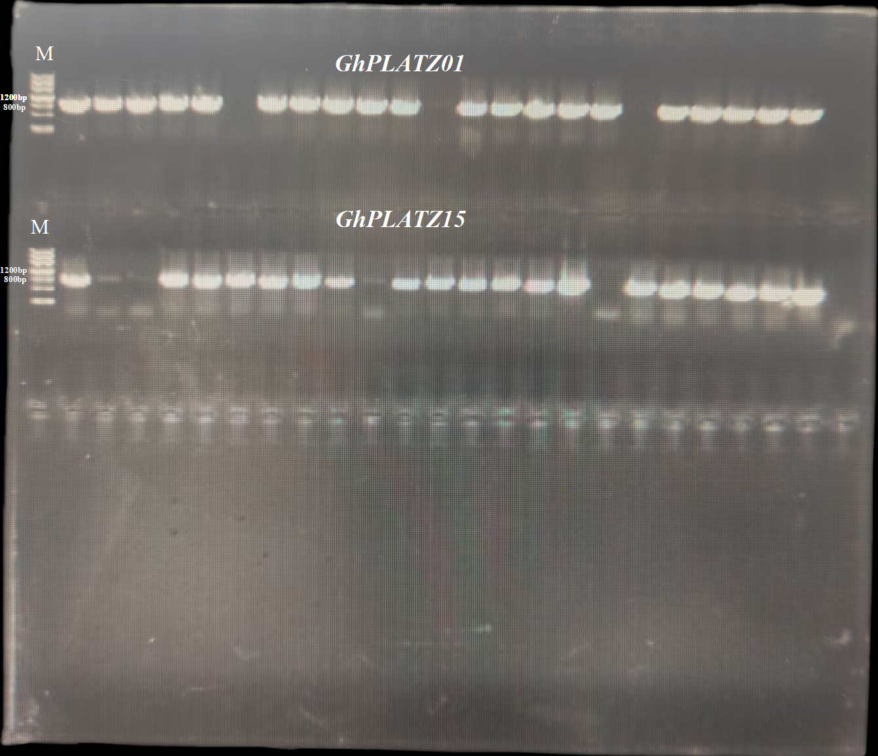
Supplementary Materials.2. PCR results of GhPLATZ01&15 bacterial liquid; M: Marker3

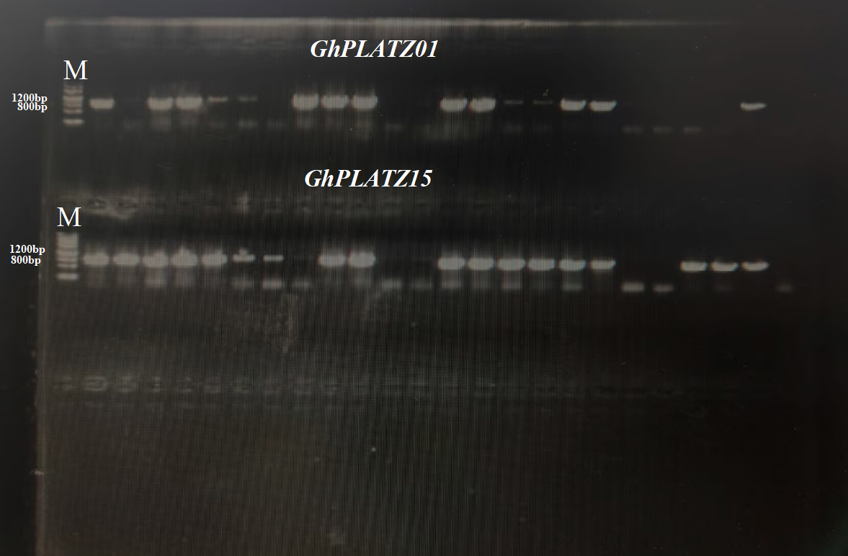
Supplementary Materials.3. PCR identification of Agrobacterium; M: Marker3
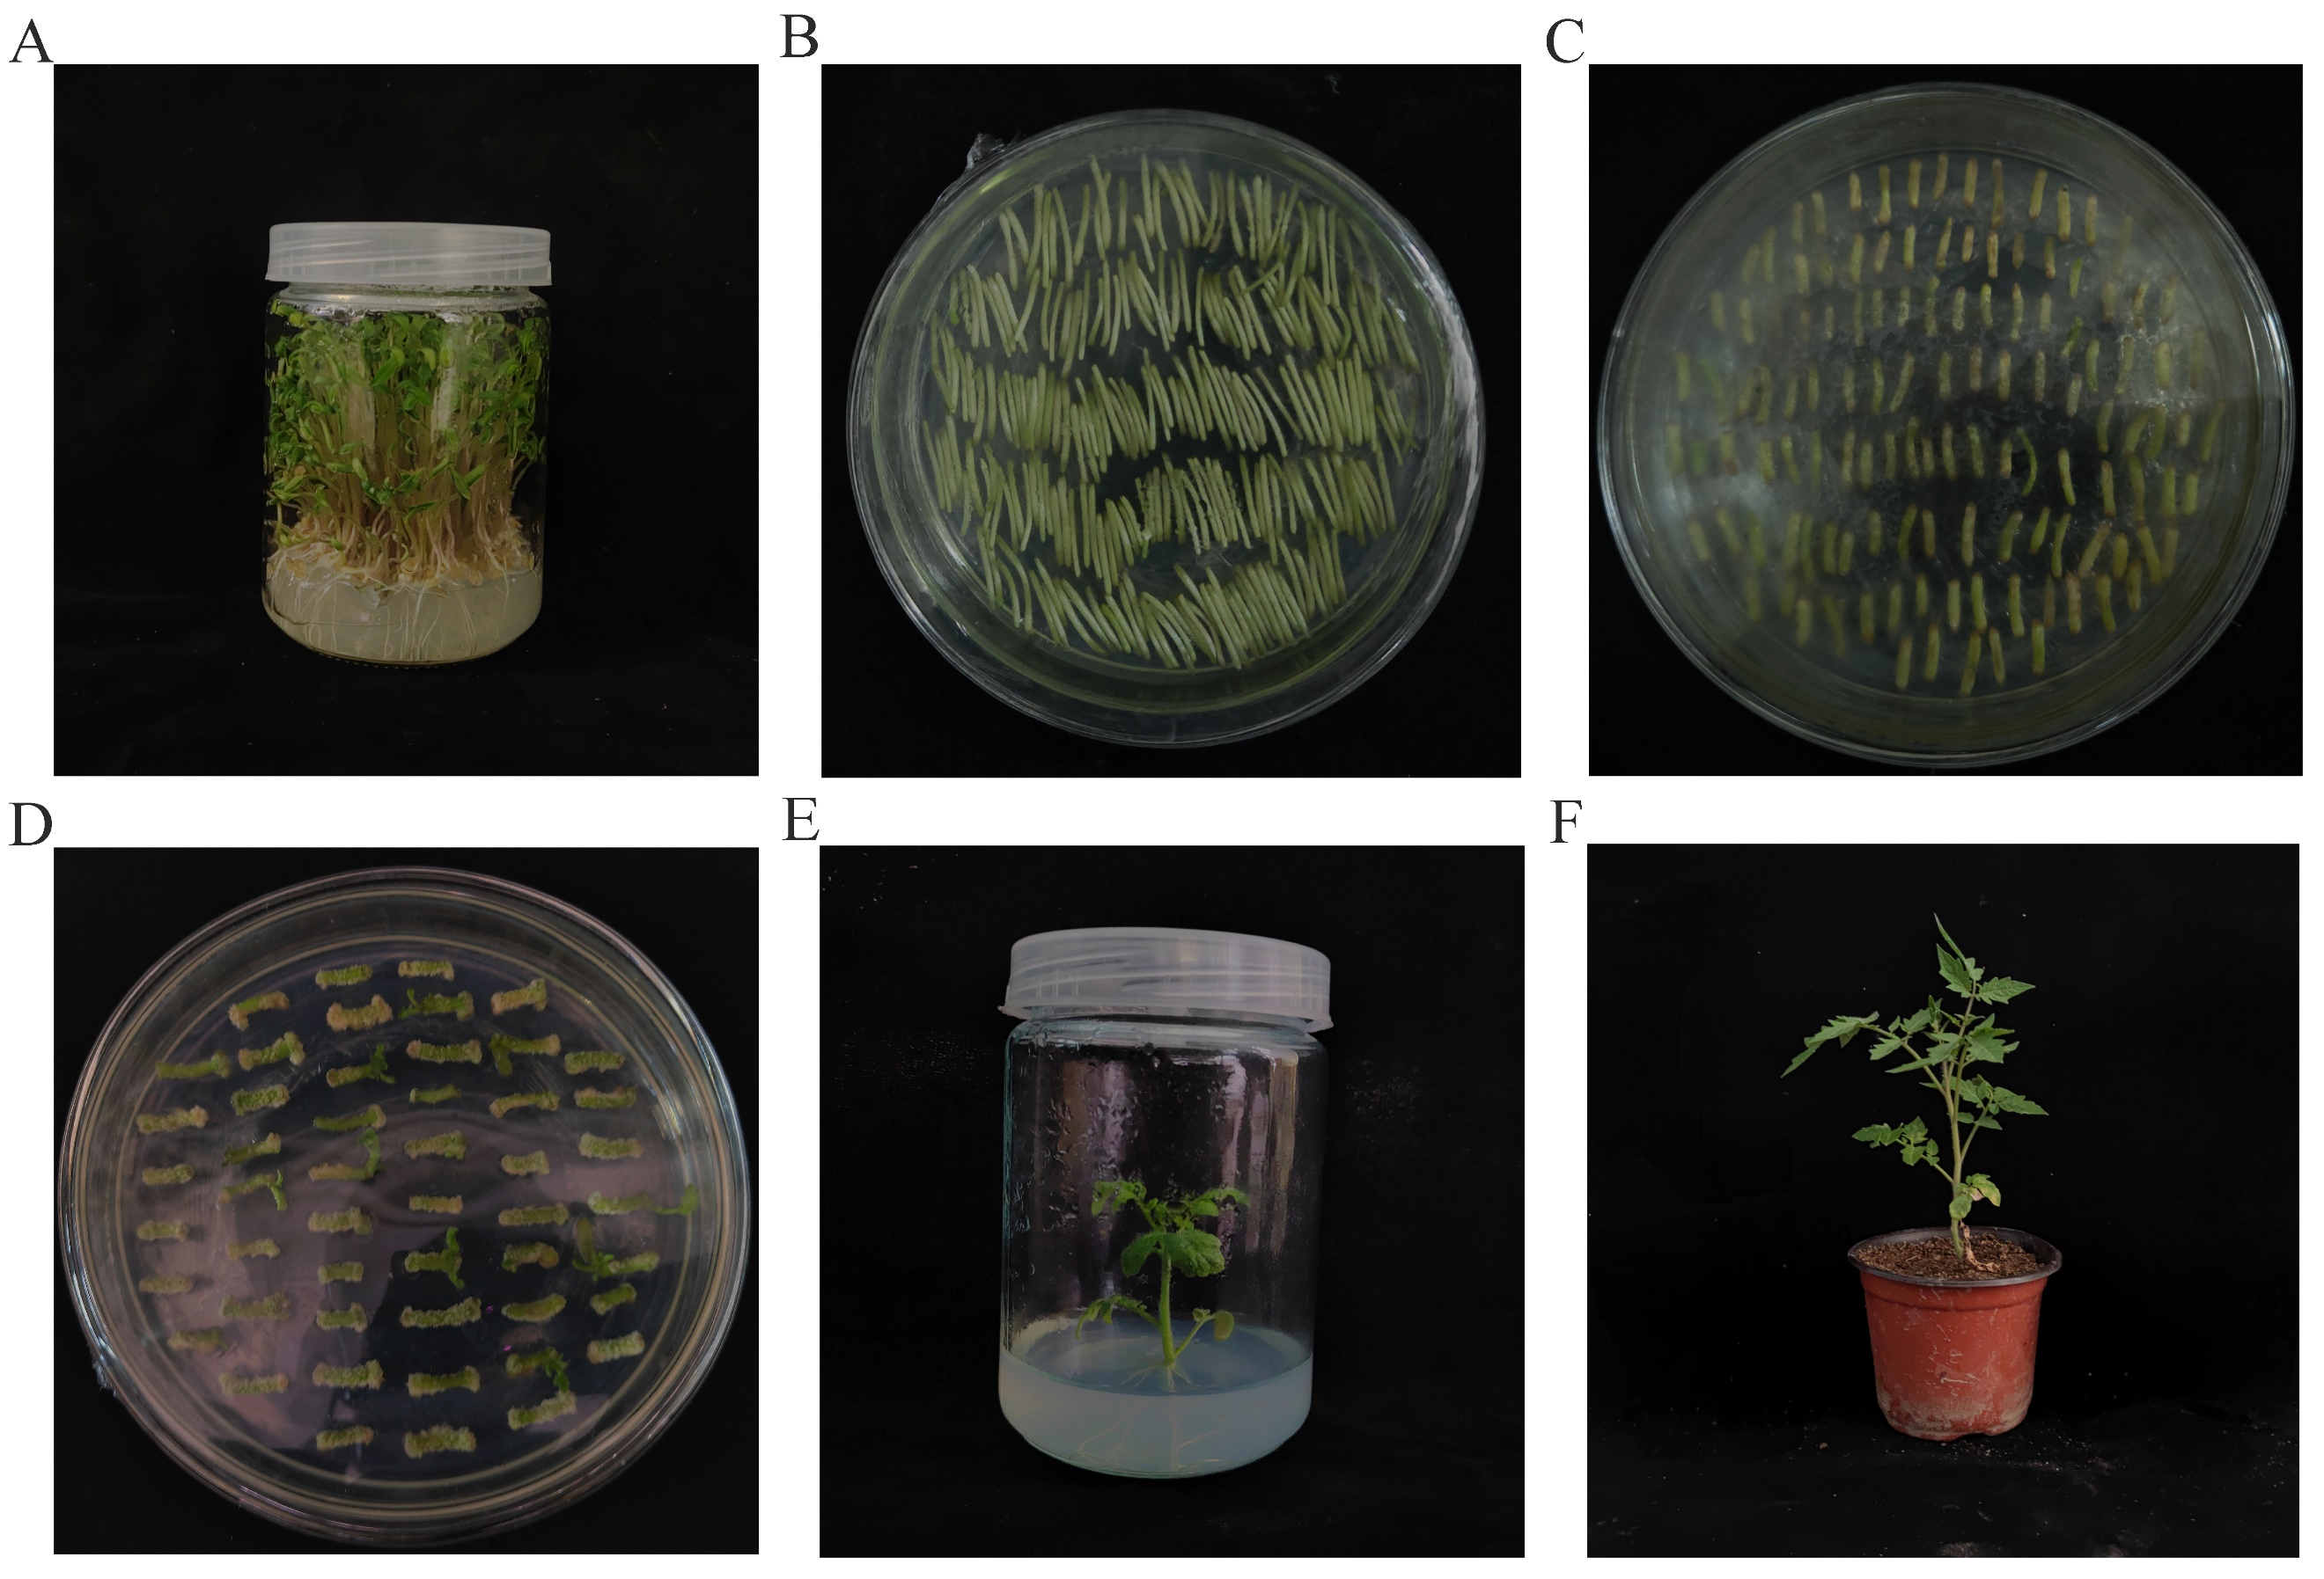
Supplementary Materials.4. Genetic transformation of tomatoes

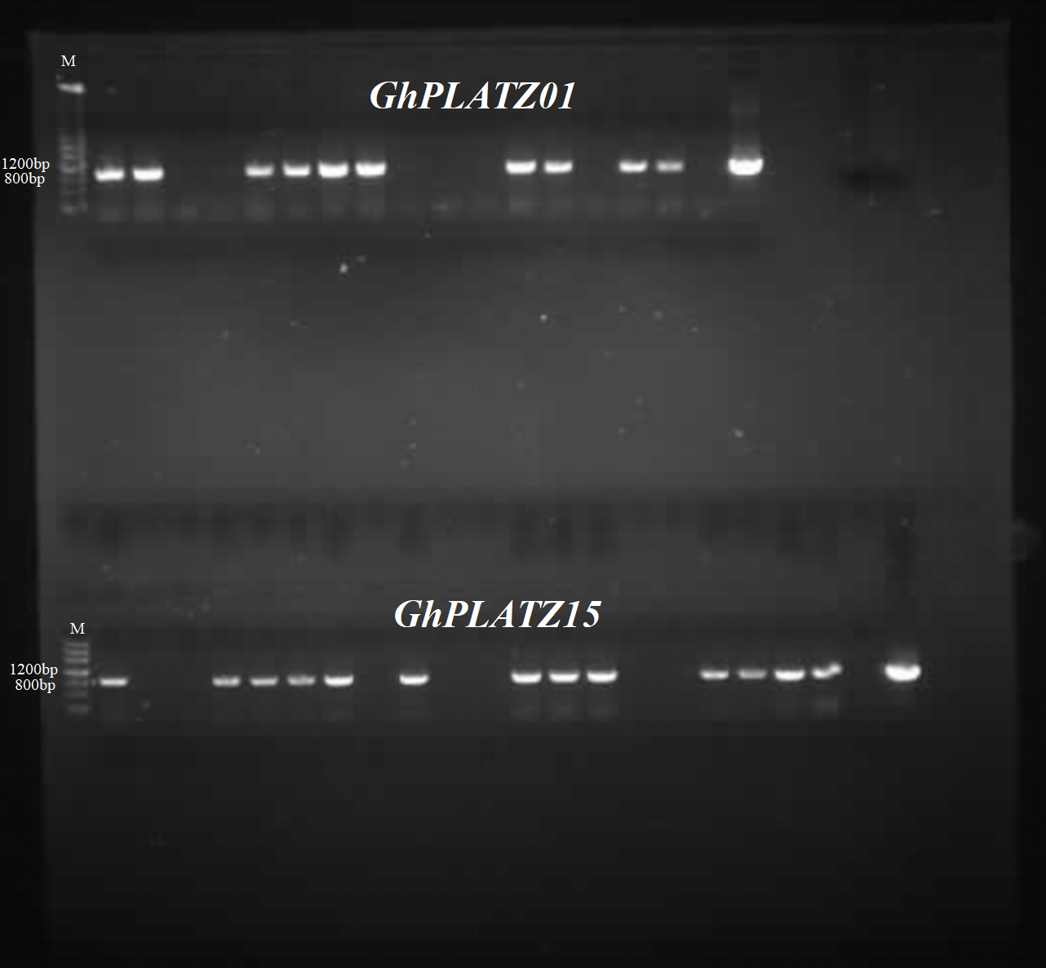
Supplementary Materials.5. Identification of tomatoe positive plants;M: Marker3

Supplementary Materials.6. The primers used in this study
Primer name | Primer sequence | Primer length（bp）
GhPLATZ01-RT-F | CTAGGCCTGGCAAAGGTGTC | 20
GhPLATZ01-RT-R | CATCCGACCCGTCTGTTTCC | 20
GhPLATZ15-RT-F | ACCTGTGAAGTCTGTGAGCG | 20
GhPLATZ15-RT-R | GTTGTTGTTGCTGTTCTTGAGAT | 23
GhUBQ14-RT-F | CAACGCTCCATCTTGTCCTT | 20
GhUBQ14-RT-R | TGATCGTCTTTCCCGTAAGC | 20
GhActin-RT-F | TCCTCCGTCTTGACCTTG | 18
GhActin-RT-R | TGTCCGTCAGGCAACTCA | 18
GhPLTAZ01-F | ggtaccTTCCTATTCTTCTTTCTCCCAG | 28
GhPLTAZ01-R | tctagaTGGTATGGTGGTTTCCTTTC | 26
GhPLTAZ15-F | ggtaccAATCGAGAATCCATTGTCCGTG | 28
GhPLTAZ15-R | tctagaTTGTTCACCATTGCTGCTTCTA | 28
GhPLTAZ01-JD-F | TCTCCCAGAACTGGCTCCA | 19
GhPLTAZ01-JD-R | TGACATTGGTATGGTGGTTTCC | 22
GhPLTAZ15-JD-F | AATCGAGAATCCATTGTCCGTG | 22
GhPLTAZ15-JD-R | TTGTTCACCATTGCTGCTTCTA | 22
NtActin-RT-F | CCTGAGGTCCTTTTCCAAC | 19
NtActin-RT-R | GATTCCGGCAGCTTCCATT | 19
NtUBQ4-RT-F | GAATGCAGATCTTCGTGAAG | 20
NtUBQ4-RT-R | TTCTGGATATTGTAGTCAGCC | 21
SlActin-RT-F | GGAATGGGACAGAAGGAT | 18
SlActin-RT-R | CAGTCAGGAGAACAGGGT | 18
SlUBQ-RT-F | GTAAGGAGTGCCCTAATGCTGA | 22
SlUBQ-RT-R | CAATCGTCCAGCCTTGTTGTAA | 22
SlAPX-RT-F | GATGTTCCCTTTCACCCTG | 19
SlAPX-RT-R | CCCCTCTTTTTCCCCACT | 18
SlCAT-RT-F | GGTGGATTATTTGCCCTCG | 19
SlCAT-RT-R | ACCTCTCCCCTGCCTGTT | 18
SlPOD-RT-F | CACATACATTTGGAAGG | 17
SlPOD-RT-R | TTTATTGTTGGATCAGGGC | 19
SlSOD-RT-F | GGCCAATCTTTGACCCTTTA | 20
SlSOD-RT-R | AGTCCAGGAGCAAGTCCAGT | 20
SlP5CS-RT-F | ACGGTCTTTACAGTGGTC | 18
SlP5CS-RT-R | AAGCAGCATACATAGCAG | 18

