Supporting Information

Microspheric hierarchical controlled-release system and cell growth platform achieves sequential dual-exosomes delivery and promote bone regeneration

Yihan Wang†, Huixin Lv†, Jingxia Chen, Yangfan Pei, Xiuyu Liu, Sheng Chen, Siyu Chen, Xuyan Wei, Jiameng Zhang, Jingjie Zhai*, Yanmin Zhou*

Department of Oral Implantology, Hospital of Stomatology, Jilin University, Changchun, 130021, China.
Jilin Provincial Key Laboratory of Tooth Development and Bone Remodeling, Hospital of Stomatology, Jilin University, Changchun, 130021, China.

Corresponding Authors:
*Jingjie Zhai, E-mail: zhaijingjie@jlu.edu.cn
*Yanmin Zhou, E-mail: zhouym@jlu.edu.cn
†These authors contributed equally to this work.

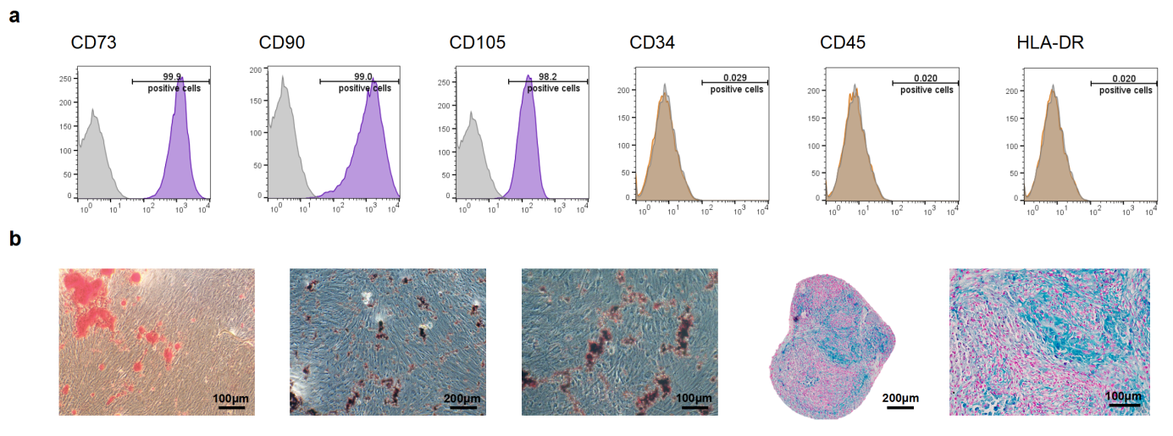

Fig. S1. Characterization of stem cell properties in PMSCs. (a) Flow cytometry analysis showing that LMSCs were positive for CD73 (99.9%), CD90 (99.0%), and CD105 (98.2%), while negative for CD34 (0.029%), CD45 (0.020%), and HLA-DR (0.020%). (b) Evaluation of the trilineage differentiation potential of PMSCs.

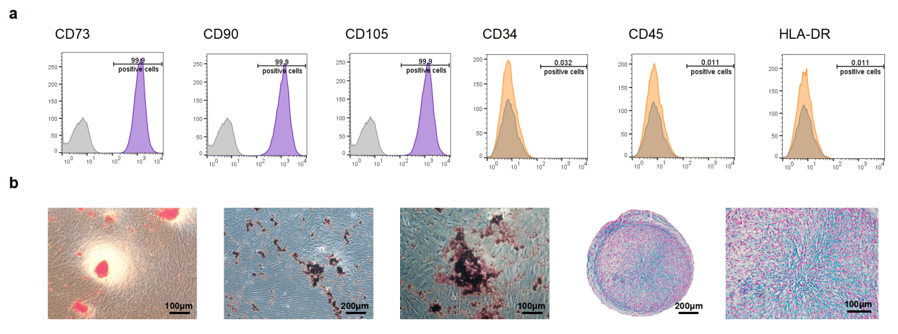

Fig. S2. Characterization of stem cell properties in LMSCs. (a) Flow cytometry analysis demonstrating that LMSCs were positive for CD73 (99.9%), CD90 (99.9%), and CD105 (99.9%), while negative for CD34 (0.032%), CD45 (0.011%), and HLA-DR (0.011%). (b) Assessment of the trilineage differentiation potential of LMSCs.

Fig. S3. Functional assessment of PMSCs-derived exosomes. (a,b) Transwell migration assay evaluating the migratory effects of C-exos and O-exos on LMSCs, with quantitative analysis. (c) RT-qPCR analysis of osteogenesis-related mRNA and stemness-associated mRNA expression levels in LMSCs.

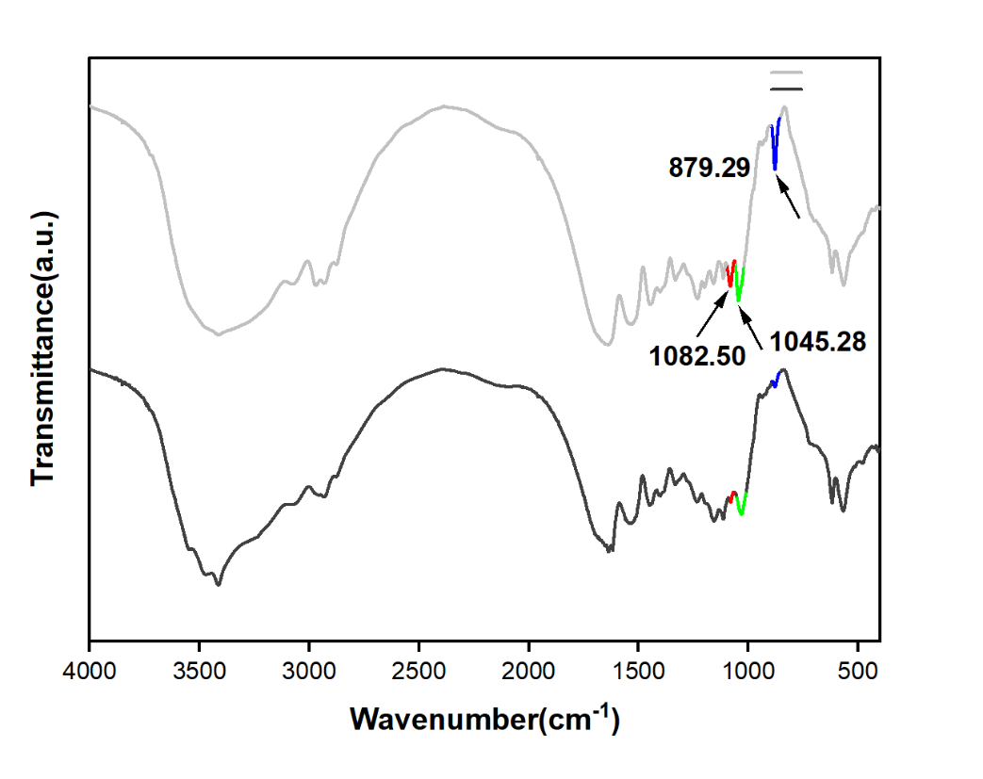
Fig. S4. The functional groups and covalent bond formation in GMs and GMs^{C-exos} were assessed by FTIR.

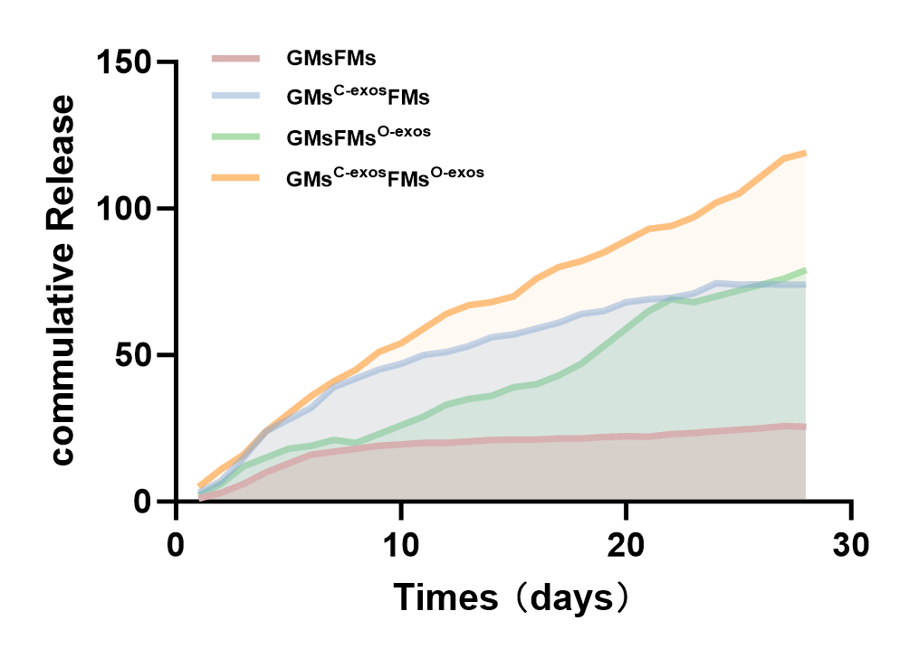
Fig. S5. Cumulative release profile of exosomes from GMs^{C-exos}FMs^{O-exos} over 28 days.

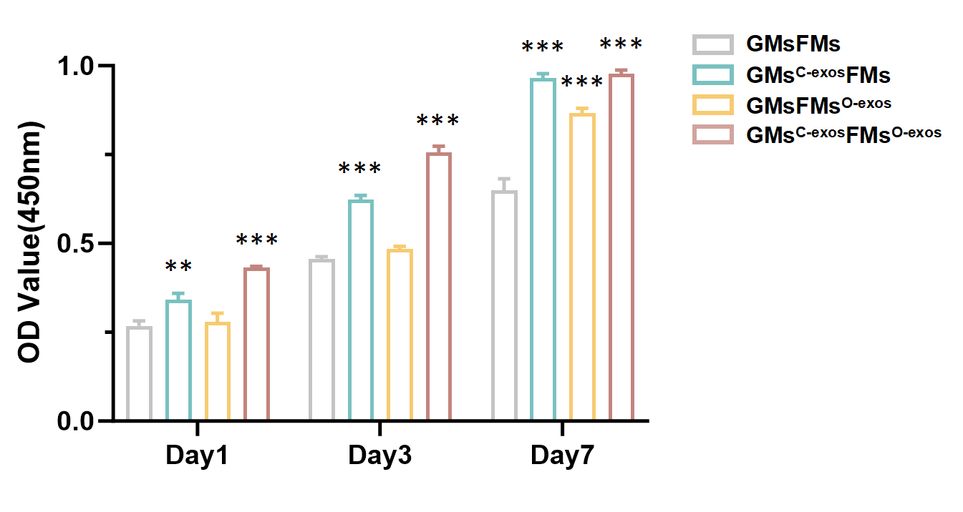
Fig. S6. CCK-8 evaluating the viability and proliferation of LMSCs co-cultured with nested microspheres at days 1, 3, and 7.

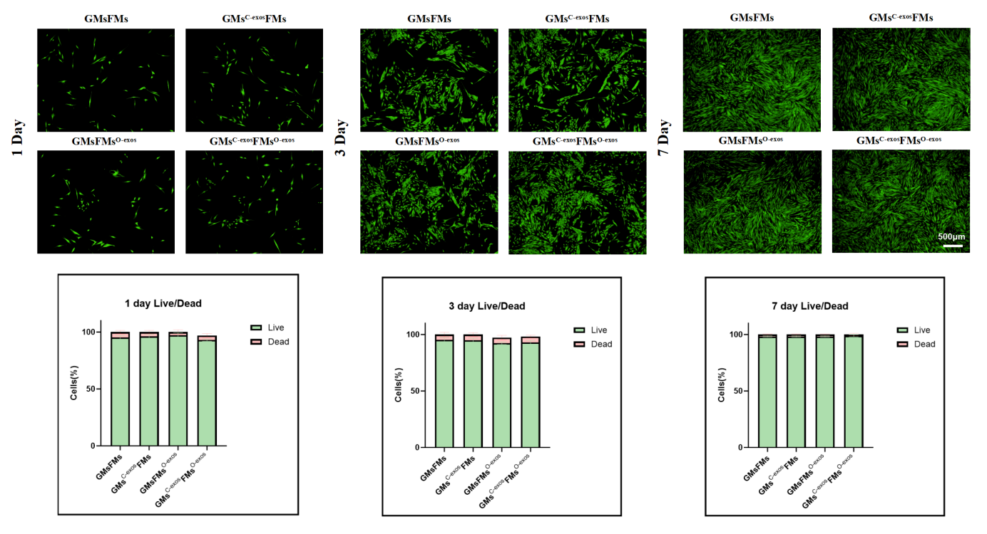
Fig. S7. Assessment of cytotoxicity and biocompatibility of nested microspheres in vitro. Live/Dead cell staining assay showing representative fluorescence images and quantitative analysis of LMSCs at days 1, 3, and 7. Live cells are stained green, while dead cells are stained red.
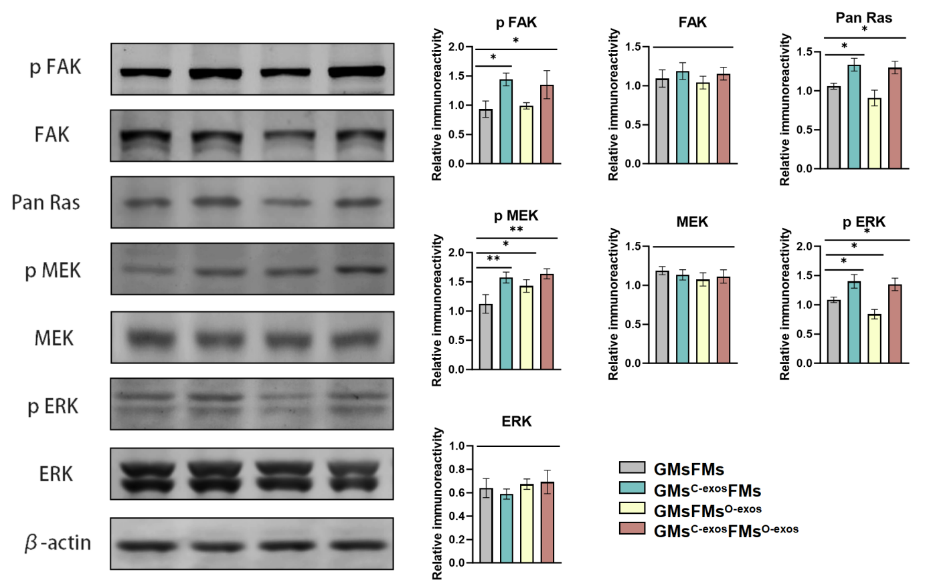
Fig. S8. Western Blot analysis was performed to assess the protein expression and relative phosphorylation levels of p FAK, Pan Ras, p MEK,and p ERK in LMSCs after 7 days of co-culture. β-actin was used as an internal control.
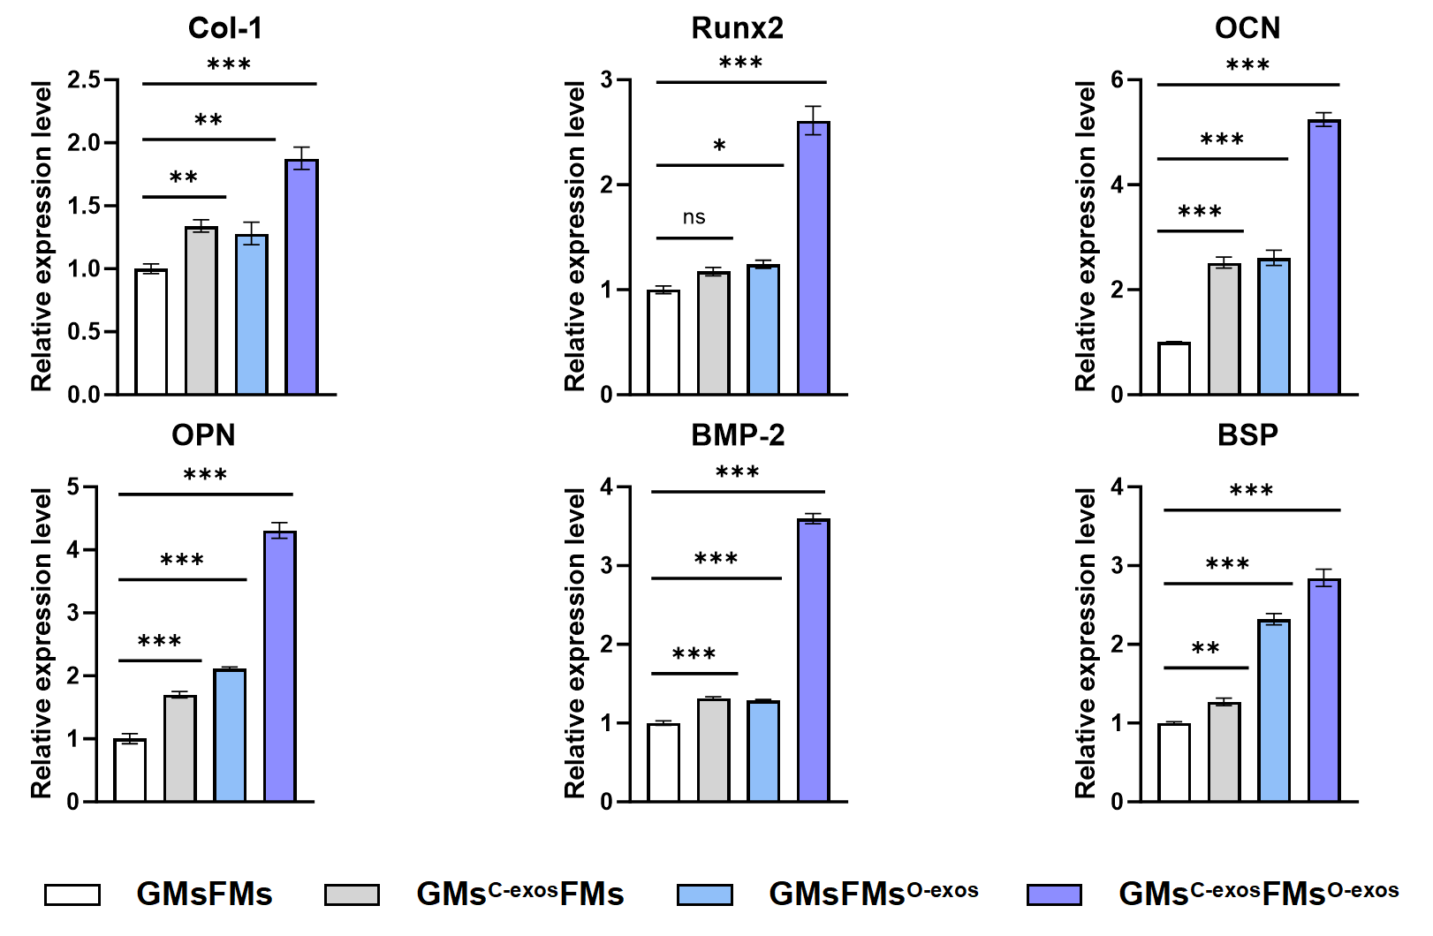
Fig. S9. RT-qPCR analysis of osteogenesis-related mRNA expression in LMSCs after 14 days of co-culture with different groups of nested microspheres.

Fig. S10. Western Blot analysis was performed to assess the protein expression and relative phosphorylation levels of p Akt, p β-catenin (Ser³³/Ser³⁷/Thr⁴¹), p β-catenin (Ser⁵⁵²), OCN, Pan-Ras in LMSCs after 3 days of co-culture. β-actin was used as an internal control.

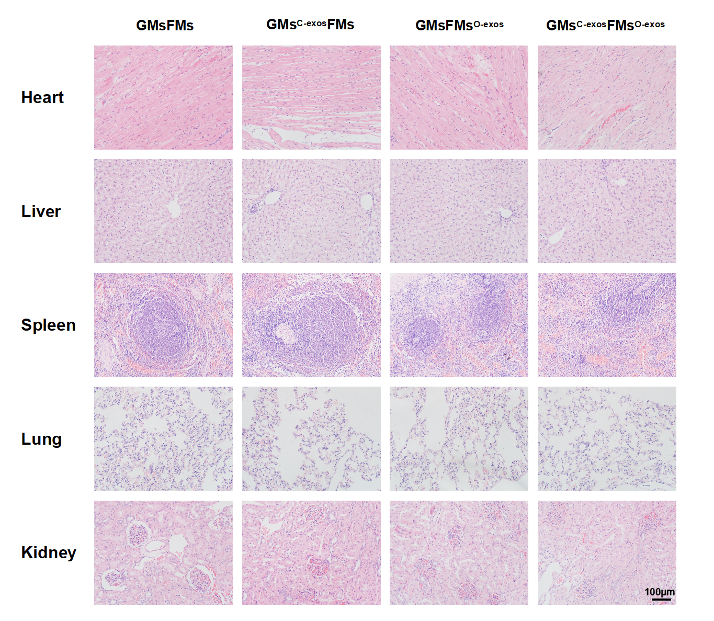
Fig. S11. All organs exhibited normal tissue morphology with no evident pathological alterations.

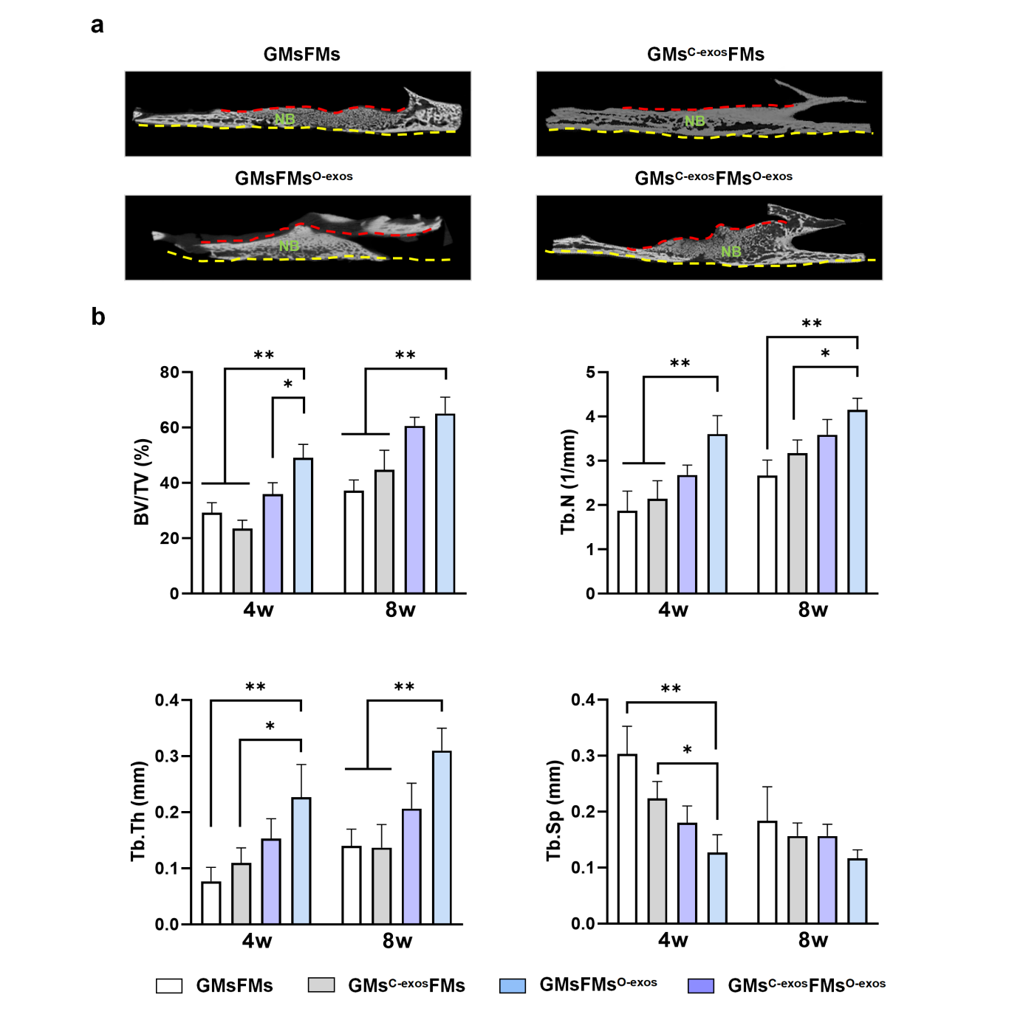
Fig. S12. Micro-CT three-dimensional reconstruction assessing new bone formation in the rabbit maxillary sinus floor elevation region. (a) Micro-CT evaluation of new bone regeneration. (b) Precise quantitative analysis of bone formation beneath the Schneiderian membrane, including bone volume/tissue volume (BV/TV), trabecular number (Tb.N), trabecular separation (Tb.Sp), and trabecular thickness (Tb.Th).

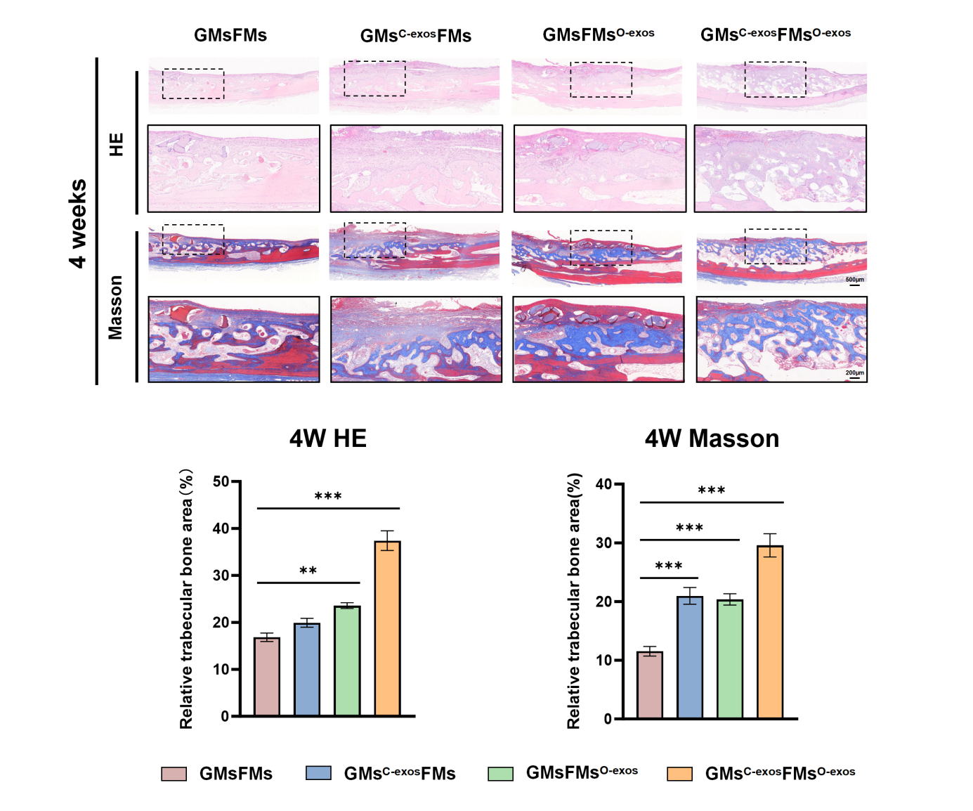
Fig. S13. H&E and Masson’s staining were used to evaluate the morphology and structural integrity of newly formed bone tissue, as well as collagen fiber deposition, with quantitative analysis. NB: newly mineralized bone.

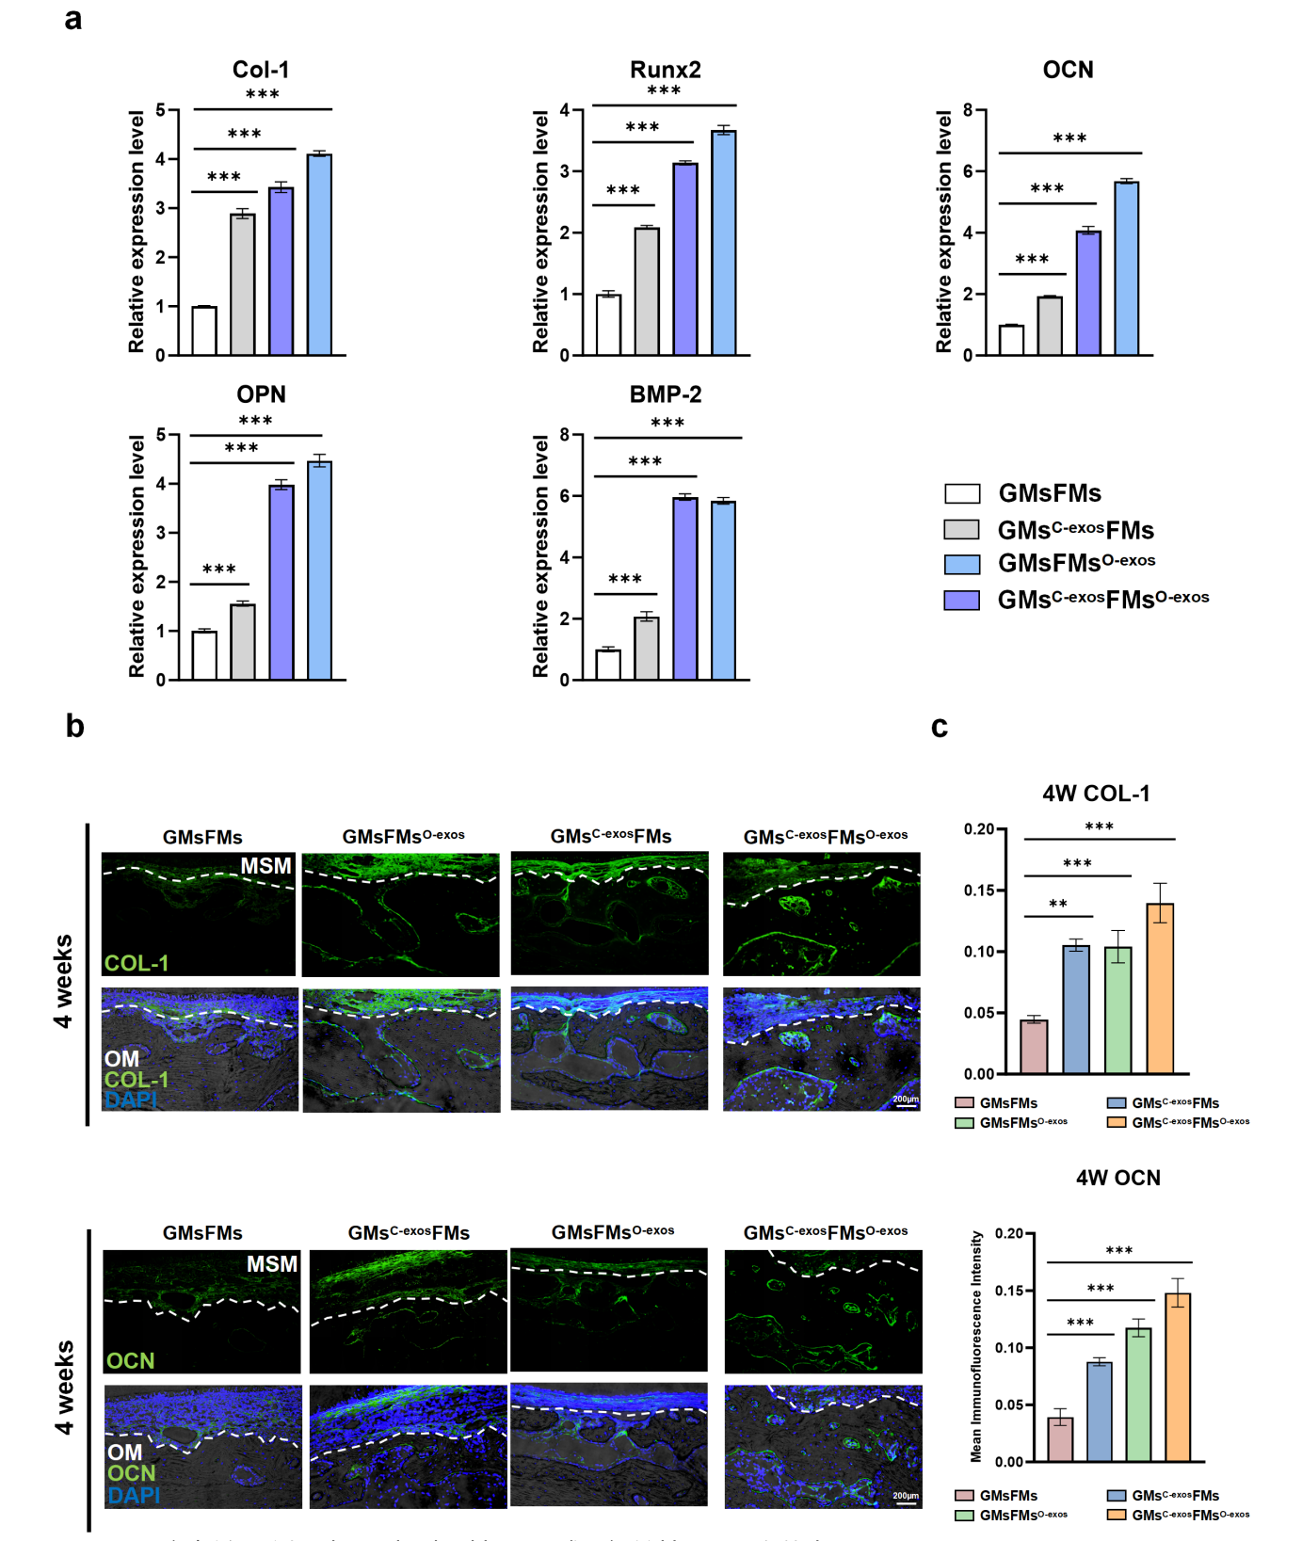
Fig. S14. Expression of osteogenesis-related genes and proteins in the MSM elevation region at 4 weeks (a) RT-qPCR analysis of osteogenesis-related mRNA expression in regenerated bone tissue. (b,c) Representative immunofluorescence images and quantitative analysis of Col-1 and OCN expression in the vicinity of the MSM.

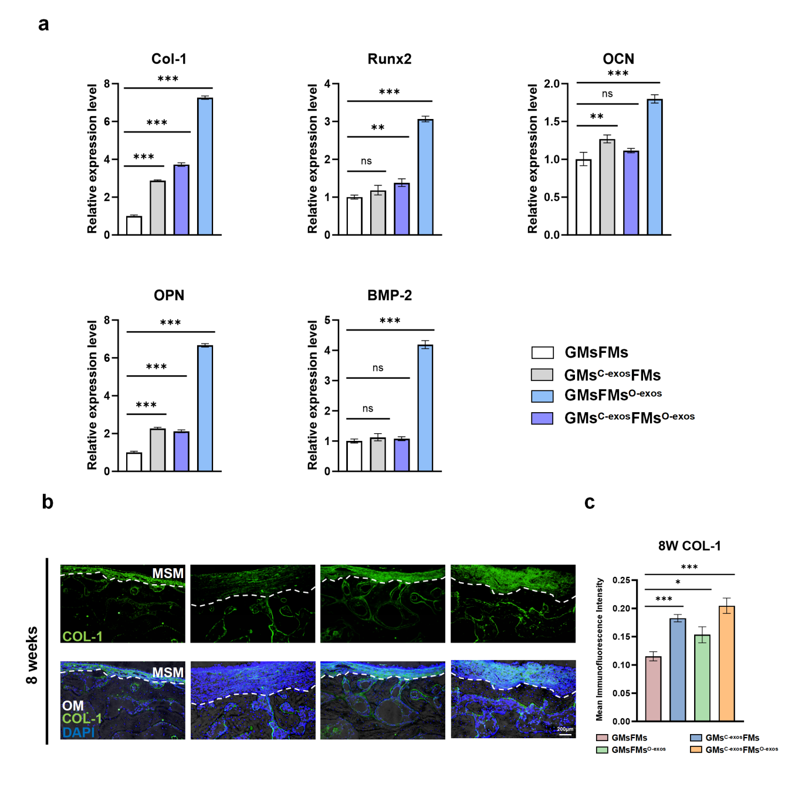
Fig. S15. Expression of osteogenesis-related genes and proteins in the MSM elevation region at 8 weeks. (a) RT-qPCR analysis of osteogenesis-related mRNA expression in regenerated bone tissue. (b,c) Representative immunofluorescence images and quantitative analysis of OCN expression in the vicinity of the MSM.

Table S1. Primer sequences used in RT-qPCR.

