Supplementary Table S1. Specific genes and primers for quantitative real-time polymerase chain reaction
Target Gene | Direction | Sequences (5’-3’) | Description |  | Base pairs (bp)
acrB | Forward  Reverse | TCTGACGGCTTCGCAAATCT  CGTCAGCATACACTTTGCCG | Multidrug efflux pump subunit AcrB |  | 260
liaH | Forward  Reverse | TTGACGACGGCGATGATTCC  TCCGTATCGCCTACGACAAG | lia operon protein LiaH |  | 248
srfAC | Forward  Reverse | TCAGCAAGGATCAAGTTCAG  ACCGGGCGCTTGACTTTTTC | Surfactin family lipopeptide synthetase C |  | 226
srfAA | Forward  Reverse | CTTTTTATCCTTTAACAAAT  ACATATTGAACGGGCTC | Surfactin family lipopeptide synthetase A |  | 220
srfAB | Forward  Reverse | ATGAGCAAAAAATCGATTCA  CAATACGACTTGGCGCGGTT | Surfactin family lipopeptide synthetase B |  | 240
srfAD | Forward  Reverse | ATGGTCCAGCTCTTTAAATC  GATTCAACTCCTGCTTGTAC | Surfactin family lipopeptide synthetase D |  | 220
ybgE | Forward  Reverse | TGATTGAAATACGTAAGGTC  AACATCAATACCCGTCCGTC | branched-chain amino acid aminotransferase |  | 247
alsS | Forward  Reverse | TTTCATGAAGTCCTTTACCG  AGTGGCAGGAAATCTTCTAT | acetolactate synthase I/II/III large subunit |  | 240
prpC3 | Forward  Reverse | TTGATTTATCGTGGATTGAA  GCGTTTCCAATAAGCCGATG | citrate synthase |  | 250
sucC | Forward  Reverse | TACGGGGTGTCTGTTCCTGA  ACCCGTTTGATGTGTGACGA | succinyl-CoA synthetase beta subunit |  | 219
sacP | Forward  Reverse | TACGGGGTGTCTGTTCCTGA  ACCCGTTTGATGTGTGACGA | PTS sugar transporter |  | 219
fabG | Forward  Reverse | ATGCTTAATGAAAAAACAGC  ACAGCCTCTTTCATCATGTT | 3-oxoacyl-[acyl-carrier protein] reductase |  | 230
recA | Forward  Reverse | TGTTGCGGCGCTTGTTCCAAAAG  AATAGAATTTCAGCGCGCGG | (Reference gene) |  | 221

Xu, X., Wang, Y., Lei, T., Sohail, M.A., Wang, J. and Wang, H. (2022). Synergistic effects of Bacillus amyloliquefaciens SDTB009 and difenoconazole on Fusarium wilt of tomato. Plant Disease 106 (8), 2165-2171. https://doi.org/10.1094/PDIS-12-21-2650-RE

Supplementary Table S2. Primer sequences in qRT-PCR analyses
Code | Sequence (5′-3′) | Target organism | Amplicon size (bp) | Reference
ForcF5 (F)  ForcR2 (R) | TCGTCACAATGATTTCAGCAT  GTGACGCAGGGTAGGCAT | F. oxysporum f. sp. radicis-cucumerinum | 198 | (Lievens et al., 2007)
BC16SF  BC16SR | TCGCGGTTTCGCTGCCCTTT  AAGTCCCGCAACGAGCGCAA | Bacillus spp. | 177 | (Mori et al., 2004)

Lievens, B., Claes, L., Vakalounakis, D. J., Vanachter, A. C., & Thomma, B. P. (2007). A robust identification and detection assay to discriminate the cucumber pathogens Fusarium oxysporum f. sp. cucumerinum and f. sp. radicis-cucumerinum. Environmental Microbiology 9, 2145–2161. https://doi.org/10.1111/j.1462-2920.2007.01329.x
Mori, K., Iriye, R., Hirata, M., Takamizawa, K. (2004). Quantification of Bacillus species in a wastewater treatment system by the molecular analyses. Biotechnology and Bioprocess Engineering 9, 482–489. https://doi.org/10.1007/BF02933490

Supplementary Table S3. Relative gene transcript levels in the six modules of surfactin synthesis in B. velezensis Bv-22 exposed to Si.
Gene code | -Si | + Si
AcrB | 1.2* b | 6.6 a
liaH | 4.3 a | 5.3 a
SrfAC | 1.2 b | 5.3 a
SrfAA | 0.45 b | 5.7 a
SrfAB | 0.76 b | 5.9 a
SrfAD | 3.7 b | 5.2 a
ybge | 2.3 b | 6.4 a
alsS | 2.7 b | 5.9 a
prpC3 | 1.9 b | 5.8 a
SucC | 1.5 b | 7.4 a
SacP | 1.4 b | 6.3 a
fabG | 1.9 b | 6.7 a
*The 2^{−ΔΔct} method was used to normalize each target gene using recA gene as the reference gene. Three biological replicates were used for each treatment, and two technical replicates were used for each.
- Different letters in the row indicate significant differences at (P < 0.05).

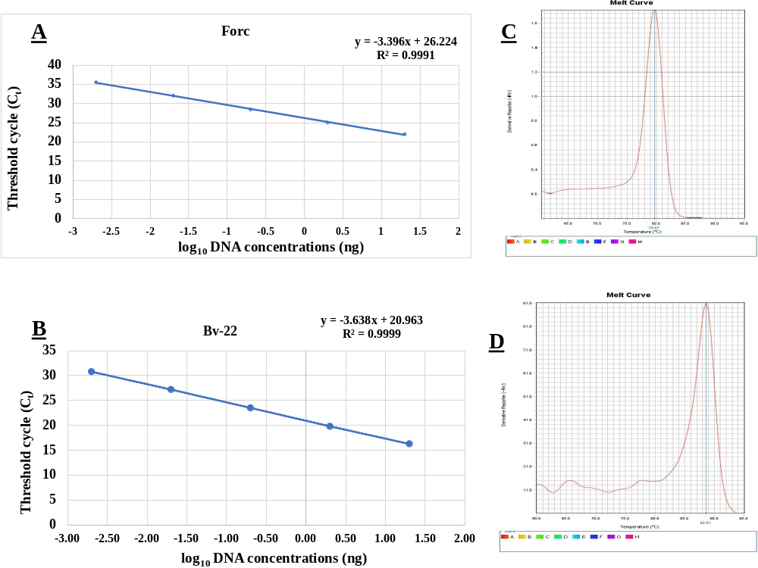
Supplementary Figure S1. Standard curves of fungal DNA concentrations plotted against threshold cycles (C_{t}). C_{t} values were plotted against log-transformed DNA abundances, and the linear regression equation was calculated. To measure the absolute abundances of Forc (A) and Bv-22 DNA (B), concentration standards ranging from 100 ng µL⁻¹ to 10⁻⁵ ng µL⁻¹ were prepared. R² = correlation coefficient. SYBR green melting curve profile for real-time polymerase chain reaction amplification of Forc (C) and Bv-22 (D) pure genomic DNAs. The single peak with Forc and Bv-22 DNA as templates indicates the specificity of the ForcF1/ForcF2 and Bs16S1/Bs16SR primers, respectively.

