Supplementary Information for
Assessment of Vulnerability to Disruptions to the Supply of Semiconductors.

Alex C. Newkirk^{1,2}, Constantine Samaras^{1,3,4}, M. Granger Morgan¹, and Erica R. H. Fuchs¹

¹ Department of Engineering and Public Policy, Carnegie Mellon University, Pittsburgh, PA, USA
² Building Technologies and Urban Systems, Energy Technologies Area, Lawrence Berkeley National Laboratory, Berkeley, CA, USA
³ Department of Civil and Environmental Engineering, Carnegie Mellon University, Pittsburgh, PA, USA
⁴ Wilton E. Scott Institute for Energy Institute, Carnegie Mellon University, Pittsburgh, PA, USA

Alex C. Newkirk
Email: anewkirk@andrew.cmu.edu

This file includes:

Supporting text
Figures S1 to S2
Tables S1 to S6
SI References

Section A: Process Node and Device Type Groupings
This appendix details the development of the device type and process node categories used in our expert elicitation. Building on the high-level classifications from Singh et al. (1), we developed our device taxonomy through iterative consultation with two trial respondents; one representing a semiconductor production perspective, and the other representing end-users. We iterated on the category definitions until both felt they reflected relevant manufacturing and commercial realities.
During the elicitation process, we observed some perceptual overlap between certain device categories. For example, high-speed communication components and analog devices share some technical characteristics and application spaces, particularly in RF and signal processing domains. To address this potential ambiguity, respondents were asked to explicitly identify which specific devices they were considering when selecting a category for discussion. This allowed us to maintain consistency in how particular devices were mapped to categories across different subjects' responses. The protocol also allowed respondents to define additional device categories they considered critical. Three respondents exercised this option, identifying Microelectromechanical Systems (MEMS), Application-Specific Integrated Circuits (ASICs), and High-Power devices.
Our process node groupings were developed through a similar iterative consultation process. The initial framework was based on the semiconductor facility type classifications outlined in the Department of Commerce's first CHIPS and Science Act Notice of Funding Opportunity (NOFO), released on February 28, 2023. Through consultation with our semiconductor production trial respondent, these categories were refined into four distinct groupings:
- Leading Edge (<7nm): The most advanced process nodes, representing the current technological frontier in semiconductor manufacturing
- Cost Optimal (14-26nm): Process nodes that provide the most economically efficient production of high-volume logic devices, typically achieving minimum cost per 100 million logic gates
- Mature (26-90nm): Well-established process nodes that balance performance and production costs
- Legacy (>90nm): Older process nodes that remain vital for specific applications and specialized markets
Our respondents noted some conceptual complexity in these categories, and more broadly in the industry convention to associate more advanced processes with a smaller eponym even after node titles ceased to correspond with any physical measurement feature. One electronics design respondent noted that these categories reflected commercial realities more than physical: “as far as I’m concerned, ‘leading-edge’ is a marketing gimmick”. A defense production respondent emphasized that while a directionally useful heuristic, feature scale did not always reflect process capabilities, stating “there are advanced production methods at any given feature scale”.

Section B: Estimated impact from loss of access to production capability and devices by sector and subsector

Figures S1 and S2 present expert assessments of semiconductor criticality across major economic and infrastructure sectors. Figure S1 displays individual expert ratings on the impact of losing specific semiconductor manufacturing capabilities, with data organized by major sectors and subsectors, highlighting similarities between electric grid and civilian aviation disruption levels. Figure S2 displays expert evaluations of semiconductor device criticality, revealing sector-specific vulnerabilities in grid infrastructure, defense applications, computation sectors, and cross-sector dependencies.

Section C: Capability and Volume in Semiconductor Dependency
A key concept to emerge out of these discussions was the distinction between a reliance of capabilities vs production volume. One government industry expert characterized the access to volume as the most meaningful indicator of resilience: “it doesn’t matter if you can make one perfect chip, the economy runs on mass volume”. This was consistent with respondents from other sectors. One design expert estimated that each AI training server, which typically contains 8 advanced GPUs and 2 supervisory CPUs, required “30,000 individual power discrete and commodity IC architectural components.” While an extreme case, automotive respondents discussed a distribution of devices directionally consistent with this characterization. Estimated quantities of individual microelectronic components in a vehicle ranged from 1,500-3,000, with “5-6 of those being high value SoCs”.

Even applications most sensitive to leading-edge improvements require significant volumes of foundational devices. Due to consumer preference for long battery life, slighter form, and the short product lifespan, smartphones are the paradigmatic driver of demand for leading-edge nodes, as they rely on constant energy and physical compactness improvements. Based on the results of our smartphone component origin assessment, while the 6 components manufactured at the leading-edge and cost optimal process nodes drive feature improvements, they are enabled by the 25 total devices manufactured at mature and legacy.

Industry estimates of volumetric consumption, and accordingly of production dependency, are only approximate. As noted by defense expert 2, “One of the fascinating things we did was we looked at a part and went back to the manufacturer, tried to get an idea of how many parts were actually built, and compared that to [publicly available inventories on] the web. Those 2 numbers didn't match, didn't even come close. There were 3 times [as many listed devices available] as were actually physically built.” One design expert estimated that each AI training server, typically containing 8 advanced GPUs and 2 supervisory CPUs, required 30,000 individual power discrete and commodity IC architectural components. This is an illustrative, if likely extreme, example of the skew in value and volume across devices within an application. As a bounding exercise, we assumed 60% of devices by volume used by a sector were priced at our low value devices, 39% were our medium case, with 1% our high value case. We used this composition alongside annual sectoral demand to estimate total device use by sector. This estimate is shown in table S3 alongside industrial data when publicly available

Section D: Methods for Valuing Semiconductor Economic Impact

Direct Economic Value Methods
Previous research has employed several approaches to evaluate the economic value of semiconductor production and utilization. A foundational methodology pioneered by Jorgenson integrates improvements in semiconductor capability with price indices to benchmark prices for a constant level of quality (2), enabling more accurate capture of productivity growth in semiconductor manufacturing. Building on this work, Jorgenson et al. (3) classified industries by their IT equipment production and IT capital expenditure share, finding that IT-producing and IT-using industries accounted for 25% of productivity growth from 1960 to 2007. Further work linked these findings to detailed NAICS industry classifications to create granular indices of IT's contribution to productivity across sectors (4).
Economic analytics firm Oxford Economics developed another approach, estimating industry impact by combining annual value-added, upstream supply expenditure, and direct labor (5). Applying Jorgenson's industry-level productivity shares to assess "induced value," they estimated the total global contribution of microelectronics in 2012 at $2.7 trillion ($3.7 trillion in 2024 dollars). More recently, Shalf (6) estimated the existing microelectronics industry provides $4 trillion in annual value.

Supply Disruption Impact Methods
Researchers have developed several approaches to evaluate the economic impact of semiconductor supply disruptions. One method links industry input/output data, prices, and production to news coverage of historical outages to identify price level impacts (7) and production effects (8). This approach was applied to assess the 2021 automotive chip shortage, which had an estimated direct cost to U.S. GDP of $240 billion (9) and reduced domestic automotive production by 7.7 million vehicles (10).
Another methodology combines secondary literature with expert interviews to evaluate disruption impacts on individual firms or countries (11, 12). This qualitative approach provides detailed insights into sector-specific vulnerabilities and adaptation strategies.

Capital Stock Valuation Methods
The Federal Emergency Management Agency (FEMA) has developed methods to estimate the economic costs of IT infrastructure outages. Their approach assigns "importance factors" to each BEA industry classification, scaling the fraction of industry-level productivity an IT outage would prevent. These factors, derived from expert assessments, are multiplied by industry-level GDP-per-capita to estimate marginal-user-outage-day costs (13). As shown in Table S3, FEMA estimates computing and communications outages cost $130 per capita per day, compared to $182 for electric grid outages.

Direct Economic Impacts of Production Stagnation
Most expert’s highest impact loss of access scenario was loss of access to Taiwanese semiconductor production. Their estimates for cross-sector impact ranged from hundreds of billions to trillions of economic damages from a 90-day outage. The highest economy-wide estimate was 10s of trillions of economic value. Notably 10s of trillions dollars of chips exceeds the global sales value of automobiles, smartphones, and PCs combined in 2023, and global GDP is 105 trillion. Even accounting for negative impacts on economic progress, this is at best an upper bound. It is also difficult to say the extent to which these experts’ focus on Taiwan was influenced by current geopolitical tensions, or simply the large share TSMC’s facilities in Taiwan hold of the global semiconductor production.
Respondents who had been directly impacted by the 2021 automotive chips shortage were able to describe the costs directly experienced by their firms or industries. The automotive respondent who estimated the 3 million cars of lost production estimated the value to be $200 billion. A supply chain expert for an automotive manufacturer stated that a loss of access to their key chips would cost their firm “$1B USD/day/line” of production for the duration of the shortage, or volumetrically 1500 cars/day/line. These expert estimates can be compared to scholarly efforts to estimate the impact of the 2021 automotive shortage. Linking industry input/output, price, and production data to news coverage of historical outages identified the price level (7) and production impacts (8). Market research assessments of the overall economic cost of the 2021 automotive chip shortage estimated a direct cost to the U.S. GDP of $240 billion (9, 14).

Section E: Detailed Substitution Strategy Definitions and Discussion
In our interviews, respondents with direct experience in the end-use of microelectronics (e.g. automotive) and those part of the production ecosystem were able to comment in detail on their past execution or perceptions of substitution strategies. One automotive respondent commented on direct chip-for-chip substitution, an automotive supplemental and a grid supplemental respondent commented on configuration-for-chip, and one government cross-sector expert spoke about greenfield fab development. Six respondents (subsectors: aeronautics (2), automotive (2), electric vehicle, and electric grid) spoke in detail on design-for-chip substitution, and four respondents (subsectors: design (2), fabrication (2)) spoke in detail on design-for-fab substitution. Respondents typically were able to provide range estimates of a substitution timeline, though two reported a point estimate.
Chip-for-chip substitution is the direct substitution of an available alternative device without significant redesign of either the electronics or the product. For example a power balancing mosfet might be replaced with an equivalent off-the-shelf alternative. Such substitution is typically only feasible for the lowest complexity devices. We predict that it would be executed by end-product manufacturers, require little to no interfirm collaborations, and minimal fiscal and time costs.
Configuration-for-chip substitution refers to the strategy of firms/users reconfiguring a system to use on-hand electronics components/systems to replace unavailable devices. This can occur through reducing the required quantity of the disrupted device per output, or by approximating the disrupted device through aggregation and configuration of other, available components. The relevant actors for this strategy are end-product manufacturers and their tier-one suppliers/OEMs. We predict that this strategy is comparatively low in time and financial costs, but requires high levels of interfirm collaboration.
Design-for-chip substitution is the redesign of the end product to accommodate an available alternative such as redesigning an automobile to accommodate an available microcontroller. The relevant actors for design-for-chip substitution would be end-product manufacturers, their tier-one suppliers/OEMs, and regulators/certifiers. We predict that strategy carries high financial and time costs, and requires a moderate level of interfirm collaboration.
Design-for-fab substitution is redesign of the disrupted microelectronics device to be manufactured at an alternative facility or with an alternative process node. We hypothesize that design-for-fab substitution involves electronics design firms, device fabricators, OEMs, and end-product manufacturers/users, requires significant time and financial resources, and requires high interfirm coordination.
Fab-for-fab substitution involves the retrofit of a different fab to switch to manufacture the disrupted device. We hypothesize that fab-for-fab substitution involves fabrication and packaging firms, carries extremely high financial and time penalties, and requires moderate interfirm coordination. Note that although a theoretical substitution strategy, we know of no existing real-world occurrence. We hypothesize that the time and capital costs are so extreme that this strategy is functionally dominated by greenfield development of a novel fabrication facility. Summaries of the substitution strategies, hypothesized characteristics, respondents, and timeline estimates can be found in Table 2 of the main manuscript.

Experts indicated that substitution strategies vary dramatically in terms of feasibility, timeline, and cost depending on the complexity of the device being substituted, the safety-critical nature of the application, and the certification requirements of the sector. While simpler substitution strategies could sometimes be implemented in months, certification requirements and technical complexity often extended timelines to years.

Chip-for-chip substitution was the cheapest option, but rarely feasible. While passive discrete and some commodity ICs will have direct substitutes on the market, any customized SoC generally doesn’t have available replacements. In the words of one automotive respondent “the [SoC] brain of the car, that is non-optional”. Commodity ICs possess heterogenous design features (clockspeed, pin map, etc.) which mean even if there isn’t a performance sensitivity to a given design feature, there often isn’t an available substitute, a phenomenon known as “overspecification”. Design lock-in then means in practice even commodity style goods can be single source, making chip-for-chip substitution non-viable.

When direct substitution fails, firms must progress to more complex configuration-based solutions. An automotive electronics expert described this progression: "substitution is first preference - if it's a discrete you can plug and play, but even a microcontroller requires software rearrangement. Even for an SoC you can usually work around it by rearranging, but we have almost no physical footprint to work with". Reconfiguring the vehicle takes “6 to 8 months” even under favorable conditions.

Configuration-for-chip as a substitution strategy was not commonly performed, but some respondents commented on architectural adjustments which make it more feasible. In the words of one chip design expert “clever designers will build in ‘rainy-day logic’ to their devices. If something comes up later or you need to react, you can enable capabilities with software”. A defense design expert also endorsed this approach: “keeping some ‘spare tire’ gates on a device can help you respond to defects or supply issues”. While these strategies can make configuration-for-chip strategies more feasible, they are not a panacea. Only certain logic devices are amenable to this architectural strategy. Additionally, this requires either close relationships with a high-capacity supplier, or high internal electrical and software engineering fluency.
Testing and certification requirements emerged as major factors extending the timeline for design-for-chip substitution. According to a grid electronics expert: “If I'm doing a low-level inverter, [and] you've got major disruptions in your key components; in principle it's not a huge problem, you can fix it with a team of 4 in 3-4 months. How do you qualify it? Have you changed enough that you need to recertify? If you do, which is often, you must add another 9-12 months of certifications.”
Certification timelines were even higher in automotive applications. According to one automotive supply chain expert “[the] fastest reconfiguration is order of years, for an advanced SOC, requiring testing you have to start in parallel, you're talking a year, worst case you're talking two years, though in practice it's probably not that bad.” This was echoed by an automotive electronics expert: [certification takes] 16-24 months for auto qualified chips, though this depends on ISO… [Engineering the] work around takes a couple of weeks, but vetting and validating is non-negotiable [and comprises the remainder of the timeline].”
Certification introduced the longest delays in civilian aviation. Our respondent noted that chip-for-chip substitution is only feasible for passive discrete devices, “if it can compute you have to certify”. Providing more details on the certification process, “It takes 3 years to get a certified safe logic chip on the civilian side…It's much more the behavior of the actual components. We have to test them for function and reliability. There's a physical process which can't really be expedited. 18 months minimum to run the test, a year to set up the lab.”
In contrast to the testing dominated design-for-chip substitution, design-for-fab almost exclusively involves electronics design, simulation, and validation. Describing direct experience, a design expert stated: “…redesign [to an alternative node] took about 18 months, not including process tuning. There's tons of value in doing everything in sim as well … companies can take ‘6 tapeout cycles’ for [design-for-fab substitution] as recently as 2019…we're talking 4-6 months and minimum $25 million per cycle.” This was echoed by another IDM designer: “redesign of a [complex] SoC at advanced or leading-edge: 18 months in house, 2-3 years to port from someone else’s process.”
A fabrication expert went even further in emphasizing the comparative difficulty of migrating a design from an unfamiliar process “There are a couple of problems about redesign, what node are we talking? If there's node mismatch there's no hope. If there are compatible nodes, switching is going to cost at least 10s of millions and 6 months to a year”. The most pessimistic estimate of design transition came from a defense fabrication expert, who estimated that “Design only transition – design of system, chip design, testing, enablement, with present [design and fabrication ecosystem] takes 3 years.”
The complexity of the underlying component strongly determines the overall cost and timeline in design-for-fab substitution. The same expert who estimated an 18 month substitution timeline for a feature rich advanced device estimated that “an easy IOT chip at 45 nm [can be ported in] 2-3 weeks”. Additionally, a defense design expert viewed portability as sensitive to design choices: “the ability of a fabrication organization to facilitate [design-for-fab substitution] is predicated on their business model”. This expert thought that through deliberate architectural choices designs could be made deliberately transferable between fabs and process nodes. In this scenario they estimated a design-for-chip substitution only taking on the order of months.
While no respondent spoke about retrofit of an existing fab, there was discussion of the timelines for greenfield expansion of supply. One cross-sector design expert estimated that even leading-edge production could be brought online: “If we lose TSMC capacity, within a couple years we can spin that up elsewhere, say 2 years”. A government cross-sectoral expert emphasized the challenge of bringing leading-edge production online “If you lose a capability, you're also looking at a huge amount of engineering talent [you have to bootstrap]”. This same expert was more sanguine on the timeline for mature and legacy fabrication facilities: “18 months max to operationalize greenfield production to respond to a disruption in legacy devices. The more well known the device, the longer it's been around, the more resilient our work is”.
For manufactured goods and infrastructure applications, the redesign process itself was often simpler, but the unavoidable certification and testing requirements meant substitution still took on the order of years in most cases. Porting chip designs to alternative fabs or process nodes showed a strong dependence on the complexity of the device; while relatively simple logic devices could be migrated in a matter of months, it could take multiple years to transition to high complexity SoCs and other advanced logic. It’s noteworthy that across all high-investment substitution strategies, design-for-chip, design-for-fab, and greenfield construction, the upper bound timeline estimate was three years.

Section F: Supply Chain Complexity and Organizational Challenges
The internal costs to firms extended beyond the direct production outages. A commercial aviation respondent noted that during the semiconductor shortage they were able to avoid any direct delivery delays, but that was due to their low volume product:

“We build, say, 500 airplanes a year. Our actual volume needs are low. The primary consequence for us was the tremendous work disruption. I have to install things out of sequence, or go reinstall things that didn't have products in them. There was a massive overhead burden to go run down those products and adjust all the schedules and staff. The internal cost of that was hundreds of millions to billions. It was more significant than we would have ever imagined…During the shortage we had to pull together a bunch of [airline] executives. [Our customers] had to pause their entire aftermarket retrofit program so we could [repurpose] the few parts we had to continue to deliver airplanes”

Firms lack visibility up their value chain (15), with large quantities of microelectronics sourced and assembled by tier-1+ suppliers . The components and systems contracted out were predominantly commodity IC based foundational systems. In the words of one data center operator “I know who designs and fabricates my logic; I know who makes my memory. I couldn’t tell you the components in the power supplies, or who makes them.” An automotive respondent noted that they were trying to rely less on suppliers, but specialized applications remained: “We’re bringing in critical component design in house. ECUs, core logic chips, but not sensors and actuators, those are outside. Radars and cameras require specialized expertise, and we don't bring that in house. For EVs, power electronics must be in house.”

Transportation respondents in particular emphasized the internal complexity of their products, and their value chain opacity. One automotive respondent scaled the quantity of electronics devices in a vehicle as “1,500 - 3,000, of which there are 5-6 ‘brain of the car’ logic SoCs”. While the source of those SoCs was well understood by the firm, large shares of the electronics services in the vehicle were provided by systems sourced from a supplier. Prior to the shortage, firms had little visibility into the device dependencies of their contracted systems. Gathering those dependencies during the shortage alone took 6 weeks. This was echoed by our civilian aviation respondent: “Every time a supplier called asking for help [during the shortage] I said ‘I will, give me details; I want to know what [microelectronic] component you’re looking for. I want the SKU so I can help you find the part you need’. I gathered 15,000 component numbers in the first week.”

The industrial organization of these sectors was also a contributing factor to the impacts of loss of supply. Automotive and aeronautical manufacturing firms often serve a coordinating role (16–18) driving interfirm collaboration across their buyer-driven value chain to address challenges (19). In the words of one automotive respondent "we are willing to bring force majeure to bear when necessary” to resolve a supply issue. This sentiment was echoed by the commercial aviation respondent, who would contact their suppliers during the shortage asking “if there's any way we can help you, if it's financial, or if it's me chartering a jet to go fly something around the world, we can do that.”

These efforts were stymied by the lack of visibility into the devices their suppliers used: “I can't set up a prioritization and go tell [Electronics Manufacturer] ‘I need you to just make sure you support these 5 deliveries over everything else’ because I don't know where their products are down in my sub tiers”. One defense design expert identified this opacity as a key systemic vulnerability: “the system houses that rely on those lower level ICs will be forced to buy overseas…yeah, I may be able to build the high end processor in the US, or somewhere else I trust, but all the peripheral items on that [defense platform] are coming from China because they've managed to drive every other supplier out of business”.

Section G: Semiconductor Demand and Trade Analysis
The most straightforward approach for assessing economic value would be sectoral device demand, as illustrated in table G1. While this is a valuable indicator, it does not cleanly map the production or service sensitivity to a specific input. The automotive case is illustrative; the devices which throttled production in 2021 were not high value systems-on-a-chip (SOC), they were low level, commodity MCU. Device price reflects capability much more than production volume; advanced process nodes (7, 5, and 3 nm processes) accounted for 67% of TSMC’s revenue share in 2023 (20), with associated devices only comprising 6% of production volume (21). For these reasons we should not use the direct fiscal cost of inputs as a straightforward proxy for the criticality of devices to a sector.
Product development lifecycle and total demand also interact for sensitivity to short run disruption. There are a subset of applications where continuous differences in semiconductor performance can lead to discrete capabilities, such as training frontier AI models. Automotive or civilian aircraft production contrastingly has greater sensitivity to supply volume than component quality. The deployed product lifespan also impacts sectoral sensitivity to supply disruptions, with high-longevity applications better able to weather a storm than those with shorter lifespans. Societal impact also does not necessarily reflect demand share. Medical devices represented 5.1 billion in global demand in 2020 (22), the 1.4 additional quality adjusted life years blood glucose monitors afford patients with type one diabetes (23) are not well captured by these sales data. The social value of defense hardware is similarly non-linear; the defense industrial base needs of a society can vary by orders of magnitude in response to geopolitical events.
As an intermediate good, semiconductors enable a tremendous amount of economic activity, both in U.S. based production as well as consumption. This activity depends on a high-complexity geographically disparate supply chain. Table S5 aggregates gross U.S. imports of relevant microelectronics product categories in 2022 as well as other key products for comparison. These data are based on BACI processed COMTRADE data on bilateral trade flows. These imports are then compared to BEA estimates of industry contributions to real GDP for the listed sectors.

The gross value of microelectronics imports and the economic value added by the domestic industries most reliant on those imports can serve as rough proxies of U.S. reliance on foreign sources of semiconductors and the subsequent US domestic value-added on top of those imports. Table S5 presents 2022 data on the gross value of imports for several critical product categories, identified by their NAICS codes. In addition to semiconductors, we display other vital intermediate goods. Alongside each import category, the table shows the most relevant industry classification from the Bureau of Economic Analysis (BEA) industry accounts, and the real value-added contribution of that industry to US GDP in 2022, to approximate the economic activity enabled by these imports.

Section H: Detailed Elicitation Protocol and Design Process
This elicitation was designed with iterative feedback from behavioral social scientists to ensure methodological robustness. Additionally, on technical matters domain experts in microelectronics provided feedback and guidance. The specific grouping of device types and process nodes were developed iteratively in consultation with multiple semiconductor and computing industry experts. A full definition of the device and process node groupings can be found in Appendix A. After the protocol was approved, three trial elicitations were conducted with subjects from the researcher's personal networks.
To ensure the specific outages described by our respondents were high in impact we asked subjects to initially discount probability and describe the disruption to access they considered highest impact. The associated estimates of the probability and costs to this disruption were then calibrated against respondent perceptions of the same quantities for a scenario they considered highly probable. Respondents were queried about the viable responses to such scenarios, and their associated costs and timelines in follow-up questions.
To provide their perception of how catastrophic a loss of access to particular devices and process nodes would be, respondents were provided with a continuous scale. Note that text of the elicitation included a definition alongside catastrophic as “loss of access for months would result in a complete shutdown” and alongside mildly disruptive as “loss of access for months would result in only minor problems”. Additionally, experts were told to select any subset of process nodes and devices to comment on, and accordingly were free to exclude those they felt would not affect their application area.
When adjusting their perceived sensitivity to disruption, respondents themselves would adjust the sliders or they would verbally indicate for the interview proctor how to iteratively adjust their positions. In all cases, the initial location of the indicator was random. After respondents indicated they were satisfied with the locations, they were obscured for a brief period, and then shown again with specific prompting to review their selections and locations. This helped reduce differential respondent diligence as a confounding factor.

Full Elicitation Protocol
Thank you again for agreeing to help us in this study of the consequences that could arise as a result of disruption(s) in the availability of microelectronic devices. As we explained in our invitation, all responses will be aggregated to the level of subsector or above. There will be no disclosure of any individually identifiable information that could be traced back to expert subjects. In your answers to these question, please don’t reveal any personally identifiable information about yourself and others. Only researchers on the project will have access to the recordings and we will destroy them after they are transcribed and anonymized. Your participation is entirely voluntary, and may stop at any time.

The interview is being conducted over zoom, and no video is being recorded. The interview will be audio recorded to allow us to accurately record your responses. Do you agree to have the audio of this interview recorded?

This protocol will consist of three topics areas and an introduction:

Introduction
A wide range of systems and products depend upon the availability of a variety of different micro-electronic devices. Rather than ask you to talk about that wide range we would like you to focus on the specific sector with which you are most engaged. Please select all of the relevant sectors. If you are focused on a subsector, please also specify. Through the survey that follows, please answer all questions from the perspective of your specific expertise and sector. (If you are an industry-wide analyst, responding for the whole system is appropriate.)
❑ I am an end-user of semiconductors:
❑ Communications and related IT
Specific uses:
❑ Computing and related IT
Specific Uses:
❑ Energy
Specific uses:
❑ Health
Specific Uses:
❑ Manufacturing and/or process industry
Specific Uses:
❑ National defense/military
Specific Uses:
❑ Non-defense government
Specific Uses:
❑ Transportation (auto, rail, air, water)
Specific Uses:
❑ Other
Specific Uses:

❑ I am part of the microelectronics production ecosystem:
❑ Wafer
❑ Design
❑ Fabrication
❑ Packaging & Testing
❑ Other_________

❑ I am an industry observer or orchestrator:

❑ Industry association
❑ Public-Private Partnership
❑ Researcher or analyst (IDA, non-profit, etc.)
❑ Government (program manager, etc.

Q1. Worst case scenario:
Q1-A. In your industrial sector or domain of expertise, ignoring probability of the disruption actually occurring (e.g. this could be an extremely low probability event), what would be the highest impact (security, economy, societal well being) scenario in terms of loss of access to semiconductor chips?

What repercussions could this have in terms of security threats, economic disruption, and impacts on societal infrastructure/well-being? Quantify potential magnitude to the extent you can (# end-users/lives; direct $ value; induced economic losses $ value; etc.).

How long could it take you to operationalize a work-around? What would this work-around be (redesign a device to be produced at another fab, etc.)? Would there be any costs (lower performing device, higher cost chip than required for the application, etc.)?

Q1-B. In your industrial sector or domain of expertise, ignoring scale of impact, what do you think are the most probable scenario(s) in terms of loss of access to semiconductor chips?

What repercussions could this have in terms of security threats, economic disruption, and impacts on societal infrastructure/well-being? Quantify potential magnitude to the extent you can (# end-users/lives; direct $ value; induced economic losses $ value; etc.).

How long could it take you to operationalize a work-around? What would this work-around be (redesign a device to be produced at another fab, etc.)? Would there be any costs (lower performing device, higher cost chip than required for the application, etc.)?

Q2. Disruption to Fabrication Facilities:

Q2-A. Microelectronic devices are manufactured using a given production process, commonly referred to as a process node. Process nodes were historically titled according to the minimum scale circuit element they could resolve (e.g. 22 nanometers). Additionally, some devices must operate in austere environments, meaning they must be impact resistant, have a wide operating temperature range, require electromagnetic shielding, or must be resilient to some other harsh environmental condition. Devices required to operate under conditions such as these we refer to as robust devices.

What process capability would be most catastrophic for you to lose access to (node, and if any, robust environment capabilities)? _________________________________________

❑ I don’t know, or not applicable (skip to Q3.)

Consider each range of process nodes and rate how significant a loss of access to fabrication capabilities at that feature scale would be by placing an X on the bars below. If a disruption would not affect you please indicate NA next to the relevant device type.
Catastrophic
Loss of access for months would result in a complete shutdown.
Mildly disruptive
Loss of access for months would result in no or only minor problems

___ Leading-Edge ( <7 nm)

___ Cost Optimal (10-22 nm)
___ Commodity (28-65 nm)

___ Mature and Legacy (>90 nm)

Are any of the above robust devices and if yes, what specifically must they be resilient to (electromagnetic shielding, impact robustness, particular operational temperature range)?
Leading-edge (Y/N) ___________________________________________________
Cost optimal (Y/N) ___________________________________________________
Commodity (Y/N) ___________________________________________________
Mature/Legacy (Y/N) ___________________________________________________
Q 2-B: A supply disruption could be damaging for a variety of reasons. Consider the process capability you selected in Q2-A whose loss would be most disruptive. Please check the relevant boxes and then tell us about the nature of the resulting disruption(s).
❑ Economic; ❑ Health and Safety; ❑ National Security, ❑ Other,
❑ Societal Infrastructure (financial transactions, air traffic control, electric grid, etc.)
How would that loss would disrupt both your operations/products and those of end-users including any order of magnitude impacts (# end-users/lives; direct $ value; induced economic losses $ value; etc.)?

What length of time did you assume for the disruption, and how could different lengths of time have different impacts?

Q3. Disruption to Device categories:
Q3-A. For the activities in which you are involved, please identify the device categories for which a loss of access would cause significant disruption to your activities. For each relevant category please indicate how catastrophic the loss of access would be by placing an X on the bars below. If a disruption would not affect you, or you do not know if it would, indicate NA next to the relevant device t

Examples under each of the categories that follow:
Analog: Power electronics, analog signal processors, wireless networking, RF components.
Commodity IC: MCUs, linear regulators, etc.
Discrete devices: Bulk electrical components such as rectifiers, diodes, LEDs, and transistors
Energy-efficient logic: e.g., Broadcom ARM chips
High-performance logic: CPUs, GPUs, IPUs/TPUs, Other accelerators, etc.
High-speed communication components: laser diodes, transceivers, etc.
Memory: DRAM, Flash, Other
Programmable logic: FPGAs
Optical and precision/integrated Sensors: LED displays, image sensors, accelerometers
Catastrophic
Loss of access would result in a complete shutdown.
Mildly disruptive
Loss of access would result in no or only minor problems

(NA)

____ Analog

____ Commodity IC.

____ Discrete devices

____ Energy-efficient logic

____ High-performance logic

____ High-speed comms.
____ Memory

____ Programmable logic

____ Optical and Sensors

____ Other ( ________ )
Details on what devices you assume for each selected category: ______________________________________________________________

Q3-B. A supply disruption could be damaging for a variety of different reasons. Consider the category you selected in Q3-A as most disruptive, please check the relevant boxes and then tell us about the nature of the resulting disruption(s).
❑ Economic; ❑ Health and Safety; ❑ National Security, ❑ Other,
❑ Societal Infrastructure (financial transactions, air traffic control, electric grid, etc.)
How would that loss would disrupt both your operations/products and those of end-users including any order of magnitude impacts (# end-users/lives; direct $ value; induced economic losses $ value, etc.)?

What length of time did you assume for the disruption, and how could different lengths of time have different impacts?

Section I: Full Respondent Profile
Our sample comprised 20 primary respondents across multiple sectors and expertise areas. In addition to those primary respondents, we conducted 6 additional supplementary interviews. Primary respondents participated in the full expert elicitation protocol, while supplemental subjects provided valuable contextual information through informal discussions. We present detailed respondent characteristics in Table S6. The table documents each subject's sector, subsector, and relevant expertise/role, with subjects numbered according to the order in which interviews were conducted.

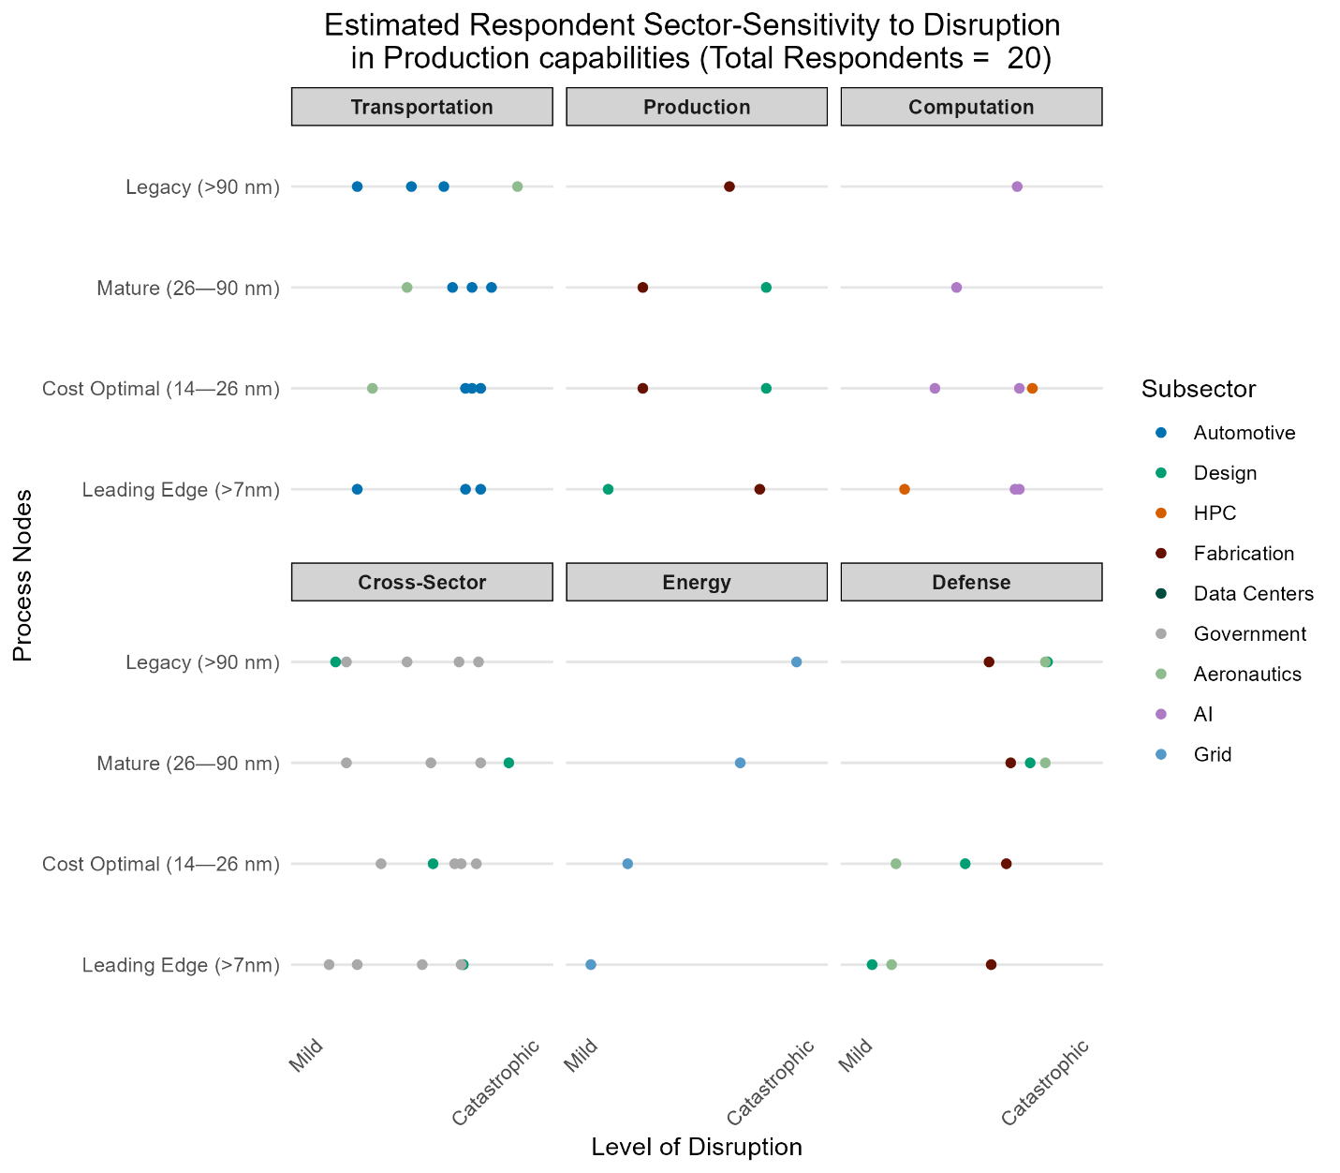

Fig. S1. Points indicate individual expert responses rating the impact of losing access to specific semiconductor manufacturing capabilities from mild to catastrophic. Data is faceted by major sector (Transportation, Production, Computation, Super Expert, Energy, Defense) with subsector indicated by color. Note the similarity in perceived level of disruption for electric grid and civilization aviation application, as well as the differential emphasis designers and fabrication process experts placed on the leading-edge.

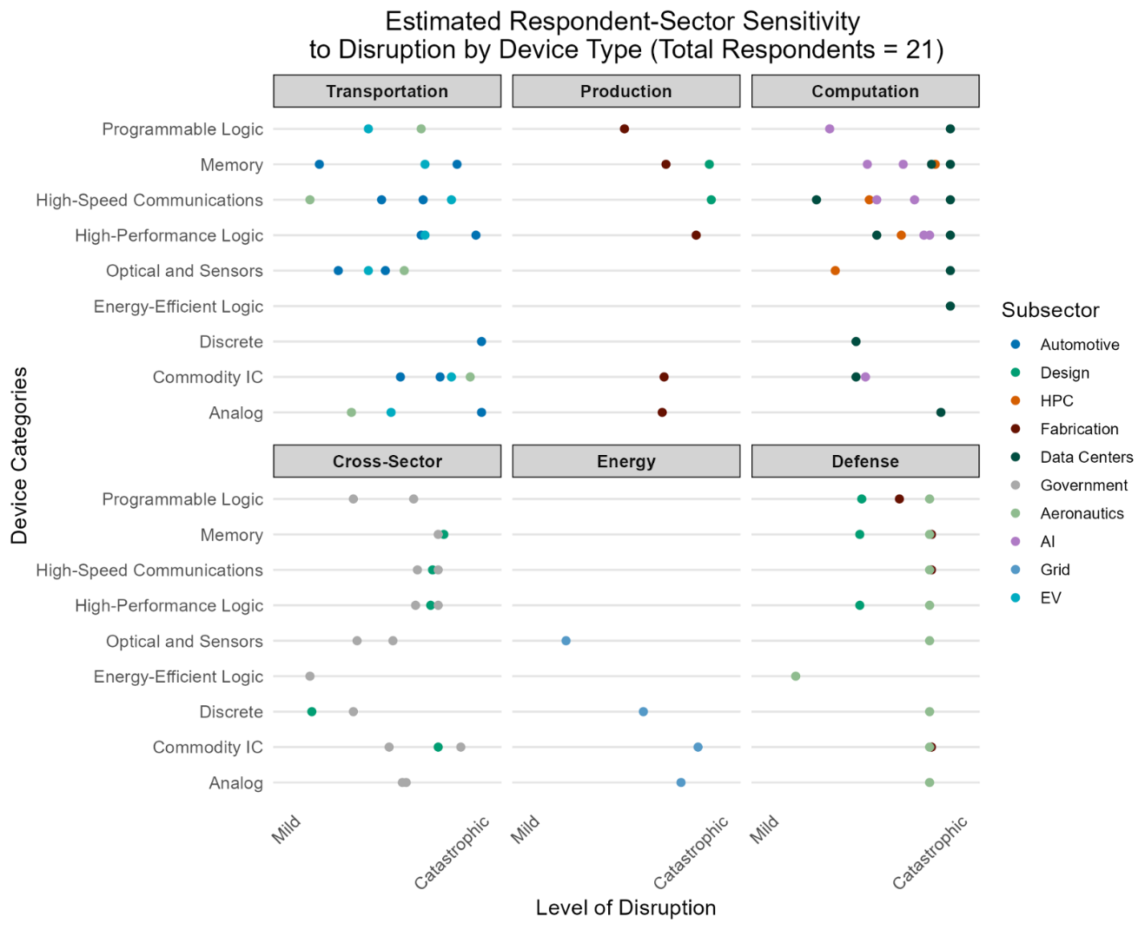

Fig. S2. Expert assessments of semiconductor device criticality by sector and subsector. Each expert was asked to select the devices for which a loss of access would significantly affect their application. For each device they selected, they estimated the impact from losing access on a continuous scale from "Mildly Disruptive: loss of access would only cause minor problems”, to "Catastrophic: loss of access would result in complete shutdown”. Responses differed by sector: grid infrastructure is primarily dependent on analog and commodity integrated circuits; defense applications show critical reliance on commodity ICs, high-speed communications, and memory; computation sectors are broadly exposed but most vulnerable to loss of high-performance logic; while cross-sector experts identified broader vulnerabilities across commodity ICs, high-speed communications, memory, and high-performance logic.

Table S1. Device type groupings, with example devices detailed definitions
Device Category | Definition | Example Devices
Analog Devices | Components that process continuous signals rather than discrete digital values | Power electronics (voltage regulators, DC-DC converters), analog and mixed signal processors, basic RF circuits and components
Commodity Integrated Circuits (ICs) | Standard, general-purpose integrated circuits used across multiple applications | Microcontroller units (MCUs), linear regulators, clock-setters, memory controllers
Discrete Devices | Individual semiconductor components performing basic electronic functions | Rectifiers, diodes, LEDs, transistors
Energy-Efficient Logic | Integrated circuits optimized for low power consumption over maximum performance | Broadcom ARM chips, mobile processors, IOT processors
High-Performance Logic | Complex processing units optimized for maximum computational capability | Central Processing Units (CPUs, Graphics Processing Units (GPUs), Tensor Processing Units (TPUs), Other accelerators
High-Speed Communication Components | Devices specifically designed for data transmission and reception | Laser diodes, Optical transceivers, High-bandwidth networking components
Memory | Data storage devices of various types | DRAM, Flash, SRAM, Other
Programmable Logic | Reconfigurable logic devices | Field Programmable Gate Arrays (FPGA)
Optical and Precision/Integrated Sensors | Devices that convert physical phenomena into electrical signals | LED displays and display drivers, Image sensors (CMOS and CCD, Accelerometers

Table S2. Volumetric estimates of total devices, based on total end-use demand, case-device costs, and modeled compositions. Benchmarking against industry estimates are included when available.

Sector and 2023 Demand  (billion USD) | High Cost Device | Medium Cost Device | Low Cost Device | Estimated Devices (billion) | Industry Estimated Devices
Communication  (172.3) | 5G Transceiver | 5g FPGA | 5G Grade Clock Generator | 25 | –
Communication  (172.3) | $1,200 | $108 | $4.32 | 25 | –
Computation  (150.7) | Nvidia H100 | Desktop CPU | PCIE Clock Generator | 28 | –
Computation  (150.7) | $33,000 | $150 | $3.28 | 28 | –
Industrial Automation  (83.1) | High Performance MCU | Analog to Digital Converter | Commodity MCU | 314 | –
Industrial Automation  (83.1) | $2,500 | $11 | $0.16 | 314 | –
Consumer Electronics  (80.5) | Game Console Processor | Wifi Chip | Op Amp | 324 | –
Consumer Electronics  (80.5) | $200 | $15 | $0.15 | 324 | –
Automotive  (78.3) | Automotive SoC | Position Sensor | Commodity MCU | 300 | 115
Automotive  (78.3) | $130 | $5 | $0.16 | 300 | 115
Grid  (66) | Half-Bridge Inverter | SiC Mosfet | Conventional Mosfet | 78 | –
Grid  (66) | $600 | $9 | $0.53 | 78 | –
Government  (9.1) | Rad Hardened Translator | Rad Hardened Voter | Rad Hardened Transceiver | .172 | –
Government  (9.1) | $200 | $100 | $40 | .172 | –
Total  (640) |  |  |  | 1,070 | 1210

Table S3. FEMA Estimates of GDP Cost per Capita Outage Day

Semiconductor End-Use | Domestic Service Outage Cost  (GDP per outage day per capita) | Data Source
Computing & Communications | $130 | (13)
Electric Grid | $182 | (13)

Table S4. Aggregated sectoral demand alongside estimated deployment lifecycles.
Semiconductor End-use | Global End-Use Demand in 2023 (Billion USD) (SIA) | Product Lifespan  (estimated from expert elicitation and grey literature)
Computing | $175.0 | ~5-7 years
Mobile | $170.6 | ~1-3 years
Automotive | $69.1 | ~10-15 years
Consumer Electronics | $68.4 | ~3-8 years
Industrial Automation | $66.9 | ~15-25 years
Government (military) | $5.8 | ~10-50 years

Table S5. Gross value of key import categories compared to the real value-added of reliant domestic industries, 2022.

Gross Value of Imported Goods  (Billion USD, 2022) |  | Enabled Industry  (BEA Real-value-add by Industry) | Real GDP Contribution  (Billion USD, 2022)
Semiconductors and IC  (HS6: 852520, 847330, 847193, 847191, 854211, 847199, 845140) | $327 | Computer and Electronics Manufacturing  (NAICS 334) | $1,212
Cars and Car Parts (HS2: 87) | $279 | Automotive Manufacturing  (NAICS 3361) | $803.8
Other Transport (HS2: 86, 88, 89) | $72 | Other Transport Manufacturing  (NAICS 3364) | $670.6
Petroleum Products  (HS5: 2709, 2710, 2711, 2716) | $310 | Chemical Manufacturing  (NAICS 32) | $1,652
Pharmaceuticals (HS2: 30) | $168 | Chemical Manufacturing  (NAICS 32) | $1,652

Table S6. Detailed Respondent Characteristics. The 21 full elicitation participants are listed first, followed by the 9 supplemental interviews
Resp. ID |  | Sector | Subsector | Details
1 |  | Transportation | Automotive | Automotive electronics system engineer
2 |  | Production | Design | Electronics designer & chip architect (advanced sensing, AI accelerators, IoT)
3 |  | Transportation | Automotive | Microelectronics and embedded systems supply chain manager
4 |  | Computation | HPC | HPC facility and systems engineer
5 |  | Transportation | Automotive | Automotive electronics firm purchasing manager
6 |  | Production | Fabrication | Fabrication process research and development expert
7 |  | Cross Sector | Design | Technology Policy Expert; System Architect (MEMS, AI Accelerators)
8 |  | Computation | Data Centers | Computer Systems Architect; Hardware-Software interface expert; Systems engineer
9 |  | Computation | Data Centers | Data Center Facility Implementer
10 | Cross Sector |  | Government | Defense and Intelligence Emerging Technology Analyst
11 | Transportation |  | Aeronautics | Civilian aviation microelectronics supply chain manager
12 | Computation |  | AI | AI reliability engineer
13 | Cross Sector |  | Government | Microelectronics program manager; Secure microelectronics design researcher
14 | Energy |  | Grid | Power electronics researcher, renewable energy systems design expert
15 | Defense |  | Fabrication | Defense microelectronics fabrication process expert
16 | Computation |  | AI | AI systems technology manager; advanced networking devices program manager
17 | Defense |  | Design | Senior defense microelectronics designer
18 | Cross Sector |  | Government | Government critical and emerging technologies expert
19 | Cross Sector |  | Government | Semiconductor industry expert; technology policy advisor
20 | Defense |  | Aeronautics | Defense industrial base and aerospace technology specialist
21 | Transportation |  | EV | Semiconductor purchasing manager for electric vehicle firm
Supp. 1 | Transportation |  | Automotive | Automotive policy expert
Supp. 2 | Transportation |  | Automotive | Automotive electronics designer
Supp. 3 | Production |  | Fabrication | Semiconductor industry expert
Supp. 4 | Cross Sector |  | Government | Defense semiconductor program manager
Supp. 5 | Transportation |  | Automotive | Economist specializing in automotive supply chain
Supp. 6 | Energy |  | Government | Infrastructure Cybersecurity Expert
Supp. 7 | Energy |  | Government | Cybersecure Infrastructure Supply Chain Analyst
Supp. 8 | Energy |  | Design | Cybersecure Infrastructure Electronics Designer
Supp.  9 | Production |  | Fabrication | Wide-bandgap microelectronics designer and production specialist

SI References

1. M. Singh, J. F. Sargent, K. M. Sutter, “Semiconductors and the semiconductor industry,” Library of Congress public edition (Congressional Research Service, 2023).
2. D. W. Jorgenson, Information Technology and the U.S. Economy. The American Economic Review 91, 1–32 (2001).
3. D. W. Jorgenson, M. S. Ho, J. D. Samuels, K. J. Stiroh, Industry Origins of the American Productivity Resurgence. Economic Systems Research 19, 229–252 (2007).
4. D. W. Jorgenson, M. S. Ho, J. D. Samuels, Information technology and U.S. productivity growth: evidence from a prototype industry production account. J Prod Anal 36, 159–175 (2011).
5. Oxford Economics, “Enabling the Hyperconnected Age: The role of semiconductors” (Oxford Economics, 2014).
6. J. Shalf, The future of computing beyond Moore’s Law. Philosophical Transactions of the Royal Society A: Mathematical, Physical and Engineering Sciences 378, 20190061 (2020).
7. F. Leibovici, J. Dunn, Supply Chain Bottlenecks and Inflation: The Role of Semiconductors. es 2021 (2021).
8. P. M. Krolikowski, K. Naggert, Semiconductor Shortages and Vehicle Production and Prices. Economic Commentary (2021). https://doi.org/10.26509/frbc-ec-202117.
9. U.S. Department of Commerce, Analysis for CHIPS Act and BIA Briefing. U.S. Department of Commerce (2022). Available at: https://www.commerce.gov/news/press-releases/2022/04/analysis-chips-act-and-bia-briefing [Accessed 19 August 2024].
10. T. Yost, Semiconductor shortages to cost the auto industry billions. (2021). Available at: https://www.alixpartners.com/newsroom/press-release-shortages-related-to-semiconductors-to-cost-the-auto-industry-210-billion-in-revenues-this-year-says-new-alixpartners-forecast/ [Accessed 16 September 2024].
11. B. Frieske, S. Stieler, The “Semiconductor Crisis” as a Result of the COVID-19 Pandemic and Impacts on the Automotive Industry and Its Supply Chains. World Electric Vehicle Journal 13, 189 (2022).
12. H. Matsuo, Implications of the Tohoku earthquake for Toyota׳s coordination mechanism: Supply chain disruption of automotive semiconductors. International Journal of Production Economics 161, 217–227 (2015).
13. T. Seibold, R. Carroll, J. Springer, C. Tanya, “Benefit-Cost Analysis Sustainment and Enhancements” (Federal Emergency Management Agency, 2022).
14. O. Villafranca, Chip shortage cost U.S. economy billions in 2021. CBS News (2022).
15. R. C. Basole, M. A. Bellamy, Supply Network Structure, Visibility, and Risk Diffusion: A Computational Approach. Decision Sciences 45, 753–789 (2014).
16. J. H. Dyer, Specialized Supplier Networks as a Source of Competitive Advantage: Evidence from the Auto Industry. Strategic Management Journal 17, 271–291 (1996).
17. E. R. Badillo, F. L. Galera, R. Moreno Serrano, Cooperation in R&D, firm size and type of partnership. European Journal of Management and Business Economics 26, 123–143 (2017).
18. D. Salvetat, M. Géraudel, S. d’Armagnac, Inter-organizational knowledge management in a coopetitive context in the aeronautic and space industry. Knowledge Management Research & Practice 11, 265–277 (2013).
19. M. Lowe, R. Golini, G. Gereffi, G. Ahmed, S. Tokuoka, U.S. Adoption of High-Efficiency Motors and Drives: Lessons Learned (Center on Globalization, Governance, and Competitiveness, 2010).
20. J. Su, TSMC Quarterly Management Report. (2024).
21. L. Ho, S. Vp, E. Sun, M. Kramer, TSMC Breaks Ground on Fab 18 in Southern Taiwan Science Park. (2018).
22. P. Pickering, Semiconductors In Medical Electronics. (2020).
23. S. Roze, et al., Long-Term Cost-Effectiveness the Dexcom G6 Real-Time Continuous Glucose Monitoring System Compared with Self-Monitoring of Blood Glucose in People with Type 1 Diabetes in France. Diabetes Ther 12, 235–246 (2021).

Based on 2023 automotive production and 1500 estimated semiconductors per vehicle.
ASML 2023 annual report estimate of total annual semiconductor production

