Supplementary material
Supplementary material 1. Failure mode and effects analysis scoring criteria to establish critical method parameters and critical analytical attributes.
S and O score | Criteria
1 | Negligible risk
2-3 | Minor effect that is easily corrected
4-5 | Moderately severe effect that needs attention
6-7 | Severe effect that needs special attention
D Score | Criteria
1 | Negligible and easily detectable risk
2-3 | Detectable, with a minor effect that is easily corrected
4-5 | Not easily detectable, with a moderate risk that needs attention
6-7 | Difficult to detect, with a severe risk that requires special attention

Supplementary Material 2. Failure Mode and Effects Analysis (FMEA)

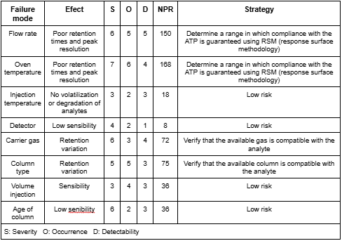

Supplementary Material 3. Experimental design of the critical parameters of the method (oven temperature and flow rate) for retention times.
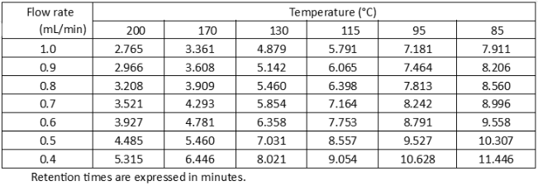
Experimental design data for the resolution of the critical method parameters (oven temperature and flow rate).
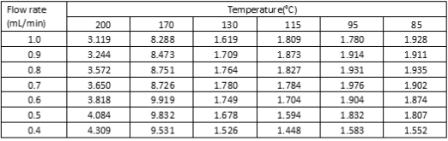
Experimental design data for critical method parameters (oven temperature and flow rate) for the capacity factor
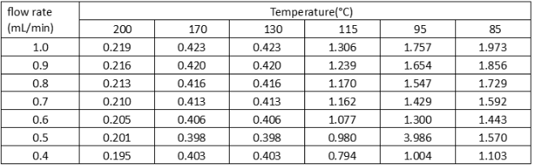

Experimental design data for critical method parameters (oven temperature and flow rate) for theoretical plates.
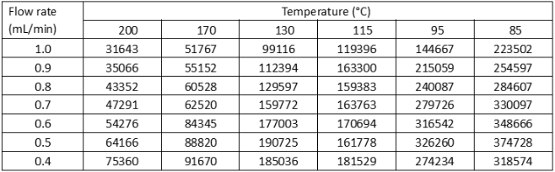

Experimental design data for critical method parameters (oven temperature and flow rate) for the choking factor.
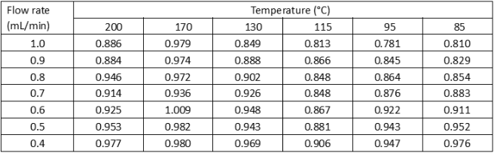

Supplementary Material 4. Final chromatographic conditions
Final chromatographic conditions of oven temperature and flow rate obtained by gradient elution.
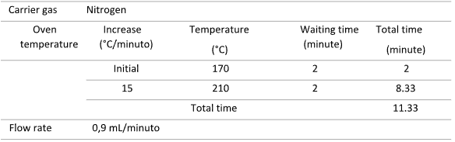
Supplementary material 5. Suitability of the menthol and thymol system.
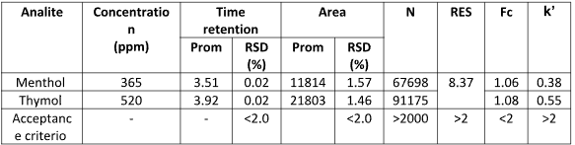

Supplementary Material 6 Linearity results.
