TABLES

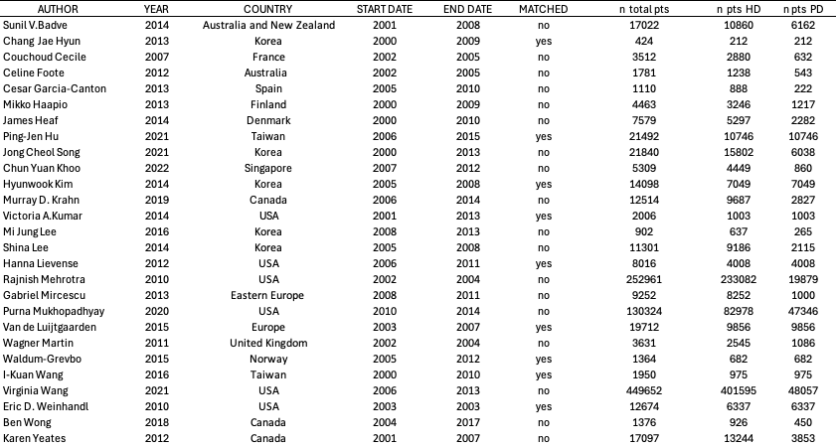

Table 1 Characteristics of the included studies
HD = hemodialysis; n = number; PD = peritoneal dialysis; pts = patients.

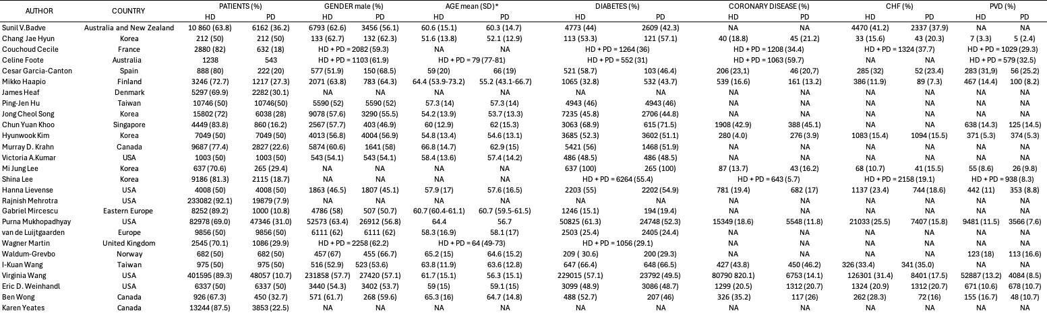

Table 2 Population characteristics of the included studies
CHF = chronic heart failure; HD = hemodialysis; n = number; NA = not available; PD = peritoneal dialysis; PVD = peripheral vascular disease. *Otherwise, median (interquartile range).

Author(s): Nardelli L, Passerini M
Question: Peritoneal dialysis (PD) compared to in-centre hemodialysis (HD) for dialysis patients
Setting: Healthcare facilities; different geographical locations
Bibliography: see main manuscript
Certainty assessment |  |  |  |  |  |  | № of patients |  | Effect |  | Certainty | Importance
№ of studies | Study design | Risk of bias | Inconsistency | Indirectness | Imprecision | Other considerations | Peritoneal dialysis (PD) | in-centre hemodialysis (HD) | Relative  (95% CI) | Absolute  (95% CI) | Certainty | Importance
17 | non-randomised studies | not serious | not seriousª | not serious | not serious | none | PD=77 908 patients  HD=336 774 patients  PD/HD HR 1.01 (0.93-1.10) |  |  |  | ⨁⨁◯◯  Lowª | CRITICAL
CI: confidence interval; HR: hazard ratio

Explanations
a. Inconsistency explained by the inclusion of studies and patients with different baseline features, such as age, geographical location, and HD access type

Table 3 GRADE evidence profile of the primary outcome (overall mortality PD vs HD patients).

