Oxygen-Tolerant Electrochemical CO₂ Capture with Doubled CO₂ Modulation per Electron
Fang-Yu Kuoª, Akachukwu D. Obi^{b*}, Glen P. Junor^{b*}, Betar M. Gallant^{c*}
ª Department of Chemical Engineering, Massachusetts Institute of Technology, Cambridge, Massachusetts 02139, United States
^{b} MIT Climate & Sustainability Consortium, Massachusetts Institute of Technology, Cambridge, MA 02139, United States
^{c} Department of Mechanical Engineering, Massachusetts Institute of Technology, Cambridge, Massachusetts 02139, United States
* Corresponding author: bgallant@mit.edu, gjunor@mit.edu, aobi@mit.edu

Table of Contents
1. Chemicals and Materials 3
1.1. Solvent and material purification 4
2. N-Heterocyclic Imine (NHI) Synthesis Procedures 5
2.1. Synthesis of 2-chloroazolium salts 5
2.2. Synthesis of N-heterocyclic iminium salts 7
2.3. Synthesis of NHI 15
2.4. Synthesis of redox-reversible NHI (6) 23
3. Supplementary Methods 25
3.1. Experimental details for reaction enthalpy measurements 25
3.2. Sample preparation for NHI-CO₂ loading determination 25
3.3. Calculation of Faradaic efficiency (FE) 25
4. Supplementary Figures and Tables 26
5. Supplementary References 47

Chemicals and Materials
Name | Specifications | Vendor
1,3-Dimethyl-2-imidazolidinone (DMI) | absolute, over molecular sieve (H₂O ≤0.04%), ≥99.5% (GC) | Sigma-Aldrich
Oxalyl chloride | reagent grade, 98% | Sigma-Aldrich
Methylammonium chloride | for synthesis | Sigma-Aldrich
Isopropyl amine | ≥99.5% | Sigma-Aldrich
Tert-butylamine | ≥99.5% | Sigma-Aldrich
triethylamine | ≥99.5% | Sigma-Aldrich
2-Hydroxybenzimidazole | 97% | Sigma-Aldrich
Methyl iodide | contains copper as stabilizer, ReagentPlus®, 99% | Sigma-Aldrich
Sodium hydroxide | reagent grade, ≥98%, pellets (anhydrous) | Sigma-Aldrich
Tetrabutylammonium bromide | ReagentPlus®, ≥99.0% | Sigma-Aldrich
Acetonitrile (MeCN) | 99%, suitable for UV/Vis spectroscopy, ReagentPlus® | Sigma-Aldrich
Toluene | suitable for HPLC, 99.9% | Sigma-Aldrich
Sodium hydride (NaH) | dry, 90% | Sigma-Aldrich
Potassium tert-butoxide (KO^{t}Bu) | reagent grade, ≥98% | Sigma-Aldrich
Potassium bis(trimethylsilyl)amide (KHMDS) | 95% | Sigma-Aldrich
Hexachloroethane | 99% | Sigma-Aldrich
N,N’-Dimethylthiourea | 99% | Sigma-Aldrich
1,3-Diisopropyl-2-thiourea | 99% | Sigma-Aldrich
Acetoin | natural, ≥95%, FG | Sigma-Aldrich
1-Hexanol | anhydrous, ≥99% | Sigma-Aldrich
Potassium (K) | chunks (in mineral oil), 98% trace metals basis | Sigma-Aldrich
Urea | ACS reagent, 99.0-100.5% | Sigma-Aldrich
Benzoin | 98% | Sigma-Aldrich
Ethylene glycol | anhydrous, 99.8% | Sigma-Aldrich
Phosphorus(V) oxychloride | ReagentPlus®, 99% | Sigma-Aldrich
Methanol | ≥99.8% (GC), HPLC grade, suitable for HPLC, LiChrosolv® | Sigma-Aldrich
Potassium hexafluorophosphate | 99.5% trace metals basis | Sigma-Aldrich
Molecular sieves, 3 Å | beads, 4-8 mesh | Sigma-Aldrich
Molecular sieves, 4 Å | beads, 4-8 mesh | Sigma-Aldrich
Ethyl acetate (EtOAc) | HPLC Plus, for HPLC, GC, and residue analysis, 99.9% | Sigma-Aldrich
Chloroform (CHCl₃) | HPLC Plus, for HPLC, GC, and residue analysis, ≥99.9%, contains amylenes as stabilizer | Sigma-Aldrich
Dimethyl sulfoxide-d₆ | anhydrous, 99.9 atom % D | Sigma-Aldrich
Acetonitrile-d₃ | ≥99.8 atom % D | Sigma-Aldrich
1,4-Phenylenediamine dihydrochloride | >99.0% | TCI Chemicals
1,3-Dimethyl-1H-imidazol-3-ium chloride | 97% | Ambeed
1,3-Diisopropyl-1H-imidazol-3-ium chloride | 97% | Ambeed
1,3-Di-tert-butyl-1H-imidazol-3-ium tetrafluoroborate | 97% | Ambeed
Diethyl ether (Et₂O) | ≥98% (by GC) stabilised | J.T.Baker®
Tetrahydrofuran (THF) | Certified | Fisher Scientific
Hexane | Certified | Fisher Scientific
Chloroform-D | D, 99.8% | Cambridge Isotope Laboratories
Methylene chloride-D₂ | D, 99.8% | Cambridge Isotope Laboratories
Carbon Dioxide | CD 4.5LS-K | Linde Gas
15% Carbon dioxide (balance nitrogen) | NI CD15C-K | Linde Gas
Nitrogen | NI 6.0RS-T | Linde Gas

Solvent and material purification
Toluene and hexanes were purified by distillation over sodium. Diethyl ether and tetrahydrofuran (THF) purified by distillation over Na/benzophenone. Acetonitrile (MeCN), acetonitrile-d₃, chloroform-d were dried and stored over 3Å molecular sieves (20 w/v%). Dimethyl sulfoxide-d₆ was dried and stored over 4Å molecular sieves (20 w/v%). Methylene chloride-D₂ was purified by distillation over calcium hydride (CaH₂). Isopropyl amine, tert-butyl amine, and triethylamine were dried and stored over 3Å molecular sieves (20 w/v%). Methylammonium chloride was recrystallized from ethanol (EtOH, 99%) and dried in vacuo prior use.

N-Heterocyclic Imine (NHI) Synthesis Procedures

Synthesis of 2-chloroazolium salts
The 2-chloroazolium salts summarized in Supplementary Fig. 1 were synthesized according to literature reported procedures, including 2-chloro-1,3-dimethyl-1H-benzimidazol-3-ium chloride (1-Cl), 2-chloro-1,3-dimethylimidazolinium chloride (2-Cl), 2-chloro-1,3-dimethyl-4,5-diphenyl-1H-imidazol-3-ium hexafluorophosphate (3-Cl), 1,3-di-tert-butyl-2-chloro-1H-imidazol-3-ium chloride (4-tBu-Cl), 2-chloro-1,3,4,5-tetramethyl-1H-imidazol-3-ium chloride (5-Cl), and 2-chloro-1,3-diisopropyl-4,5-dimethyl-1H-imidazol-3-ium chloride (5-iPr-Cl).¹⁻⁴
Supplementary Fig. 1. Structures of 2-chloroazolium salts that are synthesized following literature procedures.

2-chloro-1,3-dimethyl-1H-imidazol-3-ium chloride (4-Cl):
Inside the glovebox, a round bottom flask was charged with 1,3-dimethyl-1H-imidazol-3-ium chloride (3.98 g, 30 mmol, 1.0 equiv.) and KHMDS (5.98 g, 30 mmol, 1.0 equiv.), and the solid is suspended in 100 mL Et₂O. The mixture is stirred at room temperature for 30 mins and the color turned yellow. Subsequently, the mixture was filtered through a celite pad to obtain a clear yellow solution, which contained the carbene. The filtrate is then transferred to the glovebox freezer (−37 °C). Hexachloroethane (7.08 g, 30 mmol, 1.0 equiv.) was dissolved in Et₂O in a round bottom flask and cooled down in the freezer as well. After both solutions are cooled in the freezer for 2h, the carbene solution is added dropwise to hexachloroethane solution over 30 minutes. Upon adding the carbene solution, white precipitates formed immediately. After carbene addition, the mixture was stirred for an additional 20 mins, then filtered through a fritted Buchner funnel (medium frit) and washed with Et₂O to afford the target compound as a white solid. Yield 70% (3.49 g, 20.9 mmol). ¹H NMR (400.06 MHz, CD₂Cl₂): δ = 8.37 (s, 2 H, CH), 4.03 (s, 6 H, CH₃). ¹³C NMR (100.6 MHz, CD₂Cl₂): δ = 125.3 (CH), 36.8 (CH₃).
Supplementary Fig. 2. ¹H NMR spectrum (CD₂Cl₂, 298 K, 400 MHz) of 4-Cl.

Supplementary Fig. 3. ¹³C NMR spectrum (CD₂Cl₂, 298 K, 100 MHz) of 4-Cl.

2-chloro-1,3-diisopropyl-1H-imidazol-3-ium chloride (4-iPr-Cl):
Inside the glovebox, a round bottom flask was charged with 1,3-diisopropyl-1H-imidazol-3-ium chloride (8.00 g, 42.4 mmol, 1.0 equiv.), NaH (2.04 g, 84.8 mmol, 2.0 equiv.), and catalytic KOtBu (0.08 g, 0.7 mmol, 0.02 equiv.), and THF (100 mL) was then added to start the reaction. The mixture is stirred at room temperature for 4 h and gradually turned brown. Subsequently, the mixture was filtered through the celite to obtain a clear light brown solution, which contained the carbene. The filtrate is then transferred to the glovebox freezer (−37 °C). Hexachloroethane (11.0 g, 46.6 mmol, 1.1 equiv.) was dissolved in THF in another round bottom flask and cooled down in the freezer as well. After both solutions are cooled in the freezer for 2h, the carbene solution is added dropwise to hexachloroethane solution over 30 minutes. Upon adding the carbene solution, white precipitate formed immediately. After carbene addition, the mixture was stirred for an additional 20 mins, then filtered through a fritted Buchner funnel (medium frit) and washed with Et₂O to afford the target compound as a white solid. Yield 89% (8.50 g, 37.9 mmol).
¹H NMR (400.06 MHz, CD₂Cl₂): δ = 8.44 (s, 2 H, CH), 4.77 (m, 2 H, CH(CH₃)₂), 1.62 (d, 12 H, CH(CH₃)₂). ¹³C NMR (100.6 MHz, CD₂Cl₂): δ = 122.2 (CH), 53.8 (CH(CH₃)₂), 22.4 (CH(CH₃)₂). HRMS AccuTOF-DART for C₉H₁₆N₂Cl [M⁺]: calc m/z = 187.1002; found m/z = 187.0999.
Supplementary Fig. 4. ¹H NMR spectrum (CD₂Cl₂, 298 K, 400 MHz) of 4-iPr-Cl.

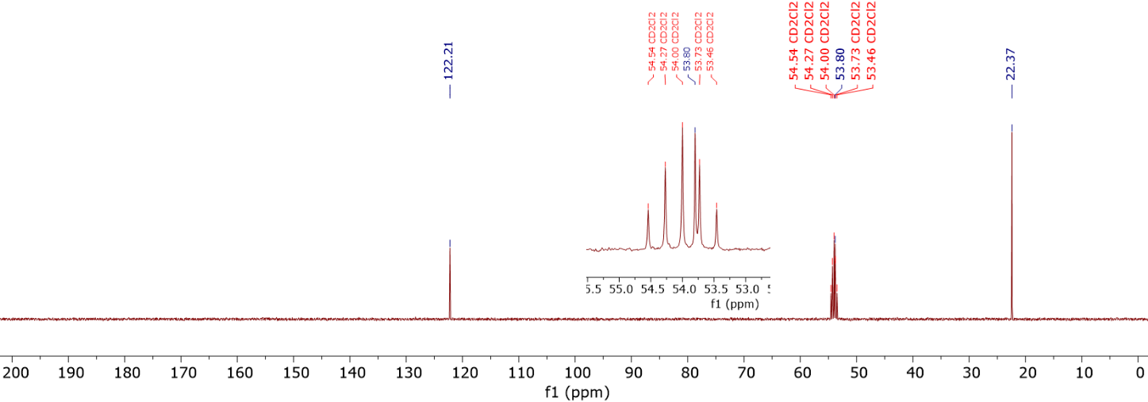
Supplementary Fig. 5. ¹³C NMR spectrum (CD₂Cl₂, 298 K, 100 MHz) of 4-iPr-Cl.

Synthesis of N-heterocyclic iminium salts
The synthesis of the N-heterocyclic iminium salts generally follows the below general procedure (GP1) unless otherwise noted: A Schlenk flask was charged with 2-chloroazolium salt (1.00 equiv.) and KF (6.00 equiv.) inside the glovebox. Then, the flask was taken out of the glovebox and cycled onto the Schlenk line. MeCN (3 mL per mmol of the 2-chloroazolium salt) was added to form a suspension. Amine RNH₂ or its hydrochloride salt RNH₃Cl (3.00 equiv.) was then dissolved in 10 mL MeCN and added to the mixture. The reaction was stirred at room temperature for 24 h (for reactions using RNH₂) or 120 h (for reactions using RNH₃Cl). The resulting mixture was filtered with a fritted Buchner funnel (medium frit) and the solid residue was washed with CHCl₃. The combined solution is extracted with aqueous solution containing sodium tetrafluoroborate (NaBF₄). The organic phase was collected and the aqueous phase was washed two more times with CHCl₃. The organic phases were then combined, dried over magnesium sulfate (MgSO₄), filtered, and dried under reduced pressure to afford a colorless or yellow oil, which was triturated using Et₂O to yield solid precipitates. The product was then recrystallized from ethyl acetate (EtOAc) and dried under vacuum at 80°C for 24 h.

Compound 1HBF₄: Synthesis according to GP1 starting from 2-chloro-1,3-dimethylbenzimidazolium chloride (1.74 g, 8.06 mmol). Yield 84% (1.95 g, 6.70 mmol) as a white solid.
¹H NMR (400.03 MHz, DMSO-d₆): 7.81 (d, 1 H, NH), 7.39-7.67 (m, 4 H, ArH), 4.18 (m, 1 H, CH₃CHCH₃) 3.75 (s, 1 H, CH₃), 1.35 (d, 6 H, CH₃CHCH₃).
¹³C NMR (100.6 MHz, DMSO-d₆): 150.0 (NCN₂), 130.7 (ArC), 124.0 (ArC), 110.8 (ArC), 48.0 (CH₃CHCH₃), 31.3 (CH₃), 23.8 (CH₃CHCH₃).
HRMS AccuTOF-DART for C₁₂H₁₈N₃ [M⁺]: calc m/z = 204.1501; found m/z = 204.1500.

Supplementary Fig. 6. ¹H NMR spectrum (DMSO-d₆, 298 K, 400 MHz) of 1HBF₄.
Supplementary Fig. 7. ¹³C NMR spectrum (DMSO-d₆, 298 K, 100 MHz) of 1HBF₄.
Compound 3HPF₆: Synthesis according to GP1, starting from 2-chloro-1,3-dimethyl-4,5-diphenyl-1H-imidazol-3-ium hexafluorophosphate (3.43 g, 8.00 mmol), except without adding NaBF₄ during extraction and without recrystallization. Yield 96% (3.45 g, 7.64 mmol) as a white solid.
¹H NMR (400.03 MHz, CD₃CN): 7.40-7.45 (m, 6 H, ArH), 7.27-7.30 (m, 4 H, ArH), 5.21 (d, 1 H, NH), 3.80 (m, 1 H, CH₃CHCH₃), 3.41 (s, 6 H, CH₃), 1.36 (d, 6 H, CH₃CHCH₃).
¹³C NMR (100.6 MHz, CD₃CN): 147.5 (NCN₂), 131.0 (ArC), 131.0 (ArC), 130.3 (ArC), 129.2 (ArC), 127.8 (ArC), 51.3 (CH₃CHCH₃), 34.0 (CH₃), 24.5 (CH₃CHCH₃).
HRMS AccuTOF-DART for C₂₀H₂₄N₃ [M⁺]: calc m/z = 306.1970; found m/z = 306.1984

Supplementary Fig. 8. ¹H NMR spectrum (CDCl₃, 298 K, 400 MHz) of 3HPF₆.
Supplementary Fig. 9. ¹³C NMR spectrum (CDCl₃, 298 K, 100 MHz) of 3HPF₆.

Compound 4H-Cl: A Schlenk flask was charged with 2-chloro-1,3-dimethyl-1H-imidazol-3-ium chloride (5.00 g, 29.9 mmol, 1.00 equiv.) and KF (6.00 equiv.) inside the glovebox. Then, the flask was taken out of the glovebox and cycled onto the Schlenk line. MeCN (10 mL per mmol of the 2-chloroazolium salt) was added to form the suspension. Isopropyl amine (3.00 equiv.) was then dissolved in 10 mL MeCN and added to the mixture. The reaction was stirred at room temperature for 72 h. After the reaction, the mixture was filtered and the solvent was removed under reduced pressure to obtain a crude sticky yellow-brown solid. This product was extracted using DCM and filtered to remove un-dissolved impurities. The solvent was then evaporated, and the remaining solid is suspended in EtOAc. ~3 mL of isopropanol (iPrOH) was then added to dissolved the unreacted chloroazolium salt. A final filtration affords the solid product as a yellow solid, and it is dried under vacuum at 80°C overnight. Yield: 67% (3.80 g, 20.03 mmol)
¹H NMR (400.03 MHz, CDCl₃): δ = 8.48 (d, 1 H, NH), 6.86 (s, 2 H, CH), 3.77 (s, 6 H, CH₃), 3.63 (m, 1 H, CH₃CHCH₃), 1.38 (d, 6 H, CH₃CHCH₃)
¹³C NMR (100.6 MHz, CDCl₃): 147.1 (NCN₂), 118.6 (CH), 49.6 (CH₃CHCH₃), 35.5 (CH₃), 24.1 (CH₃CHCH₃).
HRMS AccuTOF-DART for C₈H₁₆N₃ [M⁺]: calc m/z = 154.1344; found m/z = 154.1366.

Supplementary Fig. 10. ¹H NMR spectrum (CDCl₃, 298 K, 400 MHz) of 4HCl.
Supplementary Fig. 11. ¹³C NMR spectrum (CDCl₃, 298 K, 100 MHz) of 4HCl.

Compound 4-iPr-MeH-BF₄: Synthesis according to GP1 starting from 2-chloro-1,3-diisopropyl-1H-imidazol-3-ium chloride (1.80 g, 8.07 mmol). Yield 76% (1.65 g, 6.13 mmol) as a beige solid.
1H NMR (400.03 MHz, CDCl₃): δ = 6.95 (s, 2 H, CH), 5.61 (q, 1 H, NH), 4.62 (m, 2 H, CH₃CHCH₃), 3.08 (d, 3 H, CH₃), 1.44 (d, 12 H, CH₃CHCH₃)
¹³C NMR (100.6 MHz, CDCl₃): 145.0 (NCN₂), 114.2 (CH), 49.3 (CH₃CHCH₃), 33.9 (CH₃), 22.6 (CH₃CHCH₃).
HRMS AccuTOF-DART for C₁₀H₂₀N₃ [M⁺]: calc m/z = 182.1657; found m/z = 182.1658.

Supplementary Fig. 12. ¹H NMR spectrum (CDCl₃, 298 K, 400 MHz) of 4-iPr-MeH-BF₄.
Supplementary Fig. 13. ¹³C NMR spectrum (CDCl₃, 298 K, 100 MHz) of 4-iPr-MeH-BF₄.

Compound 4-iPr-iPrH-BF₄: Synthesis according to GP1 starting from 2-chloro-1,3-diisopropyl-1H-imidazol-3-ium chloride (5.50 g, 24.65 mmol). Yield 87% (6.35 g, 21.37 mmol) as a colorless solid.
1H NMR (400.03 MHz, CDCl₃): δ = 7.10 (s, 2 H, CH), 5.16 (d, 1 H, NH), 4.64 (m, 2 H, CH₃CHCH₃), 3.46 (m, 1 H, CH₃CHCH₃), 1.45 (d, 12 H, CH₃CHCH₃), 1.27 (d, 6 H, CH₃CHCH₃).
¹³C NMR (100.6 MHz, CDCl₃): 143.6 (NCN₂), 115.1 (CH), 51.3 (CH₃CHCH₃), 49.3 (CH₃CHCH₃), 23.5 (CH₃CHCH₃), 22.9 (CH₃CHCH₃).
HRMS AccuTOF-DART for C₁₂H₂₄N₃ [M⁺]: calc m/z = 210.1970; found m/z = 210.1970.

Supplementary Fig. 14. ¹H NMR spectrum (CDCl₃, 298 K, 400 MHz) of 4-iPr-iPrH-BF₄.
Supplementary Fig. 15. ¹³C NMR spectrum (CDCl₃, 298 K, 100 MHz) of 4-iPr-iPrH-BF₄.

Compound 4-iPr-tBuH-BF₄: Synthesis according to GP1 starting from 2-chloro-1,3-diisopropyl-1H-imidazol-3-ium chloride (2.00 g, 8.96 mmol). Yield 86% (2.40 g, 7.72 mmol) as a colorless solid.
1H NMR (400.03 MHz, CDCl₃): δ = 7.21 (s, 2 H, CH), 4.79 (m, 2 H, CH₃CHCH₃), 4.68 (s, 1 H, NH), 1.45 (d, 12 H, CH₃CHCH₃), 1.27 (s, 9 H, C(CH₃)₃).
¹³C NMR (100.6 MHz, CDCl₃): 142.0 (NCN₂), 116.5 (CH), 56.3 (C(CH₃)₃), 50.0 (CH₃CHCH₃), 30.9 (C(CH₃)₃), 23.0 (CH₃CHCH₃).
HRMS AccuTOF-DART for C₁₃H₂₆N₃ [M⁺]: calc m/z = 224.2127; found m/z = 224.2123.

Supplementary Fig. 16. ¹H NMR spectrum (CDCl₃, 298 K, 400 MHz) of 4-iPr-tBuHBF₄.
Supplementary Fig. 17. ¹³C NMR spectrum (CDCl₃, 298 K, 100 MHz) of 4-iPr-tBuHBF₄.

Compound 4-tBuH-BF₄: Synthesis according to GP1 starting from 2-chloro-1,3-ditertbutyl-1H-imidazol-3-ium chloride (3.00 g, 11.19 mmol). Yield 86% (3.35 g, 10.30 mmol) as a colorless solid.
1H NMR (400.03 MHz, CDCl₃): δ = 7.26 (s, 2 H, CH), 4.16 (s, 1 H, NH), 3.79 (m, 1 H, CH₃CHCH₃), 1.70 (s, 18 H, C(CH₃)₃), 1.17 (d, 6 H, CH₃CHCH₃).
¹³C NMR (100.6 MHz, CDCl₃): 143.5 (NCN₂), 117.2 (CH), 62.5 (C(CH₃)₃), 50.0 (CH₃CHCH₃), 30.3 (C(CH₃)₃), 22.4 (CH₃CHCH₃).
HRMS AccuTOF-DART for C₁₄H₂₈N₃ [M⁺]: calc m/z = 238.2283; found m/z = 238.2285.

Supplementary Fig. 18. ¹H NMR spectrum (CDCl₃, 298 K, 400 MHz) of 4-tBu-HBF₄.
Supplementary Fig. 19. ¹³C NMR spectrum (CDCl₃, 298 K, 100 MHz) of 4-tBuH-BF₄.

Compound 5HBF₄: Synthesis according to GP1 starting from 2-chloro-1,3,4,5-tetramethyl-1H-imidazol-3-ium chloride (1.00 g, 5.13 mmol). Yield 81% (1.12 g, 4.16 mmol) as a pale yellow solid.
1H NMR (400.03 MHz, CDCl₃): 5.19 (b, 1 H, N-H), 3.52 (s, 6 H, NCH₃), 3.50 (m, 1 H, CH₃CHCH₃), 2.14 (s, 6H, CH₃), 1.26 (d, 6H, CH₃CHCH₃).
¹³C NMR (100.6 MHz, CDCl₃): 145.0 (NCN₂), 122.2 (CH), 50.2 (CH₃CHCH₃), 31.4 (NCH₃), 23.7 (CH₃CHCH₃), 8.9 (CH₃).
HRMS AccuTOF-DART for C₁₀H₂₀N₃ [M⁺]: calc m/z = 182.1657; found m/z = 182.1667.

Supplementary Fig. 20. ¹H NMR spectrum (CDCl₃, 298 K, 400 MHz) of 5H-BF₄.
Supplementary Fig. 21. ¹³C NMR spectrum (CDCl₃, 298 K, 100 MHz) of 5H-BF₄.

Synthesis of NHI
The synthesis of the N-heterocyclic imine from N-heterocyclic iminium salts follows the general procedure (GP2) below: Inside the glovebox, a round bottom flask was charged with N-heterocyclic imine salt (1.00 equiv.). Then, THF was added as the reaction solvent. KOtBu (0.98 equiv.) was dissolved in THF and then added dropwise to the reaction mixture. The solution was stirred at room temperature for 2 h, and the solvent was evaporated. Hexane was added to the crude product to extract the N-heterocyclic imine. The mixture was then filtered through a celite pad on fritted Buchner funnel (medium frit). The filtrate was then evaporated to obtain the final N-heterocyclic imine product.

Compound 1: Synthesis according to GP2 starting from 1H-BF₄ (1.50 g, 5.15 mmol). Yield 89% (0.91 g, 4.57 mmol) as a yellow solid.
¹H NMR (400.03 MHz, DMSO-d₆): 6.81-6.86 (m, 4 H, ArH), 4.27 (m, 1 H, CH₃CHCH₃) 3.32 (s, 1 H, CH₃), 1.13 (d, 6 H, CH₃CHCH₃).
¹³C NMR (100.6 MHz, DMSO-d₆): 144.2 (NCN₂), 133.3 (ArC), 119.5 (ArC), 105.2 (ArC), 44.1 (CH₃CHCH₃), 31.3 (CH₃), 23.8 (CH₃CHCH₃).
HRMS AccuTOF-DART for C₁₂H₁₇N₃ [M+H]: calc m/z = 204.1501; found m/z = 204.1510.

Supplementary Fig. 22. ¹H NMR spectrum (DMSO-d₆, 298 K, 400 MHz) of 1.
Supplementary Fig. 23. ¹³C NMR spectrum (DMSO-d₆, 298 K, 100 MHz) of 1.

Compound 3: Synthesis according to GP2 starting from 3H-PF₆ (1.20 g, 2.66 mmol). Yield 82% (0.66 g, 2.17 mmol) as a yellow solid.
¹H NMR (400.03 MHz, DMSO-d₆): 7.23-7.31 (m, 6 H, ArH), 7.14-7.15 (m, 4 H, ArH), 4.08 (m, 1 H, CH₃CHCH₃), 3.02 (s, 6 H, CH₃), 1.13 (d, 6 H, CH₃CHCH₃).
¹³C NMR (100.6 MHz, DMSO-d₆): 148.0 (NCN₂), 129.7 (ArC), 129.4 (ArC), 128.5 (ArC), 127.3 (ArC), 123.2 (ArC), 45.2 (CH₃CHCH₃), 32.1 (CH₃), 27.2 (CH₃CHCH₃).
HRMS AccuTOF-DART for C₂₀H₂₃N₃ [M+H]: calc m/z = 306.1970; found m/z = 306.1971
Supplementary Fig. 24. ¹H NMR spectrum (DMSO-d₆, 298 K, 400 MHz) of 3.
Supplementary Fig. 25. ¹³C NMR spectrum (DMSO-d₆, 298 K, 100 MHz) of 3.

Compound 4: Synthesis according to GP2 starting from 4H-Cl (1.50 g, 7.91 mmol). Yield 62% (0.74 g, 4.83 mmol) as a colorless liquid.
¹H NMR (400.03 MHz, DMSO-d₆): δ = 6.13 (s, 2 H, CH), 4.05 (m, 1 H, CH₃CHCH₃), 3.11 (s, 6 H, CH₃), 1.02 (d, 6 H, CH₃CHCH₃)
¹³C NMR (100.6 MHz, DMSO-d₆): 145.7 (NCN₂), 113.3 (CH), 49.3 (CH₃CHCH₃), 33.1 (CH₃), 27.5 (CH₃CHCH₃).
HRMS AccuTOF-DART for C₈H₁₅N₃ [M+H]: calc m/z = 154.1344; found m/z = 154.1364.

Supplementary Fig. 26. ¹H NMR spectrum (DMSO-d₆, 298 K, 400 MHz) of 4.
Supplementary Fig. 27. ¹³C NMR spectrum (DMSO-d₆, 298 K, 100 MHz) of 4.

Compound 4-iPr-Me: Synthesis according to GP2 starting from 4-iPr-MeH-BF₄ (1.50 g, 5.57 mmol). Yield 88% (0.88 g, 4.88 mmol) as a colorless liquid.
¹H NMR (400.03 MHz, DMSO-d₆): δ = 6.34 (s, 2 H, CH), 4.43 (m, 2 H, CH₃CHCH₃), 3.11 (s, 3 H, CH₃), 1.15 (d, 12 H, CH₃CHCH₃)
¹³C NMR (100.6 MHz, DMSO-d₆): 146.5 (NCN₂), 108.2 (CH), 44.4 (CH₃CHCH₃), 34.4 (CH₃), 21.8 (CH₃CHCH₃).
HRMS AccuTOF-DART for C₁₀H₁₉N₃ [M+H]: calc m/z = 182.1657; found m/z = 182.1668.

Supplementary Fig. 28. ¹H NMR spectrum (CDCl₃, 298 K, 400 MHz) of 4-iPr-Me.
Supplementary Fig. 29. ¹³C NMR spectrum (CDCl₃, 298 K, 100 MHz) of 4-iPr-Me.

Compound 4-iPr-iPr: Synthesis according to GP2 starting from 4-iPr-iPrH-BF₄ (5.50 g, 18.5 mmol). Yield 78% (3.01 g, 14.4 mmol) as a colorless liquid.
¹H NMR (400.03 MHz, DMSO-d₆): δ = 6.31 (s, 2 H, CH), 4.27 (m, 2 H, CH₃CHCH₃), 3.88 (m, 1 H, CH₃CHCH₃), 1.15 (d, 12 H, CH₃CHCH₃), 1.03 (d, 6 H, CH₃CHCH₃).
¹³C NMR (100.6 MHz, DMSO-d₆): 143.4 (NCN₂), 108.0 (CH), 44.6 (CH₃CHCH₃), 44.4 (CH₃CHCH₃), 26.9 (CH₃CHCH₃), 21.5 (CH₃CHCH₃).
HRMS AccuTOF-DART for C₁₂H₂₃N₃ [M+H]: calc m/z = 210.1970; found m/z = 210.1974.

Supplementary Fig. 30. ¹H NMR spectrum (DMSO-d₆, 298 K, 400 MHz) of 4-iPr-iPr.
Supplementary Fig. 31. ¹³C NMR spectrum (DMSO-d₆, 298 K, 100 MHz) of 4-iPr-iPr.

Compound 4-iPr-tBu: Synthesis according to GP2 starting from 4-iPr-tBuH-BF₄ (1.20 g, 3.86 mmol). Yield 90% (0.77 g, 3.47 mmol) as a colorless solid.
¹H NMR (400.03 MHz, DMSO-d₆): δ = 6.34 (s, 2 H, CH), 4.31 (m, 2 H, CH₃CHCH₃), 1.23 (s, 9 H, C(CH₃)₃), 1.12 (d, 12 H, CH₃CHCH₃),
¹³C NMR (100.6 MHz, DMSO-d₆): 141.9 (NCN₂), 108.3 (CH), 49.6 (C(CH₃)₃), 44.9 (CH₃CHCH₃), 32.2 (C(CH₃)₃), 21.1 (CH₃CHCH₃).
HRMS AccuTOF-DART for C₁₃H₂₅N₃ [M+H]: calc m/z = 224.2127; found m/z = 224.2125.

Supplementary Fig. 32. ¹H NMR spectrum (DMSO-d₆, 298 K, 400 MHz) of 4-iPr-tBu.
Supplementary Fig. 33. ¹³C NMR spectrum (DMSO-d₆, 298 K, 100 MHz) of 4-iPr-tBu.

Compound 4-tBu: Synthesis according to GP2 starting from 4-tBuH-BF₄ (2.75 g, 8.46 mmol). Yield 95% (1.90 g, 8.00 mmol) as a colorless liquid.
¹H NMR (400.03 MHz, DMSO-d₆): δ = 6.21 (s, 2 H, CH), 4.06 (m, 1 H, CH₃CHCH₃), 1.44 (s, 18 H, C(CH₃)₃), 1.05 (d, 6 H, CH₃CHCH₃).
¹³C NMR (100.6 MHz, DMSO-d₆): 141.0 (NCN₂), 107.7 (CH), 53.8 (C(CH₃)₃), 46.8 (CH₃CHCH₃), 28.8 (C(CH₃)₃), 26.2 (CH₃CHCH₃).
HRMS AccuTOF-DART for C₁₄H₂₇N₃ [M+H]: calc m/z = 238.2283; found m/z = 238.2293.

Supplementary Fig. 34. ¹H NMR spectrum (DMSO-d₆, 298 K, 400 MHz) of 4-tBu.
Supplementary Fig. 35. ¹³C NMR spectrum (DMSO-d₆, 298 K, 100 MHz) of 4-tBu.

Compound 5: Synthesis according to GP2 starting from 5HBF₄ (0.52 g, 1.93 mmol). Yield 89% (0.31 g, 1.71 mmol) as a light-yellow liquid.
¹H NMR (400.03 MHz, DMSO-d₆): δ = 4.05 (m, 1 H, CH₃CHCH₃), 3.02 (s, 6 H, NCH₃), 1.86 (s, 6H, CH₃), 1.02 (d, 6H, CH₃CHCH₃).
¹³C NMR (100.6 MHz, DMSO-d₆): 146.4 (NCN₂), 113.8 (CH), 44.2 (CH₃CHCH₃), 29.6 (NCH₃), 21.8 (CH₃CHCH₃), 8.7 (CH₃).
HRMS AccuTOF-DART for C₁₀H₁₉N₃ [M+H]: calc m/z = 182.1657; found m/z = 182.1667.

Supplementary Fig. 36. ¹H NMR spectrum (DMSO-d₆, 298 K, 400 MHz) of 5.
Supplementary Fig. 37. ¹³C NMR spectrum (DMSO-d₆, 298 K, 100 MHz) of 5.

Synthesis of redox-reversible NHI (6)
A Schlenk flask was charged with p-phenylenediamine dihydrochloride (0.65 g, 3.60 mmol, 1 equiv.), 4-iPr-Cl (2.42 g, 10.8 mmol, 3.00 equiv.), and KF (3.76 g, 64.8 mmol, 18.0 equiv.) inside the glovebox. Then, the flask was taken out of the glovebox and transferred to the Schlenk line, where 100 mL MeCN was added to form a suspension. The flask is subsequently placed in an ice bath, and triethylamine (1.82 g, 18.0 mmol, 5 equiv.) was added dropwise. The reaction was then stirred at room temperature for 48 h and dried under reduced pressure and the resulting sticky residue was re-dissolved in 10% HCl. After addition of 50% KOH, solid precipitation occurs. The product was extracted with ethyl acetate (3 × 100 mL), dried with K₂CO₃, and the solvent is removed under vacuum. The crude product is recrystallized from hot MeCN twice, and the resulting crystalline solid is dried under vacuum at 60°C for 72 h to remove the co-crystallized MeCN. Note that the recrystallization and drying steps are important for obtaining pure, solvent-free products, as trace solvent and impurities can significantly affect cell cycling performances. Yield 69% (1.02 g, 2.50 mmol) as a white solid.
¹H NMR (400.03 MHz, MeCN-d₃): δ = 6.54 (s, 4 H, CH), 6.45 (s, 4 H, ArH), 4.26 (m, 4 H, CH₃CHCH₃), 1.15 (d, 24 H, 4×CH₃CHCH₃).
¹³C NMR (100.6 MHz, MeCN-d₃): 146.5 (NCN₂), 144.9 (N-C), 122.4 (ArC), 109.8 (CH), 46.1 (CH₃CHCH₃), 21.7 (CH₃CHCH₃).
HRMS AccuTOF-DART for C₂₄H₃₆N₃ [M]: calc m/z = 408.3001; found m/z = 408.3012.

Supplementary Fig. 38. ¹H NMR spectrum (MeCN-d₃, 298 K, 400 MHz) of 6.

Supplementary Fig. 39. ¹³C NMR spectrum (MeCN-d₃, 298 K, 100 MHz) of 6.

Supplementary Methods

Experimental details for reaction enthalpy measurements
The stainless-steel sample vial is connected with two 1/16" tubes as the inlet (with an inline flow controller to purge CO₂) and outlet (vent). After loading the sample vial into the calorimeter, the system was allowed to equilibrate until the temperature stabilized at 25.000°C, with signal fluctuations maintained within 0.01 mW. To preserve an inert atmosphere, both the inlet and outlet were initially connected to a sealed valve. Once thermal and power equilibrium were achieved, the inlet was connected to the gas flow panel to introduce CO₂, while the outlet was directed to a local ventilation system. For the experiments using MeCN as the solvent, an additional bubbler was added to the inlet tubing such that CO₂ was saturated with solvent vapor before entering the sample vial to prevent MeCN evaporation.

Sample preparation for NHI-CO₂ loading determination
For experiments using DMI and DMSO as the solvent (Figs 2c, Fig 2d, Fig 2e, Supplementary Fig. 40, and Supplementary Fig. 42), the vial was initially purged with a desired concentration of CO₂ until the atmosphere inside the vial was fully exchanged with purging gas. Subsequently, the sorbent solution was then injected into the vial through a syringe, and the weight difference of the syringe was measured to precisely quantify the amount of sorbent injected. For experiments using MeCN as the solvent (Fig. 4d, Supplementary Fig. 47, and Supplementary Fig. 49), the sample was pre-loaded in a gas-tight vial in an Ar glovebox and subsequently purged with desired concentration of CO₂. Additionally, the inlet gas is purged through a MeCN bubbler to saturate the gas with MeCN vapor to prevent solvent evaporation and the outlet gas was routed to a DMSO bubbler to trap the MeCN vapor, which has overlap IR absorption with CO₂ (4.2–4.3 μm) and could interfere with CO₂ sensor reading.

Calculation of Faradaic efficiency (FE)
During a state-of-charge (SOC) swing experiment (Fig 5b), the change in CO₂ concentration, monitored using a CO₂ sensor, was used to quantify the Faradaic efficiency (FE) (Supplementary Figs. 51–56). A baseline for the integration was defined by two reference points: the average CO₂ concentration at the beginning of the measurement and the average concentration after the signal relaxed back to equilibrium at the end of the measurement. Due to minor sensor drift over time, this baseline is not strictly horizontal. The resulting peak was integrated to obtain the integrated area (A_{peak}), and the total amount of measured CO₂ captured or released (n_{CO2, measured}) was then calculated using the following equation:
$n_{CO2, measured}=A_{peak}\dot{m}\frac{P}{RT}$ (S1)
where $\dot{m}$ is the mass flow rate of 15% CO₂ (2 sccm), P is the pressure, R is the ideal gas constant, and T is the temperature. Theoretical amount of CO₂ captured or release (n_{CO2, theory}) was calculated using the following equation:
$n_{CO2, theory}=\frac{Q}{F}$ (S2)
where Q is the total charge passed during the experiment (C) and F is the Faradaic constant (C/mol). The FE is then calculated by:
$FE=\frac{n_{CO2, measured}}{n_{CO2, theory}}$ (S3)

Supplementary Figures and Tables
CO₂ loadings of NHI:
The CO₂ loadings on NHI were measured separately at 0.1 M concentration under 100% CO₂ to mimic the conditions used for microcalorimetry (Fig. 2a). Due to the fluctuation of the baseline signal originating from solution bubbling (Supplementary Fig. 40a), the average values of dissolved CO₂ over 25 minutes are reported. The result indicated CO₂ loadings of 0.12 mmol, 0.21 mmol, and 0.22 mmol in DMSO, 0.1 M 3 in DMSO, and 0.1 M 4 in DMSO, respectively (Supplementary Fig. 40b). This corresponds to CO₂ loadings of 0.88 and 1.01 mol CO₂/mol NHI for 3 and 4 respectively, at µRC testing conditions. Since 4 reached the theoretical maximum CO₂ loading (1 mol CO₂/mol NHI), the rest of NHIs in this study with more negative reaction enthalpies (i.e., stronger binding), are assumed to have a loading of 1 mol CO₂/mol NHI.
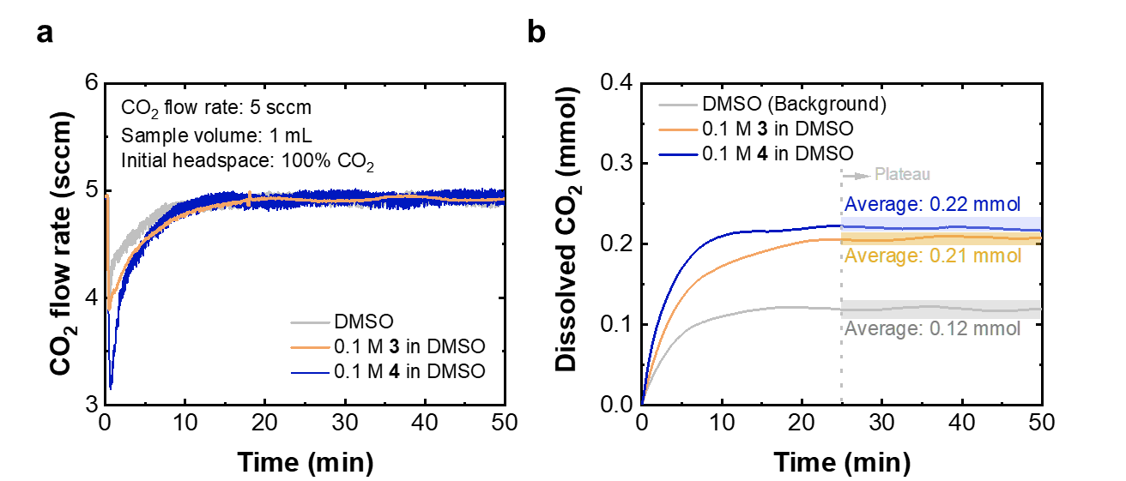
Supplementary Fig. 40. a. CO₂ flow rate versus time after the injection of 1 mL solution: DMSO, 0.1 M 3 in DMSO, 0.1 M 4 in DMSO. Testing condition: 5 sccm CO₂ and initial headspace of 100% CO₂. b. Integrated amount of dissolved CO₂ in the solution over time.

The effect of solvent on ∆H_{NHI-CO2} with 4-iPr-iPr as a representative NHI structure:
The heat of CO₂ dissolution (∆H_{CO2}) for three solvents, including dimethyl sulfoxide (DMSO), MeCN, and dimethylformamide (DMF), were measured and normalized based on the CO₂ solubility reported in literature.⁵ The ∆H_{CO2} values are used for background subtraction to determine ∆H_{NHI-CO2}. With 4-iPr-iPr as a representative NHI, Supplementary Fig. 41 shows that the solvent choice does not significantly affect ∆H_{NHI-CO2}.
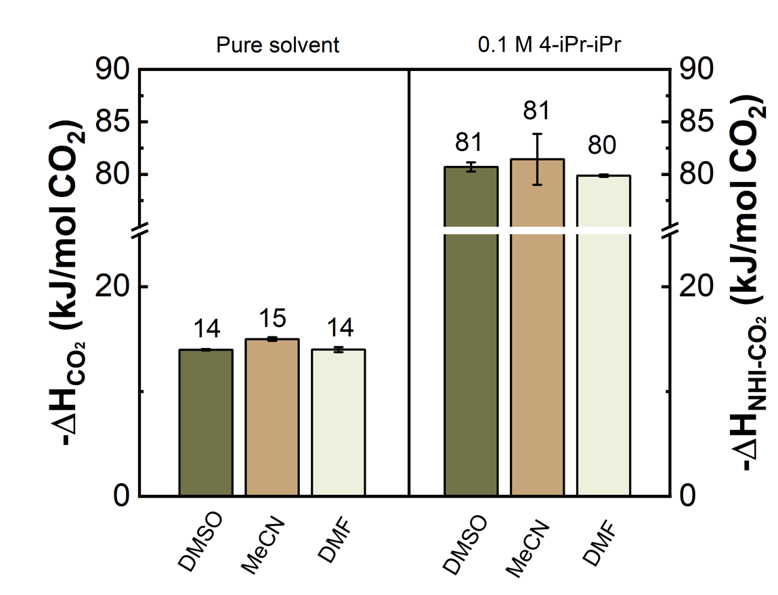
Supplementary Fig. 41. ∆H_{CO2} for DMSO, MeCN, and DMF and ∆H_{NHI-CO2} of 4-iPr-iPr in these solvents.

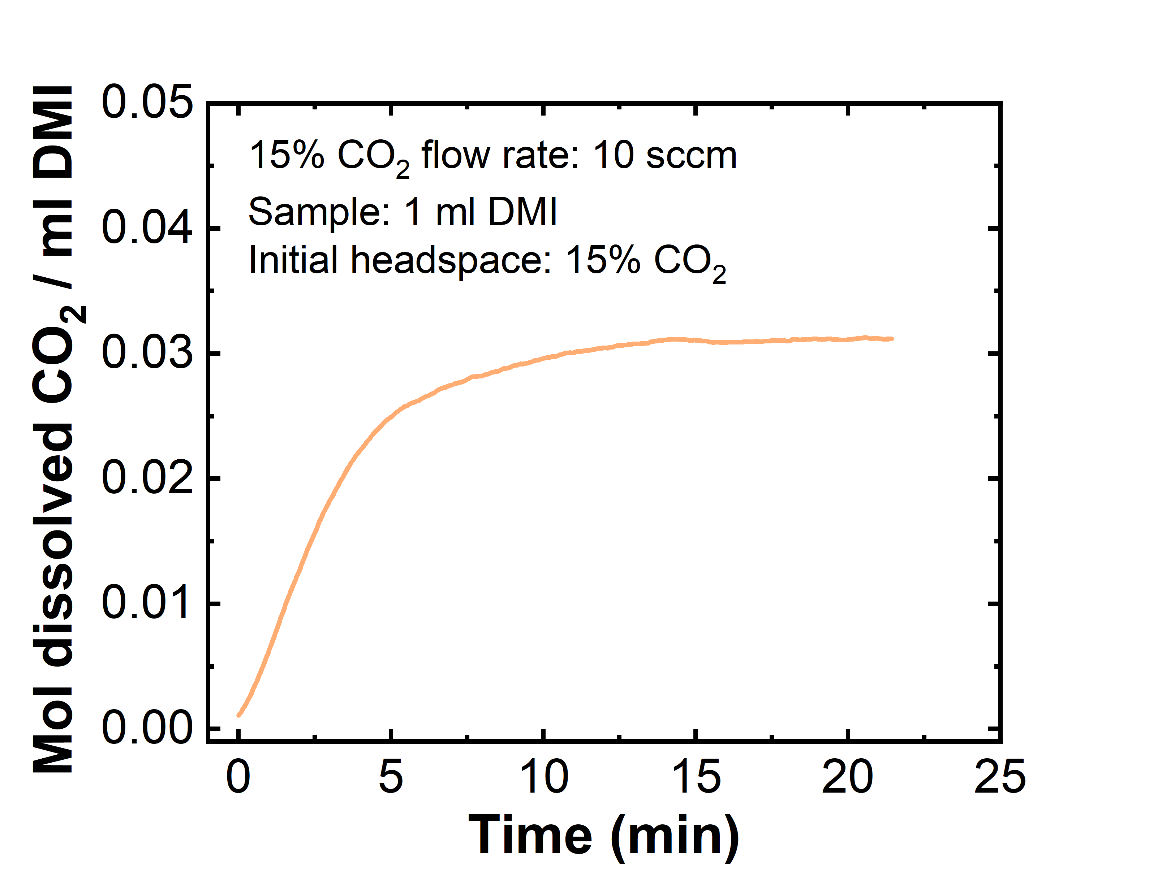
Supplementary Fig. 42. Background CO₂ solubility in 1 mL DMI at 15% CO₂. Testing condition: 1 mL of DMI, 10 sccm 15% CO₂, and initial headspace of 15% CO₂.

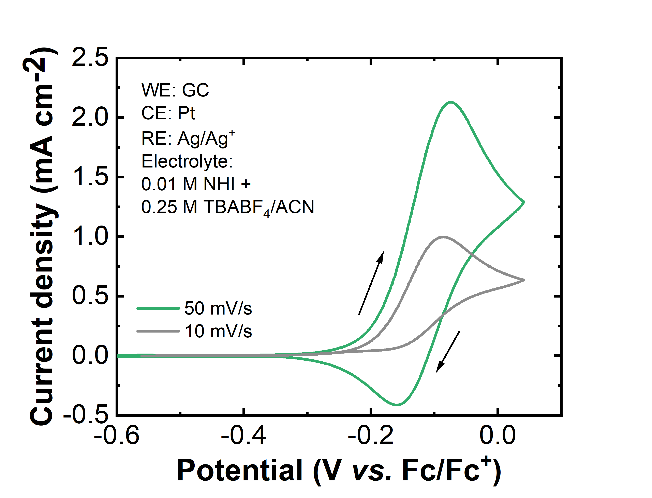
Supplementary Fig. 43. Cyclic voltammetry of 3 under Ar at a scan rate of 10 mV/s and 50 mV/s. The scan starts at open-circuit voltage (OCV), which is -0.55 V vs. Fc/Fc⁺, and first scans positively. Working electrode: glassy carbon (GC), counter electrode: Pt, and reference electrode: Ag/Ag⁺. Electrolyte contains 0.01 M NHI + 0.25 M TBABF₄ in acetonitrile.

Evidence of CO₂ release after electro-oxidation with 4-iPr-iPr as a representative NHI:
Compound 4-iPr-iPr was used as the model NHI for this experiment. The H-cell contained NHI-CO₂ as the anolyte to be oxidized (0.2 M NHI + 0.25 M TBABF₄ in MeCN saturated with 100% CO₂) and 0.2 M TEMPO + 0.25 M TBABF₄ in MeCN as the catholyte to be reduced for charge balance, as shown in Supplementary Fig. 44a. Carbon paper was used for both cathode and anode and a Ag/Ag⁺ reference electrode was used to record the applied potential during the experiment. The H-cell was sealed with septa under Ar as the initial headspace to ensure air-tightness, and an outlet was connected to the working electrode side to route released gas to a flow meter and CO₂ sensor. During the experiment, a constant current of 5 mA was passed to the working electrode to oxidize NHI-CO₂. The experiment was designed to pause the current every 60 minutes and rest for 10 minutes to confirm the outlet gas flow difference with and without current. As shown in Supplementary Fig. 44b, the resulting potential was stable during oxidation around the peak oxidation potential as observed from the CV measurement of 4-iPr-iPr (Fig 4, purple curve). An increase of the CO₂ flow rate of ~0.08 sccm, compared to the resting case, was observed when 5 mA current was applied (Supplementary Fig. 44c). Assuming 1 e⁻ oxidation per NHI-CO₂, we calculate a theoretical CO₂ release of 0.076 sccm. Therefore, this experiment confirms that the single electron oxidation of NHI-CO₂ corresponds to CO₂ release near 100% Faradaic efficiency (FE).
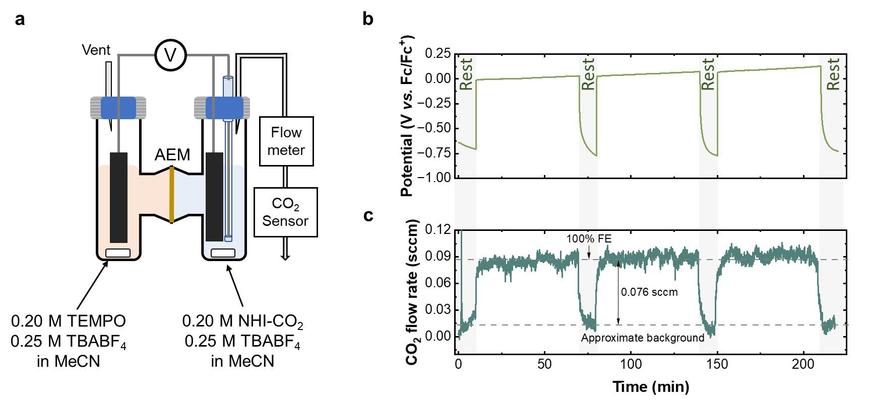
Supplementary Fig. 44. a. Schematic of the experimental setup for CO₂ release. The H-cell contained NHI-CO₂ solution (4-iPr-iPr with 0.25 TBABF₄ in MeCN) that was oxidized at constant 5 mA current at room temperature while connected to the gas ﬂow meter and an FT-IR CO₂ sensor. TEMPO catholyte (0.2 M TEMPO + 0.25 M TBABF₄ in MeCN) was reduced for charge balance. Both electrodes were carbon paper, and a Ag/Ag⁺ reference electrode was used to reference the NHI potential to Fc/Fc⁺ (Fc/Fc⁺ = 0.06 V vs. Ag/Ag⁺). b. Potential measured during 4-iPr-iPr oxidation, with intermittent rest periods to measure the CO₂ release rate difference between active oxidation vs. under no applied current. c. The corresponding CO₂ outlet flow rate versus time.

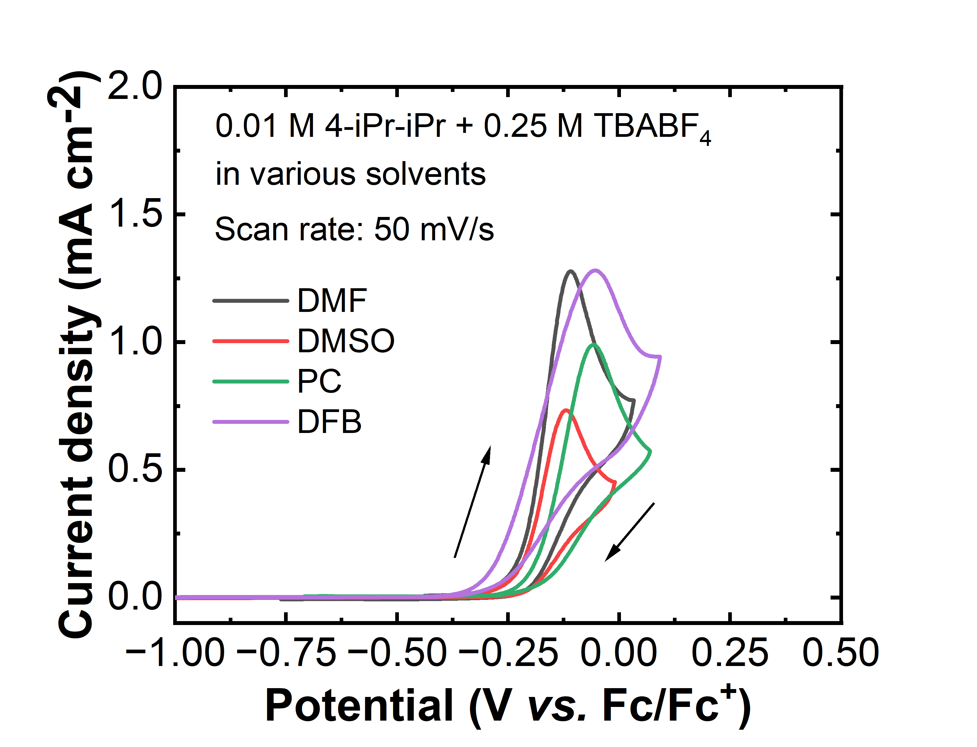
Supplementary Fig. 45. Cyclic voltammetry of 4-iPr-iPr under Ar at a scan rate of 50 mV/s. The scan starts at OCV (-0.4 to -0.7 V vs. Fc/Fc⁺ depending on the solvent) and first scans positively. Working electrode: glassy carbon (GC), counter electrode: Pt, and reference electrode: Ag/Ag⁺. The electrolyte contains 0.01 M NHI + 0.25 M TBABF₄ in DMF, DMSO, PC, and difluorobenzene (DFB). Ferrocene was used as an external standard to convert the potential of the reference electrode, and the conversion for each solvent is listed in Supplementary Table. 1.

Supplementary Table. 1. Reference potential conversion from Ag/Ag⁺ to Fc/Fc⁺ in various solvents
Solvent | Potential conversion from Ag/Ag⁺ to Fc/Fc⁺ (V)
DMF | -0.06
DMSO | -0.01
PC | -0.03
DFB | -0.21

Speciation of oxidized NHI 6 under 100% CO₂ condition:
It is important to note that although the electrochemical product formed initially after oxidation of 6-nCO₂ under 100% CO₂ condition corresponds to an oxidation state of 2⁺ (green trace in Fig. 4b), a rapid disproportionation reaction would occur between 6-nCO₂ and 6²⁺ to form two 6^{+•} (with corresponding CO₂ released from 6-nCO₂).⁶ This was also evidenced by the disappearance of the first reduction peak (6²⁺/6^{+•}) when scanning at a slower CV rate, indicating a complete spontaneous conversion of 6²⁺ to 6^{+•} by disproportionation (Supplementary Fig. 46). Consequently, the 6²⁺ species is short-lived in the presence of 6-nCO₂, thus each oxidized NHI undergoes a single electron transfer on average at the SOC range of 0 – 50% when accounting for the complete electrochemical and chemical pathways.

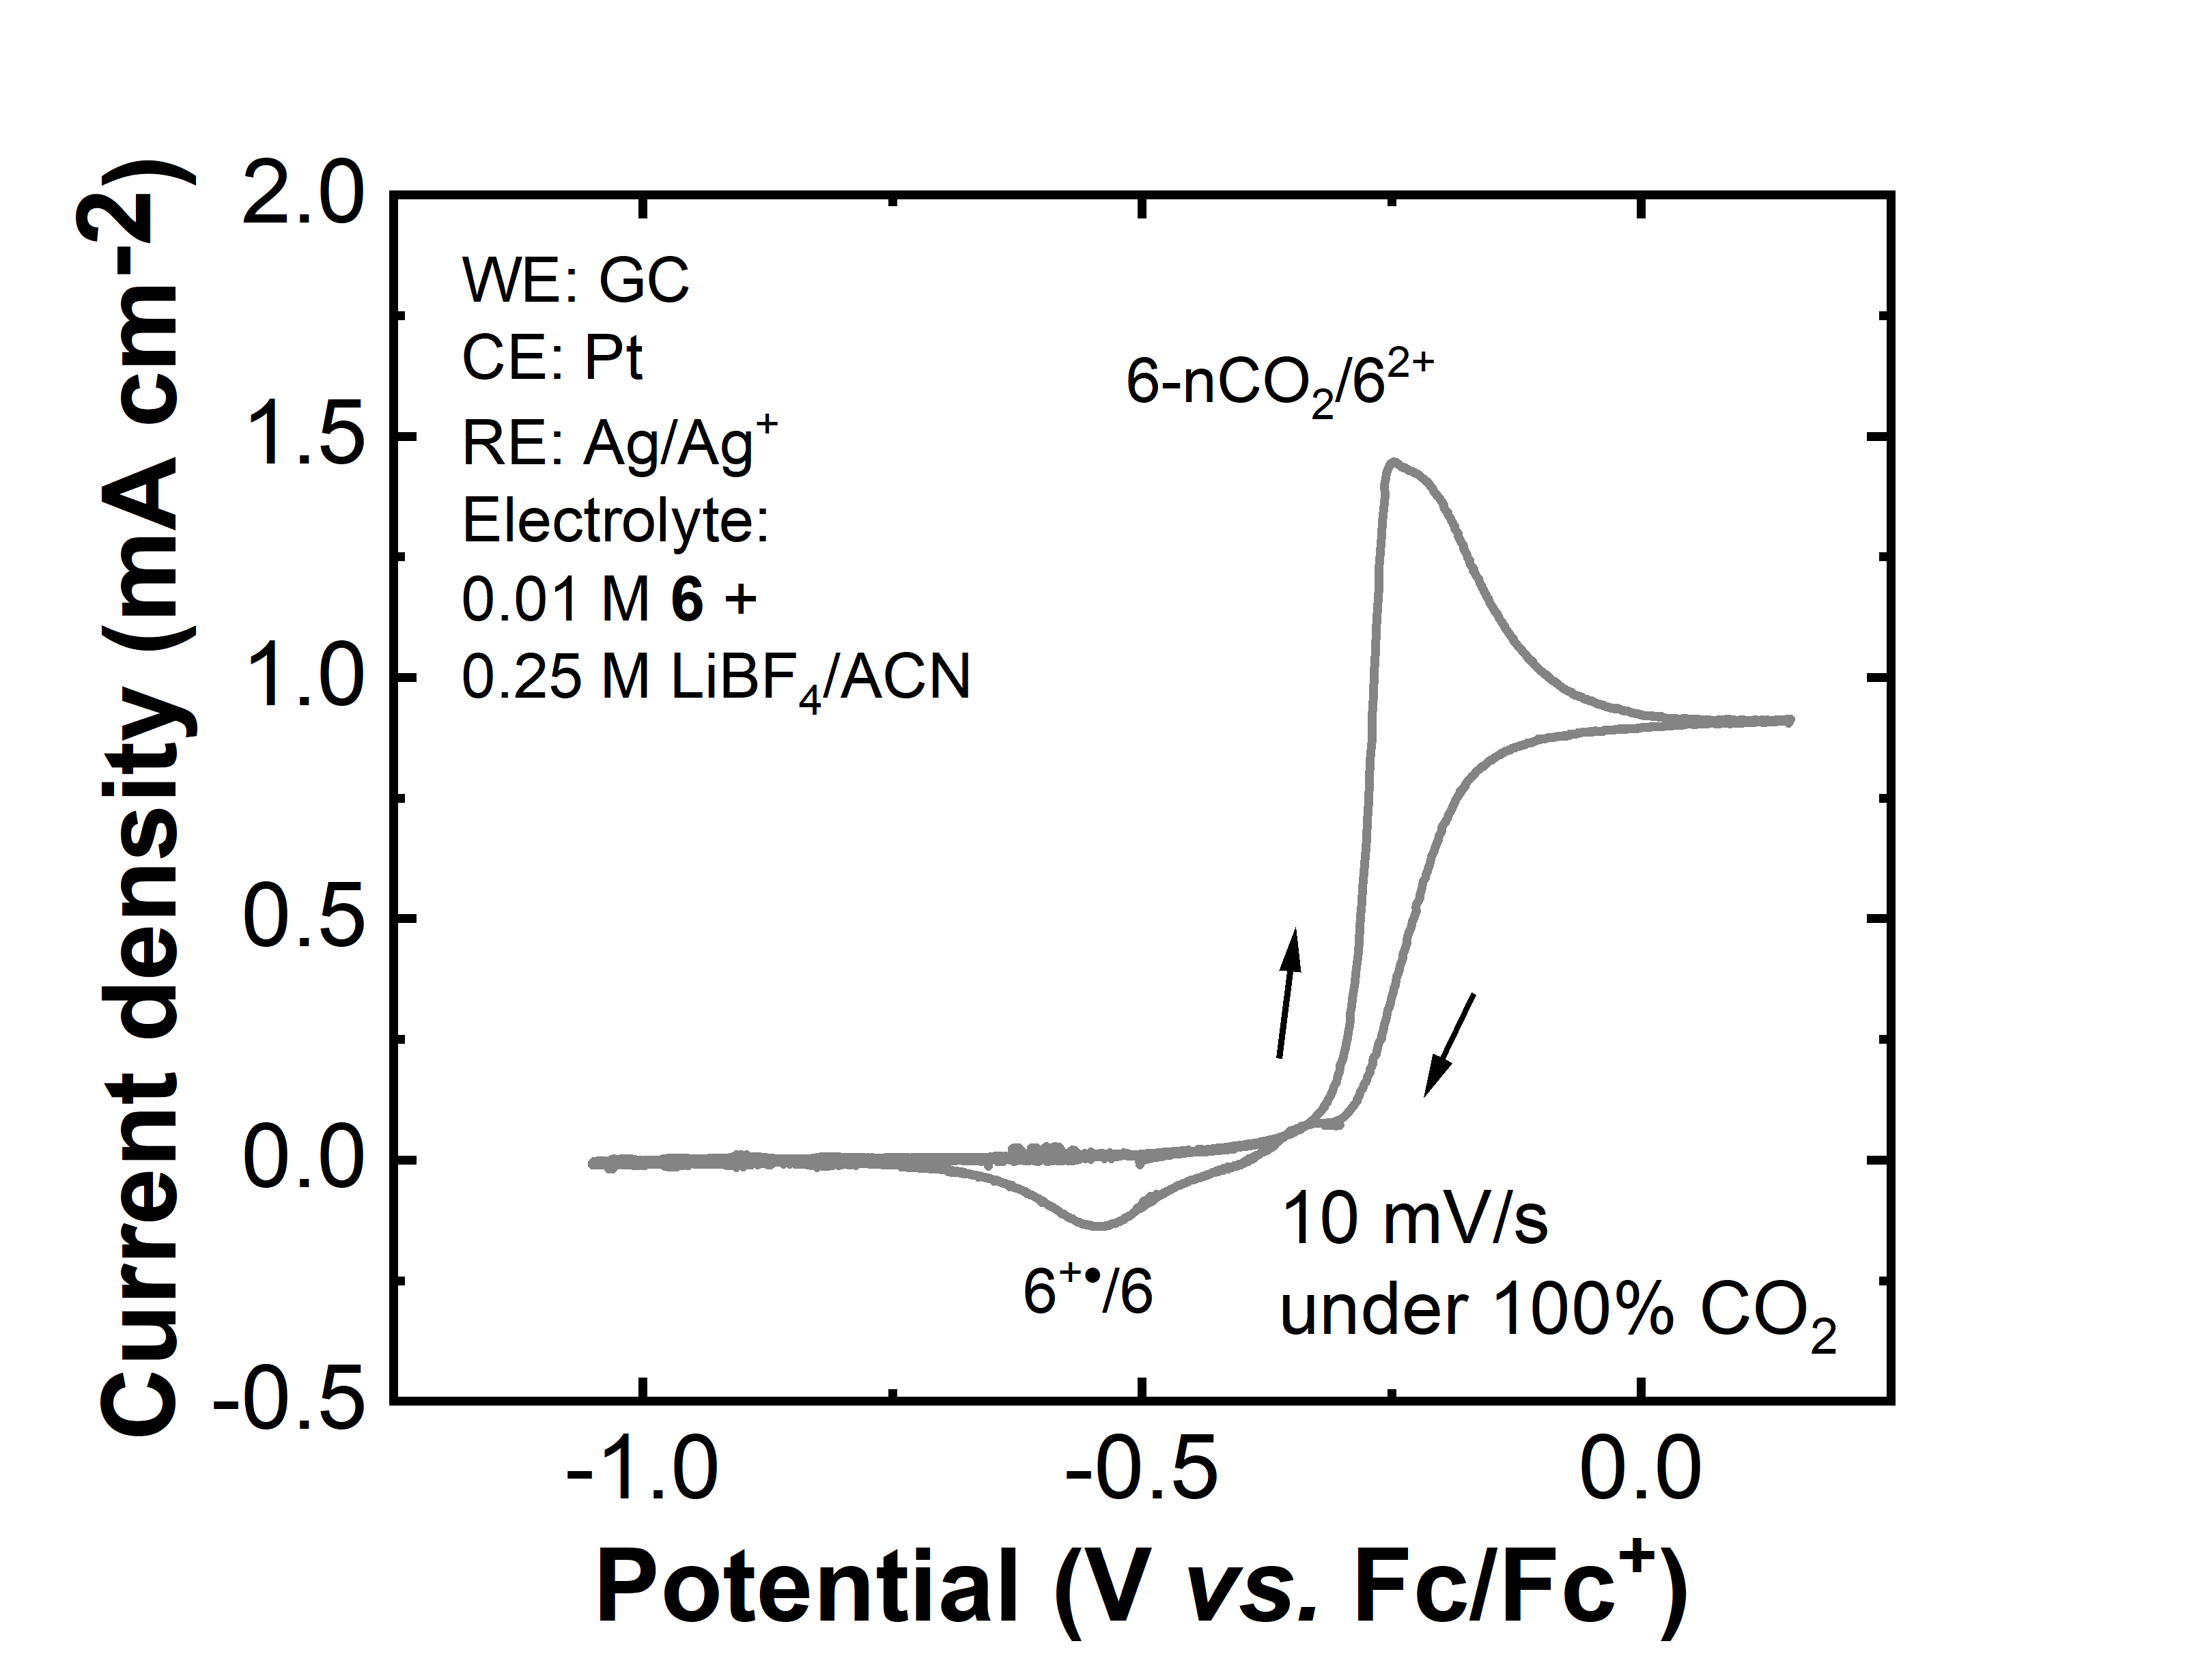
Supplementary Fig. 46. Cyclic voltammetry of 6 under 100% CO₂ at 10 mV/s. The scan starts at OCV (-0.65 V vs. Fc/Fc⁺) and first scans positively. Working electrode: GC, counter electrode: Pt, and reference electrode: Ag/Ag⁺. Electrolyte contains 0.025 M 6 + 0.25 M LiBF₄ in MeCN.

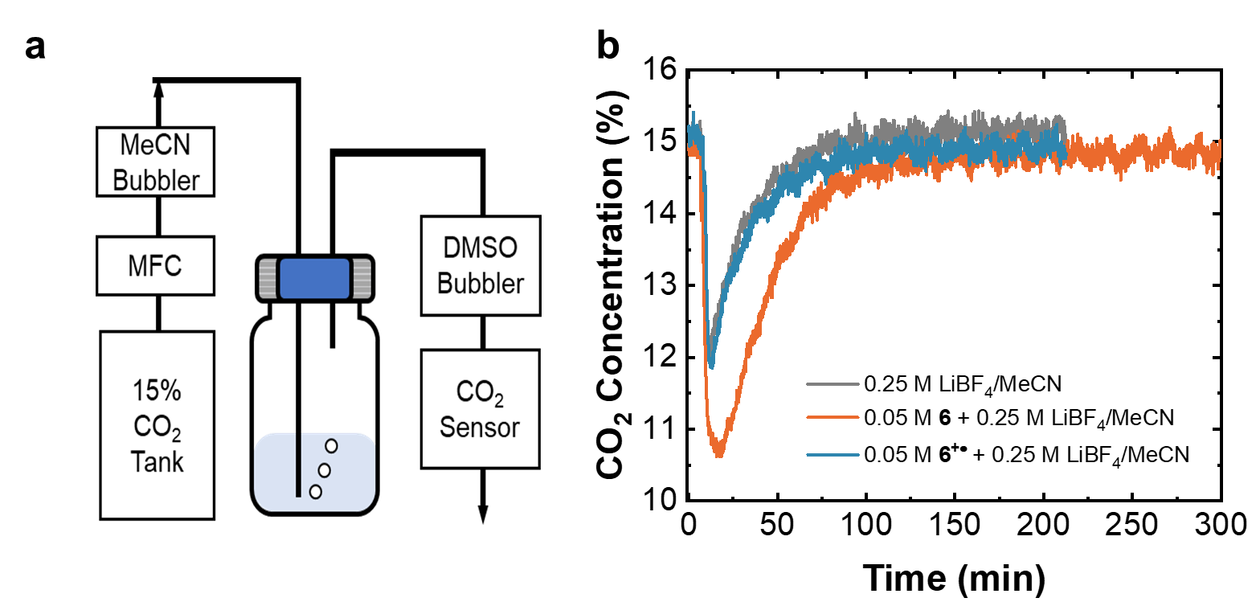
Supplementary Fig. 47. a. Experimental setup for measuring the CO₂ loading on 6 under 15% CO₂. Testing condition: 3 mL of sample purged with 5 sccm 15% CO₂. Initial headspace: Ar. b. CO₂ concentration versus time measured during CO₂ capture for the 0.25 M LiBF₄/MeCN (grey trace), 0.05 M 6 in 0.25 M LiBF₄/MeCN (orange trace), and 0.05 M 6^{+•} in 0.25 M LiBF₄/MeCN (blue trace).

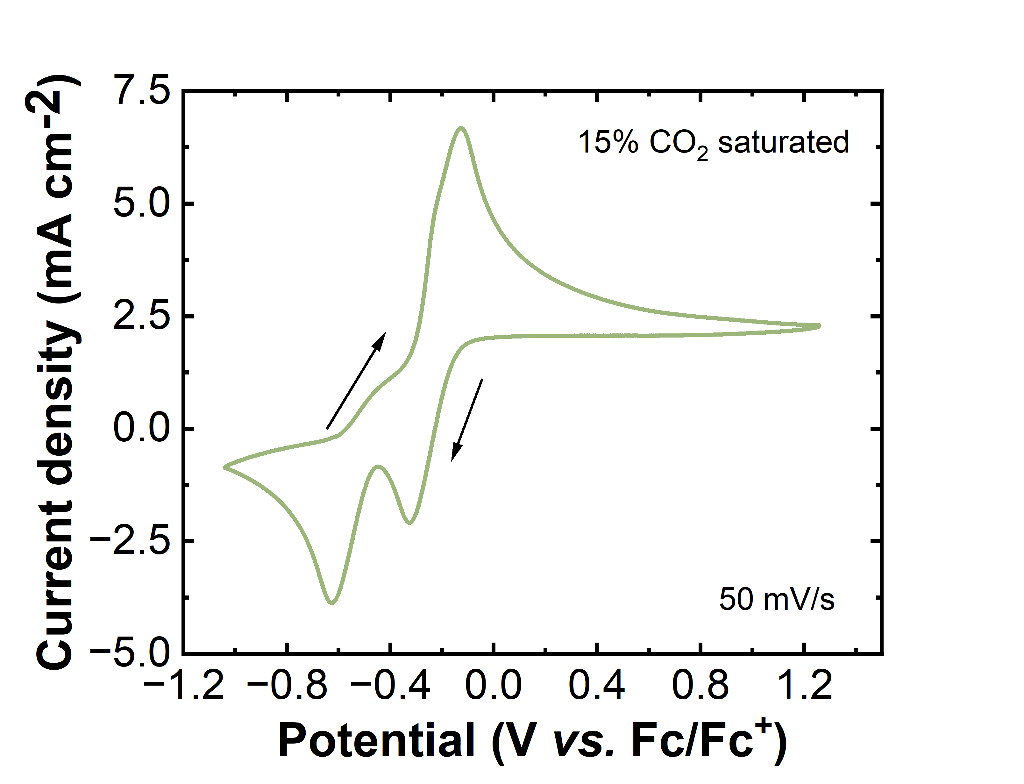
Supplementary Fig. 48. Cyclic voltammetry of 6 under 15% CO₂ at 50 mV/s. The scan starts at OCV (-0.65 V vs. Fc/Fc⁺) and first scans positively. Working electrode: GC, counter electrode: Pt, and reference electrode: Ag/Ag⁺. Electrolyte contains 0.025 M 6 + 0.25 M LiBF₄ in MeCN.

CO₂ loading of NHI 6:
Due to the fluctuation of the baseline signal from solution bubbling, the average values of dissolved CO₂ after 20 minutes were reported. The result showed a dissolved CO₂ of 0.775 and 0.926 mmol for 0.25 M LiBF₄/MeCN and 0.025 M 6 in 0.25 M LiBF4/MeCN, respectively. This corresponds to a CO₂ loading of 2.0 mol CO₂/mol NHI for 6, under µRC testing condition.
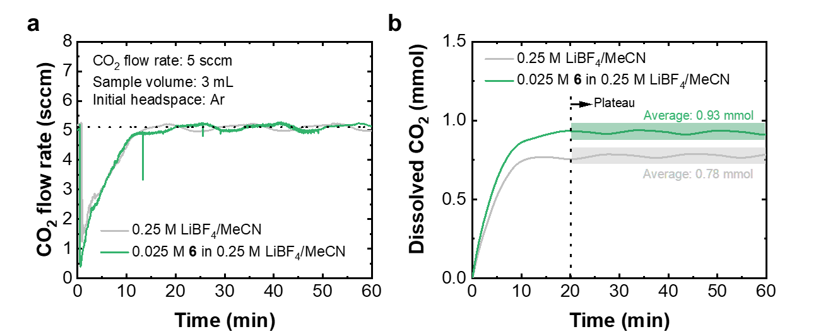
Supplementary Fig. 49. a. CO₂ flow rate versus time during the measurements. Test conditions: 5 sccm of 100% CO₂ purged to 3 mL of 0.25 M LiBF₄/MeCN or 0.025 M 6 in 0.25 M LiBF₄/MeCN. Initial headspace: Ar. b. Integrated amount of dissolved CO₂ in the solution over time.

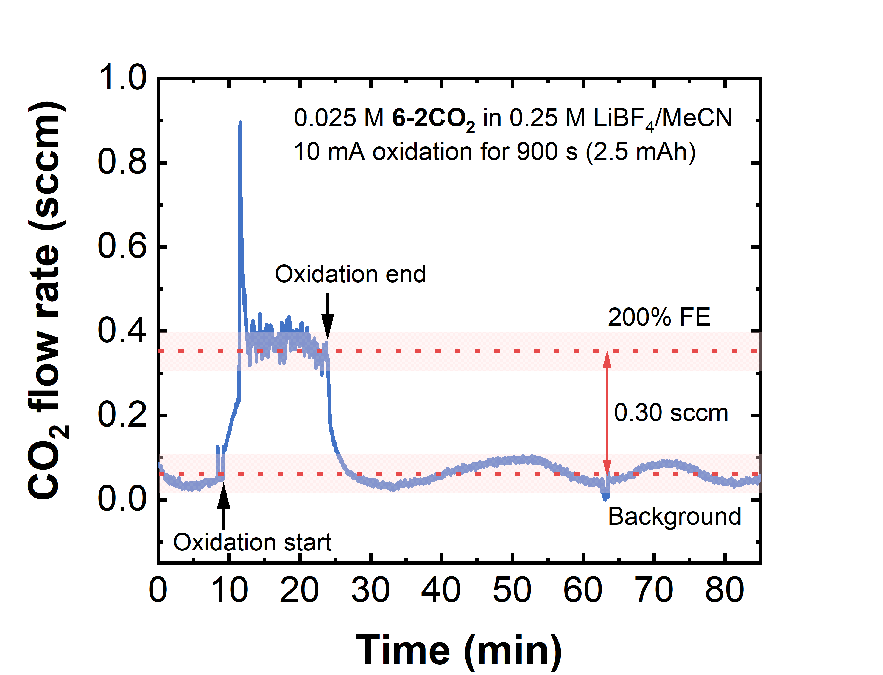
Supplementary Fig. 50. CO₂ outlet flow rate as a function of time during the oxidation of 6-2CO₂ under 100% CO₂ atmosphere. A two-electrode H-cell contained 4 mL of 6 in 0.25 M LiBF₄ in MeCN as the anolyte and 4.5 mL of 0.025 M 6⁺• in 0.25 M LiBF₄ in MeCN as the catholyte. Prior to oxidation, the anolyte was purged and saturated with 100% CO₂ to fully convert 6 to 6-2CO₂ (Supplementary Fig. 49). During electrolysis, the cell headspace was continuously purged with 0.1 sccm of 100% CO₂, and a constant current of 10 mA was applied for 900 s (2.5 mAh or 47% SOC) at room temperature. The gas outlet was connected to a gas flow meter to monitor CO₂ release. Both working and counter electrodes were carbon paper.

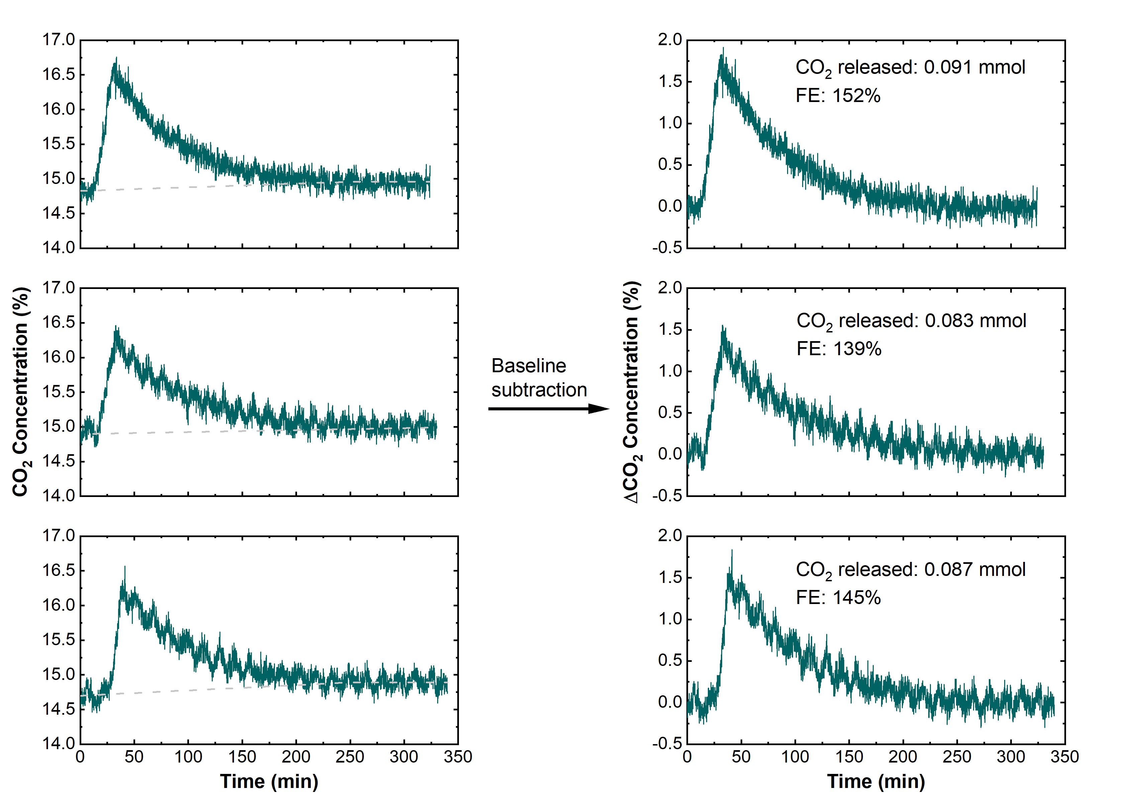
Supplementary Fig. 51. CO₂ concentration changes during a SOC swing of 10% to 25% for 4 mL of 0.05 M 6 under 15% CO₂. The oxidation is conducted at 7.5 mA for 772 s and the system rests for 5 h for the CO₂ concentration to go back to baseline.

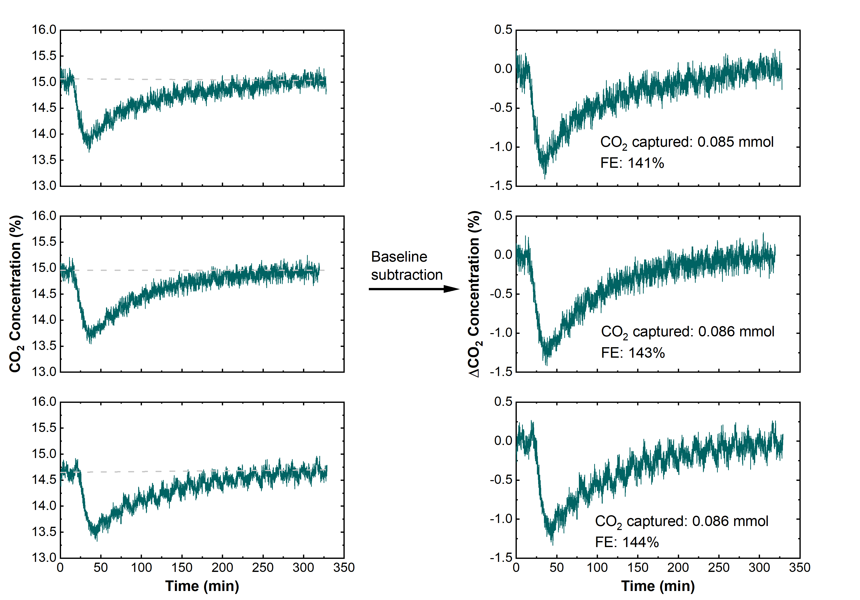
Supplementary Fig. 52. CO₂ concentration changes during SOC swing of 25% to 10% for 4 mL of 0.05 M 6 under 15% CO₂. The reduction is conducted at 7.5 mA for 772 s and the system rests for 5 h for the CO₂ concentration to go back to baseline.

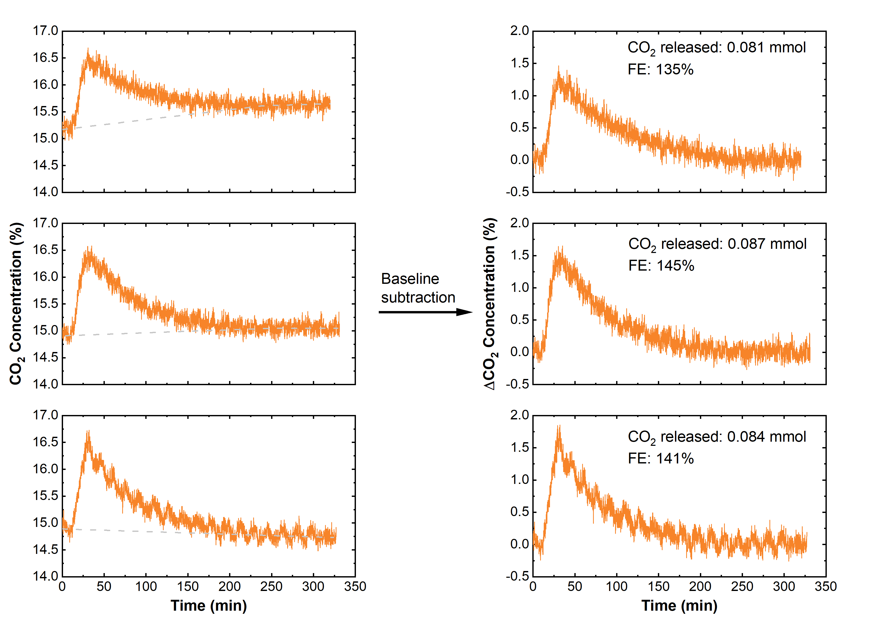
Supplementary Fig. 53. CO₂ concentration changes during the SOC swing of 25% to 40% for 4 mL of 0.05 M 6 under 15% CO₂. The oxidation is conducted at 7.5 mA for 772 s and the system rests for 5 h for the CO₂ concentration to go back to baseline.

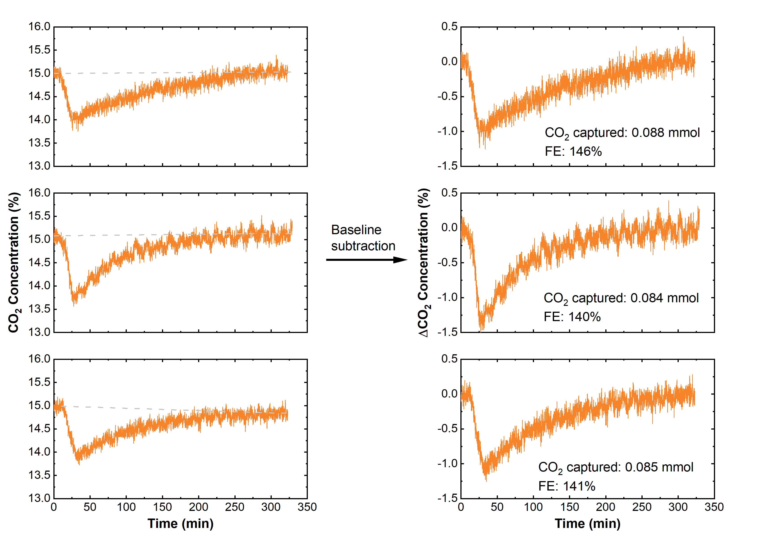
Supplementary Fig. 54. CO₂ concentration changes during the SOC swing of 40% to 25% for 4 mL of 0.05 M 6 under 15% CO₂. The reduction is conducted at 7.5 mA for 772 s and the system rests for 5 h for the CO₂ concentration to go back to baseline.

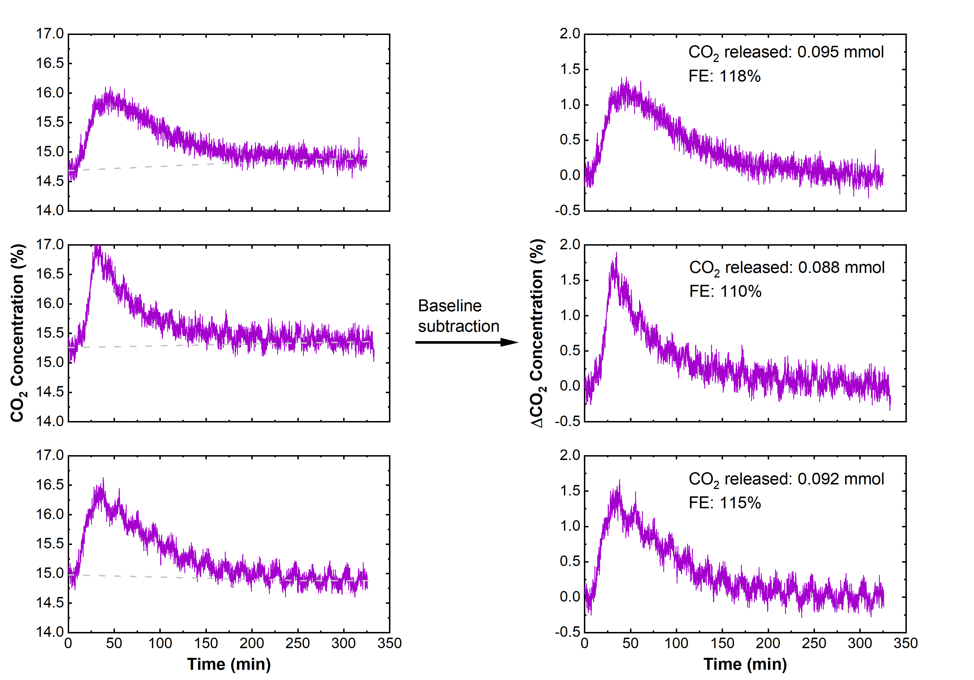
Supplementary Fig. 55. CO₂ concentration changes during the SOC swing of 30% to 50% for 4 mL of 0.05 M 6 under 15% CO₂. The oxidation is conducted at 7.5 mA for 1029 s and the system rests for 5 h for the CO₂ concentration to go back to baseline.

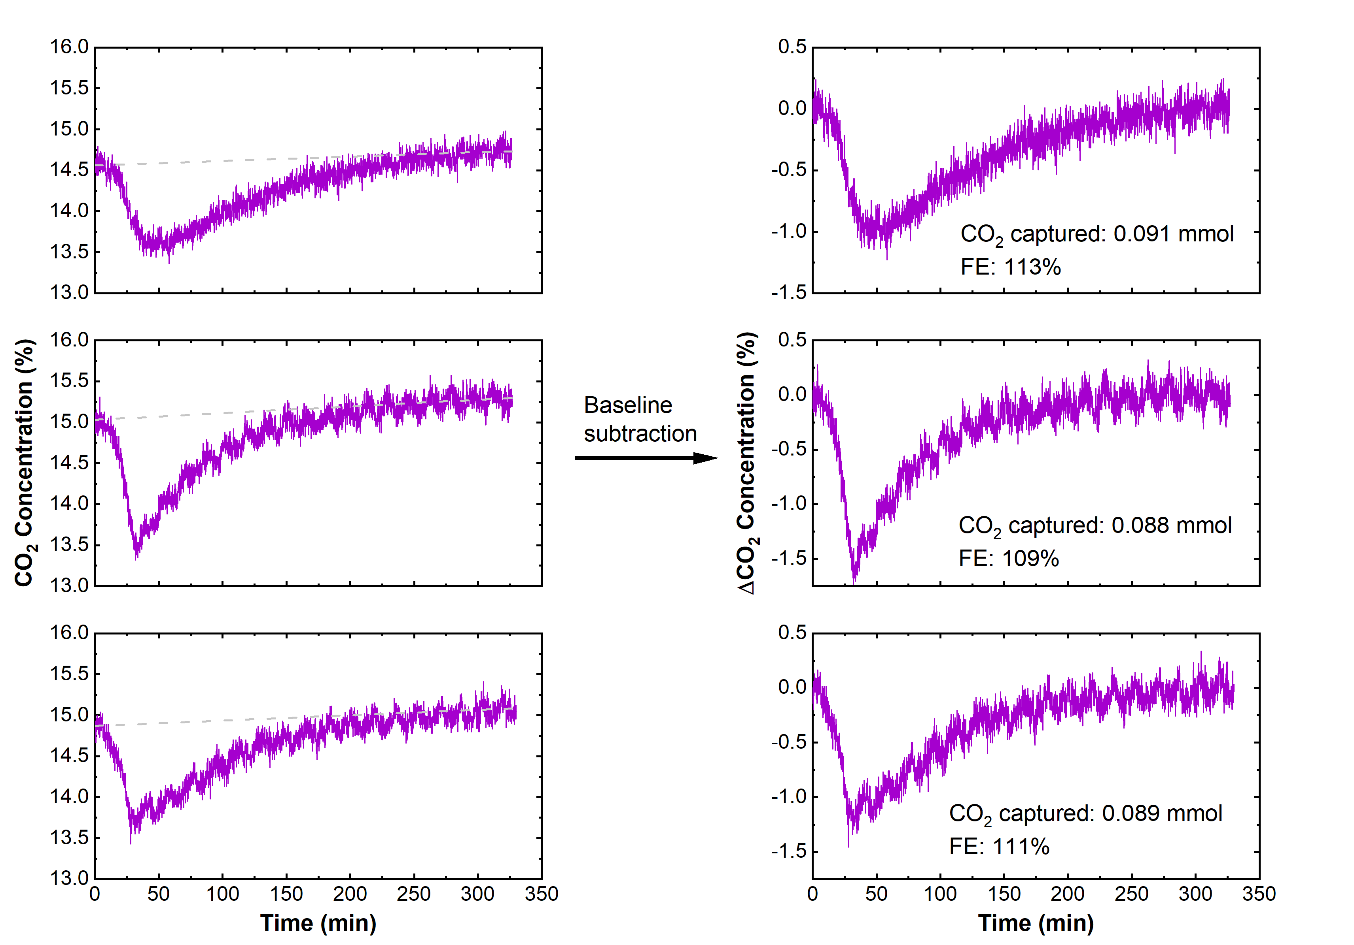
Supplementary Fig. 56. CO₂ concentration change during the SOC swing of 50% to 30% for 4 mL of 0.05 M 6 under 15% CO₂. The reduction is conducted at 7.5 mA for 1029 s and the system rest for 5 h for the CO₂ concentration to go back to baseline.

Theoretical Faradaic efficiency (FE) with different hypothetical oxidation/reduction pathways:
Based on the CO₂ loading measurements (Fig. 4d in the main text), compound 6 exists as a mixture of 60% 6-CO₂ and 40% 6-2CO₂ under equilibrium conditions at 15% CO₂, representing the initial speciation at state of charge (SOC) of 0%. Supplementary Fig. 57 illustrates the speciation changes as SOC increases, considering three possible oxidation pathways: preferential oxidation of 6-CO₂ first (Supplementary Fig. 57a), preferential oxidation of 6-2CO₂ first (Supplementary Fig. 57b), and no preferential oxidation order (Supplementary Fig. 57c). In each scenario, the corresponding Faradaic efficiency (FE) is indicated for specific SOC ranges, as labeled in the respective figures.
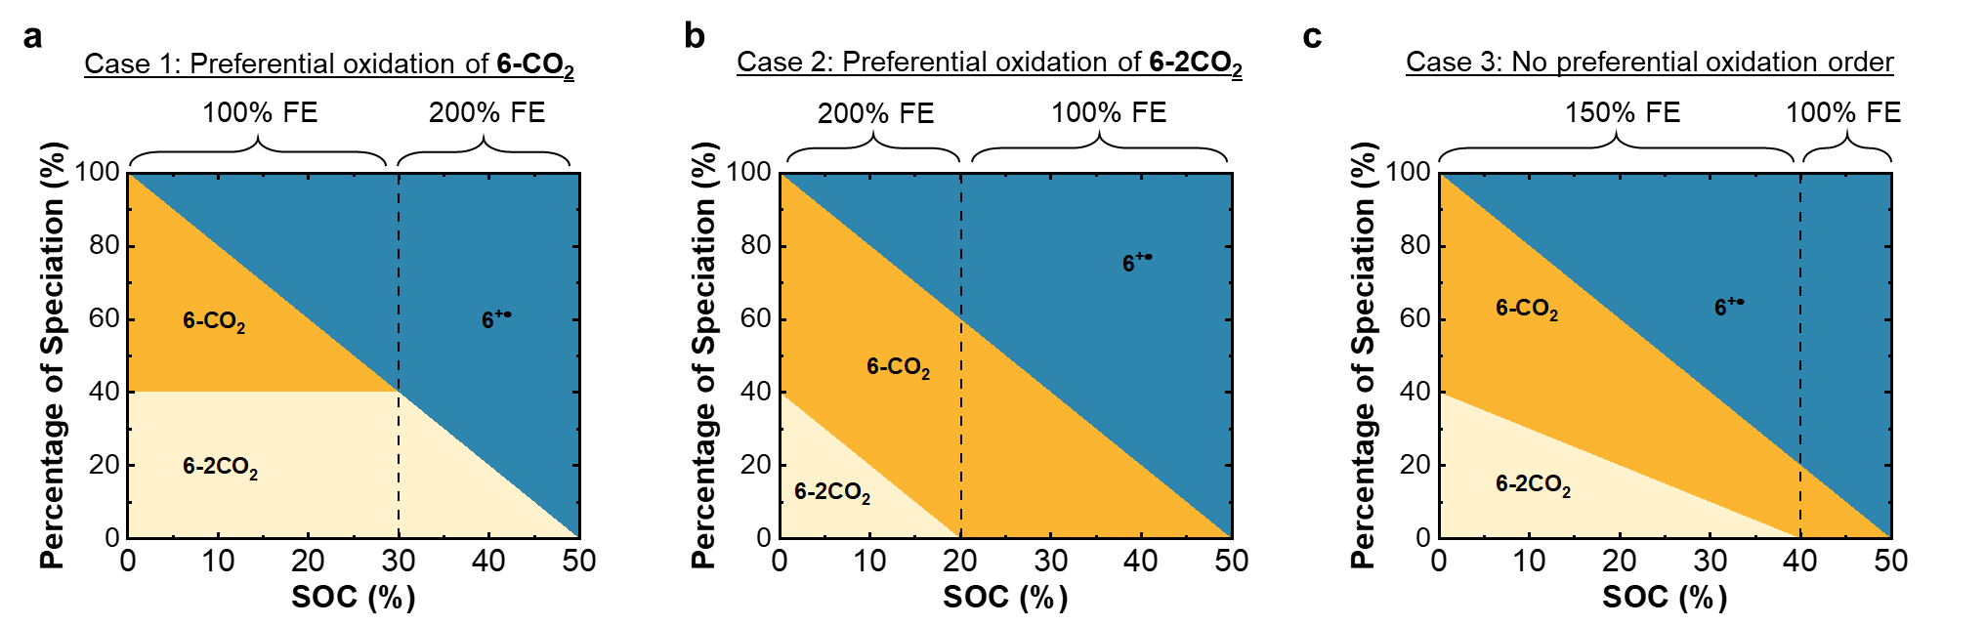
Supplementary Fig. 57. Speciation changes at various SOCs and the corresponding FEs under the assumptions of a. preferential oxidation of 6-CO₂ (6-2CO₂ is not oxidized until 6-CO₂ is depleted); b. preferential oxidation of 6-2CO₂ (6-CO₂ is not oxidized until 6-2CO₂ is depleted); c. no preferential oxidation order, such that 6-CO₂ and 6-2CO₂ are depleted at equivalent rates.

The theoretical average FE (FE_{avg}) was calculated for the three test cases in the main text (Fig. 5b) based on the proportion of the SOC (unitless fraction between 0 and 0.5) swing in each FE range. Using Case 1 and 25% to 40% SOC swing as an example:
${\text{FE}}_{\text{avg}} \text{= }\frac{\left(\text{30\% SOC} \text{↔} \text{25\% SOC}\right) \text{×} \text{100\% FE} \text{+ }\left(\text{40\% SOC} \text{↔} \text{30\% SOC}\right) \text{×} \text{200\% FE }}{\text{15\% SOC}} \text{=} \text{167\%}$ (S4)
The combinations of FE_{avg} for all three scenarios and three test cases are tabulated in Supplementary Table S2.

Supplementary Table. 2. FE_{avg} for three SOC swing cases (10% ↔ 25%, 25% ↔ 40%, and 30% ↔ 50%) under three potential oxidation scenarios.
SOC swing | 10% ↔ 25% | 25% ↔ 40% | 30% ↔ 50%
Case 1 | 100 | 167 | 200
Case 2 | 167 | 100 | 100
Case 3 | 150 | 150 | 125

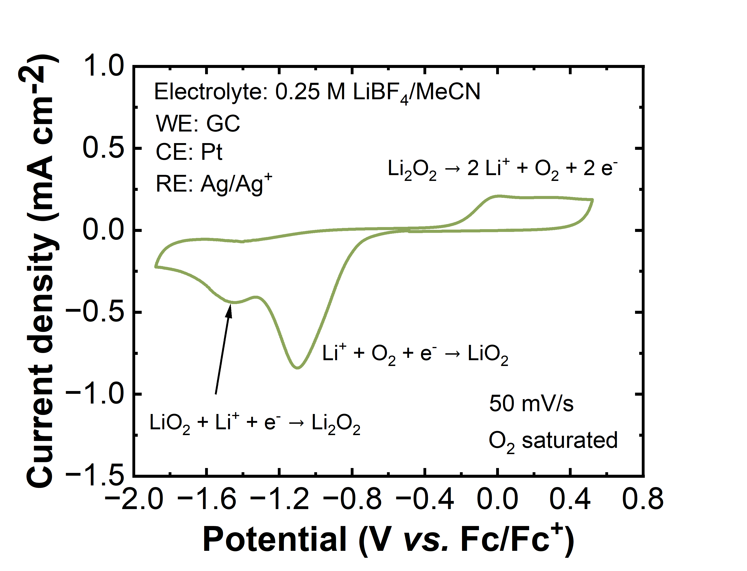
Supplementary Fig. 58. Cyclic voltammetry of O₂-saturated 0.25 M LiBF₄/MeCN electrolyte at 50 mV/s. The scan starts at OCV (-0.50 V vs. Fc/Fc⁺) and first scans negatively. Working electrode: glassy carbon (GC), counter electrode: Pt, and reference electrode: Ag/Ag⁺.

Decay of 6^{+•} at high concentrations over time:
The intrinsic stability of 6^{+•} stored under Ar was examined at elevated concentration (0.05 M). The 0.05 M 6^{+•} electrolyte was prepared by electro-oxidation in the H-cell using 0.03 M zinc bis(trifluoromethylsulfonyl)imide (Zn(TFSI)₂, Solvionic) in 0.25 M LiBF₄/MeCN as the electrolyte in the counter electrode chamber. The appearance of the 0.05 M 6^{+•} electrolyte before and following a 1:500 dilution ratio in 0.25 M LiBF₄/MeCN were shown in Supplementary Fig. 59a. The freshly prepared electrolyte was diluted to different concentrations and their UV-Vis absorbances at 620 nm were then used to build the calibration curve to determine the corresponding pre-diluted concentration, as shown in Supplementary Fig. 59b.
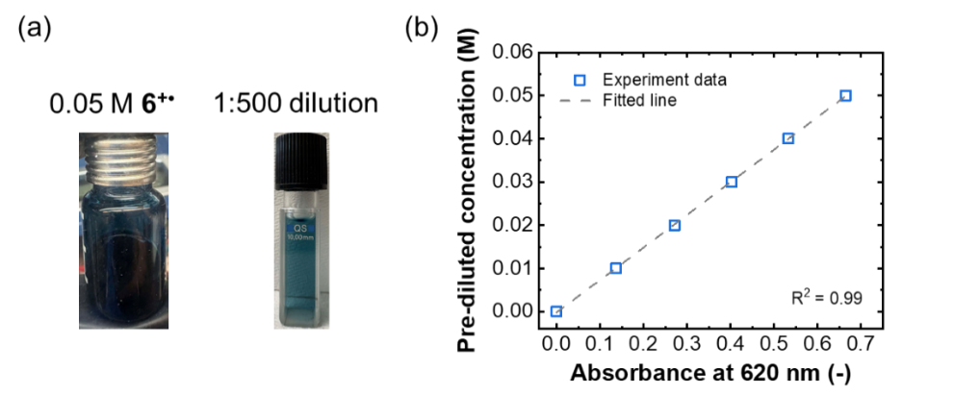
Supplementary Fig. 59. a. Photographs of vials containing 0.05 M 6^{+•} before (left) and after (right) 1:500 dilution in 0.25 M LiBF₄/MeCN. b. UV-Vis calibration curve for determining the 6^{+•} pre-dilution concentration using the absorbance peak at 620 nm.

The 0.05 M 6^{+•} electrolyte was stored in the Ar glovebox and taken for dilution right before each UV-Vis measurement at different resting time. Supplementary Fig. 60a showed the UV-Vis absorbances from 200 to 800 nm at various times, and it was observed that the characteristics peaks at 370 nm and 620 nm for 6^{+•} decay overtime, which is quantified in Supplementary Fig. 60b. The result show that after 24 h, the majority of 6^{+•} (>80%) was degraded and the emergence of the peak at 275 nm demonstrated a new species formed after the degradation, which will require further study to elucidate.
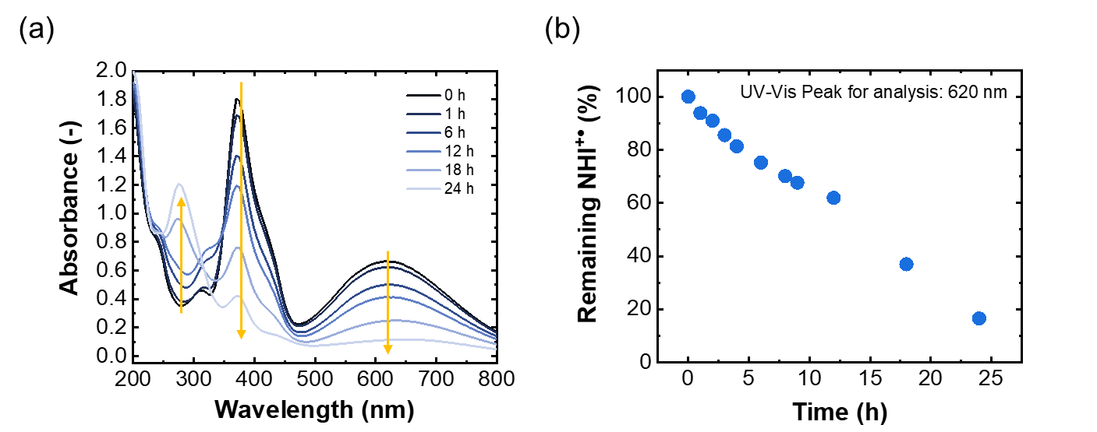
Supplementary Fig. 60. a. UV-VIS spectra of 0.05 M 6^{+•} at various resting times. b. Percentage of remaining 6^{+•} over time.
Supplementary Table 3. Summary of selected EMCC processes
Material | Reduction peak potential  (V vs. Fc/Fc⁺) | Theoretical work ª  (kJ/mol CO₂) | Current (mA) | Loading swing | Cycle condition | Cycle | CO₂ capacity utilization ^{b} | Coulombic efficiency ^{c} | Release/  capture efficiency | System work  (kJ/mol CO₂)
Liquid quinone  (LQ)⁷ | -0.9 | 35 | 10 | 2.4% | 15% CO₂ | 10 | 60-70% | 80-90% | 100% | 35-220 ^{d}
 |  |  |  |  | 15% CO₂  5% O₂ | 6 | 40% | 80-90% | 90% | 35-220 ^{d}
sp²-nitrogen  AzPy⁸ | -1.2 | 16 | 10 | 18.7% | 20% CO₂ | 20 | 100% | 90% | 100% | 120
 |  |  |  |  | 18.5% CO₂  3% O₂ | 14 | 100% | 87% | 97% | 156
Isoindigos⁹ | -1.2 | 16 | 10 | 18.7% | 10% CO₂ | 19 | 65% | 84% | 97% | 143
 |  |  |  |  | 10% CO₂  3% O₂ | 16 | 50% | 85% | 100% | 171
BDT-quinone¹⁰ | -1.4 | 8 | 10 | 80% | 13% CO₂ | 20 | 80% | - | - | 108
This work | -0.6 | 13 | 7.5 | 20% | 15% CO₂ | 40 | 150% | 100%^{e} | 100% | ~10^{f}
 |  |  |  |  | 13% CO₂ 3% O₂ | 40 | - | 100%^{e} | 100% | ~10^{f}
- Theoretical work was estimated by the separation of oxidation and reduction onset potentials under CO₂ in reported cyclic voltammetry. Onset potential was determined by the potential of which the current achieved 10% of the peak current.
- CO₂ capacity utilization efficiency is defined as the amount of CO₂ captured relative to the theoretical value under the assumption of one CO₂ molecule per electron. This is the same definition as Faradaic efficiency in the main text.
- Coulombic efficiency is defined as the electrochemical sorbent oxidation capacity relative to the reduction capacity.
- The reported system work is distinct from their cycling cell setup.
- Cell cycled between 15-35% SOC as shown in Fig. 5d.
- System work is projected using a three-electrode cell setup.

Supplementary References
1 Kunetskiy, R. A. et al. A New Class of Organosuperbases, N‐Alkyl‐and N‐Aryl‐1, 3‐dialkyl‐4, 5‐dimethylimidazol‐2‐ylidene Amines: Synthesis, Structure, pKBH+ Measurements, and Properties. Chemistry–A European Journal 18, 3621-3630 (2012).
2 Wilm, L. F. et al. Reversible CO 2 fixation by N-heterocyclic imines forming water-stable zwitterionic nitrogen-base–CO 2 adducts. Green Chemistry 21, 640-648 (2019).
3 McSkimming, A. & Suess, D. L. Selective synthesis of site-differentiated Fe4S4 and Fe6S6 clusters. Inorganic Chemistry 57, 14904-14912 (2018).
4 Mazzotta, F., Zitzer, G., Speiser, B. & Kunz, D. Electron‐Deficient Imidazolium Substituted Cp Ligands and their Ru Complexes. Chemistry–A European Journal 26, 16291-16305 (2020).
5 Jitaru, M. Electrochemical carbon dioxide reduction-fundamental and applied topics. Journal of the University of chemical Technology and Metallurgy 42, 333-344 (2007).
6 Fang, X. et al. Kinetic Control over Disproportionation Stabilizes Wurster’s Blue Catholyte for Nonaqueous Redox Flow Batteries. ACS Energy Letters 9, 5737-5743 (2024).
7 Diederichsen, K. M., Liu, Y. Y., Ozbek, N., Seo, H. & Hatton, T. A. Toward solvent-free continuous-flow electrochemically mediated carbon capture with high-concentration liquid quinone chemistry. Joule 6, 221-239 (2022).
8 Li, X., Zhao, X. H., Liu, Y. Y., Hatton, T. A. & Liu, Y. Y. Redox-tunable Lewis bases for electrochemical carbon dioxide capture. Nature Energy 7, 1065-107 (2022).
9 Li, X. et al. Redox-tunable isoindigos for electrochemically mediated carbon capture. Nat Commun 15, 117 (2024).
10 Abdinejad, M., Massen‐Hane, M., Seo, H. & Hatton, T. A. Oxygen‐Stable Electrochemical CO2 Capture using Redox‐Active Heterocyclic Benzodithiophene Quinone. Angewandte Chemie International Edition, e202412229 (2024).

