Online Resources for
Early evidence of human resilience to earthquakes from southwestern Iberia

Alvise Barbieri¹*, Javier Sánchez Martínez^{1,2,3}, Joana Belmiro¹, Paulo Fernandes⁴, Jovan Galfi¹, Pedro Horta^{1,5}, João Cascalheira¹, Nuno Bicho¹

¹ Interdisciplinary Centre for Archaeology and the Evolution of Human Behaviour (ICArEHB), Universidade do Algarve, 8005-139 Faro, Portugal.
² Centre d’Estudis del Patrimoni Arqueològic, Universitat Autònoma de Barcelona (CEPArq–UAB). Facultat de Filosofia i Lletres, C/de la fortuna s/n 08193 Bellaterra, Spain.
³ Institut Català de Paleoecologia Humana i Evolució Social (IPHES-CERCA), Zona Educacional 4, Campus Sescelades URV (Edifici W3), 43007, Tarragona, Spain.
⁴ Centre of Marine and Environmental Research (CIMA) & Infrastructure Network in Aquatic Research (ARNET), Universidade do Algarve, 8005-139 Faro, Portugal.
⁵ Department of History, University of Minho, 4704-553 Braga, Portugal.

* Alvise Barbieri
Contact:
abarbieri@ualg.pt
https://orcid.org/0000-0002-4246-7691

This PDF file includes:
Supporting Text (ST S1.1 to ST S2.5)
Supplementary Figures S1 to S9
Supplementary Tables S1 to S19
References

Supporting Information Text (ST)
ST 1 Artificial Cut, Cores A and B, and the stratigraphy of the Terrace at Vale Boi
ST 1.1 Lithological descriptions
Artificial Cut, Core A, and Core B are located 150 m south–west, 3.5 m north–east, and 51 m north–west from the Terrace, respectively (Fig. S1). We described them distinguishing separate Geological Layers (GLs) based on lithological and pedological properties. For each GL we reported depth below ground surface, transition to the next lower layer (FitzPatrick 1980), sedimentary structures/bedding, as well as percentage of coarse (>2 mm) and fine fraction (Chilingar et al. 1967). For the coarse fraction, we described color, petrography, frequency (Chilingar et al. 1967), size (International Organization for Standardization 2017), shape (Zingg 1935), and roundness (Powers 1953). For the fine fraction, we reported Munsell color, grain size by feel (Vos et al. 2016), reaction to a 10% solution of HCl, and pH measured with semi–quantitative test strips. If present, we also described frequency (Chilingar et al. 1967), size (International Organization for Standardization 2017), and type of pedofeatures (Stoops 2021). GLs from Artificial cut (e.g., GL AC1), Core A (e.g., GL A0), and Core B (e.g., GL B0) are presented in Table S1, S2, and S3 respectively. Based on their similar lithological and pedological properties we grouped GLs A13–A19 and GLs B6–B17 in Facies–A, GLs B3–B5 in Facies–B, GLs B0–B2 in Facies–C, GLs A10–A12 in Facies–D, GLs A8–A9 in Facies–E, and GLs A0–A7 in Facies–F. In the next section (S1.2) we present an overview of these facies.
ST 1.2. Lithological facies and seismites in Cores A and B
In agreement with our ERT data, Core A exhibits a sequence of weathered marls and mudstones of the Carbonated–Marl Complex of Silves (Facies–A in Fig. S2). Above it, we retrieved a 3 m deep dolomitic, locally fossiliferous, crackle–mosaic breccia (Mort and Woodcock 2008; Shukla and Sharma 2018). Based on our geological survey and published data (Rocha et al. 1975; Rocha and Ramalho 1983; Manupella 1992), the only formations with preserved fossils at Vale Boi are Jurassic limestones situated at the mountain top (Fig. 1f). Therefore, before brecciation, Facies–D likely deposited as a limestone rockfall eroding from the hilltop. The brecciation of Facies–D was triggered by fault movements, as evidenced by the weak separation and high accommodation of the coarser breccia grains (Mort and Woodcock 2008; Shukla and Sharma 2018) and the occurrence of synthaxial sigmoidal veins (Figs. S2b, c, e–g) (Hilgers and Urai 2002; Bons et al. 2012a; Lisle 2013; Tóth et al. 2020; Zhao and Li 2022). These features originated from repeated cycles of crack–&–seal, which occurred due to recurring shearing activity (Ramsay 1980; Bons and Montenari 2005; Bons et al. 2012a).
Above Facies–D, we documented a 1.2 m thick sequence of unconsolidated, calcareous, sandy gravel (Facies–E in Fig. S2), most of which was lost during core recovery. This facies possibly corresponds to weathered breccia.
Lastly, from above Facies–E, we recovered silty clay sediments exhibiting frequent gravel and boulders of limestone, rare gravels of breccia, and very rare undiagnostic Upper Paleolithic lithic artefacts (Facies–F in Fig. S2). These deposits represent the lateral margin of the archaeological sequence unearthed in the excavation area, next to Core A (Fig. S1).
In Core B, Jurassic carbonated marls (Facies–A) are buried below yellowish–brown sandy sediments (Facies–B) and dark brown clay–rich deposits (Facies–C), which likely deposited as alternating fluvial and colluvial sediments during the Quaternary. Facies A appears less weathered than in Core A and present multiple seismites (Montenat et al. 2007; Meng et al. 2021). For instance, a normal, sub–vertical fault at 9.6 m below the ground surface caused a 3 cm vertical displacement of alternating oxidized and gleyed sandy silt laminations (Fig. S2i). At depths between 7.1 and 7.5 m, oxidized and gleyed mud laminations were vertically (~1 cm) displaced by two groups of faults, showing different orientations (Fig. S2k). Along some of these faults, we identified rare instructions of brown mud from the underlying deposit. At 7 m below the ground surface, we observed calcium carbonate–infilled bio–galleries deformed by thrust faults (Fig. S2l). At a depth of 5.5 m, we documented post–depositional tectonic features consisting of multiple sigmoidal veins filled with sparite, which suggest that the host deposit was affected by extensional movement with vertical main compression (Figs. S2m and S2o) (Bons et al. 2012b).
ST 2 The Terrace
ST 2.1 Stratigraphy of the Terrace
ST 2.1.1 Excavation methods and archaeological stratigraphy of the Terrace
Deposits preserved at the Terrace were excavated with artificial spits of 5 cm and dried sieved with a 3 mm mesh. The three–dimensional coordinates of all bones and lithic artifacts larger than 25 mm were recorded using a total station. Other rare objects like perforated shells were also piece plotted with no cut–off (Fig. S4).
During excavation, separate layers were distinguished based on sediment color and grainsize, without the use of lithological and pedological properties. In this publication, we refer to these units as Excavator Layers (EL). In total, eight ELs and six sublayers (ELs 3a, 3b; ELs 4a, 4b, 4c, 4d) were distinguished. This stratigraphy has been presented in previous publications (Bicho et al. 2003, 2012; Carvalho et al. 2008; Belmiro et al. 2021), and it is summarized in Table S4.
ST 2.1.2 Geoarchaeological stratigraphy of the Terrace
In 2019, we described the sequence accumulated at the Terrace, following a protocol similar to the one used for Artificial Cut and the two cores. The lithological properties described at the Terrace included depth below ground surface, transition to the next lower sediment (FitzPatrick 1980), observable sedimentary structures/bedding, and percentage of coarse (>2 mm) and fine fraction (<2 mm)(Chilingar et al. 1967). For the coarse fraction, we described color, petrography, frequency (Chilingar et al. 1967), size (International Organization for Standardization 2017), shape (Zingg 1935), and roundness (Powers 1953). For the fine fraction, we reported Munsell color, grain size by feel (Vos et al. 2016), and pH measured with semi–quantitative test strips. We distinguished a total of nine Geological Layers (GL) and two sublayers (GL 4a, 5a), which are presented in Table S5.
ST 2.1.3 Correlation of ELs and GLs
We established correlations between ELs and GLs using the total station coordinates of these units as well as orthophotos of the excavation profiles. A visual comparison of ELs and GLs is presented in Fig. S5, while the correlations are summarized in Table S6. As shown in Fig. S5 the GLs traced in Section South reveal a higher level of stratigraphic detail. Despite these differences, both ELs and GLs indicate that, contrarily to the overlying layers, the Proto–Solutrean and Gravettian deposits in squares K18 and L18 dip towards the hilltop.
ST 2.2 Site formation processes of the deposits accumulated at the Terrace
ST 2.2.1 Materials and methods for thin section analysis
To be able to further dissect separate depositional phases within the often–homogeneous sequence accumulated at the Terrace (Schilt et al. 2022; Simões and Aldeias 2022) and reconstruct site formation processes (Goldberg 1979), we performed micromorphological analysis of thin sections. All block samples for this study were extracted from Section south of the Terrace with the help of plaster bandages. Samples were sun dried for three days, impregnated with a mixture of styrene, resin, and hardener, let consolidate for about ten days in the fume hood, cut with a rock saw, and shipped to Spectrum Petrographics Inc. (USA). For this study, a total of 11 thin sections (50 x 75 mm, 30 mm in thickness) were analyzed and described using stereo– and petrographic microscopes in plane polarized (PPL) and crossed polarized light (XPL), following terminology and protocols developed by Angelucci (2010) and Stoops (2021). Detailed micromorphological descriptions are presented in Table S7.
ST 2.2.2 Site formation Processes
Results from thin section study confirmed the apparent homogeneity of the Terrace deposits, as observed in the field. Color (5 YR 4/3 to 4/4, 2.5 YR 3/3 to 4/4), texture (silty clay to clay silt), microstructure (blocky), and composition of the fine fraction (clay, silt and sand of quartz, feldspars, gypsum, and iron–manganese oxides) remain consistent throughout the entire sequence. This suggests that the geogenic fine fraction of the archaeological deposits originated from the same primary sedimentary source, which we identified in the Carbonated Marls of Silves outcropping along the slope, uphill from the Terrace area. Frequency of rock fragments, presence or absence of bedding, pH, pedofeatures, and mineral diagenesis proved to be the most suitable geoarchaeological proxies to tease apart distinct phases of sedimentation and pedogenesis within the sequence.
The lower layers (GL12 – GL8)
The rocks on which the archaeological deposits accumulated (GL 12) are made from white, compact, fossiliferous limestone and locally fossiliferous carbonate breccias. As also indicated by our Electrical Resistivity Tomography (in the main manuscript body) and coring results (Tables S2 and S3), these rocks are not in situ but correspond to a large rockfall that covered the bedrock made from Carbonated Marls of Silves. Rockfall activity lasted throughout the formation of the lowermost deposits accumulated at the Terrace (GL11 – GL8 in Fig. S5), which are rich (> 60%) in coarse gravel– to boulder–sized rock fragments. The dissolution of these rocks increased the pH of these deposits, which are slightly more alkaline (6 – 7) than the local bedrock (GLs A13 – A19; pH 5 – 6). Due to their coarse lithology, GL11 – GL8 were not sampled for micromorphological analysis.
The central layers (GL7 – GL4)
Above GL8, we distinguished a sequence of deposits rich in rockfall limestone fragments (GL7, GL5, GL4) alternating with silty clay beds of possibly mudflow/runoff origin (GL6, GL5a, GL4a in Fig. S5). As seen for GL12 – GL8, the dissolution of limestone fragments caused the formation of solutions rich in calcium ions, which buffered the pH (6 – 7) of most of the GL7 – GL4 layers (Table S5). Dry climate favored the precipitations of these solutions into calcite pedofeatures, such as coatings, hypocoatings, and infillings (Figures S6d–e) (Mees and Ranst 2011; Durand et al. 2018). Starting from the bottom of GL 5 downwards to GL 7, we observed an increase in frequency and size of these pedofeatures. In GL 7 coatings appear laminated and sparitic, while bone fragments are extensively replaced with calcite (Figure S6d) (Kubiena 1938; Fernández-Jalvo et al. 2016). The formation of these features might not have been caused by increasing aridity but might reflect the closer proximity with GL 12. This layer is very rich in limestone rocks, which might have sourced higher amounts of calcite ions, and covers the local bedrock made from carbonated marls, which might have favored higher retention of moisture in the above layers. The pH of these sediments, the deriving soil features, as well as the enhanced calcium content of the osteological remains determined the higher frequency of organic materials preserved in these layers (White and Hannus 1983; Berna et al. 2004; Kendall et al. 2018).
GL7 – GL4 show weak to distinct bedding. These sedimentary structures are more clearly visible in the central part of GL6 and at the contact between GL6 and GL7. In this part of the stratigraphy, we observed multiple, horizontal, stacked surfaces delimited by elongated fragments of bone, limestones, sandstone, marl, and lithic artifacts. These structures could indicate surfaces on top of which foragers walked, as evidenced by the fact that these laminations do not show any evidence of grading, and, within them, bone fragments appear crushed in situ (Gé et al. 1993; Rentzel and Narten 2000; Miller et al. 2010).

The upper layers (GL3 – GL1)
In comparison with the GL7 – GL4 sequence, the layers GL3 – GL1 appear extensively bioturbated, and do not show any bedding or preferential orientation of larger components. The archaeological assemblages unearthed in these sediments were also strongly impacted by colluviation processes, as also indicated by the occurrence of Paleolithic materials in the Neolithic EL 2/GL 2 (Carvalho et al. 2008).
GL3 – GL1 show a decrease in frequency and size of limestone fragments. Due to the lower amounts of dissolving limestone rocks, these layers show a pH comparable to their primary sediment source, the Carbonated Marls of Silves (pH 5 – 6). The lower pH most likely caused more intensive dissolution of organic remains (Fig. S6A), which are rarer in this part of the sequence. In part as result of the lower pH, in GL 3 and GL 2 calcium carbonate pedofeatures are rarer, while limpid clay hypocoatings are present (Figs. S7E – F). As clay illuviation has also been correlated with wetter environments (Fedoroff 1997; Torrent 2005; Gunal and Ransom 2006; Herrmann et al. 2022), the formation of clay pedofeatures might reflect a transition from colder and drier to cooler and wetter climate. The fact that this change occurred in GL 4 seems in agreement with other paleoenvironmental studies, which proposed that the Last Glacial Maximum (25 – 20 ky cal BP) in southwestern Iberia was milder and wetter than in other regions of Europe (Cayre et al. 1999; de Abreu et al. 2003; Belmiro et al. 2021).
ST 2.3 Paleoenvironments at the Terrace
To evaluate the impact of climatic changes on human visits at the Terrace, we reconstructed paleoenvironments based on our micromorphological results, previously published malacological and faunal data from Vale Boi (Manne et al. 2012; Belmiro et al. 2021), as well as data from the relevant marine cores retrieved in proximity of the site (MD95-2042 and M39029-7 in Figs. 1a and 8 of the main manuscript body) (Eynaud et al. 2009; Salgueiro et al. 2010, 2014; Sanchez Goñi 2014; Löwemark 2016).
Our Bayesian modelling shows that the early Gravettian deposits from the Terrace (GL 10) partly overlapped in chronology with the Heinrich Event 3, dating between 30.7 and 28.8 ky cal BP (HE3). This oscillation is evidenced by the deposition of Ice Rafted Debris (IRD), a drop in Sea Surface Temperature (SST), and a decrease in tree pollen counts in core MD95-2042, which was retrieved 150 km northwest from Vale Boi in the Atlantic Ocean (Eynaud et al. 2009; Salgueiro et al. 2010; Sanchez Goñi 2014). This cold spell had little impact on the Gulf of Cadiz south from our site, where, in agreement with other drillings from the same region (Llave et al. 2006), core M39029-7 shows no IRD accumulation and more stable SST during this period (Salgueiro et al. 2014; Löwemark 2016). GLs 11 – 10 could not be sampled for micromorphological analysis due to their high amounts of limestone boulders, therefore we do not have thin section data to verify whether HE3 environments reached Vale Boi. Nevertheless, published data from the osteological and malacological assemblages buried in GL 10 suggest that the refugium of Vale Boi was likely not impacted by this cold oscillation. These early Gravettian layers exhibit rare Patella shells, which are tolerant of cool to mild water temperatures (ongoing analysis by L. André). Furthermore, they show numerous remains of rabbit and evidence of intensive grease rendering from ungulate carcasses, probably reflecting the limited number of large game available in Vale Boi´s region (Manne 2014). Similar environmental signature emerged from the organic remains uncovered from late Gravettian (GLs 7 – 6) and late Proto-Solutrean deposits (upper part of GL 5 and GL 4) (Manne et al. 2012; Manne 2014), while the early Proto-Solutrean assemblage shows evidence of a colder spell (more details below) (Belmiro et al. 2021). This continuity indicates that the region of Vale Boi remained a cool and sparsely vegetated refugium for most of the millennia between 32.5 – 31.7 and 23.6 – 23.2 ky cal BP. This reconstruction is supported by our thin section study, which revealed that the formation of features indicative of dry climate lasted from GL 7 to GL 4a, spanning from the late Gravettian to the late proto-Solutrean. These features include calcium carbonate hypocoatings, coatings, and dense incomplete infillings (Figs. S7a and c), as well as the replacement of bone apatite by calcite (Fig. S6d and S6e) (Durand et al. 2018). Within this sequence, a slight environmental change might have occurred during the formation of GLs 6 and 5a, between 26.6 – 25.4 and 25.6 – 25.2 ky cal BP (Table S18). These layers were deposited by mudflows, which eroded higher amounts of marl, sandstone, and siltstone fragments from uphill outcrops (Fig. S7b). Higher rates of bedrock denudation along the slope of Vale Boi might have been triggered by decreasing vegetation density, likely due to increasing aridity. This drier phase was followed by a colder spell, as revealed by seashell data from the lower part of GL 5, dating between 25.3 – 25.0 and 25.1 – 24.4 ky cal BP (Table S18). Excluding a fragment uncovered from the colluvial GL 3 (in square I20), this is the sole deposit from Vale Boi that yielded remains of Littorina littorea, which is capable to withstand subzero water temperatures (Murphy 1979). In agreement with our data from the Terrace, both cores MD95-2042 and M39029-7 show peaks in IRD, drops in SST, and decreases of tree pollen between 26 and 23 ky cal BP, corresponding to the onset of the Heinrich Event 2 (HE2a). At the Terrace, milder environments returned in the upper part of GL 5 and GL 4a, which yielded late Proto-Solutrean finds dating between 23.8 – 23.4 and 23.6 – 23.2 ky cal BP (Table S18). In these deposits, cool and dry climate is indicated by the occurrence of calcite pedofeatures (Fig. S7C) as well as shells of Patella (P. ulyssiponensis, P. rustica), Ruditapes decussatus, and Pecten (L. André ongoing analysis).
Major environmental amelioration occurred during the formation of GLs 4 – 2, which span from the Last Glacial Maximum to the beginning of the Holocene. In these deposits, bones, shells and limestone fragments appear extensively dissolved (Fig. S7D), reflecting a shift towards more acidic pH and warmer temperatures (Karr and Outram 2015). Furthermore, these sediments show only very rare calcite pedofeatures, but frequent limpid clay coatings (Fig. S7E and S7F), which indicate temperate climate (Kühn et al. 2018; Rodríguez-Ochoa et al. 2019). This interpretation is in line with data from cores MD95-2042 and M39029-7, which show that SST along southwestern Iberia became higher and more stable starting around 22 ka, unlike other regions of Europe (Eynaud et al. 2009; Salgueiro et al. 2010, 2014; Löwemark 2016).
ST 2.4 Refitting analysis
Colluviation reworking from uphill and post-depositional disturbances, as well as the recurrent and intensive site use by foragers led to the formation of an archaeological palimpsest at the Terrace, which might hinder the possibility to distinguish separate phases of human occupation. To help with this issue and contribute to evaluating the impact of tectonic and seismic activity on Paleolithic foragers, we combined technological analysis with the study of raw materials and lithic refittings.
In this section we detailed the methodological framework used for the analysis of the lithic assemblages from the Terrace. The materials analyzed belong to the Solutrean, (ELs 4, 4B, 4C, 4D), Proto-Solutrean (ELs 4E and top 5) and Gravettian (ELs 5, 6, and 7) deposits and were unearthed in the 2012-2019 excavation campaigns. The correlation between these ELs and the GLs is detailed in Table S8.
ST 2.4.1 Technological analysis
Technological analysis was performed on the selected assemblages, using attribute analysis (Tostevin 2011) combined with techno-economic approaches for the reconstruction of lithic operative-chains (Pelegrin et al. 1988; Karlin 1991; Geneste 2010). Knapping strategies were identified based on the technical attributes of the cores and the blank production (Pigeot 1987; Zilhão 1997; Cascalheira 2019). This analysis combined unpublished technological analysis datasets from recent works (EL 4B, 4C, 4D, 6 and 7) and published datasets (EL 4E and 5) (Belmiro et al. 2021) from previous works. The same analysis methodology was applied to all the analyses, to guarantee data comparability and cohesion.
ST 2.4.2 Raw materials characterization
Quartz, chert, and greywacke were the raw materials most exploited by foragers at the Terrace (Bicho et al. 2013; Pereira et al. 2016; Belmiro 2020). More rarely, chalcedony, dolerite, and iron-rich rocks were used in percussive activities and for knapping purposes (Belmiro et al. 2021). As part of the technological analysis, all lithic artefacts were preliminarily categorized based on raw material type, focusing on lithological groups identified through visual inspection. This included categories which are easily distinguishable such as chert, quartz, greywacke or chalcedony. Chert and chalcedony lithics were further characterized, to aid in the identification of different types of chert.
Chert lithic materials from the selected assemblages were described using a 10x hand lens and a Nikon SMZ25 stereomicroscope, reporting on the petrography, color, translucency, and feel of each specimen (Luedtke 1992). Chert samples representative of the main types distinguished during macroscopic and stereomicroscopic analysis were thin sectioned and studied with a petrographic microscope (Nikon LV100ND). Surface modifications due to post-depositional alterations or fire, such as patinas and shiny gloss, were also documented. Highly altered samples were not attributed to a raw material type. Raw material varieties were classified following Raw Material Groups (RMG), which consist of groups exhibiting comparable colors, textures or bioclast facies. Whenever possible, specific Raw Material Units (RMU) were identified (Roebroeks 1988).
ST 2.4.3 Methodological framework of lithic refittings
To improve our success rate, lithic refittings were performed following the RMG previously identified. To further facilitate the detection of core-blank refittings, cores were grouped together. Blanks were sorted following morphometrical criteria and their technical similarity. To observe the degree of fragmentation of the assemblage and discrimination between technical (knapping) or natural (post-depositional) processes, fragments were separated into proximal, medial, and distal parts.
Systematic refitting was conducted on specific chert RMGs. In the case of dolerite and greywacke, systematic refitting was carried out exclusively in the upper Solutrean layers (ELs 4B, 4C and 4D). Quartz RMGs were excluded from the refitting study due to their high fragmentation, which likely resulted from the use of bipolar method as a main knapping strategy (Horta et al. 2019).
A total of 21 connections across lithic pieces were recorded (Tables S9 and S10). We distinguished between conjoins (i.e., connections resulting from post-depositional processes) and technical refittings (i.e., knapping connections) (Villa 1982; Cziesla 1990), which comprise core-blank and blank-blank connections. The refit types identified are summarized in Tables S11 and S12. All refits were plotted in GIS using their total station coordinates to display their spatial distribution and compare them with our geoarchaeological data, as well as previously published radiocarbon dating (Figure S8).
ST 2.5 Bayesian Modelling of ¹⁴C Ages
A total of 66 radiocarbon ages have been published from the Terrace of Vale Boi (Regala et al. 2014). These consist of determinations performed on bone, charcoal, and marine shell. For the Bayesian modelling published in this paper, we considered only dates coming from the Proto-Solutrean and Gravettian assemblages, because these were unearthed from deposits affected by tectonic and seismic activity. From the available dates, we excluded bone specimens, as they all had low collagen yield, burnt shell samples, and age results with errors bigger than 400 years. All selected shell specimens had been previously checked with XRD at dating facilities. These analyses isolated aragonite from calcite polymorphs, excluding the hypothesis of significant shell recrystallisation. For marine shells classified as Acanthocardia, Litorina, Patella, and Nassarius, which are naturally richer in aragonite, we considered only dates performed on aragonitic specimens. Since aragonite weathers into calcite, ¹⁴C determinations performed on the former should be considered as more reliable than those performed on the later (Douka et al. 2010). For shells classified as Pecten and limpet, which in nature have one valve exclusively made from calcite, we consider both calcitic and aragonitic specimens.
This selection left us with 20 radiocarbon ages (Table S13). The charcoal and shell samples were pretreated with ABA protocol and acid etching, respectively. All uncalibrated dates from shells were corrected for fractionation. Based on total station point, we grouped the ¹⁴C ages by GL. For layers with multiple ages, we ordered the dates based on their relative elevation above the bottom sedimentary contact (DeltaZ in Table S14). We preferred this approach to the use of absolute elevation because of the inclined geometry of the layers. For the Bayesian modelling, we defined boundaries corresponding to the sedimentary contacts of the GLs. Exceptions are phases “Lower GL5” and “Top-GL 5/GL4a”. We made this distinction to better distinguish early and late Proto-Solutrean occupations. Calibration and Bayesian modelling were performed with the software OxCal 4.4. The curve IntCal 20 (Reimer et al. 2020) was used to calibrate determinations performed on charcoal samples. Seashell specimens were calibrated using the curve Marine20 (Heaton et al. 2020) and a ΔR of 196 ± 90, based on the closest marine core available (Soares 1993; Reimer and Reimer 2001).

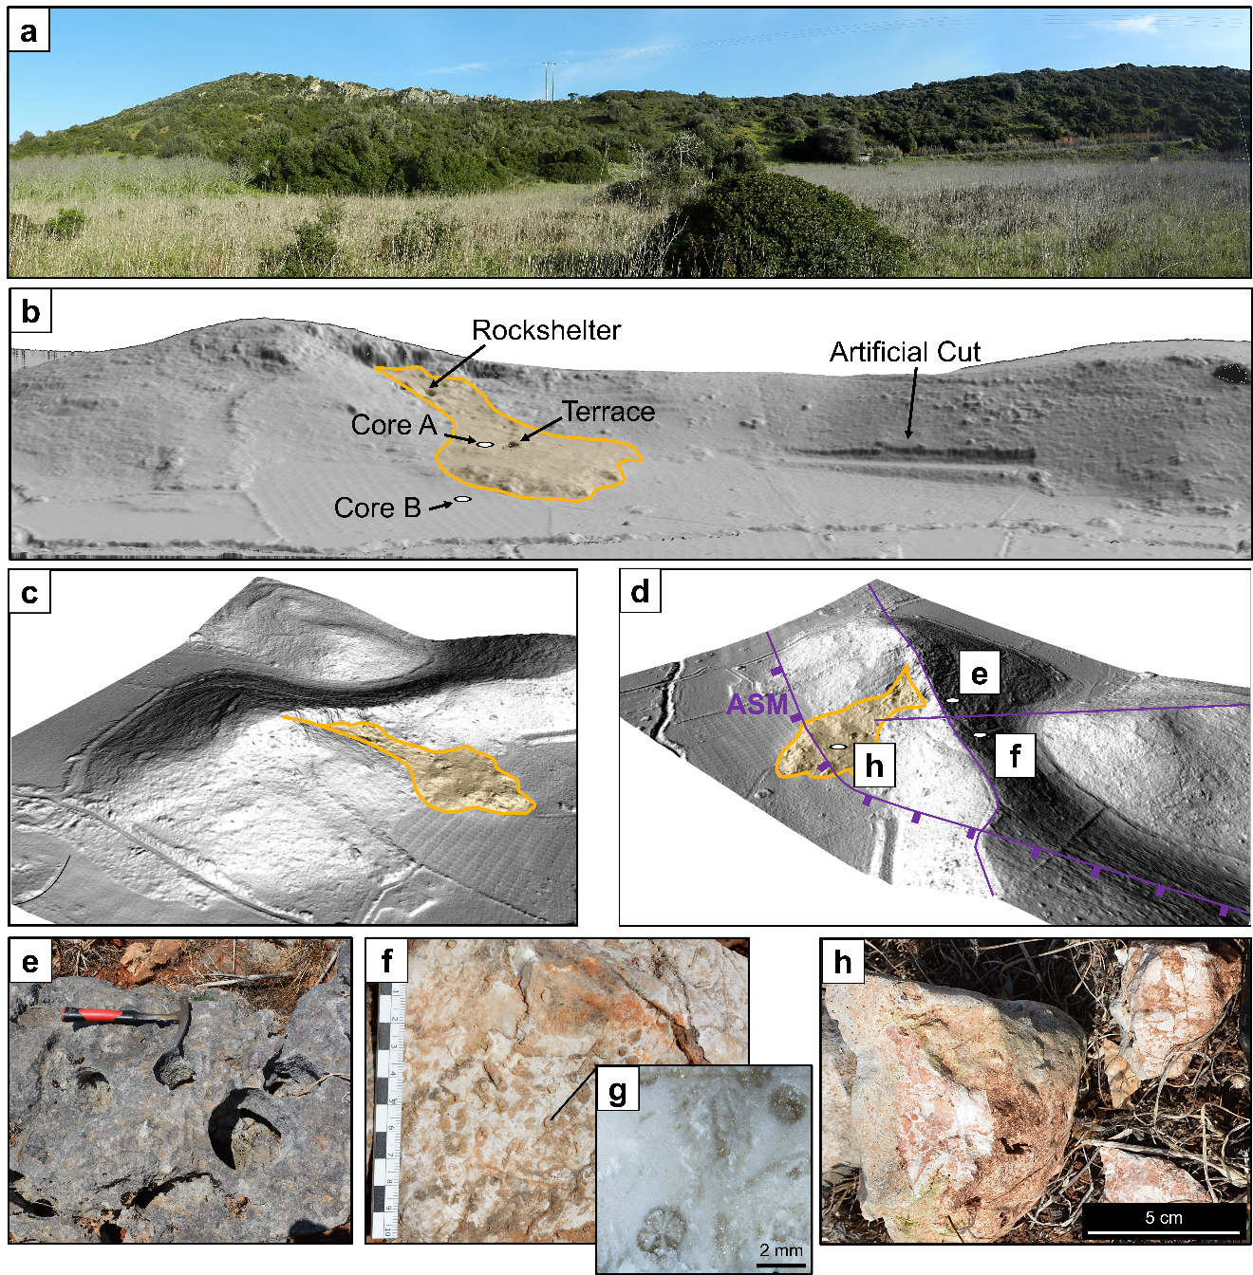

Fig. S1. Main geomorphological features at Vale Boi. Field photo (a) and corresponding LIDAR views (b, c, d) of the Rockshelter and Terrace archaeological areas, the rockfall retaining the archaeological occurrences (in orange), the Artificial Cut, as well as Core A and Core B. (e) Almadena and (f) Espiche limestones outcropping at the hilltop south and north of a potential normal fault. (g) Stereoscopic photomicrograph showing oolite and sea urchin fossils from (f). (h) Fragments of dolomitic breccia resting on the ground surface downslope from the Terrace area.
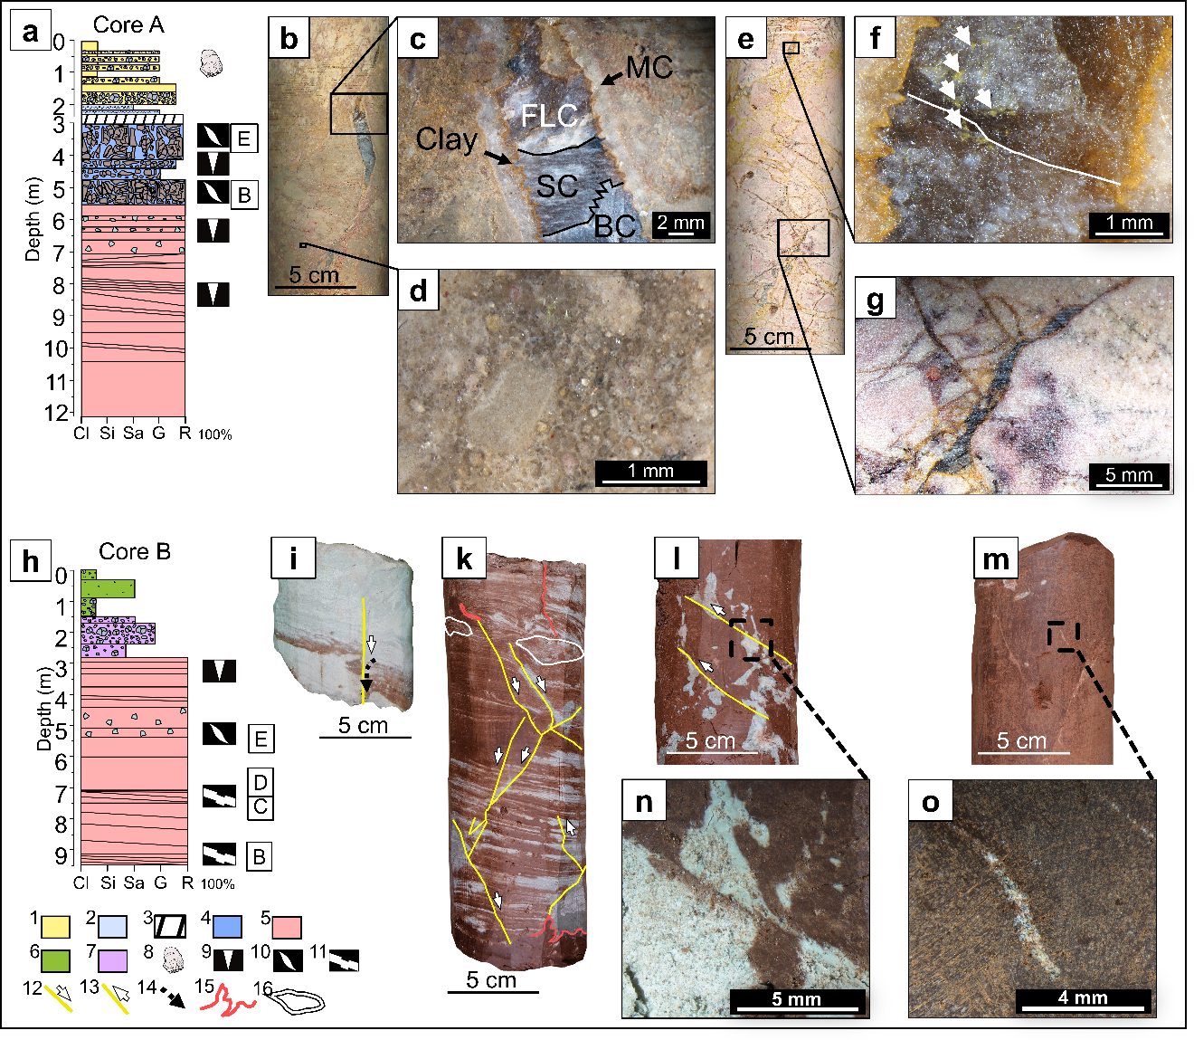

Fig. S2. Tectonic deformations in Cores A and B. (a) Log of Core A. In the x–axis of the log, we labelled the clay (Cl), silt (Si), sand (Sa), and gravel fractions (G), as well as the bedrock (R). (b) and (e) are photographs of core samples, their depth is depicted alongside the core log. Both samples are made from fault breccia (Facies–D) and exhibit sigmoidal veins. They were recovered underneath the archaeological sequence (Facies–F). (c) Stereoscopic photomicrograph showing a sigmoidal vein that underwent multiple cracking and sealing episodes, as documented by the various infilling consisting of micrite (MC), clay (Clay), fan–like sparitic calcite (FLC), stretched calcite (SC), and blocky calcite (BC) (Bons et al. 2012a; Zhao and Li 2022). (d) Stereoscopic photomicrograph showing preserved oolites within Facies–D. (f and g) stereoscopic photomicrographs of sigmoidal veins from (e). In (f), a white line marks a sealed crack, and white arrows indicate yellow clay impurities within the calcite infilling. Further explanation and references are provided in the text. (h) Log of Core B. (i, k, l, m) Photographs of core samples, depth are depicted alongside the core log in (h). (i) and (k) depict sedimentary beds and laminations vertically displaced along slip planes. (l) Bio–galleries filled with calcium carbonate and deformed by shear movement. (m) Sigmoidal veins filed with calcium carbonate. (n) and (o) are stereoscopic photomicrographs from (d) and (e). (1) Facies–F; (2) Facies–E; (3) lost during recovery; (4) Facies–D; (5) Facies–A; (6) Facies–C; (7) Facies–B; (8) undiagnostic Upper Paleolithic lithic artifacts; (9) weathered bedrock; (10) sigmoidal veins; (11) vertically displaced sedimentary structures; (12) normal fault; (13) reverse fault; (14) possible water escape feature; (15) intrusions; (16) mud slumps. All these features are discussed in the text.

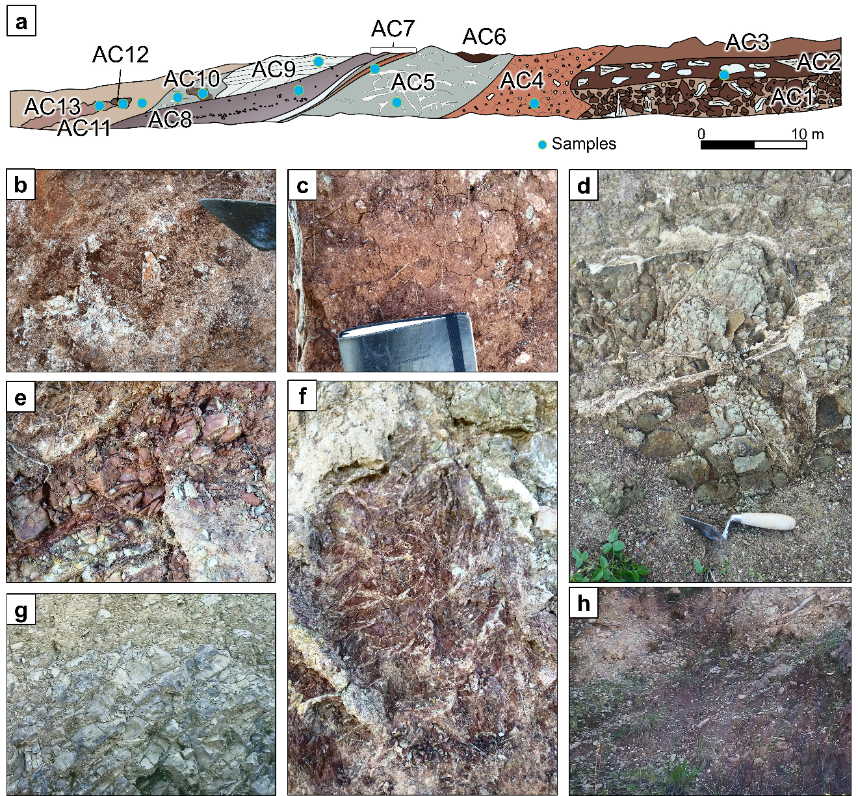

Fig. S3. Carbonated marls of Silves visible in the Artificial Cut. (a) Schematic drawing of the exposed section. Field photos from layers AC1 (b), AC4 (c), AC5 (d), AC7 (e), AC10 (f), AC9 (g), AC8 (h). Light blue circles indicate the position of loose sediment samples used for pH and CaCO3 determinations, as well as stereomicroscopy. Lithological descriptions in Table S1.

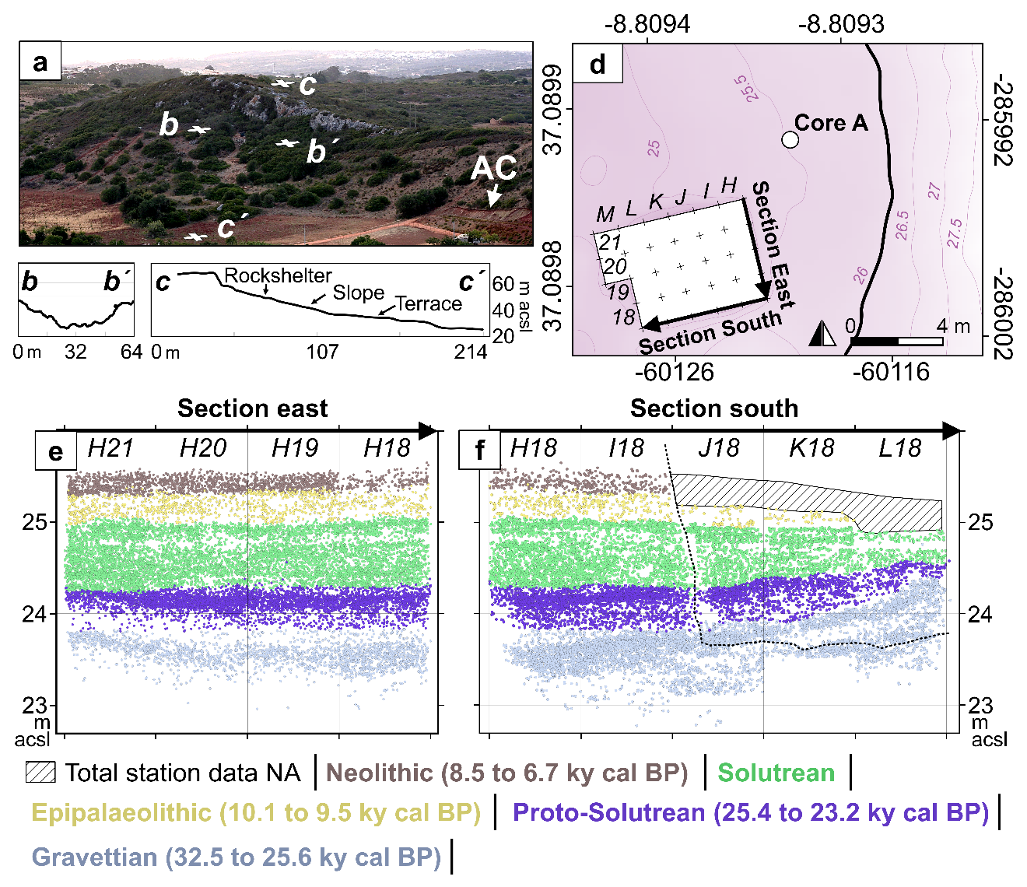Fig. S4. The Terrace of Vale Boi. (a) Photo overview and topography profiles (bb´ and cc´) depicting the archaeological area of Vale Boi. (d) Archaeological trench at the Terrace with labelled excavation squares, each measuring 1 x 1 m. The black solid line depicts a normal fault. In pink, isolines as m above current sea level. (e) Total station points of archaeological materials from squares H21, H20, H19, and H18. (f) Total station points of archaeological materials from squares H18, I18, J18, and L18. Archaeological attribution of the assemblages after (Belmiro et al. 2021). Note that the Gravettian and Proto–Solutrean assemblages dip towards the hilltop. The dashed line marks the limit between the 2003–2010 excavations (above the line) and the 2012–2019 campaigns (below the line). The Neolithic deposit in J18, K18 and L18 were excavated in 5 cm spits without a systematic use of total station, therefore we excluded those total station points from subpanel f.

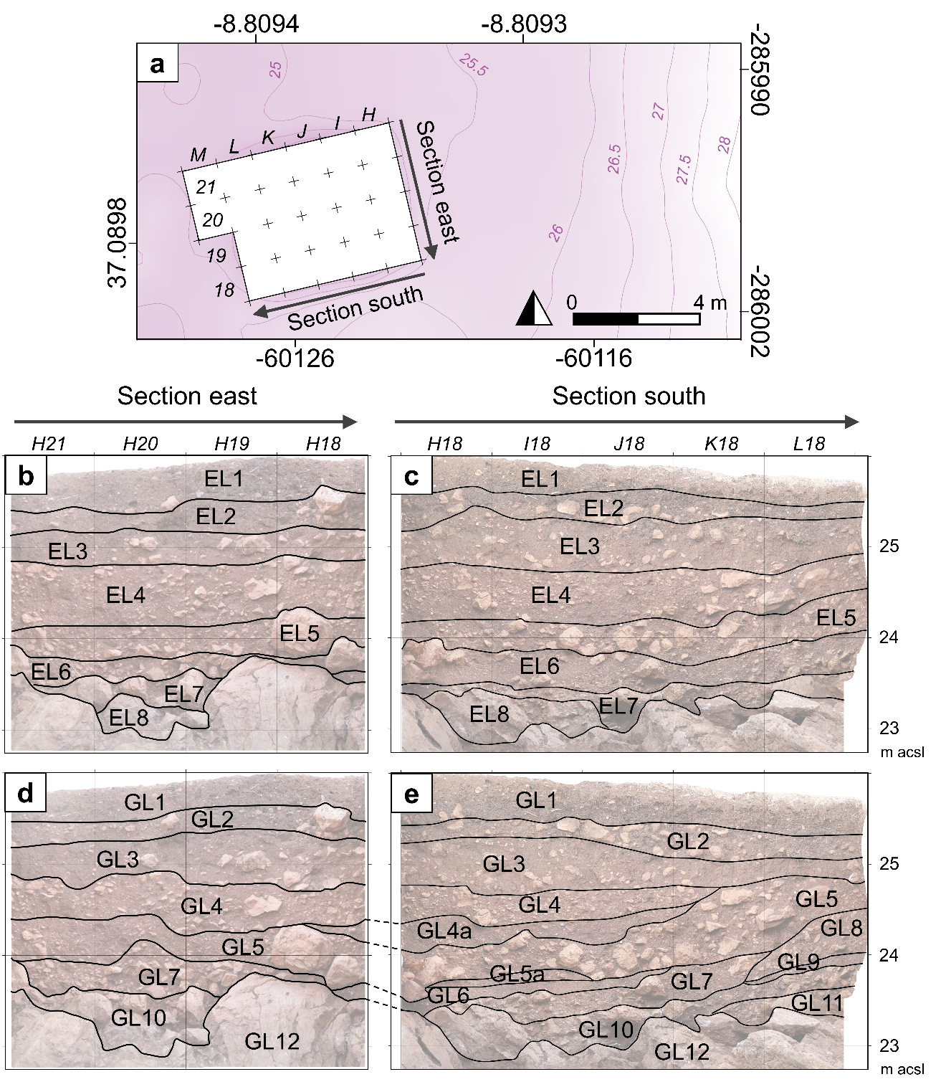

Fig. S5. Comparing Excavator Layers (ELs) and Geological Layers (GLs) in the excavation profiles of the Terrace. (a) Archaeological trench at the Terrace with labelled excavation squares, each measuring 1 x 1 m. Isolines are in dark pink (as m above current sea level, based on our Lidar data). (b) and (c) display the ELs plotted against sections east and south. (d) and (e) show the GLs we distinguished on the same sections.

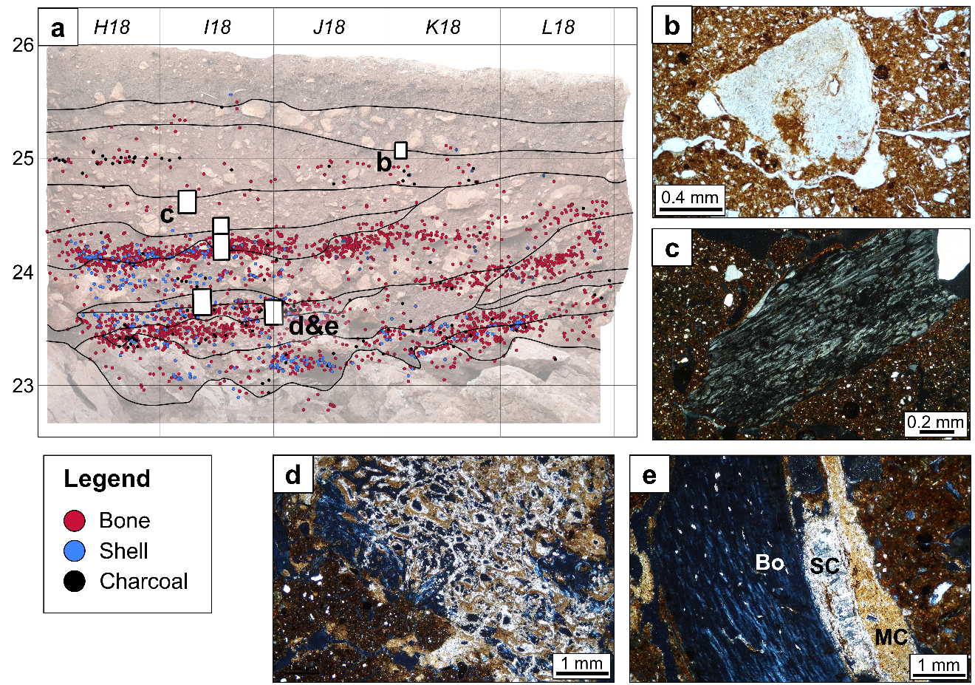
Fig. S6. Shift in pedogenesis and preservation of organic remains. (a) Orthophoto of Section south from the Terrace depicting total station points of bone (in red), shell (in blue), and charcoal fragments (in black) unearthed from squares H18, I18, J18, K18, L18. (b) Dissolving bone fragment from GL3. (c) Weathered bone fragment from GL 4. (d) Bone fragment replaced by calcium carbonate from GL7. (e) Bone fragment (Bo) coated with sparitic (SC) and micritic calcite (MC) from GL7. All photomicrographs in crossed polarized light.

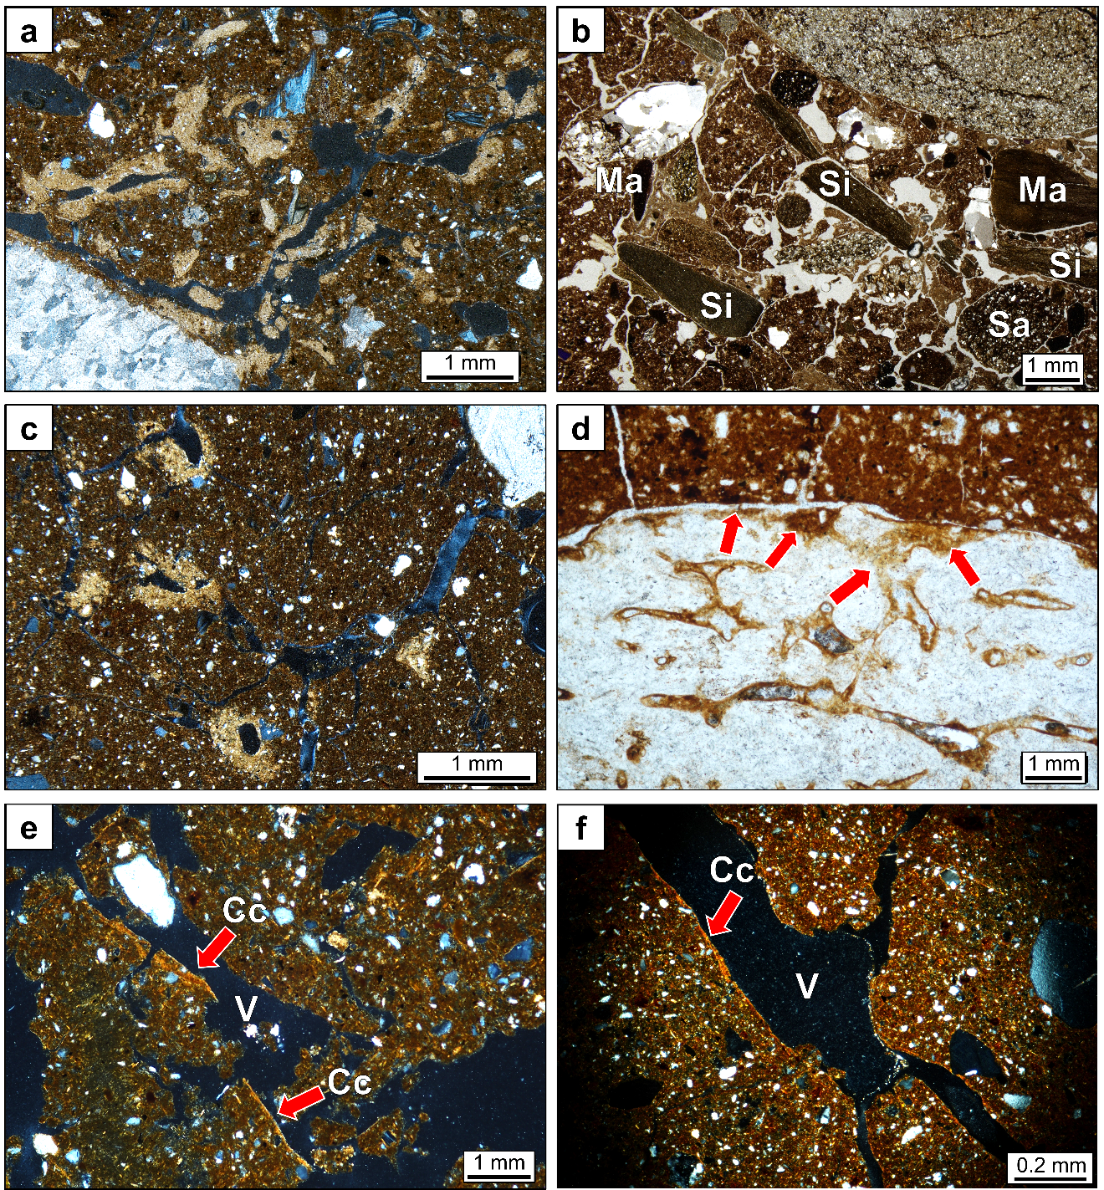Fig. S7. Changes in depositional environments at the Terrace. (a) frequent calcite hypocoatings around biogenic voids, in GL 7. Photomicrograph collected in crossed-polarized light (XPL). (b) rounded fragments of iron-stained marls (Ma), siltstones (Si), and sandstone (Sa) deposited in GL 6. Photomicrograph collected in plane polarized light (PPL). (c) calcite hypocoatings around biogenic voids, in GL 4a. Photomicrograph in XPL. (d) bone fragment with edges and internal structure dissolving into amorphous apatite (marked by red arrows), from GL 4. Photomicrograph in PPL. (e) and (f) limpid clay coatings (Cc) around biogenic voids (V) in GLs 4 and 3, respectively. Photomicrographs in XPL. Paleoenvironmental interpretations are provided in the main text.

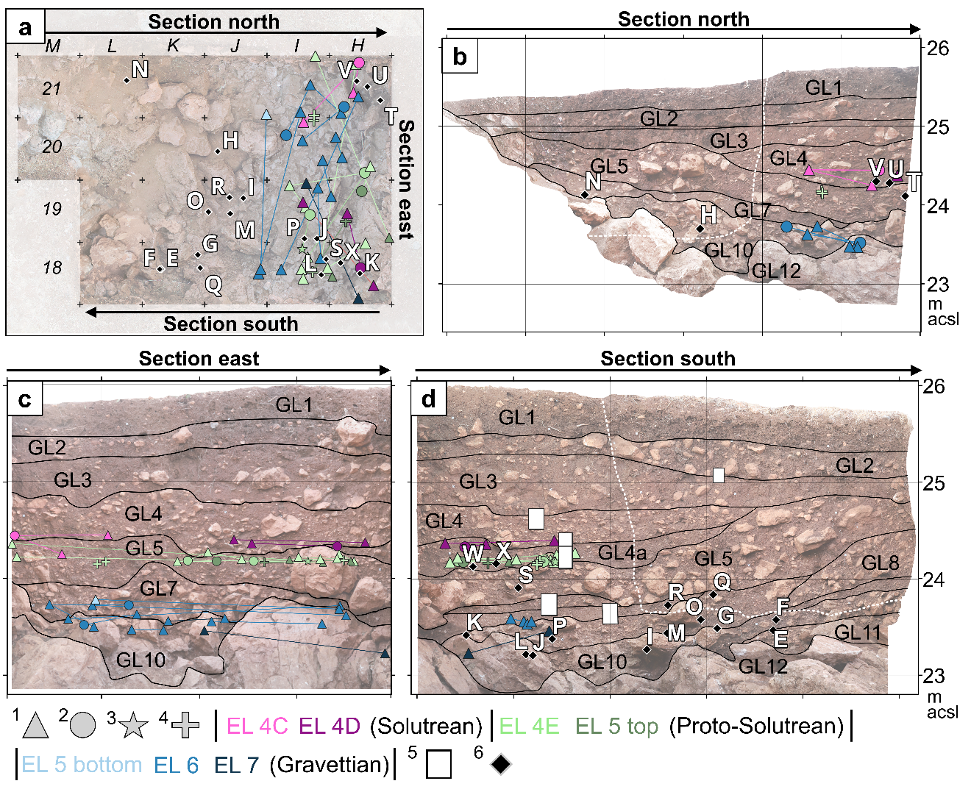

Fig. S8. Spatial distribution of refitting lithics, 14C ages, and geoarchaeological data. (a) Plan view of the Terrace showing all the refitting lithics presented and radiocarbon dating considered in this study. (b) Section north depicting refits and ¹⁴C ages (6) from squares M21–20, L21–20, K21–20, J21–20, I21–20, and H21–20. (c) Section east portraying all the refitting lithics presented in this study, as well as ¹⁴C ages (6) from the squares I21–18 and H21–18. (d) Section south displaying refitting lithics and ¹⁴C dates (6) from squares L19–18, K19–18, J19–18, I19–18, and H19–18. Micromorphological block samples are depicted as white rectangles (5). In (b), (c), and (d) Geoarchaeological Layers (GLs) are depicted and labelled in black. In (b) and (d) white dashed line indicates the limit between the assemblages excavated between 2003 and 2010 (above) and those dug between 2012 and 2019 (below). Note that only the latter have been analysed for refitting lithics. In the plots, refitting pieces are displayed as blanks (1), cores (2), shatters (3), and blank fragments (4). List of plotted radiocarbon ages: Wk-35717 (E), Wk-35712 (F), Wk-35713 (G), Wk-26801 (H), Wk-30676.2 (I), Wk-50393 (J), BRA-4952 (K), BRA-4957 (L), Wk-32147 (M), WK-24762 (N), Wk-30679.2 (O), Wk-50394 (P), Wk-32144.2 (Q), Wk-30677.2 (R), Wk-44416 (S), Wk-42830 (T), Wk-50390 (U), BRA-4936 (V), Wk-42831 (W), BRA-4946 (X). Radiocarbon ages and their Bayesian modelling are presented in the main manuscript text and in section S2.4 of this supplementary file.

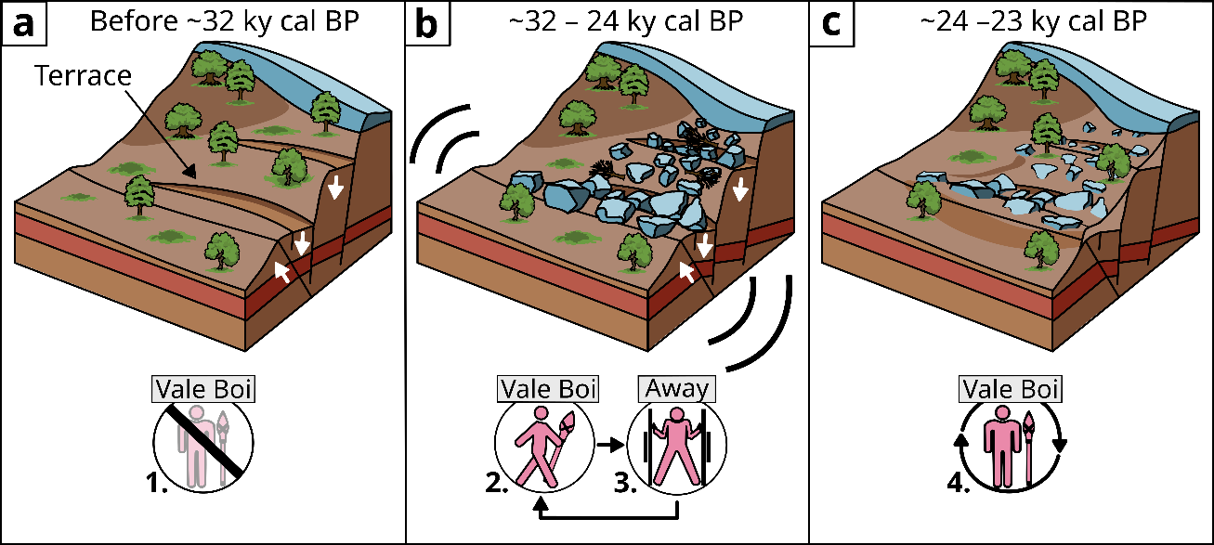

Fig. S9. Faulting, seismic activity, and forager occupations at Vale Boi. (a) Before ~32 ky cal BP, faulting opened depressions in the Carbonated Marls of Silves along the slope of Vale Boi. One of these depressions corresponds to the Terrace area. There is no evidence of forager presence at the site during this phase (1). (b) Between ~32 and 24 ky cal BP, foragers occasionally visited the Terrace (2). Seismic rockfalls periodically filled this tectonic depression with limestone boulders and pushed hunter-gatherers to settle away from the site. Ecological pressure forced early Proto-Solutrean foragers to return to Vale Boi only 50 to 500 years after seismic rockfall, when the extent of Vale Boi´s refugium shrunk due to climatic deterioration (3). (c) Tectonic and seismic activity sharply diminished between 24 and 23 ky cal BP, favoring more frequent forager stays at the site (4).

Table S1. Lithological description of the main geological units distinguished in the Artificial Cut. List of abbreviations: nd= not determined; na= not available; cs= coarse sand; wd= well–developed; san= subangular; sr= subrounded; w= white; y= yellow; p= pink; ge= grey; r–b= reddish–brown; b= brown; fg= fine gravel; tri= triaxial; an= angular; s= smooth; r= rough; ms= medium sand.

Unit: AC1 | Depth (m): na |  | Contact: na |  |  | Bedding: no |  |  | Modern Roots: yes
 | Marl | 10 YR 4/4 with  up to fg grains Gley 2 7/10BG |  |  |  |  |  |  | HCl = weak | pH=7
Unit: AC2 | Depth (m): 2 |  | Contact: sharp |  |  | Bedding: no |  |  | Modern Roots: yes
 | Marl | 10 YR 4/4 with  up to fg grains Gley 2 7/10BG |  |  |  |  |  |  | HCl = high |  | pH=7
 | Pedofeatures: | Frequent, w CaCO3 coatings
Unit: AC3 | Depth (m): 0.5 m |  | Contact: clear |  |  | Bedding: no |  |  | Modern Roots: yes
 | Fine: 90% | 5 YR 5/6, 7.5 YR 5/4 |  | clayey silt |  |  |  | san peds | HCl = weak | pH=7
 | Coarse: 10% | Marl |  | r–b |  |  | mg, fg | tri; r; s
 | Pedofeatures: | Rare, ms, w CaCO3 coatings
Unit: AC4 | Depth (m): na |  | Contact: sharp |  |  | Bedding: no |  |  | Modern Roots: yes
 | Fine: 70% | 2.5 YR 3/4 – 4/6, 10 YR 3/4 |  |  | silty clay |  |  | no | HCl = weak | pH=7
 | Coarse: 30% | Marl |  | ge |  |  | fg–cg | equi; r; r
 | Pedofeatures: | Rare, up to mg, w frags. of CaCO3 coatings
Unit: AC5 | Depth (m): na |  | Contact: sharp |  |  | Bedding: no |  |  | Modern Roots: yes
 | Friable Sandstone | 5 Y 6/3, along cracks: 2.5 YR 4/6, 5 YR 5/4 & 3/4, 2.5 Y 6/6. |  |  |  |  |  |  | HCl = none | pH=6
 | Pedofeatures: | Common, up to mg, w, CaCO3 coatings along root passages
Unit: AC6 | Depth (m): 0.3 m |  | Contact: clear |  |  | Bedding: no |  |  | Modern Roots: yes
 | Fine: 70% | 10 YR 4/3 |  | sandy silt |  |  |  | san peds | HCl = very weak | pH=7
 | Coarse: 30% | Sandstone |  | ge |  |  | mg, fg | tri; r; s
Unit: AC7 | Depth (m): na |  | Contact: sharp |  |  | Bedding: laminated a)b) |  |  | Modern Roots: yes
 | a) Marl | 10 R 5/4, 4/3 |  |  |  |  |  |  | HCl=none | pH=na
 | b) Marl | 5 Y 7/1, 7/3, 6/1 |  |  |  |  |  |  | HCl=very weak | pH=na
Unit: AC8 | Depth (m): na |  | Contact: diffuse |  |  | Bedding: gravel bed  at bottom |  |  | Modern Roots: yes
 | Fine: 70% | 7.5 YR 5/3, 4/2 |  | sandy clay |  |  |  | sr peds | HCl=moderate | pH=6
 | Coarse: 30% | Marl |  | b |  |  | fg–mg | tri, equi; sr, san; s | frequent
 |  | Limestone |  | y |  |  | fg–mg | tri; an; s | rare
 | Pedofeatures: | Common, up to mg, w CaCO3 coatings (also frags.)
Unit: AC9 | Depth (m): 2 |  | Contact: sharp |  |  | Bedding: parallel beds |  |  | Modern Roots: yes
 | Carbonated marl | 5Y 7/2 & 8/1, 10 YR 6/3 |  |  |  |  |  |  | HCl=moderate | pH=6.5
Unit: AC10 | Depth (m): 1.5 |  | Contact: clear |  |  | Bedding: laminated a), b), c) |  |  | Modern Roots: yes
 | a) Weathered marls | 2.5 Y 7/2 & 8/3 |  |  |  |  |  |  | HCl= very high | pH=8
 | b) Weathered marls | 5 Y 5/2 with up to cs grains 5 Y 4/2 &  10 R 4/6.  Laminations 10 R 5/4 with up to cs grains Gley 2 5/5BG.  Micro–laminations 5Y 8/8 |  |  |  |  |  |  | HCl=moderate to high | pH=7
 | c) Chert | 2.5 Y 6/1 & 6/2 |  |  |  |  |  |  | HCl=low to none | pH= na
Unit: AC11 | Depth (m): na |  | Contact: clear |  |  | Bedding: no |  |  | Modern Roots: yes
 | Weathered marls | 10 YR 4/3 (main), 2.5 YR 4/6 & 6/4 |  |  |  |  |  |  | HCl= moderate | pH= 7
 | Pedofeatures: | Rare, ms, w CaCO3 coatings
Unit: AC12 | Depth (m): 1.5 |  | Contact: clear |  |  | Bedding: no |  |  | Modern Roots: yes
 | Carbonated marl | 5 Y 8/1, 10 YR 7/4, 10 YR 7/8 along weathering cracks |  |  |  |  |  |  | HCl=moderate to high | pH= na
 | Pedofeatures: | Common, cs, black Mn oxides
Unit: AC13 | Depth (m): 1.5 |  | Contact: clear |  |  | Bedding: no |  |  | Modern Roots: yes
 | Carbonated marls | 2.5 YR 4/6 & 6/6, 5 YR 5/6,  more weathered 7.5 YR 5/4, 10 YR 6/8 |  |  |  |  |  |  | HCl= high | pH=7

Table S2. Lithological description of Core A. List of abbreviations: nd= not determined; na= not available; ms= medium sand; cs= coarse sand; fg= fine gravel; mg= medium gravel; cg= coarse gravel; w= white; y=yellow; p=pink; re=red; ge=grey; b=black; bro= brown; san= subangular; sr= subrounded; ro= rounded; tri= triaxial; ob= oblate; equi= equiaxial; an= angular; s= smooth; r= rough.

Unit: A0 | Depth (m): 0.31 | Contact: clear | Bedding: normal grading |  |  | Modern Roots: yes
 | Fine: 95% | 7.5 YR 3/2 | silty clay |  | san peds | HCl = weak | pH = 6
 | Coarse: 5% | Limestone | w | mg | tri; san; r | frequent
 |  | Limestone | w, y | fg | tri; an; s, r | common
 |  | Quartz | w | fg | tri; an; s | rare
 | Pedofeatures: | Common, ms, w and p CaCO3 hypocoatings
 |  | Common, ms, w CaCO3 coatings
Unit: A1 | Depth (m): 0.86 | Contact: sharp | Bedding: alternated a), b) |  |  | Modern Roots: yes
a) | Fine: 5% | 7.5 YR 3/3 & 3/4 | silty clay |  | massive | HCl = weak | pH = 6
 | Coarse: 95% | Limestone | w | cg | nd; nd; nd | frequent
 |  | Breccia | w, p | cg | nd; nd; nd | rare
b) | Fine: 90% | 7.5 YR 3/3, 3/4 | silty clay |  | massive | HCL = weak | pH = 7
 | Coarse: 10% | Limestone | w, y | mg | tri; a, san; s, r | frequent
 |  | Limestone | w, y | fg | tri; a, san; s, r | rare
 |  | Chert | p, ge | mg; fg | knapped flakes | rare, only in lower bed
 | Pedofeatures: | Rare, fs, w CaCO3 coatings
Unit: A2 | Depth (m): 1.08 | Contact: clear | Bedding: normal grading |  |  | Modern Roots: yes
 | Fine: 90% | 5 YR 3/4, mottles 5/4 | clayey silt |  | san peds | HCl = weak | pH = 8
 | Coarse: 10% | Limestone | y | fg | tri; an; s | frequent
 |  | Quartz | w | mg | tri; an; s | very rare
 |  | Quartz | w | fg | tri; an; s | rare
 |  | chert | ge | fg | tri; an; s | very rare
 | Pedofeatures: | Common, ms, b, Fe and Mn hypocoatings
 |  | Mottles, ms–sized, w of CaCO3 hypocoatings
Unit: A3 | Depth (m): 1.26 | Contact: sharp | Bedding: no |  |  | Modern Roots: yes
 | Fine: 20% | 5 YR 3/4, mottles 4/4 | silty clay |  | no | HCl = very weak | pH = 7.5
 | Coarse: 80% | Limestone | y, w | fg | tri; an; s, r | frequent
 |  | Limestone | y, w | mg | tri; sr; r | rare
 |  | Siltstone | gr | cg | na; san; r | very rare
Unit: A4 | Depth (m): 1.5 | Contact: sharp | Bedding: no |  |  | Modern Roots: no
 | Limestone |  | w
Unit: A5 | Depth (m): 1.6 | Contact: sharp | Bedding: no |  |  | Modern Roots: no
 | Fine: 5% | 7.5 YR 4/4 | silty clay |  | weak crumby | HCl = weak | pH = 7
 | Coarse: 95% | Limestone | y | fg | tri; sr, ro; s, r | very rare
 |  | Limestone | y, w | mg | tri; sr, san; s | common
 |  | Limestone | w | cg | tri, ob; sr, san; s, o | frequent
Unit: A6 | Depth (m): 1.85 | Contact: sharp | Bedding: no |  |  | Modern Roots: yes
 | Fine: 5% | 7.5 YR 3/3 | clayey silty |  | weak crumby | HCl = mod. | pH = 7
 | Coarse: 95% | Limestone | w | fg | tri; sr; r | very rare
 |  | Limestone | w | mg | tri; sr; r | common
 |  | Limestone | w | cg | tri; sr; r | common
Unit: A7 | Depth (m): 1.9 | Contact: sharp | Bedding: no |  |  | Modern Roots: yes
 | silty sand | 7.5 YR 5/6 & 7/4 & 6/4; 5YR 5/8; 5Y 7/2 |  |  | weak crumby | HCl = very high | pH = 6
 | Pedofeatures: | Dishortic Fe & Mn nodules |  | fg | equi; sr; s | na
 |  | Common, ms, w CaCO3 Hypocoatings
Unit: A8 | Depth (m): 1.97 | Contact: sharp | Bedding: no |  |  | Modern Roots: no
 | sandy clay | 7.5 YR 5/8 & 7/8; 5Y 6/1 |  |  | weak crumby | HCl = very high | pH = 7
 | Pedofeatures: | fg–sized, equi; sr; s dishortic Fe & Mn nodules
Unit: A9 | Depth (m): 3 | Contact: na | Bedding: na |  |  | Modern Roots: na
 | Fine: 10% | 7.5 YR 4/6 & 6/4 | sand |  | loose | HCl = very high | pH =na
 | Coarse: 90% | Limestone | w, g, y | fg– mg | tri, equi; sr,ro; r
 | We lost the lowermost meter of A9, because too sandy and lose to be retrieved.
Unit: A10 | Depth (m): 4 | Contact: clear | Bedding: no |  |  | Modern Roots: yes
 | Fault Breccia |  | p, re
 | locally weathered into sand (7.5 YR 8/4 & 5/6) and clay (2.5 Y 8/4; 10 YR 7/6 & 5/6)
Unit: A11 | Depth (m): 4.3 | Contact: sharp | Bedding: no |  |  | Modern Roots: no
 | fine: 5% | 7.5 YR 4/4 & 7/4 | silty sand |  | loose | HCl = high | pH = 7
 | Coarse: 95% | Fault Breccia | p, w | mg– fg | tri; sr, san; r
Unit: A12 | Depth (m): 5.9 | Contact: sharp | Bedding: no |  |  | Modern Roots: no
 | Fault Breccia |  | p, w
 | In fractures, it weathers into silty clay (7.5 YR 7/1; 2.5 YR 7/3; 10 YR 3/3)
Unit: A13 | Depth (m): 6.37 | Contact: clear | Bedding: no |  |  | Modern Roots: yes
 | Fine: 90% | 10 YR 6/6; 5 YR 6/8; 2.5 YR 7/2 & 4/4 & 4/6 | silty clay |  | loose | HCl = high | pH = 5
 | Coarse: 10% | Limestone | w, ge | fg– mg | equi; sr; s | common
 |  | Weathered marls | re, ge | fg–mg | tri; sr; r | frequent
Unit: A14 | Depth (m): 7.6 | Contact: clear | Bedding: alternated a), b) |  |  | Modern Roots: yes
a) | Fine: 95% | 2.5 YR 4/4 | silty clay |  | massive | HCl = high | pH = 5
b) | Fine: 95% | Gley 1 7/5 GY & 7/1 & 5/5G | sandy silt |  | massive | HCL = high | pH = 6
 | Coarse: 5% | Limestone | w, y | mg | tri; sr; na | common
 |  | Limestone | w, y | fg | tri; sr; na | rare
 |  | Weathered Marl | p, ge | mg | equi; sr; na | common
 |  | Weathered Marl | p, ge | fg | equi; sr; na | rare
Unit: A15 | Depth (m): 9.64 | Contact: clear | Bedding: alternating |  |  | Modern Roots: yes
 | a) silty clay | 2.5 YR 4/4 & 3/4 |  |  | san blocky | HCl = low | pH = 6
 | b) silty clay | Gley 1 8/10 Y1 8/N |  |  | san blocky | HCL = high | pH = 6
 | c) silty clay | 2.5 Y 8/4 & 8/6 & 8/8 & 7/6 |  |  | san blocky | HCL = low | pH = 6
Unit: A16 | Depth (m): 9.8 | Contact: clear | Bedding: no |  |  | Modern Roots: no
 | Fine: 100% | 2.5 YR 3/6 | sandy clay |  | san blocky | HCl = moderate | pH = 6
Unit: A17 | Depth (m): 10.5 | Contact: sharp | Bedding: no |  |  | Modern Roots: no
 | fine: 85% | Gley 1 4/10 GY & 2.5/5G | clayey sand |  | loose | HCl = moderate | pH = 7
 | Coarse: 15% | Siltstone | green | cg | ns; sr; s, r
Unit: A18 | Depth (m): 11.6 | Contact: clear | Bedding: no |  |  | Modern Roots: no
 | Same as A16 but cemented by CaCO3. Bottom part is rock hard.
Unit: A19 | Depth (m): 12 | Contact: na | Bedding: alternating |  |  | Modern Roots: no
 | Same as A15 but pH = 5.5.
END OF DRILLING

Table S3. Lithological description of Core B. List of abbreviations: nd= not determined; na= not available; ms= medium sand; cs= coarse sand; fg= fine gravel; mg= medium gravel; cg= coarse gravel; w= white; y= yellow; p= pink; re= red; ge= grey; b=black; bro=brown; san= subangular; sr= subrounded; ro= rounded; tri= triaxial; ob= oblate; equi= equiaxial; an= angular; s= smooth; r= rough.

Unit: B0 | Depth (m): 0.3 | Contact: clear | Bedding: no |  |  | Modern Roots: yes
 | Fine: 75% | 7.5 YR 3/3 | clayey silty |  | san blocky | HCl = no |  |  |  | pH = 6
 | Coarse: 25% | Limestone | w | fg | tri, ob; san, sr; r | common
 |  | Limestone | w | mg | tri, ob; san, sr; r | rare
 |  | Limestone | w | cg | tri, ob; san, sr; r | rare
 |  | Marl | b, ge | mg | equi; sr, san; s | rare
 |  | Marl | b, ge | fg | ob; sr, san; s | very rare
 |  | Quartz | w | fg | ob; sa; s, r | very rare
Unit: B1 | Depth (m): 0.94 | Contact: diffuse | Bedding: weak |  |  | Modern Roots: yes
 | Fine: 90% | 7.5 YR 3/4 | clay with cs |  | massive | HCl = high |  |  | pH = 6
 | Coarse: 10% | Limestone | y | fg | tr; a; s | frequent
 |  | Limestone | y | mg | tr; san; s | common
 |  | Marl | b | fg | tri, ob; sr, ro; r, s | very rare
 |  | Quartz | w | fg | equi; sr; s, r | very rare
 |  | Shells | w | fg | ob; sr; s, r | very rare
Unit: B2 | Depth (m): 1.5 | Contact: sharp | Bedding: no |  |  | Modern Roots: yes
 | Fine: 60% | 7.5 YR 3/3 | sandy clay |  | massive | HCl = high |  |  |  | pH = 6
 | Coarse: 40% | Limestone | y | fg | tri; an; s | common
 |  | Marl | b, bro | fg | tri, ob; san, sr; s, r | common
 |  | Limestone | y | mg | tri; sr; r | rare
 |  | Marl | b, bro | mg | tri, ob; san, sr; s | rare
 |  | Quartz | w | fg | tri; an; s | rare
 | Pedofeatures: | Common, cas, b, Fe & Mn mottles
Unit: B3 | Depth (m): 1.7 | Contact: clear | Bedding: no |  |  | Modern Roots: no
 | Fine: 20% | 10 YR 6/4, 2.5 Y 6/4 | clayey silt |  | massive | HCl = high |  |  |  | pH = 6
 | Coarse: 80% | Limestone | w | mg | tr; r; r | frequent
 |  | Marl | b, bro | fg | ob; ro, a; s | common
 |  | Limestone | y, w | fg | ob; ro; r | rare
 |  | Sandstone | re | fg | tri; sr; r | very rare
 | Pedofeatures: | Common, cs, b, Fe & Mn mottles
Unit: B4 | Depth (m): 2.4 | Contact: clear | Bedding: no |  |  | Modern Roots: no
 | Fine: 30% | as B3
 | Coarse: 70% | as B3
Unit: B5 | Depth (m): 2.8 | Contact: sharp | Bedding: no |  |  | Modern Roots: no
 | Fine: 70% | 7.5 YR 3/3 & 4/3 | clay with rare sand |  | massive | HCl = high |  |  |  | pH = 9
 | Coarse: 30% | Limestone | w | fg | tri; sr, ro; s, r | very rare
 |  | Limestone | w | mg | tri; sr, san; s | common
Unit: B6 | Depth (m): 3 | Contact: clear | Bedding: no |  |  | Modern Roots: na
 | Weathered carbonate marl |  | bro |  |  | HCl = high |  |  |  | pH = 6
Unit: B7 | Depth (m): 3.2 | Contact: clear | Bedding: no |  |  | Modern Roots: na
 | Weathered marl |  | bro |  |  | HCl = mod. low |  |  |  | pH = 6
Unit: B8 | Depth (m): 3.4 | Contact: nd | Bedding: no |  |  | Modern Roots: no
 | Weathered marl |  | bro with Fe & Mn speckles |  |  | HCl = high |  |  |  | pH = 6
Unit: B9 | Depth (m): 3 | Contact: sharp | Bedding: na |  |  | Modern Roots: na
 | Well–sorted marl |  | bro |  |  | HCl = no |  |  |  | pH = 6
Unit: B10 | Depth (m): 4.5 | Contact: clear | Bedding: alternating a), b) |  |  | Modern Roots: no
 | a) Sandy marl |  | dark bro |  |  | HCl = moderate | pH = 6.5
 | b) Marl |  | ge |  |  | HCl = moderate | pH = 6.5
Unit: B11 | Depth (m): 4.8 | Contact: clear | Bedding: no |  |  | Modern Roots: no
 | Marl |  | re–bro |  |  | HCl = high |  | pH = 6
Unit: B12 | Depth (m): 5.4 | Contact: sharp | Bedding: laminated |  |  | Modern Roots: no
 | Marl exhibiting rounded fg grains of gleyed marls |  | y–bro |  |  | HCl = low | pH = 5.5
Unit: B13 | Depth (m): 6.13 | Contact: clear | Bedding: no |  |  | Modern Roots: yes
 | Weathered marl with rare up to mg–sized grains of gleyed marls |  | dark bro |  |  | HCl = low |  |  |  | pH = 5
Unit: B14 | Depth (m): 7.1 | Contact: sharp | Bedding: laminated |  |  | Modern Roots: yes
 | Marl laminations deformed by normal faults |  | ge and bro–red |  |  | HCl = low |  |  | pH = 6
Unit: B15 | Depth (m): 7.5 | Contact: sharp | Bedding: laminated |  |  | Modern Roots: yes
 | Alternating bro and ge marl laminations deformed by normal faults |  |  |  |  | HCl = no |  |  | pH = 6
Unit: B16 | Depth (m): 9.35 | Contact: sharp | Bedding: laminated |  |  | Modern Roots: no
 | As B15 |  |  |  |  |  |  |  | pH = 5
Unit: B17 | Depth (m): 9.7 | Contact: sharp | Bedding: laminated |  |  | Modern Roots: no
 | Alternating bro and ge sandy marl laminations deformed by faults |  |  |  |  | HCl = no |  | pH = 6.5
END OF DRILLING

Table S4. Description of ELs based on (Bicho et al. 2003, 2012; Carvalho et al. 2008; Belmiro et al. 2021).
Unit | Texture | Colour | Thickness | Archaeology | Notes
EL 1 | sandy–clayey | dark brown to reddish–brown | 35 cm | modern | possibly disturbed by agricultural activity
EL 2 | richer in clayey than EL 1 | brown | 25 – 30 cm | early Neolithic | articulated bones and ceramics; hut structure
EL 3  (3a, 3b) | silt and clay with limestone fragments; sublayers separated by bed richer in limestone fragments | brown | 25 – 30 cm | Epipaleolithic (3a) Solutrean (3b)
EL 4, (4a, 4b, 4c, 4d, 4e) | similar to EL 3 but more compact, discreate layers rich in organic materials (4b, 4c, 4d, and 4e) | brown | 40 – 50 cm | Solutrean (4a – 4d)  Proto–Solutrean (4e)
EL 5 | silt and clay rich in organic remains, often calcined | dark brown | 20 – 30 cm | Proto–Solutrean (top)  Gravettian (bottom)
EL 6 | similar to EL 5 but poorer in limestone fragments | dark brown | 20 – 25 cm | Gravettian | ferruginous concretions
EL 7 | similar to EL 6 but richer in limestone fragments | dark brown | 5 – 25 cm | Gravettian | low frequency of archaeological materials
EL 8 | similar to EL 7, resting on top of large limestone rocks | dark brown | 25 – 30 cm | Gravettian | low frequency of archaeological materials

Table S5. Lithological description of the Geological Layers (GL) distinguished in the excavation trench of the Terrace area. List of abbreviations: nd= not determined; na= not available; fg = fine gravel; mg = medium gravel; cg = coarse gravel; cb = cobble; bo = boulder; tri = triaxial; obl = oblate; sr = subrounded; a = angular.

Unit: GL1 | Depth (m):  0.3 m | Contact:  clear, smooth, sub–horizontal |  | Bedding:  no |  |  | Modern Roots:  yes
 | Fine: 90% | 5YR 4/3 | Silty clay |  |  | loose, granular |  | pH=5
 | Coarse: 10% | Limestone | 8% | fg | tri; sr
 |  |  | 90% | mg | tri; sr
 |  |  | 2% | cg | tri; sr
Unit: GL2 | Depth (m):  0.6 m – 0.15 m | Contact:  sharp, tongued, sub–horizontal |  | Bedding:  weak sub–horizontal  beds |  |  | Modern Roots:  yes
 | Fine: 90% | 2.5 YR 4/3 | Silty clay |  |  | poorly aggregated in grains |  | pH=6
 | Coarse: 10% | Bone | 10% | fg
 |  | Limestone | 10% | mg | tri; sr–a
 |  | Limestone | 75% | cg–cb | tri; sr |  | recrystallized
 |  | Quartzite | 5% | mg | tri; a
Unit: GL3 | Depth (m):  1.2 m | Contact:  clear, smooth, sub–horizontal |  | Bedding:  no |  |  | Modern Roots:  yes
 | Fine: 75% | 5YR 4/3 | Silty clay |  |  | weak columnar aggregation |  | pH=5
 | Coarse: 25% | Limestone | 5% | fg | tri; sr–a
 |  | Limestone | 15% | mg | tri; sr–a
 |  | Limestone | 50% | cg–cb | tri; sr |  | recrystallized
 |  | Quartzite | 15% | fg–mg | tri; a
 |  | Bone | 5% | fg–mg | tri; a |  | Burnt and unburnt
Unit: GL4 | Depth (m):  1.6 m | Contact:  clear–diffuse, wavy, dips uphill |  | Bedding:  weak sub–horizontal |  |  | Modern Roots:  yes
 | Fine: 60% | 2.5 YR 4/3 | Silty clay |  |  | nd |  | pH=6
 | Coarse: 40% | Limestone | 70% | fg | tri; sr
 |  | Limestone | 20% | mg | tri–obl; sr–sa
 |  | Quartzite | 7% | fg | tri; a
 |  | Quartzite | 2% | mg | tri; a
 |  | Bone | 1% | fg | tri; a
Unit: GL4a | Depth (m):  1.7 m – 1.9 m | Contact:  clear, wavy–lobate, dips uphill |  | Bedding:  upslope dipping and imbrication |  |  | Modern Roots:  yes
 | Fine: 75% | 5 YR 4/4 | Silty clay |  |  | nd |  | pH=5
 | Coarse: 25% | Limestone | 94% | mg | tri–obl; sr–sa |  | dissolution and recrystallization
 |  | Bone | 3% | mg | tri–obl; a
 |  | Quartzite | 1% | fg | tri; a
 |  | Quartzite | 2% | mg | tri; a
Unit: GL5 | Depth (m):  0.9 m – 1.7 m | Contact:  clear, wavy–lobate, dips uphill |  | Bedding:  upslope dipping and imbrication |  |  | Modern Roots:  yes
 | Fine: 50% | 5 YR 4/3 | Silty clay |  |  | no |  | pH=5
 | Coarse: 50% | Limestone | 50% | bo | tri; sr |  | dissolution and recrystallization
 |  | Limestone | 49% | cg | tri; sr |  | dissolution and recrystallization
 |  | Quartzite | 1% | fg | tri; a
Unit: GL5a | Depth (m):  2.1 m – 2.12 m | Contact:  sharp, smooth, dips slightly uphill |  | Bedding:  sub–horizontal |  |  | Modern Roots:  yes
 | Fine: 35% | 2.5 YR 4/3 | Silty clay |  |  | no |  | pH=6
 | Coarse: 65% | Limestone | 86% | mg | tri–obl; a
 |  | Limestone | 10% | cg | tri; a
 |  | Quartz | 1% | fg | tri; a
 |  | Bone | 3% | fg | tri–obl; a
Unit: GL6 | Depth (m):  2.23 m –  2.37 m | Contact:  sharp, smooth, dips slightly uphill |  | Bedding:  sub–horizontal |  |  | Modern Roots:  yes
 | Fine: 90% | 5 YR 4/4;  5 YR 4/6 | Clay with silt |  |  | no |  | pH=6
 | Coarse: 10% | Limestone | 70% | mg | tri–obl; sa–sr
 |  | Limestone | 15% | cg | tri–obl; a
 |  | Bone | 12% | cg | tri–obl; a
 |  | Quartz | 3% | fg | tri; a
Unit: GL7 | Depth (m):  2.3 m –  2.5 m | Contact:  diffuse–wavy, smooth, dips uphill |  | Bedding:  weak sub–horizontal |  |  | Modern Roots:  yes
 | Fine: 60% | 2.5 YR 3/4 | Clay with little silt |  |  | no |  | pH=6
 | Coarse: 40% | Limestone | 60% | mg | tri; sa
 |  | Limestone | 30% | cg | tri; sa
 |  | Limestone | 5% | fg | tri–obl; sa
 |  | Bone | 5% | mg | obl; sa
 |  | Quartz | 3% | fg | tri; a
Unit: GL8 | Depth (m):  0.85 m –  1.95 m | Contact:  diffuse, smooth, dips uphill |  | Bedding:  no |  |  | Modern Roots:  yes
 | Fine: 35% | 2.5 YR 4/3 | Clay sand /  Silty sand |  |  | weakly aggregated in grains with 2.5 YR 5/6 coatings |  | pH=6
 | Coarse: 65% | Limestone | 30% | cb | tri; sa |  | weathered
 |  | Limestone | 55% | cg | tri; sa |  | weathered
 |  | Limestone | 10% | mg | tri–obl; sa
 |  | Limestone | 5% | fg | obl; sa
Unit: GL9 | Depth (m):  1.08 m –  2.1 m | Contact:  clear, smooth, dips uphill |  | Bedding:  no |  |  | Modern Roots:  yes
 | Fine: 60% | 5 YR 4/4 | Clay sand /  Silty sand |  |  | weakly aggregated in grains with 2.5 YR 5/6 coatings |  | pH=7
 | Coarse: 40% | Limestone | 30% | fg | tri; sr
 |  | Limestone | 70% | mg | tri; sr
Unit: GL10 | Depth (m):  1.3 m –  2.6 m | Contact:  clear, smooth, dips uphill |  | Bedding:  stacked beds |  |  | Modern Roots:  yes
 | Fine: 5% | 5 YR 4/4 | Clay sand /  Silty sand |  |  | weakly aggregated in grains with 2.5 YR 5/6 coatings |  | pH=6.5
 | Coarse: 95% | Limestone | 40% | bo | tri; sa
 |  | Limestone | 30% | mg | tri–obl; sa
 |  | Limestone | 10% | cg | tri; sa
 |  | Limestone | 10% | fg | tri; sa
Unit: GL11 | Depth (m):  2.0 m | Contact:  sharp, smooth, dips uphill |  | Bedding:  stacked beds |  |  | Modern Roots:  yes
 | Fine: 10% | 2.5 YR 3/3 | Sandy silt with some clay |  |  | weakly aggregated in grains with 2.5 YR 5/6 coatings |  | pH=nd
 | Coarse: 90% | Limestone | 30% | fg | tri; sa
 |  | Limestone | 60% | mg | tri; sa
 |  | Limestone | 10% | cg | tri; sa
Unit: GL12 | Depth (m):  na | Contact:  na |  | Bedding:  na |  |  | Modern Roots:  yes
 | Fine: 5% | 2.5 YR 3/3 | Sandy silt with some clay |  |  | weakly aggregated in grains with 2.5 YR 5/6 coatings |  | pH=nd
 | Coarse: 95% | Limestone | 5% | fg | tri; sa
 |  | Limestone | 15% | mg | tri; sa
 |  | Limestone | 10% | cg | tri; sa
 |  | Limestone | 70% | bo | tri; sa–sr
END OF EXCAVATION

Table S6. Correlation between ELs and GLs and archaeological traditions.
Archaeology | EL | GL
Modern | EL1 | GL 1
Early Neolithic | EL 2 | GL 2
Epipalaeolithic | EL 3 | GL 3
Solutrean | EL 3 | GL 3
Solutrean | EL 4(a–d) | GLs 4, 4a
Proto–Solutrean | EL 4e  EL 5 | GLs 4a bottom, GL 5
Late Gravettian | EL 6 | GLs 5a, 6, 7
Early Gravettian | EL 7 | GLs 7, 10, 11
Early Gravettian | EL 8 | GLs 7, 10, 11

Table S7. Description of thin sections from the Terrace. List of abbreviations: n.a. = not described.

Unit GL 2
Voids | 25% of thin section, channels and chambers.
Aggregation | Well–developed, accommodating, subrounded and subangular, highly separated, up to fine gravel–sized blocky peds.
Microstructure | Subrounded–subangular blocky microstructure.
c/f | 500 µm open porphyric.
Coarse | 25% of the thin section surface, unsorted, randomly oriented.  Components:  - Frequent, shape n.a., subrounded, smooth, medium gravel–sized fragment of fresh, oolitic limestone.  - Frequent prolate and equant, subrounded to subangular, smooth, coarse sand to fine gravel–sized quartz fragments. Some of them have dog–toothed edges (but it is not active weathering).  - Common prolate, angular to subrounded, smooth, coarse sand to fine gravel–sized bones. Most of them have been heated. Some of them are coated with iron–manganese oxides.  - Rare prolate and equant, subrounded to subangular, smooth to rough, up to coarse sand–sized fragments of charcoal.  - Very rare prolate to acicular, angular, smooth, medium sand–sized frags of lithic debitage.
Fine | 50% of thin section surface, unsorted, random orientation of the components. Reddish brown in XPL and PPL. Crystallitic b–fabric. Frequent quartz, bones, clay, rare charcoals, and micas.
Pedofeatures | Common, prolate, subrounded, smooth fragments of disorthic and unorthic iron–manganese nodules. Some are quite rich in silt of quartz and rare micas, occasionally organized in weak laminations.
Unit GL 3
Voids | 25% of thin section, channels and chambers.
Aggregation | Well–developed, accommodating, subrounded and subangular, highly separated, up to fine gravel–sized blocky peds.
Microstructure | Subrounded–subangular blocky microstructure.
c/f | 500 µm open porphyric.
Coarse | 25% of the thin section surface, unsorted.  Components:  - Frequent equant, subrounded, rough to dog–toothed, up to medium gravel–sized weakly dissolving, fragments of oolitic and brecciated limestone.  - Frequent prolate, angular to subrounded, smooth, coarse sand to fine gravel–sized bones and teeth. Some of them have been heated.  - Common prolate and equant, subrounded to subangular, smooth, coarse sand to fine gravel–sized quartz fragments. Some of them have dog–toothed edges (but it is not active weathering). Polycrystalline grains are more common than in GL2.  - Very rare fragments of fresh roots.
Fine | 50% of thin section surface, unsorted, random orientation of the components. Reddish brown in XPL and PPL. Crystallitic, locally poro– and granostriated b–fabric. Frequent quartz, bones, clay, very rare glauconite.
Pedofeatures | Common, prolate, subrounded, smooth up to coarse sand–sized fragments of disorthic and unorthic iron–manganese nodules rich in silt of quartz.  Around root voids very rare calcite hypocoatings up to 100 µm thick. Rare limpid clay hypocoatings around root voids, up to 50 µm thick, orange in XPL, brown in PPL.
Unit GL 4
Voids | 25% of thin section, channels and chambers.
Aggregation | Well–developed, accommodating, subrounded and subangular, highly separated, up to fine gravel–sized blocky peds.
Microstructure | Subrounded–subangular blocky microstructure.
c/f | 500 µm open porphyric.
Coarse | 25% of the thin section surface, unsorted, crude bedding.  Components:  - Frequent equant, subrounded, rough to dog–toothed, up to medium gravel–sized weakly dissolving, fragments of oolitic and brecciated limestone.  - Frequent prolate, angular to subrounded, smooth, coarse sand to medium gravel–sized bones and teeth. Some of them have been heated. A few of them are in the early stages of dissolution, showing rough and diffuse edges and osteon structure not well preserved.  - Common prolate and equant, subrounded to subangular, smooth, coarse sand to fine gravel–sized fragments of quartz.  - Common prolate, subangular, dog–toothed up to coarse sand–sized fragments of gypsum.  - Very rare equant, subrounded, smooth, up to coarse sand–sized potential coprolite fragments, coated with silty clay that is stained by iron–manganese oxides.  - Very rare prolate, rounded, smooth, up to fine gravel–sized fragments of reddish–brown siltstone.  - Very rare fragments of fresh roots.  - Very rare prolate, subangular, smooth to rough, up to medium sand–sized shell fragments.
Fine | 50% of thin section surface, unsorted, random orientation of the components. Reddish brown in XPL and PPL. Crystallitic, locally poro– and granostriated b–fabric. Frequent quartz, bones, clay, very rare glauconite.
Pedofeatures | Common, prolate, subrounded, smooth up to coarse sand–sized fragments of disorthic and unorthic iron–manganese nodules rich in silt of quartz. Common orthic iron–manganese nodules up to 200 µm.  Around root voids common calcite hypocoatings up to 100 µm thick.
Unit GL 4a
Voids | 40% of thin section, channels and chambers.
Aggregation | Poorly developed, partly accommodating, subrounded, highly separated, up to fine gravel–sized blocky peds.
Microstructure | Subrounded blocky microstructure.
c/f | 160 µm open porphyric.
Coarse | 20% of the thin section surface, moderately sorted, randomly oriented.  Components:  - Frequent prolate, angular to subrounded, smooth, fine to coarse sand–sized quartz and feldspars.  - Rare prolate, angular to subrounded, smooth, fine to coarse sand–sized bone and tooth fragments.  - Very rare prolate, angular, dog toothed, up to coarse sand sized gypsum fragments.
Fine | 40% of thin section surface, well–sorted, random orientation of the components. Reddish brown in XPL and yellowish–brown PPL. Crystallitic, locally poro– and granostriated b–fabric. Frequent quartz, bones, clay, common aggregates of micritic calcite (possibly reworked calcite hypocoatings).
Pedofeatures | Common, prolate, subrounded, smooth up to coarse sand–sized fragments of disorthic and unorthic iron–manganese nodules rich in silt of quartz.  Around root voids rare calcite hypocoatings up to 500 µm thick.
Unit GL 5
Voids | 15% of thin section, channels, planes, and chambers.
Aggregation | Well–developed, accommodating, angular, highly separated, up to fine gravel–sized blocky peds.
Microstructure | Angular blocky microstructure.
c/f | 380 µm open porphyric.
Coarse | 20% of the thin section surface, moderately sorted, randomly oriented.  Components:  - Frequent prolate rare equant, subangular to rounded, smooth to rough, coarse sand to coarse gravel–sized fossiliferous limestone (oolites and sponges).  - Frequent prolate, angular to subrounded, smooth, fine to coarse sand–sized quartz and feldspar.  - Common prolate, angular to subrounded, smooth to rough and diffuse, medium sand to coarse sand–sized fragments of bone and tooth. A few are heated. Only rare fragments are partly dissolved and replaced by micritic calcite.  - Common (in the lower part of the unit) equant, rounded, smooth to rough, medium sand–sized aggregates of micritic calcite (derived from the reworking of calcite hypocoatings by bioturbation).  - Rare prolate, rounded, smooth, fine gravel–sized fragments of siltstones (grey and green) and coarse sandstone (red).  - Very rare prolate, angular, smooth, up to coarse sand–sized fresh shell fragments.  - Very rare prolate, angular, dog toothed, up to coarse sand sized gypsum fragments.
Fine | 65% of thin section surface, unsorted, random orientation of the components. Reddish brown in XPL and PPL. Crystallitic, locally poro– and granostriated b–fabric. Frequent quartz, bones, and clay.
Pedofeatures | Frequent calcite hypocoatings and dense incomplete infillings up to 1 mm thick, developed around root voids and along the edges of some limestone fragments. Size and frequency of calcite pedofeatures increase downwards throughout this unit. Common, prolate, subrounded, smooth up to fine gravel–sized fragments of disorthic and unorthic iron–manages nodules rich in silt of quartz. Frequent orthic iron–manganese nodules up to 300 µm.
Unit GL 5a
Voids | 40% of thin section, channels and chambers.
Aggregation | Mostly up to fine gravel–sized, subrounded crumbs, but also well–developed, accommodating, angular, highly separated, up to fine gravel–sized blocky peds.
Microstructure | Crumby to angular blocky microstructure.
c/f | 300 µm open porphyric.
Coarse | 25% of the thin section surface, moderately sorted, randomly oriented.  Components:  - Frequent prolate rare equant, subangular to rounded, wavey to rough, coarse sand to medium gravel–sized fossiliferous (oolites and sponges) and spiritic limestone.  - Frequent prolate, angular, smooth, coarse sand to medium gravel–sized quartz fragments (likely the larger fragments are fragments of lithic tools).  - Frequent prolate, angular to subrounded, smooth, medium sand to fine gravel–sized bones and teeth.  - Common equant, rounded, smooth to rough, medium sand–sized aggregates of micritic calcite (derived from the reworking of calcite pedofeatures by bioturbation).  - Rare prolate, rounded, smooth, fine gravel–sized fragments of siltstones (green) and coarse sandstone (red).  - Very rare prolate, angular, smooth, up to coarse sand–sized fresh shell fragments.  - Very rare prolate, angular, dog toothed, up to coarse sand sized gypsum fragments.
Fine | 25% of thin section surface, unsorted, random orientation of the components. Reddish brown in XPL and PPL. Crystallitic, locally weakly granostriated b–fabric. Frequent quartz, bones, clay, and micas.
Pedofeatures | Frequent calcite hypocoatings and dense incomplete infillings up to 1 mm thick, developed around root voids and along the edges of coarse fraction components. Some are coalescent into incipient calcium carbonate nodules up to coarse sand–sized, in which we documented also fresh bone fragments. Frequent prolate, subrounded, smooth up to fine gravel–sized fragments of disorthic and unorthic iron–managense nodules rich in silt of quartz. Frequent orthic iron–managense nodules up to 300 µm.
Unit GL 6 top
Voids | 15% of thin section, channels and chambers.
Aggregation | Well–developed, accommodating, subangular to subrounded, highly separated, up to coarse sand–sized blocky peds.
Microstructure | Angular blocky microstructure.
c/f | 350 µm open porphyric.
Coarse | 35% of the thin section surface, well sorted, randomly oriented.  Components:  - Frequent equant and rare prolate, subrounded to rounded, smooth, medium and rare coarse sand–sized quartz fragments.  - Rare prolate, subangular to angular, smooth, medium to coarse sand–sized bone and tooth fragments.  - Rare prolate, rounded, smooth, medium sand–sized green and red siltstone fragments.  - Very rare prolate, angular, smooth, medium to coarse sand–sized shell fragments.
Fine | 50% of thin section surface, well–sorted, random orientation of the components. Reddish brown in XPL and PPL. Crystallitic, locally weakly granostriated b–fabric. Frequent quartz, bones, clay, and shells.
Pedofeatures | Frequent dense incomplete to complete calcite infillings up to 600 µm thick, rare calcite hypocoatings around voids. Frequent prolate, subrounded, smooth up to fine gravel–sized fragments of iron–managense anorthic, typic nodules rich in silt of quartz. Frequent typic, orthic iron–manganese nodules up to 200 µm.
Unit GL 6 middle
Voids | 15% of thin section, channels and chambers.
Aggregation | Well–developed, accommodating, subangular to subrounded, highly separated, up to coarse sand–sized blocky peds.
Microstructure | Angular blocky microstructure.
c/f | 350 µm open porphyric.
Coarse | 50% of the thin section surface, unsorted, normal grading, weakly bedded. Most prolate components show a linear, parallel with small angle, strongly expressed basic orientation pattern.  Components:  - Frequent equant and rare prolate, rounded, very rough (dog toothed), spiritic and oolitic limestone.  - Common prolate and rare equant, subangular, smooth, up to fine gravel–sized bone fragments. Some have been heated. In contrast with the upper part of the unit, the bottom part exhibits bones fractured in situ and partly replaced by calcite.  - Common prolate, rounded, smooth, up to medium gravel–sized green, yellow, and red siltstone/mudstone and red sandstone fragments.  - Rare prolate, angular, smooth, up to fine gravel–sized quartz fragments (likely fragments of lithic artifacts)  - Rare prolate, angular, smooth, up to fine gravel sand–sized shell fragments.  - Very rare equant, rounded, smooth, up to fine gravel–sized gypsum fragments.
Fine | 50% of thin section surface, well–sorted, random orientation of the components. Reddish brown in XPL and PPL. Crystallitic, locally weakly granostriated b–fabric. Frequent quartz, bones, clay, and shells.
Pedofeatures | Frequent dense incomplete to complete calcite infillings up to 1 mm thick, which are occasionally bioturbated into typic disorthic calcite nodule measuring up to 3 mm in diameter. Laminated calcite coatings around coarser components and voids measuring up to 500 µm. Frequent prolate, subrounded, smooth up to fine gravel–sized fragments of iron–manganese anorthic, typic nodules rich in silt of quartz. Frequent typic, orthic iron–manganese nodules up to 200 µm.
Unit GL 6 bottom
Voids | 15% of thin section, channels and chambers.
Aggregation | Well–developed, accommodating, subangular to subrounded, highly separated, up to coarse sand–sized blocky peds.
Microstructure | Angular blocky microstructure.
c/f | 350 µm open porphyric.
Coarse | 50% of the thin section surface, unsorted, normal grading, weakly bedded. Most prolate components show a linear, parallel with small to medium angle, moderate to weakly expressed basic orientation pattern.  Components:  - Frequent prolate, angular, smooth to rough up to coarse gravel sized bone fragments. Dissolved and replaced by amorphous apatite and extensively replaced by micritic calcite.  - Common prolate, rounded, smooth, up to coarse sand–sized green, yellow, and red siltstone/mudstone and red sandstone fragments.  - Common equant, rounded, smooth, up to fine gravel–sized gypsum fragments.  - Rare prolate, angular, rough, up to fine gravel sand–sized shell fragments.
Fine | 35% of thin section surface, well–sorted, random orientation of the components. Reddish brown in XPL and PPL. Crystallitic, locally weakly granostriated b–fabric. Frequent quartz, bones, clay, and shells.
Pedofeatures | Frequent dense incomplete to complete calcite infillings up to 1 mm thick, which are occasionally bioturbated into typic disorthic calcite nodule measuring up to 3 mm in diameter. Laminated calcite coatings around coarser components and voids measuring up to 500 µm. Frequent prolate, subrounded, smooth up to fine gravel–sized fragments of iron–manganese anorthic, typic nodules rich in silt of quartz. Frequent typic, orthic iron–manganese nodules up to 200 µm.
Unit GL 7
Voids | 15% of thin section, channels and chambers.
Aggregation | Well–developed, accommodating, subangular to subrounded, highly separated, up to coarse sand–sized blocky peds; and rare fine gravel–sized, subrounded crumbs.
Microstructure | Angular blocky microstructure.
c/f | 400 µm open porphyric.
Coarse | 45% of the thin section surface, unsorted, normal grading, weakly bedded.  Components:  - Frequent prolate, angular to subrounded, smooth to rough (but less than in GL 6) up to medium gravel sized fragments of micritic, spiritic, fossiliferous, limestone showing inclusions of gypsum.  - Common prolate, angular, smooth, up to fine gravel–sized bone fragments less weathered than in GL6 bottom, increasingly fresher moving downwards.  - Common green, yellow, and red siltstone/mudstone and red sandstone fragments.  - Common prolate, angular, smooth, up to fine gravel sand–sized shell fragments, some of these are clearly from gastropods.  - Common equant, rounded, rough, up to fine gravel–sized gypsum fragments.
Fine | 35% of thin section surface, well–sorted, random orientation of the components. Reddish brown in XPL and PPL. Crystallitic, locally weakly granostriated b–fabric. Frequent quartz, bones, clay, and shells.
Pedofeatures | Rare dense incomplete calcite infillings up to 200 µm thick. Typic disorthic calcite nodule measuring up to 150 µm in diameter. Laminated limpid calcite coatings around coarser components measuring up to 250 µm. Frequent calcite hypocoatings around voids. Frequent prolate, subrounded, smooth up to fine gravel–sized fragments of iron–manganese anorthic, typic nodules rich in silt of quartz. Frequent typic, orthic iron–manganese nodules up to 100 µm.
Table S8. Correlation between ELs analysed for refitting lithics, GLs, and chronocultural taxa.

Archaeology | EL | GL
Solutrean | EL 4C | GL 4
Solutrean | EL 4D | GL 4
Proto-Solutrean | EL 4E | GLs 4bottom, 4a, 5
Proto-Solutrean | EL 5 | GLs 4bottom, 4a, 5
Gravettian | EL 6 | GLs 6top, 7
 | EL 7 | GLs 7 & 11

Table S9. Refits and the total amount of pieces refitted by Chronocultures, Excavation Layer (EL), and Geological Layer (GL). Note that some refits comprise more than two artefacts. Archaeological attribution of ELs and GLs based on Belmiro (et al., 2021).

Chronocultural Taxa | EL | GL | Refits |  | Pieces
Chronocultural Taxa | EL | GL | Σ | % | Σ | %
Solutrean | EL 4C | GL 4 | 1 | 4,8 | 3 | 5,5
Solutrean | EL 4D | GL 4 | 2 | 9,5 | 7 | 12,7
Proto-Solutrean | EL 4E | GL 4a bottom  GL 5 top contact | 5 | 23,8 | 18 | 32,7
Proto-Solutrean | EL 5 top | GL 4a bottom  GL 5 top contact | 4 | 19,0 | 9 | 16,4
 | EL 5 bottom | GL 7 | 1 | 4,8 | 2 | 3,6
Gravettian | EL 6 | GLs 7 top & 6 | 7 | 33,3 | 14 | 25,5
 | EL 7 | GLs 7 & 10 | 1 | 4,8 | 2 | 3,6
Total |  |  | 21 | 100 | 55 | 100

Table S10. Number of artefacts involved in each refit.

Refitting artefacts | Σ | %
2 | 16 | 76,2
>2 | 5 | 23,8
Total | 21 | 100

Table S11. Type or paste caption here. Create a page break and paste in the Table above the caption.

Refit type | Connection | Description | General type
RT 1 | Core–blank | Refit between core and blank | Technological refits
RT 2 | Blank–Blank | Refit between blanks. Dorso–ventral refit | Technological refits
RT 3 | Sagital fracture | Refit between two artefacts fractured by the sagittal axis | Conjoins
RT 4 | Transversal fracture | Refit between two artefacts fractured by the transversal axis | Conjoins
RT 5 | Postdepositional fracture | Refit between fragments caused by postdepositional processes | Conjoins

Table S12. Refit types identified in all the connections within the refitting assemblage.

Refit type | Σ | %
RT 1 | 7 | 26,9
RT 2 | 15 | 57,7
RT 3 | 0 | 0,0
RT 4 | 2 | 7,7
RT 5 | 2 | 7,7
Total | 26 | 100

Table S13. All radiocarbon dates from the Terrace, excluding burnt samples, potentially weathered shells, and bone samples, which all showed low collagen yield.

Lab Ref | EL | GL | Archaeo | Material | XRD | 14C | 1s | Reference
Wk-35717 | 6 | 11 | Gravettian | Charcoal (Arbutus unedo) |  | 28012 | 192 | (Bicho et al. 2013)
Wk-35712 | 6 | 10 | Gravettian | Pecten | Calcite | 26026 | 114 | (Bicho et al. 2013)
Wk-35713 | 6 | 10 | Gravettian | Pecten | Calcite | 25930 | 122 | (Bicho et al. 2013)
Wk-26801 | 5 | 10 | Gravettian | Charcoal |  | 27720 | 370 | (Manne et al. 2012)
Wk-30676.2 | 8 | 10 | Gravettian | Patella | Aragonite | 26353 | 284 | (Bicho et al. 2013)
Wk-50393 | 8 | 10 | Gravettian | Pecten maximus | Calcite | 27349 | 172 | (Paleček et al. 2024)
BRA-4952 | 6 | 10 | Gravettian | Pecten maximus | Calcite | 33416 | 240 | (Paleček et al. 2024)
BRA-4957 | 7 | 10 | Gravettian | Pecten maximus | Aragonite & calcite | 25091 | 96 | (Paleček et al. 2024)
Wk-32147 | 7 | 7 | Gravettian | Acanthocardia | Aragonite | 27141 | 365 | (Bicho et al. 2013)
WK-24762 | 4 | 7 | Gravettian | Charcoal |  | 24769 | 180 | (Manne et al. 2012)
Wk-30679.2 | 6 | 7 | Gravettian | Patella | Aragonite | 25390 | 255 | (Bicho et al. 2013)
Wk-50394 | 7 | 7 | Gravettian | Pecten maximus | Calcite | 26403 | 149 | (Paleček et al. 2024)
Wk-32144.2 | 4 | 7 | Gravettian | Patella | Aragonite | 23613 | 240 | (Bicho et al. 2013)
Wk-30677.2 | 5 | 6 | Gravettian | Patella | Aragonite | 22235 | 173 | (Bicho et al. 2013)
Wk-44416 | 5 | 5 | Gravettian | Litorina littorea | Aragonite | 22358 | 80 | (Belmiro et al. 2021)
Wk-42830 | 5 | 5 | Proto-Solutrean | Charcoal |  | 20818 | 107 | (Cascalheira et al. 2017)
Wk-50390 | 4 | 5/4a | Proto-Solutrean | Patella | Aragonite & calcite | 20554 | 75 | (Paleček et al. 2024)
BRA-4936 | 4 | 5/4a | Proto-Solutrean | Pecten maximus | Aragonite & calcite | 22499 | 74 | (Paleček et al. 2024)
Wk-42831 | 5 | 4a | Proto-Solutrean | Limpet | Aragonite & calcite | 20329 | 90 | (Cascalheira et al. 2017)
BRA-4946 | 5 | 4a | Proto-Solutrean | Pecten maximus | Calcite (aragonite 0.02%) | 20562 | 61 | (Paleček et al. 2024)

Table S14. Same as Table S13 exhibiting excavation square (Square), total station coordinates (X, Y, Z), and vertical distance from bottom sedimentary contact (DelatZ). DeltaZ was calculated only for the GL with multiple ages. For the dates Wk-50390 and BRA-4936, which come from the transition between GLs 5 and 4a, the DeltaZ has been calculated based on the topography of the bottom contact of GL 5.

Lab Ref | EL | GL | Archaeo | Square | X | Y | Z | DeltaZ (m)
Wk-35717 | 6 | 11 | Gravettian | K18 | 116.31 | 126.57 | 23.47
Wk-35712 | 6 | 10 | Gravettian | K20 | 116.28 | 126.57 | 23.58 | 0.12
Wk-35713 | 6 | 10 | Gravettian | K18 | 116.89 | 126.8 | 23.49 | 0.26
Wk-26801 | 5 | 10 | Gravettian | J20 | 117.21 | 128.46 | 23.7 | 0.28
Wk-30676.2 | 8 | 10 | Gravettian | J19 | 117.62 | 127.71 | 23.27 | 0.3
Wk-50393 | 8 | 10 | Gravettian | I19 | 118.8 | 127.06 | 23.21 | 0.3
BRA-4952 | 6 | 10 | Gravettian | H18 | 119.49 | 126.5 | 23.42 | 0.36
BRA-4957 | 7 | 10 | Gravettian | I18 | 118.87 | 126.48 | 23.22 | 0.37
Wk-32147 | 7 | 7 | Gravettian | J19 | 117.41 | 127.46 | 23.44 | 0.02
WK-24762 | 4 | 7 | Gravettian | K21 | 115.75 | 129.6 | 24.13 | 0.05
Wk-30679.2 | 6 | 7 | Gravettian | J19 | 117.06 | 127.49 | 23.58 | 0.12
Wk-50394 | 7 | 7 | Gravettian | I19 | 118.6 | 127.06 | 23.38 | 0.12
Wk-32144.2 | 4 | 7 | Gravettian | J18 | 116.93 | 126.59 | 23.84 | 0.34
Wk-30677.2 | 5 | 6 | Gravettian | J19 | 117.4 | 127.72 | 23.73
Wk-44416 | 5 | 5 | Gravettian | I18 | 118.95 | 126.73 | 23.91 | 0.15
Wk-42830 | 5 | 5 | Proto-Solutrean | H21 | 119.82 | 129.28 | 24.17 | 0.25
Wk-50390 | 4 | 5/4a | Proto-Solutrean | H21 | 119.61 | 129.5 | 24.28 | 0.35
BRA-4936 | 4 | 5/4a | Proto-Solutrean | H21 | 119.44 | 129.59 | 24.3 | 0.36
Wk-42831 | 5 | 4a | Proto-Solutrean | H18 | 119.42 | 126.79 | 24.13 | 0.03
BRA-4946 | 5 | 4a | Proto-Solutrean | H18 | 119.18 | 126.67 | 24.16 | 0.08

Table S15. Oxcal Code for Bayesian modelling of dates listed in Tables S13 and S14.

Plot()
{
Outlier_Model("General",T(5),U(0,4),"t");
Sequence()
{
Boundary("Start GL11");
Phase("GL11")
{
Curve("IntCal20","intcal20.14c");
R_Date("WK-35717",28012,192)
{
Outlier(0.05);
};
};
Boundary("End GL11");
Boundary("Start GL10");
Phase("GL10")
{
// Delta_R values checked for Marine20
Curve("Marine20","marine20.14c");
Delta_R(196,90);
R_Date("Wk-35712",26026,114)
{
Outlier(0.05);
};
Curve("=Marine20");
Delta_R(196,90);
R_Date("Wk-35713",25930,122)
{
Outlier(0.05);
};
Curve("=IntCal20");
R_Date("Wk-26801",27720,370)
{
Outlier(0.05);
};
Curve("=Marine20");
Delta_R(196,90);
R_Date("Wk-50393",27349,172)
{
Outlier(0.05);
};
Curve("=Marine20");
Delta_R(196,90);
R_Date("Wk-30676.2",26353,284)
{
Outlier(0.05);
};
Curve("=Marine20");
Delta_R(196,90);
R_Date("BRA-4952",33416,240)
{
Outlier(0.05);
};
Curve("=Marine20");
Delta_R(196,90);
R_Date("BRA-4957",25091,96)
{
Outlier(0.05);
};
};
Boundary("End GL10");
Boundary("Start GL7");
Phase("GL7")
{
Curve("=Marine20");
Delta_R(196,90);
R_Date("Wk-32147",27141,365)
{
Outlier(0.05);
};
Curve("=IntCal20");
R_Date("WK-24762",24769,180)
{
Outlier(0.05);
};
Curve("=Marine20");
Delta_R(196,90);
R_Date("Wk-50394",26403,149)
{
Outlier(0.05);
};
Curve("=Marine20");
Delta_R(196,90);
R_Date("Wk-30679.2",25390,255)
{
Outlier(0.05);
};
Curve("=Marine20");
Delta_R(196,90);
R_Date("Wk-32144.2",23613,240)
{
Outlier(0.05);
};
};
Boundary("End GL7");
Boundary("Start GL6");
Phase("GL6")
{
Curve("=Marine20");
Delta_R(196,90);
R_Date("Wk-30677.2",22235,173)
{
Outlier(0.05);
};
};
Boundary("End GL6");
Boundary("Start Lower GL5");
Phase("Lower GL5")
{
Curve("=Marine20");
Delta_R(196,90);
R_Date("Wk-44416",22358,80)
{
Outlier(0.05);
};
Curve("=IntCal20");
R_Date("WK-42830",20818,107)
{
Outlier(0.05);
};
};
Boundary("End Lower GL5");
Boundary("Start Top GL5/GL4a");
Phase("Top GL5/GL4a")
{
Curve("=Marine20");
Delta_R(196,90);
R_Date("Wk-50390",20554,75)
{
Outlier(0.05);
};
Curve("=Marine20");
Delta_R(196,90);
R_Date("BRA-4936",22499,74)
{
Outlier(0.05);
};
Curve("=Marine20");
Delta_R(196,90);
R_Date("Wk-42831",20329,90)
{
Outlier(0.05);
};
Curve("=Marine20");
Delta_R(196,90);
R_Date("BRA-4946",20562,61)
{
Outlier(0.05);
};
};
Boundary("End Top GL5/GL4a");
};
};

Table S16. Results of the Bayesian modelling of the 14C ages listed in Tables S12 and S13. In red we labelled the ages with poor Agreement.

Name | Unmodelled (BP) |  | Modelled (BP) |  | Indices
 | from_68.3 | to_68.3 | from_68.3 | to_68.3 | Acomb | A | P | C
End Top GL5/GL4a |  |  | 23562 | 23129 |  |  |  | 97.9
BRA-4946 | 23718 | 23388 | 23661 | 23387 |  | 112.3 | 99.4 | 99.7
 | 104.5 | 287.5 | 137 | 299 |  | 104 |  | 99.9
Wk-42831 | 23465 | 23055 | 23634 | 23315 |  | 93.7 | 99.1 | 99.7
 | 104.5 | 287.5 | 76 | 241 |  | 100 |  | 99.9
BRA-4936 | 25840 | 25570 | 23698 | 23314 |  | 5.5 |  | 98.6
 | 104.5 | 287.5 | 113 | 297.5 |  | 98.8 |  | 99.6
Wk-50390 | 23717 | 23374 | 23660 | 23382 |  | 113.8 | 99.4 | 99.6
 | 104.5 | 287.5 | 133 | 296 |  | 104.1 |  | 99.8
Top GL5/GL4a
Start Top GL5/GL4a |  |  | 23860 | 23437 |  |  |  | 99
End Lower GL5 |  |  | 25273 | 24705 |  |  |  | 99.5
WK-42830 | 25235 | 24980 | 25270 | 25034 |  | 104.5 | 98.9 | 99.8
Wk-44416 | 25726 | 25403 | 25444 | 25149 |  | 56.9 | 94.3 | 99.7
 | 104.5 | 287.5 | 181.5 | 354 |  | 87.3 |  | 99.8
Lower GL5
Start Lower GL5 |  |  | 25551 | 25208 |  |  |  | 99.8
End GL6 |  |  | 25721 | 25351 |  |  |  | 99.8
Wk-30677.2 | 25657 | 25219 | 25824 | 25471 |  | 83.2 | 91.2 | 99.8
 | 104.5 | 287.5 | 79.5 | 256 |  | 98.7 |  | 99.8
GL6
Start GL6 |  |  | 26380 | 25460 |  |  |  | 98.8
End GL7 |  |  | 29132 | 26303 |  |  |  | 85.9
Wk-32144.2 | 27083 | 26502 | 29233 | 26755 |  | 47.8 | 45 | 85.3
 | 104.5 | 287.5 | 101.5 | 282 |  | 100 |  | 99.8
Wk-30679.2 | 28867 | 28230 | 29128 | 28441 |  | 90.3 | 97.4 | 96.7
 | 104.5 | 287.5 | 95.5 | 278.5 |  | 99.1 |  | 99.5
Wk-50394 | 29828 | 29376 | 29417 | 28747 |  | 29.7 | 63.4 | 95.6
 | 104.5 | 287.5 | 152 | 338 |  | 92.1 |  | 99.5
WK-24762 | 29155 | 28833 | 29141 | 28786 |  | 97.5 | 93.1 | 98.7
Wk-32147 | 30700 | 29983 | 29420 | 28378 |  | 6.5 | 30.2 | 94.6
 | 104.5 | 287.5 | 121.5 | 311 |  | 96.8 |  | 99.7
GL7
Start GL7 |  |  | 29410 | 28922 |  |  |  | 96.2
End GL10 |  |  | 29495 | 29045 |  |  |  | 97
BRA-4957 | 28431 | 28009 | 30683 | 29243 |  | 8.3 | 3.7 | 89.2
 | 104.5 | 287.5 | 107 | 284 |  | 101.3 |  | 99.3
BRA-4952 | 37246 | 36558 | 31162 | 29370 |  | 5.6 | 0.1 | 95.9
 | 104.5 | 287.5 | 107 | 289.5 |  | 100 |  | 99.8
Wk-30676.2 | 29840 | 29220 | 29896 | 29355 |  | 106.3 | 96.9 | 98.3
 | 104.5 | 287.5 | 100.5 | 279 |  | 100.7 |  | 99.7
Wk-50393 | 30739 | 30284 | 30730 | 30179 |  | 92.2 | 90.7 | 98.8
 | 104.5 | 287.5 | 115 | 291.5 |  | 100.7 |  | 99.9
Wk-26801 | 32022 | 31221 | 31732 | 29356 |  | 70.6 | 62.3 | 96.6
Wk-35713 | 29251 | 28876 | 29616 | 29144 |  | 51.1 | 87.2 | 97
 | 104.5 | 287.5 | 43 | 224 |  | 89.3 |  | 99.5
Wk-35712 | 29394 | 28992 | 29632 | 29202 |  | 71.9 | 92 | 97.2
 | 104.5 | 287.5 | 56 | 230.5 |  | 93.4 |  | 99.4
GL10
Start GL10 |  |  | 31943 | 30334 |  |  |  | 97.3
End GL11 |  |  | 32167 | 31376 |  |  |  | 99.3
WK-35717 | 32199 | 31646 | 32207 | 31656 |  | 103.7 | 97 | 99.5
IntCal20
GL11
Start GL11 |  |  | 32784 | 31750 |  |  |  | 97.4
 | 3.98986e-17 | 4 | 3.244 | 3.656 |  | 100 |  | 43.6
 | -1.14 | 1.14 |  |  |  |  |  | 71.4
General |  |  | -2685 | 2660 |  | Amodel 6.6  Aoverall 8.1 |  | 88.9

Table S17. Oxcal Code we wrote to produce our final Bayesian model.

Plot()
{
Outlier_Model("General",T(5),U(0,4),"t");
Sequence()
{
Boundary("Start GL11");
Phase("GL11")
{
Curve("IntCal20","intcal20.14c");
R_Date("WK-35717",28012,192)
{
Outlier(0.05);
};
};
Boundary("End GL11");
Boundary("Start GL10");
Phase("GL10")
{
// Delta_R values checked for Marine20
Curve("Marine20","marine20.14c");
Delta_R(196,90);
R_Date("Wk-35712",26026,114)
{
Outlier(0.05);
};
Curve("=Marine20");
Delta_R(196,90);
R_Date("Wk-35713",25930,122)
{
Outlier(0.05);
};
Curve("=Marine20");
Delta_R(196,90);
R_Date("Wk-30676.2",26353,284)
{
Outlier(0.05);
};
};
Boundary("End GL10");
Boundary("Start GL7");
Phase("GL7")
{
Curve("=IntCal20");
R_Date("WK-24762",24769,180)
{
Outlier(0.05);
};
Curve("=Marine20");
Delta_R(196,90);
R_Date("Wk-30679.2",25390,255)
{
Outlier(0.05);
};
};
Boundary("End GL7");
Boundary("Start GL6");
Phase("GL6")
{
Curve("=Marine20");
Delta_R(196,90);
R_Date("Wk-30677.2",22235,173)
{
Outlier(0.05);
};
};
Boundary("End GL6");
Boundary("Start Lower GL5");
Phase("Lower GL5")
{
Curve("=IntCal20");
R_Date("WK-42830",20818,107)
{
Outlier(0.05);
};
};
Boundary("End Lower GL5");
Boundary("Start Top GL5/GL4a");
Phase("Top GL5/GL4a")
{
Curve("=Marine20");
Delta_R(196,90);
R_Date("Wk-50390",20554,75)
{
Outlier(0.05);
};
Curve("=Marine20");
Delta_R(196,90);
R_Date("Wk-42831",20329,90)
{
Outlier(0.05);
};
Curve("=Marine20");
Delta_R(196,90);
R_Date("BRA-4946",20562,61)
{
Outlier(0.05);
};
};
Boundary("End Top GL5/GL4a");
};
};

Table S18. Results of our final Bayesian modelling of 14C ages.

Name | Unmodelled (BP) |  | Modelled (BP) |  | Indices
 | from_68.3 | to_68.3 | from_68.3 | to_68.3 | Acomb | A | P | C
End Top GL5/GL4a |  |  | 23563 | 23150 |  |  |  | 97.3
BRA-4946 | 23718 | 23388 | 23660 | 23389 |  | 109.3 | 96.3 | 99.9
 | 104.5 | 287.5 | 138 | 299 |  | 104 |  | 99.8
Wk-42831 | 23465 | 23055 | 23637 | 23326 |  | 90.2 | 96 | 99.9
 | 104.5 | 287.5 | 75.5 | 239.5 |  | 99.9 |  | 99.8
Wk-50390 | 23717 | 23374 | 23660 | 23384 |  | 110.9 | 96.3 | 99.9
 | 104.5 | 287.5 | 134.5 | 295.5 |  | 104.3 |  | 99.8
Top GL5/GL4a
Start Top GL5/GL4a |  |  | 23834 | 23442 |  |  |  | 99.5
End Lower GL5 |  |  | 25156 | 24443 |  |  |  | 99.7
WK-42830 | 25235 | 24980 | 25205 | 24935 |  | 95.5 | 95.5 | 99.9
Lower GL5
Start Lower GL5 |  |  | 25358 | 25000 |  |  |  | 99.9
End GL6 |  |  | 25606 | 25203 |  |  |  | 99.9
Wk-30677.2 | 25657 | 25219 | 25750 | 25390 |  | 98.9 | 94.7 | 99.9
 | 104.5 | 287.5 | 91.5 | 268 |  | 100.5 |  | 99.9
GL6
Start GL6 |  |  | 26589 | 25356 |  |  |  | 99.3
End GL7 |  |  | 28933 | 28158 |  |  |  | 99.4
Wk-30679.2 | 28867 | 28230 | 28958 | 28531 |  | 106 | 96 | 99.9
 | 104.5 | 287.5 | 96 | 274.5 |  | 100.6 |  | 99.9
WK-24762 | 29155 | 28833 | 28976 | 28717 |  | 87.9 | 95 | 99.9
GL7
Start GL7 |  |  | 29099 | 28805 |  |  |  | 99.9
End GL10 |  |  | 29265 | 28970 |  |  |  | 99.8
Wk-30676.2 | 29840 | 29220 | 29466 | 29108 |  | 103.5 | 96.1 | 99.8
 | 104.5 | 287.5 | 123 | 299.5 |  | 100.9 |  | 99.8
Wk-35713 | 29251 | 28876 | 29370 | 29070 |  | 90 | 95.9 | 99.8
 | 104.5 | 287.5 | 66.5 | 241 |  | 96.4 |  | 99.8
Wk-35712 | 29394 | 28992 | 29392 | 29095 |  | 110.5 | 96.2 | 99.9
 | 104.5 | 287.5 | 83.5 | 255 |  | 100.4 |  | 99.8
GL10
Start GL10 |  |  | 29660 | 29155 |  |  |  | 99.2
End GL11 |  |  | 32022 | 30689 |  |  |  | 99.3
WK-35717 | 32199 | 31646 | 32080 | 31635 |  | 106.7 | 95.3 | 99.7
IntCal20
GL11
Start GL11 |  |  | 32538 | 31679 |  |  |  | 97.4
 | 3.98986e-17 | 4 | 5.37764e-17 | 2.504 |  | 100 |  | 99.9
 | -1.14 | 1.14 |  |  |  |  |  | 98.7
General |  |  | -90 | 92 | Amodel 104.2  Aoverall 102.8 |  |  | 99.9

Table S19. Results of outlier analysis of our final Bayesian model, showing a good convergence between prior and posterior estimates.

Element | Prior (%) | Posterior (%)
WK-35717 | 5 | 5
Wk-35712 | 5 | 4
Wk-35713 | 5 | 4
Wk-30676.2 | 5 | 4
WK-24762 | 5 | 5
Wk-30679.2 | 5 | 4
Wk-30677.2 | 5 | 5
WK-42830 | 5 | 4
Wk-50390 | 5 | 4
Wk-42831 | 5 | 4
BRA-4946 | 5 | 4

References
Angelucci DE (2010) The recognition and description of knapped lithic artifacts in thin section. Geoarchaeology 25:220–232. https://doi.org/10.1002/gea.20303
Belmiro J, Bicho N, Haws J, Cascalheira J (2021) The Gravettian-Solutrean transition in westernmost Iberia: New data from the sites of Vale Boi and Lapa do Picareiro. Quaternary International 587–588:19–40. https://doi.org/10.1016/j.quaint.2020.08.027
Belmiro JFN (2020) Proto-Solutrean lithic technology of western Iberia: the sites of Vale Boi and Lapa do Picareiro
Berna F, Matthews A, Weiner S (2004) Solubilities of bone mineral from archaeological sites: the recrystallization window. Journal of Archaeological Science 31:867–882. https://doi.org/10.1016/j.jas.2003.12.003
Bicho N, Cascalheira J, Marreiros J (2012) On the (L)edge: The Case of Vale Boi Rockshelter (Algarve, Southern Portugal). In: Caves in Context. Oxbow Books, pp 65–81
Bicho N, Manne T, Marreiros J, et al (2013) The ecodynamics of the first modern humans in Southwestern Iberia: The case of Vale Boi, Portugal. Quaternary International 318:102–116. https://doi.org/10.1016/j.quaint.2013.06.029
Bicho NF, Stiner MC, Lindly JM, et al (2003) Preliminary Results from the Upper Paleolithic Site of Vale Boi, Southwestern Portugal. Journal of Iberian Archaeology 5:51–65
Bons PD, Elburg MA, Gomez-Rivas E (2012a) A review of the formation of tectonic veins and their microstructures. Journal of Structural Geology 43:33–62. https://doi.org/10.1016/j.jsg.2012.07.005
Bons PD, Elburg MA, Gomez-Rivas E (2012b) A review of the formation of tectonic veins and their microstructures. Journal of Structural Geology 43:33–62. https://doi.org/10.1016/j.jsg.2012.07.005
Bons PD, Montenari M (2005) The formation of antitaxial calcite veins with well-developed fibres, Oppaminda Creek, South Australia. Journal of Structural Geology 27:231–248. https://doi.org/10.1016/J.JSG.2004.08.009
Carvalho A, Dean R, Bicho N, et al (2008) O Neolítico antigo de Vale Boi (Algarve, Portugal): primeiros resultados
Cascalheira J (2019) Territoriality and the organization of technology during the Last Glacial Maximum in southwestern Europe. PLOS ONE 14:e0225828. https://doi.org/10.1371/journal.pone.0225828
Cascalheira J, Bicho N, Manne T, Horta P (2017) Cross-scale adaptive behaviors during the Upper Paleolithic in Iberia: The example of Vale Boi (Southwestern Portugal). Quaternary International 446:17–30. https://doi.org/10.1016/j.quaint.2017.01.002
Cayre O, Lancelot Y, Vincent E, Hall MA (1999) Paleoceanographic reconstructions from planktonic foraminifera off the Iberian Margin: Temperature, salinity, and Heinrich events. Paleoceanography 14:384–396. https://doi.org/10.1029/1998PA900027
Chilingar GV, Bissell HJ, Wolf KH (1967) Diagenesis of carbonate rocks. In: Developments in sedimentology. Elsevier, pp 179–322
Cziesla E (1990) On refitting of stone artefacts. In: E.Cziesla, S.Eickhoff, N.Arts &amp; D.Winter (Hrsg.) THE BIG PUZZLE. International symposium on refitting stone artefacts. Monrepos 1987. Studies in modern Archaeology Vol.1. Bonn 1990, 9-44.
de Abreu L, Shackleton NJ, Schönfeld J, et al (2003) Millennial-scale oceanic climate variability off the Western Iberian margin during the last two glacial periods. Marine Geology 196:1–20. https://doi.org/10.1016/S0025-3227(03)00046-X
Douka K, Higham TF, Hedges RE (2010) Radiocarbon dating of shell carbonates: old problems and new solutions. Munibe Suplemento 31:18–27
Durand N, Monger HC, Canti MG, Verrecchia EP (2018) Chapter 9 - Calcium Carbonate Features. In: Stoops G, Marcelino V, Mees F (eds) Interpretation of Micromorphological Features of Soils and Regoliths (Second Edition). Elsevier, pp 205–258
Eynaud F, de Abreu L, Voelker AHL, et al (2009) (Appendix 1) Stable oxygen isotope record of Globigerina bulloides, and abundances of Neogloboquadrina pachyderma and ice-rafted debris in sediment core MD95-2042. In supplement to: Eynaud, F et al. (2009): Position of the Polar Front along the western Iberian margin during key cold episodes of the last 45 ka. Geochemistry, Geophysics, Geosystems, 10(7), Q07U05, https://doi.org/10.1029/2009GC002398
Fedoroff N (1997) Clay illuviation in Red Mediterranean soils. CATENA 28:171–189. https://doi.org/10.1016/S0341-8162(96)00036-7
Fernández-Jalvo Y, Pesquero MD, Tormo L (2016) Now a bone, then calcite. Palaeogeography, Palaeoclimatology, Palaeoecology 444:60–70. https://doi.org/10.1016/j.palaeo.2015.12.002
FitzPatrick EA (1980) Soils. Their formation, classification and distribution. Longman.
Gé T, Courty M-A, Matthews W, Wattez J (1993) Sedimentary formation processes of occupation surfaces. Formation processes in archaeological context 17:149–164
Geneste J-M (2010) Systèmes techniques de production lithique. Techniques & Culture Revue semestrielle d’anthropologie des techniques 419–449. https://doi.org/10.4000/tc.5013
Goldberg P (1979) Micromorphology of Pech-de-l’Azé II sediments. Journal of Archaeological Science 6:17–47. https://doi.org/10.1016/0305-4403(79)90031-1
Gunal H, Ransom MD (2006) Clay illuviation and calcium carbonate accumulation along a precipitation gradient in Kansas. CATENA 68:59–69. https://doi.org/10.1016/j.catena.2006.04.027
Heaton TJ, Köhler P, Butzin M, et al (2020) Marine20—The Marine Radiocarbon Age Calibration Curve (0–55,000 cal BP). Radiocarbon 62:779–820. https://doi.org/10.1017/RDC.2020.68
Herrmann N, Stadtmann R, Meister J, Kirchner A (2022) Importance of substrate genesis for Mediterranean soil evolution – An example from a limestone hillslope in the Estremadura (W-Portugal). CATENA 218:106566. https://doi.org/10.1016/j.catena.2022.106566
Hilgers C, Urai JL (2002) Microstructural observations on natural syntectonic fibrous veins: implications for the growth process. Tectonophysics 352:257–274. https://doi.org/10.1016/S0040-1951(02)00185-3
Horta P, Cascalheira J, Bicho N (2019) The Role of Lithic Bipolar Technology in Western Iberia’s Upper Paleolithic: the Case of Vale Boi (Southern Portugal). Journal of Paleolithic Archaeology 2:134–159. https://doi.org/10.1007/s41982-019-0022-5
International Organization for Standardization (2017) Geotechnical investigation and testing — Identification and classification of soil — Part 1: Identification and description
Karlin C (1991) Connaissances et savoir-faire: comment analyser un processus technique en prehistoire introduction. Treballs d’Arqueologia 1:99–124
Karr LP, Outram AK (2015) Bone Degradation and Environment: Understanding, Assessing and Conducting Archaeological Experiments Using Modern Animal Bones. International Journal of Osteoarchaeology 25:201–212. https://doi.org/10.1002/oa.2275
Kendall C, Eriksen AMH, Kontopoulos I, et al (2018) Diagenesis of archaeological bone and tooth. Palaeogeography, Palaeoclimatology, Palaeoecology 491:21–37. https://doi.org/10.1016/j.palaeo.2017.11.041
Kubiena WL (1938) Micropedology. Collegiate Press, Inc.
Kühn P, Aguilar J, Miedema R, Bronnikova M (2018) Chapter 14 - Textural Pedofeatures and Related Horizons. In: Stoops G, Marcelino V, Mees F (eds) Interpretation of Micromorphological Features of Soils and Regoliths (Second Edition). Elsevier, pp 377–423
Lisle RJ (2013) Shear zone deformation determined from sigmoidal tension gashes. Journal of Structural Geology 50:35–43. https://doi.org/10.1016/j.jsg.2012.08.002
Llave E, Schönfeld J, Hernández-Molina FJ, et al (2006) High-resolution stratigraphy of the Mediterranean outflow contourite system in the Gulf of Cadiz during the late Pleistocene: The impact of Heinrich events. Marine Geology 227:241–262. https://doi.org/10.1016/j.margeo.2005.11.015
Löwemark L (2016) Geochemistry and grain size analyses of sediment core M39/1_29-7 (M39029-7). In supplement to: Löwemark, L (2001): Biogenic traces as palaeoceanographic indicators in Late Quaternary sediments from the SW Iberian margin [thesis]. Berichte-Reports, Institut für Geowissenschaften, Universität Kiel, 14, 138 pp, https://doi.org/10.2312/reports-ifg.2001.14
Luedtke BE (1992) An archaeologist’s guide to chert and flint. Cotsen Institute of Archaeology Press, Los Angeles
Manne T (2014) Early Upper Paleolithic bone processing and insights into small-scale storage of fats at Vale Boi, southern Iberia. Journal of Archaeological Science 43:111–123. https://doi.org/10.1016/j.jas.2013.12.003
Manne T, Cascalheira J, Évora M, et al (2012) Intensive subsistence practices at Vale Boi, an Upper Paleolithic site in southwestern Portugal. Quaternary International 264:83–99. https://doi.org/10.1016/j.quaint.2012.02.026
Manupella G (1992) Carta Geológica da região do Algarve, Escala 1:100’000. Serviços Geológicos de Portugal, Lisboa.
Mees F, Ranst EV (2011) Euhedral sparitic calcite in buried surface horizons in lake basins, southwestern Kalahari, Namibia. Geoderma 163:109–118. https://doi.org/10.1016/j.geoderma.2011.04.009
Meng J, Jiang Z, Yang Y, Nian T (2021) Soft-sediment deformation structures in a lacustrine depositional context: An example from the Eocene Dongying Depression in the Bohai Bay Basin, East China. Sedimentary Geology 426:106039. https://doi.org/10.1016/j.sedgeo.2021.106039
Miller CE, Conard NJ, Goldberg P, Berna F (2010) Dumping, Sweeping and Trampling: Experimental Micromorphological Analysis of Anthropogenically Modified Combustion Features. Palethnologie. https://doi.org/10.4000/palethnologie.8197
Montenat C, Barrier P, Ott d′Estevou P, Hibsch C (2007) Seismites: An attempt at critical analysis and classification. Sedimentary Geology 196:5–30. https://doi.org/10.1016/j.sedgeo.2006.08.004
Mort K, Woodcock NH (2008) Quantifying fault breccia geometry: Dent Fault, NW England. Journal of Structural Geology 30:701–709. https://doi.org/10.1016/j.jsg.2008.02.005
Murphy DJ (1979) A Comparative Study of the Freezing Tolerances of the Marine Snails Littorina littorea (L.) and Nassarius obsoletus (Say). Physiological Zoology 52:219–230. https://doi.org/10.1086/physzool.52.2.30152565
Paleček D, Falini G, Wacker L, et al (2024) To date or not to date? A comparison of different 14C pretreatment methods applied to archeological marine shells from Vale Boi (Portugal)
Pelegrin J, Karlin C, Bodu P (1988) Chaînes opératoires: un outil pour le préhistorien. Technologie préhistorique 25:55–62
Pereira T, Bicho N, Cascalheira J, et al (2016) Territory and abiotic resources between 33 and 15.6 ka at Vale Boi (SW Portugal). Quaternary International 412:124–134. https://doi.org/10.1016/j.quaint.2015.08.071
Pigeot N (1987) Magdaléniens d’Étiolles. Économie de débitage et organisation sociale (l’unité d’habitation U5). In: Gallia Préhistoire. CNRS, pp 1–168
Powers MC (1953) A new roundness scale for sedimentary particles. Journal of Sedimentary Research 23:117–119
Ramsay JG (1980) The crack-seal mechanism of rock deformation. Nature 284:135–139. https://doi.org/10.1038/284135a0
Regala FT, Cascalheira J, Marreiros J, et al (2014) Shell bead production in the Upper Paleolithic of Vale Boi (SW Portugal): An experimental perspective. Journal of Archaeological Science 42:29–41. https://doi.org/10.1016/j.jas.2013.10.029
Reimer PJ, Austin WEN, Bard E, et al (2020) The IntCal20 Northern Hemisphere Radiocarbon Age Calibration Curve (0–55 cal kBP). Radiocarbon 62:725–757. https://doi.org/10.1017/RDC.2020.41
Reimer PJ, Reimer RW (2001) A Marine Reservoir Correction Database and On-Line Interface. Radiocarbon 43:461–463. https://doi.org/10.1017/S0033822200038339
Rentzel P, Narten GB (2000) Zur Entstehung von Gehniveaus in sandig-lehmigen Ablagerungen: Experimente und archäologische Befunde. Jahresbericht der Archäologischen Bodenforschung des Kantons Basel-Stadt 1999 2000:107–127
Rocha RB, Lopes JC, Dãmaso LG, António HP (1975) Carta Geologica de Portugal 1:50’000 - Folha 52A Portimão
Rocha RB, Ramalho MM (1983) Jurássico. In: Rocha RB, Ramalho MM, Antunes MT, Coelho AVP (eds) Carta Geologica de Portugal 1:50’000 - Notícia Explicativa da Folha 52A Portimão. Servicios Geologicos de Portugal, pp 11–19
Rodríguez-Ochoa R, Olarieta JR, Santana A, et al (2019) Relict periglacial soils on Quaternary terraces in the Central Ebro Basin (NE Spain). Permafrost and Periglacial Processes 30:364–373. https://doi.org/10.1002/ppp.2005
Roebroeks W (1988) From find scatters to early hominid behaviour: a study of middle Palaeolithic riverside settlements at Maastricht-Belvédère, 1st edition. Modderman Stichting, Leiden
Salgueiro E, Naughton F, Voelker AHL, et al (2014) Summer sea surface temperature and export production sediment core M39029-7. In supplement to: Salgueiro, E et al. (2014): Past circulation along the western Iberian margin: a time slice vision from the Last Glacial to the Holocene. Quaternary Science Reviews, 106, 316-329, https://doi.org/10.1016/j.quascirev.2014.09.001
Salgueiro E, Voelker AHL, de Abreu L, et al (2010) Sea surface temperature and export production reconstructions of sediment core MD95-2042. In supplement to: Salgueiro, E et al. (2010): Temperature and productivity changes off the western Iberian margin during the last 150 ky. Quaternary Science Reviews, 29(5-6), 680-695, https://doi.org/10.1016/j.quascirev.2009.11.013
Sanchez Goñi MF (2014) Pollen profile on sediment core MD95-2042
Schilt F, Miller CE, Wright DK, et al (2022) Hunter-gatherer environments at the Late Pleistocene sites of Mwanganda’s Village and Bruce, northern Malawi. Quaternary Science Reviews 292:. https://doi.org/10.1016/j.quascirev.2022.107638
Shukla MK, Sharma A (2018) A brief review on breccia: it’s contrasting origin and diagnostic signatures. Solid Earth Sciences 3:50–59. https://doi.org/10.1016/j.sesci.2018.03.001
Simões CD, Aldeias V (2022) Thermo-microstratigraphy of shells reveals invisible fire use and possible cooking in the archaeological record. Frontiers in Earth Science 10:1–17. https://doi.org/10.3389/feart.2022.869487
Soares AM (1993) The14C content of marine shells: Evidence for variability in coastal upwelling of Portugal during the Holocene. In: Isotope techniques in the study of past and current environmental changes in the hydrosphere and the atmosphere. pp 471–485
Stoops G (2021) Guidelines for Analysis and Description of Soil and Regolith Thin Sections. Wiley
Torrent J (2005) MEDITERRANEAN SOILS. In: Hillel D (ed) Encyclopedia of Soils in the Environment. Elsevier, Oxford, pp 418–427
Tostevin G (2011) Levels of theory and social practice in the Reduction Sequence and Chaîne Opératoire methods of lithic analysis. PaleoAnthropology 2011:352–375. https://doi.org/10.4207/PA.2011.ART64
Tóth E, Hrabovszki E, Tóth TM, Schubert F (2020) Shear strain and volume change associated with sigmoidal vein arrays in the Boda Claystone. Journal of Structural Geology 138:104105. https://doi.org/10.1016/J.JSG.2020.104105
Villa P (1982) Conjoinable Pieces and Site Formation Processes. American Antiquity 47:276–290. https://doi.org/10.2307/279901
Vos C, Don A, Prietz R, et al (2016) Field-based soil-texture estimates could replace laboratory analysis. Geoderma 267:215–219. https://doi.org/10.1016/j.geoderma.2015.12.022
White EM, Hannus LA (1983) Chemical Weathering of Bone in Archaeological Soils. Am antiq 48:316–322. https://doi.org/10.2307/280453
Zhao B, Li R (2022) Formation mechanism of bedding-parallel antitaxial fibrous veins in shale: A review. Journal of Structural Geology 161:104653. https://doi.org/10.1016/J.JSG.2022.104653
Zilhão J (1997) O Paleolítico superior da Estremadura portuguesa, Ediçòes Colibri. Lisboa
Zingg T (1935) Beitrag zur schotteranalyse

