Table S1The Gradient elution procedure in LC-MS/MS analysis
Time (min) | A | B | Speed (nL/min)
0 | 94% | 6% | 600
8 | 91% | 9% | 600
24 | 86% | 14% | 600
60 | 70% | 30% | 600
75 | 60% | 40% | 600
78 | 5% | 95% | 600
85 | 5% | 95% | 600
86 | 94% | 6% | 600
90 | 94% | 6% | 600

Table S2. Composition of the basal diets （air-dry basis）
Ingredients | Content | Calculated nutrient content
Corn | 58.00 | AME/（Mcal/kg） | 2.90
Soybean meal | 35.00 | CP,% | 21.30
Soybean oil | 2.75 | Ca,% | 1.00
DL-Met | 0.20 | Lys,% | 1.20
L-Lys.HCL | 0.02 | Met,% | 0.50
Limestone | 1.25 | Met+Cys,% | 0.85
CaHPO₄ | 2.00 | Thr,% | 0.85
NaCl | 0.30 | AP,% | 0.47
Trace mineral premix^{1）} | 0.20
Trace Vitamine premix^{2）} | 0.03
50% Choline chloride | 0.25
Total | 100
^{1）}The trace mineral premix provided the following per kg of diets: Cu 8mg, Zn 75mg, Fe 80mg, Mn 100mg, Se 0.15mg,10.35mg
^{2）}The vitamin premix provided the following per kg of diets：VA 12500 IU, VD₃ 2500 IU, VE 18.75mg, VK₃ 2.65mg，VB₂ 6mg, VB₁₂ 0.025mg, biotin 0.0325mg, folic acid 1.25mg, pantothenic acid 12mg, nicotinic acid 50mg.

Table S3. Composition of the Metabolic diets（air-dry basis）
Ingredients |  | Content
Corn |  | 96.00
CaHPO₄ |  | 1.80
Limestone |  | 1.13
NaCl |  | 0.35
Trace mineral premix^{1）} |  | 0.02
Trace Vitamine premix^{2）} |  | 0.20
Titanium dioxide |  | 0.50
Total |  | 100.00
^{1）}The trace mineral premix provided the following per kg of diets: Cu 8mg, Zn 75mg, Fe 80mg, Mn 100mg, Se 0.15mg,10.35mg
^{2）}The vitamin premix provided the following per kg of diets：VA 12500 IU, VD₃ 2500 IU, VE 18.75mg, VK₃ 2.65mg，VB₂ 6mg, VB₁₂ 0.025mg, biotin 0.0325mg, folic acid 1.25mg, pantothenic acid 12mg, nicotinic acid 50mg.

Table S4 CAZymes analysis
Taxa | HM | TM | p-value | q-value
GH59 | 1.7E-06 | 7.30E-05 | <0.001 | <0.001
CE7 | 1.0E-06 | 1.58E-04 | 0.001 | 0.024
GT14 | 4.6E-06 | 5.54E-05 | 0.001 | 0.032
GH106 | 2.0E-06 | 2.71E-04 | 0.002 | 0.036
GH109 | 7.8E-05 | 3.63E-04 | 0.002 | 0.038
GH115 | 5.7E-05 | 3.23E-04 | 0.003 | 0.041
GH73 | 4.7E-04 | 3.13E-04 | 0.004 | 0.042
PL10 | 1.4E-06 | 2.81E-04 | 0.004 | 0.043
GH63 | 4.8E-05 | 1.86E-04 | 0.005 | 0.043
PL17 | 1.3E-05 | 1.20E-06 | 0.005 | 0.044
CBM57 | 1.4E-06 | 2.07E-04 | 0.006 | 0.044
GT30 | 6.0E-05 | 2.67E-04 | 0.006 | 0.044
GH67 | 1.2E-05 | 7.65E-05 | 0.007 | 0.045
CE12 | 7.0E-05 | 4.25E-04 | 0.007 | 0.045
GH108 | 1.5E-05 | 1.78E-04 | 0.008 | 0.045
CBM58 | 6.1E-06 | 9.19E-05 | 0.008 | 0.045
GH55 | 8.0E-06 | 2.30E-05 | 0.009 | 0.045
CBM51 | 3.8E-05 | 7.08E-05 | 0.009 | 0.045
GH28 | 4.9E-04 | 1.77E-03 | 0.010 | 0.046
GH105 | 2.4E-04 | 1.06E-03 | 0.010 | 0.046
GH89 | 5.2E-05 | 2.59E-04 | 0.011 | 0.046
CE8 | 9.0E-05 | 3.75E-04 | 0.011 | 0.046
GH24 | 7.0E-05 | 2.09E-04 | 0.012 | 0.046
GH97 | 1.2E-04 | 7.23E-04 | 0.012 | 0.046
PL11 | 2.9E-05 | 2.06E-04 | 0.013 | 0.046
GH5 | 1.3E-04 | 3.29E-04 | 0.013 | 0.046
PL6 | 0.0E+00 | 2.23E-07 | 0.014 | 0.046
GH78 | 2.8E-04 | 5.65E-04 | 0.014 | 0.046
CE14 | 6.2E-05 | 2.01E-05 | 0.015 | 0.048
PL1 | 4.8E-05 | 1.58E-04 | 0.016 | 0.048
GH92 | 2.2E-04 | 1.23E-03 | 0.016 | 0.048
GH43 | 1.1E-03 | 2.94E-03 | 0.017 | 0.048
GH66 | 4.9E-06 | 1.59E-05 | 0.017 | 0.048
CBM59 | 0.0E+00 | 4.85E-06 | 0.018 | 0.048
GT9 | 1.2E-04 | 3.59E-04 | 0.018 | 0.048
CBM3 | 1.6E-06 | 6.01E-06 | 0.019 | 0.048
GT34 | 4.7E-07 | 2.37E-05 | 0.019 | 0.048
GH47 | 5.9E-05 | 2.22E-05 | 0.020 | 0.048
GH84 | 7.4E-05 | 1.63E-04 | 0.020 | 0.048
Others | 9.7E-01 | 9.48E-01 | 0.021 | 0.048
GH30 | 7.8E-05 | 1.84E-04 | 0.022 | 0.048
CE15 | 3.6E-05 | 1.15E-04 | 0.022 | 0.048
GT66 | 2.5E-04 | 1.55E-04 | 0.023 | 0.048
GH132 | 0.0E+00 | 3.16E-07 | 0.023 | 0.048
GH15 | 3.0E-06 | 5.93E-05 | 0.024 | 0.048
CBM62 | 3.1E-05 | 1.35E-04 | 0.024 | 0.048
GH93 | 1.3E-06 | 6.41E-06 | 0.025 | 0.048
CBM20 | 4.6E-05 | 1.31E-04 | 0.025 | 0.048
GT3 | 1.7E-05 | 1.04E-04 | 0.026 | 0.048
GH9 | 2.8E-05 | 1.01E-04 | 0.026 | 0.048
GH127 | 2.2E-04 | 3.61E-04 | 0.027 | 0.048
GH117 | 5.2E-05 | 1.81E-04 | 0.027 | 0.048
GT20 | 1.2E-05 | 7.13E-05 | 0.028 | 0.048
GH85 | 2.8E-05 | 1.10E-04 | 0.028 | 0.048
GT41 | 6.0E-07 | 1.61E-05 | 0.029 | 0.048
GT19 | 4.1E-05 | 1.40E-04 | 0.029 | 0.048
CBM14 | 6.5E-07 | 6.39E-06 | 0.030 | 0.048
GH58 | 4.9E-07 | 2.52E-06 | 0.030 | 0.048
GH16 | 1.7E-04 | 5.23E-04 | 0.031 | 0.048
GH20 | 4.4E-04 | 1.06E-03 | 0.031 | 0.048
CBM32 | 3.1E-04 | 4.75E-04 | 0.032 | 0.048
GH116 | 1.7E-05 | 3.78E-05 | 0.032 | 0.048
GH32 | 7.7E-04 | 4.12E-04 | 0.033 | 0.048
GH53 | 3.5E-05 | 1.02E-04 | 0.034 | 0.049
CBM66 | 1.0E-04 | 1.21E-05 | 0.035 | 0.049
CE9 | 3.9E-04 | 4.62E-04 | 0.038 | 0.049
GH130 | 1.5E-04 | 3.26E-04 | 0.036 | 0.049
GH2 | 1.7E-03 | 3.03E-03 | 0.036 | 0.049
GH72 | 2.2E-04 | 3.19E-04 | 0.037 | 0.049
GH79 | 2.6E-05 | 5.20E-06 | 0.039 | 0.049
GH88 | 2.2E-04 | 4.14E-04 | 0.035 | 0.049
GH95 | 3.0E-04 | 6.06E-04 | 0.039 | 0.049
GT32 | 8.0E-05 | 1.63E-04 | 0.040 | 0.049
GT73 | 3.8E-07 | 2.61E-06 | 0.038 | 0.049
PL22 | 1.4E-05 | 6.01E-05 | 0.037 | 0.049
GH68 | 3.8E-06 | 4.49E-07 | 0.041 | 0.049

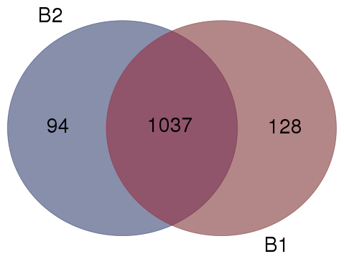
HM
TM
Fig S1 Venn diagram showing the overlap of protein identities in two stored period of freshly harvested corn for (B1) half month storage and B2 two months storage.

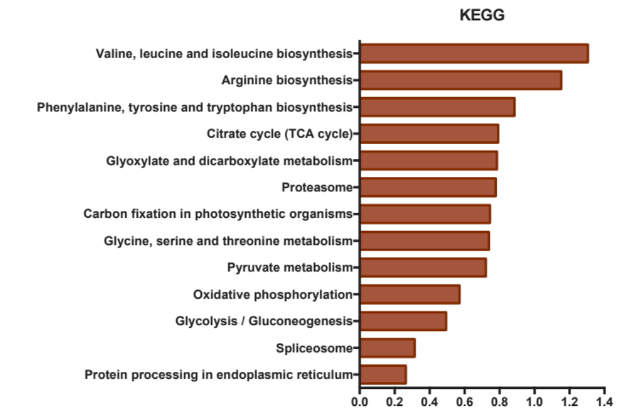
Fig S2 The proportion of the differentially expressed protein categorized by KEGG pathway.

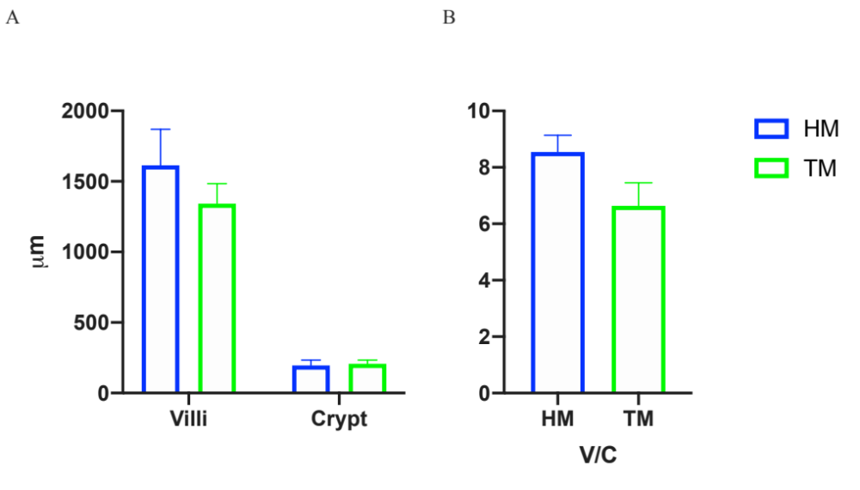
Fig S3. Influence of corn storage on duodenal villi height and crypt depth (A) and the ratio of villi and crypt (B) for broiler chickens. HM: half month storage corn; TM: two months storage corn.
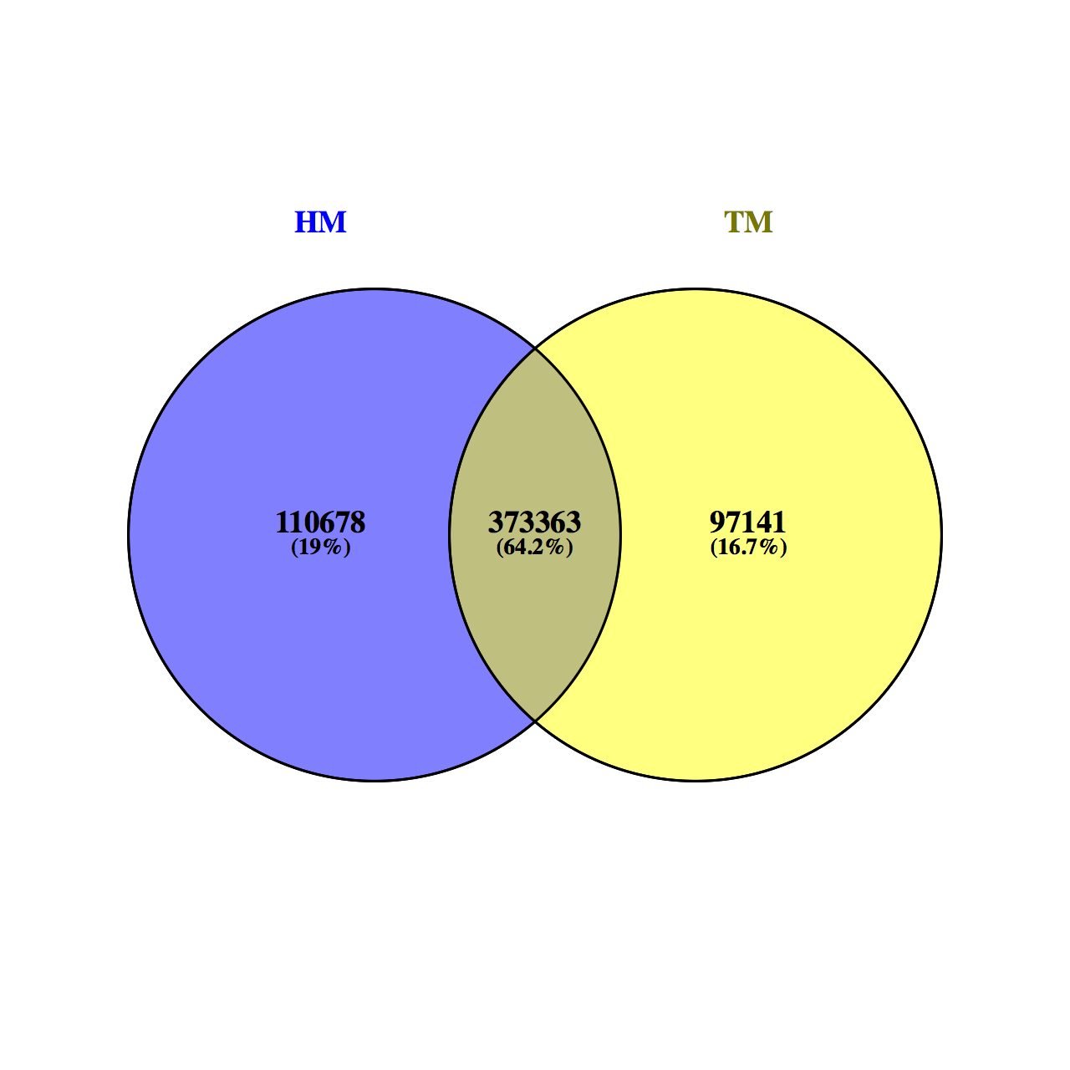
Fig S4 Venn graph
(HM: half month storage corn; TM: two months storage corn)

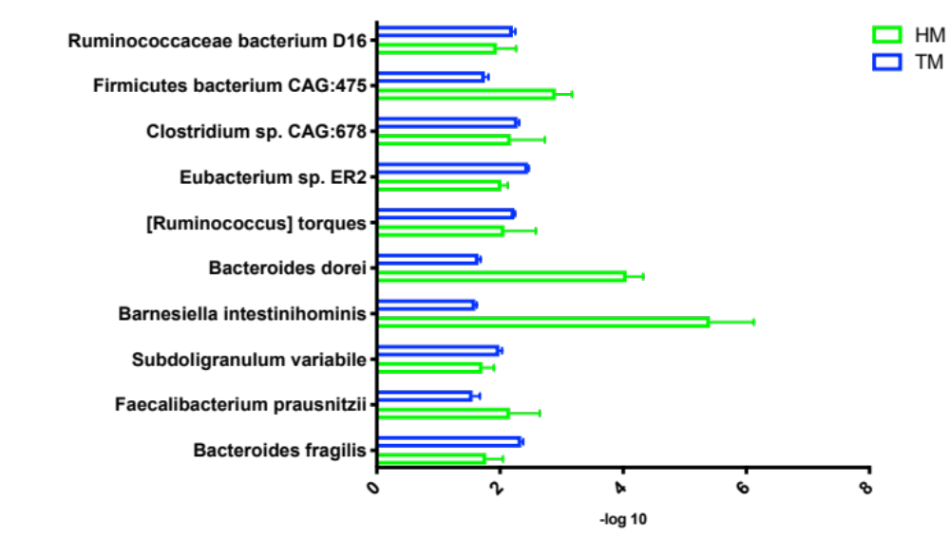
Fig S5. Relative abundance of annotated significant different species (Top 10) in cecal microbiota of broilers. (HM, half months stored corn; TM, two months stored corn)

