Image 1: Site marking with the pencil
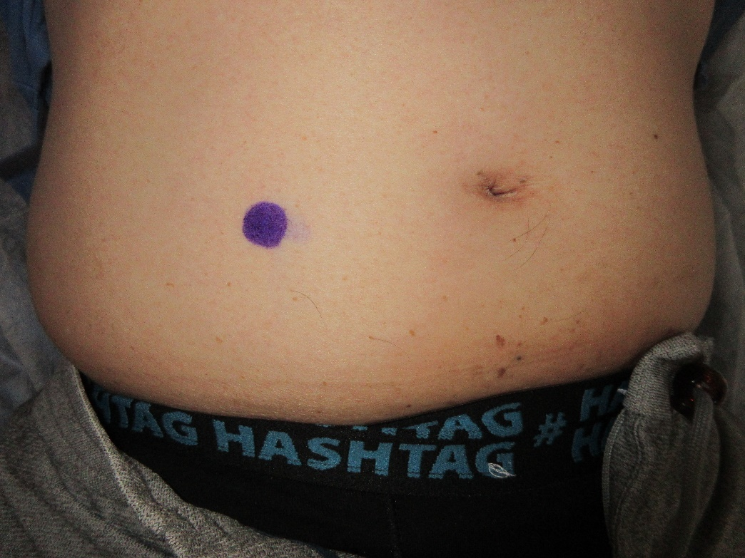

Image 2: Stomadhesive® dressing
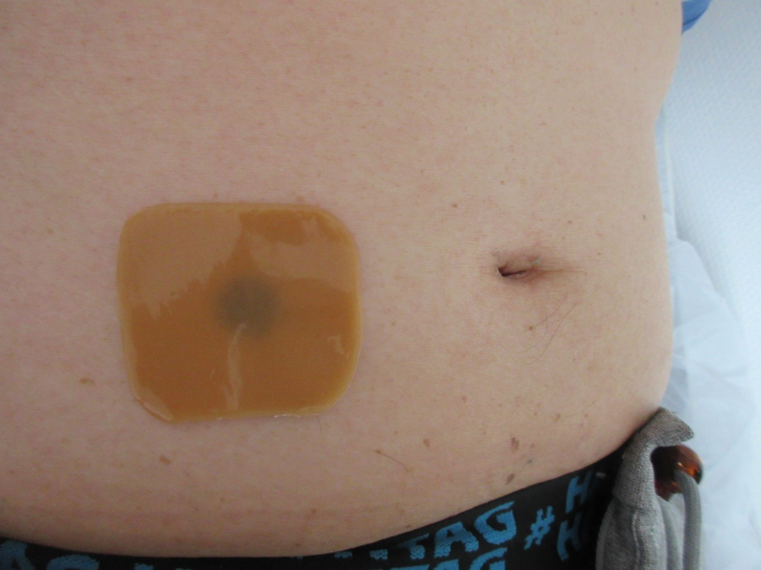

Image 3: 3D-printed device
