Supplementary 1: Stoma-QoL questionnaire in French
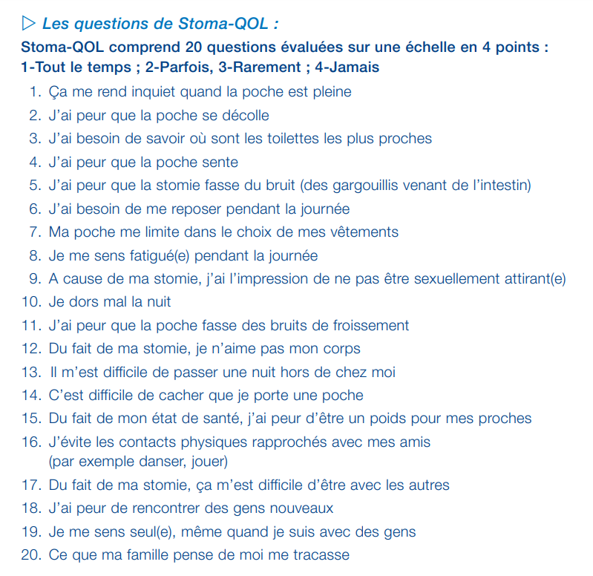
Supplementary 2: Correspondence between row and final scores of the Stoma-QoL scale

