Title:
A High-Throughput Drug Screening Assay for Anti-Tau Aggregation Using Split GFP and Flow Cytometry
Authors
Omnia M. H. Ibrahium^{1,}; Taiwo A. Ademoye²; Jessica S Fortin²; Raluca Ostafe¹*
- Purdue Institute of Inflammation, Immunology and Infectious Diseases, Purdue University, West Lafayette, IN 47907, USA
- Department of Basic Medical Sciences, College of Veterinary Medicine, Purdue University, West Lafayette, Indiana 47907, United States

Supplementary data
Figure S 1 MO-19-10, N-(3,4-dichlorophenyl)-N′-[2-(1H-indol-3-yl)ethyl]urea, chemical formula

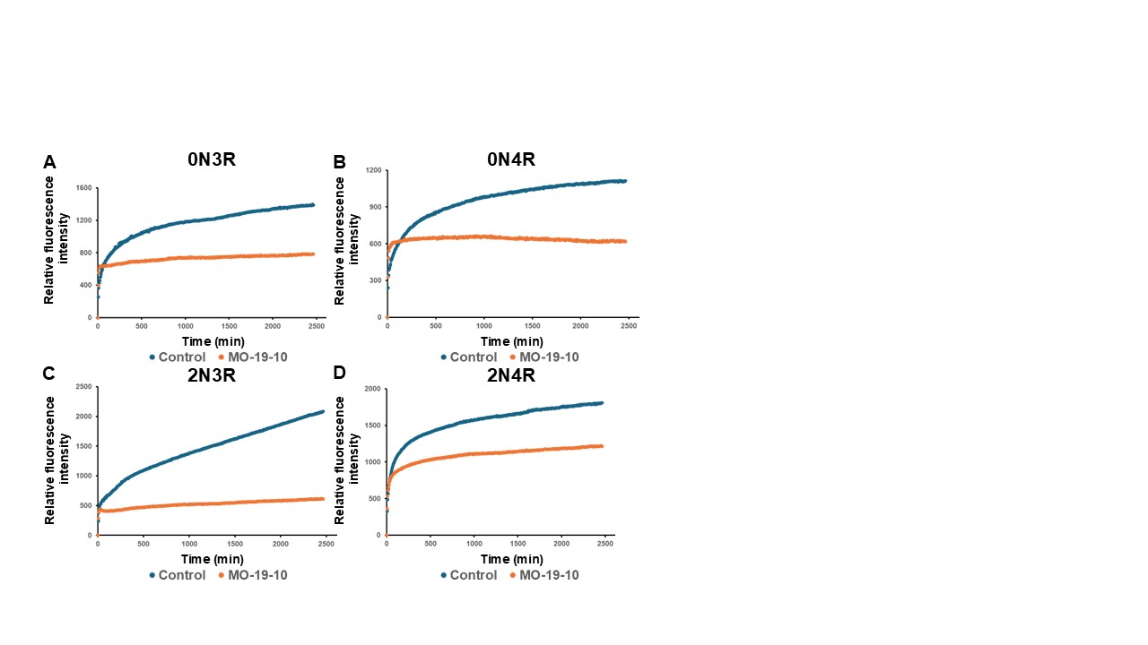
Figure S 2 MO-19-10, a urea-based compound, reduced the aggregation of tau 2N3R isoform by about 75% and other isoforms by less than 50%. The ThS fluorescence curves are indicative of the aggregation kinetics of tau isoform (A) 0N3R, (B) 0N4R, (C) 2N3R, and (D) 2N4R at 12 μM in PBS-treated with chelex beads. The solution was supplemented with 150 μM heparin, 5 mM dithiothreitol (DTT), 40 μM ThS, and 10 mg/mL arachidonic acid in order to induce the aggregation. The control condition contained 0.25% DMSO, while the urea compound was tested at a concentration of 100 μM. The data represented by each curve are an average of three independent replicates.

