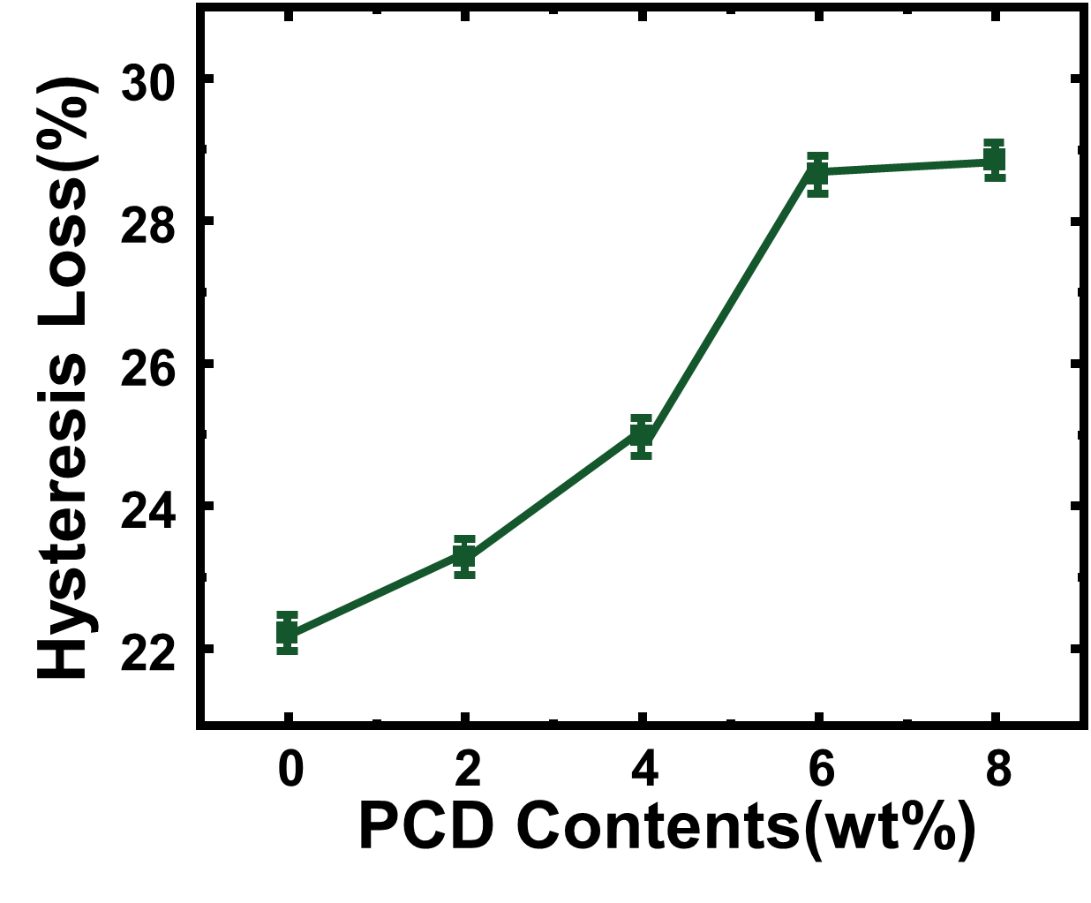
Table 1 Formulation of PU foam according to various PCD Contents
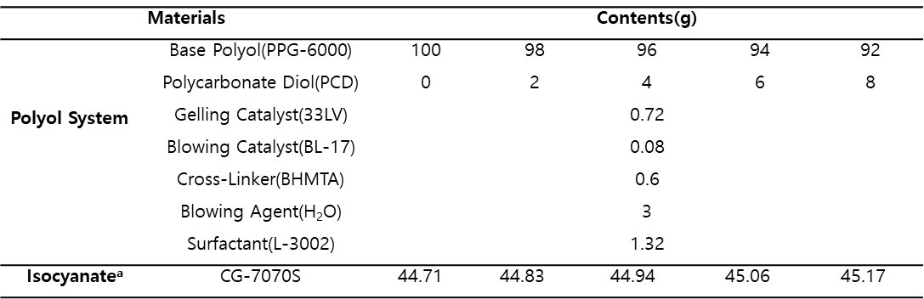
- NCO index 1.

Table 2 Formulation of PU foam including various amounts of IPDI
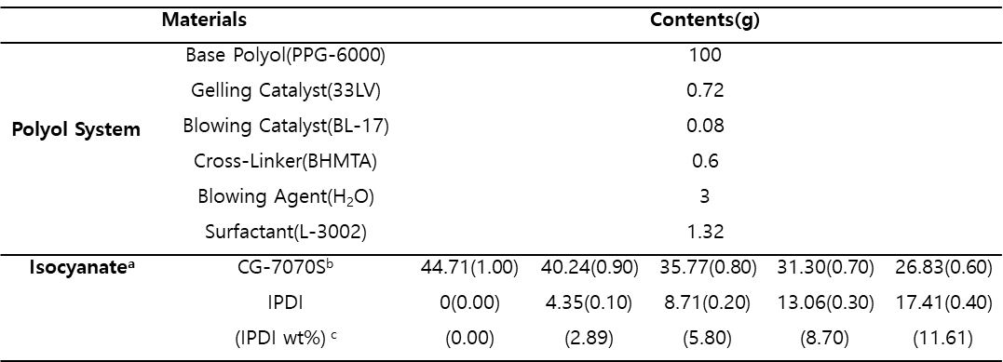
- Total NCO index 1.0
- The numbers in parentheses indicate the NCO index
- IPDI weight percent for total mass ingredient

Table 3 Formulation of PU foam with fixed IPDI and various amounts of PCD
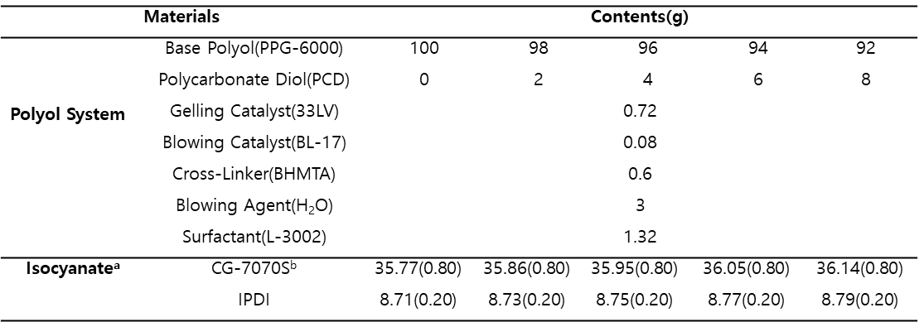
- Total NCO index 1.0
- The numbers in parentheses indicate the NCO index

