Supplementary information

The Olympic challenge of reverse-bias bipolar membranes for CO₂ electrolysis

Gerard Prats Vergel, Huan Mu, Nikita Kolobov, Jasper Biemolt, David A. Vermaas, Thomas Burdyny*
Department of Chemical Engineering, Faculty of Applied Sciences, Delft University of Technology, van der Maasweg 9, 2629 HZ Delft, The Netherlands.
*Corresponding author email: T.E.Burdyny@tudelft.nl

Methods

CO₂ electrolysis
The CO₂ electrolysis experiments were performed in a 5 cm² CO₂ MEA electrolyser from Dioxide Materials. The cathode was prepared using magnetron sputtering (AJA International Inc) to deposit 100 nm of Ag onto a Sigracet 39BB gas diffusion layer (Ion Power GmbH). A nickel foam Ni-4753.005 (Recemat BV) was used as the anode. The membrane was a Fumasep FBM bipolar membrane (Quintech). The cell was assembled and compressed with a torque of 2.5 N·m. The inlet cathodic part of the cell was connected to a humidified CO₂ inlet stream with a flowrate of 50 sccm. After the MFM the gas products concentrations were analyzed by a gas chromatograph (compact GC 4.0, GAS) in which injections were taken every 5 minutes for the 1-hour experiments. At the anode side a KOH or CsOH solution was recirculated with a peristaltic pump (Masterflex) at 20 ml/min. The KOH and CsOH solutions were prepared by diluting a stock solution from Sigma-Aldrich 45 wt.% in H₂O, and 50 wt.% in H₂O (99.9% trace metals basis) respectively. The volume of the anolyte was fixed to 90 ml for all the experiments that measured the water dissociation efficiency (WDE). One-hour chronopotentiometry was performed during WDE measurements.
CO₂ electrolysis performance evaluation
The Faradaic efficiencies for the gas products were calculated using Eq. S1:
$FE_{i,gas}=\frac{z·P·Q_{gas}·c_{i}·F}{R·T·I}$ (S1)
Where P is the pressure (101325 Pa), Q_{gas} is the volumetric flow rate of the gases and c_{i} the concentration of product i measured by the GC. F corresponding to the Faraday constant (96485 C·mol⁻¹), R is the gas constant (8.3145 m³·Pa·K⁻¹·mol-1, T the temperature, z the number of charges transferred in the electrochemical reaction, and I the total current.
The volumetric flow rate of the gases, Q_{gas}, is measured by a mass flow meter calibrated for CO₂. To convert the measured CO₂-calibrated flowrate from to flowrate (Q_{gas}) we use the following equations (Eq S2-S3):
$Q_{gas}=\frac{Q_{MFM}}{C_{CO_{2}}}C_{mix}$ (S2)
$C_{mix}=\frac{1}{\sum_{i}{\frac{c_{i}}{C_{i}}}}$ (S3)
Q_{MFM} is obtained from the last 30 seconds flowrates registered by the MFM before a GC injection. C_{mix} is the gas mixture conversion factor obtained from the volume fraction of the gases (c_{i}) and their gas conversion factor (C_{i}), being 0.74 for CO₂, 1.00 for CO, 1.01 for H₂ and 0.79 for H₂O vapour. It is assumed 100% relative humidity.

Determination of the Water Dissociation Efficiency (WDE)
The Water Dissociation Efficiency of a reverse-bias BPM in a CO₂ electrolyzer can be obtained from the concentrations of the different ions transported through the membrane. For this analysis we quantify the cation (K⁺ or Cs⁺), the carbon species (CO₃²⁻) and the hydroxide (OH⁻) concentrations at the anolyte. Since the pH after electrolysis is larger than 12 it can be assumed that all the carbon species exist as carbonate (CO₃²⁻). We measure these concentrations before and after CO₂ electrolysis. From the difference in concentration between the samples we can obtain the molar fluxes that are used in the WDE equation (Eq. S11). For each of the variables studied, each WDE is determined at least three times.
Experimental conditions
The Water Dissociation Efficiency (WDE) has been experimentally determined at different process conditions, such as current density, concentration and cation identity. This refers to the data plotted in Fig. 3 and 4 in the manuscript.
- Current density: base anolyte 1 M KOH;
  - Variations: 25, 50, 100, 150, 200, 250 mA·cm⁻²
- Concentration: base current density 100 mA·cm⁻²;
  - Variations: 0.1, 0.5, 1, 2, 3 M KOH
- CsOH: base anolyte 1 M CsOH;
  - Variations: 25, 50, 100, 150, 200 mA·cm⁻²
All experiments have been performed at a constant current density (chronopotentiometry) during 1h with an anolyte volume of 90 ml. The duration of these experiments has been minimized in order to speed-up the data collection while maintaining the reliability of the measurements. Shorter experiments made it difficult to determine the species concentrations via the method used (as carbonate concentration are below the detection limit of the titrator), whereas longer experiments may result in significant electrolyte, membrane or anode changes that provide greater time-variance in ion measurements.
Derivation of the WDE formula
The WDE can be defined as the ratio between the partial current density of OH⁻ or H⁺ generated by the BPM and the total current density applied (Eq. S4).
$WDE \left[\%\right]=\frac{j_{OH^{-},BPM}}{j_{tot}}$ (S4)
At any point of the electrolyzer, the total ionic current is equal to the sum of the partial ionic currents for all species present (Eq. S5):
$j_{tot}=\sum_{i}{j_{i}}$ (S5)
Assuming that in the AEL the only charged species are OH⁻ and co-ions (cation from anolyte and carbon species), $j_{OH^{-},BPM}$ can be obtained (Eq. S6).
$j_{OH^{-},BPM}=j_{tot}-j_{co-ions}$ (S6)
The WDE equation can be translated from partial current densities to molar fluxes by using the Faraday’s law of electrolysis (Eq. S7).
$J_{i}=\frac{j_{i}}{\left|z_{i}\right|F}$ (S7)
If species “i” is charged, the total flux can be decomposed in the diffusive and migrative flux (Eq. S8). Consequently, we assume that the flux measured experimentally corresponds to both diffusion and migration (Eq. S9), and that both mechanisms are fully captured by $j_{i}$ in the WDE equation (Eq. S4).¹
$J_{i}=\frac{j_{i}}{z_{i}F}=\frac{j_{d,i}}{z_{i}F}+\frac{j_{m,i}}{z_{i}F}$ (S8)
$j_{tot}=\frac{F^{2}}{RT}·\frac{∂ϕ}{∂x}\sum_{i}{z_{i}^{2}D_{i}C_{i}}+F\sum_{i}{z_{i}D_{i}\frac{∂C_{i}}{∂x}}$ (S9)
Combining Eq. S4, S6 and S7, we can obtain the WDE as a function of the experimentally determined fluxes and current density used (Eq. S10).
$WDE \left[\%\right]=1-F\frac{\sum_{i}{z_{i}J_{i, co-ion}}}{j_{tot}}$ (S10)
Where J_{i} refers to the ionic flux of the i co-ion (mol∙m⁻²∙s⁻¹), j_{i} to the partial current density of i co-ion (A∙m⁻²), F is the Faraday constant (96485 C·mol⁻¹), z_{i} the absolute value of the charge of the i ion, and j_{tot} the applied current density during chronopotentiometry.
For our specific case, Eq. S10 can be transformed to Eq. S11, assuming the only co-ions present crossing the CEL of the BPM are HCO₃⁻ and K⁺. We hypothesize that the carbon specie entering the CEL is HCO₃⁻, which can be converted to H₂CO₃ or CO₃²⁻ with the respective fluxes of H+ and OH- in the CEL or AEL respectively. Our hypothesis is based on the modelling results from recent works r-BPMEA CO₂ electrolyzers^{2,3}, in which they simulated the pH profile close to the interface between the cathodic catalyst layer and the CEL from the BPM. Although, the models include the addition of an ionomer with the catalyst, the CEL surface pH values reported are always below 6. Therefore, we discard the possibility of any CO₃²⁻ existing in the vicinity of the CEL from the BPM due to the acidic conditions (Fig. S6a). Consequently, only molecular CO₂ (dissolved CO₂) or bicarbonate (HCO₃⁻) can exist and be the carbon species crossing the CEL. Since dissolved CO₂ is uncharged and has low solubility in the hydrophilic ion exchange membranes we hypothesized and assumed that HCO₃⁻ is solely responsible for carrying carbon from the cathode to the BPM CEL (Fig. S6b). Importantly, even though the WDE value is a function of the carbon specie chosen, it does not have any effect on the model developed as H⁺ or OH⁻ consumption are taken into account as part of the carbonate equilibrium (Fig. S6c).
$WDE [\%]=1-F\frac{{J_{HCO_{3}^{-}}+J}_{K^{+}}}{j_{tot}}$ (S11)
The experimental fluxes can be derived from the concentrations difference before and after CO₂ electrolysis, $c_{i, co-ion}^{0}$ and $c_{i,co-ion}^{end}$ respectively (Eq. S12). The concentrations are obtained from the respective titrations (Eq. S13-S17).
$J_{i,co-ion}=\frac{\left(c_{i,co-ion}^{end}-c_{i, co-ion}^{0}\right)·V_{tank}}{A·t_{CP}}$ (S12)
$V_{tank}$is the volume of anolyte used, t_{CP} is the duration of the chronopotentiometry test, A the electrochemically active area.

Determination of CO₃²⁻, K⁺ and OH⁻ concentration in the anolyte
Warder’s acid-base titration⁴ is used to determine the concentration of CO₃²⁻ and OH⁻ in the anolyte. Since the initial volume is high enough (90 ml) and the pH of the anolyte remains highly alkaline (pH > 12), we assume all carbon measured is in the form of CO₃²⁻. The titrations were performed using a 848 Titrino Plus titrator (Metrohm) with a 0.1N HCl standardized solution ($c_{HCl}$) as titrant (Carl Roth). In Fig. S7 we show an example of a before and after electrolysis titration curve. In the zoom-in curves it can be differentiated the amount of equivalence points for each of the cases.
Before CO₂ electrolysis we assumed no carbonate was present (Eq. S13) as anolyte was freshly prepared, and that only one equivalent point ($V_{EP,0}$) was obtained from the neutralization of H⁺ with OH⁻ (Eq. S14). $V_{titrate}$ is the volume of anolyte sample taken for titration, ranging from 1-10 ml depending on anolyte original concentration.
$c_{CO_{3}^{2-}}^{0}=0$ (S13)
$c_{OH^{-}}^{0}=\frac{V_{EP,0}·c_{HCl}}{V_{titrate}}$ (S14)
On the other hand, after CO₂ electrolysis the concentration of both CO₃²⁻ and OH⁻ (Eq. S15 and Eq. S16, respectively) can be directly obtained by the volume of titrant used for both equivalence points ($V_{EP,1}$ and $V_{EP,2}$). $V_{EP,1}$ corresponds to the equilibrium point between CO₃²⁻ and HCO₃⁻ (Eq. S25), whereas$V_{EP,2}$ represents the equivalent point of CO₂ and HCO₃⁻ (Eq. S25).
$c_{CO_{3}^{2-}}^{end}=\frac{\left(V_{EP, 2}-V_{EP,1}\right)·c_{HCl}}{V_{titrate}}$ (S15)
$c_{OH^{-}}^{end}=\frac{\left({2·V}_{EP, 1}-V_{EP,2}\right)·c_{HCl}}{V_{titrate}}$ (S16)
The K⁺ concentrations can then be obtained by applying the principle of electroneutrality (Eq. S17).
${c_{K^{+}}=c}_{OH^{-}}+2·c_{CO_{3}^{2-}}$ (S17)

Modelling the long-term stability of a PGM-free CO₂ electrolyzer
The objective of the model is to use the experimental measured WDE to extrapolate long-term operation of a PGM-free r-BPM CO₂ electrolyzer. The model proposed consists of a simple transient species balance of the ionic species evolving in the anolyte tank over time. The species considered include OH–, CO₃²⁻, HCO₃⁻, CO₂ and H⁺. The modelling of cationic species such as K⁺ or Cs⁺ has been neglected. The control volume is limited to the anolyte tank and the ionic fluxes across the BPM obtained experimentally. The cathodic reactions and phenomena are therefore ignored. The volume of the tank and the density of the anolyte are assumed to remain constant over the experiments and simulation. The concentration ($c_{i}$) for each of the i species can be obtained by dividing the mole ($n_{i}$) obtained from solving the system of ordinary differential equations (Eq. S18-S22), with the volume of the tank ($V_{tank}$).
$\frac{∂n_{OH^{-}}}{∂t}=-N_{OER}+N_{BPM}-R_{3}-R_{4}+R_{w}$ (S18)
$\frac{∂n_{CO_{3}^{2-}}}{∂t}=R_{2}+R_{4}$ (S19)
$\frac{∂n_{HCO_{3}^{-}}}{∂t}=R_{1}-R_{2}+R_{3}-R_{4}+N_{HCO_{3}^{-},BPM}$ (S20)
$\frac{∂n_{CO_{2}}}{∂t}={-R}_{1}-R_{3}$ (S21)
$\frac{∂n_{H^{+}}}{∂t}=R_{1}+R_{2}-R_{w}$ (S22)
In which R_{i} correspond to the kinetic molar flows of each carbonate reaction (Eq. S31-S35), $N_{OER}$ and $N_{BPM}$ to the molar flux (mol·s⁻¹) equivalent to the consumption of OH- via OER and generation of OH- from the BPM respectively (Eq. S23-S24), and $N_{HCO_{3}^{-}}$ to the molar flux of HCO₃⁻ crossing the BPM (Eq. S25).
The input variables of the model are: current density (mA·cm⁻²) and active area (cm²), anolyte volume (L), operation time (h), initial KOH concentration (M) and WDE with the respective co-ion fluxes ($J_{HCO_{3}^{-}}$ and $J_{K^{+}}$). It is assumed that the WDE is constant over time. The ratio HCO₃⁻/K⁺ is assumed to be independent of current density and equal to 2 (as demonstrated in Fig. S1a) for the several simulations run at 1M KOH over different WDE. However, it can be easily adjusted and tuned to each experiment with specific WDE and $J_{HCO_{3}^{-}}$ determined experimentally (Eq. S25).
$N_{OER}=\frac{j_{i}}{F}$ (S23)
$N_{BPM}=\frac{j_{i}}{F}·WDE$ (S24)
$N_{HCO_{3}^{-}}=\frac{j_{i}}{F}·\left(1-WDE\right)·\frac{J_{HCO_{3}^{-}}}{J_{HCO_{3}^{-}}+J_{K^{+}}}$ (S25)
To account for the carbonate equilibrium (Eq. S26-S30) the kinetic constants are used to calculate its reaction rates (Eq. S31-S35). As shown in Fig. S8, not considering the carbonate crossover and therefore its buffer capability results in an overestimation of the stability of the system, therefore it is critical to predicting long-term pH changes.
$CO_{2}+H_{2}O\underset{↔}{k_{1},k_{-1}}H^{+}+HCO_{3}^{-}$ (S26)
$HCO_{3}^{-}\underset{↔}{k_{2},k_{-2}}H^{+}+CO_{3}^{2-}$ (S27)
$CO_{2}+OH^{-}\underset{↔}{k_{3},k_{-3}}HCO_{3}^{-}$ (S28)
$HCO_{3}^{-}+OH^{-}\underset{↔}{k_{4},k_{-4}}H_{2}O+CO_{3}^{2-}$ (S29)
$H_{2}O\underset{↔}{k_{w},k_{-w}}H^{+}+OH^{-}$ (S30)
The reaction rates in mol·s⁻¹ for each of the previous reactions are represented in Eq. S31-S35. The kinetic constants have been obtained from ⁵ and are shown in Table S1.
$R_{1}=\left(k_{1}·c_{CO_{2},aq}-k_{-1}·c_{H^{+}}·c_{HCO_{3}^{-}}\right)·V_{tank}$ (S31)
$R_{2}=(k_{2}·c_{HCO_{3}^{-}}-k_{-2}{·c}_{H^{+}}·c_{CO_{3}^{2-}})·V_{tank}$ (S32)
$R_{3}=(k_{3}·c_{CO_{2},aq}·c_{OH^{-}}-k_{-3}·c_{HCO_{3}^{-}})·V_{tank}$ (S33)
$R_{4}={(k}_{4}·c_{HCO_{3}^{-}}·c_{OH^{-}}-k_{-4}·c_{CO_{3}^{2-}})·V_{tank}$ (S34)
$R_{w}={(k}_{w}-k_{-w}·c_{H^{+}}·c_{OH^{-}})·V_{tank}$ (S35)

Table S1. Buffering carbonate rate constants.⁵
Rate constant | Value | Unit
$$k_{1}$$ | $$3.71·{10}^{-2}$$ | $$s^{-1}$$
$$k_{2}$$ | $$59.44$$ | $$s^{-1}$$
$$k_{3}$$ | $$2.23·{10}^{3}$$ | $${M^{-1}s}^{-1}$$
$$k_{4}$$ | $$6{·10}^{9}$$ | $${M^{-1}s}^{-1}$$
$$K_{1}$$ | $${10}^{-6.37}$$ | $$M$$
$$K_{2}$$ | $${10}^{-10.32}$$ | $$M$$

The moles of CO produced by the r-BPMEA CO₂ electrolyzer can be obtained by using the Faraday electrolysis law (Eq. S36), and can be converted to kg by using its molar mass (Eq. S37).
$n_{CO}=\frac{j_{tot}·A}{z_{CO_{2}R}·F}·t$ (S36)
$m_{CO}=n_{CO}·M_{w,CO}$ (S37)
Where $n_{CO}$ and $m_{CO}$ the moles and kg of CO respectively, $j_{tot}$ the total current density applied (A·cm⁻²), $A$ the electroactive area (cm⁻²), $z_{CO_{2}R}=2$ the number of electrons involved in the reaction, $F$ the Faraday constant and $t$ the time of operation of the electrolyzer.

Derivation of the Ratio of CO Produced to KOH Consumed
As a means of determining the comparative energy cost of regenerating an alkaline solution versus the electrolytic production of CO, it is useful to relate the production of CO versus the consumption of KOH. This ratio can be derived from the definition of the WDE, and the assumption that bicarbonate is the primary carbon species crossing the membrane (as opposed to carbonate or carbonic acid). Note that this assumption only impacts the coefficients of the below formulas and not the resulting values, which would be changed for a different carbon assumption. We then begin with Eq. S38 below which describes the OH⁻ lost in the anolyte due to non-unity WDE’s and the loss of hydroxide due to bicarbonate to carbonate conversion.
$j_{OH^{-}, lost}=j_{tot}-j_{OH^{-},BPM}+j_{OH^{-},carbonate}$ (S38)
Assuming from the experimental results from Fig. S1a that 2/3 of the unwanted co-ion transport is related to bicarbonate, and 1/3 to cations, we can transform Eq. S38 to Eq. S39.
$j_{OH^{-}, lost}=j_{tot}-j_{tot}·WDE+j_{tot}\left(\frac{2}{3}\left(1-WDE\right) \right)$ (S39)
$\frac{j_{OH^{-}, lost}}{j_{tot}}=\frac{5}{3}\left(1-WDE\right)$ (S40)
Using the Faraday’s Law of Electrolysis, we can convert Eq. S40 into a molar ratio. Here we aim for the produced CO instead of the total current, which converts j_{tot} into j_{CO}/FE(CO). In the derivation, the number of electrons for CO to OH⁻ is 2. Finally, the ratio is converted into mass using the molar masses of KOH and CO, noting that 1 mol of OH⁻ is equal to 1 mol of KOH.
$\frac{j_{OH^{-}, lost}}{(\frac{j_{CO}}{FE_{CO}})}=\frac{\left(\frac{{\dot{n}}_{OH^{-},lost}z_{OH^{-}}F}{Area}\right)}{\left(\frac{{\dot{n}}_{CO}z_{CO}F}{Area}\right)·\frac{1}{FE_{CO}}}=\frac{5}{3}\left(1-WDE\right)$ (S41)
$\frac{{\dot{n}}_{OH^{-},lost}}{{\dot{n}}_{CO}}=\frac{n_{e^{-},CO}}{n_{e^{-},OH}}\left(1-WDE\right)=\frac{2}{FE_{CO}}\frac{5}{3}\left(1-WDE\right)$ (S42)
$\frac{{\dot{n}}_{OH^{-},lost}}{{\dot{n}}_{CO}}=\frac{{\dot{n}}_{KOH, lost}}{{\dot{n}}_{CO}}=\frac{\frac{{\dot{m}}_{KOH, lost}}{M_{KOH}}}{\frac{{\dot{m}}_{CO}}{M_{CO}}}=\frac{2}{FE_{CO}}\frac{5}{3}\left(1-WDE\right)$ (S43)
$\frac{{\dot{m}}_{KOH, lost}}{{\dot{m}}_{CO}}=\frac{10}{3}\frac{\left(1-WDE\right)}{FE(CO)}·\frac{M_{KOH}}{M_{CO}}$ (S44)
This equation is used to produce Fig. S5. Thus, from Eq. S44 when WDE = 90% and FE(CO) = 60%, then the ratio of lost KOH to produced CO is 1.1.

Supplementary Data

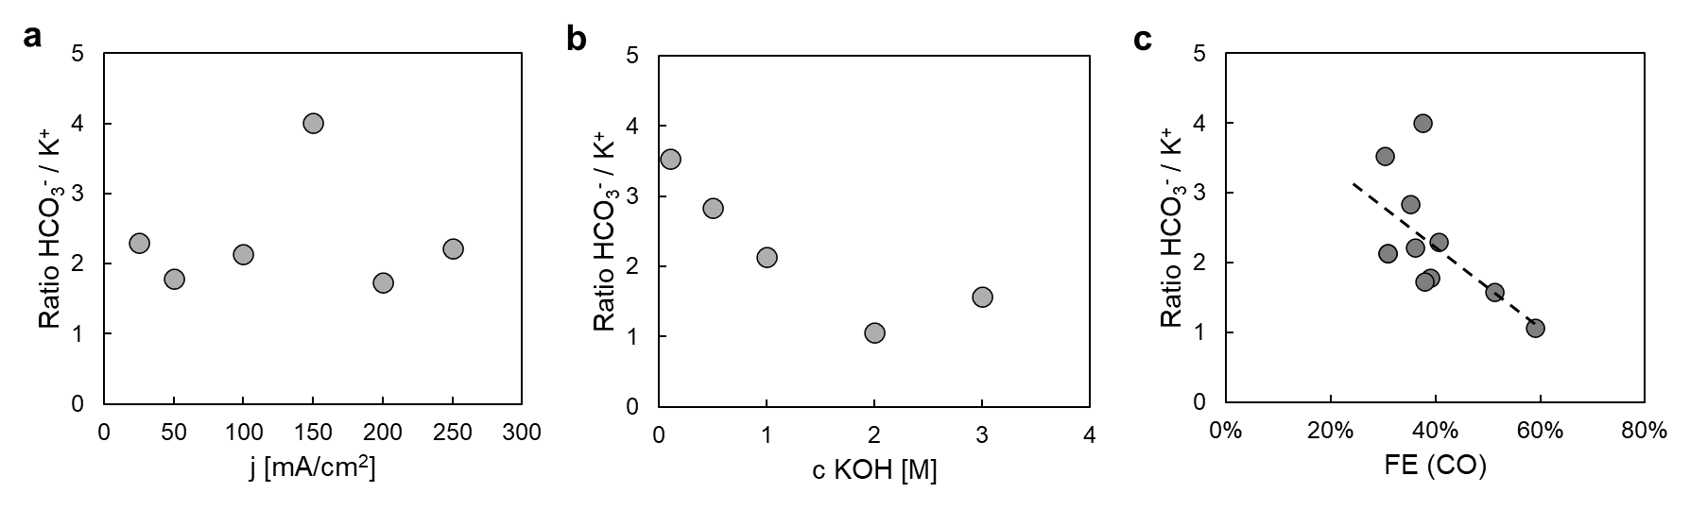
Fig. S1. Co-ion crossover ratio. Ratio of HCO₃⁻ vs K⁺ as a function of a. current density (average of 2) and b. KOH concentration. c. relationship between Ratio of HCO₃⁻ / K⁺ and the FE(CO).

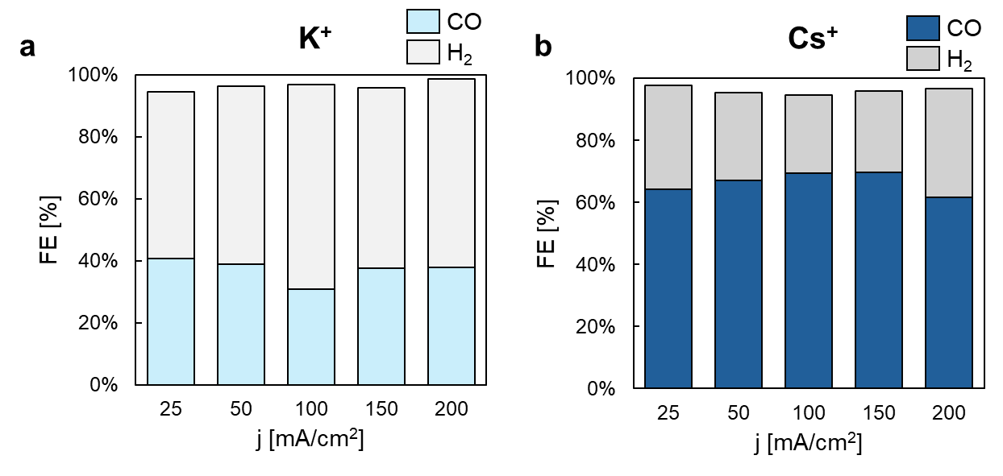
Fig. S2. Faradaic Efficiency of CO and H₂ for 1M a. KOH and b. CsOH anolytes at different current densities 25-200 mA·cm⁻².

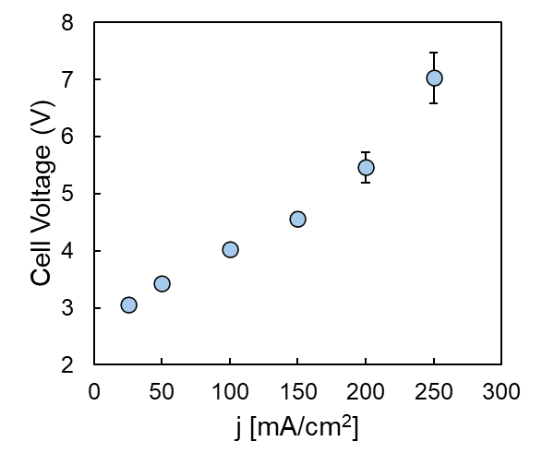
Fig. S3. Cell voltage of a r-BPMEA CO₂ electrolyzer as a function of current density 25-250 mA·cm⁻².

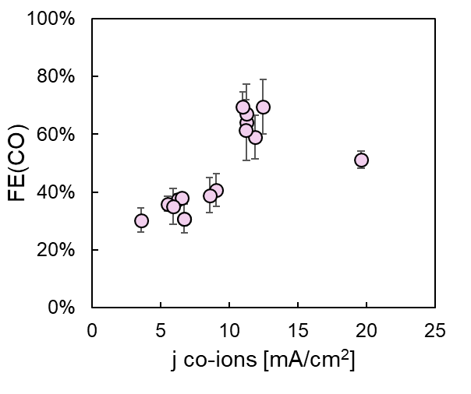
Fig. S4. Trade-off between co-ion transport and CO2R selectivity towards CO in r-BPMEA CO₂ electrolyzer. All data presented in Fig. 3 and Fig. 4 in the manuscript is included.
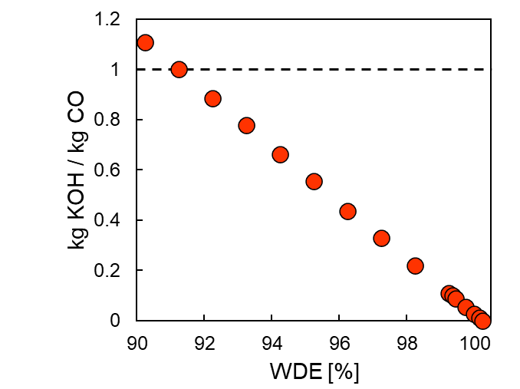
Fig. S5. WDE dependency on the amount of KOH required per kg of CO produced. It is assumed a FE(CO) = 60%.

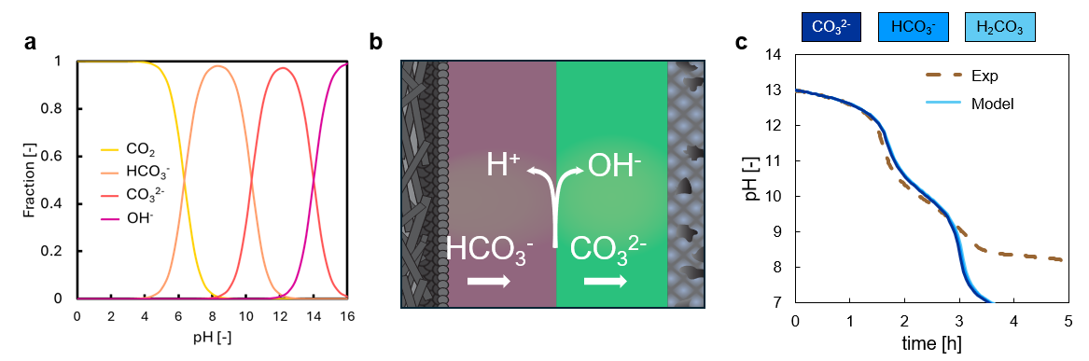
Fig. S6. Which carbon specie is crossing through the BPM? a. Carbon species distribution as a function of pH. b. Assuming HCO₃⁻ as carbon specie crossing the CEL and converted to CO₃²⁻ in the AEL. c. Modelling verification with a experiment (20 ml 0.1M KOH at 100 mA·cm⁻²) in which it is determined that the carbon specie considered in the model has not any effect on the prediction of pH shift.
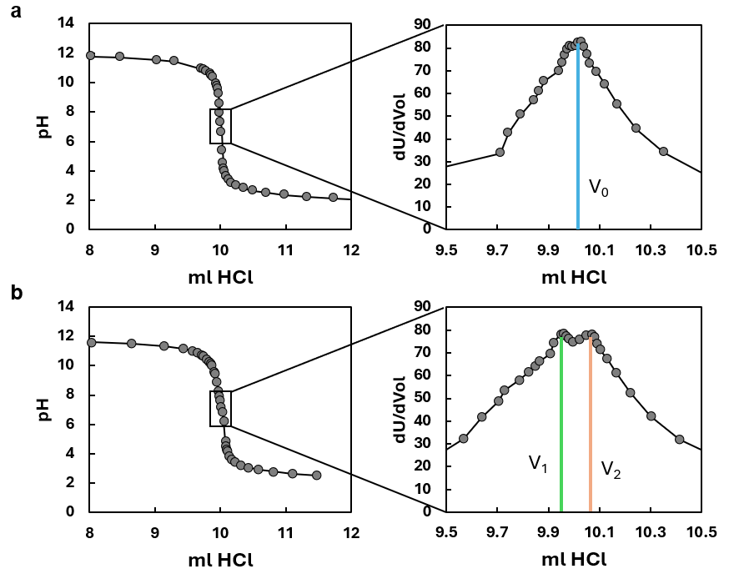
Fig. S7. Titration of anolyte sample a. before and b. after CO₂ electrolysis. Equivalence points obtained for determining the concentration of OH⁻ and CO₃²⁻.
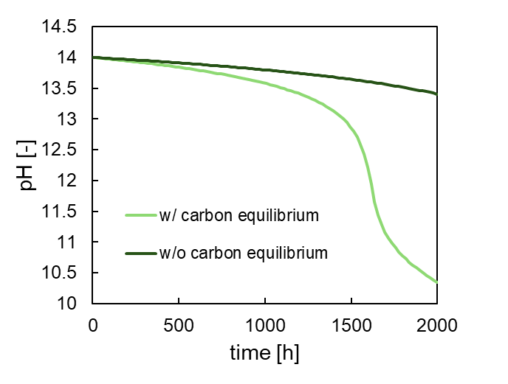
Fig. S8. Modelling output differences when carbonate crossover and buffering effects are considered in the anolyte tank. The model represents a r-BPMEA CO2 electrolyzer operating with a WDE = 99% at 200 mA·cm-2, and with a 1 L of 1M KOH anolyte.
References
1. Allen J. Bard, Larry R. Faulkner & Henry S. White. Electrochemical Methods - Fundamentals and Applications. (Wiley, 2022).
2. Li, M. et al. Local ionic transport enables selective PGM-free bipolar membrane electrode assembly. Nature Communications 15, (2024).
3. Yue, P. et al. Microenvironment Regulation Strategies Facilitating High-Efficiency CO2 Electrolysis in a Zero-Gap Bipolar Membrane Electrolyzer. ACS Appl Mater Interfaces 15, 53429–53435 (2023).
4. Benedetti-Pichler, A. A. & Cefola, M. Warder’s method for the titration of carbonates. Industrial & Engineering Chemistry Analytical Edition 11, 327–332 (1939).
5. Schulz, K. G., Riebesell, U., Rost, B., Thoms, S. & Zeebe, R. E. Determination of the rate constants for the carbon dioxide to bicarbonate inter-conversion in pH-buffered seawater systems. Mar Chem 100, 53–65 (2006).

