Supporting information
for
Understanding Adsorption Geometry of Organometallic Molecules on Graphene

Seungtaek Oh^{1,2}, Jungyoon Seo^{1,2}, Giheon Choi^{1,2}, Hwa Sung Lee^{1*}

¹Department of Materials Science and Chemical Engineering, Hanyang University, Ansan Gyeonggi 15588, Republic of Korea.
²BK21 FOUR ERICA-ACE Center, Hanyang University, Ansan, Gyeonggi 15588, Republic of Korea

*Corresponding author. E-mail: hslee78@hanyang.ac.kr (H. S. Lee)

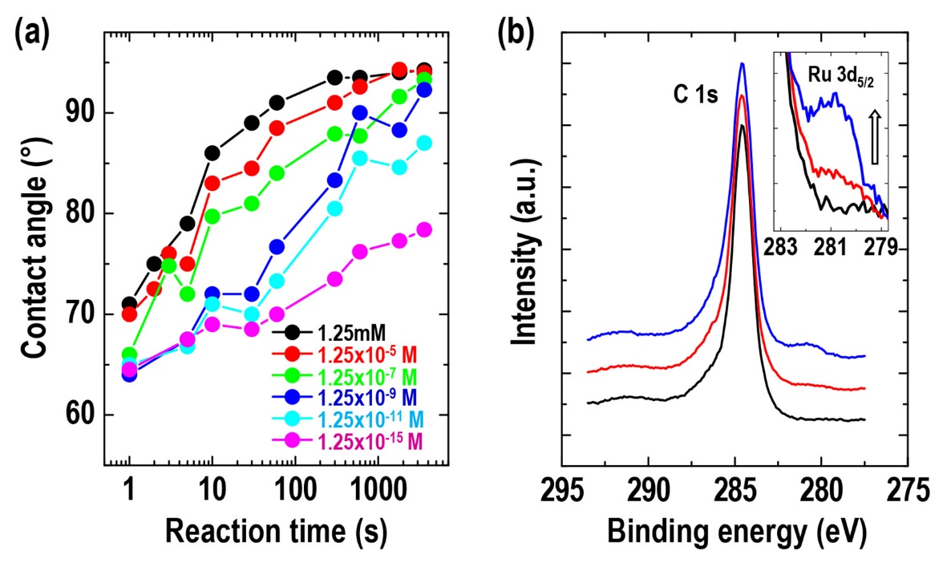
Figure S1. (a) Contact angle variations of deionized water on graphite surface as functions of reaction time and concentration of [Cp*Ru(CH₃CN)₃]⁺ solutions. Contact angle increased with reaction time and solution concentration, i.e., from 60° for pristine to 95° for HOPG reacted with 1.25 mM of [Cp*Ru(CH₃CN)₃]⁺ solution for 1 h. This increase is attributable to the decrease in surface energy of reacted graphite induced by five methyl groups in Cp*. (b) XPS spectra of Ru 3d_{5/2} signal regions for pristine graphite (black) and Cp*Ru⁺-graphites reacted with 1.25×10⁻⁷ M (gray) and 1.25 mM (dark gray) solutions.

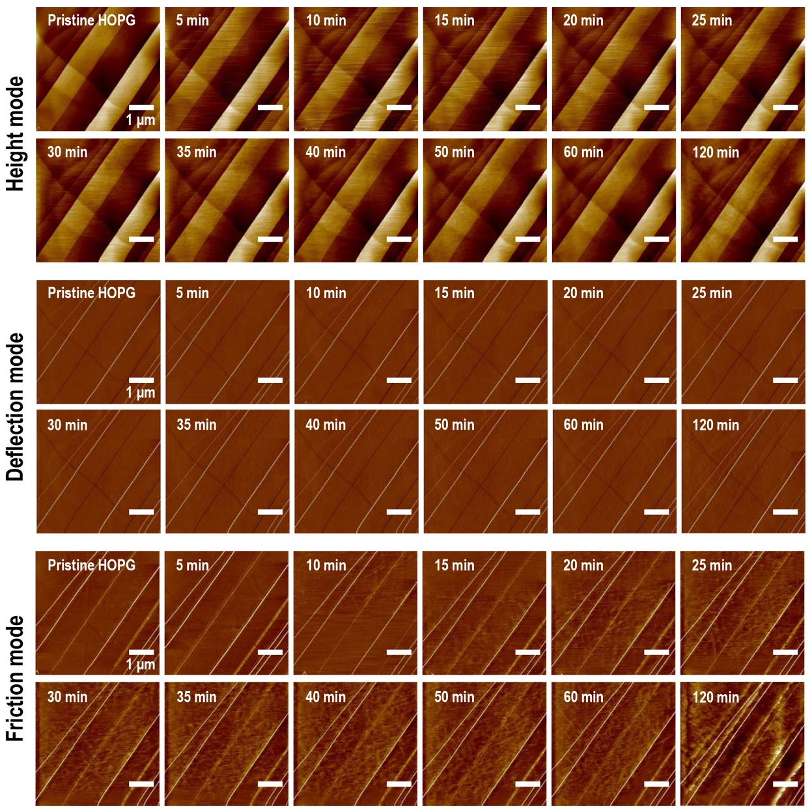
Figure S2. Sequential images of HOPG surface obtained via real-time in-situ AFM during reaction in 1.25 × 10⁻¹¹ M of Cp*Ru(CH₃CN)₃PF₆ solution. In height and deflection modes of AFM, morphological evolutions on surface were barely visible, likely due to small molecular size (approximately 3.5 Å in height and approximately 5 Å in width) of Cp*Ru⁺ fragment. By contrast, friction mode shows consecutive modification of HOPG surface by adsorbing Cp*Ru⁺ fragments. This occurred because surface energy was reduced by methyl groups of Cp*Ru⁺ fragment, thereby inducing a decrease in friction force between AFM tip and HOPG surface. Furthermore, adsorption of Cp*Ru⁺ fragments occurred evenly on the surface, not on specific regions such as cracks and steps of graphite surface. All scales are 1 μm in size.

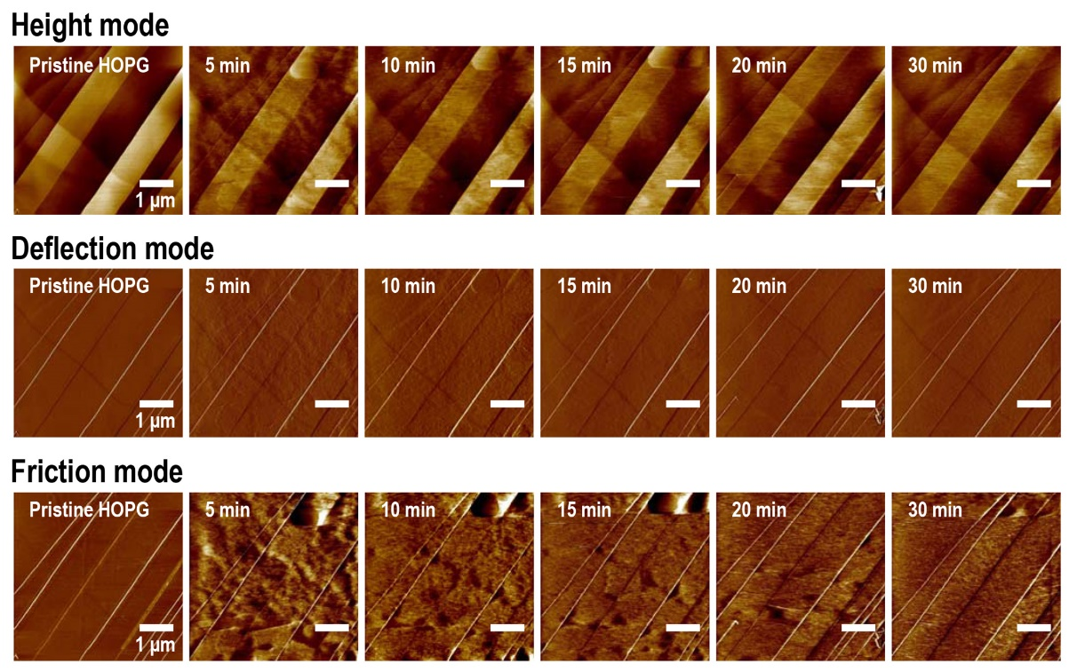
Figure S3. Sequential images of HOPG surface obtained via real-time in-situ AFM during reaction with 1.25 mM of Cp*Ru(CH₃CN)₃PF₆ solution. All scales are 1 μm in size.

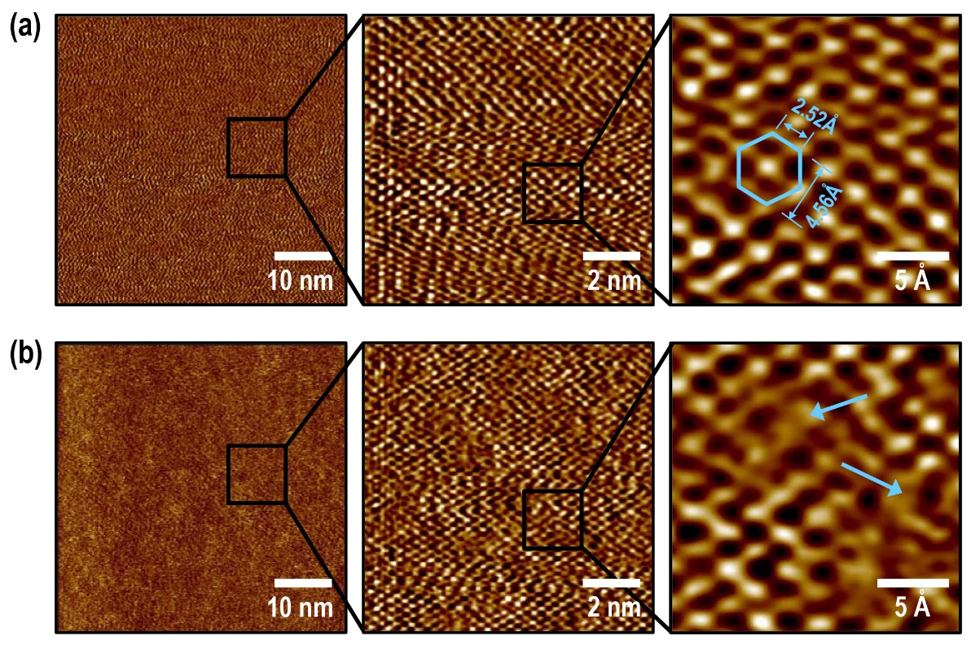
Figure S4. AFM images of (a) pristine graphite and (b) Cp*Ru⁺-graphite reacted in 1.25 × 10⁻¹¹ M solution. In pristine graphite, hexagonal lattice structure of graphite surface without adsorbates was defined through magnified view. We observed many adsorbates (arrow regions) on Cp*Ru⁺-graphite surface with weak topographic contrast; therefore, the shapes and adsorbed positions on graphite lattice structures could not be clarified. We conclude that AFM measurements for obtaining clear molecule images of Cp*Ru⁺ fragments are impossible due to AFM resolution limitation despite operating under liquid ambience and the extremely small Cp*Ru⁺ fragments.

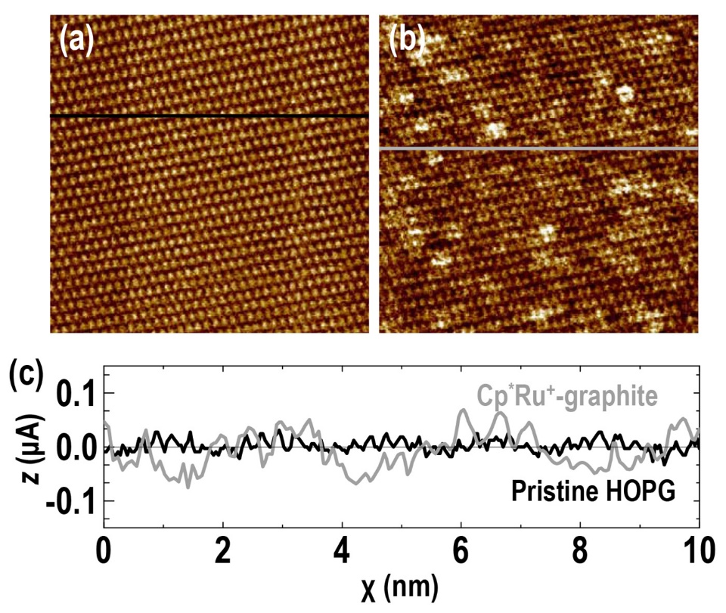
Figure S5. STM images of (a) pristine and (b) Cp*Ru⁺-graphites. (c) shows section profiles shown in (a) (black) and (b) (gray).

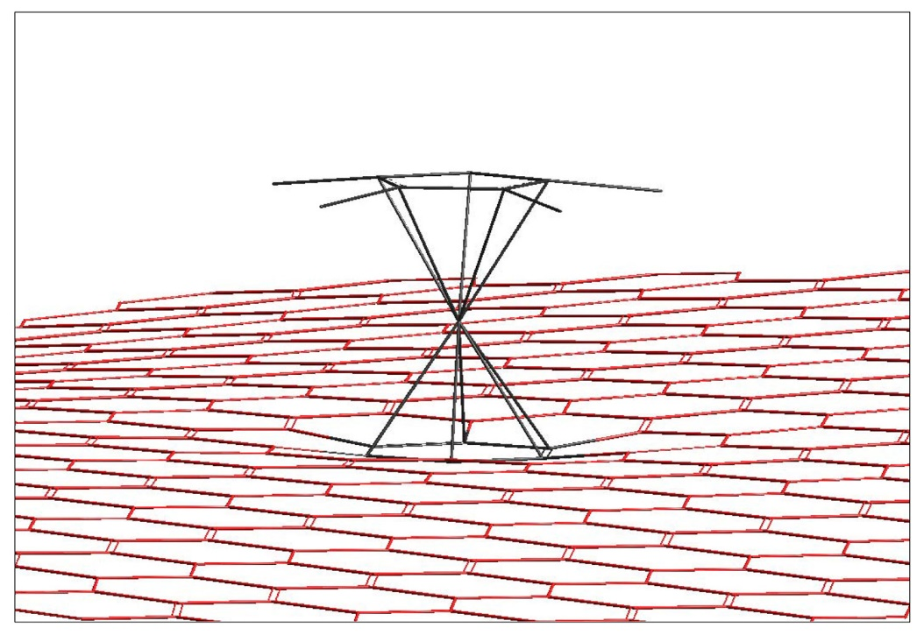
Figure S6. Minimum energy configuration of Cp*Ru⁺-graphene calculated via molecular mechanics force field. A concavely bent graphite structure bound with a Cp*Ru⁺ fragment, which is induced by the increase in compressive surface stress due to adsorption of fragment, is shown.
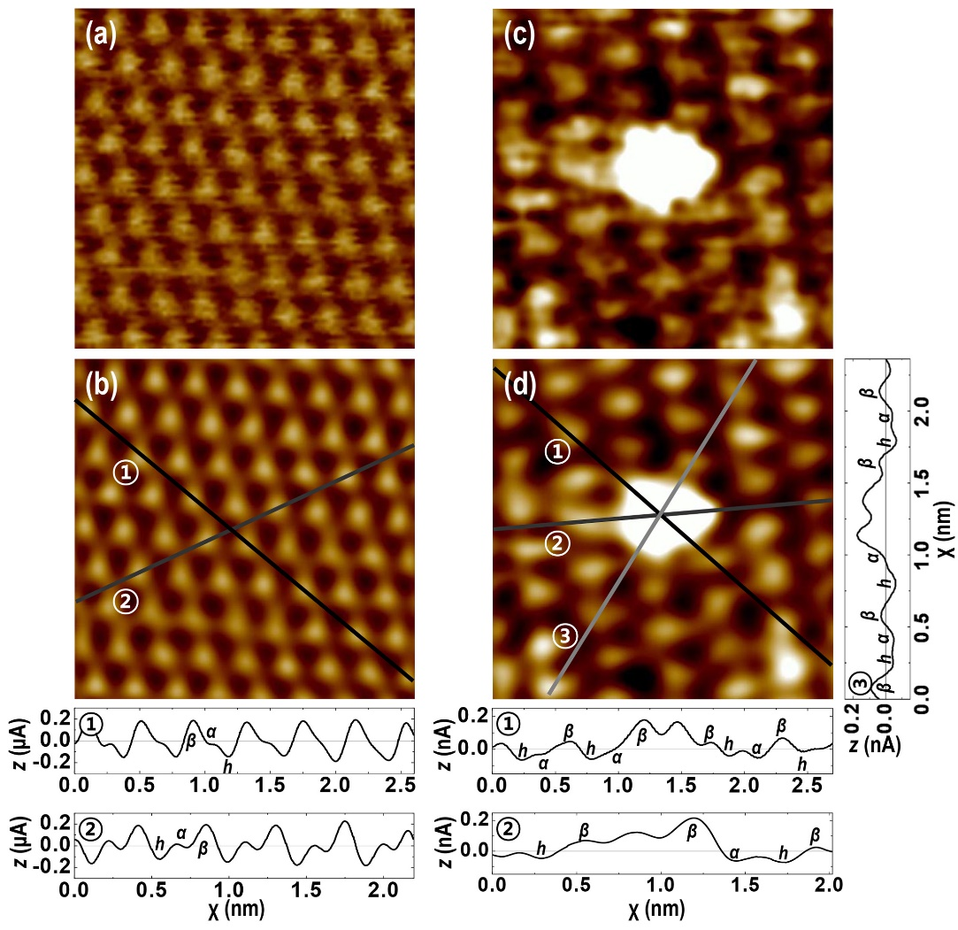
Figure S7. STM lattice images of (a) HOPG and (c) Cp*Ru⁺ fragment absorbed on surface. (b) and (d) show Fourier-filtered data and cross-sections of (a) and (c), respectively. Two peaks are shown in cross section of STM image. They exhibit current relations between α- and β-site carbons and hollow sites resulting from their charge density asymmetry. According to imaging mechanism theory,¹⁻⁴ bright spots with higher intensity correspond to β-site carbons and spots with less intensity to α-site. Hence, we conclude that absorbing site of Cp*Ru+ fragment is above hollow position of hexagon structure of graphite surface.

References
- Atamny, F.; Spillecke, O.; Schlögl, R. On the STM Imaging Contrast of Graphite: Towards a “true’’ Atomic Resolution. Phys. Chem. Chem. Phys. 1999, 1, 4113.
- Hembacher, S.; Giessibl, F. J.; Mannhart, Local Spectroscopy and Atomic Imaging of Tunneling Current, Forces, and Dissipation on Graphite. J. Phys. Rev. Lett. 2005, 94. 056101.
- Tománek, D.; Louie, S. G. First-Principles Calculation of Highly Asymmetric Structure in Scanning-Tunneling-Microscopy Images of Graphite. Phys. Rev. B 1988, 37, 8327.
- Hembacher, S.; Giessibl, F. J.; Mannhart, J.; Quate, C. F. Revealing the Hidden Atom in Graphite by Low-Temperature Atomic Force Microscopy. PNAS, 2003, 100, 12539.
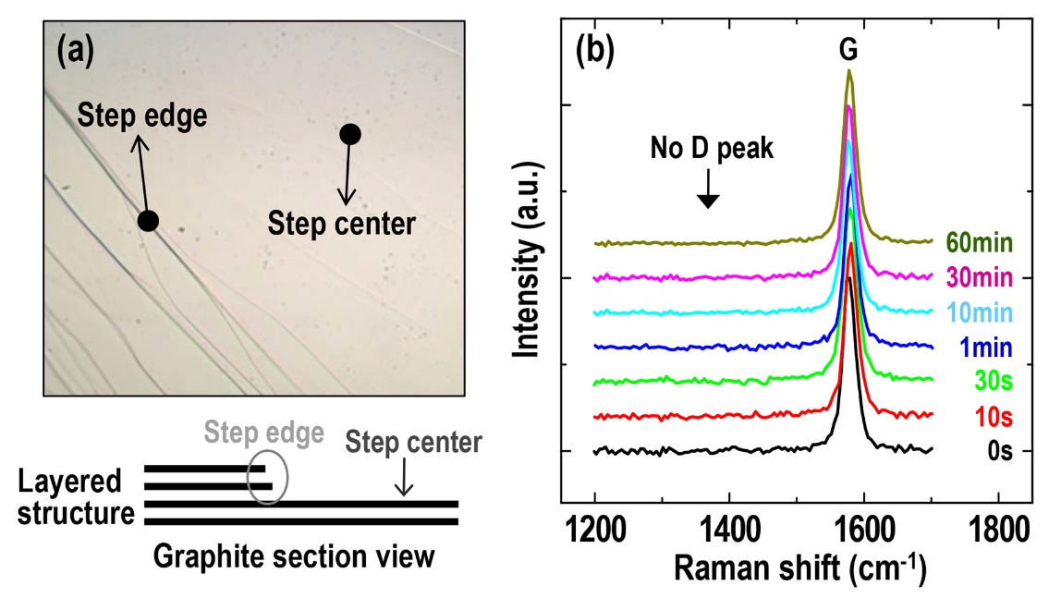
Figure S8. (a) Optical microscopic image and schematic section view of HOPG surface. The graphite is a graphene-layered structure. Numerous graphite step centers and edges are formed during mechanical exfoliation. (b) G and D peak Raman spectra on the step center of graphite as a function of reaction time in 1.25×10⁻⁷ M Cp*RuL₃PF₆ solution. Contrary to the step edge shown in Figure 5, we found that there is no D peak evolution with reaction times.

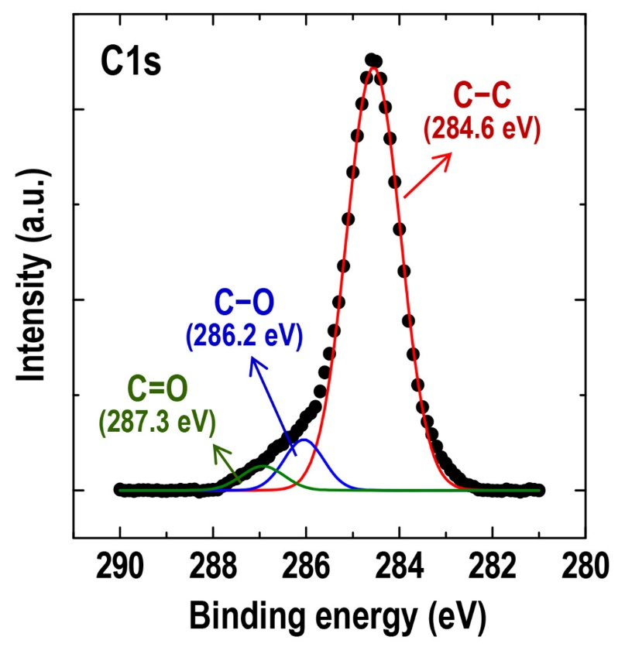
Figure S9. XPS spectra and fit of the C1s core level region of pristine HOPG.

