supplementary information files

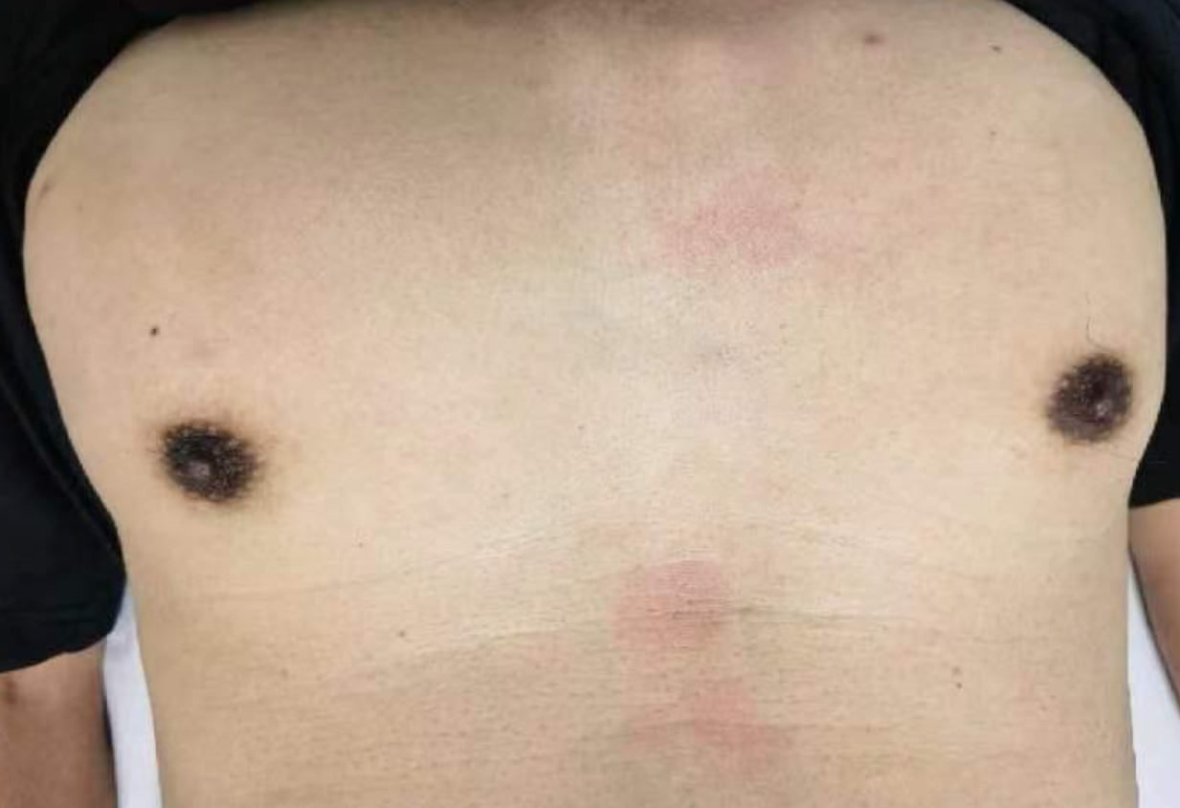

Fig1 The patient's undeveloped breasts

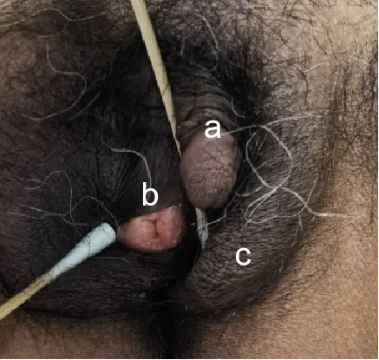

Fig2: Genitalc haracteristics. a Underdeveloped “phallus” b.Urethral opening c.Labia majora-like structures

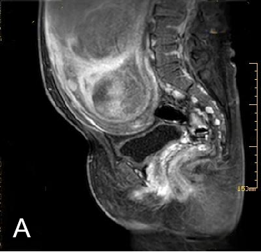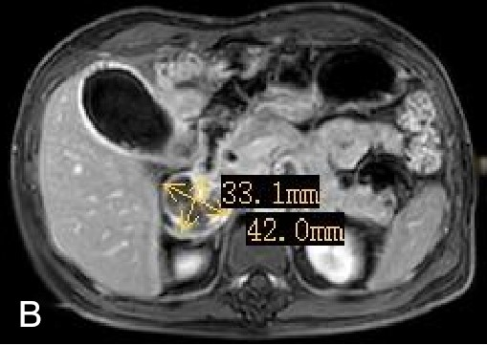

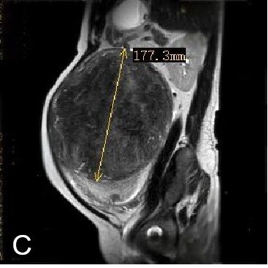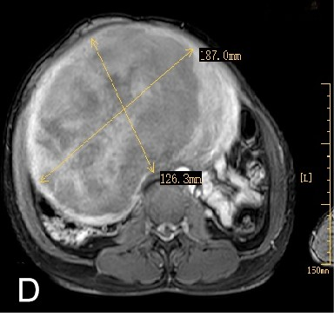

Fig3: Enhanced magnetic resonance imaging (MRI) scan of the entire abdomen.A In the sagittal view of the pelvis, the uterus and part of the vagina are visible, while the prostate and male urethral structures are not seen.B right adrenal tumor, with a cross-sectional size of approximately 42×33 mm.C.D The sagittal and axial views show that the size of the uterine fibroid is 187×126mm×178mm.

Laboratory Investigations:

Table 1 Baseline laboratory test
Inspection items | Result | Tip | Unit Reference | Range
Cortisol | 159.9 |  | ng/ml | 7-9AM：52.7-224.5  3-5PM：34.4-167.6
AFP | 1.5 |  | ng/ml | 0-8.1
Total prostate-specific antigen | 0.1 |  | ng/ml | 0.0-4.0
Human epididymis protein 4 | 203 | ↓ | pmol/L | 34.72-114.90
Anti-Mullerian hormone | <0.0098  0 | ↓ | ng/mL | 2.150--10.100
Luteinizing hormone | 3.2 |  | mIU/L | 1. 5 9. 3
Testosterone | 214.8 |  | ng/dl | 187.72-694.19
Progesterone | 32.47 | ↑ | mmol/l | 0.39-3.98
Follicle-stimulating hormone | 9.3 |  | mIU/L | 1.4-14.81
Prolactin | 11.5 |  | ng/ml | 2.1-17.7
Estradiol | 36.3 |  | pg/ml | 0.0-39.8
Aldosterone | 237.88 |  | Pg/ml | Lying：10.0-160.0  Standing：40.0-310
17α-Hydroxyprogesterone | 117.2 | ↑ | ng/ml | Male 0.31-2.01
Dehydroepiandrosterone Sulfate | 905.51 | ↑ | ug/dl | 44.67-347.34
Dihydrotestosterone | 691.64 | ↑ | pg/ml | Male 143.00-842  Female 0.00-431
Na | 135 |  | mmol/l | 137-147
K | 4.05 |  | mmol/l | 3.5-5.3
Thyroid Stimulating Hormone(TSH) | 2.602 |  | uIU/L | 0.55-4.78
Free Triiodothyronine（FT4） | 4,62 |  | pmol/L | 3.5-6.5
Free Thyroxine（FT3） | 16.27 |  | pmol/L | 11.5-22.7
Androstenedione | 47.45 | ↑ | nmol/l | 1.75-7.68

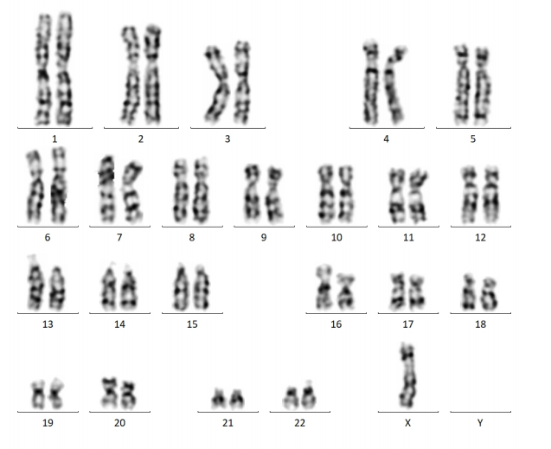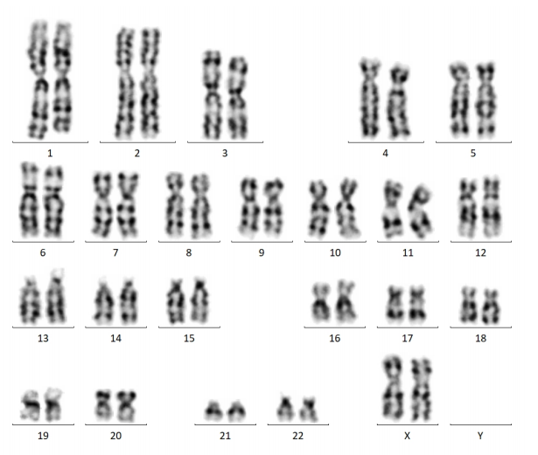
Fig4:Chromosomal karyotype analysis of peripheral blood

A 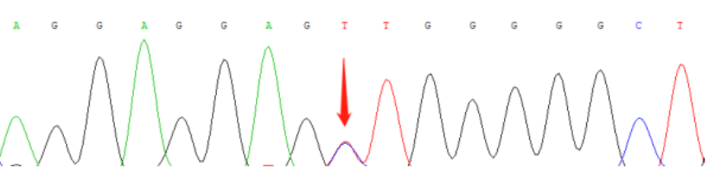

B