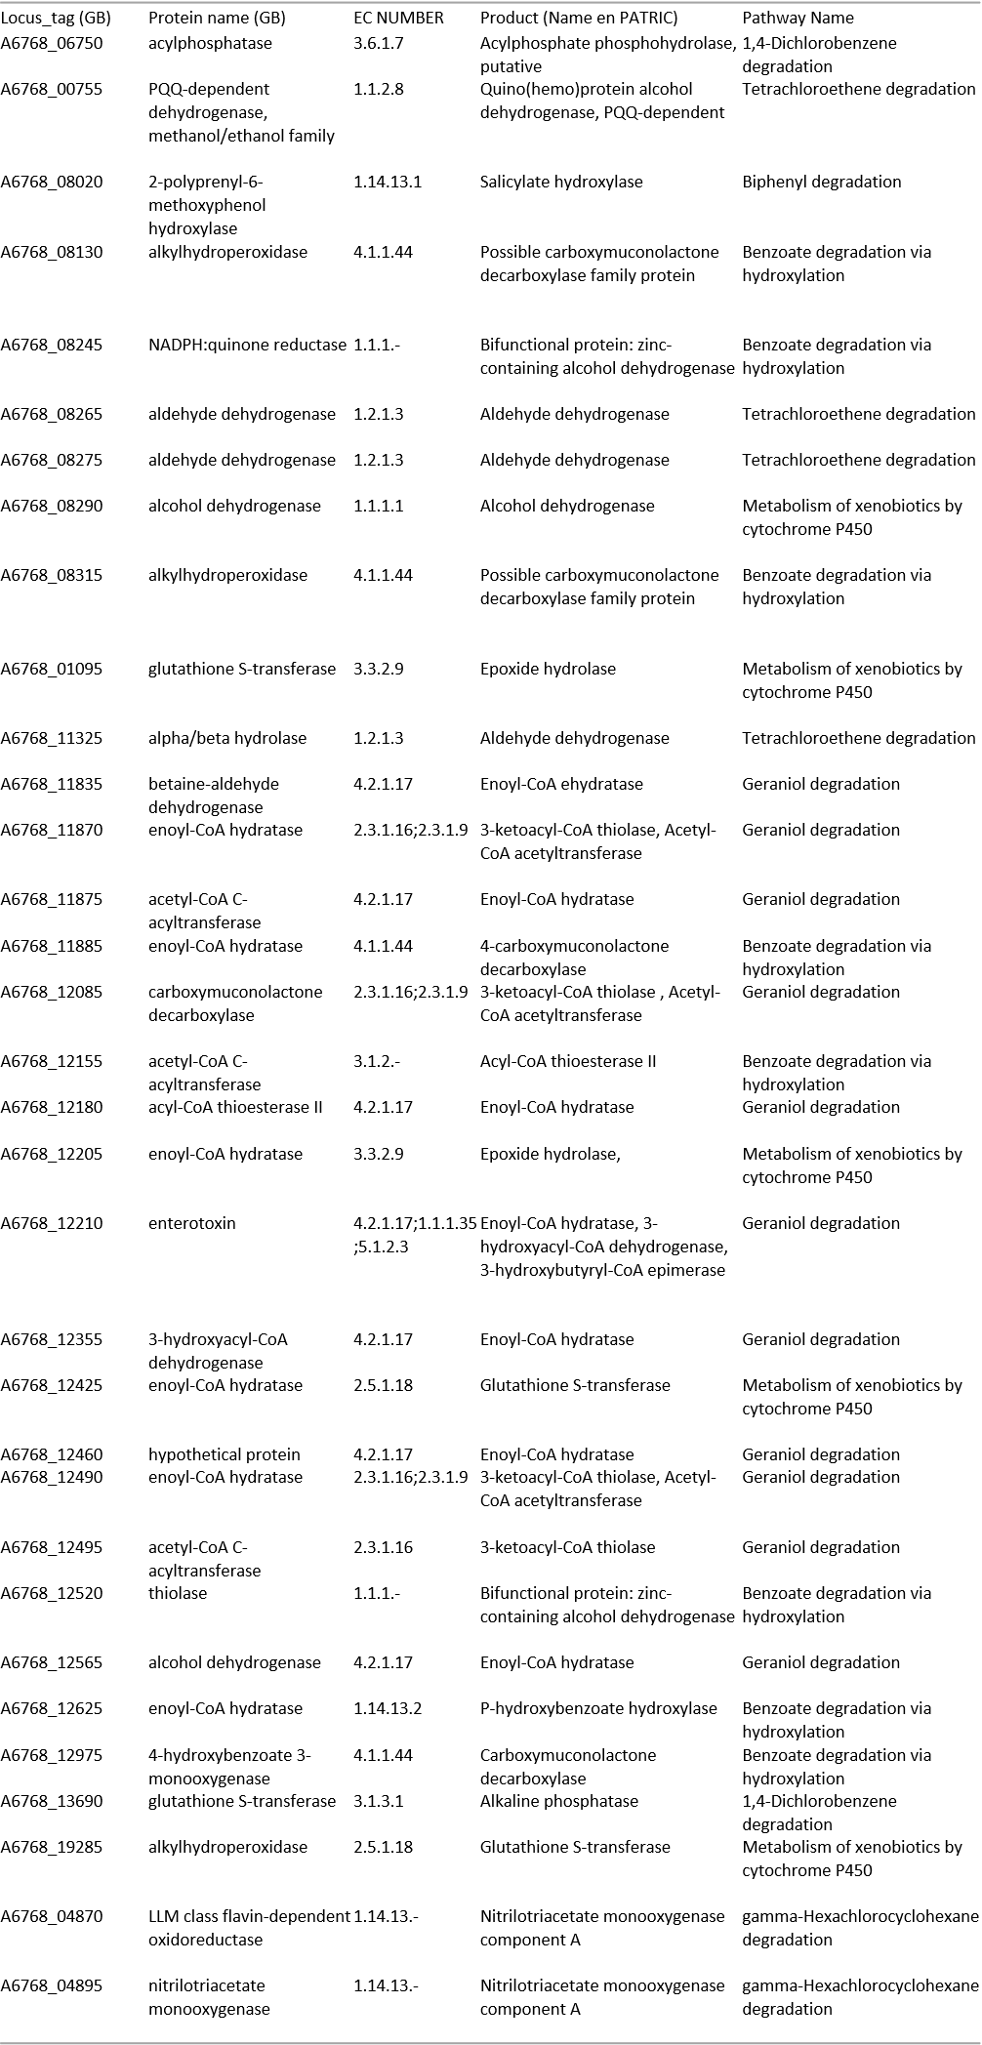
Table S1. List of genes in Sphingobium yanoikuyae S72 which is associated with the degradation of S72

