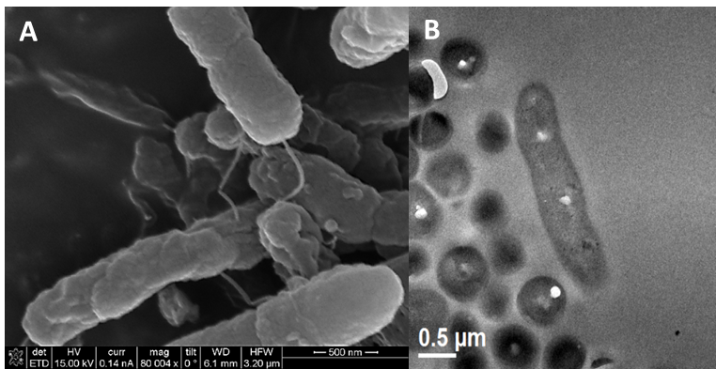
Fig. S1. Morphological features. (A) Scanning electron micrographs of cells Sphingobium yanoikuyae strain S72.Scale bar, 500 nm. The presence of a single polar flagellum and a small globular formation is observed. B) Transmission electron micrographs of S. yanoikuyae strain S72. Scale bars 0.5 μm.

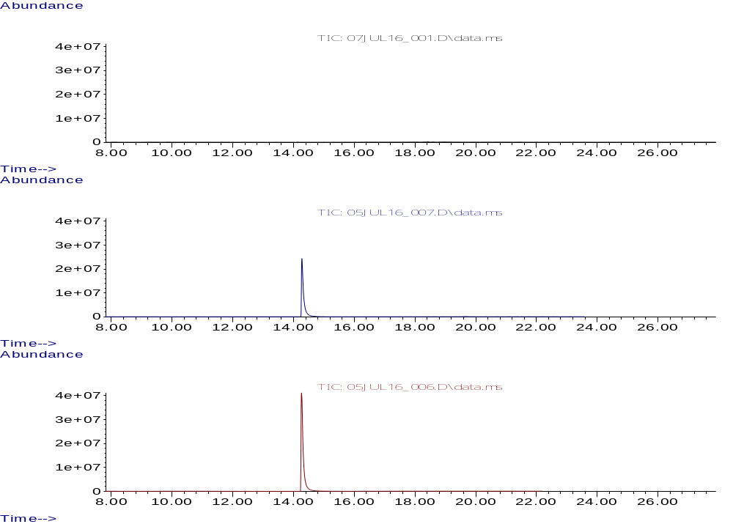
CONTROL BACTERIA S72 (CULTURE MEDIUM WITH BACTERIA, WITHOUT CONTAMINANT

BIFENILO-CONTROL

BIFENILO-SAMPLE
Figure S2: Gas column chromatography image for the degradation of biphenyl by S72- The images showed the images for the culture medium without bacteria and biphenyl, culture with S72 and biphenyl and culture with biphenyl without S72.

Figure S3: Gene region in Sphingobium yanoikuyae S72 that are associated with PAH degradation and showing hypothetical genes that may also be helping in the degradation of PAH.

