APPENDIX
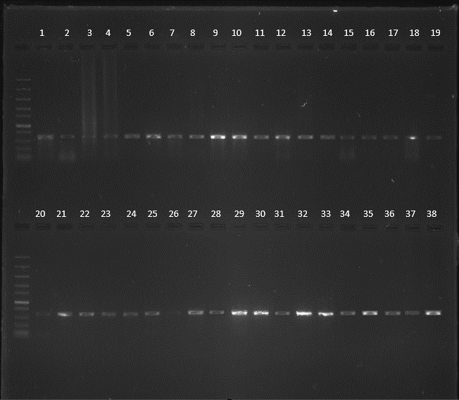

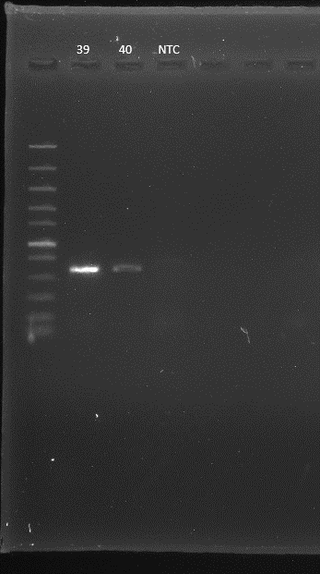

Electrophloregram for 1-40 landraces of Jatropha spp

INDIVIDUAL COMPOUNDS CONTRIBUTION TO THE PC LEVELS
Compounds | PC 1 | PC 2 | PC 3 | PC 4 | PC 5 | PC 6
3-Methyl-6-hepten-1yn-3-ol | 0.147 | 4.644 | -5.396 | -10.32 | -8.059 | -3.349
Citral | 5.575 | 8.25 | -3.75 | -11.08 | -5.32 | -2.045
Hexadecanoic acid | 6.550 | 9.549 | -1.070 | -2.749 | -1.067 | 0.797
n-Hexadecanoic acid | 8.766 | 10.62 | -1.959 | -0.960 | -1.162 | 1.518
Cyclopentaneundecanoic acid | 12.13 | 10.43 | -0.127 | 0.794 | -1.79 | 0.470
Trans-13-octadecenoic acid | 14.43 | 9.97 | 1.27 | 2.47 | -1.50 | -0.19
Methyl stearate | 16.18 | 10.28 | 1.022 | 3.09 | -0.507 | -0.751
Dimethyl-12-tetradecen-1-ol | 17.57 | 9.925 | 0.336 | 3.30 | -0.10 | -0.19
Oleic acid | 18.04 | 9.906 | 0.130 | 3.56 | 0.042 | 0.075
6-Octadecenoic acid | 19.29 | 9.567 | 0.957 | 3.73 | 0.103 | 0.082
p-menth-8 (10) –en-9-ol | 19.87 | 9.45 | 0.76 | 3.91 | 0.29 | 0.38
Octadec-9-enoic acid | 21.39 | 11.02 | 0.499 | 5.63 | -1.07 | 0.720
9-Octadecenoic acid | 15.61 | -1.26 | 0.98 | -8.23 | 11.92 | 0.53
Oleic acid | 16.08 | -1.44 | 1.02 | -8.07 | 12.21 | 0.65
9-Octadecenoic acid | 7.23 | -15.55 | 1.58 | 0.11 | -1.89 | -1.16
1,3-Dioxolane | 7.50 | -15.79 | 1.55 | 0.37 | -1.70 | -1.04
Cyclopropane carboxamide | 7.83 | -16.03 | 1.45 | 0.522 | -1.60 | -0.977
Octadec-9-enoic acid | 8.42 | -16.38 | 1.77 | 0.48 | -1.69 | -0.62
9,17-Octadecadienal | 16.50 | -20.86 | 6.42 | -0.44 | -3.19 | 2.40
3,7,11-Tridecatrienoic acid | 17.01 | -21.19 | 6.56 | -0.37 | -3.18 | 2.59
Trimethylsilyl-di—silane | 1.677 | -14.36 | -14.53 | 7.51 | 5.08 | -9.02
Glyceric acid (ISP-TFA) | -8.064 | -8.54 | -20.50 | 0.67 | -0.89 | 9.18
2,5-Furandione | -22.12 | 1.88 | 1.02 | -1.44 | -1.17 | -1.37
Oleic acid | -22.13 | 1.88 | 1.04 | -1.40 | -1.13 | -1.34
(6-Methylhe-5- cyclohex-2-enol | -22.14 | 1.87 | 1.05 | -1.37 | -1.11 | -1.32
1H-Indene | -22.30 | 1.80 | 1.30 | -0.80 | -0.64 | -0.93
1,2-hydrazinedicarbothioamide | -22.61 | 1.66 | 1.75 | 0.21 | 0.18 | -0.23
9-Octadecenoic acid | -22.71 | 1.61 | 1.91 | 0.57 | 0.48 | 0.010
3,7,11-Tridecatrienoic acid | -22.98 | 1.49 | 2.31 | 1.46 | 1.21 | 0.62
Benzoic acid | -22.99 | 1.48 | 2.33 | 1.51 | 1.25 | 0.65
3,7,11-Tridecatrienoic acid | -23.14 | 1.41 | 2.56 | 2.03 | 1.68 | 1.01
6-octadecenoic acid | -23.30 | 1.345 | 2.79 | 2.56 | 2.11 | 1.37
Bicyclo[4.2.0]oct-2-ene | -23.35 | 1.322 | 2.87 | 2.72 | 2.24 | 1.49

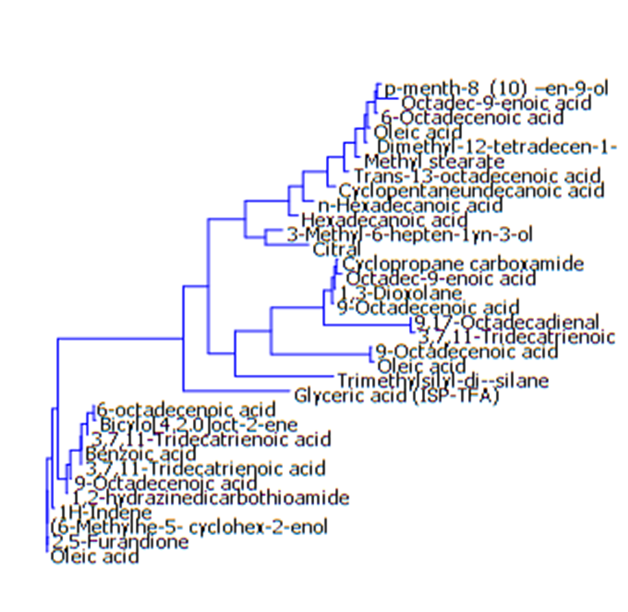
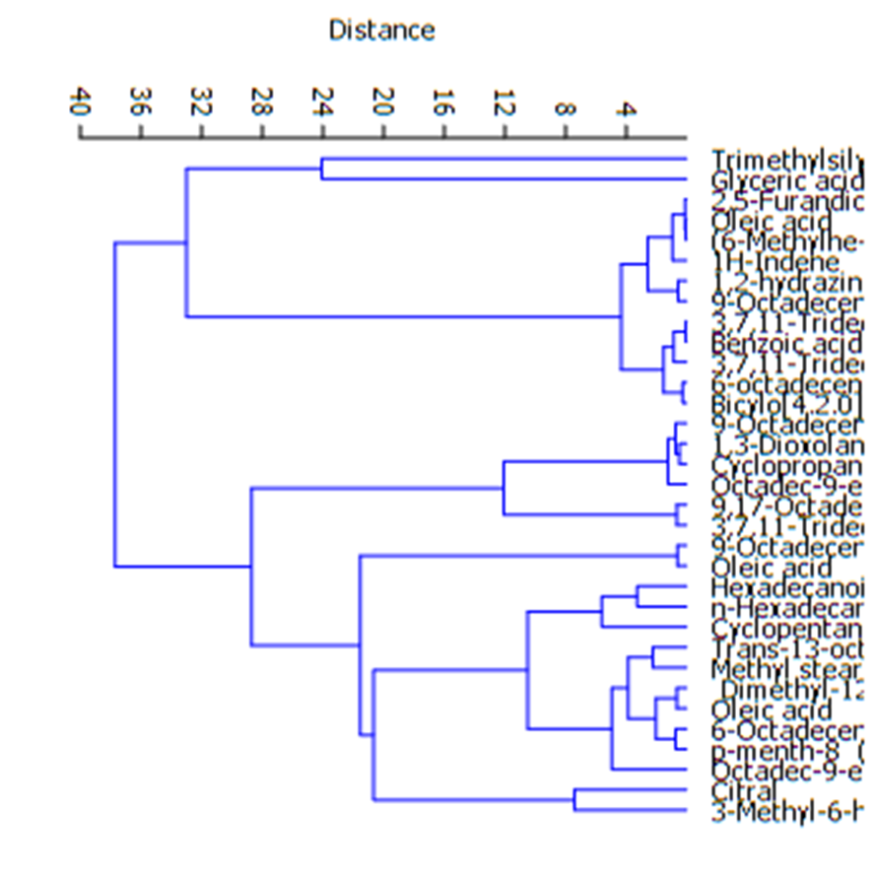

Dendogram showing the relatedness of compounds present

