Appendix A

For the simulation, the two-dimensional surface profile of a 5 mm long section of the test region was captured for both specimens IA and IT. This section was selected to be representative of the surface condition within the mechanically loaded region. The surface geometry was extracted from scanning electron microscope images using a spline-based interpolation method, which allowed for accurate digital reconstruction of the complex surface topology. The extracted geometry was subsequently imported into the simulation environment to serve as the basis for the finite element model. If distinct internal defects were visible in the cross-section between the up-skin and down-skin surfaces, they were incorporated into the model. Each surface was analyzed in an individual simulation by generating a 2D plane with a width of 2 mm from the 5 mm section. All simulations were conducted using ANSYS Mechanical 2024 R2, a commercially available finite element software widely used for structural analyses. A linear elastic material model was applied, assuming isotropic behavior of the material. Although anisotropic properties may result from the manufacturing process, these were not considered in the model. Additionally, residual stresses were not included. These assumptions represent simplifications that may lead to deviations from the real stress distribution. The material used for the simulation was AISI 316L stainless steel. An example of the simulation model for the down-skin surface of specimen IT is shown in Fig. A1. A Cartesian mesh with a 0.5 mm element size was applied, while a refined mesh with a 0.2 mm element size was used in the vicinity of the surfaces and internal defects. Furthermore, as depicted in Fig. A1, symmetry conditions were imposed. A stress of 1 MPa was applied to the cross-section, while the opposite side was constrained in the longitudinal direction.
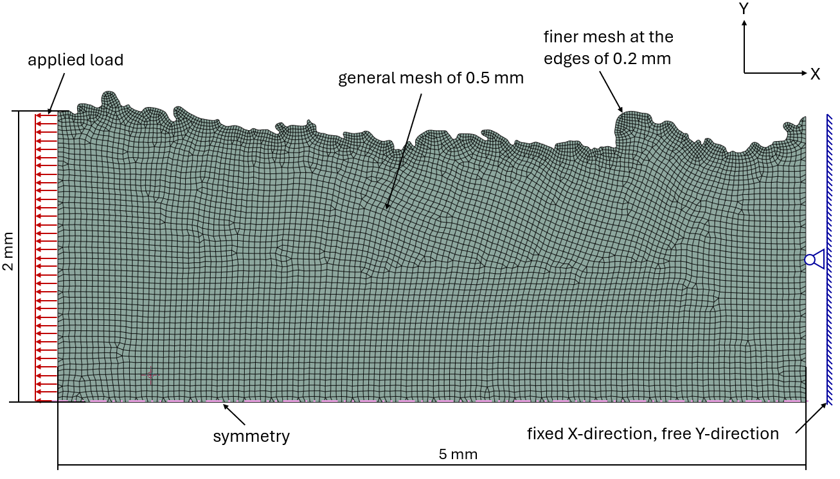
Fig. A1 Schematic representation of melt pool formation as a function of the incidence angle a Specimen IT, b Specimen IA

