List of supplementary figures and table
Fig S1. Cytotoxicity of various concentrations of rotenone in SH-SY5Y cells
Fig S2. Characterization of purified monomeric and fibrillar α-syn through ThT assay, circular dichroism and transmission electron microscopy
Fig S3. Cytotoxicity of various concentrations of α-syn-seeds and MG132 in SH-SY5Y cells
Fig S4. Validation of PCR array with real-time PCR
Fig S5. The mRNA repression of HSF1 and NRF2 under different stress conditions
Fig S6. Layout (Template design) of PCR array and heat map of gene expression
Fig S7. Western blots of HSPA family proteins
Fig S8. Western blots of DNAJ family proteins
Fig S9. Western blots of transcription factors

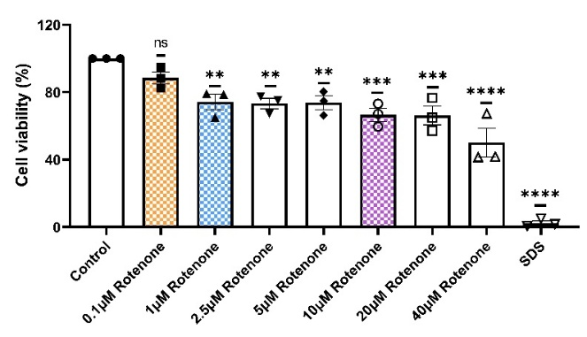
Figure S1. Cytotoxicity of various concentrations of rotenone in SH-SY5Y cells.
The effect of various concentrations of rotenone (0.1-40µM) and SDS (0.1%) in SH-SY5Y cells were measured by MTT assay. The percent cell viability was calculated by normalizing the control (DMSO) cell population to 100%. The normal distribution of data was tested by the Shapiro-Wilk (W) and Kolmogorov-Smirnov normality test. The one-way ANOVA post Dunnett’s multiple comparisons test was used for statistical significance using GraphPad Prism 8, and data was expressed as means and +/− SEM (N=3; N = number of independent experiments with sufficient replicates), ns (P>0.05), **(P≤0.01), ***(P≤0.001), ****(P≤0.0001).

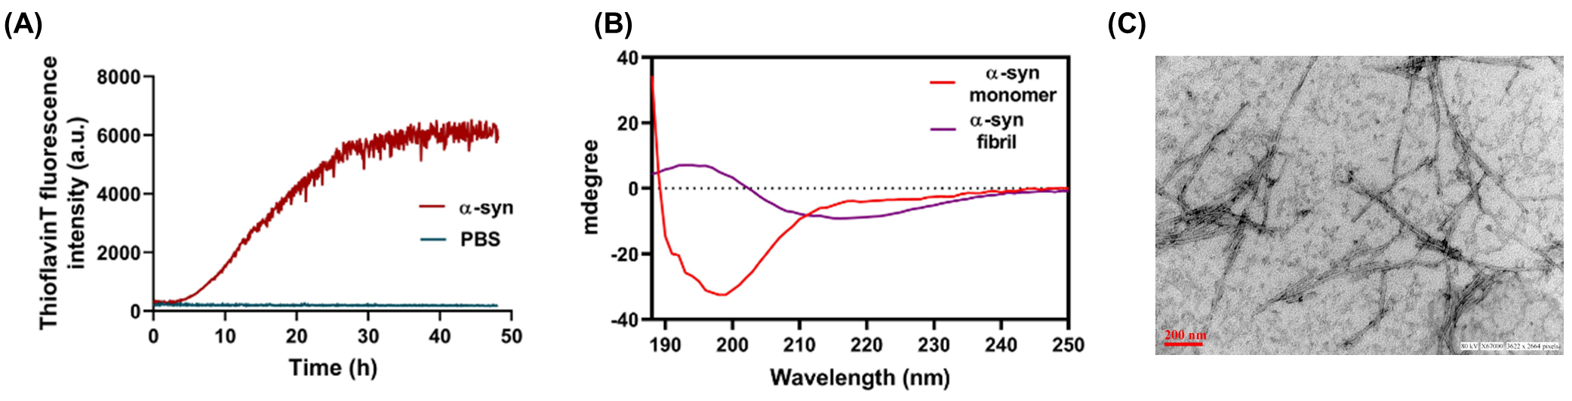
Figure S2. Characterization of purified monomeric and fibrillar α-syn through ThT assay, circular dichroism and transmission electron microscopy
(A) The purified α-syn monomers were characterized by monitoring the aggregation kinetics using the thioflavin T assay. The aggregation kinetics was carried out for 48 h at 37 ºC and ThT fluorescence was measured at excitation/emission wavelengths 450/480 nm. (B) The secondary structure characterization of purified monomers and 48 h fibrils of α-syn by far UV CD spectra. (C) The morphological analysis of 48 h α-syn fibrils through TEM, scale bar = 200 nm.

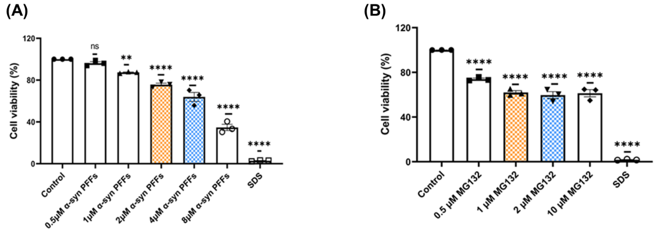
Figure S3. Cytotoxicity of various concentrations of α-syn-seeds and MG132 in SH-SY5Y cells
MTT assay was performed to measure the effect of various concentrations of (A) α-syn-seeds (0.5-8 µM) and (B) MG132 (0.5-10 µM) on SH-SY5Y cells. The percent cell viability was calculated by normalizing the control cell population to 100%. The normal distribution of data was tested by the Shapiro-Wilk (W) and Kolmogorov-Smirnov normality test. Statistical significance was calculated by one-way ANOVA post-Dunnett’s multiple comparisons test using GraphPad Prism 8, and data was expressed as means and +/− SEM (N=3; N = number of independent experiments with sufficient replicates), ns (P>0.05), **(P≤0.01), ****(P≤0.0001).

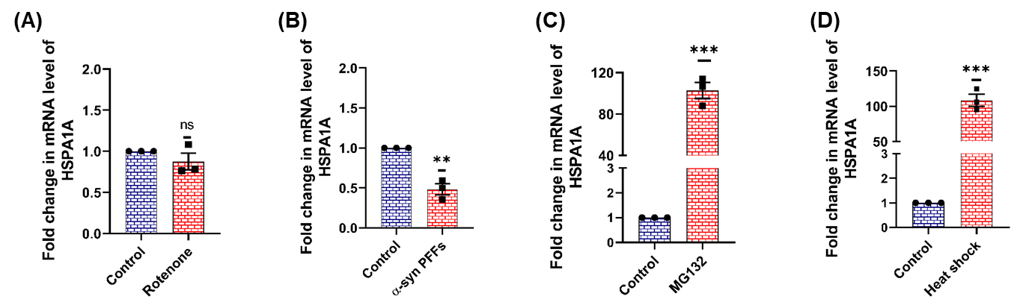
Figure S4. Validation of PCR array with real-time PCR
The fold change in the mRNA of HSPA1A (HSP70) using primers specific for HSP70 (Given in methodology) in (A) rotenone-induced oxidative stress, (B) α-syn-seeds, (C) MG132-induced proteotoxic and (D) heat shock was determined by real-time PCR. The Shapiro-Wilk test was done to determine the normality of the distribution. The statistical significance was calculated by the student-t test using Graph Pad Prism 8, and data was expressed as means and +/− SEM (N=3; N = number of independent experiments with sufficient replicates) as ns (P>0.05), **(P≤0.01), ***(P≤0.001).

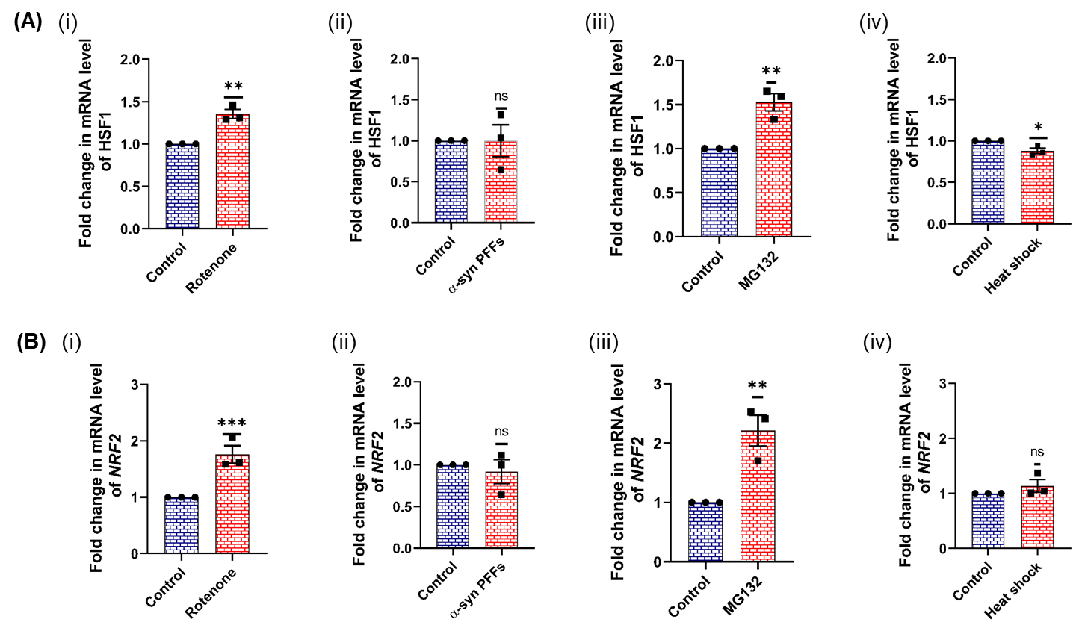
Figure S5. The mRNA repression of HSF1 and NRF2 under different stress conditions
The fold change in the mRNA of (A) HSF1 and (B) NRF2 in (i) rotenone-induced oxidative stress, (ii) α-syn-seeds, (ii) MG132-induced proteotoxic and (iv) heat shock was determined by real-time PCR. The Shapiro-Wilk test was done to determine the normality of the distribution. The statistical significance was calculated by the student-t test using Graph Pad Prism 8, and data was expressed as means and +/− SEM (N=3; N = number of independent experiments with sufficient replicates) as ns (P>0.05), *(P≤0.05) **(P≤0.01), ***(P≤0.001).

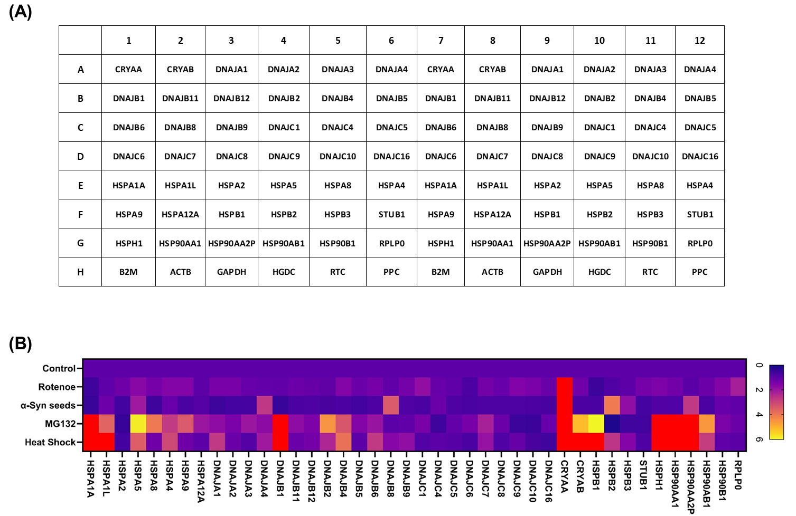
Figure S6. Layout (Template design) of PCR array and heat map of the genes expression
(A) Layout of 96 well plate format of customized PCR array gene expression, RT² ProfilerTM PCR Array of Human Heat Shock Proteins & Chaperones (Qiagen, CLAH47524A), having a total of 48 genes: 42 genes of heat shock proteins, 3 housekeeping genes (B2M, ACTB and GAPDH) and 3 reaction control genes (HGDC, RTC and PPC). (B) The gene expression pattern of 42 different heat shock proteins under different stress conditions is shown as a heat map using fold change median values of N = 3 independent experiments.

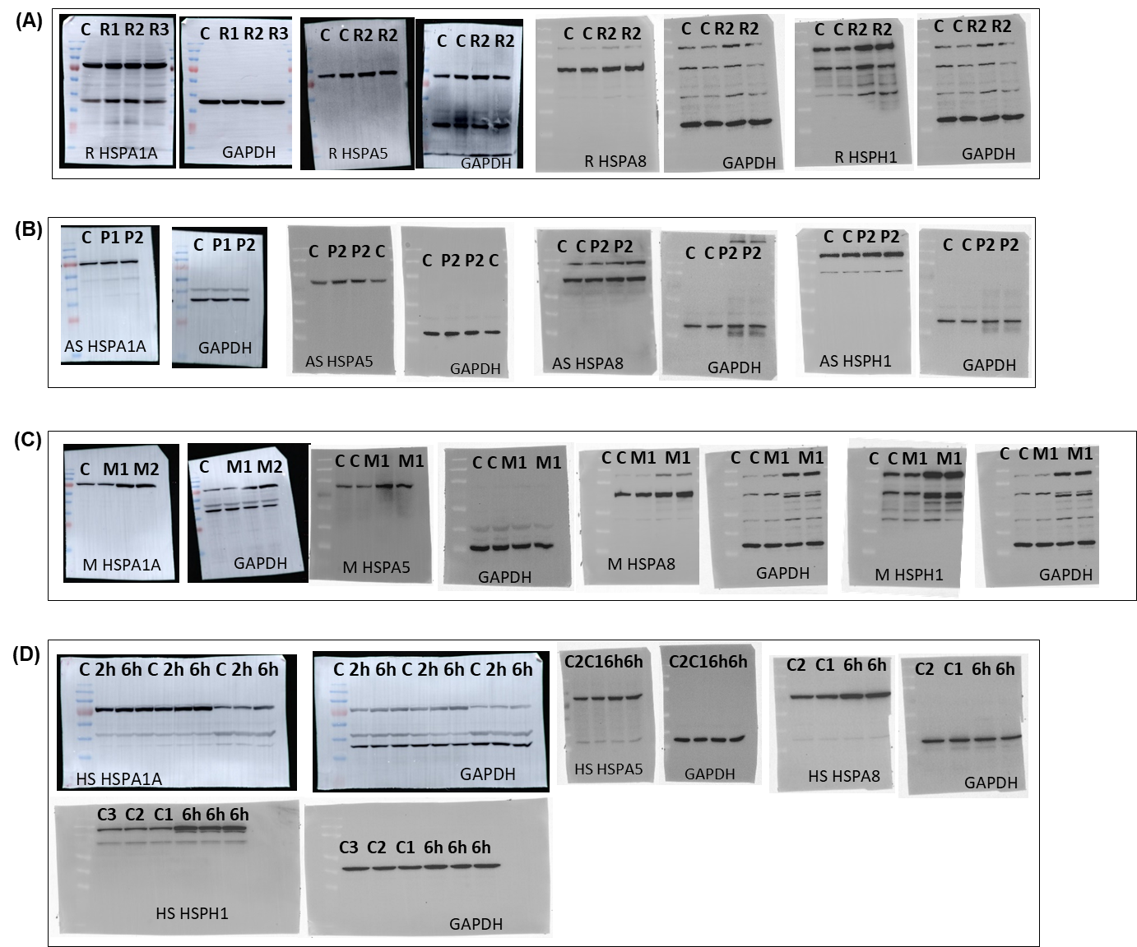
Figure S7. Western blots of HSPA family proteins
Western blots of HSPA1A, HSPA5, HSP8 and HSPH1 proteins and their respective loading controls of cells treated with (A) 1 µM rotenone (R2), (B) 4 µM α-syn seeds (P2), (C) 1 µM MG132 (M1) and (D) 6 h recovery at 37 ºC after 1 h heat shock at 42 ºC (6h). HSPA8 and HSPH1(A, C) were probed on the same blot with common control GAPDH.

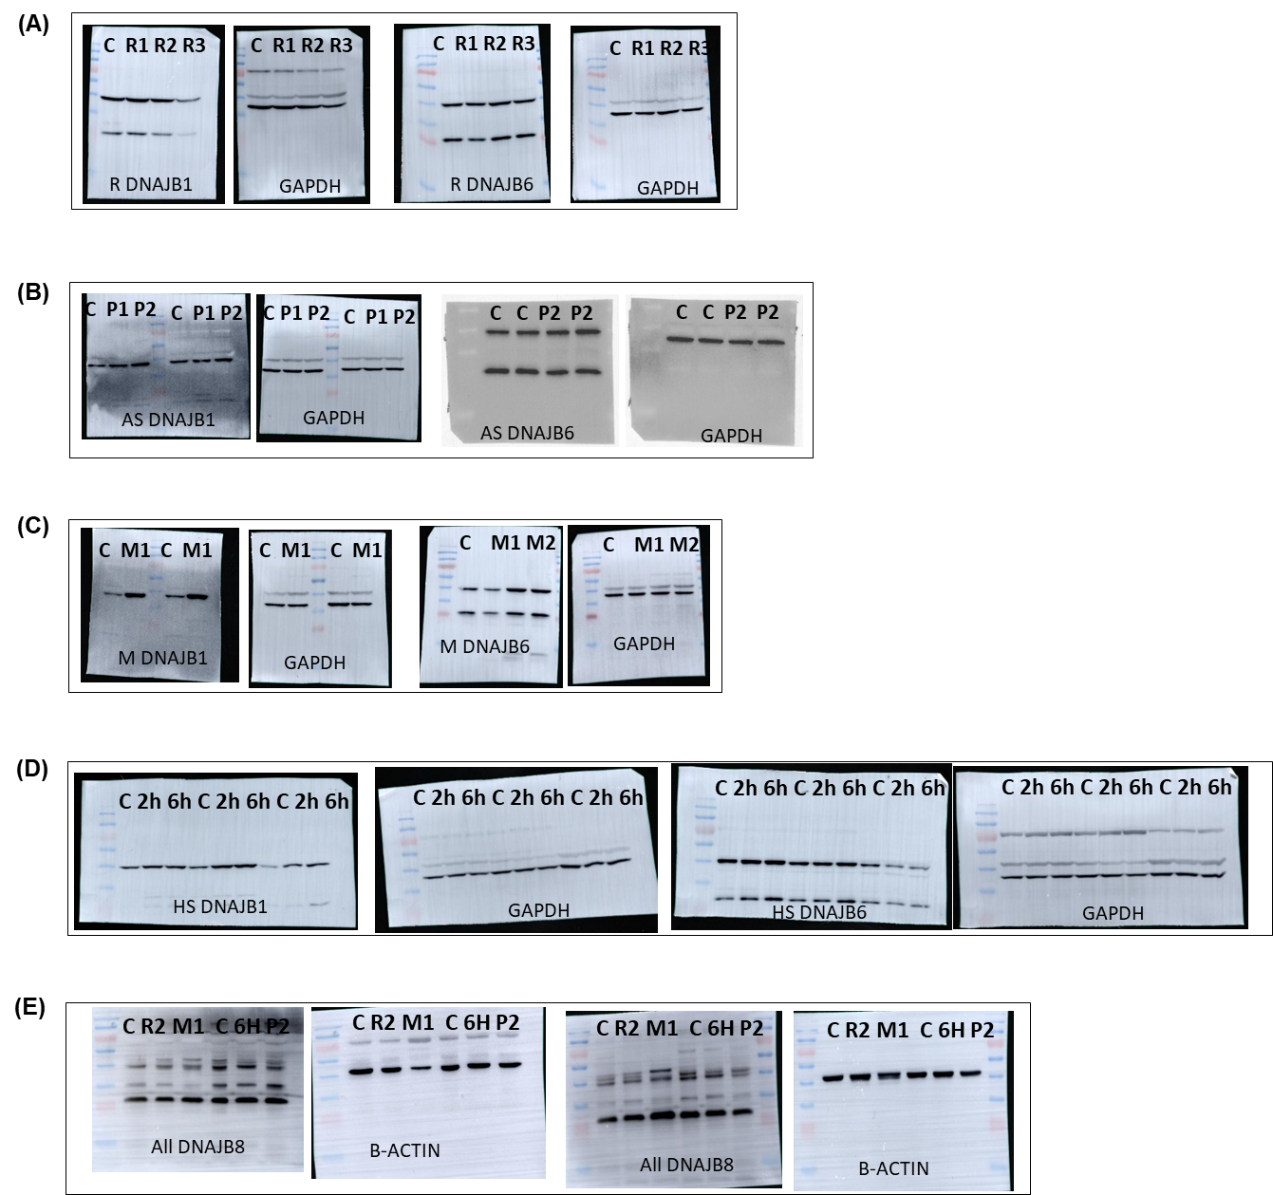
Figure S8. Western blots of DNAJ family proteins
Western blots of DNAJB1 and DNAJB6 proteins and their respective loading controls of cells treated with (A) 1 µM rotenone (R2), (B) 4 µM α-syn seeds (P2), (C) 1 µM MG132 (M1), (D) 6 h recovery at 37 ºC after 1 h heat shock at 42 ºC (6h) and (E) western blots of DNAJB8 protein in all stress conditions. In case of DNAJB8 protein expression (E), rotenone and MG132 treatment groups have same control group and α-syn-seeds and heat shock, treatment groups have same control.

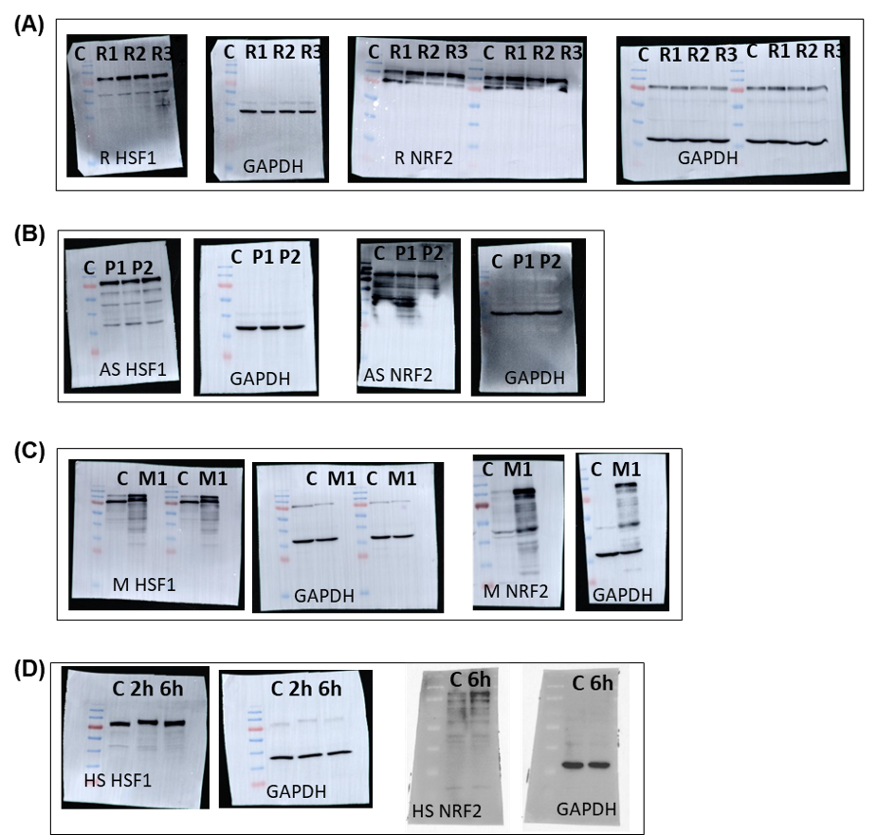
Figure S9. Western blots of transcription factors
Western blots of HSF1 and NRF2 proteins and their respective loading controls of cells treated with (A) 1 µM rotenone (R2), (B) 4 µM α-syn seeds (P2), (C) 1 µM MG132 (M1) and 6 h recovery at 37 ºC after 1 h heat shock at 42 ºC (6h).

