Metabolomic Profiling Reveals Interindividual Metabolic Variability and Its Association with Cardiovascular-Kidney-Metabolic Disease Risk
Meng Zhou^{1, 2}, Wenxiu Sun³, Yuhan Gao^{1, 2}, Bei Jiang^{1, 2}, Tianwei Sun^{1, 2}, Rui Xu^{1, 2}, Xiujuan Zhang^{4#}, Qian Wang^{5#}, Qiuhui Xuan^{1, 2#}, Shizhan Ma^{1, 2#}
¹Key Laboratory of Endocrine Glucose & Lipids Metabolism and Brain Aging, Ministry of Education; Department of Endocrinology, Shandong Provincial Hospital Affiliated to Shandong First Medical University, Jinan, Shandong, China.
²Shandong Institute of Endocrine and Metabolic Disease, Jinan, Shandong, China.
³ Department of Nursing, Taishan Vocational College of Nursing, Taian, China.
⁴Health Management Center, Shandong Provincial Hospital Affiliated to Shandong First Medical University, Jinan, Shandong, China.
⁵Department of Ultrasound, Shandong Provincial Hospital affiliated to Shandong First Medical University, Jinan, Shandong, China.
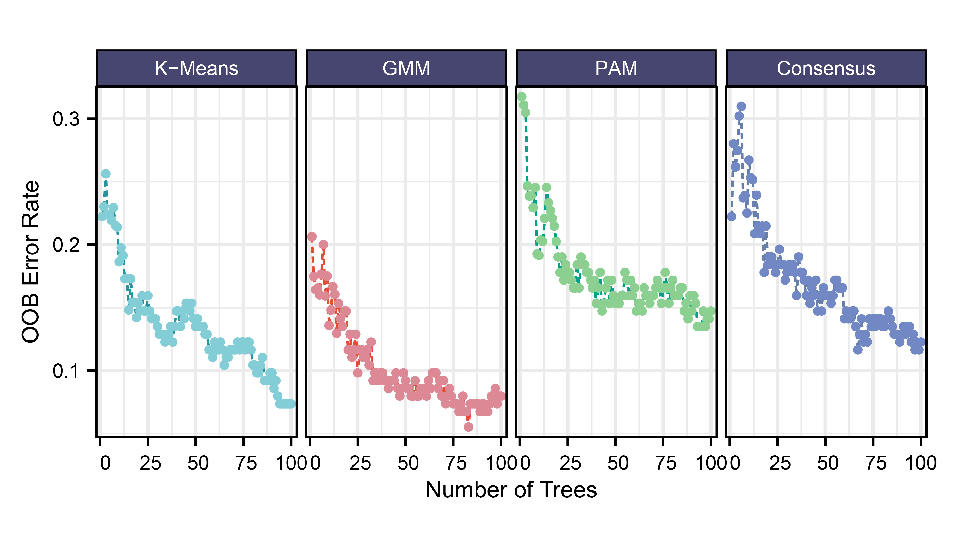
Supplementary Figure 1. Comparison of clustering algorithms by Random Forest out-of-bag error rate.
OOB error rate as a function of the number of trees for four clustering-informed Random Forest models: K-means, Gaussian mixture model (GMM), partitioning around medoids (PAM), and consensus clustering. Each point represents the mean error at a given tree count.
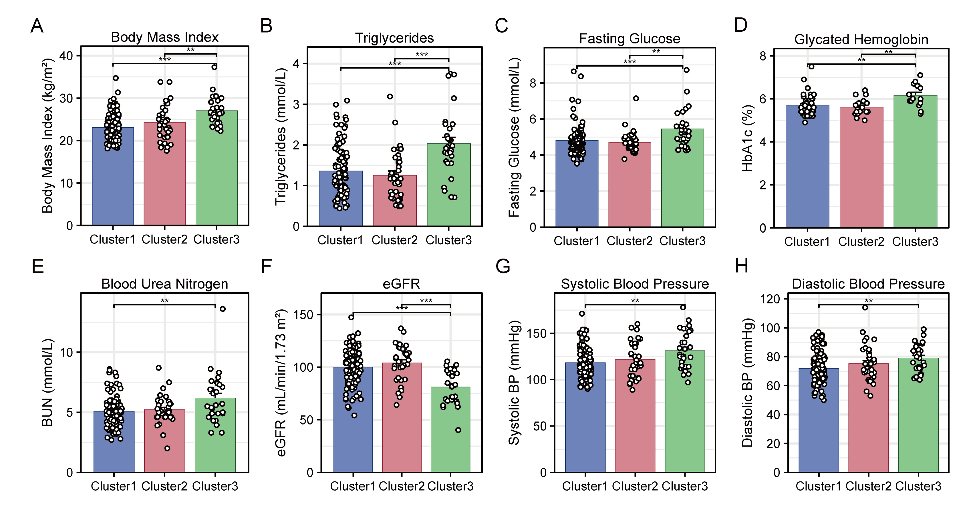Supplementary Figure 2. Clinical characteristics across the three metabolically defined clusters.
Bar plots show the distribution of representative CKM-related clinical indicators across Cluster 1, Cluster 2, and Cluster 3, including: (A) Body Mass Index (BMI), (B) Triglycerides (TG), (C) Fasting Glucose, (D) Glycated Hemoglobin (HbA1c), (E) Blood Urea Nitrogen (BUN), (F) Estimated Glomerular Filtration Rate (eGFR), (G) Systolic Blood Pressure (SBP), and (H) Diastolic Blood Pressure (DBP).
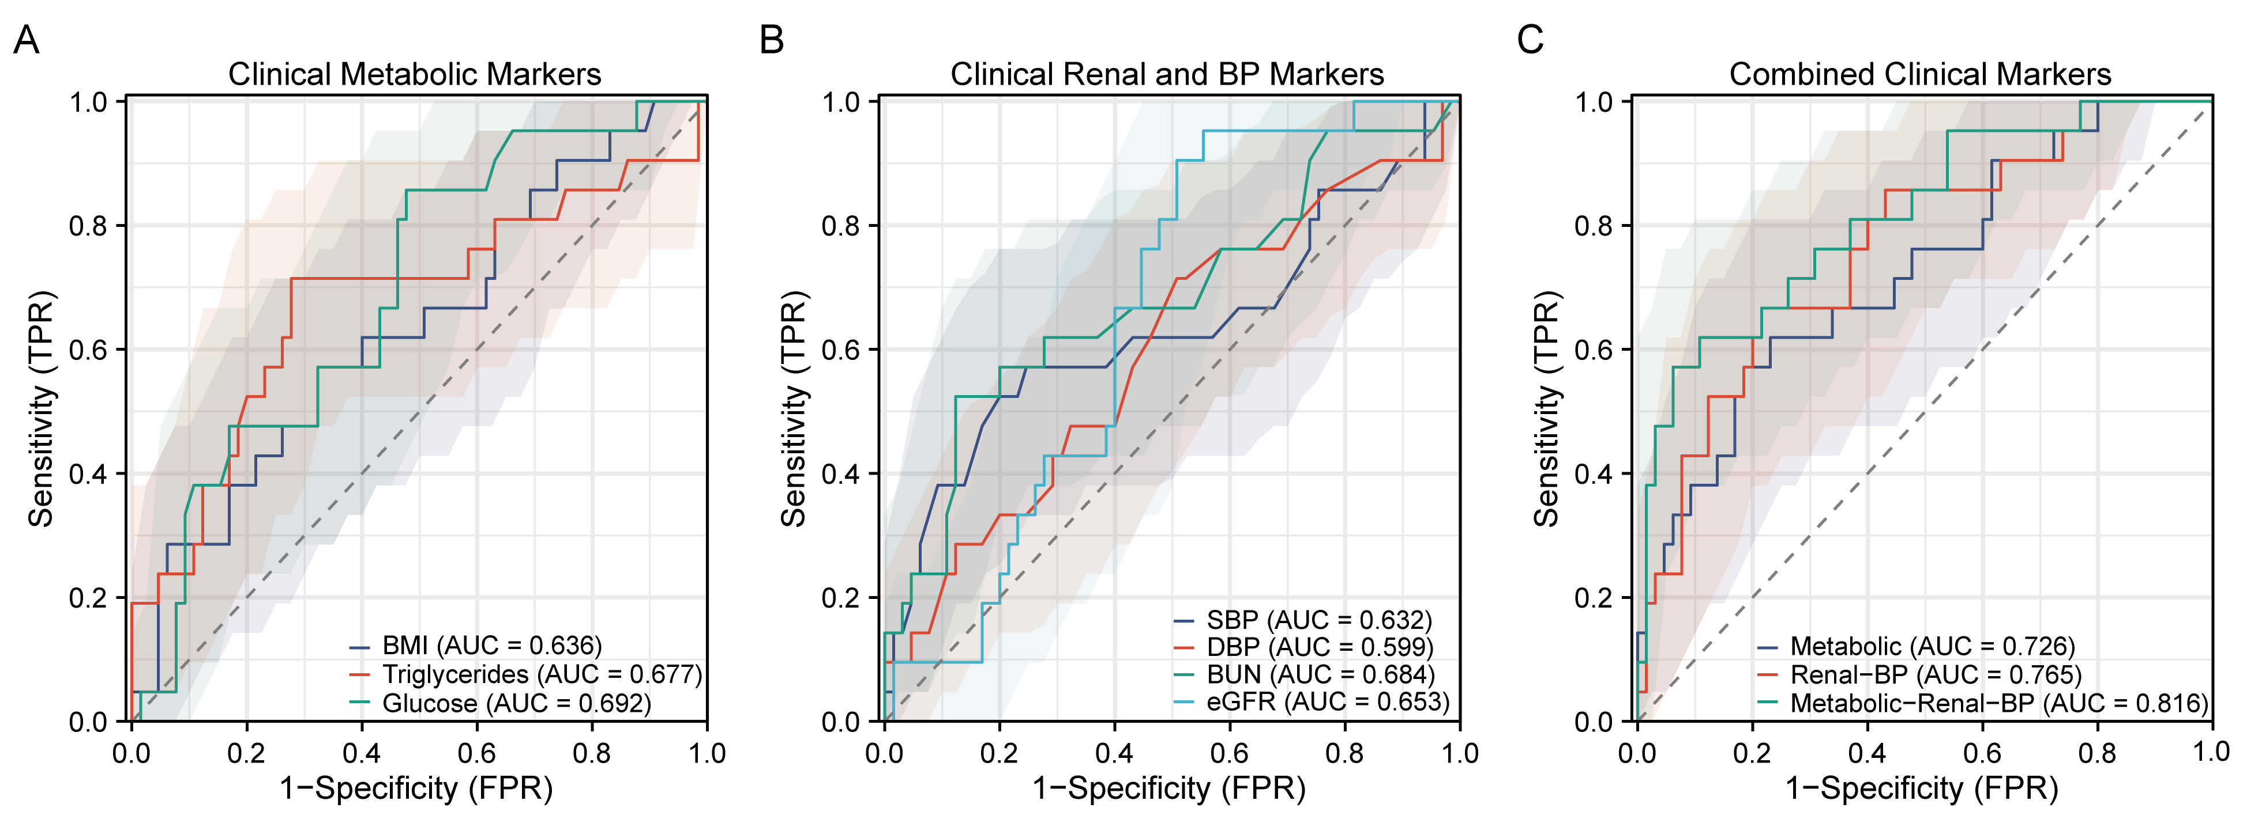Supplementary Figure 3. Classification performance of conventional clinical markers for CKM risk stratification.
(A) ROC curves for individual metabolic indicators: body mass index (BMI), triglycerides, and glucose. (B) ROC curves for renal and blood pressure indicators: systolic blood pressure (SBP), diastolic blood pressure (DBP), blood urea nitrogen (BUN), and estimated glomerular filtration rate (eGFR). (C) ROC curves for combination models: metabolic markers (AUC = 0.726), renal-BP markers (AUC = 0.765), and combined metabolic + renal-BP model (AUC = 0.816).
Shaded areas represent 95% confidence intervals. TPR: true positive rate; FPR: false positive rate.
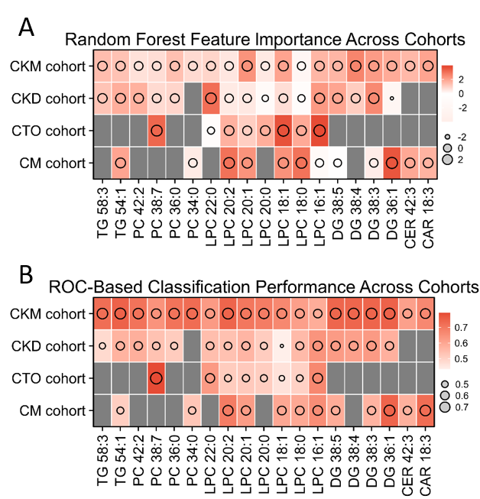
Supplementary Figure 4. Cross-cohort validation of the CKM-associated metabolites using Random Forest feature importance and ROC-based classification performance.
(A) Random Forest (RF) feature importance (MeanDecreaseAccuracy) of the CKM-characteristic metabolites across four cohorts: the discovery CKM cohort, and three validation cohorts: CKD cohort (ST000816, diabetic kidney disease), CTO cohort (ST003661, coronary artery chronic total occlusion), and CM cohort (ST003275, coronary microvascular disease).
(B) ROC-based classification performance of these CKM-associated metabolites in each cohort. Heat color intensity represents RF importance (A) or AUC values (B); circle size indicates the corresponding magnitude. Gray tiles indicate unavailable metabolites in the given cohort.
Supplementary Table 1. Comparison of metabolite abundances among Cluster 1, 2, and 3 using one-way ANOVA.
Metabolite | P_value | FDR | Significant  (FDR<0.05) | From  metabolomics | From  lipidomics
Glutamine | 3.54E-38 | 1.38E-35 | TRUE | Yes
TG 56:6 | 4.38E-37 | 3.94E-35 | TRUE |  | Yes
TG 52:1 | 4.42E-37 | 3.94E-35 | TRUE |  | Yes
TG 58:6 | 5.05E-37 | 3.94E-35 | TRUE |  | Yes
TG 58:5 | 4.69E-37 | 3.94E-35 | TRUE |  | Yes
DG 38:5 | 2.00E-35 | 1.30E-33 | TRUE |  | Yes
TG 52:2 | 8.03E-34 | 4.47E-32 | TRUE |  | Yes
TG 56:5 | 2.58E-33 | 1.26E-31 | TRUE |  | Yes
TG 58:7 | 3.06E-33 | 1.33E-31 | TRUE |  | Yes
DG 36:1 | 4.02E-33 | 1.57E-31 | TRUE |  | Yes
DG 34:3 | 7.30E-33 | 2.59E-31 | TRUE |  | Yes
DG 38:4 | 1.02E-32 | 3.31E-31 | TRUE |  | Yes
TG 56:8 | 1.80E-32 | 5.39E-31 | TRUE |  | Yes
DG 34:2 | 2.22E-32 | 6.19E-31 | TRUE |  | Yes
TG 50:4 | 3.62E-32 | 9.41E-31 | TRUE |  | Yes
TG 51:4 | 7.68E-32 | 1.87E-30 | TRUE |  | Yes
CE 18:3 | 1.09E-31 | 2.50E-30 | TRUE |  | Yes
TG 60:9 | 1.81E-31 | 3.92E-30 | TRUE |  | Yes
TG 52:5 | 2.03E-31 | 4.16E-30 | TRUE |  | Yes
TG 60:8 | 4.53E-31 | 8.83E-30 | TRUE |  | Yes
DG 36:2 | 5.08E-31 | 9.43E-30 | TRUE |  | Yes
DG 36:3 | 6.85E-31 | 1.21E-29 | TRUE |  | Yes
TG 54:1 | 7.76E-31 | 1.32E-29 | TRUE |  | Yes
DG 40:7 | 9.93E-31 | 1.61E-29 | TRUE |  | Yes
TG 54:2 | 1.28E-30 | 1.99E-29 | TRUE |  | Yes
TG 56:4 | 1.68E-30 | 2.52E-29 | TRUE |  | Yes
TG 51:3 | 2.18E-30 | 3.14E-29 | TRUE |  | Yes
TG 50:2 | 4.47E-30 | 6.23E-29 | TRUE |  | Yes
TG 58:8 | 9.47E-30 | 1.27E-28 | TRUE |  | Yes
TG 50:0 | 1.55E-29 | 2.01E-28 | TRUE |  | Yes
TG 60:10 | 1.62E-29 | 2.04E-28 | TRUE |  | Yes
L-Glutamic acid | 2.10E-29 | 2.56E-28 | TRUE | Yes
DG 36:4 | 2.36E-29 | 2.79E-28 | TRUE |  | Yes
TG 52:3 | 3.42E-29 | 3.92E-28 | TRUE |  | Yes
DG 38:6 | 3.56E-29 | 3.97E-28 | TRUE |  | Yes
TG 50:3 | 4.63E-29 | 5.01E-28 | TRUE |  | Yes
TG 58:9 | 5.19E-29 | 5.47E-28 | TRUE |  | Yes
L-Tyrosine | 6.97E-29 | 7.15E-28 | TRUE | Yes
TG 52:6 | 9.80E-29 | 9.80E-28 | TRUE |  | Yes
TG 54:3 | 1.18E-28 | 1.16E-27 | TRUE |  | Yes
TG 52:4 | 1.70E-28 | 1.62E-27 | TRUE |  | Yes
TG 56:7 | 2.03E-28 | 1.89E-27 | TRUE |  | Yes
Phosphoric acid | 2.41E-28 | 2.19E-27 | TRUE | Yes
TG 56:3 | 3.08E-28 | 2.73E-27 | TRUE |  | Yes
TG 50:5 | 1.53E-27 | 1.33E-26 | TRUE |  | Yes
Penicillamine | 3.88E-27 | 3.29E-26 | TRUE | Yes
TG 54:5 | 4.23E-27 | 3.51E-26 | TRUE |  | Yes
TG 53:4 | 1.38E-26 | 1.12E-25 | TRUE |  | Yes
DG 34:0 | 2.46E-26 | 1.94E-25 | TRUE |  | Yes
DG 38:3 | 2.48E-26 | 1.94E-25 | TRUE |  | Yes
TG 54:4 | 4.27E-26 | 3.27E-25 | TRUE |  | Yes
TG 56:9 | 5.90E-26 | 4.43E-25 | TRUE |  | Yes
CE 18:2 | 1.09E-25 | 7.99E-25 | TRUE |  | Yes
TG 50:1 | 1.17E-25 | 8.47E-25 | TRUE |  | Yes
CE 18:1 | 2.91E-25 | 2.06E-24 | TRUE |  | Yes
DG 34:1 | 4.11E-25 | 2.86E-24 | TRUE |  | Yes
TG 53:3 | 5.19E-25 | 3.55E-24 | TRUE |  | Yes
TG 52:0 | 1.09E-24 | 7.31E-24 | TRUE |  | Yes
CE 16:1 | 3.86E-24 | 2.55E-23 | TRUE |  | Yes
TG 56:2 | 5.92E-24 | 3.85E-23 | TRUE |  | Yes
TG 58:10 | 9.10E-24 | 5.82E-23 | TRUE |  | Yes
CE 20:4 | 1.08E-23 | 6.80E-23 | TRUE |  | Yes
TG 52:7 | 1.50E-23 | 9.29E-23 | TRUE |  | Yes
TG 49:3 | 2.47E-23 | 1.51E-22 | TRUE |  | Yes
LPA 18:0 | 2.69E-23 | 1.61E-22 | TRUE | Yes | Yes
TG 51:2 | 1.37E-22 | 8.10E-22 | TRUE |  | Yes
TG 53:2 | 2.13E-22 | 1.24E-21 | TRUE |  | Yes
TG 48:3 | 4.30E-22 | 2.47E-21 | TRUE |  | Yes
DG 36:0 | 6.09E-22 | 3.44E-21 | TRUE |  | Yes
CE 22:6 | 7.14E-22 | 3.98E-21 | TRUE |  | Yes
TG 48:2 | 1.47E-21 | 8.08E-21 | TRUE |  | Yes
TG 54:8 | 1.79E-21 | 9.72E-21 | TRUE |  | Yes
LPA 16:0 | 3.20E-21 | 1.71E-20 | TRUE | Yes | Yes
CE 22:5 | 6.69E-21 | 3.53E-20 | TRUE |  | Yes
TG 48:1 | 1.56E-20 | 8.10E-20 | TRUE |  | Yes
TG 48:0 | 1.78E-20 | 9.15E-20 | TRUE |  | Yes
TG 54:6 | 2.40E-20 | 1.22E-19 | TRUE |  | Yes
TG 49:2 | 1.25E-19 | 6.24E-19 | TRUE |  | Yes
TG 58:4 | 3.97E-19 | 1.96E-18 | TRUE |  | Yes
LPC 16:0 | 1.56E-18 | 7.59E-18 | TRUE | Yes | Yes
LPC 14:1 | 1.62E-18 | 7.81E-18 | TRUE | Yes | Yes
Lactic acid | 1.82E-18 | 8.64E-18 | TRUE | Yes
TG 56:1 | 2.44E-18 | 1.15E-17 | TRUE |  | Yes
CE 20:3 | 3.41E-18 | 1.58E-17 | TRUE |  | Yes
Cer 38:1 | 4.79E-18 | 2.20E-17 | TRUE |  | Yes
DG 40:2 | 7.16E-18 | 3.25E-17 | TRUE |  | Yes
TG 55:3 | 7.62E-18 | 3.41E-17 | TRUE |  | Yes
TG 60:12 | 3.94E-17 | 1.75E-16 | TRUE |  | Yes
TG 40:1 | 4.30E-16 | 1.88E-15 | TRUE |  | Yes
TG 54:7 | 5.20E-16 | 2.25E-15 | TRUE |  | Yes
TG 55:2 | 5.82E-16 | 2.50E-15 | TRUE |  | Yes
SM 38:1 | 1.35E-15 | 5.71E-15 | TRUE | Yes | Yes
16-OH-C16:0 | 9.44E-15 | 3.96E-14 | TRUE
TG 56:10 | 9.92E-15 | 4.12E-14 | TRUE |  | Yes
PC 40:4 | 1.12E-14 | 4.61E-14 | TRUE | Yes | Yes
TG 49:1 | 1.25E-14 | 5.09E-14 | TRUE |  | Yes
TG 51:1 | 1.47E-14 | 5.92E-14 | TRUE |  | Yes
TG 44:2 | 2.04E-14 | 8.13E-14 | TRUE |  | Yes
AOZ | 5.22E-14 | 2.06E-13 | TRUE |  | Yes
TG 46:0 | 5.52E-14 | 2.15E-13 | TRUE |  | Yes
PE 38:3 | 6.67E-14 | 2.57E-13 | TRUE |  | Yes
CE 20:5 | 7.42E-14 | 2.84E-13 | TRUE |  | Yes
Cer 32:1 | 1.84E-13 | 6.99E-13 | TRUE |  | Yes
Cholesterol sulfate | 2.36E-13 | 8.87E-13 | TRUE | Yes
LPA 18:1 | 3.08E-13 | 1.15E-12 | TRUE | Yes
FA 24:1 | 8.85E-13 | 3.26E-12 | TRUE |  | Yes
FA 20:3 | 9.82E-13 | 3.58E-12 | TRUE | Yes | Yes
DG 38:1 | 1.12E-12 | 4.05E-12 | TRUE |  | Yes
FA 16:0 | 1.25E-12 | 4.46E-12 | TRUE | Yes | Yes
Cer 34:2 | 1.35E-12 | 4.80E-12 | TRUE |  | Yes
TG 55:5 | 1.61E-12 | 5.67E-12 | TRUE |  | Yes
TG 47:2 | 2.97E-12 | 1.04E-11 | TRUE |  | Yes
Cer 38:2 | 3.23E-12 | 1.12E-11 | TRUE |  | Yes
TG 46:2 | 3.52E-12 | 1.20E-11 | TRUE |  | Yes
FA 18:1 | 3.78E-12 | 1.28E-11 | TRUE | Yes | Yes
Lys | 4.15E-12 | 1.40E-11 | TRUE | Yes
CE 18:0 | 5.06E-12 | 1.69E-11 | TRUE |  | Yes
Cer 42:0 | 9.46E-12 | 3.13E-11 | TRUE |  | Yes
FA 20:1 | 1.19E-11 | 3.89E-11 | TRUE | Yes | Yes
FA 19:1 | 1.98E-11 | 6.45E-11 | TRUE |  | Yes
TG 62:13 | 2.02E-11 | 6.52E-11 | TRUE |  | Yes
PC 32:0 | 2.34E-11 | 7.48E-11 | TRUE | Yes | Yes
FA 22:4 | 2.45E-11 | 7.76E-11 | TRUE |  | Yes
PC 34:1 | 2.62E-11 | 8.24E-11 | TRUE | Yes | Yes
FA 22:5 | 2.76E-11 | 8.60E-11 | TRUE | Yes | Yes
TG 46:1 | 2.85E-11 | 8.81E-11 | TRUE |  | Yes
SM 32:0 | 3.05E-11 | 9.35E-11 | TRUE |  | Yes
PC 38:3 | 3.37E-11 | 1.02E-10 | TRUE | Yes | Yes
PC 38:1 | 3.35E-11 | 1.02E-10 | TRUE |  | Yes
TG 47:1 | 3.68E-11 | 1.10E-10 | TRUE |  | Yes
FA 16:1 | 3.90E-11 | 1.16E-10 | TRUE | Yes | Yes
PC 36:1 | 3.94E-11 | 1.16E-10 | TRUE | Yes | Yes
FA 20:4 | 5.19E-11 | 1.52E-10 | TRUE | Yes | Yes
PC 42:9 | 8.83E-11 | 2.57E-10 | TRUE |  | Yes
PC 42:7 | 9.23E-11 | 2.67E-10 | TRUE |  | Yes
PC 32:1 | 1.06E-10 | 3.03E-10 | TRUE | Yes | Yes
FA 20:2 | 1.69E-10 | 4.82E-10 | TRUE | Yes | Yes
FA 22:6 | 1.73E-10 | 4.89E-10 | TRUE | Yes | Yes
Cer 41:1 | 2.42E-10 | 6.80E-10 | TRUE |  | Yes
PC 36:0 | 2.47E-10 | 6.83E-10 | TRUE |  | Yes
PE 40:6 | 2.46E-10 | 6.83E-10 | TRUE |  | Yes
Cer 36:1 | 3.06E-10 | 8.41E-10 | TRUE |  | Yes
FA 18:0 | 3.11E-10 | 8.48E-10 | TRUE |  | Yes
Cer 42:1 | 3.17E-10 | 8.60E-10 | TRUE |  | Yes
Cer 40:1 | 3.63E-10 | 9.77E-10 | TRUE |  | Yes
PC 36:3 | 3.79E-10 | 1.00E-09 | TRUE | Yes | Yes
FA 14:0 | 3.77E-10 | 1.00E-09 | TRUE | Yes | Yes
FA 18:2 | 5.18E-10 | 1.37E-09 | TRUE | Yes | Yes
PC 38:2 | 7.66E-10 | 2.01E-09 | TRUE |  | Yes
SM 36:2 | 1.06E-09 | 2.76E-09 | TRUE | Yes | Yes
SM 36:0 | 1.21E-09 | 3.12E-09 | TRUE |  | Yes
Cer 44:3 | 1.34E-09 | 3.43E-09 | TRUE |  | Yes
SM 34:2 | 1.51E-09 | 3.84E-09 | TRUE | Yes | Yes
PC 42:6 | 1.56E-09 | 3.95E-09 | TRUE |  | Yes
PC 34:0 | 1.67E-09 | 4.17E-09 | TRUE |  | Yes
FA 22:2 | 1.67E-09 | 4.17E-09 | TRUE |  | Yes
TG 58:11 | 1.72E-09 | 4.28E-09 | TRUE |  | Yes
FA 16:2 | 1.88E-09 | 4.65E-09 | TRUE | Yes | Yes
SM 40:2 | 1.96E-09 | 4.82E-09 | TRUE | Yes | Yes
PE 38:6 | 1.99E-09 | 4.86E-09 | TRUE | Yes | Yes
PC 40:5 | 3.18E-09 | 7.70E-09 | TRUE | Yes | Yes
FA 19:0 | 3.47E-09 | 8.34E-09 | TRUE | Yes | Yes
PE 34:1 | 4.42E-09 | 1.06E-08 | TRUE |  | Yes
TG 44:1 | 5.04E-09 | 1.20E-08 | TRUE |  | Yes
FA 18:4 | 5.70E-09 | 1.35E-08 | TRUE |  | Yes
PC 36:4 | 6.67E-09 | 1.57E-08 | TRUE | Yes | Yes
FA 20:5 | 7.41E-09 | 1.73E-08 | TRUE | Yes | Yes
TG 58:3 | 8.54E-09 | 1.98E-08 | TRUE |  | Yes
SM 32:1 | 1.18E-08 | 2.73E-08 | TRUE | Yes | Yes
FA 17:0 | 1.32E-08 | 3.02E-08 | TRUE | Yes | Yes
SM 36:4 | 1.49E-08 | 3.40E-08 | TRUE |  | Yes
L-Glutamine | 1.51E-08 | 3.42E-08 | TRUE | Yes
PE 38:4 | 1.61E-08 | 3.64E-08 | TRUE |  | Yes
PC 42:8 | 2.08E-08 | 4.66E-08 | TRUE |  | Yes
Cer 42:3 | 2.13E-08 | 4.74E-08 | TRUE |  | Yes
Cer 43:2 | 2.36E-08 | 5.24E-08 | TRUE |  | Yes
PE 36:2 | 2.46E-08 | 5.43E-08 | TRUE |  | Yes
FA 17:1 | 2.51E-08 | 5.49E-08 | TRUE | Yes | Yes
D?Pip | 2.63E-08 | 5.73E-08 | TRUE |  | Yes
PE 37:4 | 3.85E-08 | 8.34E-08 | TRUE |  | Yes
PE 36:4 | 5.87E-08 | 1.27E-07 | TRUE | Yes | Yes
PC 42:5 | 7.65E-08 | 1.64E-07 | TRUE |  | Yes
TG 58:2 | 7.96E-08 | 1.70E-07 | TRUE |  | Yes
Cer 40:2 | 8.33E-08 | 1.77E-07 | TRUE |  | Yes
Met | 8.51E-08 | 1.79E-07 | TRUE | Yes
TG 44:0 | 1.34E-07 | 2.81E-07 | TRUE |  | Yes
PC 38:6 | 1.49E-07 | 3.11E-07 | TRUE | Yes | Yes
HexCer 38:1 | 1.54E-07 | 3.20E-07 | TRUE |  | Yes
FA 14:1 | 1.70E-07 | 3.50E-07 | TRUE | Yes | Yes
Lolitriol | 2.53E-07 | 5.19E-07 | TRUE | Yes
SM 36:1 | 2.62E-07 | 5.33E-07 | TRUE | Yes | Yes
2-OH-C14:0 | 2.62E-07 | 5.33E-07 | TRUE
PE 36:5 | 3.55E-07 | 7.17E-07 | TRUE |  | Yes
FA 20:0 | 3.70E-07 | 7.44E-07 | TRUE | Yes | Yes
PC 42:11 | 4.24E-07 | 8.48E-07 | TRUE |  | Yes
FA 18:3 | 6.16E-07 | 1.23E-06 | TRUE | Yes | Yes
SM 34:0 | 8.28E-07 | 1.64E-06 | TRUE | Yes | Yes
PC 37:4 | 9.28E-07 | 1.83E-06 | TRUE |  | Yes
CAR 18:0 | 1.17E-06 | 2.30E-06 | TRUE | Yes | Yes
PE 34:2 | 1.24E-06 | 2.41E-06 | TRUE | Yes | Yes
13-KODA | 1.63E-06 | 3.17E-06 | TRUE | Yes
Leu | 1.68E-06 | 3.24E-06 | TRUE | Yes
CAR 16:0 | 1.85E-06 | 3.55E-06 | TRUE | Yes | Yes
SM 44:2 | 2.47E-06 | 4.72E-06 | TRUE |  | Yes
FA 22:0 | 2.49E-06 | 4.74E-06 | TRUE | Yes | Yes
Cholesterol | 2.73E-06 | 5.16E-06 | TRUE | Yes
PC 36:5 | 3.29E-06 | 6.19E-06 | TRUE | Yes | Yes
FA 10:0 | 4.99E-06 | 9.35E-06 | TRUE | Yes | Yes
PCho | 5.69E-06 | 1.06E-05 | TRUE |  | Yes
SM 41:3 | 6.84E-06 | 1.27E-05 | TRUE |  | Yes
SM 39:1 | 7.68E-06 | 1.42E-05 | TRUE |  | Yes
Betaine | 8.13E-06 | 1.50E-05 | TRUE | Yes
CAR 14:0 | 8.27E-06 | 1.51E-05 | TRUE | Yes | Yes
FA 24:0 | 8.55E-06 | 1.56E-05 | TRUE |  | Yes
Choline | 8.75E-06 | 1.59E-05 | TRUE | Yes
Leu-Leu | 1.02E-05 | 1.84E-05 | TRUE | Yes
FA 24:6 | 1.26E-05 | 2.27E-05 | TRUE | Yes | Yes
Val | 1.34E-05 | 2.40E-05 | TRUE | Yes
PC 36:2 | 1.36E-05 | 2.43E-05 | TRUE | Yes | Yes
Octylamine | 1.40E-05 | 2.49E-05 | TRUE | Yes
Cer 42:4 | 1.54E-05 | 2.72E-05 | TRUE |  | Yes
LPC 26:0 | 1.60E-05 | 2.81E-05 | TRUE |  | Yes
SM 39:2 | 2.07E-05 | 3.62E-05 | TRUE |  | Yes
N?Hep?Gly | 2.11E-05 | 3.68E-05 | TRUE | Yes
PC 40:8 | 2.45E-05 | 4.25E-05 | TRUE | Yes | Yes
FA 12:0 | 2.69E-05 | 4.64E-05 | TRUE | Yes | Yes
PC 31:1 | 2.75E-05 | 4.73E-05 | TRUE |  | Yes
1-Hexadecanol | 2.95E-05 | 5.05E-05 | TRUE | Yes
PC 34:3 | 3.10E-05 | 5.27E-05 | TRUE | Yes | Yes
PAc | 3.64E-05 | 6.18E-05 | TRUE | Yes
FA 25:0 | 3.73E-05 | 6.30E-05 | TRUE |  | Yes
PC 34:4 | 4.16E-05 | 7.00E-05 | TRUE | Yes | Yes
FA 22:1 | 4.79E-05 | 8.01E-05 | TRUE | Yes | Yes
TG 62:14 | 5.70E-05 | 9.51E-05 | TRUE |  | Yes
Cer 42:2 | 6.67E-05 | 1.11E-04 | TRUE |  | Yes
FA 15:0 | 7.08E-05 | 1.17E-04 | TRUE | Yes | Yes
SM 42:2 | 8.40E-05 | 1.38E-04 | TRUE |  | Yes
FA 26:0 | 8.60E-05 | 1.41E-04 | TRUE |  | Yes
HexCer 42:2 | 1.13E-04 | 1.84E-04 | TRUE |  | Yes
PE 37:5 | 1.14E-04 | 1.86E-04 | TRUE |  | Yes
SM 33:1 | 1.24E-04 | 2.01E-04 | TRUE | Yes | Yes
SM 42:1 | 1.32E-04 | 2.13E-04 | TRUE |  | Yes
CAR 16:1 | 1.43E-04 | 2.29E-04 | TRUE | Yes | Yes
LPA 20:4 | 1.44E-04 | 2.29E-04 | TRUE | Yes | Yes
Cer 41:2 | 1.76E-04 | 2.80E-04 | TRUE |  | Yes
PC 40:6 | 1.90E-04 | 3.01E-04 | TRUE | Yes | Yes
SM 35:0 | 3.24E-04 | 5.12E-04 | TRUE |  | Yes
LPC 18:3 | 3.52E-04 | 5.54E-04 | TRUE | Yes | Yes
SM 40:4 | 3.60E-04 | 5.63E-04 | TRUE |  | Yes
PE 37:3 | 3.71E-04 | 5.79E-04 | TRUE |  | Yes
Cer 44:1 | 4.09E-04 | 6.36E-04 | TRUE |  | Yes
HexCer 40:2 | 4.26E-04 | 6.59E-04 | TRUE |  | Yes
N?Und?Gly | 4.74E-04 | 7.31E-04 | TRUE
LPA 20:2 | 5.43E-04 | 8.33E-04 | TRUE | Yes | Yes
PC 40:2 | 6.11E-04 | 9.35E-04 | TRUE |  | Yes
PE 36:0 | 6.51E-04 | 9.92E-04 | TRUE |  | Yes
PC 42:10 | 7.13E-04 | 1.08E-03 | TRUE | Yes | Yes
Cer 34:1 | 7.58E-04 | 1.15E-03 | TRUE |  | Yes
LPC 16:1 | 7.84E-04 | 1.18E-03 | TRUE | Yes | Yes
PC 38:5 | 7.87E-04 | 1.18E-03 | TRUE | Yes | Yes
PE 40:7 | 8.19E-04 | 1.22E-03 | TRUE |  | Yes
SM 36:3 | 8.58E-04 | 1.28E-03 | TRUE |  | Yes
CAR 14:1 | 9.95E-04 | 1.48E-03 | TRUE | Yes | Yes
PC 37:3 | 1.00E-03 | 1.48E-03 | TRUE | Yes | Yes
SM 40:1 | 1.30E-03 | 1.92E-03 | TRUE |  | Yes
Bilirubin | 1.36E-03 | 2.00E-03 | TRUE | Yes
CAR 16:2 | 1.52E-03 | 2.21E-03 | TRUE | Yes | Yes
PE 39:6 | 1.87E-03 | 2.73E-03 | TRUE |  | Yes
FA 15:1 | 1.92E-03 | 2.78E-03 | TRUE |  | Yes
CAR 12:0 | 2.19E-03 | 3.16E-03 | TRUE | Yes
PC 38:4 | 2.19E-03 | 3.16E-03 | TRUE | Yes | Yes
PEA | 2.21E-03 | 3.16E-03 | TRUE |  | Yes
SEA | 2.67E-03 | 3.82E-03 | TRUE |  | Yes
SM 38:4 | 2.72E-03 | 3.87E-03 | TRUE |  | Yes
SM 35:2 | 2.77E-03 | 3.93E-03 | TRUE |  | Yes
SM 34:1 | 3.13E-03 | 4.42E-03 | TRUE | Yes | Yes
Hex2Cer 42:2 | 3.18E-03 | 4.48E-03 | TRUE |  | Yes
PE 40:4 | 3.29E-03 | 4.62E-03 | TRUE | Yes | Yes
Lenticin | 3.57E-03 | 4.99E-03 | TRUE | Yes
PC 35:4 | 3.67E-03 | 5.11E-03 | TRUE | Yes | Yes
PC 33:1 | 3.71E-03 | 5.15E-03 | TRUE | Yes | Yes
SM 40:3 | 3.95E-03 | 5.46E-03 | TRUE |  | Yes
PC 35:3 | 4.08E-03 | 5.62E-03 | TRUE | Yes | Yes
CAR 18:3 | 4.19E-03 | 5.75E-03 | TRUE | Yes | Yes
SM 38:2 | 4.63E-03 | 6.34E-03 | TRUE |  | Yes
Farnesylacetone | 5.01E-03 | 6.83E-03 | TRUE | Yes
CAR 2:0 | 5.20E-03 | 7.06E-03 | TRUE | Yes
HexCer 42:1 | 5.35E-03 | 7.24E-03 | TRUE |  | Yes
PC 37:6 | 5.39E-03 | 7.28E-03 | TRUE |  | Yes
SM 41:1 | 5.89E-03 | 7.92E-03 | TRUE |  | Yes
CAR 14:2 | 6.46E-03 | 8.66E-03 | TRUE | Yes
SM 41:2 | 7.02E-03 | 9.38E-03 | TRUE | Yes | Yes
Hex2Cer 34:1 | 9.82E-03 | 1.31E-02 | TRUE |  | Yes
PC 30:1 | 1.10E-02 | 1.46E-02 | TRUE |  | Yes
PC 35:1 | 1.18E-02 | 1.56E-02 | TRUE | Yes | Yes
LPC 14:0 | 1.18E-02 | 1.56E-02 | TRUE | Yes | Yes
SM 42:3 | 1.28E-02 | 1.69E-02 | TRUE | Yes | Yes
HexCer 34:1 | 1.37E-02 | 1.79E-02 | TRUE |  | Yes
PE 38:5 | 1.41E-02 | 1.84E-02 | TRUE |  | Yes
PC 34:5 | 1.47E-02 | 1.91E-02 | TRUE |  | Yes
PC 38:7 | 1.55E-02 | 2.01E-02 | TRUE | Yes | Yes
LPC 24:0 | 1.62E-02 | 2.09E-02 | TRUE | Yes | Yes
PC 32:2 | 1.73E-02 | 2.22E-02 | TRUE | Yes | Yes
SM d18:1/18:0 | 1.76E-02 | 2.25E-02 | TRUE |  | Yes
Sphingosine | 1.86E-02 | 2.38E-02 | TRUE | Yes | Yes
PC 40:7 | 2.06E-02 | 2.63E-02 | TRUE | Yes | Yes
Cer 43:1 | 2.19E-02 | 2.78E-02 | TRUE |  | Yes
LPC 22:6 | 2.47E-02 | 3.13E-02 | TRUE | Yes | Yes
Pip-2-one | 2.78E-02 | 3.50E-02 | TRUE
PC 35:2 | 2.87E-02 | 3.61E-02 | TRUE | Yes | Yes
PE 36:3 | 2.90E-02 | 3.64E-02 | TRUE |  | Yes
HexCer 40:1 | 3.37E-02 | 4.22E-02 | TRUE |  | Yes
SM 35:1 | 3.76E-02 | 4.69E-02 | TRUE |  | Yes
CAR 18:1 | 4.24E-02 | 5.27E-02 | FALSE | Yes | Yes
Glu-Leu | 4.43E-02 | 5.48E-02 | FALSE | Yes
LPC 22:1 | 5.03E-02 | 6.20E-02 | FALSE |  | Yes
CAR 18:2 | 5.18E-02 | 6.37E-02 | FALSE | Yes | Yes
Leu-Pro | 5.73E-02 | 7.02E-02 | FALSE | Yes
SM 43:1 | 5.84E-02 | 7.14E-02 | FALSE |  | Yes
PC 42:2 | 5.95E-02 | 7.25E-02 | FALSE |  | Yes
CAR 22:1 | 6.06E-02 | 7.36E-02 | FALSE |  | Yes
HexCer 41:1 | 6.12E-02 | 7.41E-02 | FALSE |  | Yes
PE 38:2 | 6.16E-02 | 7.44E-02 | FALSE |  | Yes
CAR 12:1 | 6.81E-02 | 8.20E-02 | FALSE | Yes
SM 43:2 | 6.85E-02 | 8.22E-02 | FALSE |  | Yes
LPC 18:0 | 8.05E-02 | 9.63E-02 | FALSE | Yes | Yes
LPC 18:2 | 8.19E-02 | 9.76E-02 | FALSE | Yes | Yes
SM 44:1 | 8.44E-02 | 1.00E-01 | FALSE |  | Yes
Cepanone | 8.63E-02 | 1.02E-01 | FALSE | Yes
CAR 12:3 | 9.14E-02 | 1.08E-01 | FALSE | Yes
LPA 14:0 | 9.23E-02 | 1.09E-01 | FALSE | Yes | Yes
LPA 22:6 | 1.05E-01 | 1.23E-01 | FALSE | Yes | Yes
CAR 3:0 | 1.06E-01 | 1.24E-01 | FALSE | Yes
CAR 10:0 | 1.06E-01 | 1.24E-01 | FALSE | Yes
DL?AOA | 1.15E-01 | 1.34E-01 | FALSE | Yes
Me-Pent-Fur-C11:0 | 1.25E-01 | 1.45E-01 | FALSE | Yes
PC 30:0 | 1.26E-01 | 1.46E-01 | FALSE | Yes | Yes
LPC 22:0 | 1.28E-01 | 1.48E-01 | FALSE | Yes | Yes
Neo | 1.33E-01 | 1.53E-01 | FALSE | Yes
CAR 5:0 | 1.33E-01 | 1.53E-01 | FALSE | Yes
DEET | 1.35E-01 | 1.54E-01 | FALSE | Yes | Yes
PC 31:0 | 1.35E-01 | 1.54E-01 | FALSE |  | Yes
PC 37:2 | 1.46E-01 | 1.66E-01 | FALSE |  | Yes
CE 16:0 | 1.61E-01 | 1.83E-01 | FALSE |  | Yes
PC 34:2 | 1.63E-01 | 1.84E-01 | FALSE | Yes | Yes
CAR 10:1 | 1.64E-01 | 1.85E-01 | FALSE | Yes
LPC 17:1 | 1.73E-01 | 1.94E-01 | FALSE | Yes | Yes
CAR 14:3 | 2.01E-01 | 2.25E-01 | FALSE | Yes
Pro-leu | 2.11E-01 | 2.36E-01 | FALSE | Yes
CAR 13:1 | 2.20E-01 | 2.44E-01 | FALSE | Yes
PE 36:1 | 2.19E-01 | 2.44E-01 | FALSE |  | Yes
LPC 20:4 | 2.29E-01 | 2.53E-01 | FALSE | Yes | Yes
LPC 20:3 | 2.56E-01 | 2.83E-01 | FALSE | Yes | Yes
CAR C8:0 | 2.60E-01 | 2.86E-01 | FALSE | Yes
LPC 20:5 | 2.68E-01 | 2.95E-01 | FALSE | Yes | Yes
FANH2 18:0 | 2.86E-01 | 3.13E-01 | FALSE | Yes | Yes
SM 42:4 | 2.92E-01 | 3.19E-01 | FALSE | Yes | Yes
Stearamide | 3.22E-01 | 3.51E-01 | FALSE | Yes | Yes
LPC 18:1 | 3.51E-01 | 3.81E-01 | FALSE | Yes | Yes
LPC 22:5 | 3.78E-01 | 4.10E-01 | FALSE | Yes | Yes
CAR 13:0 | 4.42E-01 | 4.77E-01 | FALSE | Yes
CAR 12:2 | 4.43E-01 | 4.77E-01 | FALSE | Yes
FANH2 16:0 | 4.47E-01 | 4.81E-01 | FALSE | Yes | Yes
PE 40:5 | 4.54E-01 | 4.86E-01 | FALSE |  | Yes
CAR 6:0 | 5.02E-01 | 5.37E-01 | FALSE | Yes
PC 33:0 | 5.06E-01 | 5.39E-01 | FALSE |  | Yes
PE 38:1 | 5.48E-01 | 5.82E-01 | FALSE |  | Yes
Indoline | 6.07E-01 | 6.43E-01 | FALSE | Yes
DCA/CDCA | 6.09E-01 | 6.43E-01 | FALSE | Yes
CAR C8:1 | 6.15E-01 | 6.48E-01 | FALSE | Yes
SM 32:2 | 6.21E-01 | 6.52E-01 | FALSE |  | Yes
Biliverdin | 6.52E-01 | 6.84E-01 | FALSE | Yes
LPC 22:4 | 6.64E-01 | 6.94E-01 | FALSE | Yes | Yes
CAR 10:2 | 6.80E-01 | 7.09E-01 | FALSE | Yes
LPC 20:1 | 6.93E-01 | 7.21E-01 | FALSE | Yes | Yes
27-HC | 6.98E-01 | 7.24E-01 | FALSE | Yes
LPC 17:0 | 7.31E-01 | 7.56E-01 | FALSE | Yes | Yes
CAR 11:1 | 7.75E-01 | 7.99E-01 | FALSE | Yes
Hex2Cer 34:2 | 7.83E-01 | 8.06E-01 | FALSE |  | Yes
LPC 20:0 | 8.03E-01 | 8.24E-01 | FALSE | Yes | Yes
CAR 4:0 | 8.16E-01 | 8.35E-01 | FALSE | Yes
CAR 6:1 | 8.20E-01 | 8.38E-01 | FALSE | Yes
PC 28:0 | 8.58E-01 | 8.73E-01 | FALSE |  | Yes
16,17-DDP | 8.61E-01 | 8.74E-01 | FALSE
Arginine | 8.68E-01 | 8.79E-01 | FALSE | Yes
LPC 20:2 | 8.78E-01 | 8.87E-01 | FALSE | Yes | Yes
CAR 9:0 | 8.83E-01 | 8.90E-01 | FALSE | Yes
CAR 5:1 | 9.32E-01 | 9.36E-01 | FALSE | Yes
LPC 15:0 | 9.71E-01 | 9.73E-01 | FALSE | Yes | Yes
IPA | 9.73E-01 | 9.73E-01 | FALSE | Yes
Note: P-values are from the ANOVA tests, and q-values are the false discovery rate (FDR)-adjusted p-values using the Benjamini-Hochberg method. Metabolites are sorted by increasing q-value; those with FDR < 0.05 are marked as Yes in the significance column.
Supplementary Table 2. Baseline characteristics of participants across the three metabolically defined clusters.
Characteristics | Cluster1 | Cluster2 | Cluster3 | P value
n | 100 | 35 | 28
SEX, n (%) |  |  |  | 0.157
Female | 49 (30.1%) | 16 (9.8%) | 8 (4.9%)
Male | 51 (31.3%) | 19 (11.7%) | 20 (12.3%)
AGE, mean ± sd | 43.9 ± 11.654 | 46.0 ± 11.7 | 48.5 ± 12.1 | 0.172
BMI, median (IQR) | 22.6 (20.5, 25.1) | 23.8 (21.1, 26.9) | 26.6 (24.8, 29.1) | < 0.001
TG, median (IQR) | 1.2 (0.9, 1.8) | 1.8 (0. 8, 1.6) | 1.9 (1.6, 2.4) | < 0.001
TC, median (IQR) | 5.4 (4.9, 6.2) | 5.4 (5.1, 6.0) | 5.3 (4.7, 5.7) | 0.243
HDL, median (IQR) | 1.5 (1.22, 1.7) | 1.5 (1.2, 1.8) | 1.1 (1.0, 1.3) | < 0.001
LDL, median (IQR) | 3.1 (2.6, 3.7) | 3.1 (2.7, 3.7) | 3.0 (2.8, 3.5) | 0.886
GLU, median (IQR) | 4.6 (4.4, 5.0) | 4.6 (4.4, 5.0) | 5.3 (4.8, 5.7) | < 0.001
HbA1c, median (IQR) | 5.6 (5.4, 5.9) | 5.6 (5.4, 5.8) | 6 (5.9, 6.6) | 0.003
BUN, median (IQR) | 4.9 (4.2, 5.6) | 5.02 (4.6, 5.8) | 5.7 (4.9, 7.3) | 0.011
eGFR, mean ± sd | 100.0 ± 17.4 | 104.0 ± 17.5 | 81.1 ± 16.2 | < 0.001
SBP, median (IQR) | 115.0 (105.0, 130.25) | 117.0 (107.5, 138.5) | 126.0 (114.0, 148.3) | 0.011
DBP, median (IQR) | 71.0 (64.8, 77.3) | 73.0 (67.0, 83.0) | 79.5 (72.0, 87.3) | 0.007
Carotid plaque, n (%) |  |  |  | < 0.001
NO | 45 (52.3%) | 12 (14%) | 8 (9.3%)
YES | 5 (5.8%) | 5 (5.8%) | 11 (12.8%)
Demographic, anthropometric, metabolic, and renal function indicators are presented as mean ± SD or median (IQR), as appropriate. Differences across clusters were assessed using Kruskal–Wallis or chi-squared tests.

