Supplementary Information for
Low-voltage and fully flexible analogue/digital mixed-signal circuits based on carbon nanotubes for epidermal sensor applications

Taiga Kashima¹, Shigeru Kishimoto¹, Jun Hirotani¹, Hiromichi Kataura², and Yutaka Ohno^{1,3,*}
¹ Department of Electronics, Nagoya University, Furo-cho, Chikusa-ku, Nagoya 464-8603, Japan
² Nanomaterials Research Institute, National Institute of Advanced Industrial Science and Technology, Tsukuba, Ibaraki, 305-8565, Japan
³ Institute of Materials and Systems for Sustainability, Nagoya University, Furo-cho, Chikusa-ku, Nagoya 464-8601, Japan
* Corresponding author e-mail: yohno@nagoya-u.jp

Contents:
- Modeling of CNT TFT
- AC and DC gains of the proposed op-amp
- Supplemental descriptions on fabricated circuits.
- Parameters of CNT TFTs and passive elements in each circuit
- Performance comparison of TFT-based differential amplifiers and op-amps
- Measurement of CMRR of instrumentation amplifier
- Evaluation of ENOB and energy efficiency
- Performance comparison of flexible ADCs
- Continuous operation of AFE
- Modeling of CNT TFT
The equivalent circuit model for a CNT TFT developed in this study is shown in Fig. S1. The device model was fundamentally based on the previous study,^{S1} which was modified to exhibit ambipolar characteristics of CNT TFTs to obtain more accurate frequency characteristics. The equations for the current and voltage are shown below,^{S1}
$$\begin{aligned}I_{{DS}_{p}}=-μ_{p}C_{ox}\frac{W}{L}\left(\frac{{f_{p}\left(V_{G}, V_{S}\right)}^{γ+2}-{f_{p}\left(V_{G}, V_{D}\right)}^{γ+2}}{γ+2}\right)\left(1+λ\left|V_{DS}\right|\right),\#\left(S1\right)\end{aligned}$$
$$\begin{aligned}I_{{DS}_{n}}=μ_{n}C_{ox}\frac{W}{L}\left(\frac{{f_{n}\left(V_{G},V_{D}\right)}^{γ+2}-{f_{n}\left(V_{G}, V_{S}\right)}^{γ+2}}{γ+2}\right)\left(1+λ\left|V_{DS}\right|\right),\#\left(S2\right)\end{aligned}$$
$$\begin{aligned}f_{p}\left(V_{G}, V\right)=V_{SS}×ln\left\{1+exp\left(-\frac{V_{G}-V_{T_{p}}-V}{V_{SS}}\right)\right\},\#\left(S3\right)\end{aligned}$$
$$\begin{aligned}f_{n}\left(V_{G}, V\right)=V_{SS}×ln\left\{1+exp\left(\frac{V_{G}-V_{T_{n}}-V}{V_{SS}}\right)\right\},\#\left(S4\right)\end{aligned}$$
where V_{G}, V_{S}, and V_{D} are the gate, source, and drain potentials relative to ground, respectively. V_{SS} is subthreshold voltage that represents the steepness of SS. μ is mobility, C_{OX} is oxide capacitance per unit area, W is channel width, L is channel length, γ is mobility enhancement factor and λ is channel length modulation factor.
Table S1 shows the mean value and standard deviation of parameters extracted by fitting above equations to experimentally measured I-V and C-V characteristics as following procedure,
- Extraction of γ from measured I_{D}-V_{GS} characteristics by using H_{VG} function.^{S2}
- Extraction of λ from the saturation slope of measured I_{D}-V_{DS} characteristics.
- Extraction of R_{C} from measured I_{D}-V_{GS} characteristics using Y-function method.^{S3}
- Extraction of V_{SS} from logarithmic subthreshold slope of measured I_{D}-V_{GS} characteristics.
- Extraction of C_{OX} and overlap capacitance per unit area (C_{OV}) by using L dependence of measured gate capacitance (C_{G} = C_{OX}LW + 2C_{OV}W).
- Extraction of μ_{p,} μ_{n}, V_{Tp} and V_{Tn} from measured I_{D}-V_{GS} characteristics by fitting to Eqs. S1 and S2.
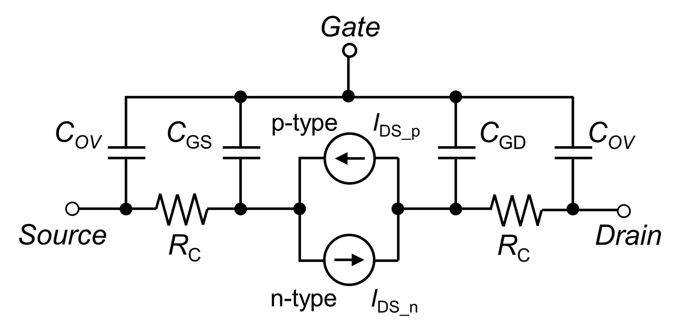
Fig. S1 | Equivalent circuit of the CNT-TFT model.

Table S1 | Extracted parameters of the fabricated CNT-TFTs.
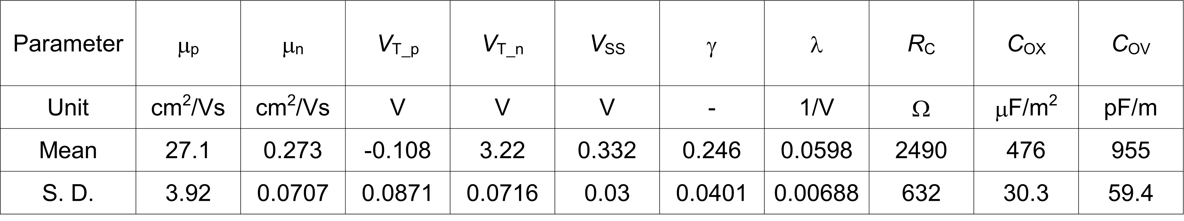

- AC and DC gains of the proposed op-amp
The AC gain A_{AC} and DC gain A_{DC} of the proposed op-amp circuit are given by
$A_{AC}={gm}_{2}{\left(\frac{1}{{ro}_{2}}+\frac{1}{{ro}_{4}}+\frac{1}{{ro}_{6}}\right)}^{-1}{gm}_{7}{\left(\frac{1}{{ro}_{7}}+\frac{1}{{ro}_{8}}\right)}^{-1}$, (S5)
$A_{DC}={gm}_{2}{\left(\frac{1}{{ro}_{2}}+{gm}_{4}+\frac{1}{{ro}_{6}}\right)}^{-1}{gm}_{7}{\left(\frac{1}{{ro}_{7}}+{gm}_{8}\right)}^{-1}≤\frac{{gm}_{2}}{{gm}_{4}}\frac{{gm}_{7}}{{gm}_{8}}=\sqrt{\frac{\left({W_{2}}/{L_{2}}\right)\left({W_{7}}/{L_{7}}\right)}{\left({W_{4}}/{L_{4}}\right)\left({W_{8}}/{L_{8}}\right)}}$, (S6)
where gm and ro are the transconductance and output resistance, respectively, of a transistor; W and L are the channel width and length, respectively, of a transistor; and the subscript indicates the number of the transistor.
The proposed op-amp can achieve an A_{AC} comparable to that of the two-stage CMOS-based op-amp (${gm}_{2}{\left(1/{{ro}_{2}}+1/{{ro}_{4}}\right)}^{-1}{gm}_{6}{\left(1/{{ro}_{5}}+1/{{ro}_{6}}\right)}^{-1}$), even though it comprises single-polarity transistors. In contrast, A_{DC} can be controlled to be less than unity by adjusting the W/L ratio of the transistors. For instance, A_{DC} < 0 dB can be achieved by setting W₂ = W₄ and W₇ = W₈ with a constant L. The transistors M₃, M₄, and M₈ are biased under the condition V_{OUT} < V_{B} < V_{DD} to operate in the saturation region through R₁, R₂, and R₃. Thus, their ro values are sufficiently high to obtain a high A_{AC}.
In the circuit simulation, the optimal V_{B} for maximising A_{AC} was derived at V_{B}/V_{DD} = 0.7 as can be seen in Fig. S2. The optimal V_{B} should realise a high A_{AC} = 48 dB and small A_{DC} = -4.8 dB.
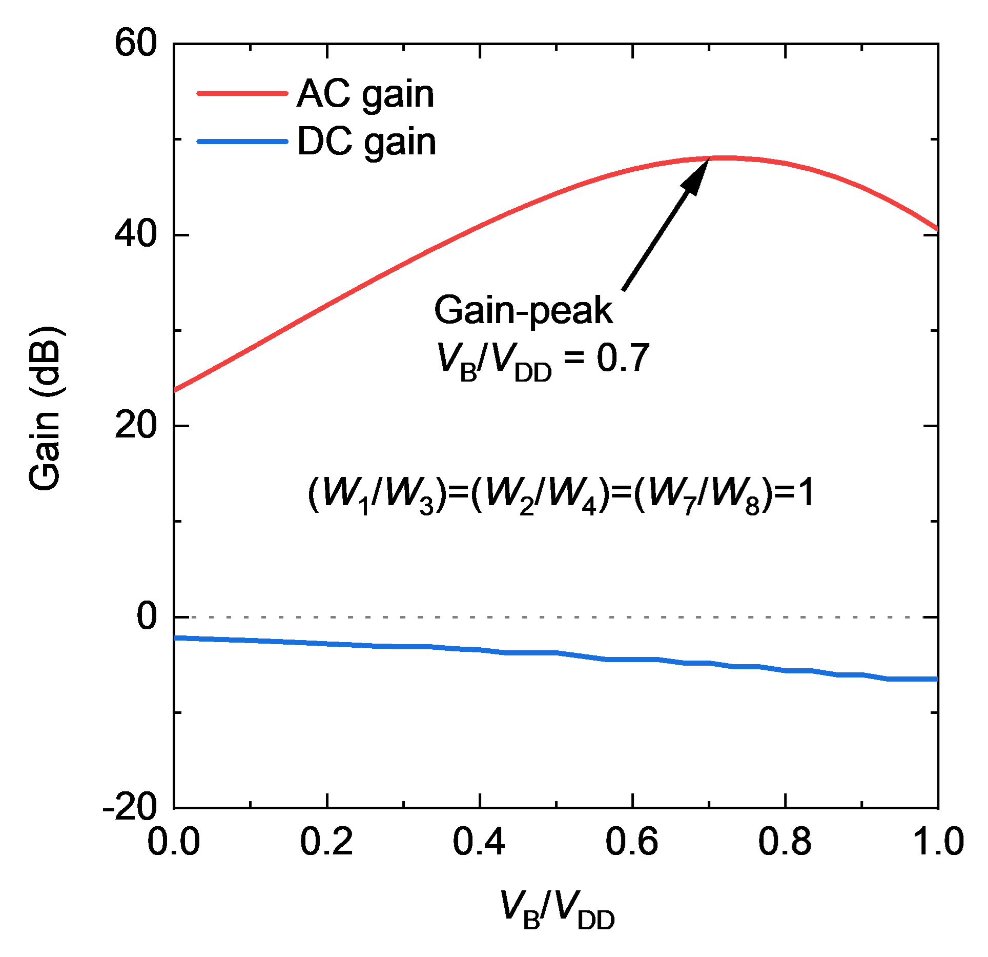
Fig. S2 | Simulated gain characteristics of the proposed op-amp circuit as a function of V_{B}/V_{DD}.

- Supplemental descriptions on fabricated circuits
Op-amp circuit
The AC-coupled load comprised a CNT TFT and capacitor (e.g. M₉ and C₁ in Fig. 3b in the main text) and the cut-off frequency was set as lower than 1 Hz by tuning W/L of the TFT. The bias voltage V_{B}, which was applied to the load TFTs (M₉, M₁₀, and M₂₂), was carefully determined by the five TFTs (M₁–M₅) in the bias circuit to realise the optimal condition V_{B}/V_{DD} = 0.625. The source follower output stage was used to reduce the output impedance of the op-amp by a magnitude of ten to a few hundred kiloohms. This reduction in the output impedance was essential to configure the negative-feedback circuit with the op-amp. The detailed circuit parameters are shown in Table S2.

Non-inverting amplifier
A 20-nm-thick nichrome thin film was used for resistors R₁ and R₂ of the non-inverting amplifier. The dimensions of the resistors were designed to obtain R₂/R₁ = 8, which would achieve an ideal gain of 19.1 dB for the non-inverting amplifier. The resistors exhibited good ohmic I–V characteristics and linear dependence on the length as shown in Fig. S3.
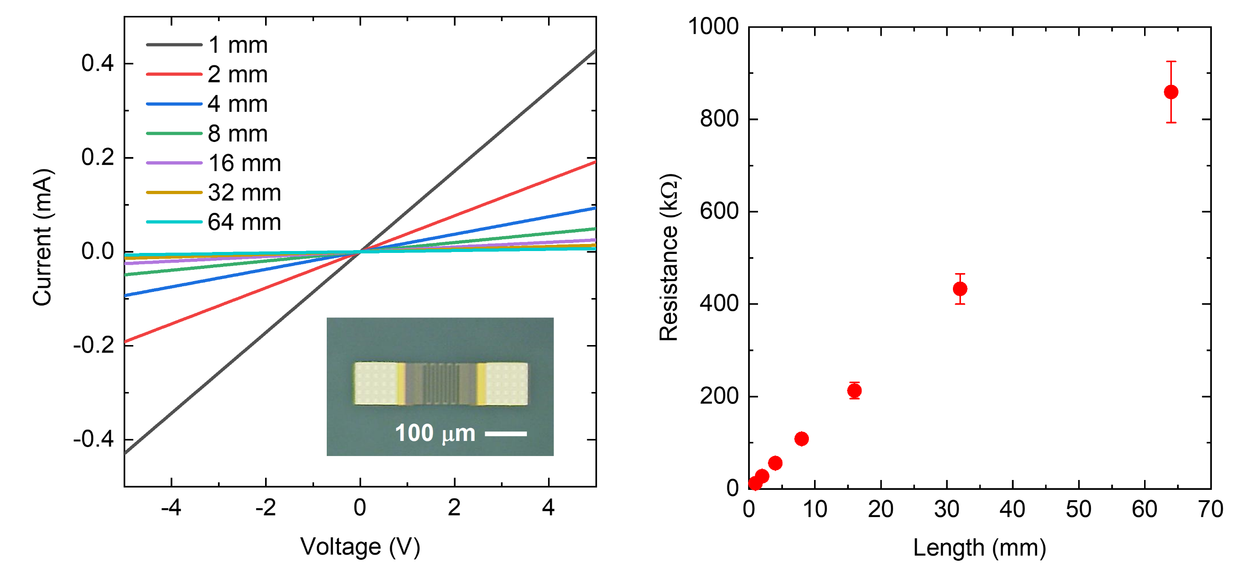
a b
Fig. S3 | Electrical characteristics of nichrome thin film resistors. a, I-V characteristics of nichrome resistance for various length of nichrome thin film resistors. Inset shows a micrograph of a resistor. b, Resistance as a function of length of nichrome thin film resistor.

Delta-sigma ADC
The non-overlapping clock generator generates the clock phases φ₁ and φ₂, which are distributed to the SC ΔΣ ADC. The SC integrator consists of capacitors C₁ and C₂ and switches M₁–M₄. When φ₁ = V_{DD} and φ₂ =V_{SS}, M₁ and M₂ are closed so that C₁ is charged by C₁V_{IN}. After half a clock, φ₁ (φ₂) turns to V_{SS} (V_{DD}), and M₃ and M₄ are closed. Then, the charge of C₁V_{IN} − C₁Q₂ is integrated into C₂, where Q₂ is the output of the RS latch and equal to V_{DD} or V_{SS}. The op-amp outputs the voltage gain of C₁/C₂ to the latched comparator. When φ₁ = V_{DD} and φ₂ =V_{SS}, the output of the latched comparator Q₁ is determined by the relation between the input voltage V₁ and ground (GND). The latched comparator is reset after half a clock (i.e. at φ₁ = V_{SS} and φ₂ =V_{DD}) (The operation of the latched comparator is described below). The following RS latch maintains the output Q₁ for one clock and then provides feedback to the SC integrator through C₁. Thus, the ΔΣ ADC outputs a 1-bit pulse density modulation signal that depends on the input voltage.

Latched comparator
A latched comparator operates in comparison mode and in reset mode during one clock cycle. The two pairs of pseudo-CMOS inverters, composed of four TFTs (M₄, M₆, M₈, M₁₀, or M₅, M₇, M₉, M₁₁) were used for the latch as shown in Fig. S4a. When φ₁ = V_{SS} and φ₂ = V_{DD}, the circuit operates in the reset mode, where M₁₂ and M₁₃ are turned on to set the inverters’ input and output voltage to be V_{DD} as can be seen in Fig. S4b. After a half clock, φ₁ and φ₂ respectively turns to V_{DD} and V_{SS}, and the circuit operates in the comparison mode. In this mode, M₁ is turned on, so that, currents begin to flow through M₂ and M₃. Here, if V_{IN} < GND, $\overline{Q}$reaches V_{SS} faster than Q, and positive feedback will further accelerate the imbalance between Q and $\overline{Q}$, so that, the output state Q = V_{SS} and $\overline{Q}$= V_{DD} are determined.
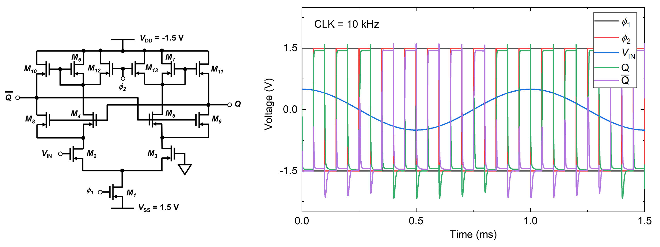Fig. S4 | Operation of latched comparator. a, Circuit diagram. b, simulation result.
a b

AFE
The gains were designed to be 26.5 dB for the instrumentation amplifier, -6.1 dB for the bandpass filter, and 18.7 dB for the non-inversion amplifier for an overall gain of 39.1 dB. The detailed parameters are given in Table S2. The AFE had a circuit area of 8.84 mm² and used 187 transistors.

- Parameters of CNT TFTs and passive elements in each circuit
The parameters of CNT TFTs and passive elements for each circuit simulated or fabricated in this work are summarized in Table S2.

Table S2 | Parameters of CNT TFTs and passive elements for each circuit.
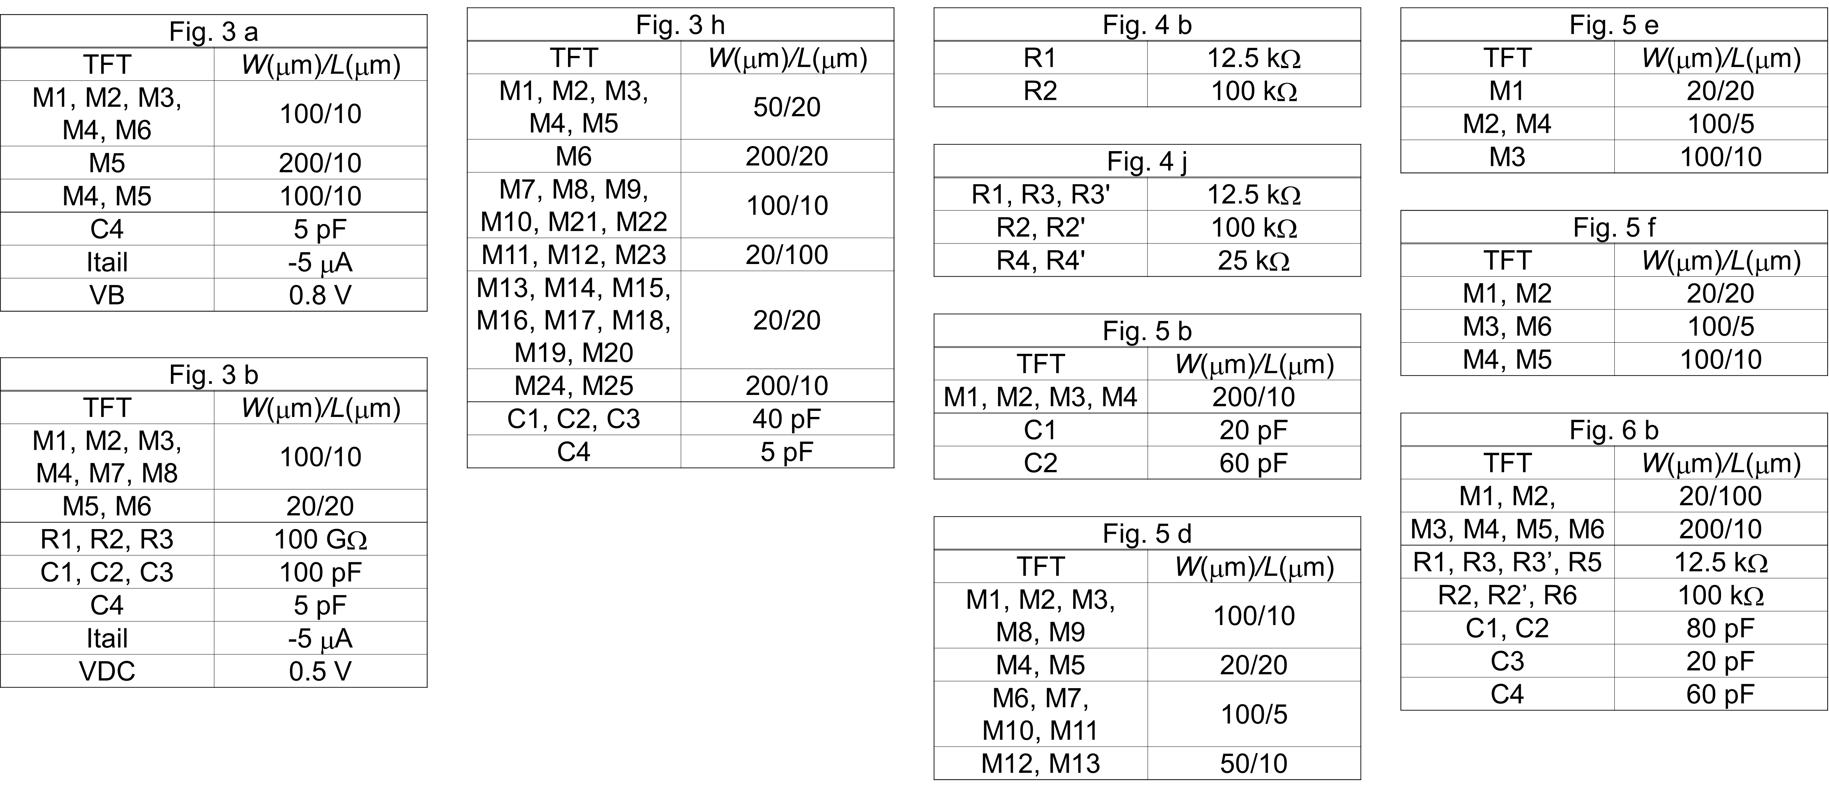

- Performance comparison of TFT-based differential amplifiers and op-amps
The detailed performance indices of TFT-based differential amplifiers and op-amps reported previously and that of op-amp fabricated in this work are summarized in Table S3.

Table S3 | Performance comparison of TFT-based differential amplifiers.
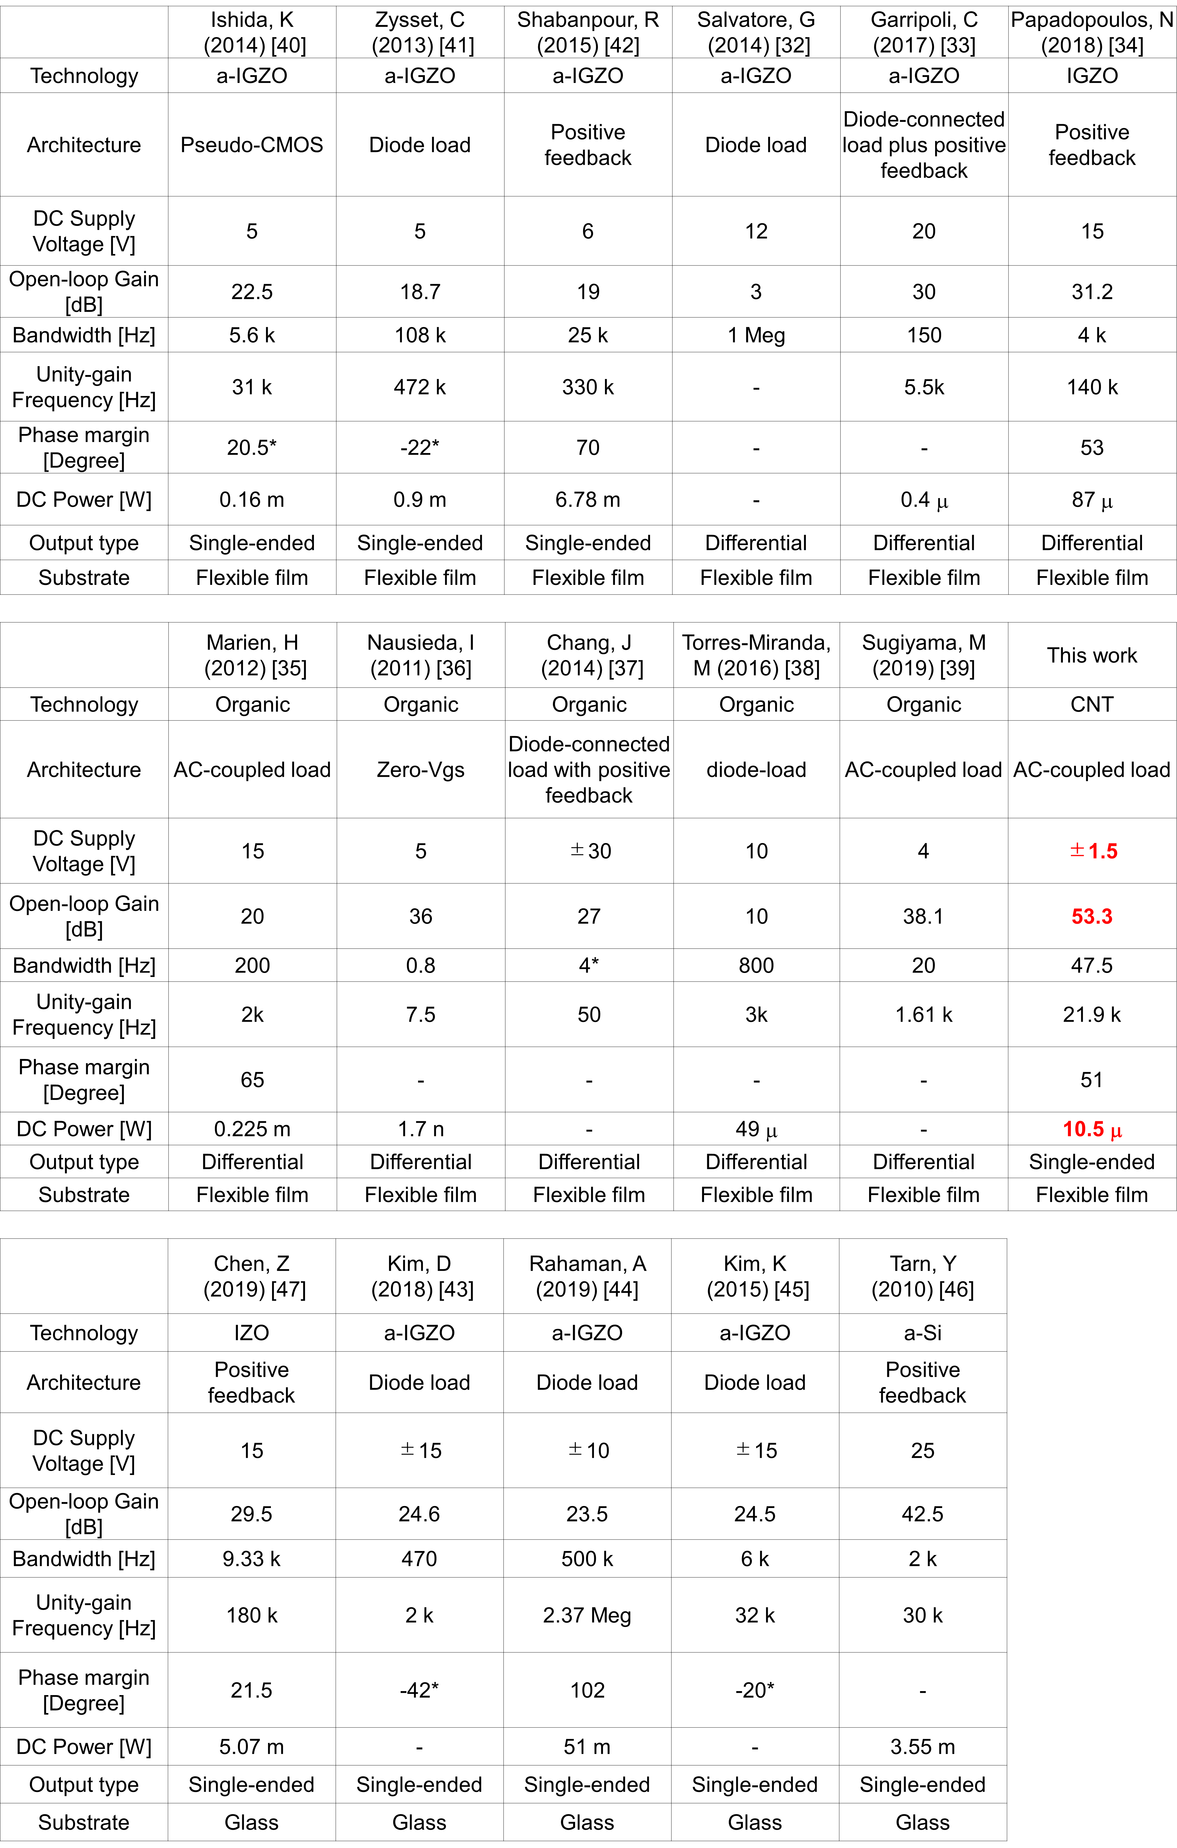

- Measurement of CMRR of instrumentation amplifier
To evaluate common-mode rejection ration (CMRR) of the instrumentation amplifier, we measured both differential-mode gain and common-mode gain of the circuit as shown in Fig. S5. For differential mode gain, a sinusoidal voltage was applied to the positive input terminal and the negative terminal was grounded. The input and output voltage waveforms were measured by an oscilloscope. The differential gain A_{DM} was measured to be 28.6 dB from the voltage waveforms. For the common-monde gain, a sinusoidal voltage is applied to both positive and negative input terminals. The common-mode gain A_{CM} was measured to be −18.1 dB. Thus, CMRR (= A_{DM} / A_{CM}) was evaluated to be 46.7 dB.
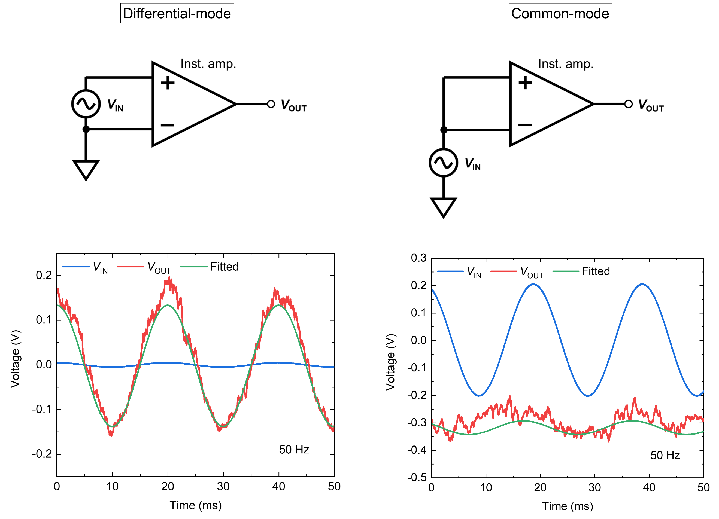
a b
Fig. S5 | Measurement setups (upper) and transient characteristics (bottom) to measure (a) differential-mode and (b) common-mode gains of an instrumentation amplifier.

- Evaluation of ENOB and energy efficiency
ENOB was evaluated as,
$$\begin{aligned}ENOB \left[bit\right]= \frac{SNDR \left[dB\right]-1.76}{6.02}\#\left(S7\right)\end{aligned}$$
The Walden figure of merit^{S4} (FoM) that commonly used to evaluate the energy efficiency of ADC is described as follows,
$$\begin{aligned}FoM \left[\frac{J}{conv.step.}\right]=\frac{Power \left[W\right]}{2^{ENOB \left[bit\right]}∙2∙Bandwidth \left[Hz\right]}\#\left(S8\right)\end{aligned}$$

- Performance comparison of flexible ADCs
The detailed performance indices of flexible ADCs are summarized in Table S4 for comparison of the CNT-based flexible ADC realized in this work to those reported in previous works.

Table S4 | Performance comparison of flexible ADCs.^{S5–S9}
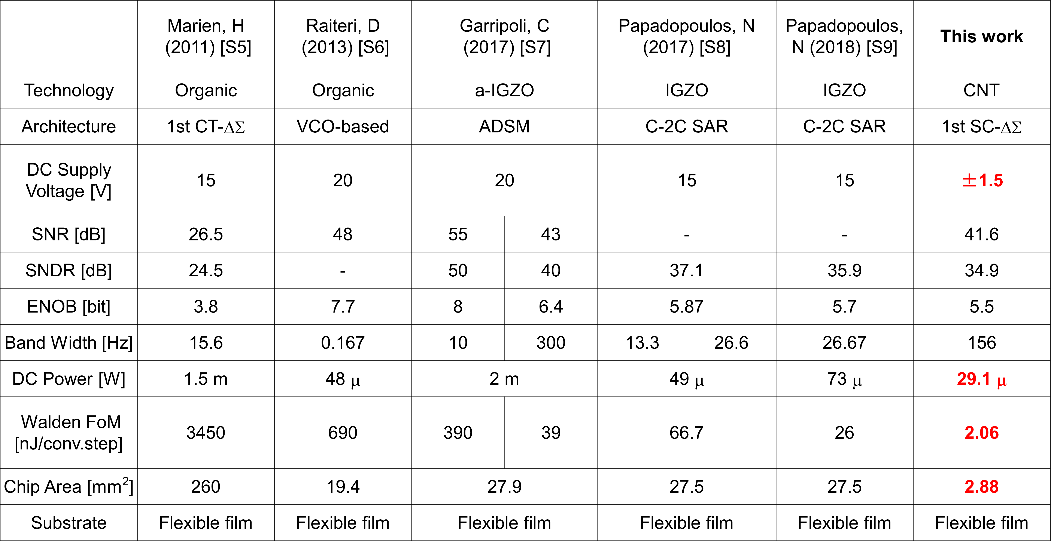

- Continuous operation of AFE
To demonstrate the stability of the present AFE circuit, ECG was continuously measured through the AFE. The methods for the measurement and reconstruction of the digital data are same as described in the main text. Figure S6 shows the ECG waveforms reconstructed from the digital data in the beginning of the continuous measurement and after 1 h. The ECG was observable even after 1 h.
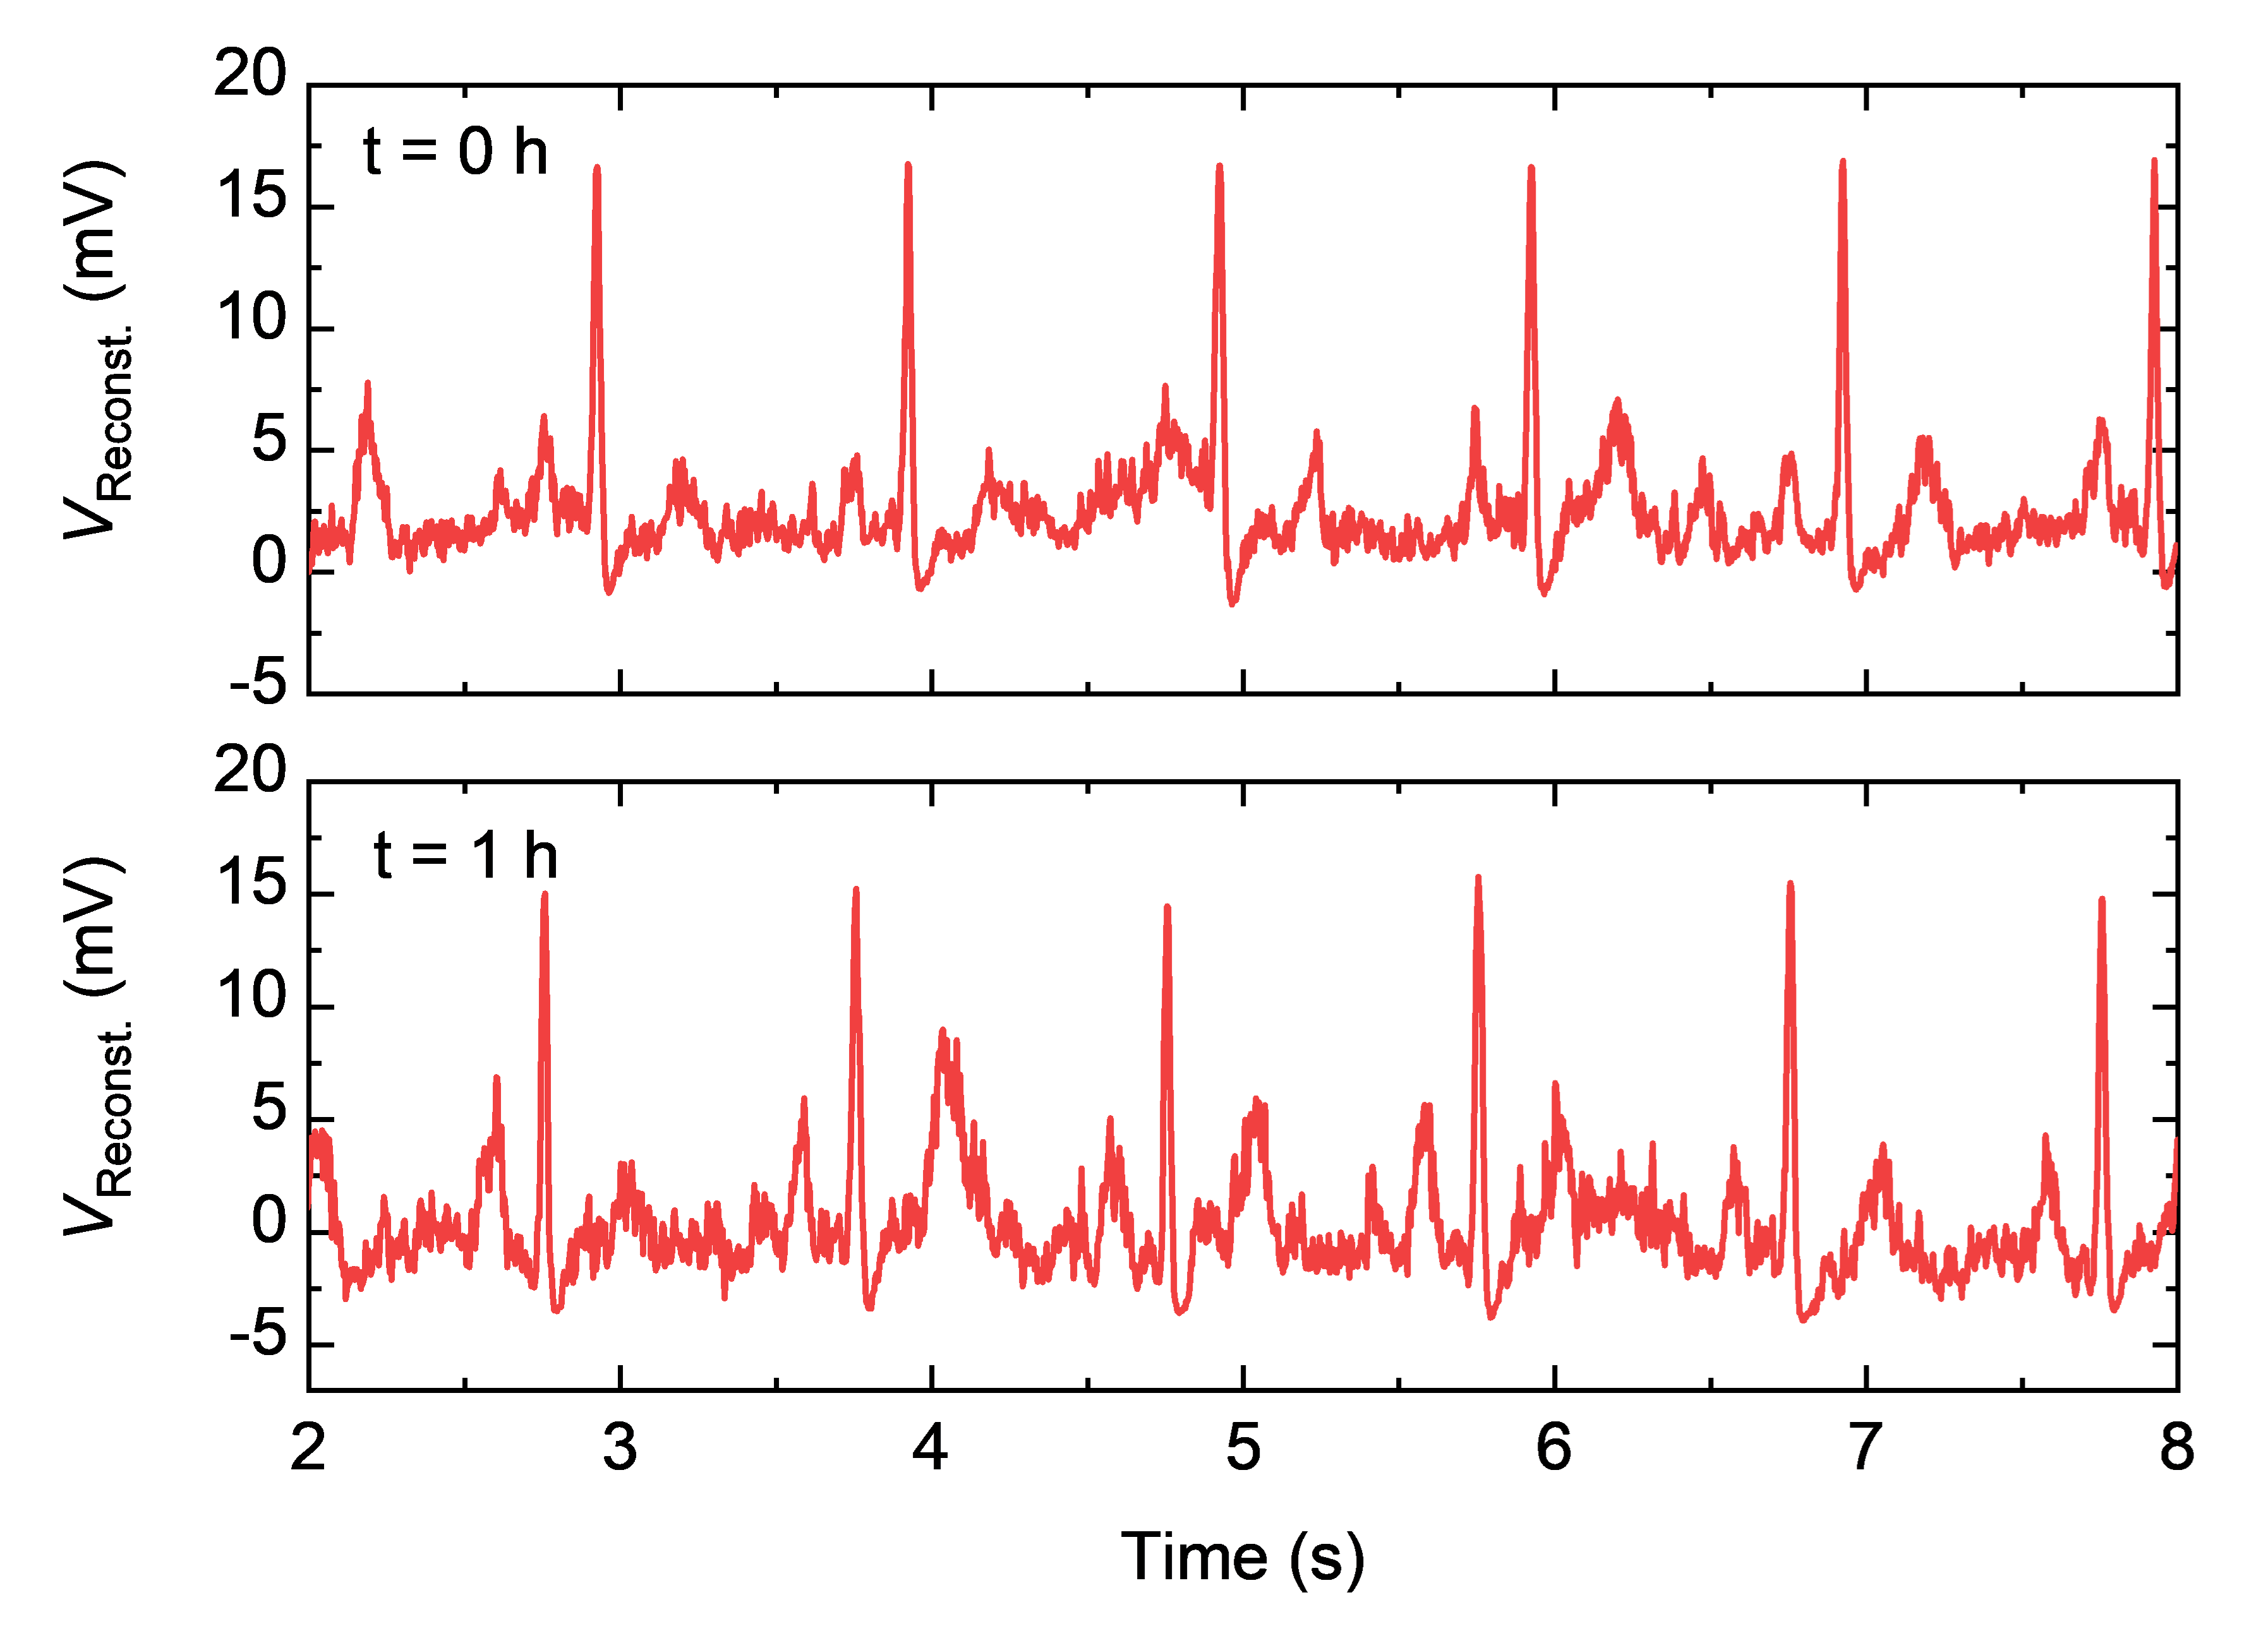
Fig. S6 | ECG waveforms at the beginning (upper) after 1 h (bottom).

References
S1. Shao, L. et al. Compact modeling of thin film transistors for flexible hybrid IoT design. IEEE Design and Test 36, 6-14 (2019).
S2. Deen, M. J., Marinov, O., Zschieschang, U. & Klauk, H. Organic thin-film transistors: Part II-parameter extraction. IEEE Trans. Electron Devices 56, 2962–2968 (2009).
S3. Diouf, C. et al. ‘y function’ method applied to saturation regime: Apparent saturation mobility and saturation velocity extraction. Solid. State. Electron. 85, 12–14 (2013).
S4. Walden, R. H. Analog-to-digital converter survey and analysis. IEEE J. Sel. Areas Commun. 17, 539–550 (1999).
S5. Marien, H., Steyaert, M. S. J., van Veenendaal, E. & Heremans, P. A fully integrated ΔΣ ADC in organic thin-film transistor technology on flexible plastic foil. IEEE J. Solid-State Circuits 46, 276–284 (2011).
S6. Raiteri, D., Lieshout, P. Van, Roermund, A. Van & Cantatore, E. An organic VCO-based ADC for quasi-static signals achieving 1LSB INL at 6b resolution. Dig. Tech. Pap. - IEEE Int. Solid-State Circuits Conf. 56, 108–109 (2013).
S7. Garripoli, C. et al. An a-IGZO asynchronous delta-sigma modulator on foil achieving up to 43dB SNR and 40dB SNDR in 300Hz bandwidth. Dig. Tech. Pap. - IEEE Int. Solid-State Circuits Conf. 60, 260–261 (2017).
S8. Papadopoulos, N. et al. Flexible selfbiased 66.7nJ/c.s. 6bit 26S/s successive-approximation C-2C ADC with offset cancellation using unipolar Metal-Oxide TFTs. Proc. Cust. Integr. Circuits Conf., 7–10 (2017).
S9. Papadopoulos, N. P. et al. Toward temperature tracking with unipolar metal-oxide thin-film SAR C-2C ADC on Plastic. IEEE J. Solid-State Circuits 53, 2263–2272 (2018).

