Supplementary Analyses
Relationships between Autistic Traits and Other Executive Function Processes
Some studies investigated the relationships between autistic traits and other executive functions (EFs), including emotional control (k = 6)​, initiation (k = 6)​, planning (k = 6)​, monitoring (k = 5), reasoning (k = 4), verbal fluency (k = 4), and decision-making (k = 1)​​​​. Random-effects meta-analyses and robust Bayesian meta-analyses were conducted for all these processes, except for decision-making, which was examined in only one study.
For emotional control, a random-effects meta-analysis was conducted on six studies, which included a total of 909 individuals with mean ages of 18.4 to 41.6 years. The measures included the Emotional control score of the Behavior Rating inventory of Executive Function (BRIEF; k = 5) and the Impulse Control score of the Executive Function Index (k = 1). Autistic traits were measured using the Broad Autism Phenotype Questionnaire (BAPQ; k = 3), Social Responsiveness Scale (SRS; k = 2), and Autism Spectrum Quotient (AQ; k = 1). We found a significant negative correlation between autistic traits and planning (Supplementary Figure 5), z' = -.32 (r = -.31), p = .007, 95% CI [-.51, -.13]. True heterogeneity in the effect sizes reported by different studies was significant, I² = 78%, p < .001. In addition, a robust Bayesian meta-analysis revealed a Bayes factor (BF₁₀) of 1.29, indicating anecdotal evidence supporting the alternative hypothesis (H₁) over the null hypothesis (H₀).
For initiation, a random-effects meta-analysis was conducted on six studies, which included a total of 909 individuals with mean ages of 18.4 to 41.6 years. The measures included the BRIEF Initiate score (k = 5) and the Motivational Drive score of the Executive Function Index (k = 1). Autistic traits were measured using the BAPQ (k = 3), SRS (k = 2), and AQ (k = 1). We found a significant negative correlation between autistic traits and initiation (Supplementary Figure 6), z' = -.38 (r = -.36), p = .008, 95% CI [-.61, -.15]. True heterogeneity in the effect sizes was significant, I² = 85%, p < .001. In addition, a robust Bayesian meta-analysis revealed a BF₁₀ of 1.35, indicating anecdotal evidence supporting H₁ over H₀.
For planning, a random-effects meta-analysis was conducted on six studies, which included a total of 635 individuals with mean ages of 18.4 to 41.6 years. The measures included the BRIEF Plan/Organize score (k = 5) and the Strategic Planning score of the Executive Function Index (k = 1). Autistic traits were measured using the BAPQ (k = 3), SRS (k = 2), and AQ (k = 1). We found a significant negative correlation between autistic traits and planning (Supplementary Figure 7), z' = -.46 (r = -.43), p < .001, 95% CI [-.60, -.33]. There was no significant true heterogeneity in the effect sizes, I² = 44%, p = .20. Additionally, a robust Bayesian meta-analysis revealed a BF₁₀ of 17.54, indicating strong evidence supporting H₁ over H₀.
For monitoring, a random-effects meta-analysis was conducted on five studies, which included a total of 635 individuals with mean ages of 18.4 to 41.6 years. All used the BRIEF Task Monitor score (k = 5). Autistic traits were measured using the BAPQ (k = 3) and SRS (k = 2). We found a significant negative correlation between autistic traits and monitoring (Supplementary Figure 8), z' = -.43 (r = -.41), p < .002, 95% CI [-.59, -.27]. True heterogeneity in the effect sizes was not significant, I² = 55%, p = .072. In addition, a robust Bayesian meta-analysis revealed a BF₁₀ of 7.64, indicating substantial evidence supporting H₁ over H₀.
For reasoning, a random-effects meta-analysis was conducted on four studies, which involved 12,322 participants with mean ages of 20.6 to 61.3 years. All used task measures, which included the Raven Colored Progressive Matrices (k = 3) and the verbal reasoning Task (k = 1). Autistic traits were measured using the AQ (k = 3) and PROTECT AST screener questions (k = 1). The correlation between autistic traits and reasoning was not significant (Supplementary Figure 9), z’ = .02 (r = .02), p = .73, 95% CI [-.13, .17]. True heterogeneity in the effect sizes was not significant, I² = 57% p = .32. Additionally, a robust Bayesian meta-analysis revealed a BF₁₀ of 0.24, indicating substantial evidence favoring H₀ over H₁.
For verbal fluency, a random-effects meta-analysis was conducted on four studies, which involved a total of 303 participants with mean ages of 20.6 to 73.1 years. The letter fluency score was used across studies (k = 4). Autistic traits were measured using the AQ (k = 2) and BAPQ (k = 2). The analysis revealed a nonsignificant correlation between autistic traits and verbal fluency (Supplementary Figure 10), z' = -.02 (r = -.02), p = .72, 95% CI [-.16, .12]. There was no significant true heterogeneity in the effect sizes, I² = 11%, p = .67. Additionally, a robust Bayesian meta-analysis revealed a BF₁₀ of 0.15, indicating substantial evidence in favor of H₀ against H₁.
For decision-making, a study with 44 adults examined the relationship between autistic traits and the net score on the Iowa Gambling Task. A significant negative relationship was reported, r = -.30, p = .025.

Supplementary Figures
Supplementary Figure 1
Funnel Plot for the Effect Sizes of the Relationships between Autistic Traits and Overall Executive Function
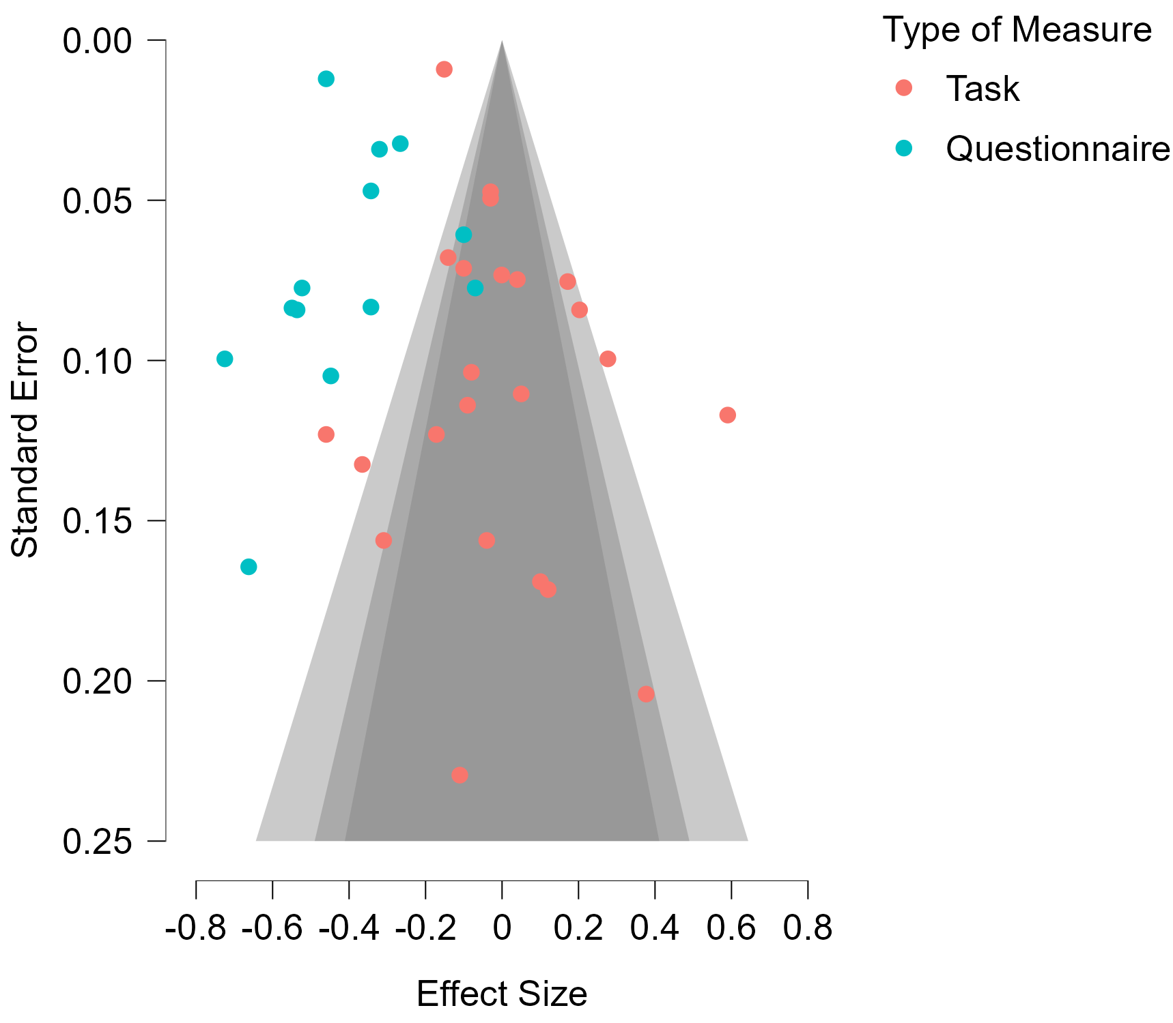

Supplementary Figure 2
Funnel Plot for the Effect Sizes of the Relationships between Autistic Traits and Working Memory
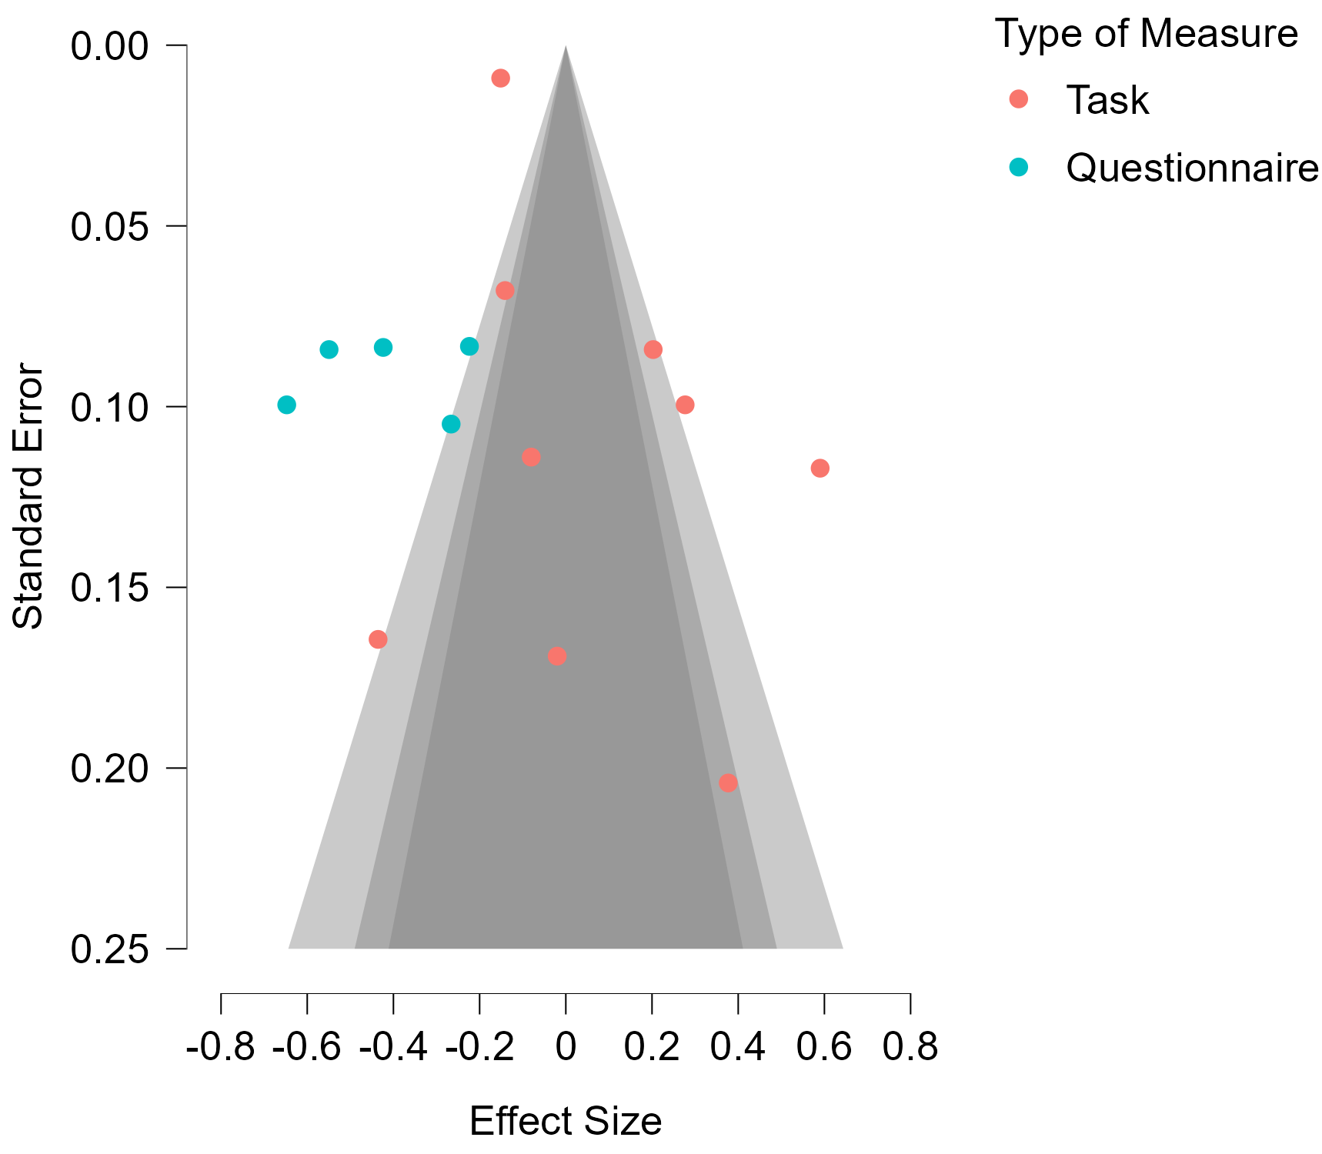

Supplementary Figure 3
Funnel Plot for the Effect Sizes of the Relationships between Autistic Traits and Inhibition
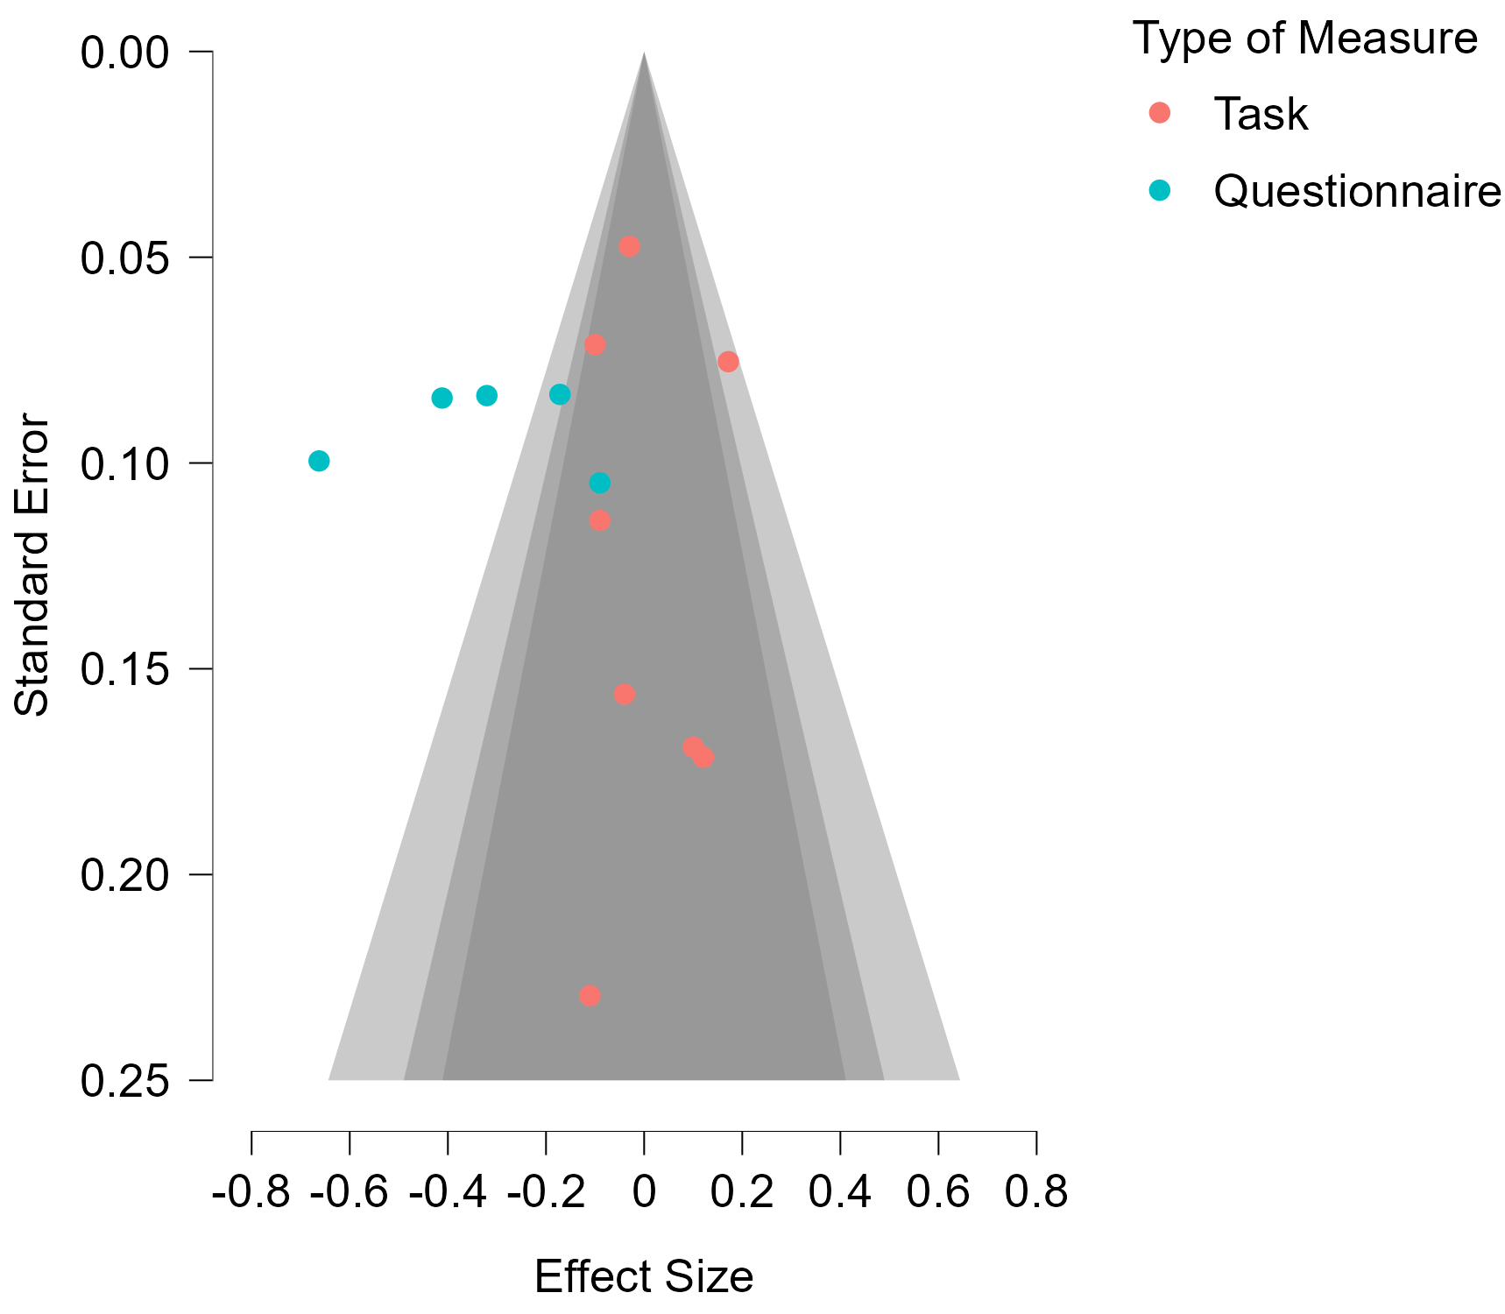

Supplementary Figure 4
Funnel Plot for the Effect sizes of Relationship between Autistic Traits and Shifting
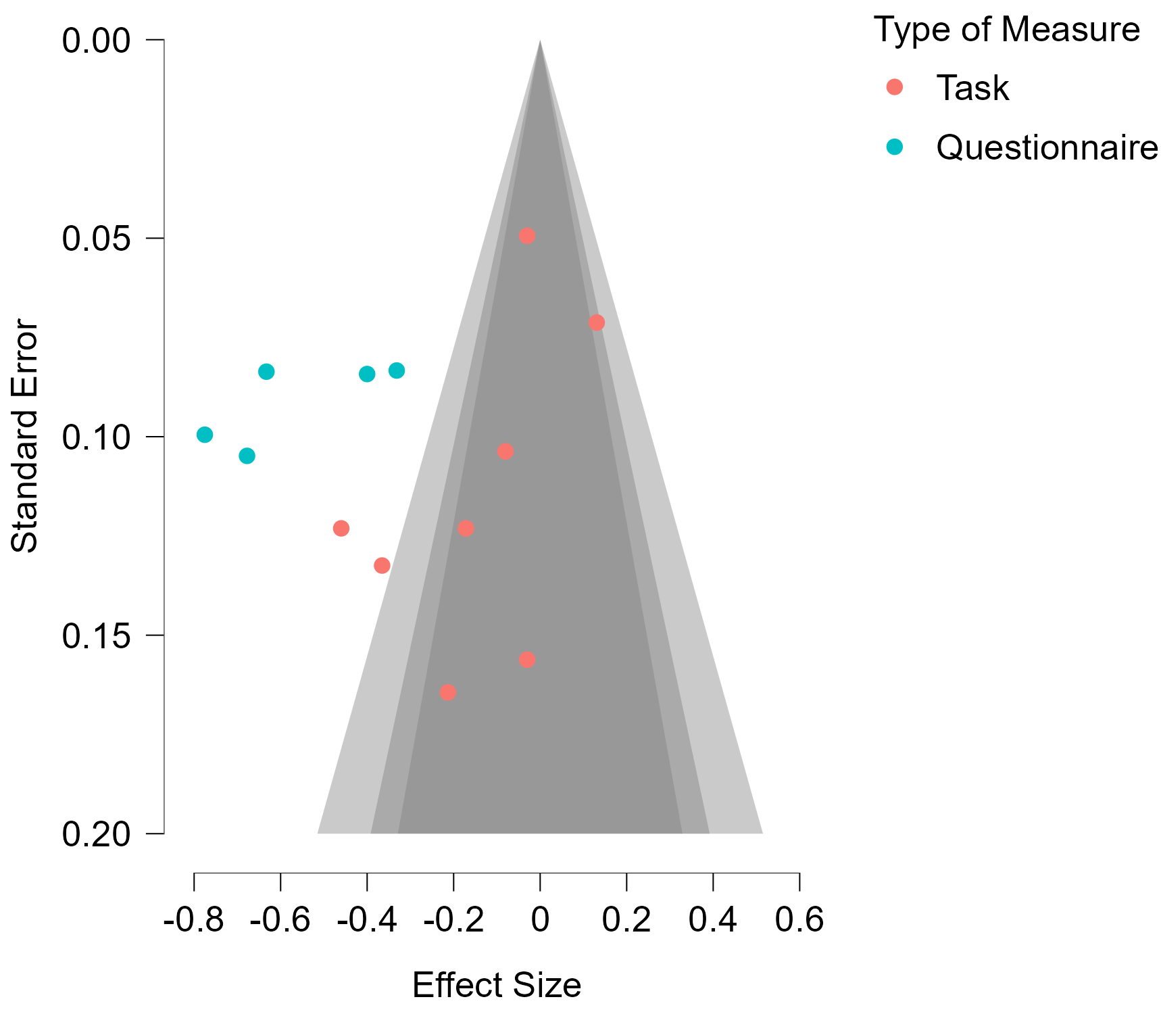
Supplementary Figure 5
Forest Plot of the Random-Effects Meta-Analysis for the Relationship between Autistic Traits and Emotional Control
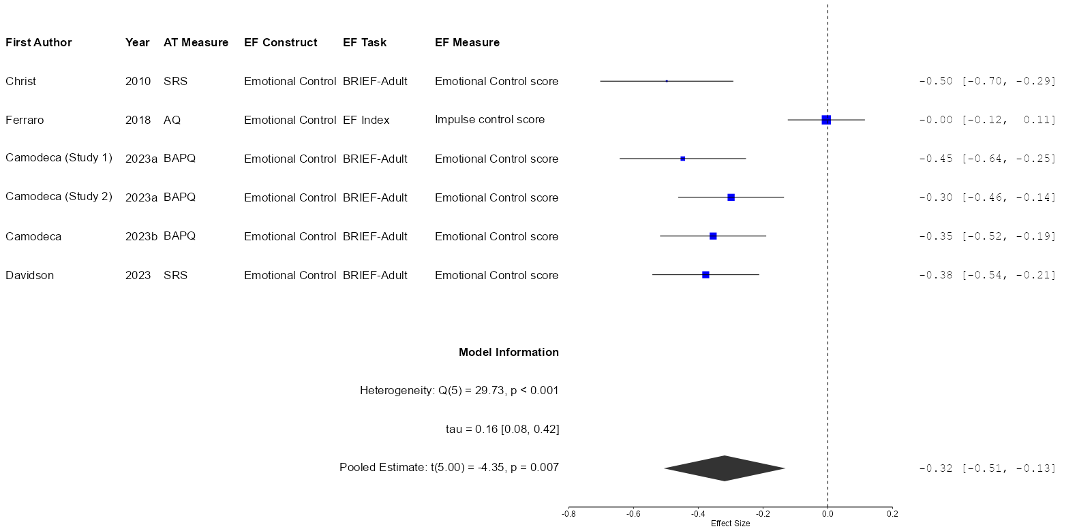
Note. AQ = Autism Spectrum Quotient; AT = Autistic traits; BAPQ = Broad Autism Phenotype Questionnaire; BRIEF = Behavior Rating Inventory of Executive Function; EF = executive function; SRS = Social Responsiveness Scale. The Fisher’s z-transformed correlation coefficients (z’) and 95% confidence intervals are displayed.
Supplementary Figure 6
Forest Plot of the Random-Effects Meta-Analysis for the Relationship between Autistic Traits and Initiation
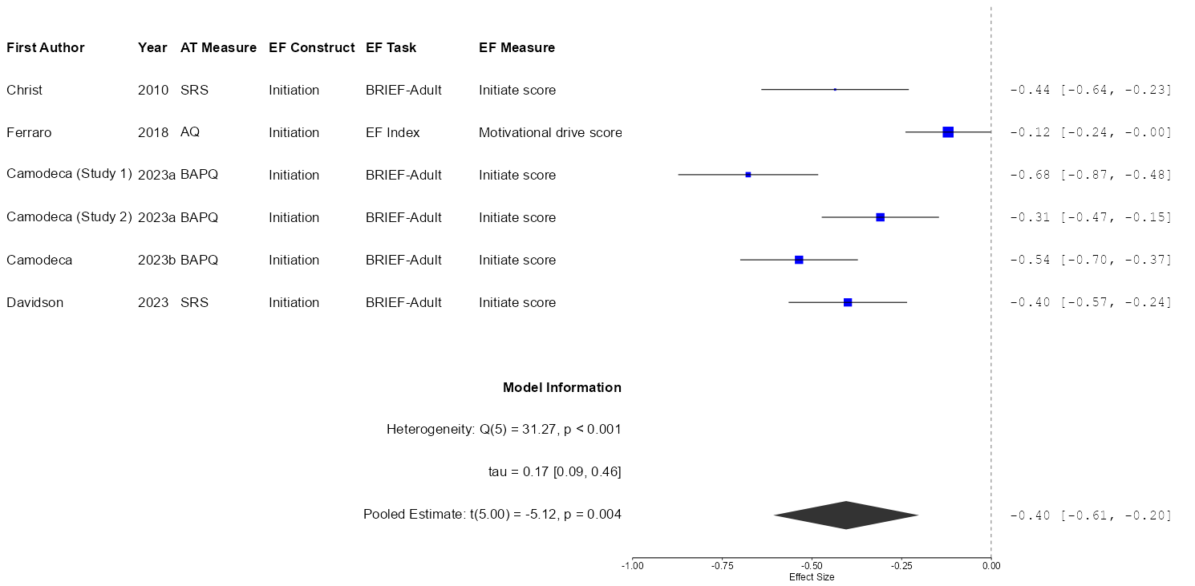
Note. AQ = Autism Spectrum Quotient; AT = Autistic traits; BAPQ = Broad Autism Phenotype Questionnaire; BRIEF = Behavior Rating Inventory of Executive Function; EF = executive function; SRS = Social Responsiveness Scale. The Fisher’s z-transformed correlation coefficients (z’) and 95% confidence intervals are displayed. The blue color indicates questionnaire measures.

Supplementary Figure 7
Forest Plot of the Random-Effects Meta-Analysis for the Relationship between Autistic Traits and Planning
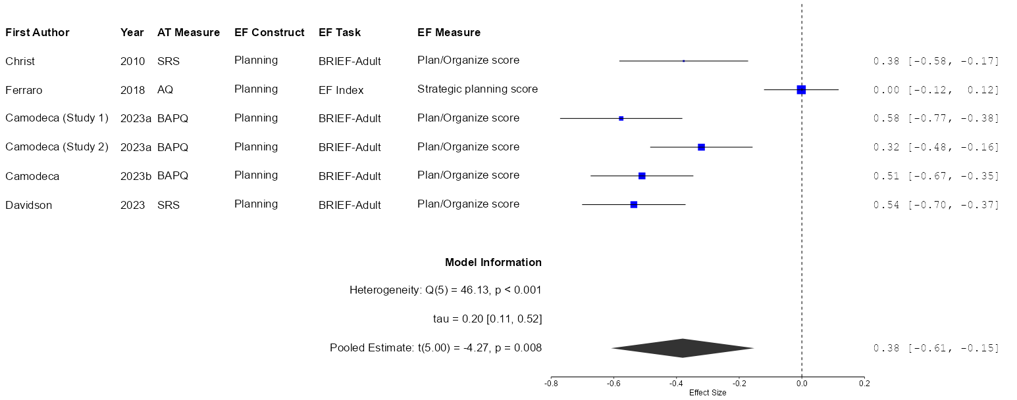
Note. AQ = Autism Spectrum Quotient; AT = Autistic traits; BAPQ = Broad Autism Phenotype Questionnaire; BRIEF = Behavior Rating Inventory of Executive Function; EF = executive function; SRS = Social Responsiveness Scale. The Fisher’s z-transformed correlation coefficients (z’) and 95% confidence intervals are displayed. The blue color indicates questionnaire measures.

Supplementary Figure 8
Forest Plot of the Random-Effects Meta-Analysis for the Relationship between Autistic Traits and Monitoring
Note. AQ = Autism Spectrum Quotient; AT = Autistic traits; BAPQ = Broad Autism Phenotype Questionnaire; BRIEF = Behavior Rating Inventory of Executive Function; EF = executive function; SRS = Social Responsiveness Scale. The Fisher’s z-transformed correlation coefficients (z’) and 95% confidence intervals are displayed. The blue color indicates questionnaire measures.

Supplementary Figure 9
Forest Plot of the Random-Effects Meta-Analysis for the Relationship between Autistic Traits and Reasoning
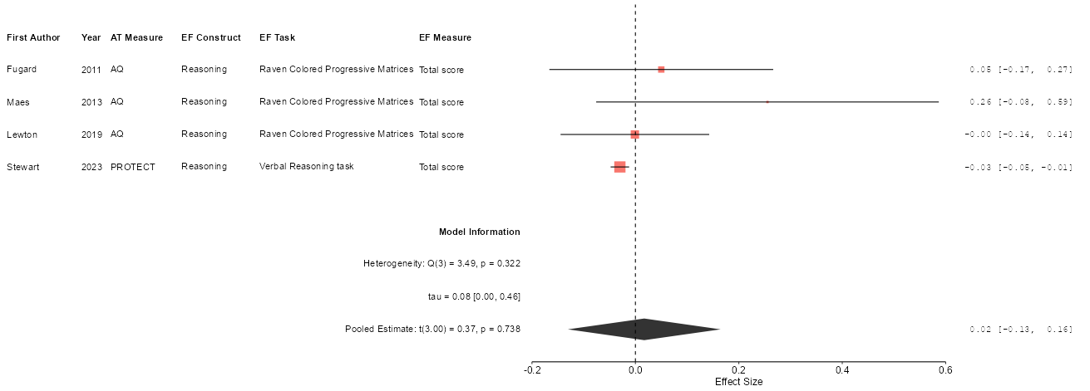
Note. AQ = Autism Spectrum Quotient; AT = Autistic traits; EF = executive function; PROTECT = PROTECT AST screener questions. The Fisher’s z-transformed correlation coefficients (z’) and 95% confidence intervals are displayed. The red color indicates task measures.

Supplementary Figure 10
Forest Plot of the Random-Effects Meta-Analysis for the Relationship between Autistic Traits and Verbal Fluency
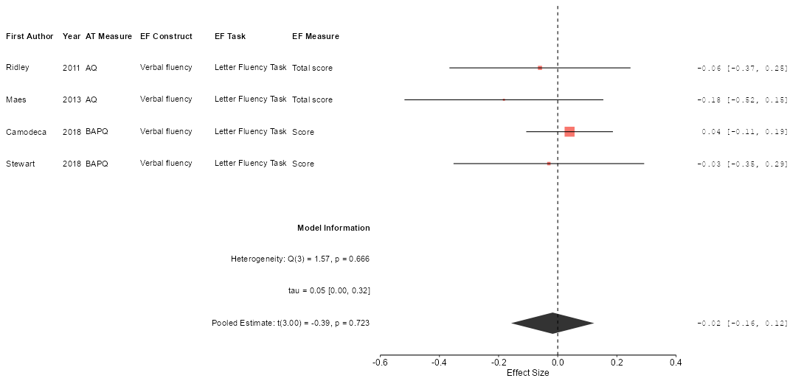
Note. AQ = Autism Spectrum Quotient; AT = Autistic traits; BAPQ = Broad Autism Phenotype Questionnaire; EF = executive function. The Fisher’s z-transformed correlation coefficients (z’) and 95% confidence intervals are displayed. The red color indicates task measures.

