Supplementary Information
Programmable RNA multiphasic condensates and act as micromotor for biomoleculeas delivery
Long Wang¹†, Ting Zhu¹†, Xinyi Guo², Weiwei Zhang¹, Yang Xiao¹, Bin Li², Yijie Ma¹, Dinghua Wang¹, Ying Cui¹, Yuting Dai¹, Shengyuan Deng² and Kewei Ren¹*

¹School of Chemistry and Chemical Engineering, Nanjing University of Science and Technology, Nanjing, 210094, China.
²School of Environmental and Biological Engineering, Nanjing University of Science and Technology, Nanjing 210094, P.R. China.
†These authors contributed equally to this work.
*Corresponding author

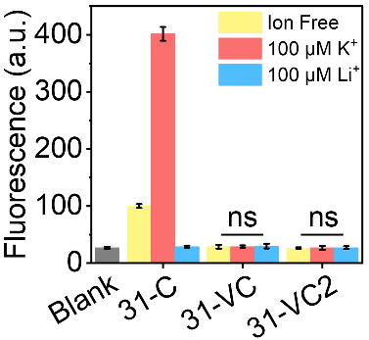
Supplementary Fig. 1. Characterization of G-quadruplex in different RNAs. Fluorescence intensity of 1 μM ThT incubated without (Blank) and with1 μM 31-C (31-C), 31-VC (31-VC) or 31-VC2 (31-VC2) at 37 °C in the absence (Ion Free) and presence of 100 μM K⁺ or Li⁺. The error bars indicate mean ± s.d. (n = 3 independent samples).

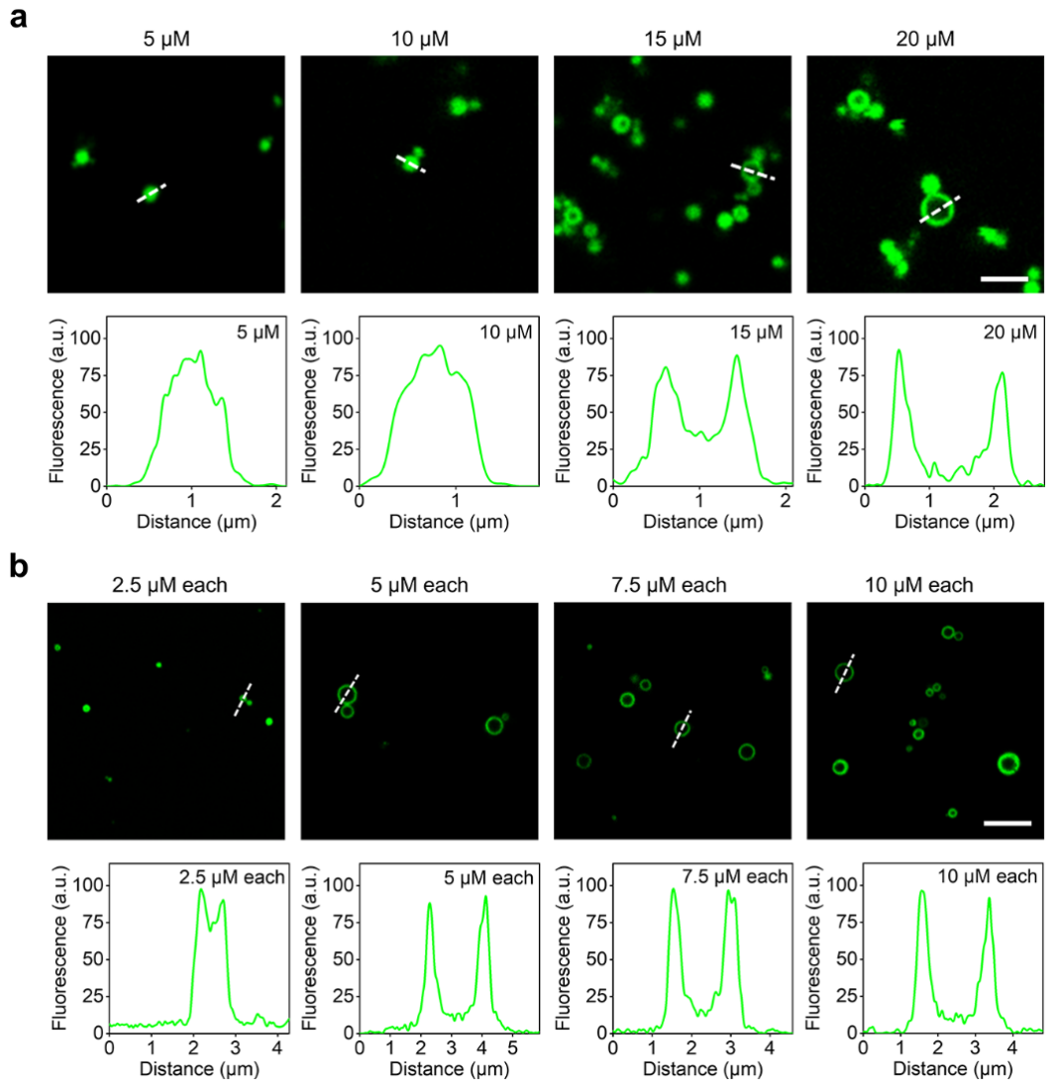
Supplementary Fig. 2. Effects of RNA concentrations on the structure and morphology of condensate. a, Representative confocal fluorescence imaging and fluorescence intensity distribution of RNA condensates assembled with 5, 10, 15 and 20 μM 31-dB, and stained with 1 × SYBR Gold. Scale bar, 2.5 μm. b, Representative confocal fluorescence imaging and fluorescence intensity distribution of RNA condensates assembled with 31-P and 31-C mixture at each RNA concentration of 2.5, 5, 7.5 and 10 μM, and stained with 1 × SYBR Gold. Scale bar, 5 μm.
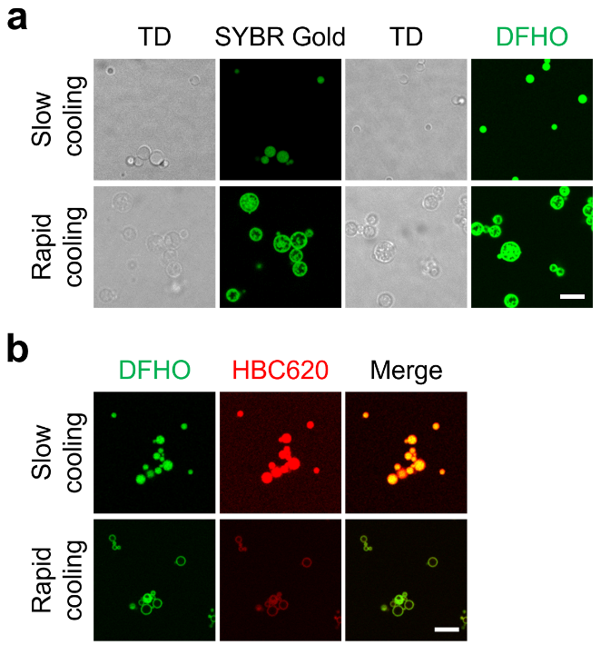
Supplementary Fig. 3. Effects of cooling rates on the structure and morphology of the condensate. a, Representative confocal fluorescence imaging of RNA condensates assembled with 31-C by rapid or slow cooling, stained with 1 × SYBR Gold or 100 μM DFHO, respectively. Scale bar, 5 μm. b, Representative confocal fluorescence imaging of RNA condensates assembled with the mixture of 31-P and 31-C by rapid or slow cooling, stained with 100 μM HBC620 and 100 μM DFHO. Scale bar, 5 μm.

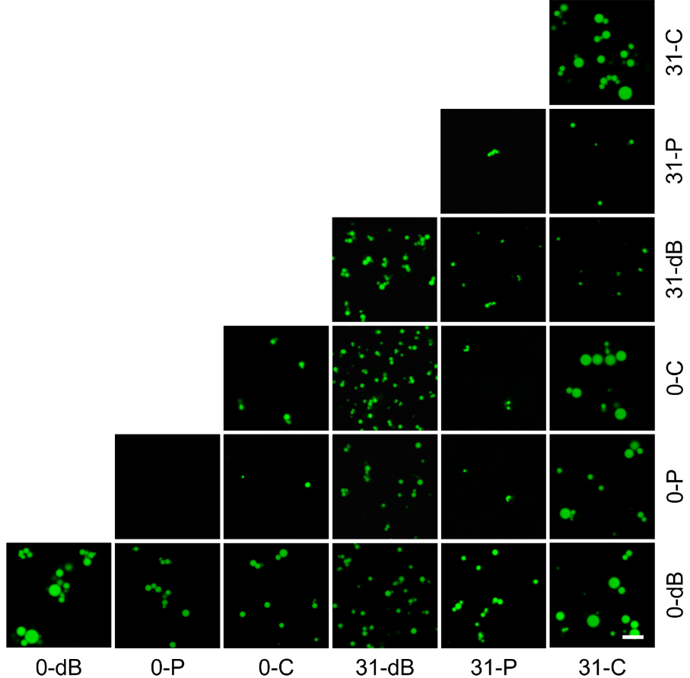
Supplementary Fig. 4. RNA condensates assembled with slow cooling. Representative confocal fluorescence imaging of RNA condensates assembled by orthogonal mixing of 0-dB, 0-P, 0-C, 31-dB, 31-P and 31-C with slow cooling, and stained with 1 × SYBR Gold. Scale bar, 5 μm.
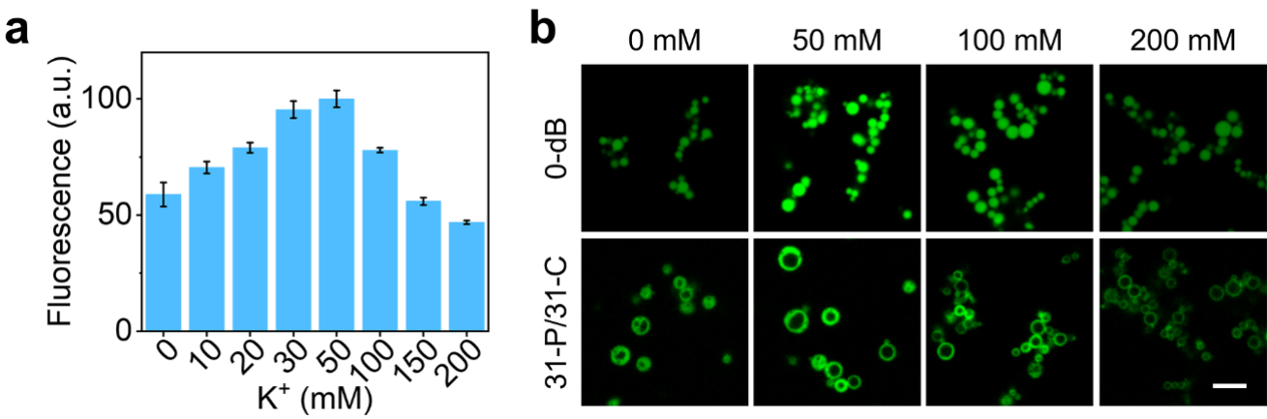
Supplementary Fig. 5. Effects of potassium ion concentrations on condensates. a, Normalized fluorescence signals of 31-C incubated with 1 μM ThT at different K⁺ concentration. The error bars indicate mean ± s.d. (n = 3 independent samples). b, Representative confocal fluorescence imaging of RNA condensates assembled with 20 μM 0-dB, or the mixture of 10 μM 31-P and 10 μM 31-C (31-P/31-C) in presence of 60 mM Mg²⁺ and different K⁺ concentrations, then stained with 1 × SYBR Gold. Scale bar, 5 μm.

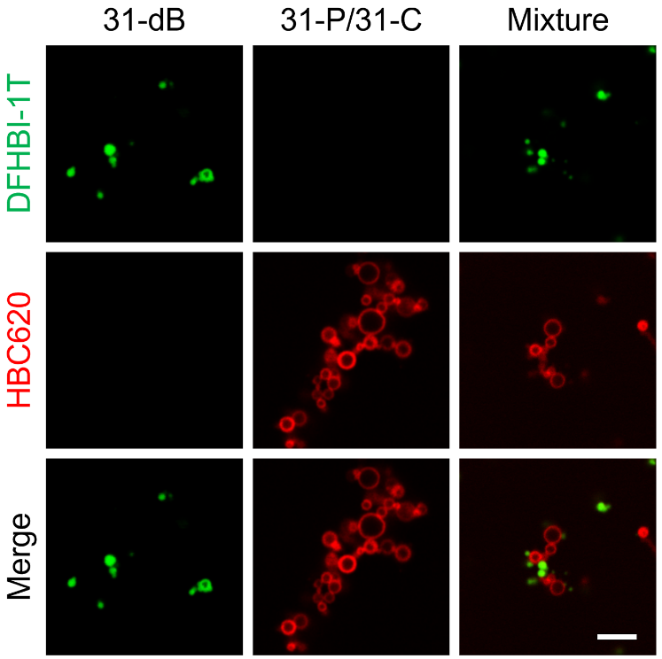
Supplementary Fig. 6. Fusion of different condensates. Representative confocal fluorescence imaging of 31-dB based condensates (31-dB), 31-P and 31-C mixture based condensates (31-P/31-C), and these two condensates mixture (mixture) incubated at 37 °C for 2-h, then stained with 100 μM DFHBI-1T and 100 μM HBC620. Scale bar, 5 μm.

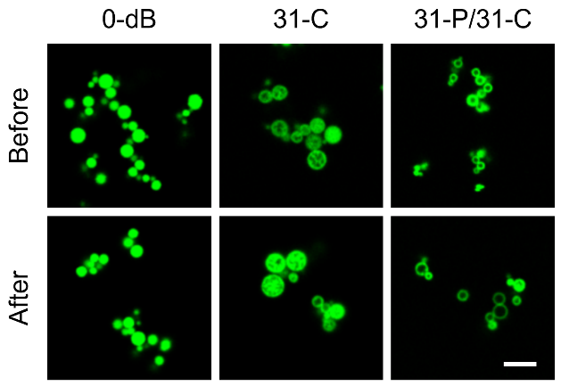
Supplementary Fig. 7. Stability of RNA condensates. Representative confocal fluorescence imaging of RNA condensates assembled with 0-dB, 31-C and the mixture of 31-P and 31-C (31-P/31-C) before (Before) and after centrifugation (After), then stained with 1 × SYBR Gold. Scale bar, 5 μm.

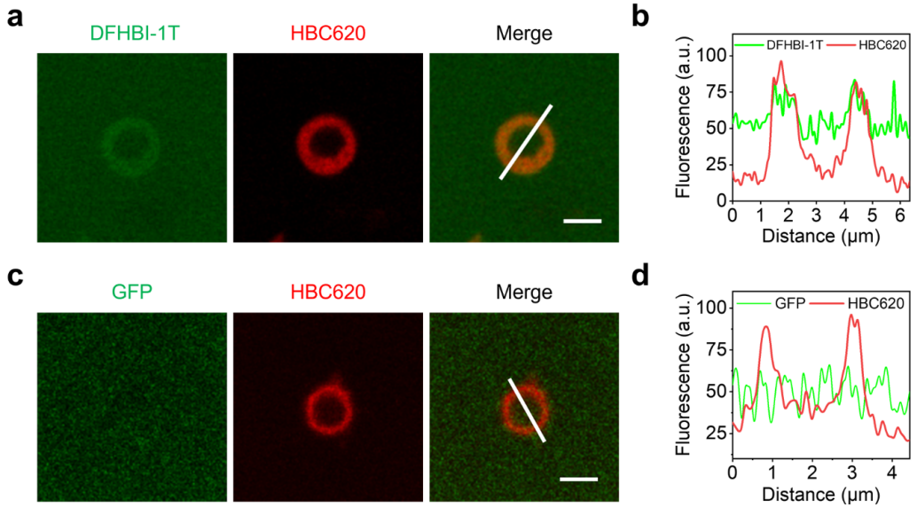
Supplementary Fig. 8. Permeability of Soccer constructed by 31-P and 31-C mixture. a, Representative confocal fluorescence imaging of 10 μM free 0-dB incubated with 10 μM Soccer assembled with mixture of 31-P and 31-C for 2 h, then stained with 100 μM DFHBI-1T (0-dB) and 100 μM HBC620 (31-P/31-C). Scale bar, 2 μm. b, The fluorescence intensity distribution of DFHBI-1T (0-dB) and HBC620 (31-P/31-C) indicated with white lines in Supplementary Fig. 8a, respectively. c, Representative confocal fluorescence imaging of 5 μM GFP incubated with 10 μM Soccer assembled with mixture of 31-P and 31-C for 2 h, then stained with 100 μM HBC620. Scale bar, 2 μm. d, The fluorescence intensity distribution of GFP and HBC620 (31-P/ 31-C) indicated with white lines in Supplementary Fig. 8c.
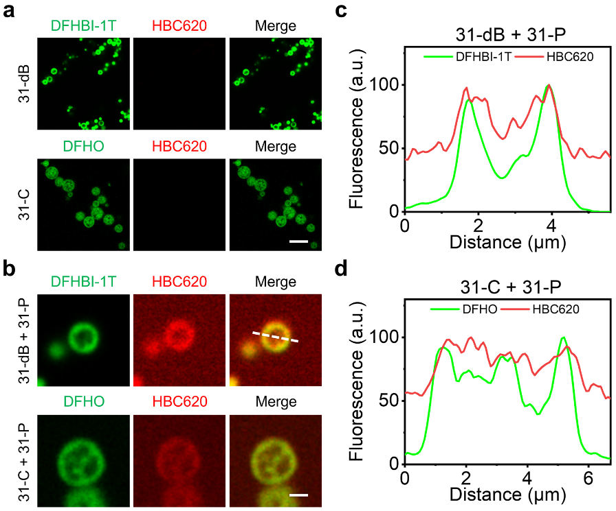
Supplementary Fig. 9. Enrichment of 31-P in Soccer or Cuju. Representative confocal fluorescence imaging of 10 μM RNA condensates assembled with 31-dB or 31-C by rapid cooling before (31-dB or 31-C) (a) and after incubation with 10 μM 31-P (31-dB + 31-P or 31-C + 31-P) for 2 h (b). Scale bar, 5 μm. c, The fluorescence intensity distribution of DFHBI-1T (31-dB) and HBC620 (31-P) indicated with white lines in Supplementary Fig. 9b, respectively. d, The fluorescence intensity distribution of DFHO (31-C) and HBC620 (31-P) indicated with white lines in Supplementary Fig. 9b, respectively.

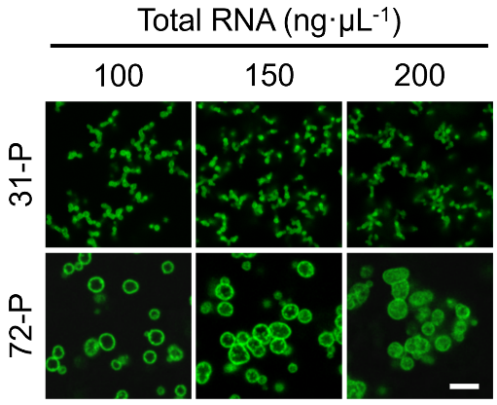
Supplementary Fig. 10. Controllable regulation of different concentration total RNA based condensates with CUG repeats. Representative confocal fluorescence imaging of the condensates assembled by mixing of different concentrations of total RNA with 10 μM 72-P or 10 μM 31-P, respectively. The RNA condensates were stained with 1 × SYBR Gold. Scale bar, 5 μm.

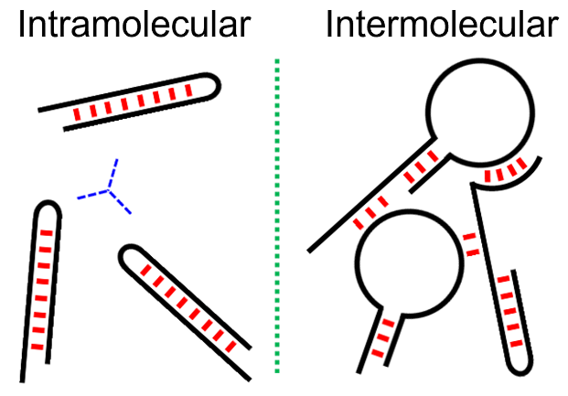
Supplementary Fig. 11. Schematic for intramolecular and intermolecular RNA interactions in condensates.

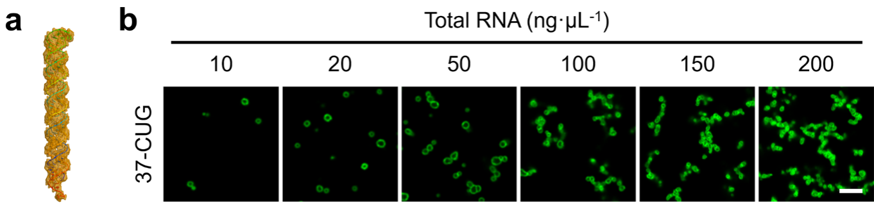
Supplementary Fig. 12. Controllable regulation of total RNA based condensates with 37-CUG repeats. a, 3D structures of 37-CUG simulated by RNA composer. b, Representative confocal fluorescence imaging of RNA condensates assembled with 37-CUG repeats with different concentrations of total RNA extracted from MCF-7 cells, then stained with 1 × SYBR Gold. Scale bar, 5 μm.

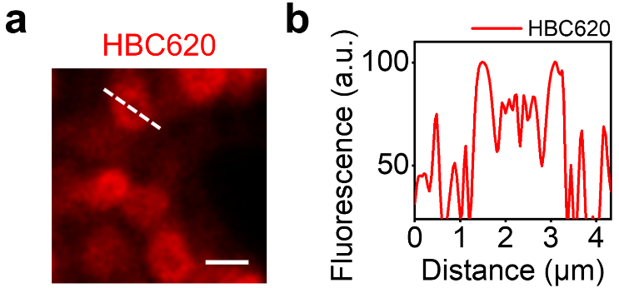
Supplementary Fig. 13. Monocomponent RNA forms Soccer in mammalian cells. a, Representative confocal fluorescence imaging of MCF-7 cells expressing 72-P. The cells were stained with 10 μM HBC620. Scale bars, 2 μm. b, The normalized fluorescence intensity distributions of HBC620 indicated with white lines in Supplementary Fig. 13a.

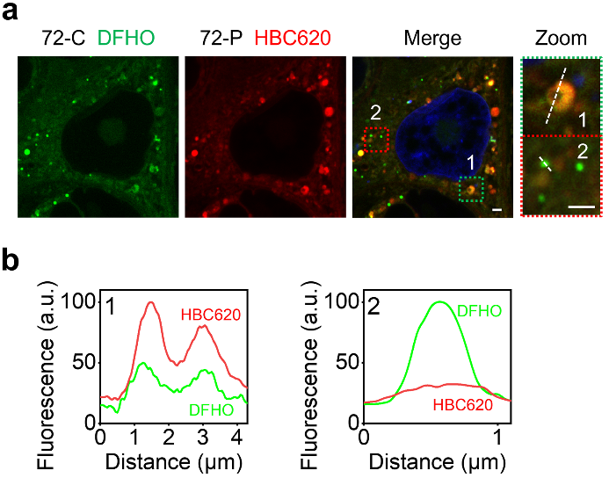
Supplementary Fig. 14. Preparation of RNA multiphasic condensates in living cells. a, Representative confocal fluorescence imaging of MCF-7 cells expressing both 72-C and 72-P. The cells were stained with 10 μM HBC620 and 10 μM DFHO. Scale bars, 2 μm. b, The normalized fluorescence intensity distributions of DFHO and HBC620 indicated with white lines in Supplementary Fig. 14a.

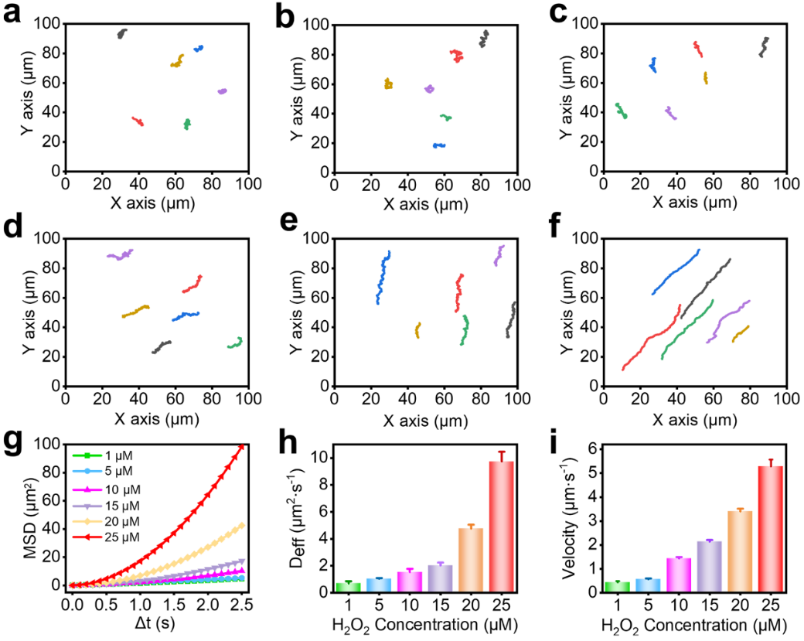
Supplementary Fig. 15. Effects of H₂O₂ concentrations on the motion of RCM. Motion behavior analysis of the RCM at H₂O₂ concentrations of 1 mM (a), 5 mM (b), 10 mM (c), 15 mM (d), 20 mM (e) and 25 mM (f). The MSD (Mean-square-displacement) (g), corresponding Deff (diffusion coefficient) (h), Velocity (i) of RCM at different concentrations of H₂O₂. The error bars indicate mean ± s.d. (n = 6 independent micromotor).

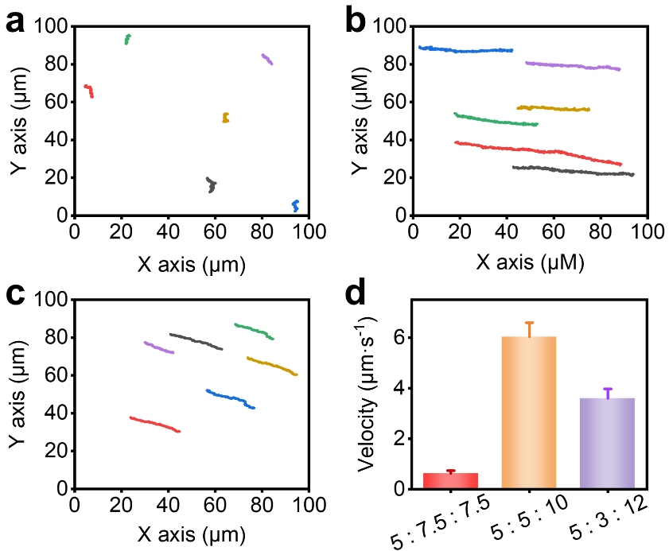
Supplementary Fig. 16. The motion comparation of RNA condensates assembled with different ratios of 18-G4C2 and 72-P. Typical tracking paths of RNA condensates assembled with G-31, 18-G4C2 and P-72 at concentration ratios of 5 : 7.5 : 7.5 (a), 5 : 5 : 10 (b), and 5 : 3 : 12 (c) in presence of 10 μM Hemin and 25 mM H₂O₂. d, The velocity of RNA condensates assembled with different ratios of 18-G4C2 and P-72 in presence of 10 μM Hemin and 25 mM H₂O₂. The error bars indicate mean ± s.d. (n = 6 independent micromotor).

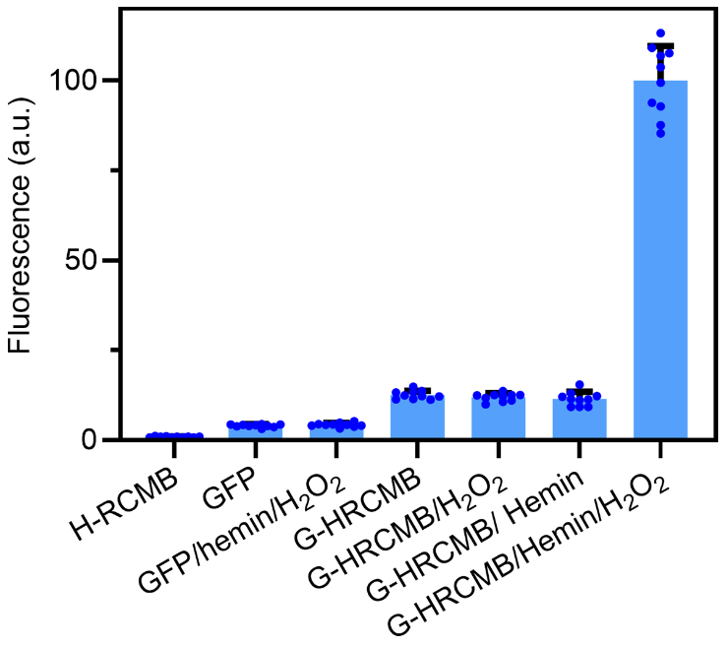
Supplementary Fig. 17. Cellular fluorescence intensities were quantified in ∼ 10 individual cells based on Fig. 5m. The error bars indicate mean ± s.d. (n = 10 independent cells).

Supplementary Table 1. Sequences of RNAs used in this project
Name | RNA Sequence (5’-3’)
sBroccoli | GGA CGG AGA CGG UCG GGU CCA GAU AUU CGU AUC UGU CGA GUA GAG UGU GGG CUC CGU UUU
dBroccoli, 0-dB | GGA GGA GAC GGU CGG GUC CAU CUG AGA CGG UCG GGU CCA GAU AUU CGU AUC UGU CGA GUA GAG UGU GGG CUC AGA UGU CGA GUA GAG UGU GGG CUC CUC C
31-dB | GGA GGA GAC GGU CGG GUC CAU CUG AGA CGG UCG GGU CCA GAU AUU CGU AUC UGU CGA GUA GAG UGU GGG CUC AGA UGU CGA GUA GAG UGU GGG CUC CUC CAA AAA CUG CUG CUG CUG CUG CUG CUG CUG CUG CUG CUG CUG CUG CUG CUG CUG CUG CUG CUG CUG CUG CUG CUG CUG CUG CUG CUG CUG CUG CUG CUG
0-C | GGU GGA CGA GGA AGG AGG UCU GAG GAG GUC ACU GUC CAC C
31-C | GGU GGA CGA GGA AGG AGG UCU GAG GAG GUC ACU GUC CAC CCU GCU GCU GCU GCU GCU GCU GCU GCU GCU GCU GCU GCU GCU GCU GCU GCU GCU GCU GCU GCU GCU GCU GCU GCU GCU GCU GCU GCU GCU GCU G
31-VC | GGU GGA CGA GGA AGC AGA UCU GAA GAC GUC ACU GUC CAC CCU GCU GCU GCU GCU GCU GCU GCU GCU GCU GCU GCU GCU GCU GCU GCU GCU GCU GCU GCU GCU GCU GCU GCU GCU GCU GCU GCU GCU GCU GCU G
72-C | GGU GGA CGA GGA AGG AGG UCU GAG GAG GUC ACU GUC CAC CCU GCU GCU GCU GCU GCU GCU GCU GCU GCU GCU GCU GCU GCU GCU GCU GCU GCU GCU GCU GCU GCU GCU GCU GCU GCU GCU GCU GCU GCU GCU GCU GCU GCU GCU GCU GCU GCU GCU GCU GCU GCU GCU GCU GCU GCU GCU GCU GCU GCU GCU GCU GCU GCU GCU GCU GCU GCU GCU GCU GCU GCU GCU GCU GCU GCU GCU GCU GCU GCU GCU GCU G
Pepper (0-P) | GGU AUC CCC AAU CGU GGC GUG UCG GCC UGC UUC GGC AGG CAC UGG CGC CGG GAU ACC
31-P | GGU AUC CCC AAU CGU GGC GUG UCG GCC UGC UUC GGC AGG CAC UGG CGC CGG GAU ACC CUG CUG CUG CUG CUG CUG CUG CUG CUG CUG CUG CUG CUG CUG CUG CUG CUG CUG CUG CUG CUG CUG CUG CUG CUG CUG CUG CUG CUG CUG CUG
31-VP1 | GGU AAC AAC AAU AGA UUC GGU AAG CUC UGU CUA CGA CGA GAC UGC CUC CGG GAU ACC CUG CUG CUG CUG CUG CUG CUG CUG CUG CUG CUG CUG CUG CUG CUG CUG CUG CUG CUG CUG CUG CUG CUG CUG CUG CUG CUG CUG CUG CUG CUG

Supplementary Table 1. continued from previous page
Name | RNA Sequence (5’-3’)
31-VP1 | GGU AAC AAC AAU AGA UUC GGU AAG CUC UGU CUA CGA CGA GAC UGC CUC CGG GAU ACC CUG CUG CUG CUG CUG CUG CUG CUG CUG CUG CUG CUG CUG CUG CUG CUG CUG CUG CUG CUG CUG CUG CUG CUG CUG CUG CUG CUG CUG CUG CUG
31-VP2 | GGU AUC CCA CAU AGU ACA AAU CGU CGA CGC UGA CUG CCA AGG AAA GAC CGG GAU ACC CUG CUG CUG CUG CUG CUG CUG CUG CUG CUG CUG CUG CUG CUG CUG CUG CUG CUG CUG CUG CUG CUG CUG CUG CUG CUG CUG CUG CUG CUG CUG
72-P | UAU CCC CAA UCG UGG CGU GUC GGC CUG CUU CGG CAG GCA CUG GCG CCG GGA UAC CCU GCU GCU GCU GCU GCU GCU GCU GCU GCU GCU GCU GCU GCU GCU GCU GCU GCU GCU GCU GCU GCU GCU GCU GCU GCU GCU GCU GCU GCU GCU GCU GCU GCU GCU GCU GCU GCU GCU GCU GCU GCU GCU GCU GCU GCU GCU GCU GCU GCU GCU GCU GCU GCU GCU GCU GCU GCU GCU GCU GCU GCU GCU GCU GCU GCU GCU GCU GCU GCU GCU GCU G
10-CUG | CUG CUG CUG CUG CUG CUG CUG CUG CUG CUG
20-CUG | CUG CUG CUG CUG CUG CUG CUG CUG CUG CUGCUG CUG CUG CUG CUG CUG CUG CUG CUG CUG
37-CUG | CUG CUG CUG CUG CUG CUG CUG CUG CUG CUGCUG CUG CUG CUG CUG CUG CUG CUG CUG CUG CUG CUG CUG CUG CUG CUG CUG CUG CUG CUGCUG CUG CUG CUG CUG CUG CUG
1-G4C2 | GGG GCC
2-G4C2 | GGG GCC GGG GCC
5-G4C2 | GGG GCC GGG GCC GGG GCC GGG GCC GGG GCC
9-G4C2 | GGG GCC GGG GCC GGG GCC GGG GCC GGG GCC GGG GCC GGG GCC GGG GCC GGG GCC
18-G4C2 | GGG GCC GGG GCC GGG GCC GGG GCC GGG GCC GGG GCC GGG GCC GGG GCC GGG GCC GGG GCC GGG GCC GGG GCC GGG GCC GGG GCC GGG GCC GGG GCC GGG GCC GGG GCC
H1 | GGU AUC CCA CAU AAU AAC CGG GAU ACC
31-H1 | GGU AUC CCA CAU AAU AAC CGG GAU ACC CUG CUG CUG CUG CUG CUG CUG CUG CUG CUG CUG CUG CUG CUG CUG CUG CUG CUG CUG CUG CUG CUG CUG CUG CUG CUG CUG CUG CUG CUG CUG
H2 | GGU AUC CCA CAU AAU ACA AAU AGC UGC CCG GGA UAC C
31-H2 | GGU AUC CCA CAU AAU ACA AAU AGC UGC CCG GGA UAC CCU GCU GCU GCU GCU GCU GCU GCU GCU GCU GCU GCU GCU GCU GCU GCU GCU GCU GCU GCU GCU GCU GCU GCU GCU GCU GCU GCU GCU GCU GCU G
Supplementary Table 1. continued from previous page
Name | RNA Sequence (5’-3’)
31-H3 | GGU AUC CCA CAU AAU ACA AAU AGC UGC CAA GGA AAG ACC GGG AUA CCC UGC UGC UGC UGC UGC UGC UGC UGC UGC UGC UGC UGC UGC UGC UGC UGC UGC UGC UGC UGC UGC UGC UGC UGC UGC UGC UGC UGC UGC UGC UG
S1 | GGA ACA UAA CAU AAU AAC CGG GAU ACC
31-S1 | GGA ACA UAA CAU AAU AAC CGG GAU ACC CUG CUG CUG CUG CUG CUG CUG CUG CUG CUG CUG CUG CUG CUG CUG CUG CUG CUG CUG CUG CUG CUG CUG CUG CUG CUG CUG CUG CUG CUG CUG
S2 | GGA ACA UAA CAU AAU ACA AUA GAC UCG CCG GGA UAC C
31-S2 | GGA ACA UAA CAU AAU ACA AUA GAC UCG CCG GGA UAC CCU GCU GCU GCU GCU GCU GCU GCU GCU GCU GCU GCU GCU GCU GCU GCU GCU GCU GCU GCU GCU GCU GCU GCU GCU GCU GCU GCU GCU GCU GCU G
31-S3 | GGA ACA UAA CAU AAU ACA AUA GAC UCG CAA GGA AAG ACC GGG AUA CCC UGC UGC UGC UGC UGC UGC UGC UGC UGC UGC UGC UGC UGC UGC UGC UGC UGC UGC UGC UGC UGC UGC UGC UGC UGC UGC UGC UGC UGC UGC UG
31-G | GGA GCU UCU GGA CUG CGA UGG GAG CAC GAA ACG UCG UGG CGC AAU UGG GUG GGG AAA GUC CUU AAA AGA GGG CCA CCA CAG AAG CUC UGC UGC UGC UGC UGC UGC UGC UGC UGC UGC UGC UGC UGC UGC UGC UGC UGC UGC UGC UGC UGC UGC UGC UGC UGC UGC UGC UGC UGC UGC UG
31-VC2 | GGU GAA AGA AGA AGG AGA UCU GAA GAC GUC ACU GUC CAC CCU GCU GCU GCU GCU GCU GCU GCU GCU GCU GCU GCU GCU GCU GCU GCU GCU GCU GCU GCU GCU GCU GCU GCU GCU GCU GCU GCU GCU GCU GCU G
31-E | GGA UGA CAA GGA CAC UGA AAU AAA CGU AUC CCU UUU CGC GUC CUU AUU UCA GUG UCC UUG UCA UAG GUG GAC GAG GAA GGA GGU CUG AGG AGG UCA CUG UCC ACC CUG CUG CUG CUG CUG CUG CUG CUG CUG CUG CUG CUG CUG CUG CUG CUG CUG CUG CUG CUG CUG CUG CUG CUG CUG CUG CUG CUG CUG CUG CUG

Supplementary Table 2. Sequences of DNAs used in this project
Name | DNA Sequence (5’-3’)
6 × CAG | TAMRA-CAG CAG CAG CAG CAG CAG
S3 blocker | Cy5-GCG AGT CTA TTG TAT TAT GTT ATG TTC C
EpCAM Forward | AAC TAC AAG CTG GCC GTA
EpCAM Reverse | CAG GTT TTG CTC TTC TCC
β-actin Forward | CTC TTC CAG CCT TCC TTC CT
β-actin Reverse | GGG CAG TGA TCT CTT TCT GC

Video S1- Typical tracking paths of RCM after incubation without (a), and with 25 mM H₂O₂ (b), 10 μM Hemin (c), or 25 mM H₂O₂ and 10 μM Hemin (d, TD; e, SYBR Gold field), and 31-VC2 incubated with 25 mM H₂O₂ and 10 μM Hemin (f).
Video S2- Typical tracking paths of the RCM incubated with different concentrations of H₂O₂. Motion behavior analysis of the RCM at H₂O₂ concentrations of 1 mM (a), 5 mM (b), 10 mM (c), 15 mM (d), 20 mM (e) and 25 mM (f).
Video S3- The motion comparation of RNA condensates assembled with different ratios of 18-G4C2 and 72-P. Typical tracking paths of RNA condensates assembled with G-31, 18-G4C2 and P-72 at concentration ratios of 5 : 7.5 : 7.5 (a), 5 : 5 : 10 (b), and 5 : 3 : 12 (c) in presence of 10 μM Hemin and 25 mM H₂O₂. Videos were collected with an excitation at 488 nm (GFP).
Video S4- The motion comparations of G-HRCMB and G-SRCMB. Typical tracking paths of HRCMB (a), G-HRCMB (b), H-GRCMB incubated with 10 μM Hemin and 25 mM H₂O₂ (c), SRCMB (d), G-SRCMB (e), or G-SRCMB incubated with 10 μM Hemin and 25 mM H₂O₂ (f). Videos were collected with an excitation at 561 nm (4S GelRed, Red) or 488 nm (GFP, Green).
Video S5- Typical tracking paths of E-RCM after incubation without (a), and with the mixture of 25 mM H₂O₂ and 10 μM Hemin (b).

