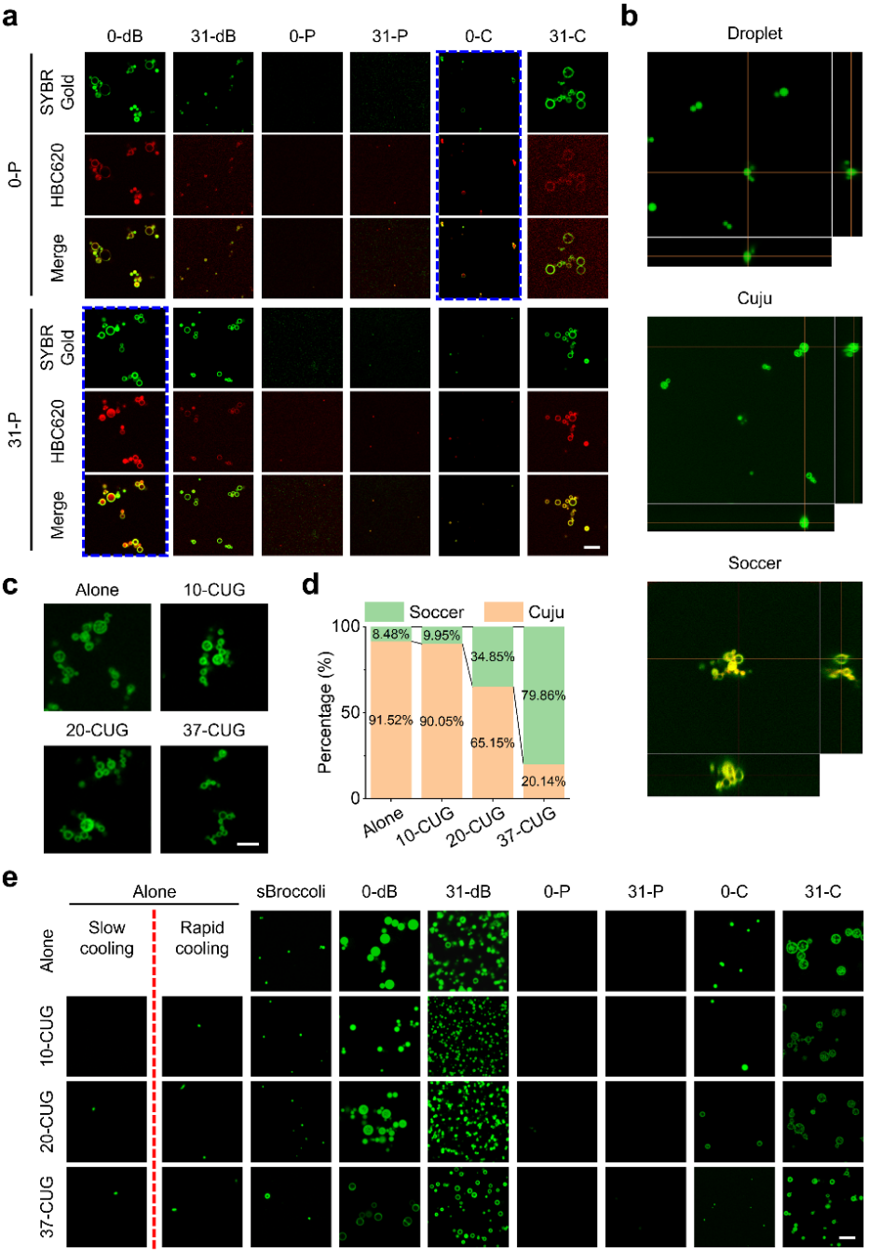
Extended Data Fig. 1 | Effects of Pepper aptamers and CUG repeat numbers on RNA condensate structure and morphology. a，Representative confocal fluorescence imaging of RNA multiphasic condensates assembled by mixing of 0-P (or 31-P) and 0-dB, 31-dB, 0-P, 31-P, 0-C and 31-C, respectively. RNA condensates were stained with 1 × SYBR Gold and 100 μM HBC620. Scale bar, 5 μm. Blue boxes indicated that the 0-P or 31-P was enriched in Soccer. b, Three slide imaging of RNA condensates assembled with 0-dB (droplet), 31-C (Cuju) or the mixture of 31-P and 31-C (Soccer), then stained with 100 μM DFHBI-1T, 100 μM DFHO or 100 μM HBC620, respectively. c, Representative confocal fluorescence imaging of RNA condensates assembled with single component of 31-C (Alone) or mixed with 10-CUG (10-CUG), 20-CUG (20-CUG) and 37-CUG (37-CUG), respectively. The RNA condensates were stained with 1 × SYBR Gold. Scale bar, 5 μm. d, The percentage of Cuju and Soccer in RNA condensates from Extended Data Fig. 1c. e, Representative confocal fluorescence imaging of RNA multiphasic condensates assembled by rapid cooling of the RNAs mixed with 0-CUG, 20-CUG or 37-CUG, and sBroccoli, 0-dB, 31-dB, 0-P, 31-P, 0-C or 31-C, respectively. The condensates that were constructed with single component of 0-CUG, 20-CUG or 37-CUG by slow cooling or rapid cooling, and sBroccoli, 0-dB, 31-dB, 0-P, 31-P, 0-C or 31-C by rapid cooling were used as controls. All RNA condensates were stained with 1 × SYBR Gold. Scale bar, 5 μm.
Extended Data Fig. 2 | Effects of cooling rates on the structure and morphology of the RNA condensate. a, Representative confocal fluorescence imaging of RNA condensates assembled with 31-C by different cooling rates of 2 °C·min⁻¹ (Slow cooling), 10 °C·min⁻¹, 37 °C bath (Rapid cooling), or Ice bath (directly ice bath). Scale bar, 5 μm. b, The percentage of heterogeneous and homogenous condensate in Extended Data Fig. 2a. c, Representative confocal fluorescence imaging of RNA condensates assembled with the mixture of 31-P and 31-C by different cooling rates of 2 °C·min⁻¹ (Slow cooling), 5 °C·min⁻¹, 10 °C·min⁻¹, or 37 °C bath (Rapid cooling). Scale bar, 5 μm. d, The percentage of heterogeneous and homogenous condensate in Extended Data Fig. 2b. e, Representative confocal fluorescence imaging of RNA condensates assembled with the mixture of 10 μM 31-C and 10 μM 31-P by slow cooling to different temperatures, then directly stored at 37 °C, stained with 100 μM HBC620 (31-P) and 100 μM DFHO (31-C). Scale bar, 10 μm.
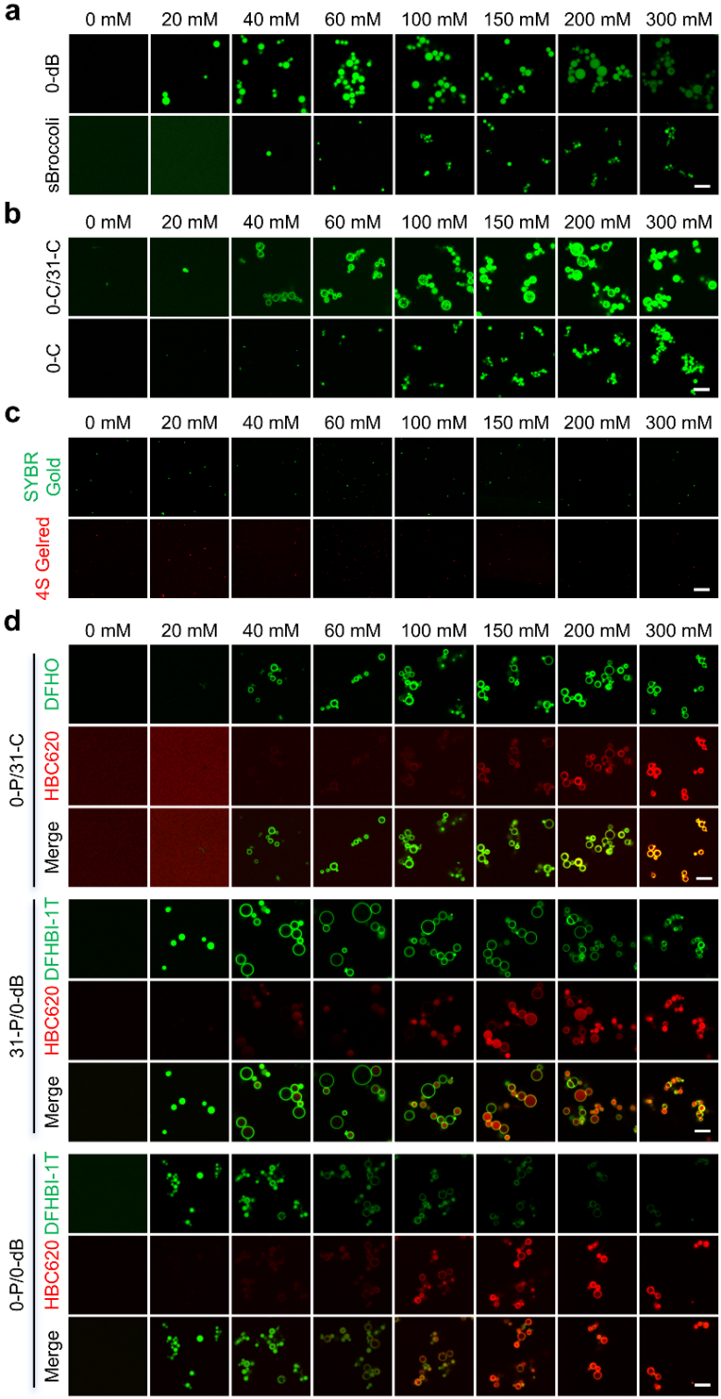
Extended Data Fig. 3 | Effects of magnesium ion concentrations on multiphasic RNA condensates assembly. a, Representative confocal fluorescence imaging of RNA condensates assembled with 20 μM 0-dB or sBroccoli at different Mg²⁺ concentration, and stained with 100 μM DFHBI-1T. Scale bar, 5 μm. b, Representative confocal fluorescence imaging of RNA condensates assembled with 10 μM 0-C and 10 μM 31-C mixture (0-C/31-C), or 20 μM 0-C (0-C) at different Mg²⁺ concentration, and stained with 100 μM DFHO. c, Representative confocal fluorescence imaging of RNA condensates assembled with 20 μM 37-CUG at different Mg²⁺ concentration, and stained with 1 × SYBR Gold and 1 × 4S Gelred. Scale bar, 5 μm. d, Representative confocal fluorescence imaging of RNA condensates assembled with 10 μM 0-P and 10 μM 31-C mixture (0-P/31-C), 10 μM 0-dB and 10 μM 31-P mixture (31-P/0-dB), or 10 μM 0-P and 10 μM 0-dB mixture (0-P/0-dB) at different Mg²⁺ concentrations, and stained with 100 μM DFHBI-1T, DFHO or HBC620, respectively. Scale bar, 5 μm.
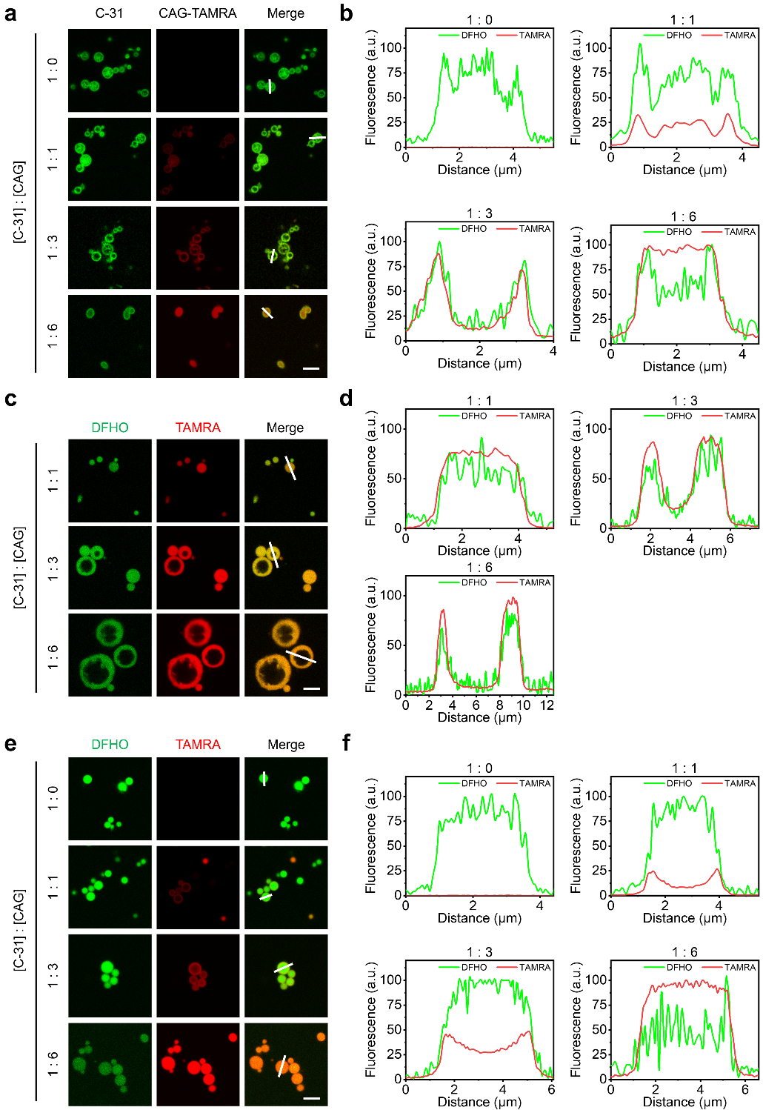
Extended Data Fig. 4 | Effects of 6 × CAG on RNA condensate morphology. a, Representative confocal fluorescence imaging of RNA condensates assembled with the mixtures of 31-C and different ratios of TAMRA labelled-6 × CAG (CAG-TAMRA) by rapid cooling, then stained by 100 μM DFHO. Scale bar, 5 μm. b, The normalized fluorescence intensity distributions of DFHO (31-C) and TAMRA (CAG) indicated with white lines in Extended Data Fig. 4a. c, Representative confocal fluorescence imaging of the condensates assembled with the mixtures of 31-C and different ratios of TAMRA labelled-6 × CAG (CAG-TAMRA) by slow cooling, then stained by 100 μM DFHO. Scale bar, 5 μm. d, The normalized fluorescence intensity distributions of DFHO (31-C) and TAMRA (CAG) indicated with white lines in Extended Data Fig. 4c. e, Representative confocal fluorescence imaging of the condensates assembled with 31-C by slow cooling, then incubated with different ratios of TAMRA labelled-6 × CAG (CAG-TAMRA) for 30-min at 37 °C, and stained by 100 μM DFHO. Scale bar, 5 μm. f, The normalized fluorescence intensity distributions of DFHO (31-C) and TAMRA (CAG) indicated with white lines in Extended Data Fig. 4e.
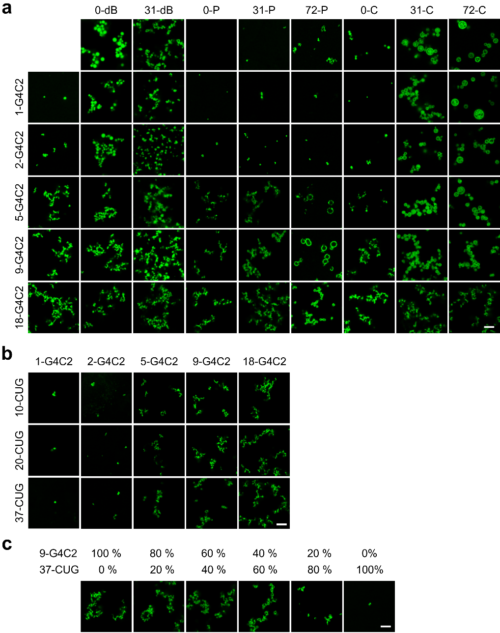
Extended Data Fig. 5 | Controllable regulation of G4C2 repeat expansion based condensates. a, Representative confocal fluorescence imaging of the condensates assembled by orthogonal mixing of 1-G4C2, 2-G4C2, 5-G4C2, 9-G4C2 or 18-G4C2 and 0-dB, 31-dB, 0-P, 31-P, 72-P, 0-C, 31-C or 72-C in equal proportions, respectively. The RNA condensates were stained with 1 × SYBR Gold. Scale bar, 5 μm. b, Representative confocal fluorescence imaging of the condensates assembled by mixing of 1-G4C2, 2-G4C2, 5-G4C2, 9-G4C2 or 18-G4C2, and 10-CUG, 20-CUG or 37-CUG in equal proportions, respectively. c, Representative confocal fluorescence imaging of the condensates assembled by mixing of 9-G4C2 and 37-CUG with different ratios. The RNA condensates were stained with 1 × SYBR Gold. Scale bar, 5 μm.
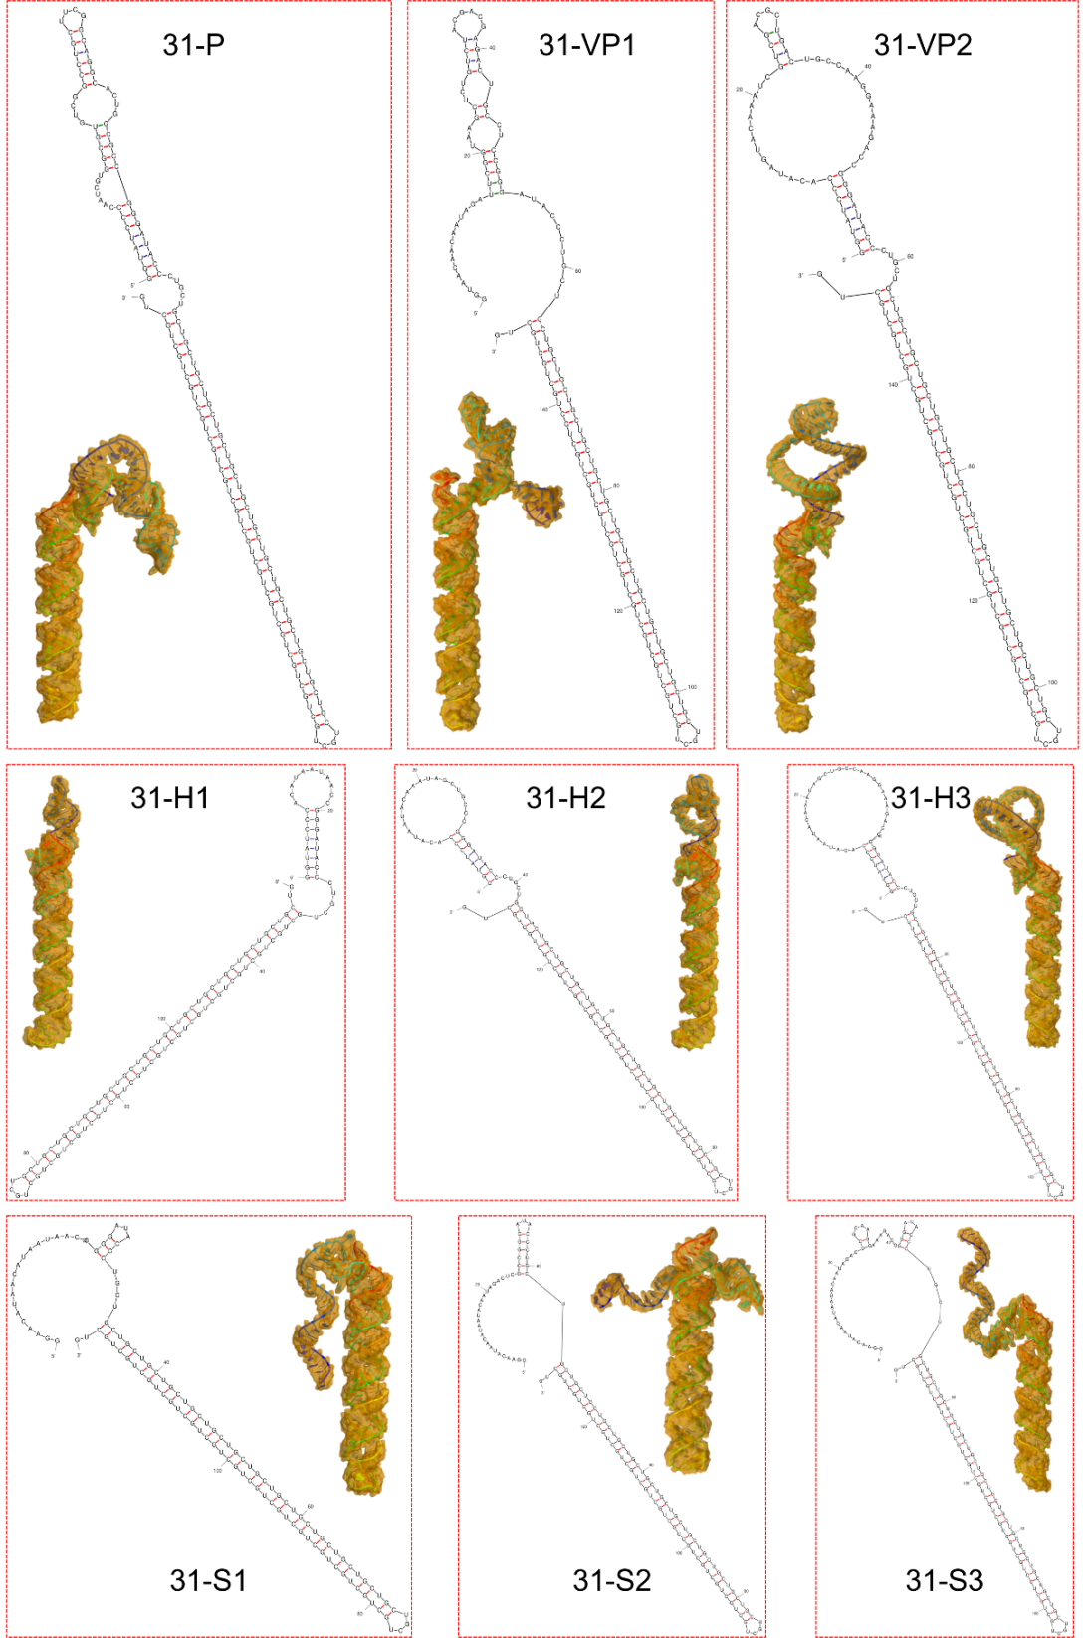
Extended Data Fig. 6 | Simulation of RNA structures. Hairpin and 3D structures of 31-P, 31-Variant Pepper 1 (31-VP1), 31-Variant Pepper 2 (31-VP2), 31-H1, 31-H2, 31-H3, 31-S1, 31-S2 and 31-S3 simulated with the UNAFold Web Server and RNA composer, respectively.
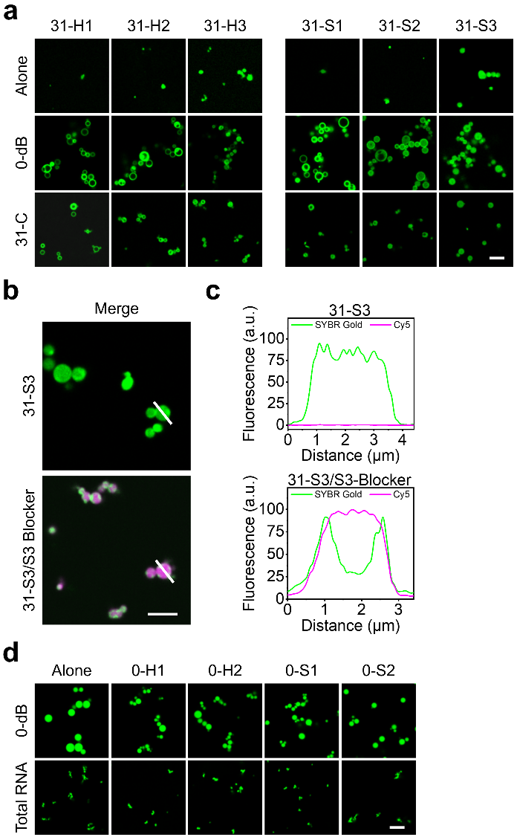
Extended Data Fig. 7 | Multiphasic RNA condensates transformation general regulation. a, Representative confocal fluorescence imaging of RNA condensates assembled with 31-H1, 31-H2, 31-H3, 31-S1, 31-S2 or 31-S3 before (Alone) and after mixed with 0-dB or 31-C, respectively. The RNA condensates were stained with 1 × SYBR Gold. Scale bar, 5 μm. b, Representative confocal fluorescence imaging of RNA condensates assembled with 31-S3 (31-S3) or mixture of 31-S3 and Cy5 labelled S3 blocker (31-S3/S3 blocker) by rapid cooling, then stained with 1 × SYBR Gold. Scale bar, 5 μm. c, The normalized fluorescence intensity distributions of SYBR Gold and Cy5 indicated with white lines in Extended Data Fig. 6a. d, Representative confocal fluorescence imaging of RNA condensates assembled with 10 ng·μL⁻¹ of total RNA or 0-dB mixed without (Alone) or with 0-H1, 0-H2, 0-S1 or 0-S2, respectively. The RNA condensates were stained with 1 × SYBR Gold. Scale bar, 5 μm.

Extended Data Fig. 8 | Fabrication and application of protein-loading micromotors. a, Representative confocal fluorescence imaging of RNA condensates assembled with mixture of G-31, 18-G4C2 and P-72, or mixture of G-31, 18-G4C2 and 37-CUG with different ratios, respectively. Scale bar, 5 µm. b, Representative confocal fluorescence imaging of RNA condensates assembled with mixture G-31 and 18-G4C2 (Without P-72), or mixture of G-31, 18-G4C2 and P-72 with different ratios of RNA constituent, then incubation with and without 5 μM GFP respectively. Scale bar, 5 µm. c, The fluorescence intensities of GFP of RNA condensates in Extended Data Fig. 8b. The error bars indicate mean ± s.d. (n = 3 independent samples). Typical tracking paths of HRCMB (d), G-HRCMB (e), H-GRCMB incubated with 10 μM Hemin and 25 mM H₂O₂ (f), SRCMB (g), G-SRCMB (h), or G-SRCMB incubated with 10 μM Hemin and 25 mM H₂O₂ (i), which were recorded for 10 s (n = 6). The MSD (Mean-square-displacement) (j), corresponding Deff (diffusion coefficient) (k), velocity (m) of H-RCMB, G-HRCMB, H-GRCMB, S-RCMB, G-SRCMB, G-SRCMB incubated with and without 10 μM Hemin and 25 mM H₂O_{2.} The error bars indicate mean ± s.d. (n = 6 independent micromotor).

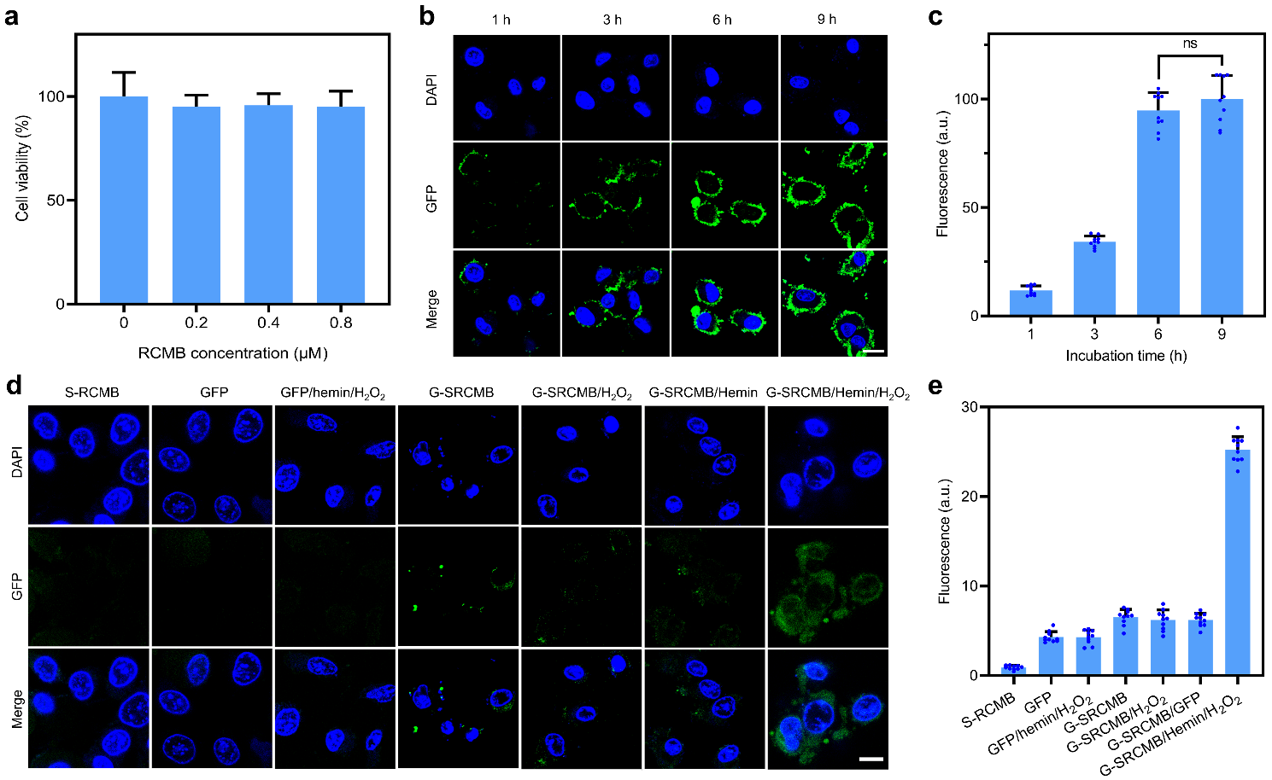
Extended Data Fig. 9 | RNA condensate based micromotors for protein cellular delivery. a, Cell viability of HeLa cells treated with RCM at concentrations of 0, 0.2, 0.4, 0.8 µM for 6 h. The error bars indicate mean ± s.d. (n = 3 independent cell samples). b, Confocal fluorescence imaging of HeLa cells incubated with 0.4 μM G-HRCMB, 100 μM H₂O₂ and 5 μM Hemin for different times. Scale bar, 20 µm. c, Cellular fluorescence intensities were quantified in ∼ 10 individual cells based on Extended Data Fig. 9b. The error bars indicate mean ± s.d. (n = 10 independent cells). d, Confocal fluorescence imaging of HeLa cells after incubation with 0.4 μM RCMB, 1 μM GFP, 1 μM GFP incubated with 100 μM H₂O₂ and 5 μM Hemin (GFP + Hemin + H₂O₂), 0.4 μM G-SRCMB, 0.4 μM G-SRCMB incubated with 100 μM H₂O₂ (G-SRCMB + H₂O₂), 0.4 μM G-SRCMB incubated with 5 μM Hemin (G-SRCMB + Hemin), 0.4 μM G-SRCMB incubated with 5 μM Hemin and 100 μM H₂O₂ (G-SRCMB + Hemin + H₂O₂). Scale bar, 20 µm. e, Cellular fluorescence intensities were quantified in ∼ 10 individual cells based on Extended Data Fig. 9e. The error bars indicate mean ± s.d. (n = 10 independent cells).
Extended Data Fig. 10 | Cellular uptake of ECM. a, Cellular fluorescence intensities were quantified in ∼ 10 individual cells based on Fig. 6e. The error bars indicate mean ± s.d. (n = 10 independent cells). b, Confocal fluorescence imaging of MCF-7 cells pretreated without (Blank) and with methyl-β-cyclodextrin (Me-β-CD, 2.5 mM), sodium azide (NaN₃, 100 mM)), amiloride (AM, 40 μM), chlorpromazine (CPZ, 30 μM), and nocodazole (NOC, 100 nm), then incubated with the mixture of 0.8 μM E-RCM, 5 μM Hemin and 100 μM H₂O₂. Scale bar, 20 µm. c, Cellular relative fluorescence intensities were quantified in ∼ 10 individual cells based on Extended Data Fig. 10b. The error bars indicate mean ± s.d. (n = 10 independent cells).

