Synthesis of Pyrazolyl Acrylamide-Chalcone Conjugates with Sub-Micromolar Antitrypanosomal Activities
Devesh S Agarwalª, Karol R. Francisco^{b}, Richard M. Beteckª, Yashpreet Kaur ^{b}, Adeline Y. Cheng ^{b}, Conor R. Caffrey^{b}*, Lesetja J. Legoabeª*
ªCentre of Excellence for Pharmaceutical Sciences, North-West University, Potchefstroom 2520, South Africa; ^{b}Center for Discovery and Innovation in Parasitic Diseases, Skaggs School of Pharmacy and Pharmaceutical Sciences, 9255 Pharmacy Lane, MC0657, University of California San Diego, La Jolla, CA 92093, USA

*Corresponding Authors: LJL- lesetja.legoabe@nwu.ac.za; Tel.: +27 18 299 2182.
CRC- ccaffrey@health.ucsd.edu; Tel.: +1 858 534 5340.

Supporting information
S. No. |  | Page No.
1 | ¹H and ¹³C NMR of 3
2 | ¹H and ¹³C NMR of 5a-m
5 | HRMS spectra of 3 & 5a-m

¹H NMR of 3
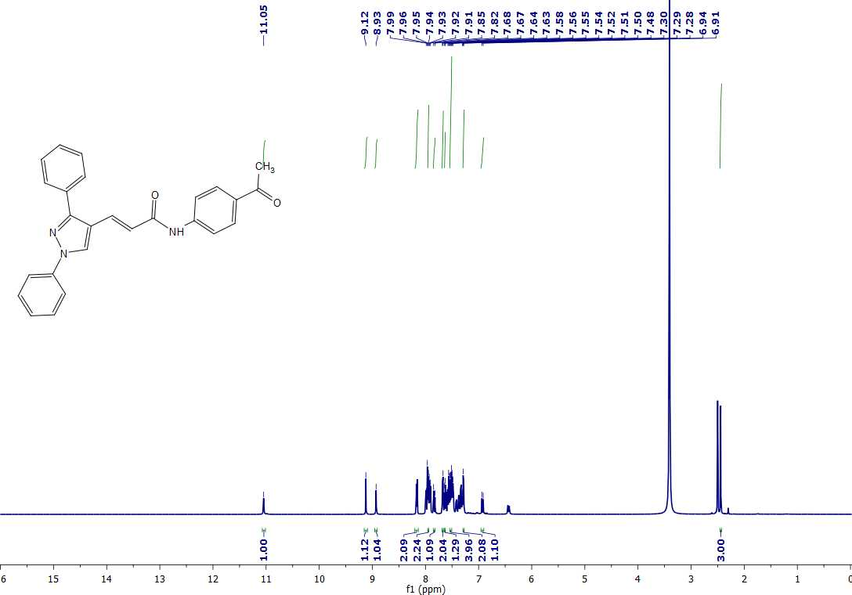
¹³C NMR of 3

¹H NMR of 5a
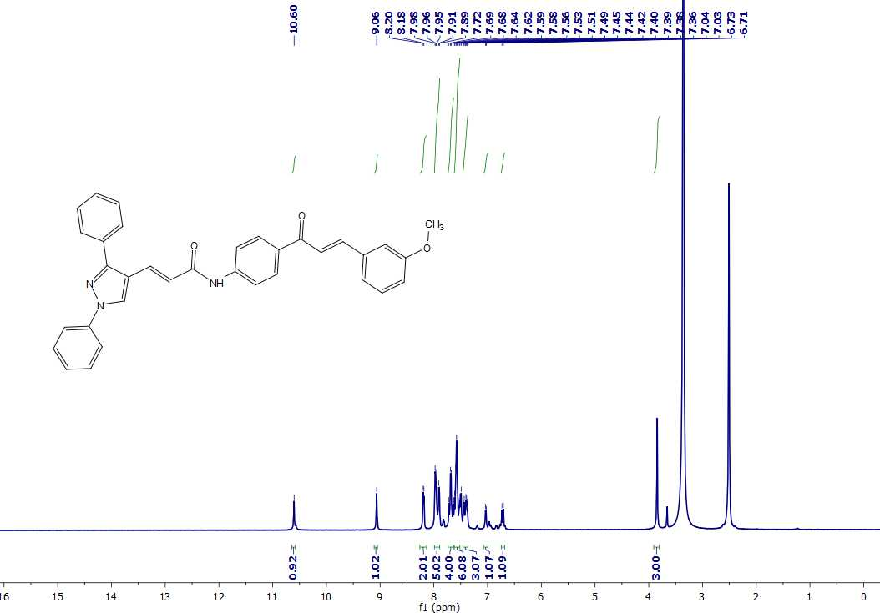
¹³C NMR of 5a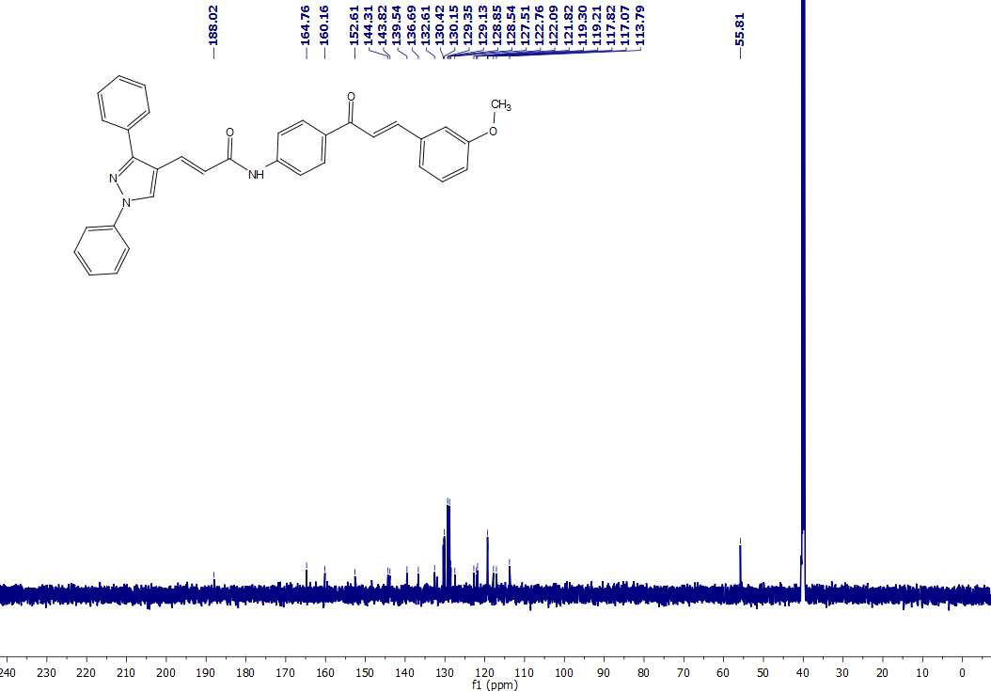
¹H NMR of 5b
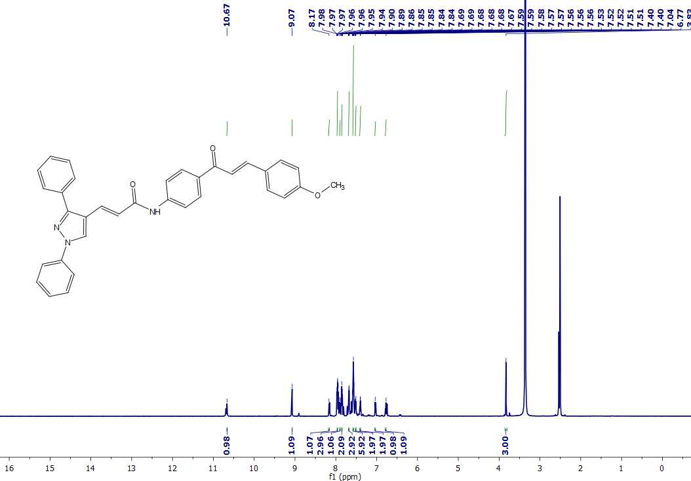
¹³C NMR of 5b
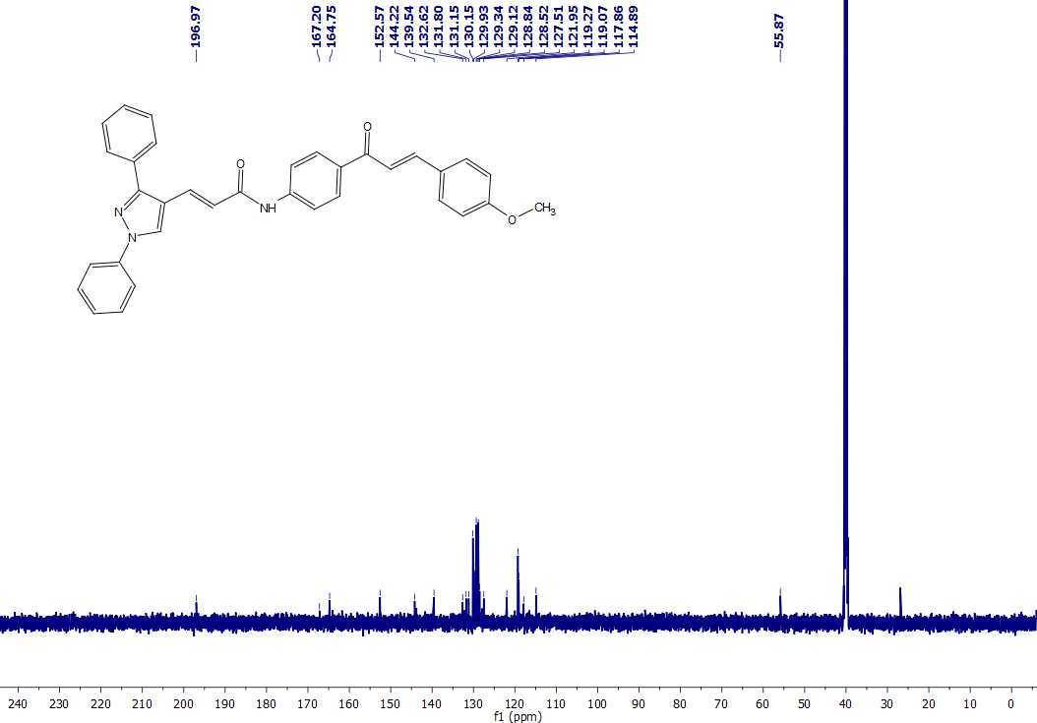
¹H NMR of 5c
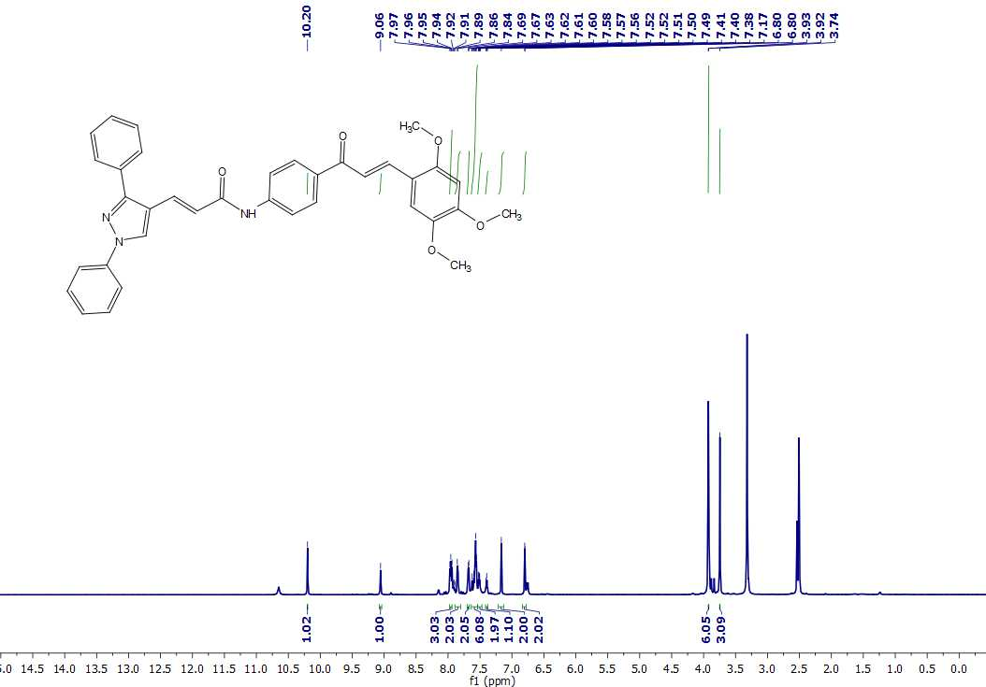
¹³C NMR of 5c

¹H NMR of 5d
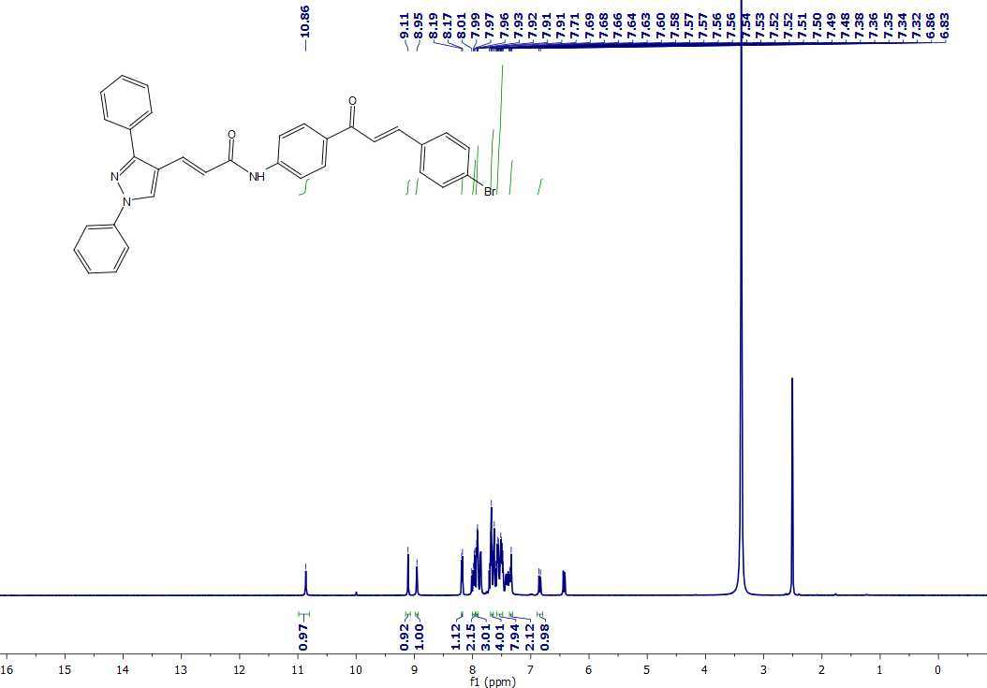
¹³C NMR of 5d
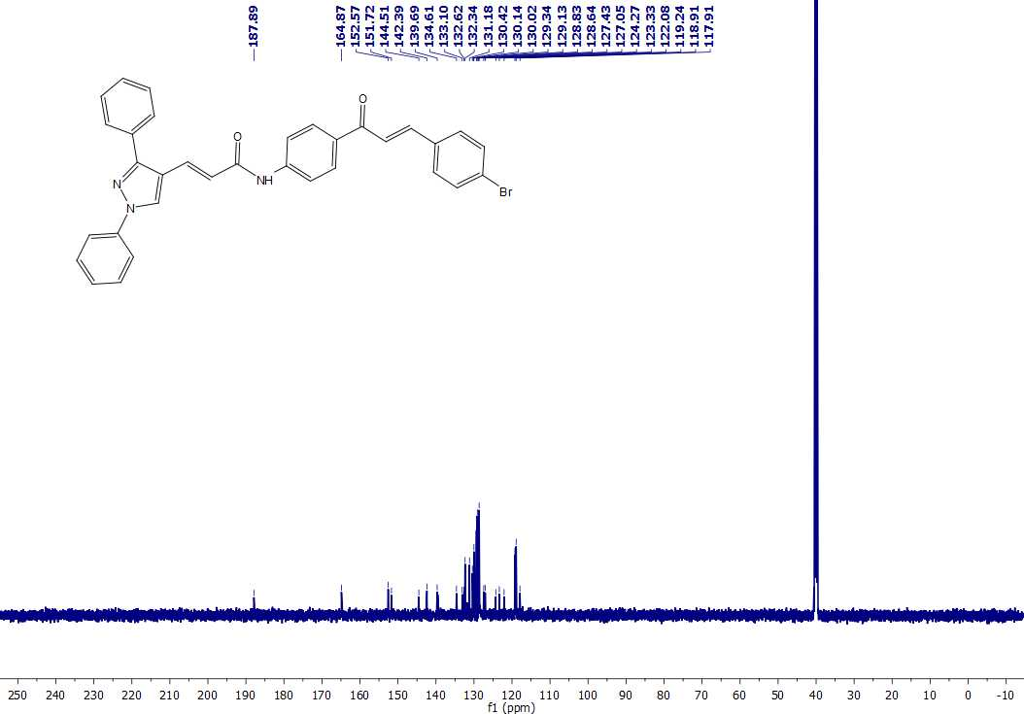
¹H NMR of 5e
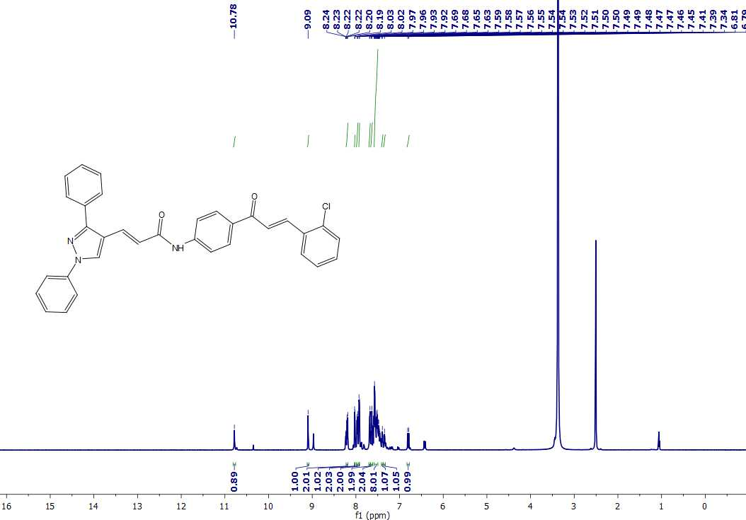
¹³C NMR of 5e
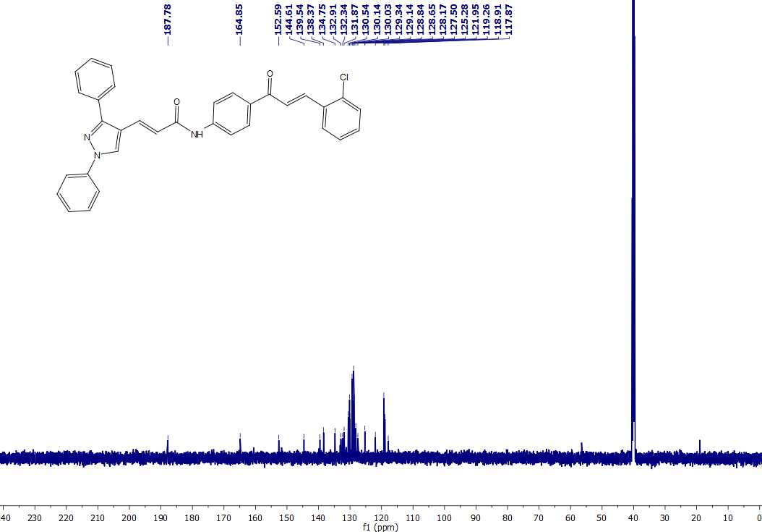
¹H NMR of 5f
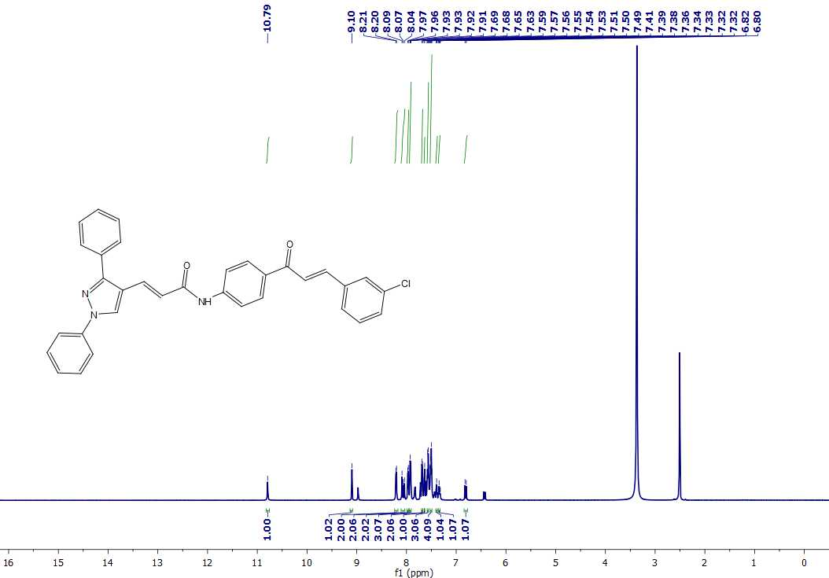
¹³C NMR of 5f
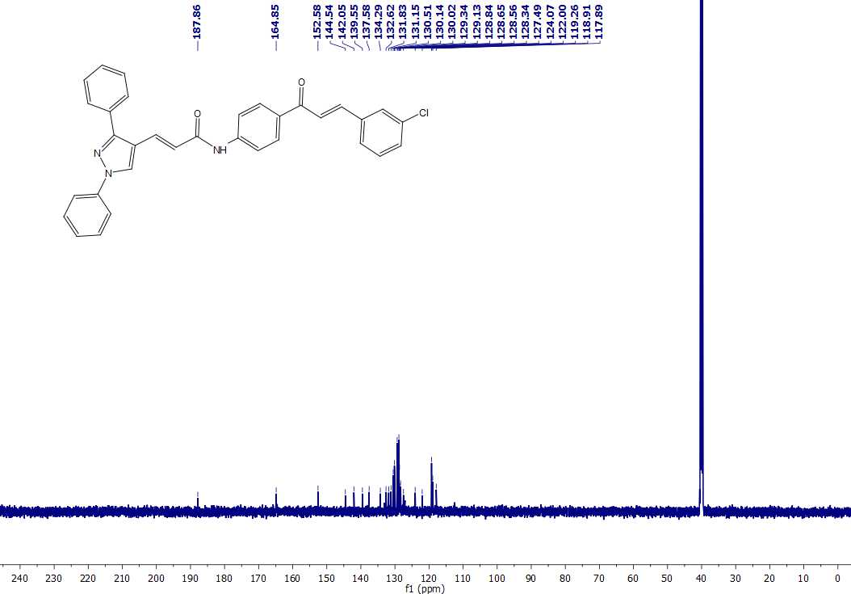
¹H NMR of 5g
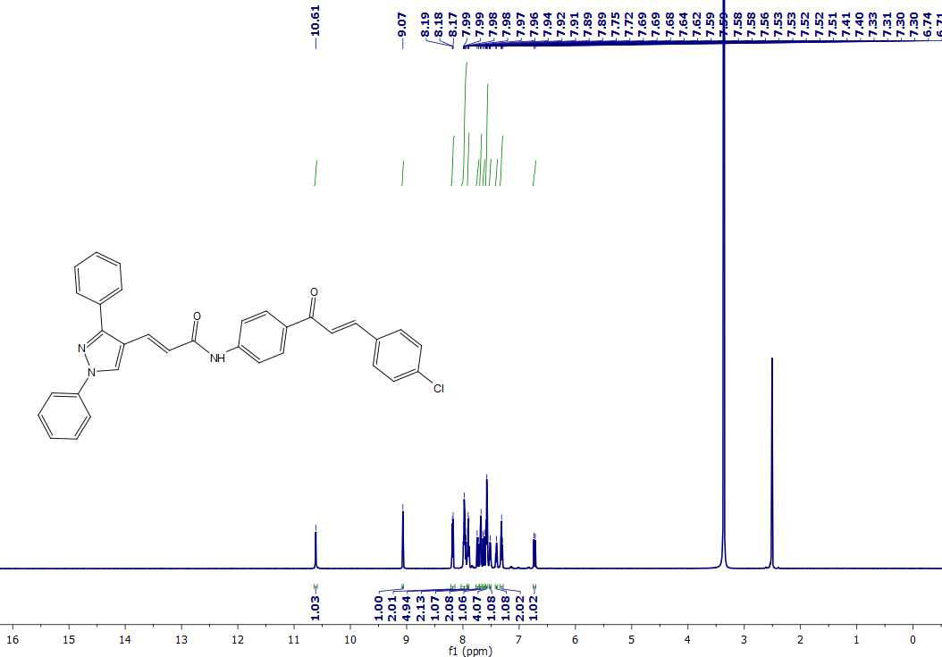
¹³C NMR of 5g
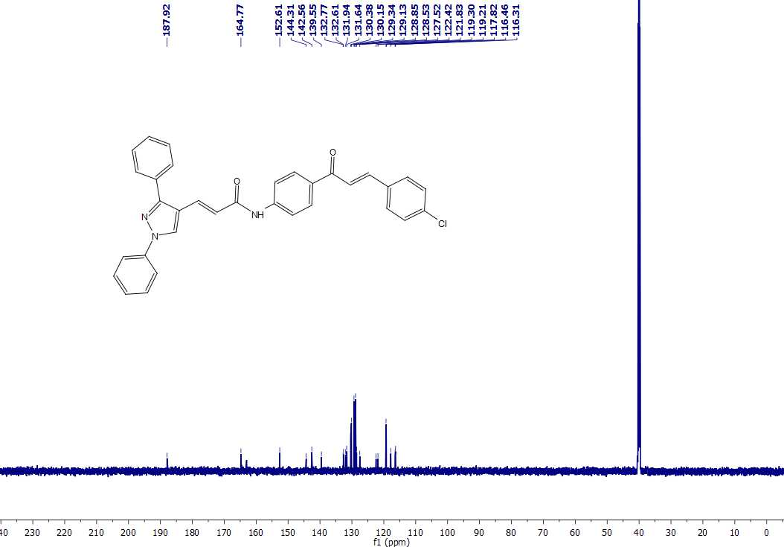
¹H NMR of 5h
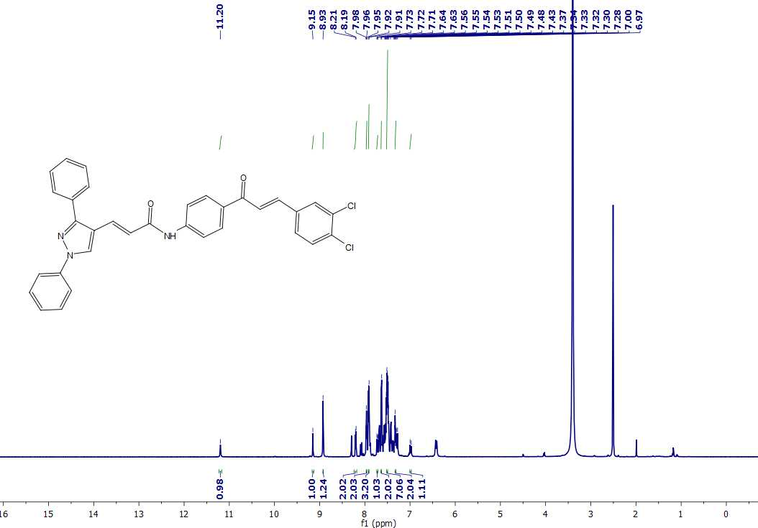
¹³C NMR of 5h
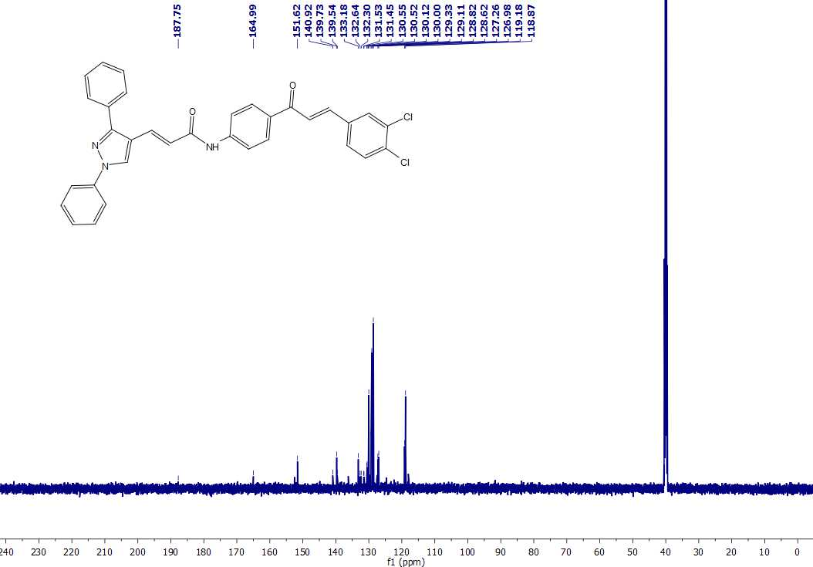
¹H NMR of 5i
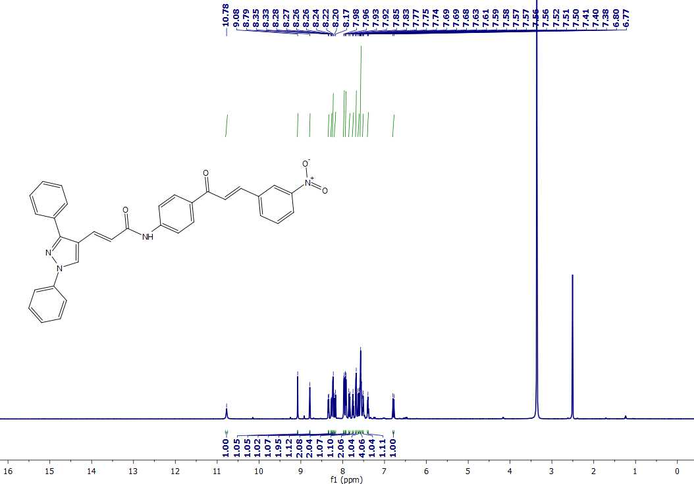
¹³C NMR of 5i
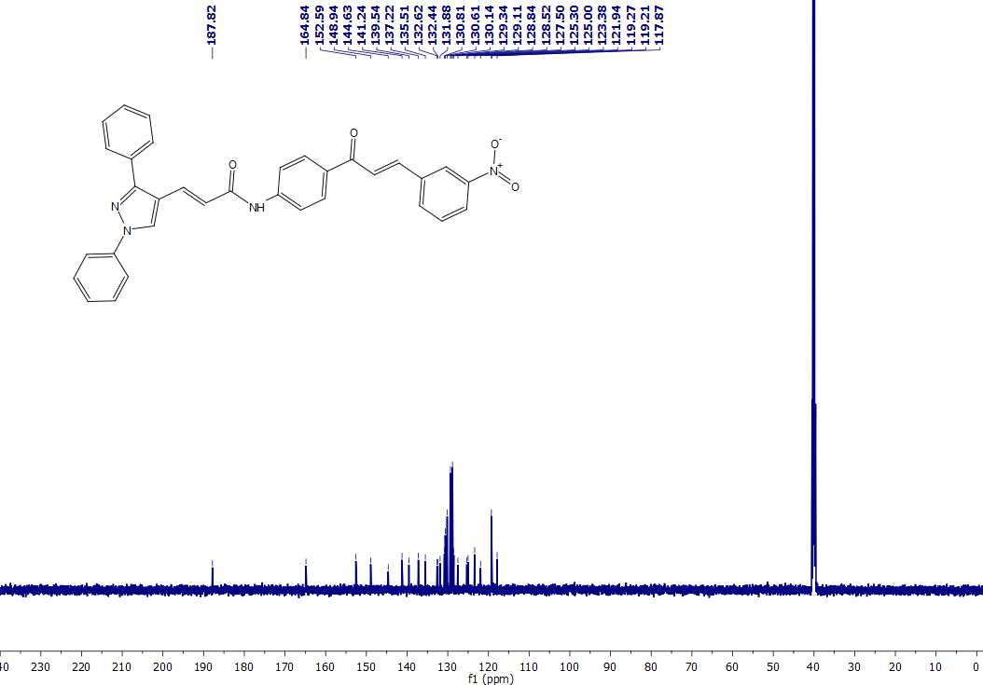
¹H NMR of 5j
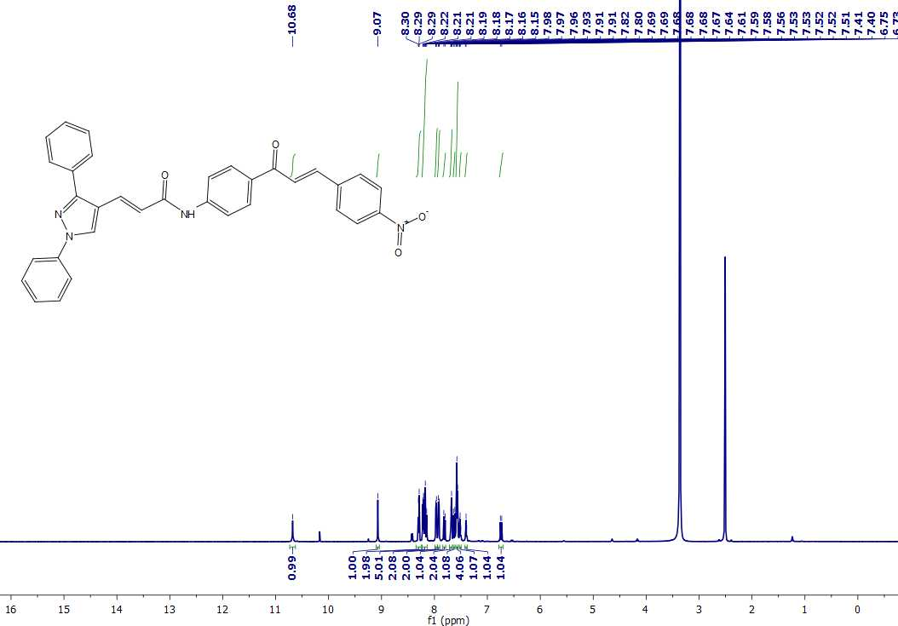
¹³C NMR of 5j
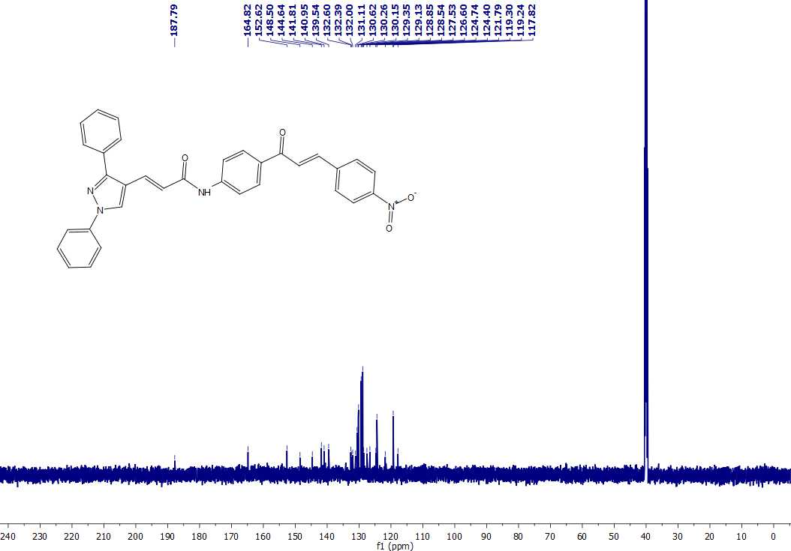
¹H NMR of 5k
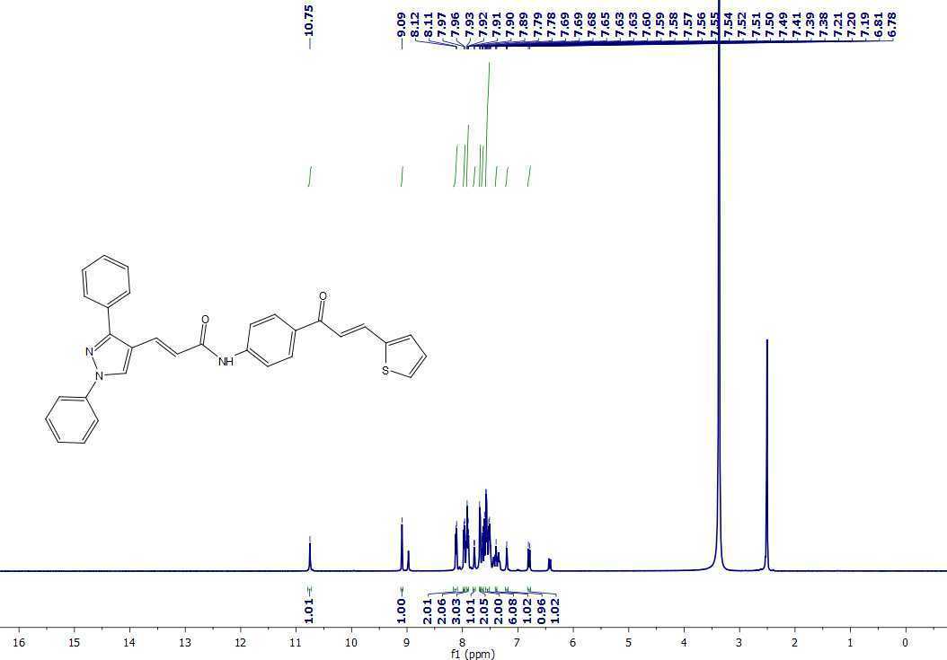
¹³C NMR of 5k
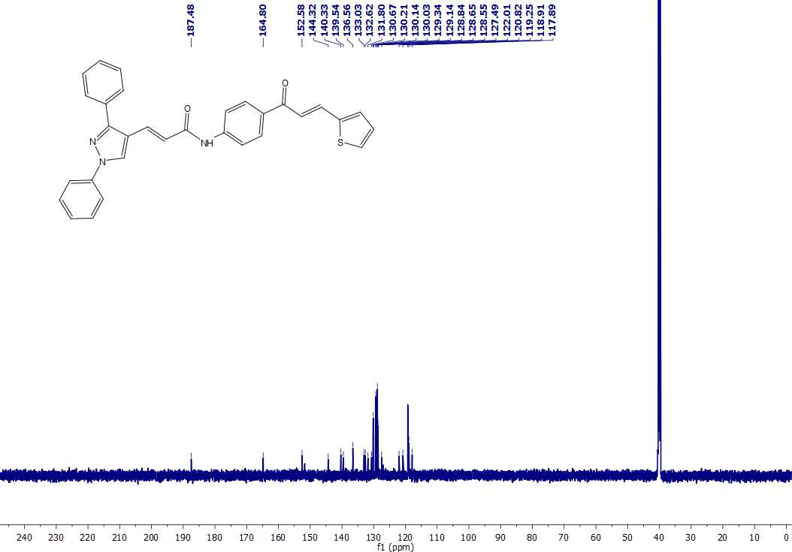
¹H NMR of 5l
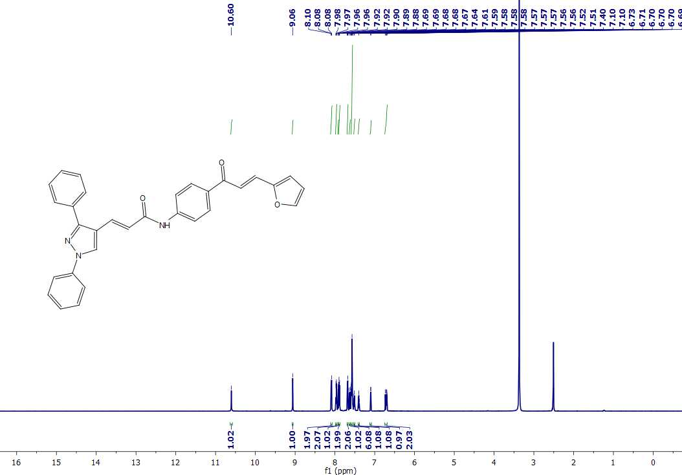
¹³C NMR of 5l
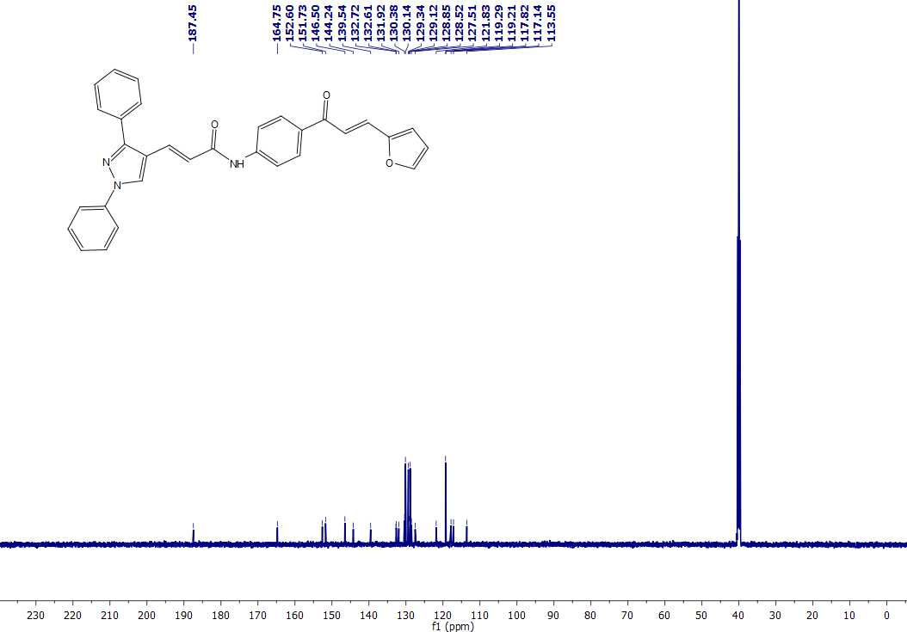
¹H NMR of 5m
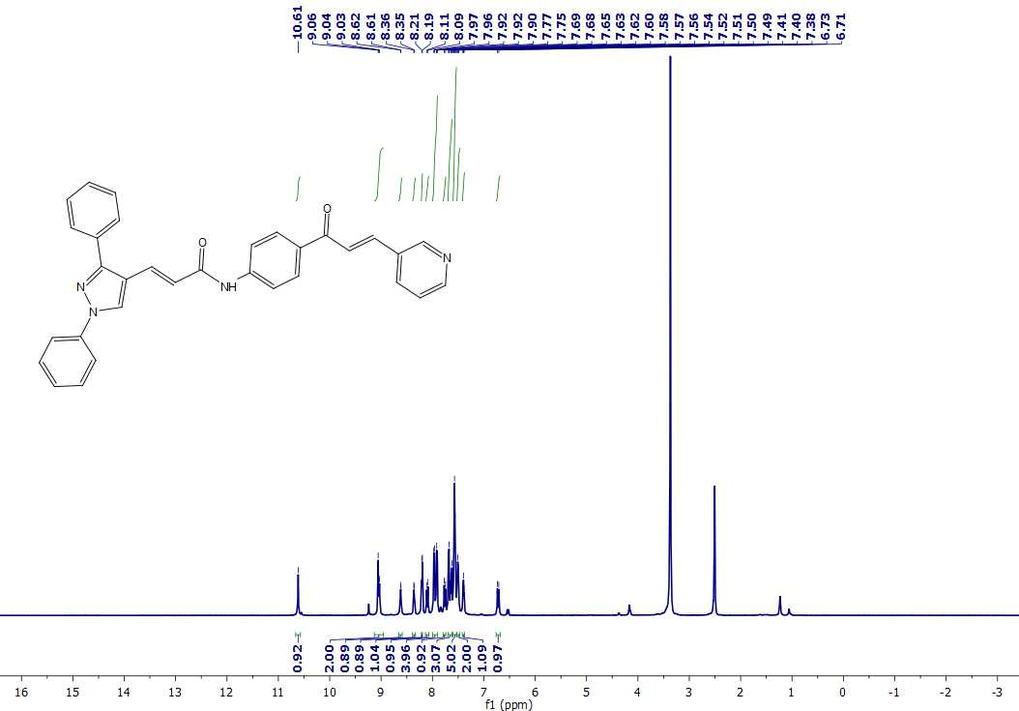
¹³C NMR of 5m
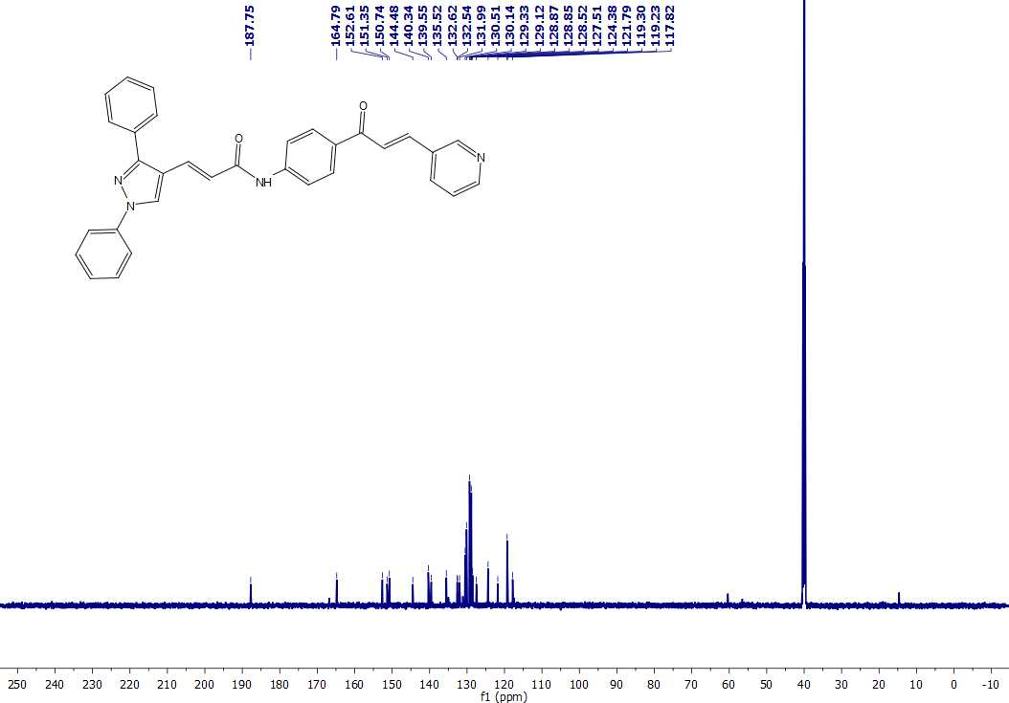
HRMS spectra of 3
HRMS spectra of 5a
HRMS spectra of 5b
HRMS spectra of 5c
HRMS spectra of 5d
HRMS spectra of 5e
HRMS spectra of 5f
HRMS spectra of 5g
HRMS spectra of 5h
HRMS spectra of 5i
HRMS spectra of 5j
HRMS spectra of 5k
HRMS spectra of 5l
HRMS spectra of 5m

