Table 1 Antitrypanosomal and cytotoxic activities of compounds 3 and 5a-m
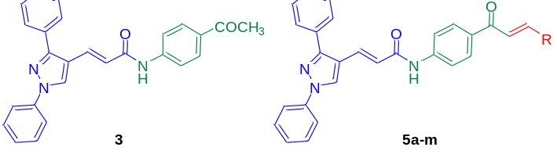
Compound | R | T. b. brucei  EC₅₀ ± SD (µM) | HEK293  CC₅₀ ± SD (µM)
3 | - | >4 | >20
5a | 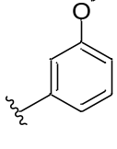 | 0.356 ± 0.071 | >20
5b | 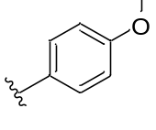 | 0.983 ± 0.058 | 6.524 ± 0.870
5c | 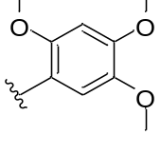 | 1.352 ± 0.251 | 5.810 ± 0.982
5d | 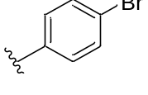 | 0.399 ± 0.044 | >20
5e | 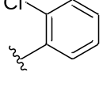 | 0.403 ± 0.051 | >20
5f | 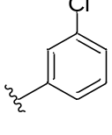 | 0.371 ± 0.032 | >20
5g | 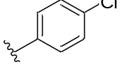 | 0.278 ± 0.081 | >20
5h | 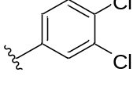 | 0.483 ± 0.102 | >20
5i | 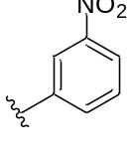 | 0.256 ± 0.043 | >20
5j | 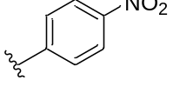 | 0.268 ± 0.061 | >20
5k | 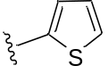 | 0.339 ± 0.097 | >20
5l | 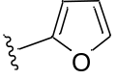 | 0.520 ± 0.050 | >20
5m | 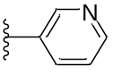 | 0.245 ± 0.067 | 0.285 ± 0.062
Reference compounds | Pentamidine | 0.005 ± 0.001 | -ª
Reference compounds | Bortezomib | -ª | 0.0106 ± 0.0006
ª Activity not determined.

