Supplementary Figures
Supplementary Figure 1: Schematic representation of early failure of induction (EFI) therapy and failure of induction (FI) duration definition.
Abbreviations: EFI: early failure of induction; FI duration: failure of induction duration; HSCT: hematopoietic stem cell transplantation.

Supplementary Figure 2: CONSORT diagram of study flow
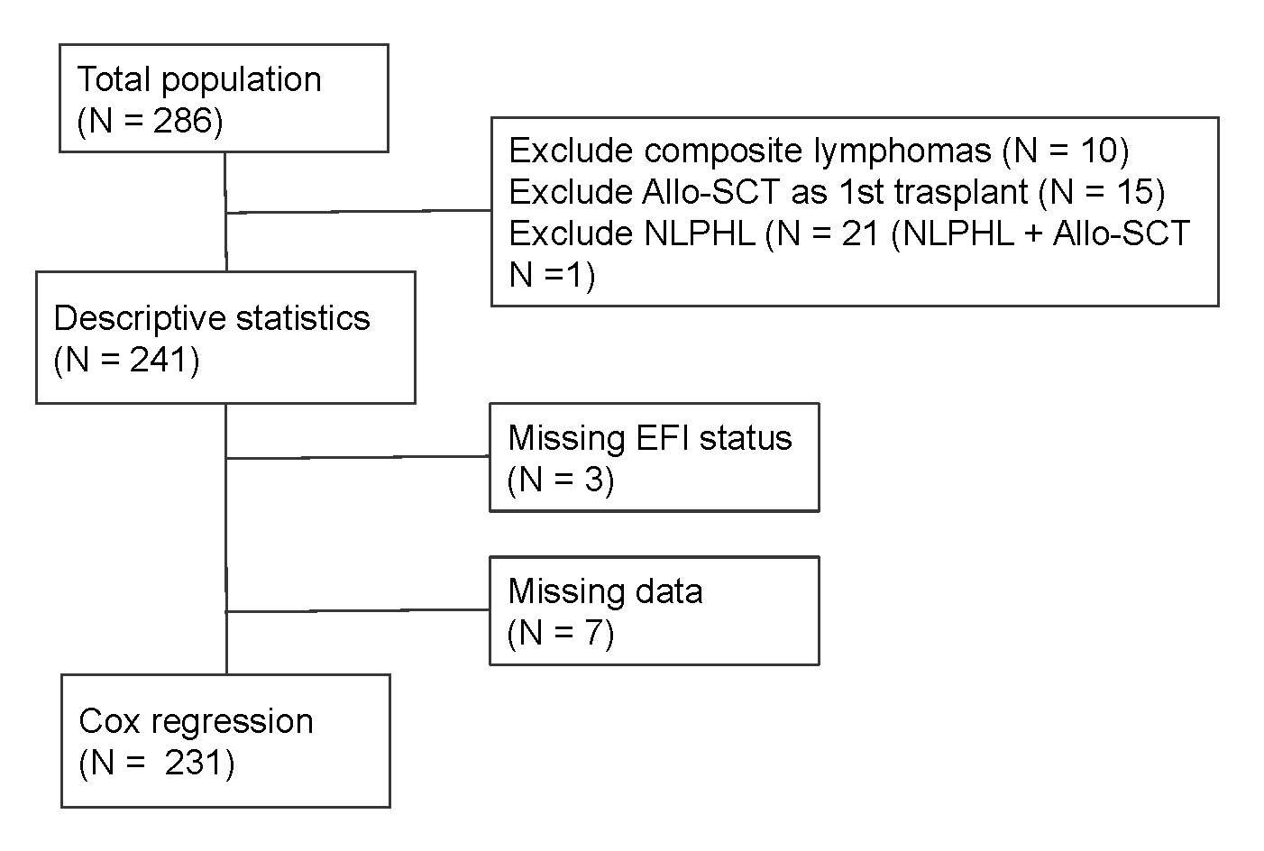

Supplementary Figure 3: Therapy approaches used in second-line settings 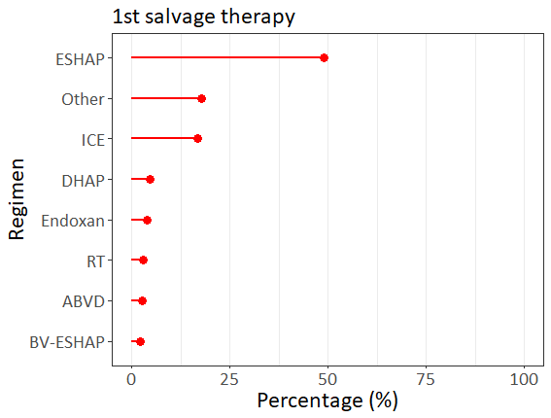

Supplementary Figure 4: Cycles of post-transplantation in patients (n = 35) who received BV consolidation.
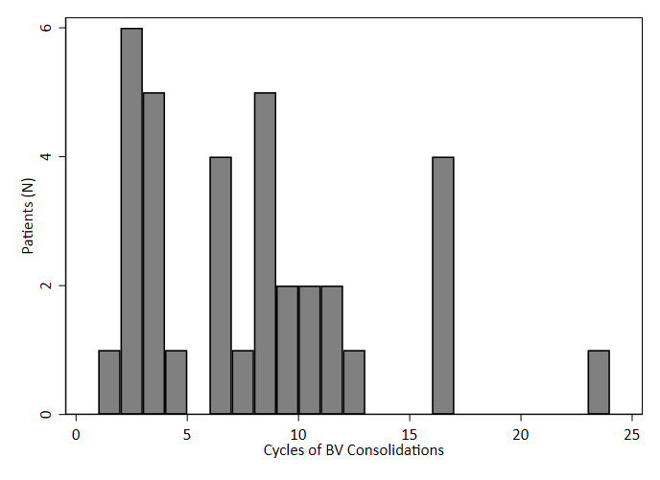

Supplementary Figure 5: Kaplan–Meier estimates of survival in post-transplantation relapse stratified by early failure of induction (EFI) status.

Supplementary Figure 6: Love plot before and after propensity score matching (PSM) and inverse probability treatment weighting (IPTW) among characteristics.

Supplementary Figure 7: Performance comparison of Cox proportional hazards models using linear and restricted cubic splines with varying knots for early failure of induction (EFI).
Abbreviations: Abbreviations: AIC: Akaike information criterion; BIC: Bayesian Information Criterion; C-index: concordance index; RCS: Restricted cubic splines.

Supplementary Table
Supplementary Table 1: Performance comparison of Cox proportional hazards models using linear and restricted cubic splines with varying knots for early failure of induction (EFI)."
Model | AIC | BIC | C-index
Linear | 196.9 | 226.0 | 0.745
RCS with 3 knots | 194.6 | 226.6 | 0.763
RCS with 4 knots | 196.3 | 231.2 | 0.755
RCS with 5 knots | 196.7 | 234.6 | 0.758
Abbreviations: AIC: Akaike information criterion; BIC: Bayesian Information Criterion; C-index: concordance index; RCS: Restricted cubic splines.

