Ultrasound-Assisted Green Synthesis of 1,4-Disubstituted 1,2,3-Triazoles Using Natural Polymer Supports

Khatereh Haseli¹, Maryam Esmkhani¹, Shahrzad Javanshir^{1*}
¹Pharmaceutical and Heterocyclic Compounds Research Laboratory, Department of Chemistry, Iran University of Science and Technology, Tehran, 16846-13114, Iran.

Figure S 1. FTIR spectrum of Shilajit, Cs-Sh, and Cs-Sh@Cu ..................................................................2
Figure S 2. XRD pattern of Cs-Sh@Cu and reused catalyst........................................................................3
Figure S 3. BET analysis of Cs-Sh@Cu......................................................................................................3
Table S 1. Investigation of the prepared CS-Sh@Cu catalyst in different conditions in model reaction…4
Table S 2. Optimization the type of the catalyst…………………………………………………………...4

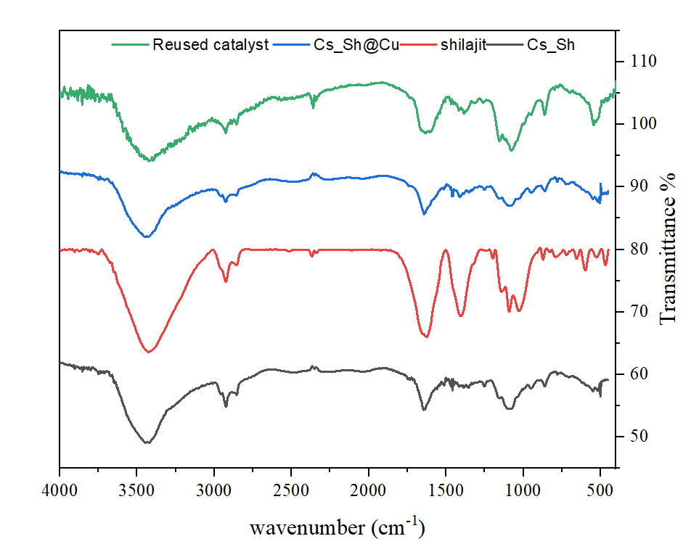
Figure S 1. FTIR spectrum of Shilajit, Cs-Sh, Cs-Sh@Cu, and the reused catalyst.

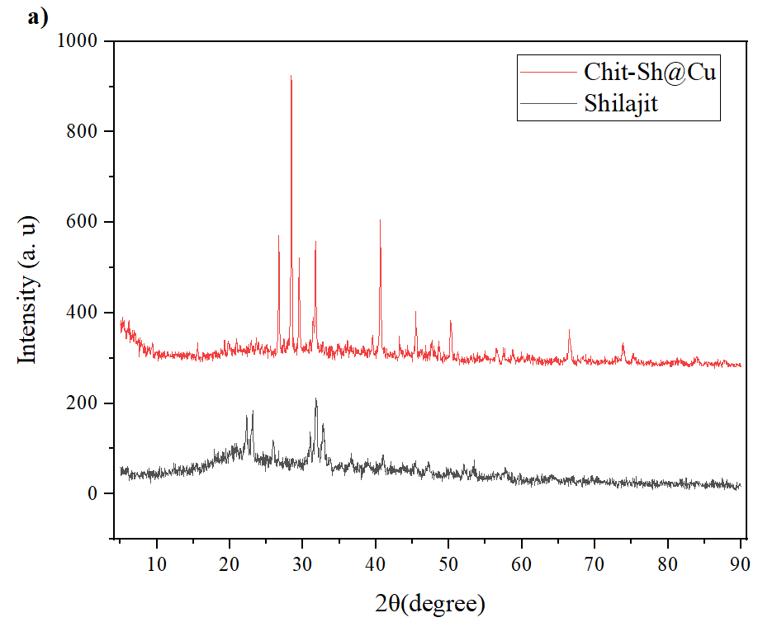
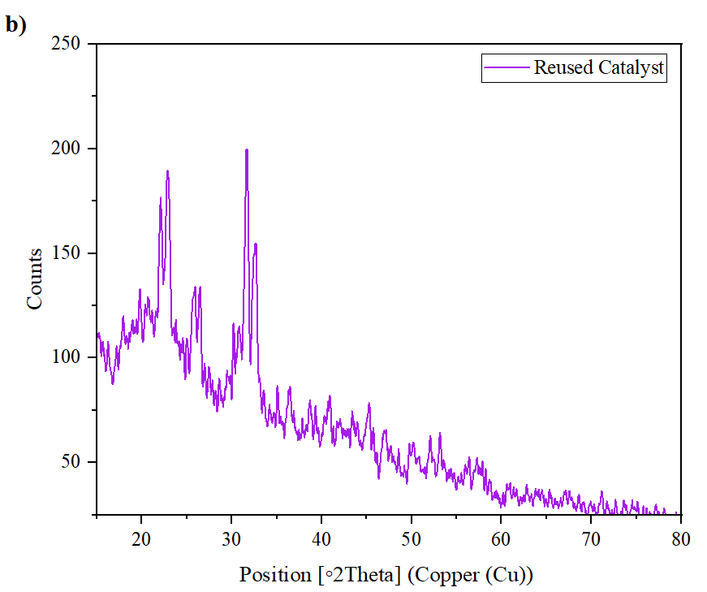
Figure S 2. XRD pattern of a) Cs-Sh@Cu and b) reused Cs-Sh@Cu.

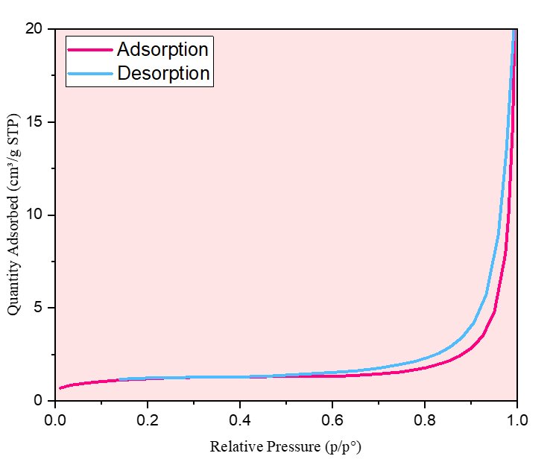
Figure S 3. BET analysis of Cs-Sh@Cu.
Table S 1. Investigation of the prepared CS-Sh@Cu catalyst in different conditions in model reaction.
Time | Yield (%) | Condition | Catalyst (mg) | Solvent
90min | 19 | Reflux | 10 | (1:1)MeOH: H₂O
90min | 15 | Reflux | 10 | Ethanol
90min | 84 | Reflux | 10 | Water
90min | Trace | Reflux | 10 | Toluene
90min | 5 | Reflux | 10 | Acetonitrile
90min | 5 | Reflux | 10 | Chloroform
90min | 16 | Reflux | 10 | (1:1) Ethanol: H₂O
25min | 59 | Sonication, r.t. | 10 | (1:1) Ethanol: H₂O
25min | 50 | Sonication, r.t. | 10 | Ethanol
25min | 93 | Sonication, r.t. | 10 | H₂O
25min | 79 | Sonication, r.t. | 10 | (2:1) Ethanol: H₂O
25min | - | Sonication, r.t. | - | H₂O
25min | 34 | Sonication, r.t. | 5 | H₂O
25min | 93 | Sonication, r.t. | 10 | H₂O
25min | 74 | Sonication, r.t. | 15 | H₂O
25min | 51 | Sonication, r.t. | 20 | H₂O
25min | 29 | Sonication, r.t. | 30 | H₂O

Table S 2. Optimization the type of the catalyst.
Yield | Time (min) | Dosage (mg) | Catalyst
0 | 25 | 10 | Chitosan
≤10 | 25 | 10 | Shilajit
≤10 | 25 | 10 | Cs-Sh
93 | 25 | 10 | Cs-Sh@Cu

