Interventional Package for Postpartum Family Planning PPFP in Nepal

Maternal mortality remains high in Nepal, with 259/100000 live births in 2016, according to the Nepal Demography and Health Survey NDHS. Nepal has made considerable progress in improving access to and utilization of family planning services. The Government of Nepal had endorsed the National Family Planning Costed Implementation Plan (CIP) 2015-2020. The postpartum period, within 12 months following childbirth, presents a well-timed opportunity to reach women with an acceptable and effective family planning method. This ultimately leads to the likelihood of healthy timing and spacing of pregnancy, thereby reducing the possibility of unintended pregnancy. However, postpartum family planning is one such gap where Nepal has a high unmet need during this period.

The objective of this interventional package
This package of interventions is based on WHO standards and can be implemented in postpartum family planning to address unmet needs, enhance child spacing, and limit pregnancy.

Components
- Family planning services are integrated with preventive and curative sexual and reproductive health care.
- Education and counseling for informed contraception decision-making.
- Referral and access to contraceptive supplies
- Family planning within integrated primary healthcare

Benefits and potential impact
Empower women and families and promote gender equity
Family planning has the potential to reduce 32% of maternal deaths and 10% of newborn deaths. Infant and child deaths.
Family planning has the potential to decrease 71% of unwanted pregnancies.
Slowing population growth contributes significantly to reducing poverty and hunger, ultimately helping to achieve the Sustainable Development Goals (SDGs).

Routine care and interventional package
Routine care
Family planning services are regularly provided in government health facilities. Female community health volunteers FCHVs are giving information about family planning and distributing condoms and resupplying with pills.

Interventional package
- Provider behavior change communication refresher training, PBCC-RT
The objective of PBCC-RT is to enhance the knowledge and competencies of service providers in PPFP.
The focus will be on the quality and effectiveness of counselling. Refresher training includes integrations and exchange of experiences, challenges faced, role-plays with PPFP counselling tools, and clinical practice.

- PPFP counselling tool
- Definition of family planning and contraception
Contraception is the act of intentional prevention of pregnancy by intentionally preventing pregnancy by artificial or natural means (Bansode et al., 2022).

Family planning allows individuals and couples to anticipate and achieve their desired spacing and timing of their births. It is achieved through the use of contraceptive methods and the treatment of involuntary infertility(WHO Contraception, n.d.).

- Describe the risks of pregnancy and delivery among women with short spacing and various characteristics.
In South Asia, about 66,000 maternal deaths occur, and 1 in 210 has a lifetime risk of maternal death.
Over 303,000 women per year die in pregnancy or childbirth.
Forty-seven thousand women per year die from complications of unsafe abortion.
Complications of pregnancy and childbirth are a leading cause of death in young women.

Women who are at an increased risk of having problems during pregnancy and delivery are:
- Under the age of 18, or over the age of 35
- Become pregnant less than 2 years after a previous live birth
- Become pregnant less than 6 months post-abortion or post-marriage
- Have high parity (many children)
- Have certain existing health problems
- Do not have access to a skilled healthcare center

Pregnancy is a greater risk for adolescents
- Over 70,000 maternal deaths occur among adolescents aged 15-19 each year.
- Girls below the age of 15 are 5 times more likely to die in childbirth than women in their twenties.
- Adolescents are more likely to
- Have pregnancy-related complications
- Deliver prematurely
- Have babies that die before their first birthday

Pregnant is at greater risk for complications with pregnancies are spaced too closely
- Women who become pregnant less than 2 years after a previous live birth are more likely to:
- Become sick or die from pregnancy and delivery complications
- Have babies at risk of prematurity, low birth weight, small size for gestational age, fetal and neonatal death
- Women who become pregnant less than 6 months postpartum or experience a miscarriage may be at increased risk of complications for mother and child.

Pregnancy is a greater risk for women over the age of 35
- At least twice as likely to die in pregnancy or childbirth as women aged 20-24
- More likely to have problems during pregnancy, such as miscarriage, hypertension, or diabetes
- More likely to give birth to small babies, babies with disability, or stillbirth

Pregnant is at greater risk of complications of high parity
- Women with more than four children who have an additional pregnancy are more likely to:
- Die during pregnancy or childbirth
- Have anemia, experience blood loss (postpartum hemorrhage)
- Develop complications such as uterine relaxation (during and after delivery) and uterine rupture

Pregnancy poses a greater risk for women with specific existing health problems
- Health risks associated with pregnancy make effective contraception especially important for women with these conditions:
- Reproductive tract cancers and infections
- Serious cardiovascular disease
- Diabetes with vascular complications
- Sickle cell anemia
- Serious liver conditions
- Infections such as TB and HIV

- Describe how FP improves the lives of women, children, families, and communities.
List the benefits of FP for all women, for children, for families, and communities.
Benefits for all women
- Lower risk of maternal deaths
- Lower risk of anemia, poor pregnancy outcomes, and complications related to unsafe abortion
- Improved educational and economic activities
Non-contraceptive benefits from some methods like protection from:
- Disease transmission/ acquisition
- Certain cancers and other gynecological problems

Benefits of FP for children
- Longer breastfeeding
- Provides nutrition
- Protects from childhood diseases
- Improves mother/child bonding
- Reduces child illness and death
- Allows more time and resources for parents to meet the needs of each child

Benefits of FP for families and communities
- Families can devote more resources to providing for each child
- Reduced maternal and child illness reduces economic strain on the family
- Reduced maternal deaths strengthen families and communities
- Relieves economic, social, and environmental pressures
- Enhances women`s status and promotes equality between men and women

Key message for participants
Women and infants may get sick or die if pregnancy occurs:
- Too early among adolescents (delay first pregnancy until 20 years
- Too soon after giving birth (wait at least 24 months before trying to become pregnant
- Too soon after an abortion or miscarriage (delay trying to become pregnant for at least 6 months)
- Too late in a woman`s life (plan before age 35)
- After having 4 children (risk increases with each pregnancy)

- List the types, effectiveness, side effects, and complications that may arise from all FP methods.

For counselling about family planning, WHO`s FP Counseling Handout #1: Counseling Tool for Family Planning will be used by family planning providers.
https://www.fptraining.org/training/8/downloads#

STEP 1: Assess client`s needs and concerns
During this session…
- We will listen to each other.
- Ask questions about anything, anytime.
- If I do not know the answer, I will find it for you
- Everything you say is private
- We will use this bool to guide our discussion

Tell me about you and your family
How many children do you have?
How old are your children?
Are you interested in family planning?

There are many methods of family planning; you can choose one that is right for you.
Do you have any questions?

STEP 2: Provide information to address the client`s identified needs or concerns
Keep this in your mind as you decide….
Mothers and babies are healthier if women and girls:
- Wait until they are 18 to get pregnant
- Wait at least 2 years after a birth before trying to get pregnant
- Wait 6 months after a miscarriage or abortion to get pregnant
- Have their children before age 35

Family planning benefits everyone
Benefits to the baby:
- Born healthy and strong and protected from childhood diseases
- Breastfeeds for a longer period, and provides enough nutrition, and grows well
Benefits to the mother:
- Regains er strength
- More time for the baby and to care for the family
Family benefits:
- More resources for food, clothing, housing, and education

STEP 3: Help the client make an informed decision about FP
Tell me about you and your family…
How many children do you have?
How old are your children?
Are you interested in family planning?
There are many methods of family planning; you can choose one that is right for you.

Do you have any questions?

Modern methods
- Permanent contraception-vasectomy and tubal ligation
- Hormonal contraception pill or the Depo Provera injection
- Barrier methods-condoms
- Emergency contraception
- Long-acting reversible contraception implant and intra-uterine device (IUD)/IUCD/Cooper-T
- Lactation Amenorrhea Method (LAM)

Traditional methods
- Standard days method
- Rhythm methods

Lactation amenorrhea method (LAM)-for breastfeeding mothers
The main 3 criteria for LAM:
- Exclusively breastfeeding for 6 months
- The baby is within 6 months old
- No return of menses

Use condoms to prevent sexually transmitted infections

LAM is applicable if it fulfills these 3 criteria strictly:
Exclusive breastfeeding for 6 months

- Do you wish to have children in the future?

If YES, remove tubal ligation and vasectomy from your method choices.
If NO, these are possible choices.

- Are you breastfeeding an infant less than 6 months old?
If YES, remove the Pill (Combined Oral Contraceptive Pill, COCs) from your choices.
If the client is not fully breastfeeding or her monthly bleeding has returned, also remove Lactation Amenorrhea Method (LAM).
If NO, remove LAM from your choice.
- Do you have the cooperation of your partner in family planning?
If NO, remove condoms from your choices.
- Are there any methods that you do not want to use or have not tolerated in the past?
If so, could you please explain why? What had happened?

- If used correctly, condoms do not break or come off in the woman’s body.
- Pills, implants, and injectables:
  - Do not cause infertility; you can have babies after stopping.
  - Do not cause deformed babies if accidentally given to a pregnant woman.
  - Do not cause an abortion.
  - It can be used by women who have never been pregnant.
- IUDs do not move to other parts of the body. It does not cause discomfort during sex. It can be removed at any time you want.
- The womb is not removed during a tubal ligation. It does not cause any illness.
- Testicles are not removed during a vasectomy. It does not cause illness or weakness. It does not decrease sex drive, erection, ejaculation, or sexual performance.

Remember that contraceptive methods do not cause cancer. All methods are safe.

But you should know about all these questions before you choose the FP methods:
- Are there side effects?
- Is it easy to use?
- How soon can I get pregnant after I stop?
- Can I get it now?
- How long will it last?
- Does it prevent STIs and HIV?
- How effective is the method?
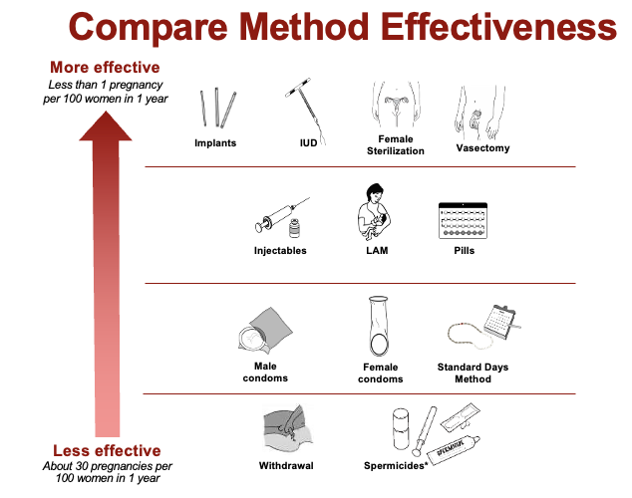

Lactational Amenorrhea Method (LAM) (for breastfeeding mothers only)
- Breastfeeding only, day and night, to prevent pregnancy
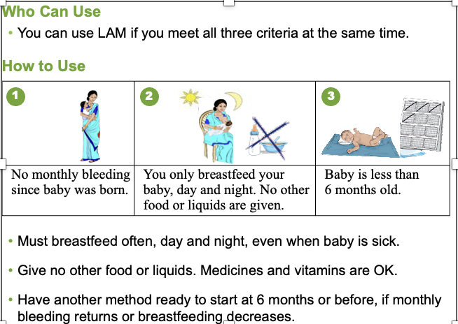
- Very effective for 6 months if breastfeeding exclusively and monthly bleeding has not returned
- Do not use bottles, pacifiers, or other artificial nipples; these discourage your baby from breastfeeding as frequently.
- Use with condoms to prevent sexually transmitted infections

Standard Days Methods (Cycle Beads)
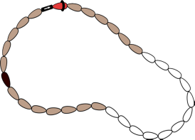
- Natural method with no side effects
- Helps you know what days during the month you can get pregnant
- Prevent pregnancy by using condoms or not having sex on days you can get pregnant
- Also, use condoms to prevent sexually transmitted infections
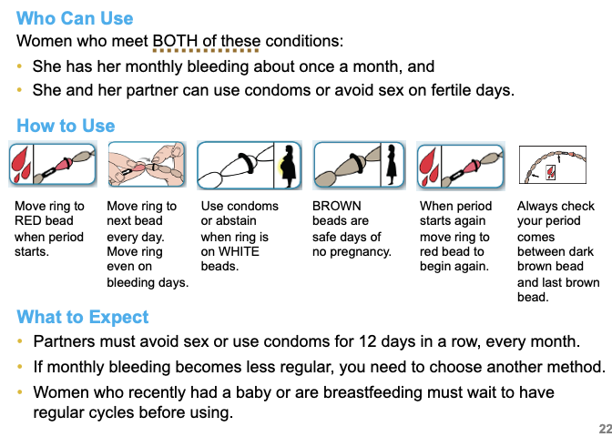

Male Condoms
- A thin rubber cover that fits over the erect penis
- Prevents pregnancy and sexually transmitted infections, including HIV/AIDS
- Effective when used correctly, every time you have sex
- Use alone or with another method
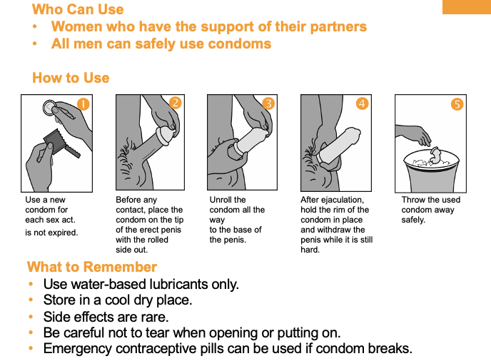
- Can be used by any couple who agrees to use it

The Pill
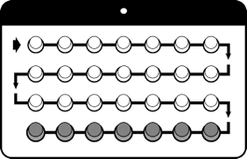
- A pill taken every day to prevent pregnancy
- Prevents eggs from leaving the ovaries
- After you stop taking it, you can have babies
- Use with condoms to prevent sexually transmitted infections

Who can use
Most women can safely use pills.
Women who are breastfeeding should not use
How to use
Take one pill at the same time each day
If you miss 1 or 2 active pills in a row or start a pack 1 or 2 days late, take a pill as soon as you remember. If you miss inactive pills, throw them away.
If you miss 3 or more active pills in a row, or start a pack 3 or more days late:
- Take a pill as soon as possible, continue taking 1 pill each day, and use condoms or avoid sex for the next 7 days.
- If you miss these pills in week 3. ALSO, skip the inactive pills and start a new pack.
Go to the clinic if you have sharp pain in your leg or abdomen, severe chest pain, or severe headache with vision problems.
Return if questions or concerns, and for resupply of pills.
Some women have:
Nausea: Take the pill with food
Headache and dizziness: take the pill at night and take NSAIDS
Irregular spotting: take the pill at the same time every day, and take NSAIDS
Breast tenderness or mood changes.

Injectables
Given by injection every 13 weeks
Prevents eggs from leaving the ovaries
It may take more time to become pregnant after stopping
Use with condoms to prevent sexually transmitted infections

Who can use
Most women can safely use injectables
Women with certain conditions should not use injectables. Use a screening checklist to find out.
How to use
Get an injection every 13 weeks
Do not massage the injection site
Go to the clinic if you have a severe headache with vision problems, yellow skin or eyes, or unusually heavy or long bleeding.
Return on time for injection. It can be 2 weeks early or 4 weeks late. Come back even if late, or if you have questions or concerns.
Some women have
Bleeding pattern or changes such as prolonged or heavy bleeding, irregular bleeding or spotting, or no bleeding at all.
Headaches and dizziness
Abdominal bloating and discomfort
Changes in mood and sex drive
Weight gain

Implants
Small plastic capsules or rods placed under the skin of the inside upper arm ( 1 or 2 capsules or rods, depending on type)
Last 3 to 5 years
Use with condoms to prevent sexually transmitted infections

Who can use
Most women can safely use implants
Women with certain conditions should not use implants. Refer interested clients to a clinician.
How does it work
Prevent eggs from leaving the ovaries and thicken cervical mucus.
It can be removed at any time if you want to get pregnant.
What to expect
Start any day of the menstrual cycle, if not pregnant.
Insertion and removal are quick, easy, and painless.
The provider bandages the opening stitches.
The most common side effects are a change in bleeding pattern.
Return to the clinic any time you have questions, problems, or want the implant removed or replaced.

Intrauterine device (IUD)
Small, plastic “T” wrapped in copper wire placed in the womb
Stops sperm from reaching an egg
Can be used up to 12 years
Must be inserted and removed by a trained nurse or doctor
Use with condoms to prevent sexually transmitted infections

Who can use
Safe for all healthy women
It can be put in right after giving birth, as well as at other times.
How does it work
Prevents sperm from meeting the egg.
It can be removed at any time if you want to get pregnant.
What to expect
Start any day of the menstrual cycle, if not pregnant
It may be uncomfortable during insertion
May have cramps or menstrual spotting for a few weeks after.

Female Sterilization
Permanent method for women and couples who do not want more children
Women`s tubes that carry eggs to the womb are cut or blocked
Simple surgery that must be performed by a trained doctor
Use condoms to prevent sexually transmitted infections.

Who can use
Women who do not want any more children
Can be done right after you have a baby, as well as at other times
How does it work
Tubes that carry eggs to the womb are cut. This prevents sperm and egg from meeting.
What to expect
A local painkiller is given
Can go home after a few hours.
May have soreness for a day after the procedure.
Monthly bleeding will continue as usual.
No side effects.

Vasectomy
Permanent method for men or couples who do not want more children.
Tubes that carry sperm to the egg are cut
Simple surgery that must be performed by a trained doctor
Use condoms to prevent sexually transmitted infections

Who can use
Men who do not want any more children,
How it works
Tubes that carry sperm are cut. This keeps sperm out of semen.
Testicles are not removed.
What to expect
A local painkiller is given.
Does not decrease sex drive, erection, ejaculation, or sexual performance.
Must use the backup method for the first 3 months.
No side effects.

Emergency contraception ECPs
Pills taken to prevent pregnancy soon after unprotected sex or failure of other methods (up to 3 days)
It is not a replacement for regular methods

ECPs: Do not cause an abortion and will not prevent pregnancy the next time you have sex.

How to use ECPs
Take the first pill as soon as possible; take the second pill 12 hours later.
Take up to 3 days after unprotected sex; most effective when used early.
May cause nausea and vomiting and vaginal spotting or bleeding for few days.
The next period may come a few days earlier or later.
Use with condoms to prevent STIs or HIV/AIDS.

Come back anytime you have concerns or questions.

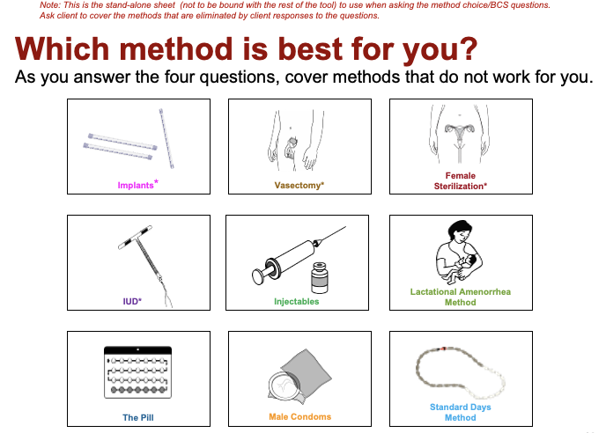

Counselling on Lactation Amenorrhea Method LAM)

Return of fertility and risk of pregnancy
In women not breastfeeding, ovulation will occur at 45 days postpartum on average, but may occur as early as 21 days.
Breastfeeding women not practicing LAM are likely to ovulate before the return of menses.
Between 5% and 10% of women conceive within the first year postpartum.

Key counselling topic for LAM users
Screen for/educate about LAM criteria
- 3 criteria and why each is important
- Any conditions that exclude the use of LAM
Discuss the effectiveness of LAM
Select another modern method to transition from LAM
Encourage spacing of pregnancies by using another method of family planning for at least 2 years
Discuss optimal breastfeeding practices
Ensure that the client knows to return if she has a problem.

Transition to another method: an essential component of LAM
LAM can be a bridge to other modern methods of contraception
LAM provides the couple time to decide on another modern method to use after LAM.

Transition to another method
When LAM counselling is initiated, the provider should discuss transition from LAM to another contraceptive method with the client:
- Another method should be started as soon as any one of the 3 LAM criteria is not met.
- Transition method should be selected before this occurs.

Where can LAM counselling be provided
- Antenatal clinic
- Postpartum ward
- Family planning clinic
- Child immunization day
- Labor ward (during early labor or following birth)
- Community health visits or home visits

Health Benefits of Breastfeeding

Mother

-Stimulates uterine contraction in the early postpartum period
-Promotes involution (return of uterus to pre-pregnancy state)
-Leads to less anemia because of less iron depletion (due to amenorrhea)
-Strengthens mother-baby bonding
Baby
-Adapts to the needs of a growing infant
-Promotes optimal brain development
-Provides passive immunity and protects from infections
-Provides some protection against allergies

Limitations of LAM
Offers only temporary contraceptive protection (up to 6 months)
It is not usually appropriate if the mother will be separated from the baby for periods
HIV-positive mothers may worry about HIV transmission through breastfeeding

Correcting rumors and misunderstandings
Many misconceptions about LAM need to be addressed, including:
- LAM is not effective
- Women who work away from home cannot use LAM
- Women with HIV cannot use LAM
- Concerns that if used for 6 months, the women will run out of milk
- Fat/thin women cannot use LAM
- Special foods are needed by women
- Babies need more than just breastmilk in their first 6 months.

Optimal breastfeeding practices
Allow the newborn to breastfeed as soon as possible after birth, and to remain with the mother after birth
Breastfeed as often as the baby wants, for as long as he/she wants, day and night
Continue breastfeeding even if the mother or infant becomes ill
Do not give baby any foods or other liquids for the first 6 months
Do not use bottles, pacifiers, or other artificial nipples.
Offer the second breast after the infant releases the first
Eat and drink more than usual
Continue to breastfeed for the first 2 years, providing complementary foods beginning at six months of age.

Remember: breastfeeding mothers often need family or social support

LAM and HIV
Every woman should be supported in her infant-feeding decision and in her contraceptive choice.
Breastfeeding will not make HIV worse.

LAM-Summary
Over 90% effective if all 3 criteria are met:
-No menses
-Breastfeeding only
-Baby less than 6 months
Can be a bridge to other modern methods of family planning
Provides important health benefits to the mother and child
Natural and no side effects

- Discuss FP in the context of human rights
All individuals and couples have the right: “to decide freely and responsibly the number, spacing, and timing of their children and to have the information, education, and means to do so, and the right to attain the highest standard of sexual and reproductive health”. -ICPD Program of Action

- Explain how FP contributes to the Sustainable Development Goals.

- Home visit by FP trained health personnel  Interventions at home/community level | Commodities needed
Health education to women, their husband and mother-in-law:  - To increase awareness on benefits of family planning and birth spacing starting from pregnancy period and postpartum, within 6 months after child births.  - Counselling about the contraceptive methods and informed choice about family planning  - Family planning and human rights | Job aids  Counselling, health education and promotion materials
- Referral for family planning to healthcare facility by FCHVs | PPFP flyers
Female community health volunteers do home visit every month. FCHVs will distribute flyers about PPFP and will refer the eligible women willing to adopt family planning to nearby healthcare facility for further counselling and service. | PPFP flyers
- Intervention at Healthcare facility | Decision making aids for clients  Full range of contraceptive methods available in healthcare facility  Appropriate surgical theatre and equipment available in district hospital
All the above plus:
- Counselling and provision of full range of family planning methods
- Counselling on STIs and HIV/AIDS protection
- Screening for breast self-examination
- Management or referral of the problems
Interventions at referral facility (district hospital)
All the above plus:
- Treatment of medication conditions, side effects and complications
- Management of methods of choices if not provided at healthcare facility (sterilization, removal of implants, difficult removal of devices)

Indicators
Contraceptive prevalence rate
Unmet need for family planning
Reduce unintended pregnancy

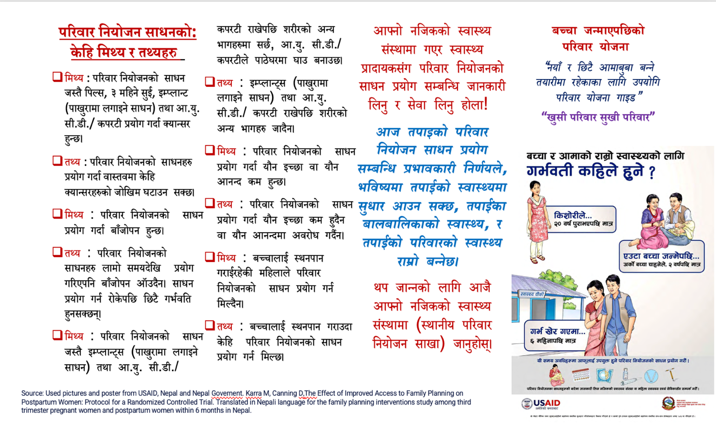

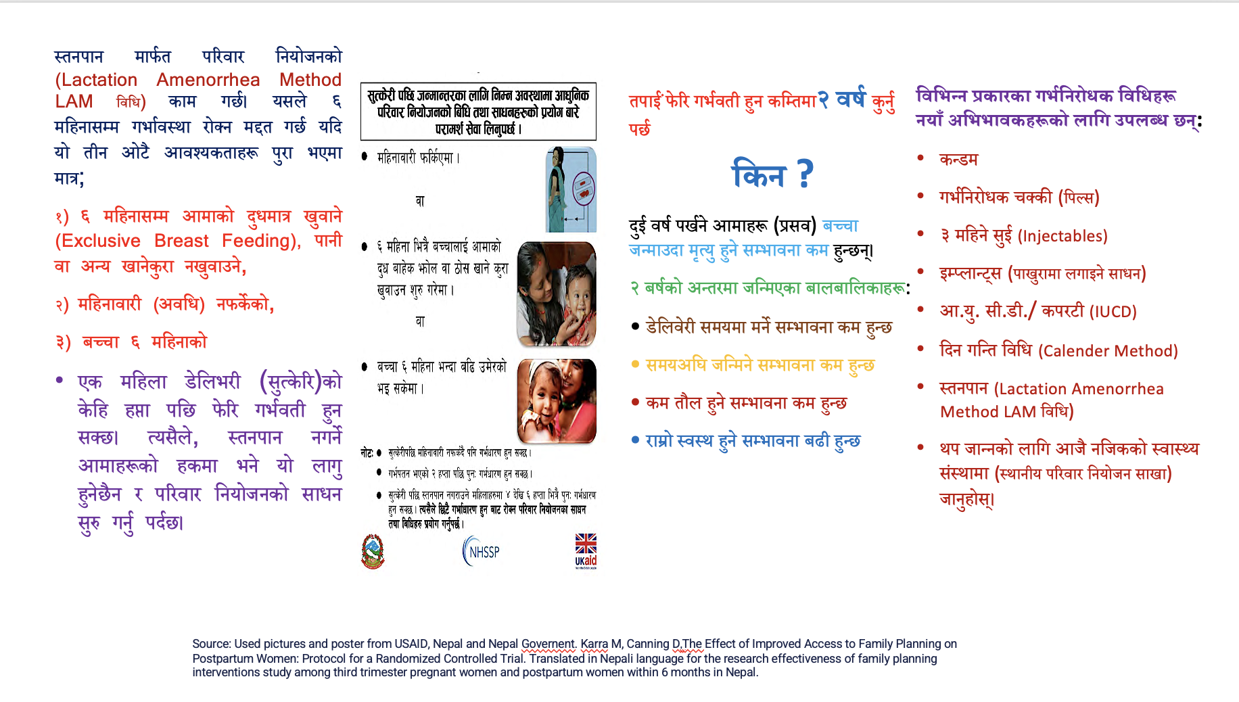

References:

Bansode, O. M., Sarao, M. S., & Cooper, D. B. (2022). Contraception. In StatPearls. StatPearls Publishing. http://www.ncbi.nlm.nih.gov/books/NBK536949/
Contraception. (n.d.). Retrieved 9 September 2022, from https://www.who.int/health-topics/contraception

