APPENDIX
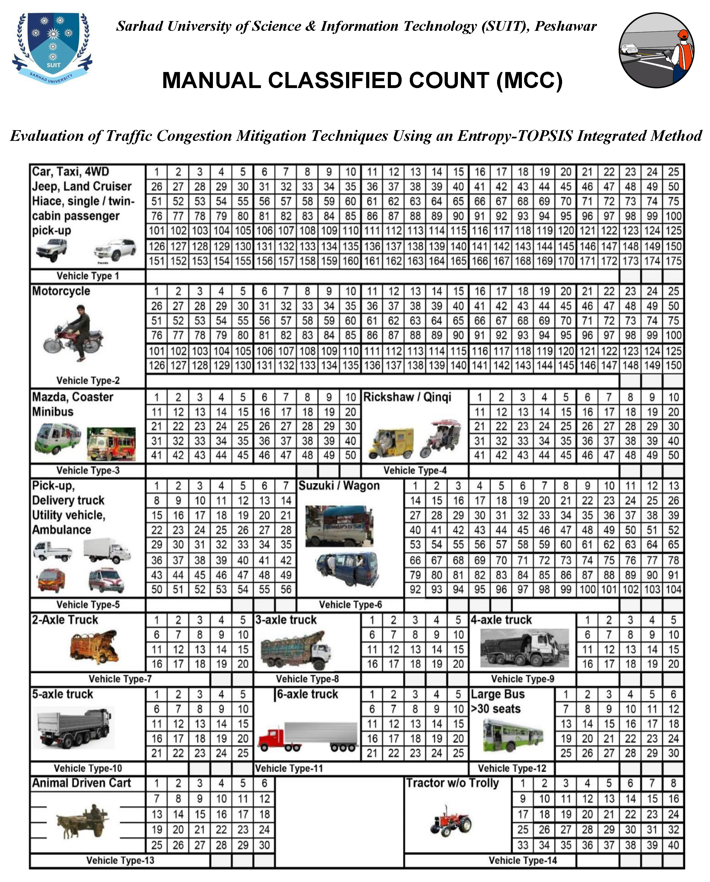
Figure 9: Performa used for Volume Study
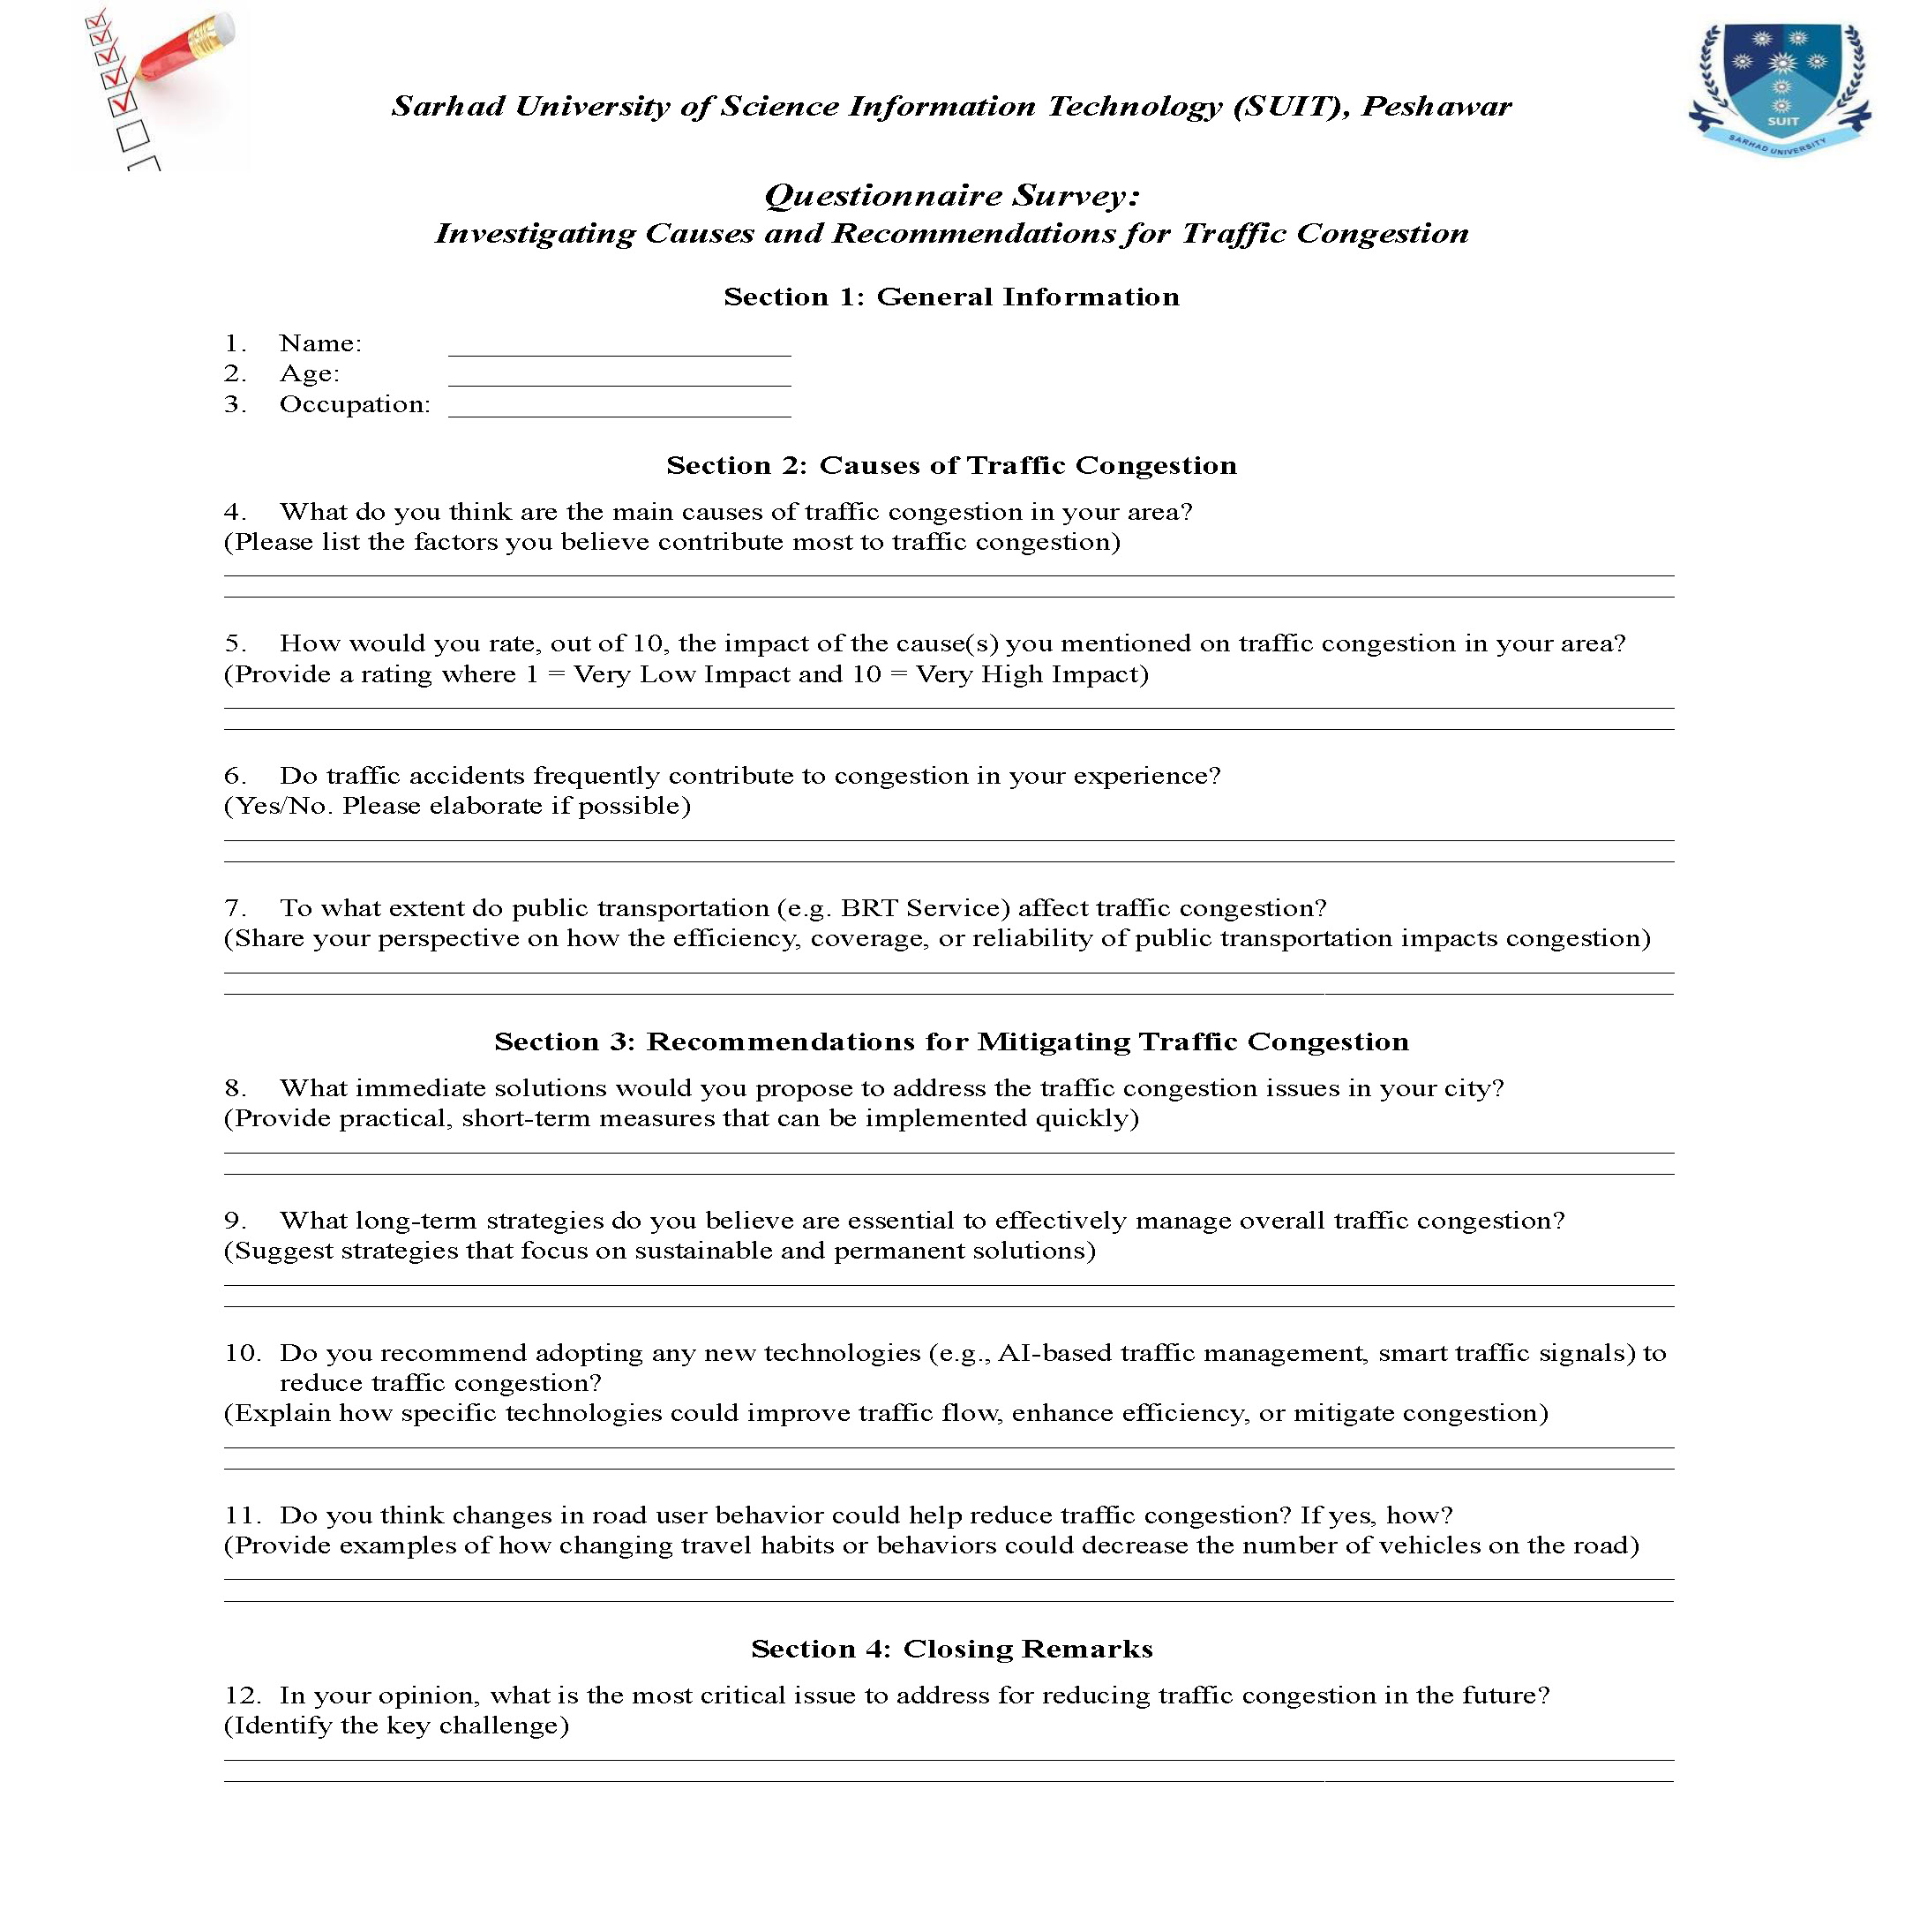
Figure 10: Questionnaire Form used for Survey on identifying Traffic Congestion causes and solutions

