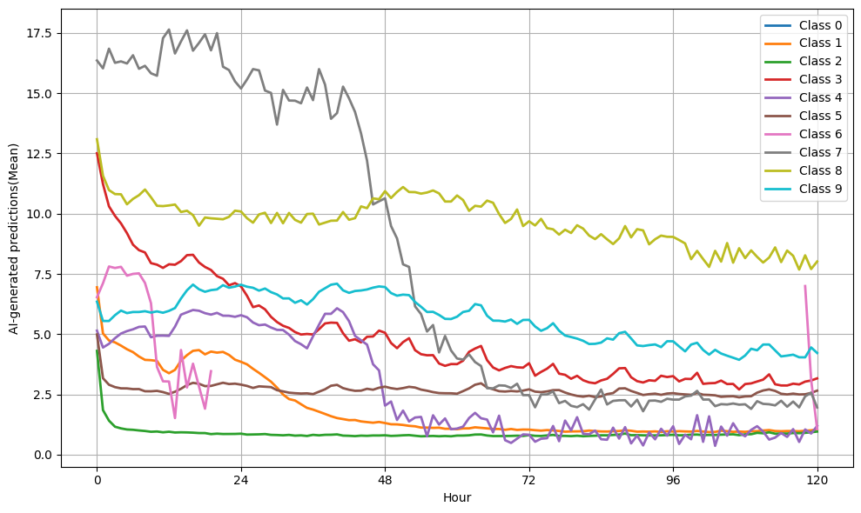
Supplementary Figure 1. Clustering pattern in cardiopulmonary resuscitation events

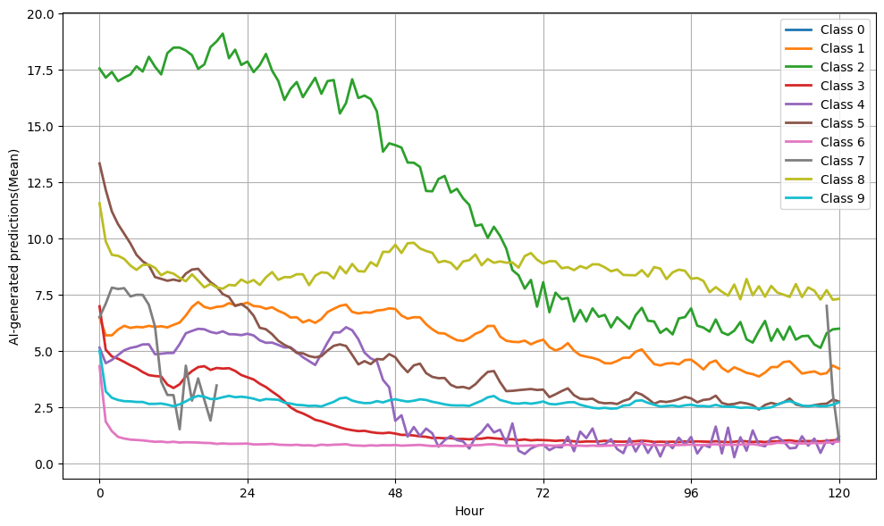
Supplementary Figure 2. Clustering pattern in unexpected death events
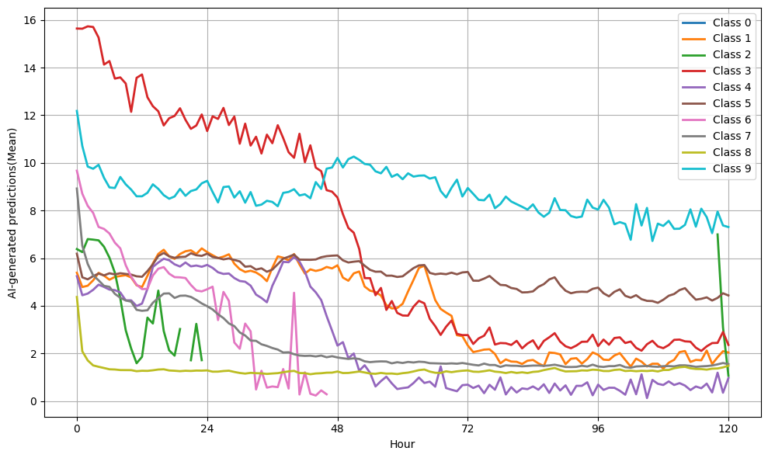
Supplementary Figure 3. Clustering pattern in unanticipated transfers to the intensive care unit (ICU) events
Supplementary Table 1. Performance results according to decision-making approaches for each outcome.
Outcome | Class | AUROC | AUPRC | Recall | Specificity | Precision | NPV | F₁ score
Composite | A.I. | 74.54 | 6.21 | 10.72 | 99.51 | 53.59 | 95.49 | 17.86
Composite | (5) | 74.99 | 4.45 | 7.56 | 99.67 | 54.64 | 95.35 | 13.28
Composite | (5,6) | 69.73 | 7.29 | 14.52 | 99.02 | 43.80 | 95.66 | 21.81
Composite | (2,5,6) | 66.93 | 14.53 | 31.73 | 97.21 | 37.43 | 96.44 | 34.35
Composite | (2,5,6,8) | 62.74 | 22.45 | 54.99 | 92.55 | 27.96 | 97.51 | 37.07
Composite | A.I. or (5) | 71.91 | 7.30 | 13.63 | 99.23 | 48.19 | 95.62 | 21.25
Composite | A.I. or (5,6) | 69.06 | 7.61 | 15.46 | 98.90 | 42.42 | 95.70 | 22.67
Composite | A.I. or (2,5,6) | 66.70 | 14.75 | 32.44 | 97.09 | 36.93 | 96.47 | 34.54
Composite | A.I. or (2,5,6,8) | 62.74 | 22.45 | 54.99 | 92.55 | 27.96 | 97.51 | 37.07
CPR | A.I. | 52.25 | 2.35 | 17.78 | 98.50 | 4.86 | 99.64 | 7.64
CPR | (7) | 53.95 | 1.36 | 10.45 | 99.50 | 8.29 | 99.61 | 9.24
CPR | (7,8) | 52.45 | 2.58 | 19.86 | 98.46 | 5.25 | 99.65 | 8.30
CPR | (3,7,8) | 51.18 | 5.50 | 30.06 | 95.28 | 2.67 | 99.69 | 4.90
CPR | (3,7,8,9) | 50.46 | 13.89 | 38.92 | 86.53 | 1.23 | 99.70 | 2.38
CPR | A.I. or (7) | 50.36 | 10.01 | 24.64 | 90.21 | 1.07 | 99.64 | 2.05
CPR | A.I. or (7,8) | 52.03 | 3.07 | 22.41 | 97.91 | 4.41 | 99.66 | 7.37
CPR | A.I. or (3,7,8) | 51.14 | 5.70 | 30.54 | 95.08 | 2.60 | 99.69 | 4.79
CPR | A.I. or (3,7,8,9) | 50.46 | 13.92 | 39.00 | 86.50 | 1.23 | 99.70 | 2.38
DEATH | A.I. | 66.94 | 11.76 | 30.43 | 98.93 | 35.20 | 98.68 | 32.64
DEATH | (2) | 74.80 | 8.61 | 16.25 | 99.70 | 51.18 | 98.42 | 24.67
DEATH | (2,8) | 65.87 | 11.98 | 32.54 | 98.74 | 33.02 | 98.71 | 32.78
DEATH | (2,5,8) | 58.50 | 11.49 | 43.25 | 96.27 | 18.11 | 98.89 | 25.53
DEATH | (2,5,6,8) | 54.90 | 13.49 | 51.37 | 91.91 | 10.80 | 99.00 | 17.85
DEATH | A.I. or (2) | 66.74 | 12.00 | 31.32 | 98.88 | 34.79 | 98.69 | 32.97
DEATH | A.I. or (2,8) | 63.49 | 12.07 | 36.61 | 98.22 | 28.20 | 98.78 | 31.86
DEATH | A.I. or (2,5,8) | 58.38 | 11.77 | 44.49 | 96.10 | 17.86 | 98.91 | 25.48
DEATH | A.I. or (2,5,6,8) | 54.92 | 13.80 | 52.61 | 91.73 | 10.82 | 99.02 | 17.95
ICU | A.I. | 60.06 | 2.32 | 6.53 | 99.19 | 23.59 | 96.53 | 10.23
ICU | (6) | 66.94 | 11.04 | 25.67 | 98.31 | 36.68 | 97.20 | 30.20
ICU | (3,6) | 65.21 | 12.47 | 30.80 | 97.62 | 33.05 | 97.37 | 31.88
ICU | (2,3,6) | 61.90 | 22.85 | 63.26 | 92.87 | 25.28 | 98.52 | 36.12
ICU | (2,3,6,9) | 60.75 | 23.01 | 65.25 | 91.64 | 22.92 | 98.58 | 33.93
ICU | A.I. or (6) | 64.52 | 12.00 | 30.31 | 97.51 | 31.70 | 97.35 | 30.98
ICU | A.I. or (3,6) | 63.73 | 12.36 | 32.03 | 97.16 | 30.06 | 97.40 | 31.01
ICU | A.I. or (2,3,6) | 61.51 | 23.08 | 64.47 | 92.41 | 24.46 | 98.56 | 35.46
ICU | A.I. or (2,5,6,9) | 60.74 | 23.19 | 65.78 | 91.55 | 22.88 | 98.60 | 33.96

Supplementary Table 3. Performance results by AI solution thresholds for composite events.
Method | AUROC | AUPRC | Recall | Specificity | Precision | NPV | F₁ score
A.I. or (2,5,6) | 66.70 | 14.75 | 32.44 | 97.09 | 36.93 | 96.47 | 34.54
A.I. threshold (34) | 74.54 | 6.21 | 10.72 | 99.51 | 53.59 | 95.49 | 17.86
A.I. threshold (20) | 66.03 | 9.00 | 20.00 | 98.14 | 36.18 | 95.89 | 25.76
A.I. threshold (15) | 60.41 | 11.07 | 27.74 | 95.54 | 24.64 | 96.17 | 26.01
A.I. threshold (10) | 55.63 | 18.71 | 42.72 | 86.88 | 14.62 | 96.65 | 21.79

Supplementary Table 3. Alarm results according to decision-making approaches for each outcome.
Outcome | Class | Total alarm(n, %) | Appropriate alarm(n, %) | False alarm(n, %)
Composite | A.I. | 2,928(1.00) | 1,569(53.59) | 1,359(46.41)
 | (5) | 2,026(0.69) | 1,107(54.64) | 919(45.36)
 | (5,6) | 4,854(1.66) | 2,126(43.80) | 2,728(56.20)
 | (2,5,6) | 12,414(4.24) | 4,646(37.43) | 7,768(62.57)
 | (2,5,6,8) | 28,786(9.83) | 8,050(27.96) | 20,736(72.04)
 | A.I. or (5) | 4,142(1.41) | 1,996(48.19) | 2,146(51.81)
 | A.I. or (5,6) | 5,337(1.82) | 2,264(42.42) | 3,073(57.58)
 | A.I. or (2,5,6) | 12,858(4.39) | 4,749(36.93) | 8,109(63.07)
 | A.I. or (2,5,6,8) | 28,786(9.83) | 8,050(27.96) | 20,736(72.04)
CPR | A.I. | 4,585(1.56) | 223(4.86) | 4,362(95.14)
 | (7) | 1,581(0.54) | 131(8.29) | 1,450(91.71)
 | (7,8) | 4,744(1.62) | 249(5.25) | 4,495(94.75)
 | (3,7,8) | 14,145(4.83) | 377(2.67) | 13,768(97.33)
 | (3,7,8,9) | 39,797(13.58) | 488(1.23) | 39,309(98.77)
 | A.I. or (7) | 4,935(1.68) | 250(5.07) | 4,685(94.93)
 | A.I. or (7,8) | 6,376(2.18) | 281(4.41) | 6,095(95.59)
 | A.I. or (3,7,8) | 14,749(5.03) | 383(2.60) | 14,366(97.40)
 | A.I. or (3,7,8,9) | 39,881(13.61) | 489(1.23) | 39,392(98.77)
DEATH | A.I. | 4,738(1.62) | 1,668(35.20) | 3,070(64.80)
 | (2) | 1,741(0.59) | 891(51.18) | 850(48.82)
 | (2,8) | 5,402(1.84) | 1,784(33.02) | 3,618(66.98)
 | (2,5,8) | 13,091(4.47) | 2,371(18.11) | 10,720(81.89)
 | (2,5,6,8) | 26,078(8.90) | 2,816(10.80) | 23,262(89.20)
 | A.I. or (2) | 4,935(1.68) | 1,717(34.79) | 3,218(65.21)
 | A.I. or (2,8) | 7,116(2.43) | 2,007(28.20) | 5,109(71.80)
 | A.I. or (2,5,8) | 13,659(4.66) | 2,439(17.86) | 11,220(82.14)
 | A.I. or (2,5,6,8) | 26,646(9.09) | 2,884(10.82) | 23,762(89.18)
ICU | A.I. | 2,976(1.02) | 702(23.59) | 2,274(76.41)
 | (6) | 7,528(2.57) | 2,761(36.68) | 4,767(63.32)
 | (3,6) | 10,021(3.42) | 3,312(33.05) | 6,709(66.95)
 | (2,3,6) | 26,915(9.19) | 6,803(25.28) | 20,112(74.72)
 | (2,3,6,9) | 30,613(10.45) | 7,017(22.92) | 23,596(77.08)
 | A.I. or (6) | 10,282(3.51) | 3,259(31.70) | 7,023(68.30)
 | A.I. or (3,6) | 11,458(3.91) | 3,444(30.06) | 8,014(69.94)
 | A.I. or (2,3,6) | 28,350(9.68) | 6,933(24.46) | 21,417(75.54)
 | A.I. or (2,5,6,9) | 30,912(10.55) | 7,074(22.88) | 23,838(77.12)

