Benchmarking the Builders: A Comparative Analysis of PRosettaC and AlphaFold3 for Predicting PROTAC Ternary Complexes

Joseph M. Schulz¹, Sarah I. Schürer², Robert C. Reynolds³, Stephan C. Schürer* ^{1,4,5}

1. Department of Molecular and Cellular Pharmacology, University of Miami, Miami, FL, USA.
2. Santa Catalina School, Monterey CA, USA.
3. O’Neal Comprehensive Cancer Center, University of Alabama at Birmingham, Birmingham, AL 35205, USA
4. Sylvester Comprehensive Cancer Center, University of Miami Miller School of Medicine, Miami, FL, USA.
5. Frost Institute for Data Science & Computing, University of Miami, Miami, FL, USA.

*Corresponding author: sschurer@miami.edu

SUPPORTING MATERIAL

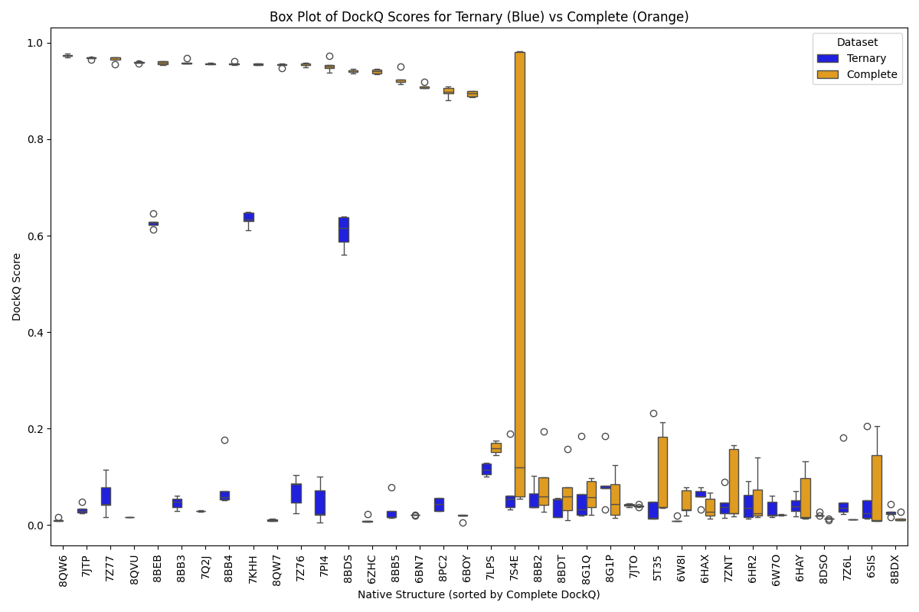
Figure S1. Boxplot comparison of DockQ scores for Ternary vs Complete AlphaFold3 predictions. Each native complex is represented along the x-axis, with DockQ score distributions shown for Ternary (blue) and Complete (orange) models. Complete models consistently achieve higher scores, frequently entering the high-quality prediction range (DockQ > 0.8).

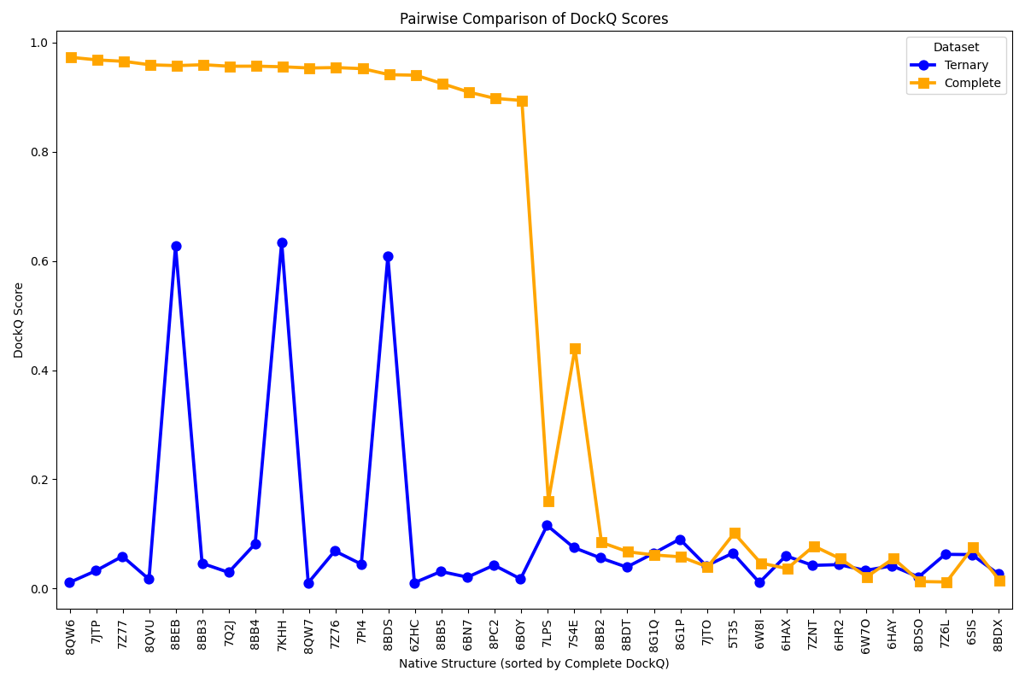
Figure S2. Pairwise line comparison of median DockQ scores for each native complex. Lines connect the median DockQ values for Ternary (blue solid line) and Complete (orange solid line) models across all benchmark structures. The large vertical deltas highlight systematic improvement across the dataset, with 89% (32/36) of complexes favoring the Complete configuration.

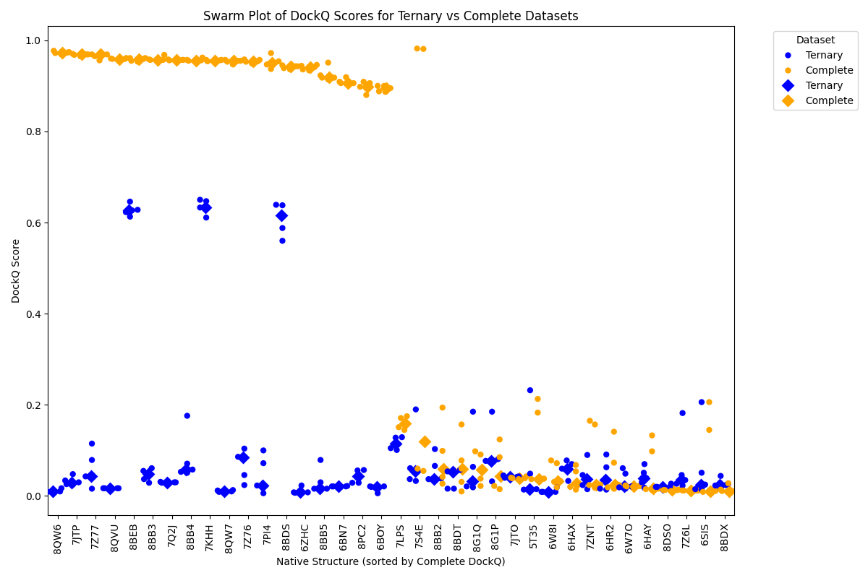
Figure S3. Swarm plot comparison of DockQ scores between Ternary and Complete models. Each dot represents an individual model’s DockQ score. Diamonds indicate cluster centers for each modeling group. The swarm structure reveals both the magnitude and consistency of DockQ improvements in Complete models, reinforcing their advantage over isolated Ternary predictions in accurately reproducing crystallographic interfaces.

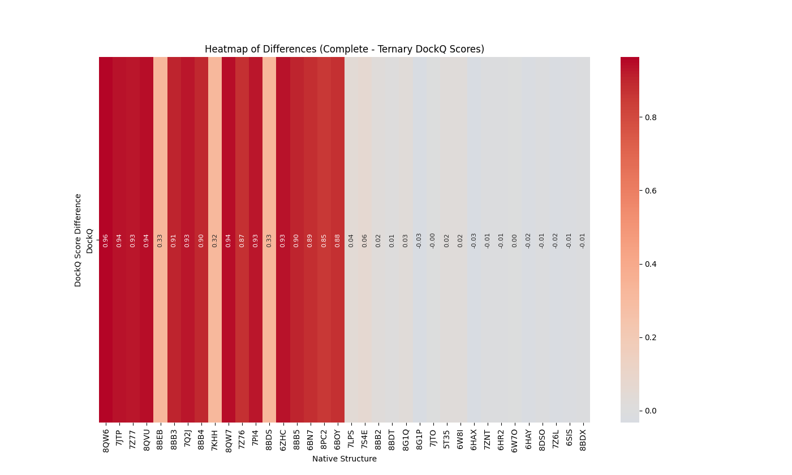 Figure S4. Heatmap of per-complex differences in median DockQ scores between Complete and Ternary predictions. This heatmap represents the difference (Complete – Ternary) in median DockQ for each of the 36 native structures. Shades of red indicate improved performance by the Complete models, with deeper reds reflecting greater improvement. Very few complexes showed marginal or negative differences, underscoring the consistent advantage of Complete modeling.

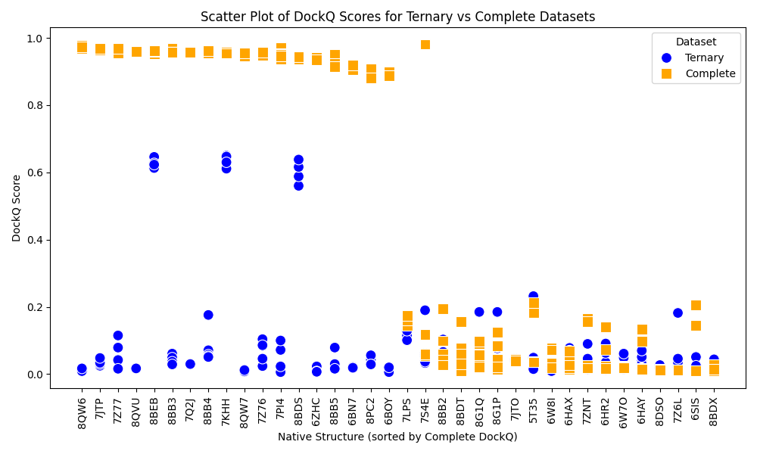
Figure S5. Scatter plot of individual DockQ scores for all models grouped by native structure.
Ternary and Complete model scores are plotted as blue circles and orange squares, respectively. Complete models cluster tightly at higher DockQ values across nearly all systems, while Ternary scores remain broadly dispersed and typically lower, suggesting reduced reliability and higher variance in minimal-context predictions.

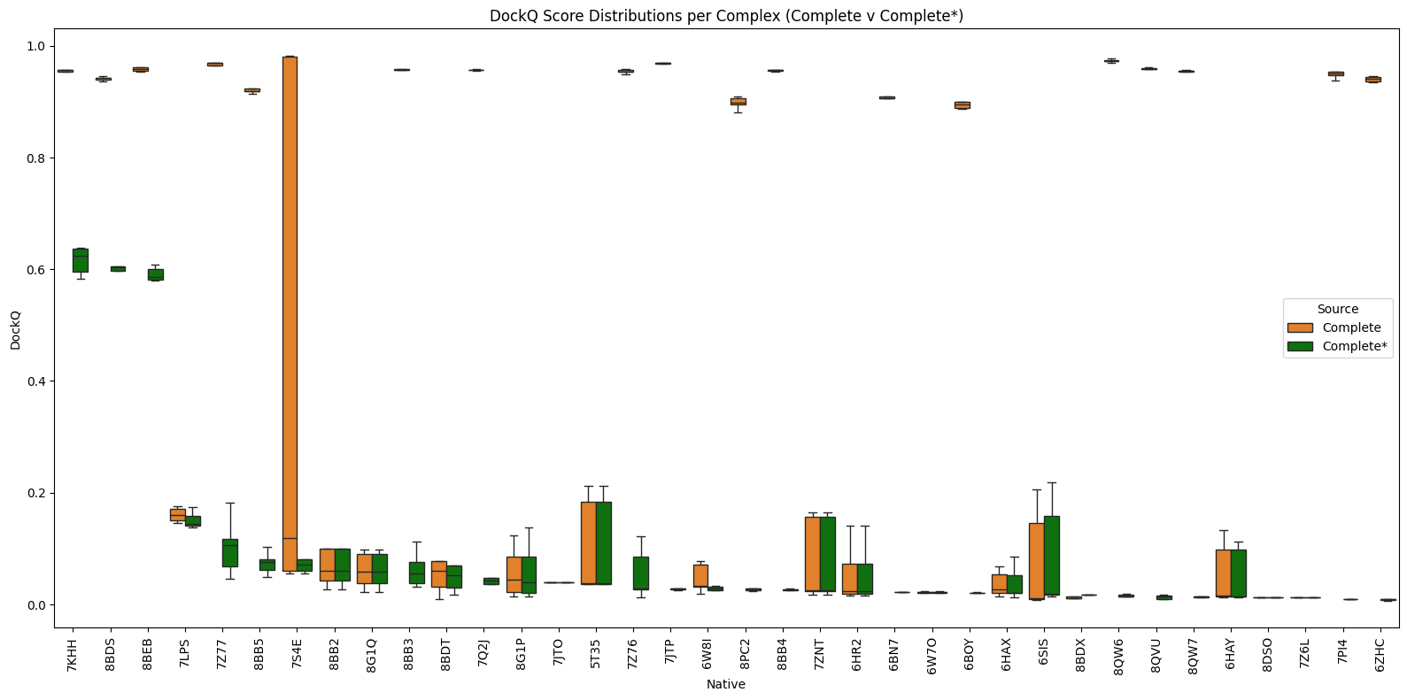

Figure S6. Box plot comparison of DockQ scores between unmodified Complete and stripped Complete* model predictions across 36 ternary complexes. Each complex is shown along the x-axis, with boxplots summarizing the distribution of DockQ scores before (orange) and after (green) removing auxiliary non-ligase subunits such as Elongin B/C. The broad reduction in DockQ values across most complexes reveals the substantial contribution of these subunits to the predictive accuracy of AlphaFold3. Notably, the largest drop-offs are seen in complexes like 8BEB and 7KHH where Elongin B/C form significant structural contacts.

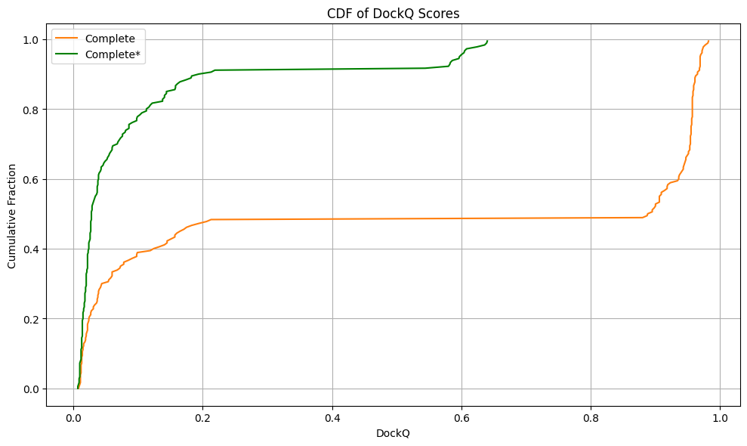

Figure S7. Cumulative distribution function (CDF) of DockQ scores across all models and all ternary complexes for Complete and Complete* predictions.The CDFs visualize the global shift in model quality following structure cleaning. The steep leftward shift in the Complete* curve (green) indicates a higher proportion of low-scoring models after cofactor removal. In contrast, the Complete models (orange) maintain a more gradual accumulation with a tail of high-scoring predictions, further supporting the importance of including biological context.

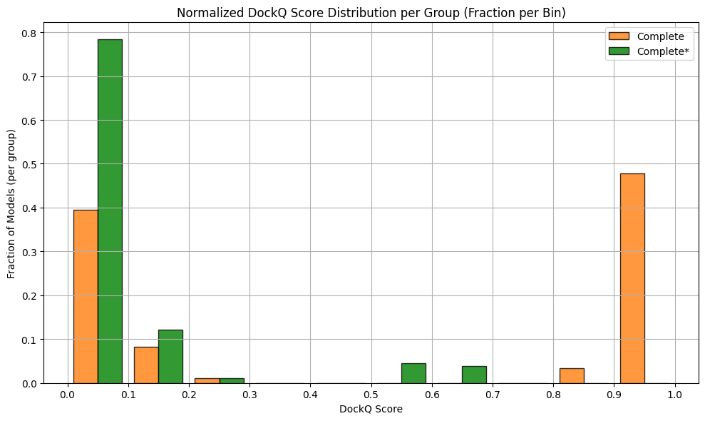Figure S8. Normalized Histogram of DockQ Scores Across Binned Ranges (Per Group). The histogram shows the distribution of DockQ scores for AlphaFold-predicted complexes before (Complete, orange) and after (Complete*, green) cleaning, binned in intervals of 0.1. For each group, the y-axis represents the fraction of models that fall into each bin, normalized independently per group so that the total area under each histogram sums to 1.0. This normalization allows direct comparison of distribution shapes across groups.

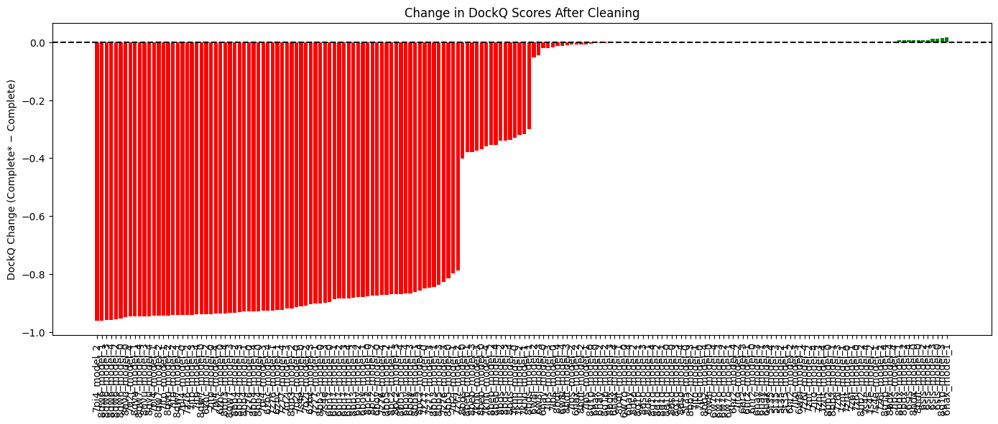

Figure S9. Per-model DockQ change following removal of cofactors from Complete complexes (Complete* – Complete). Each vertical bar represents a model, colored by direction of change: red for negative (performance drop), green for positive (improvement). Nearly all bars fall below zero, highlighting the consistency of degradation across models after stripping accessory proteins. This figure confirms that improvements observed in the Complete models are not spurious but tied to meaningful interface contributions.

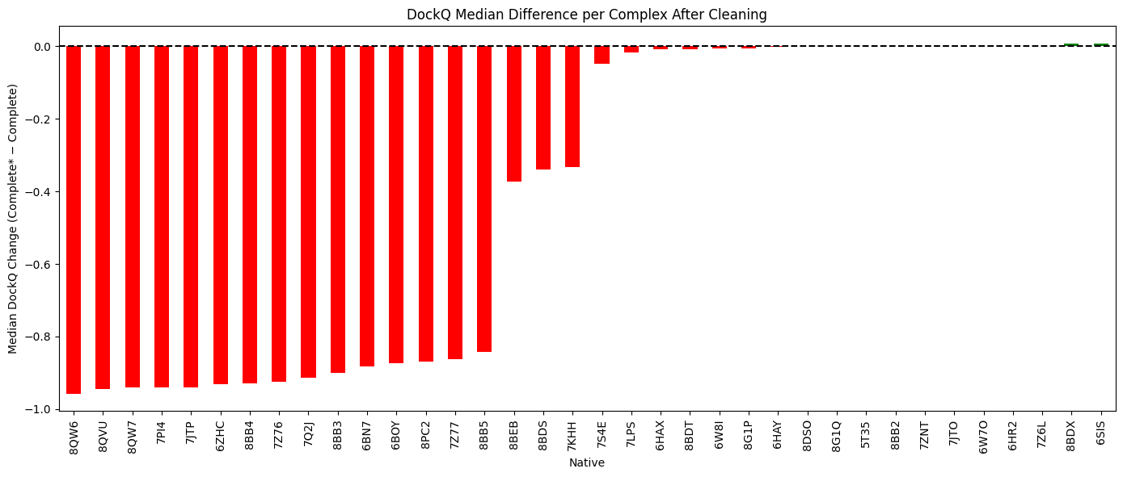

Figure S10. Median DockQ change per native complex after model cleaning. For each structure, the difference in median DockQ between Complete* and Complete models is shown (Complete* – Complete). Most complexes show a large drop (red bars), indicating that the predictive benefit of cofactors is reproducible across models for a given system. Only a few structures exhibit neutral or slightly positive changes, likely due to non-interacting cofactors or minimal rearrangement.

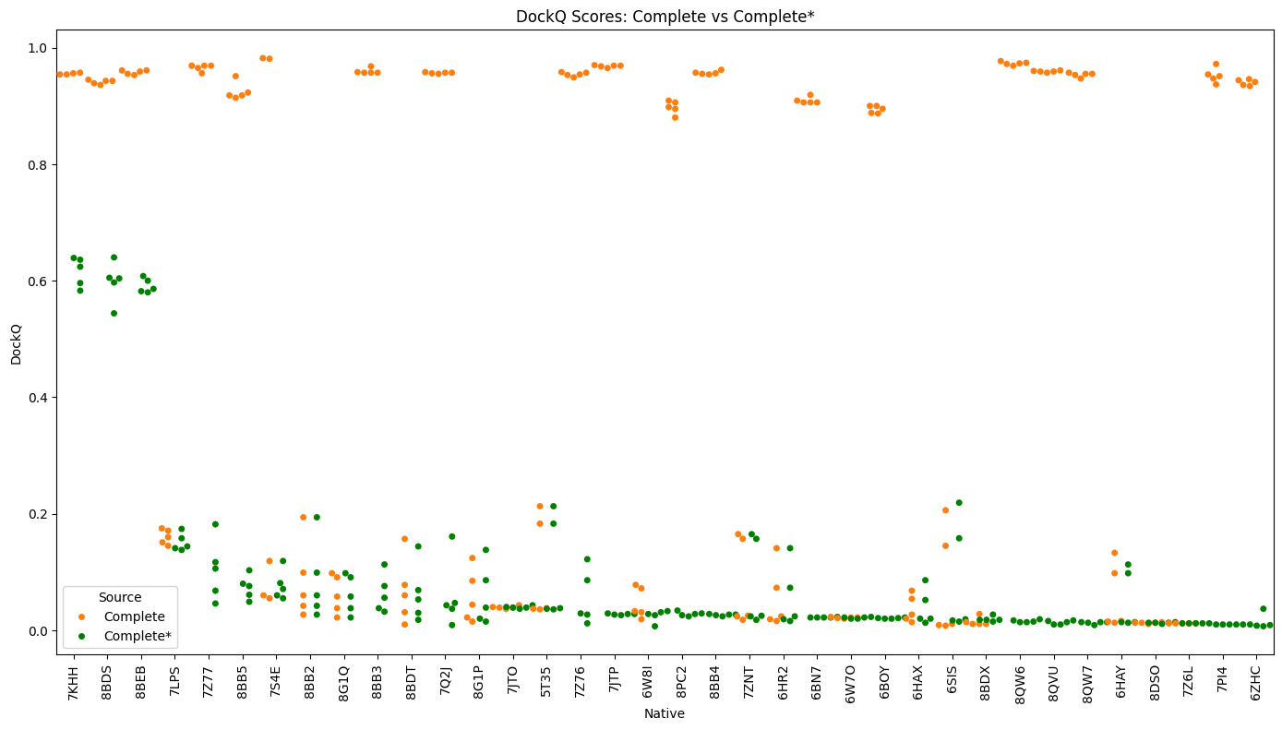 Figure S11. Scatter plot of individual model DockQ scores for Complete and Complete* predictions across all benchmark systems. Each point represents a model, color-coded by condition (orange for Complete, green for Complete*). The vertical alignment shows models within the same native system. A clear separation is evident, with Complete* models clustering toward lower DockQ scores, reinforcing the role of multimeric context in improving predictive fidelity of AF3.
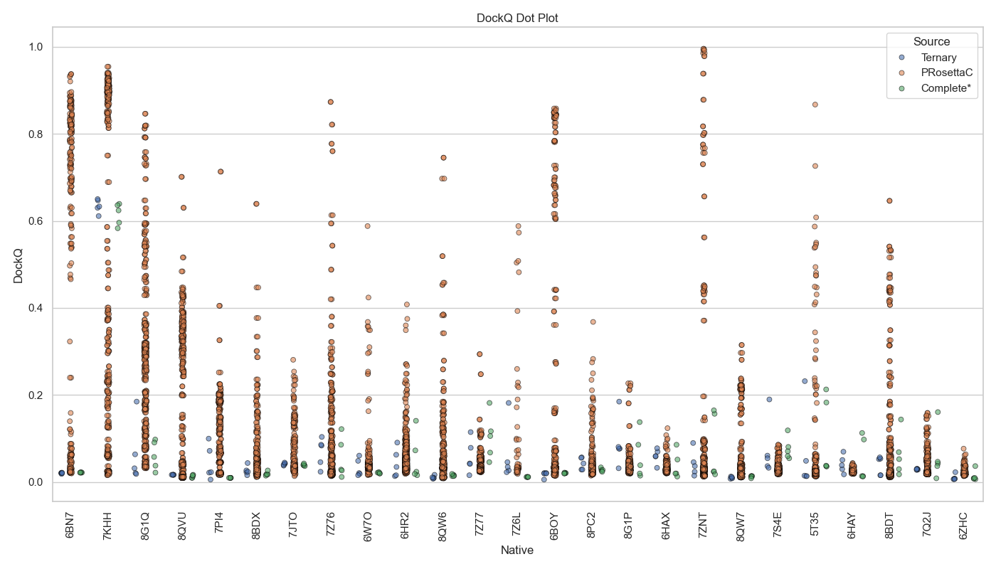
Figure S12. DockQ dot plot showing individual model scores per crystal structure. PRosettaC predictions span a wide range, including many high-fidelity outliers not achieved by AF3 methods.
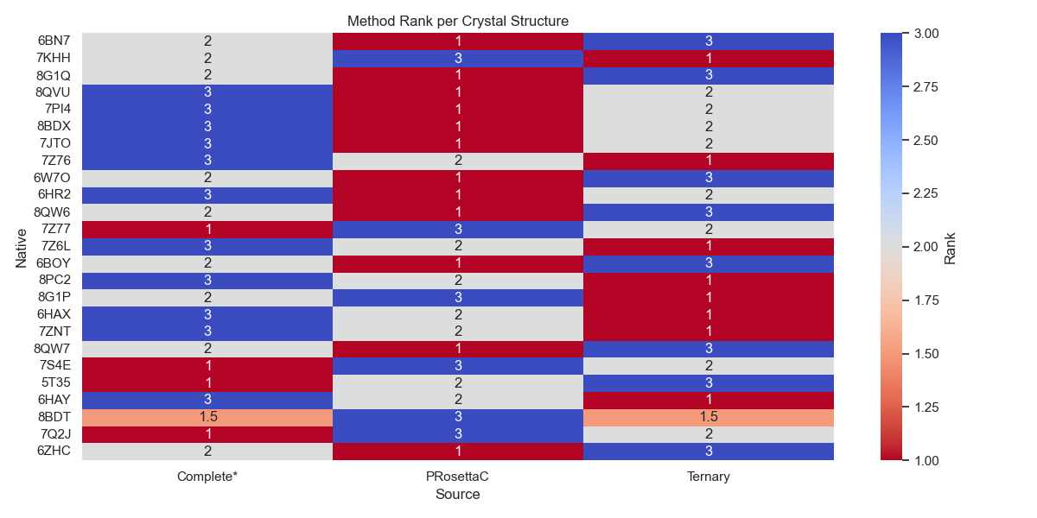
Figure S13. Method rank per crystal structure based on median DockQ. Ranks were computed such that 1 = best, 3 = worst. PRosettaC frequently ranks first, but AF3 methods outperform it in certain systems. **For crystal structure 8BDT, a tie in scoring occurred between both of the AF3 methodologies resulting in a 1.5 (indicating a ‘tie’ for second place).
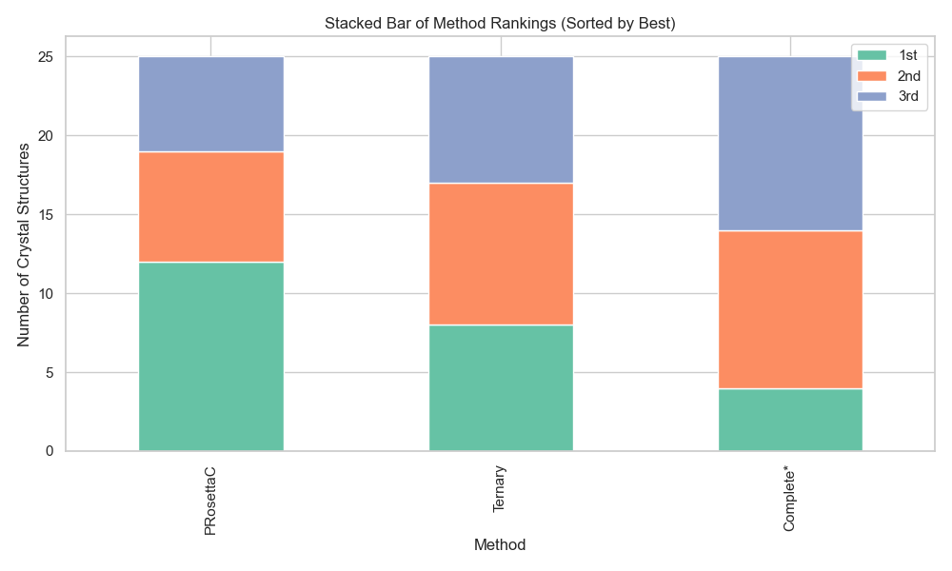
Figure S14. Stacked bar plot summarizing method ranks across 25 benchmark targets. PRosettaC secured the top spot most frequently, followed by AF3 Ternary and Complete*. **For crystal structure 8BDT, a tie in scoring occurred between both of the AF3 methodologies resulting in a 1.5 (indicating a ‘tie’ for second place).
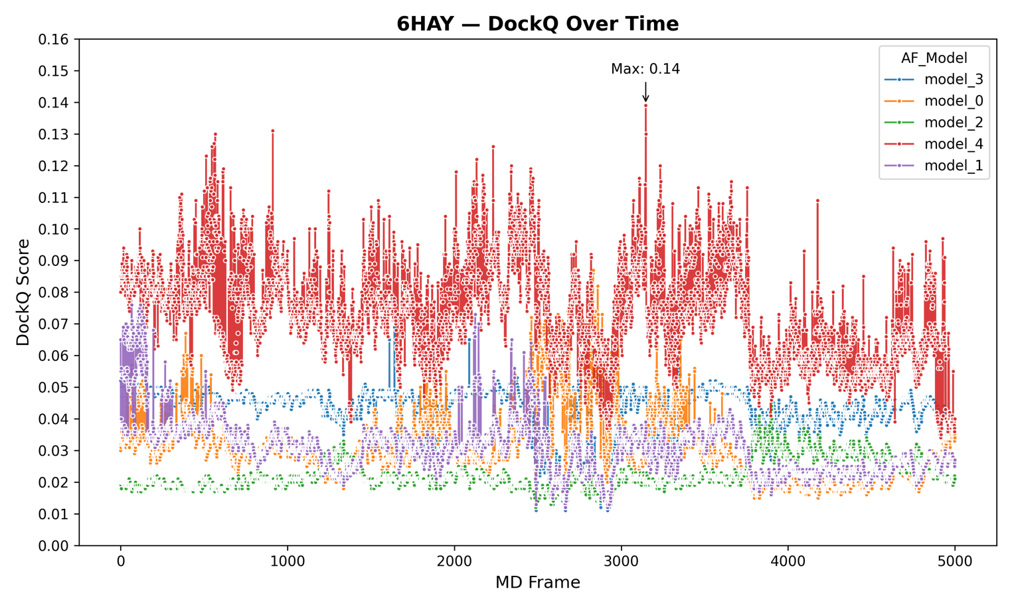 Figure S15. Time-course DockQ trajectories for 6HAY (SMARCA2:VHL) during molecular dynamics simulation. Among all five AF3 models, model_4 achieves the highest DockQ score of 0.14, observed in the mid-region of the simulation near frame 2800. This peak, while notable, is brief and not replicated by other models, which tend to hover in the 0.02–0.08 range. Fluctuations are persistent throughout the trajectory, and none of the models demonstrate consistent or progressive improvement in interface alignment. The elevated activity suggests some conformational exploration, yet structural fidelity remains poor relative to the native complex.

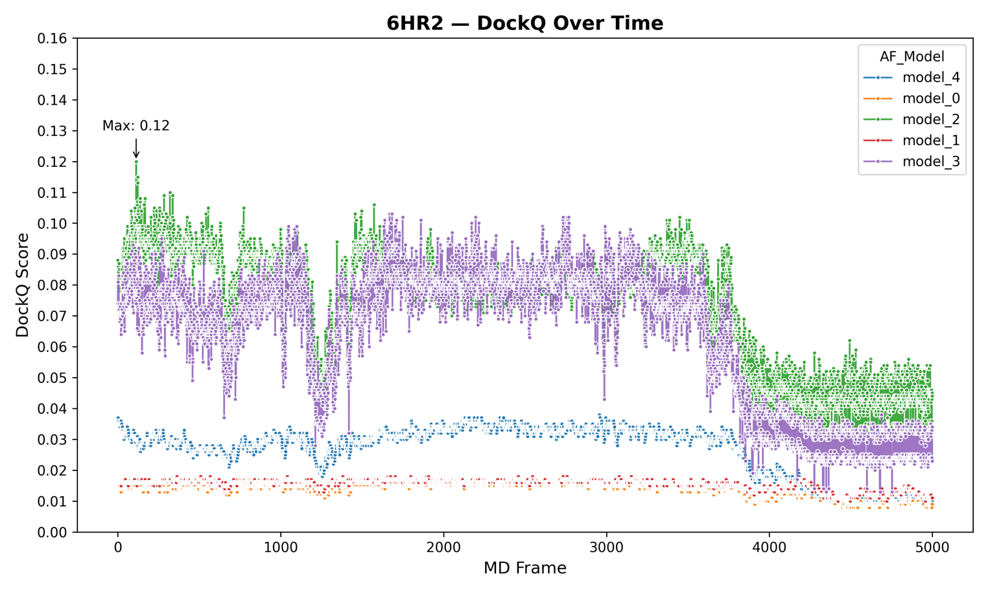
Figure S16. DockQ score evolution for the 6HR2 (SMARCA4:VHL) ternary complex over a 50 ns trajectory. The overall behavior of this system is comparatively stable, with lower noise and fewer sharp transitions than 6HAX or 6HAY. Model_2 reaches a maximum score of 0.12 around frame 500, while model_3 shows moderate consistency in the 0.07–0.10 range across the middle segment. Despite this stability, all values remain below the “acceptable” DockQ threshold of 0.23, indicating that none of the sampled frames come close to recapitulating the native geometry.

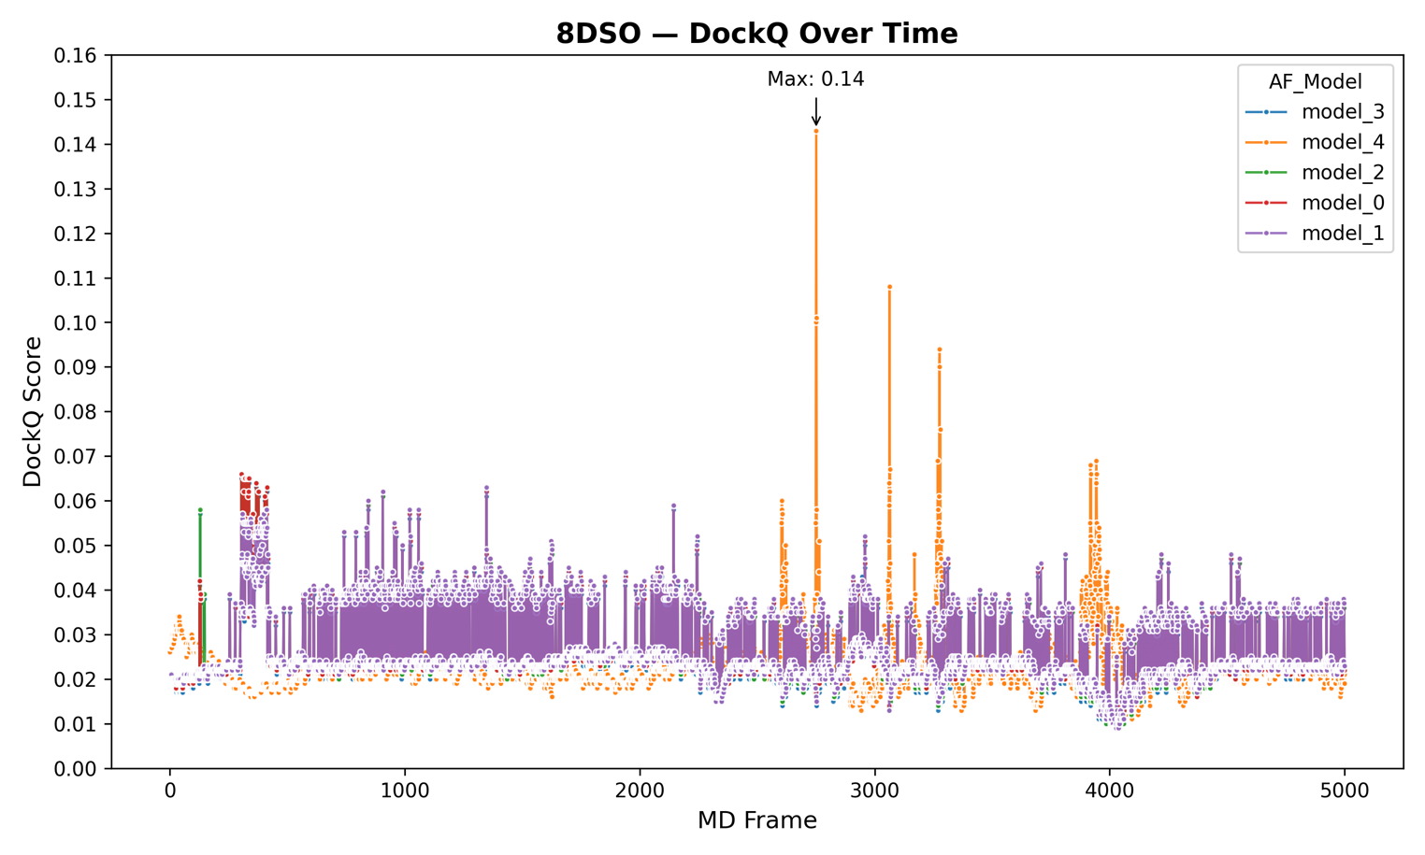Figure S17. Molecular dynamics DockQ profiles for 8DSO (BTK:RNF48), comparing all five AF3 Ternary model trajectories. The highest score of 0.14 appears abruptly in model_4 around frame 2750, yet this spike is highly transient and unaccompanied by consistent improvements in nearby frames. Other models (especially model_1) maintain low, noisy trajectories between 0.02–0.05. The large number of isolated fluctuations suggests dynamic sampling but limited structural fidelity, as no trajectory achieves sustained alignment with the crystallographic pose.

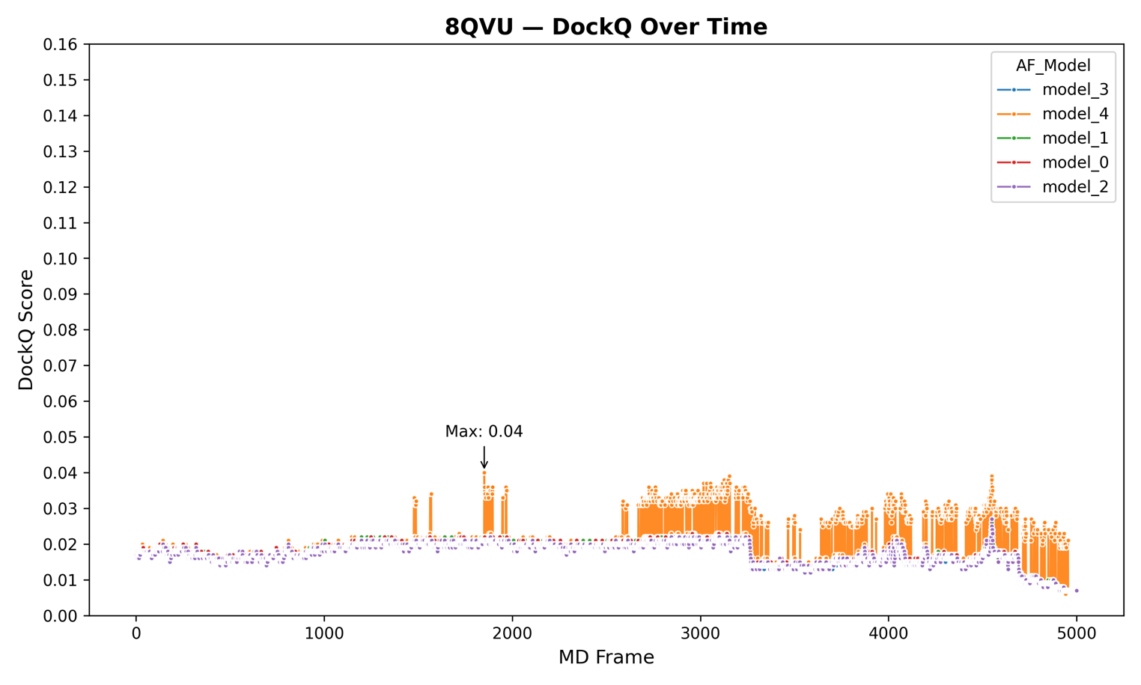
Figure S18. Time-resolved DockQ data for the 8QVU (KRAS:VHL) ternary complex across AlphaFold3 Ternary models. This system displays the lowest structural fidelity of all five cases. The maximum DockQ score observed is a mere 0.04, seen in model_4 around frame 1800. All models exhibit tightly clustered, flat trajectories with minimal variance or upward trends. The near-complete absence of DockQ progression across frames indicates a lack of interface reorganization or induced fit that might bring the models closer to the native geometry. In effect, this structure remains persistently misaligned throughout the simulation.

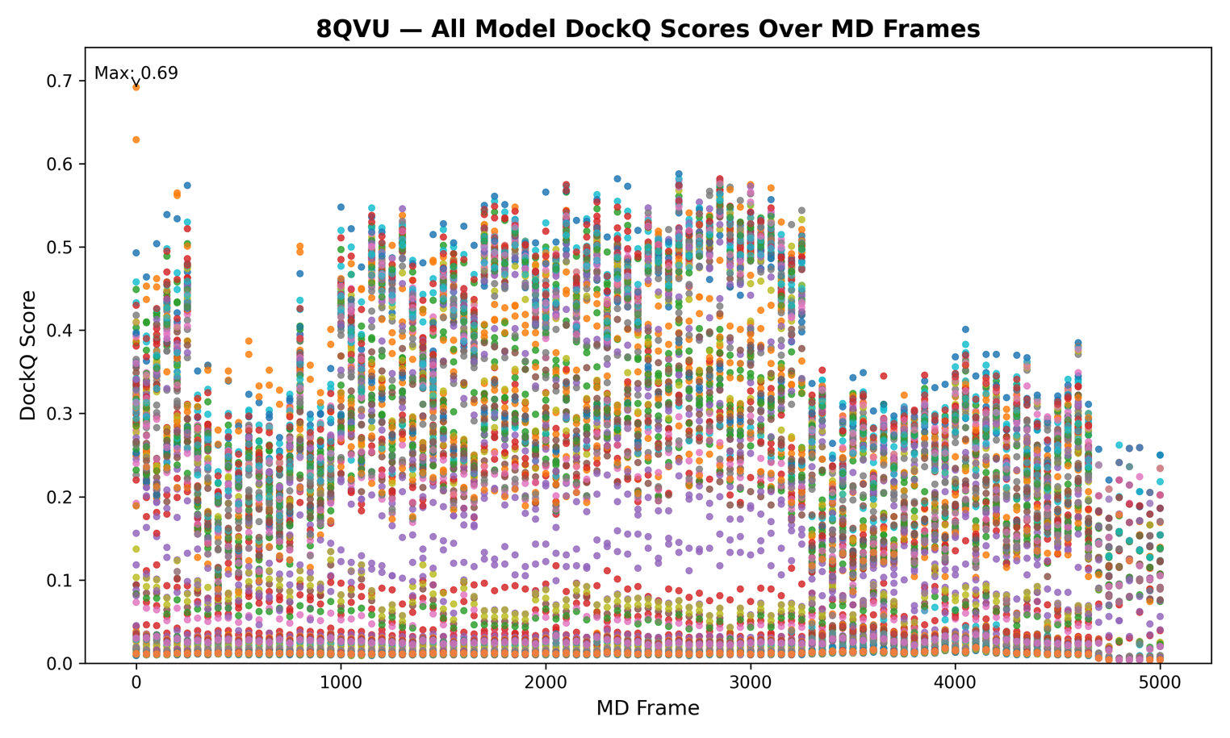
Figure S19. 8QVU yields frequent and high-fidelity alignments between PRosettaC predictions and MD crystal frames. This system exhibits the highest DockQ scores of all tested benchmarks, peaking at 0.69. These results indicate that certain KRAS:VHL conformations captured during MD are highly compatible with PRosettaC geometries, reinforcing the importance of receptor dynamics in degrader modeling.

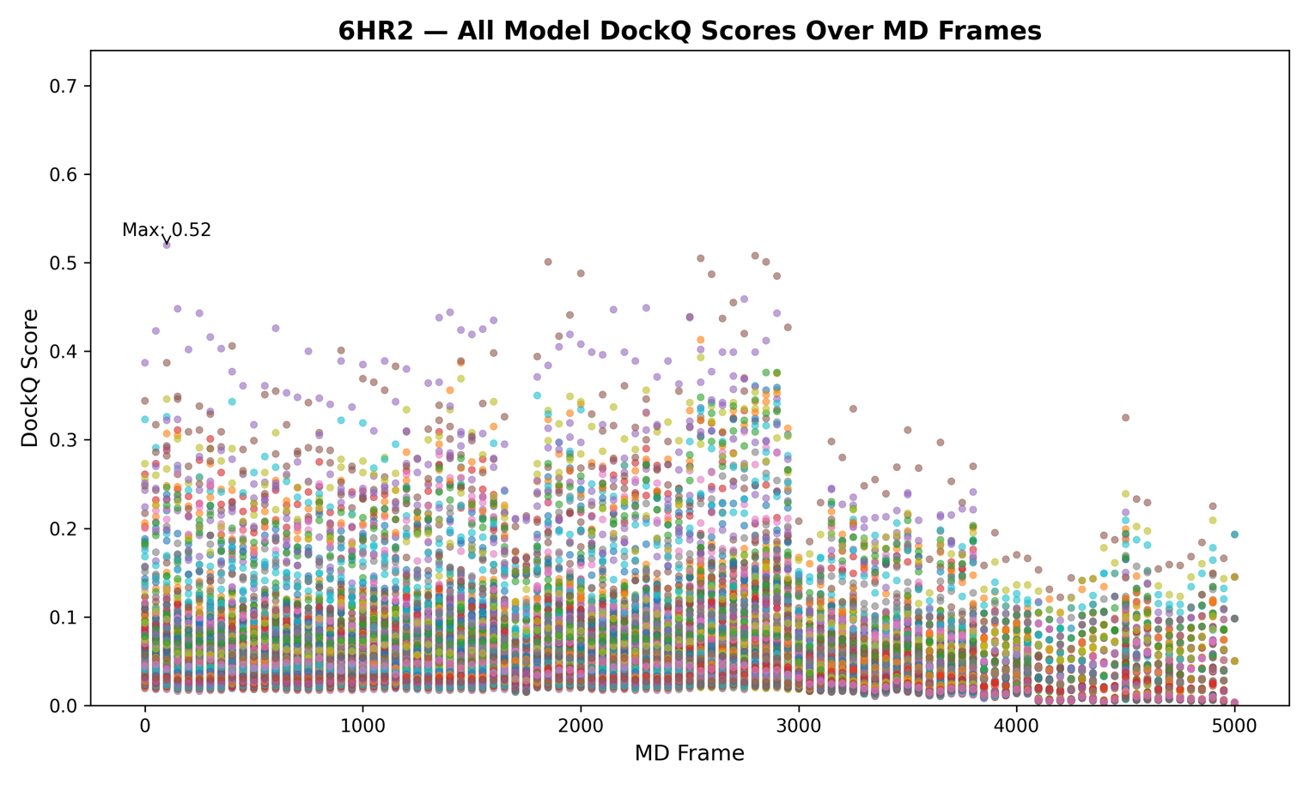Figure S20. The 6HR2 system shows sustained mid-range DockQ values, with multiple high-scoring model-frame pairs. Numerous PRosettaC models align moderately well (DockQ > 0.4) with MD-sampled frames of the SMARCA4:VHL complex. The broader score distribution suggests greater receptor flexibility and a wider conformational tolerance for ternary complex formation.

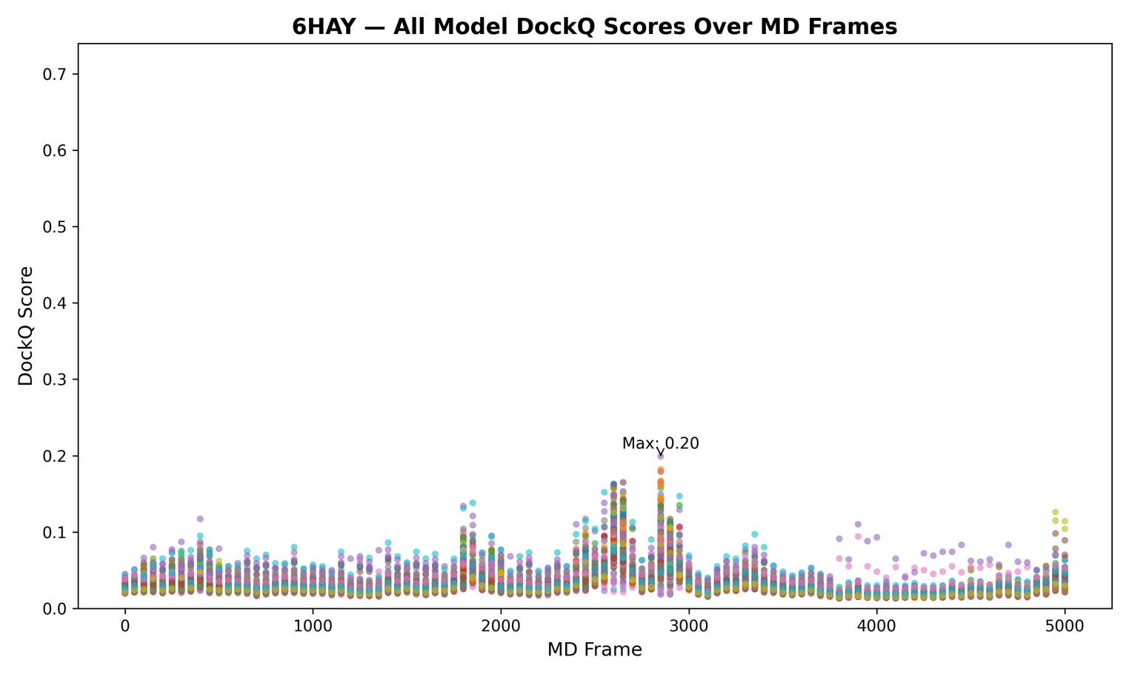Figure S21. 6HAY displays limited conformational compatibility with PRosettaC predictions across all frames. Despite extensive sampling, the highest observed DockQ score remains below 0.2. The low and tightly clustered distribution across time indicates that PRosettaC models struggle to align with either static or dynamic forms of the SMARCA2:VHL complex in this system.

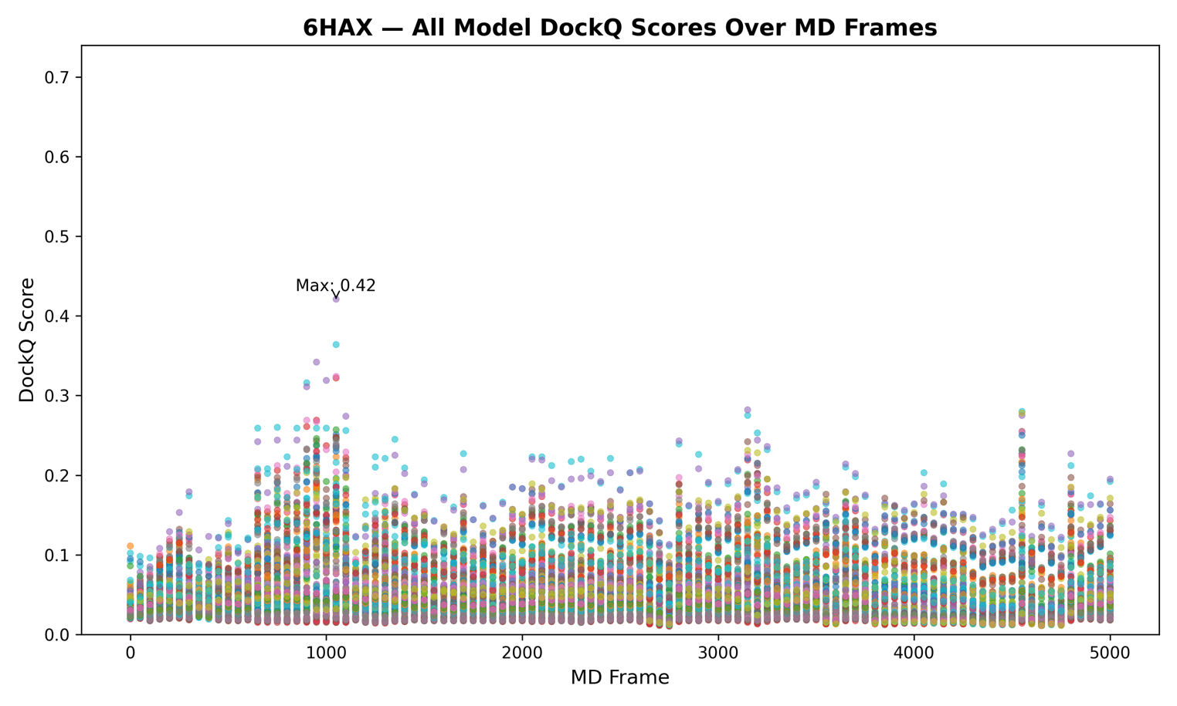
Figure S22. PRosettaC models transiently align with high fidelity to select frames of the 6HAX MD trajectory. Each point represents the DockQ similarity between a PRosettaC-predicted ternary complex and one frame from a MD simulation of the 6HAX crystal structure, sampled every 50 frames. While the highest DockQ score against the static crystal structure remained below 0.2, several model-frame comparisons during the trajectory exceeded 0.4, with the best reaching 0.42. These results reveal episodic, high-quality alignments with dynamic conformations that would be overlooked in a static evaluation, underscoring the importance of temporal resolution in benchmarking ternary complex predictions. These findings demonstrate the importance of considering protein flexibility when evaluating ternary complex predictions. By leveraging MD trajectories as dynamic reference structures, we reveal the latent quality of PRosettaC-generated models that would otherwise be dismissed using conventional static benchmarks. This frame-resolved analysis may offer a powerful framework for prioritizing degrader candidates whose efficacy is dependent on receptor conformational plasticity.

