Table 1. Common Readmission Factors for AMI Patients. This table displays the frequency and percentage of key clinical and behavioral factors associated with 30-day readmissions in AMI patients (n = 10). Variables assessed include hypertension, diabetes, obesity, medication non-compliance, and smoking history. All patients presented with hypertension, obesity, and smoking behaviors.
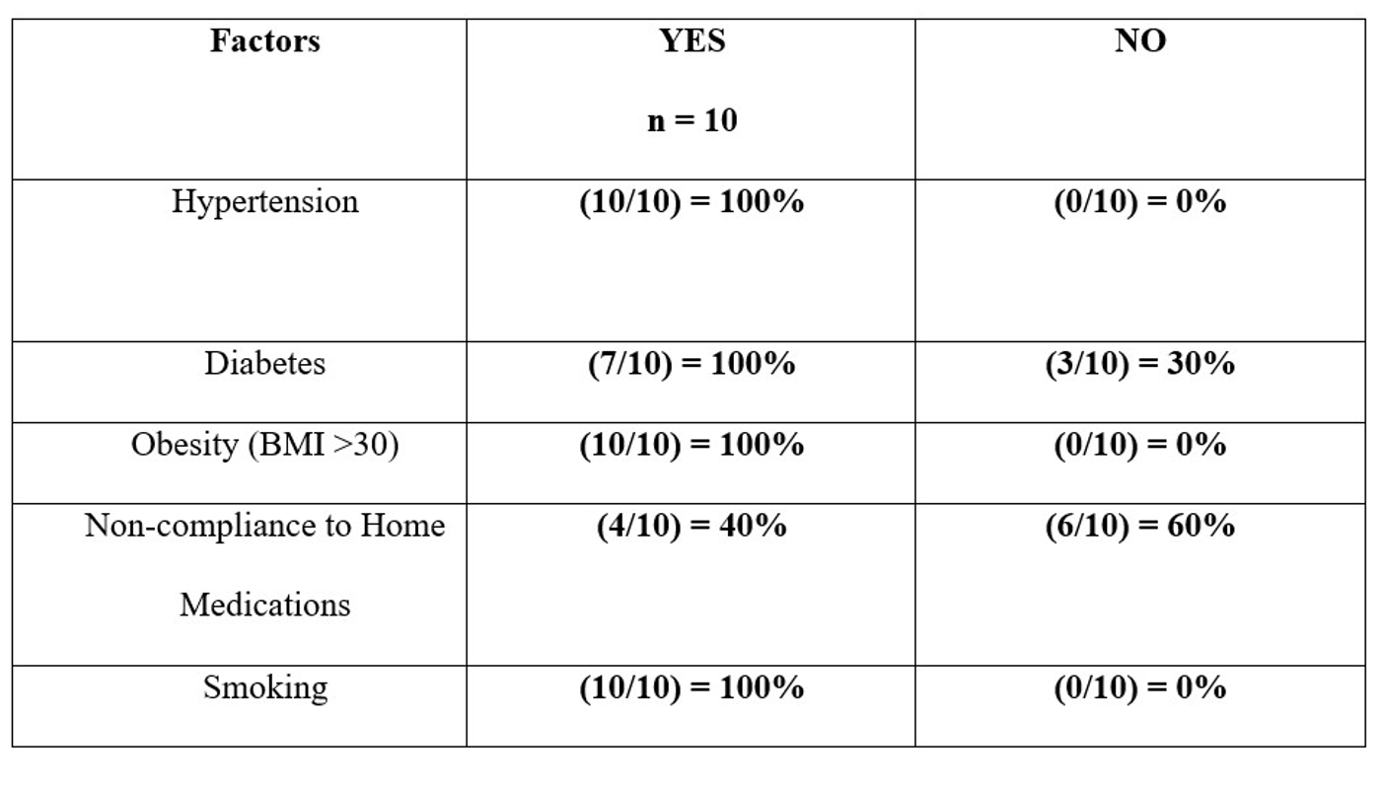

Table 2. Common Readmission Factors for HF Patients. This table summarizes the distribution of major risk factors contributing to readmission among HF patients (n = 10). Factors include hypertension, diabetes, obesity, medication non-compliance, and smoking. Medication non-compliance and obesity were the most prevalent contributors among this group.
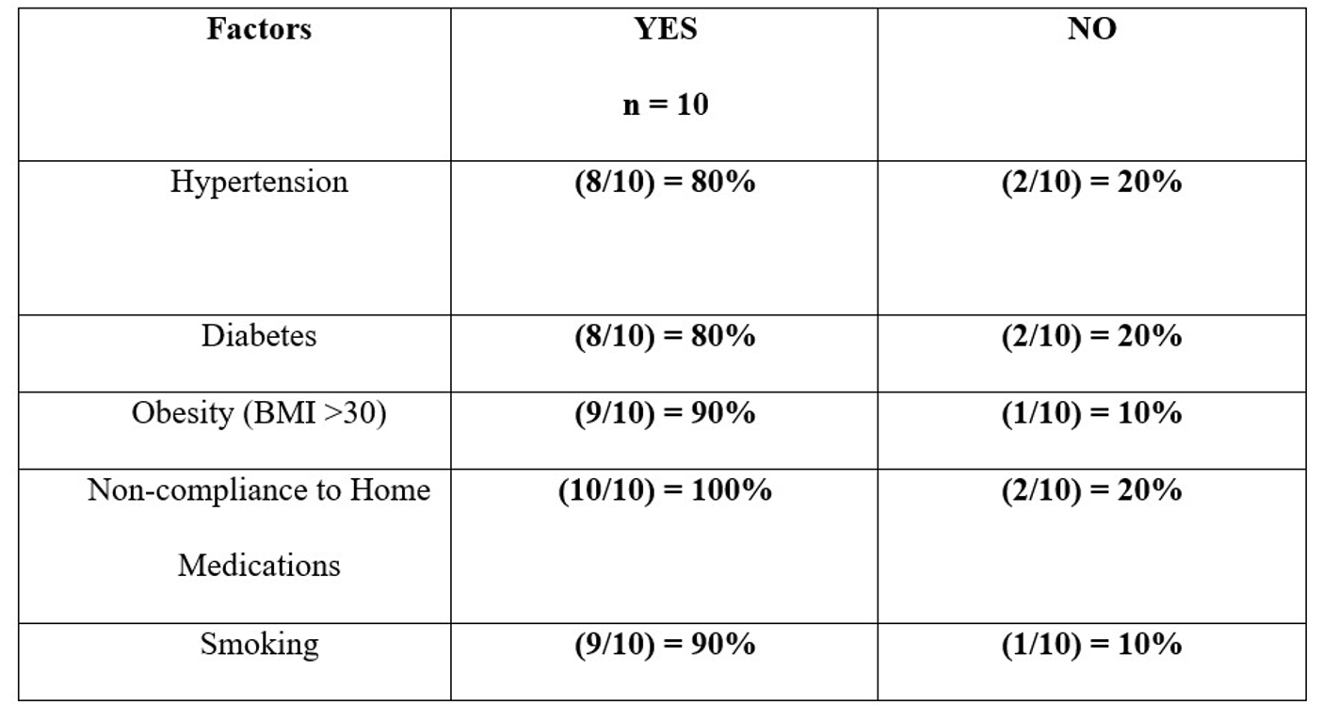

Table 3. Common Readmission Factors for PNA Patients. This table outlines the presence of clinical and functional factors linked to pneumonia readmissions (n = 10). These include vaccination status, ADL (activities of daily living) scores, swallowing dysfunction, and smoking. Swallowing dysfunction and impaired functional status were found in nearly all readmitted patients.
