SUPPLEMENTARY FIGURES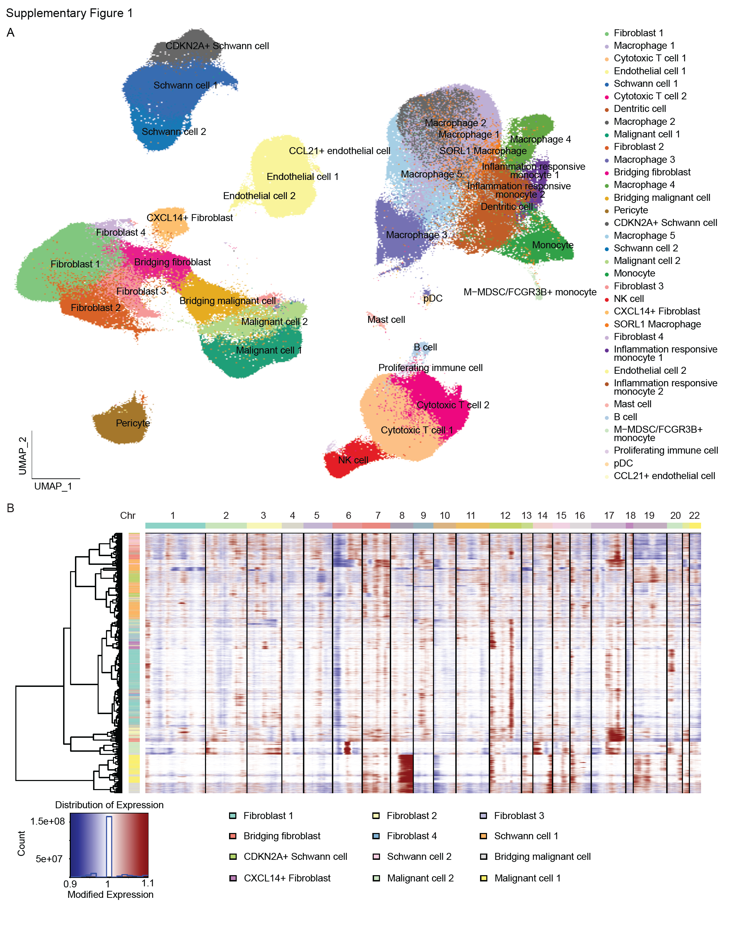Supplementary Figure 1. A. Uniform Manifold Approximation and Projection for Dimension Reduction (UMAP) plot of the NF1-associated nerve sheath tumor single-cell RNAseq reference dataset. B. Heatmap of inferCNV result comparing cells from fibroblast, Schwann cell, and malignant cell clusters to normal cells.

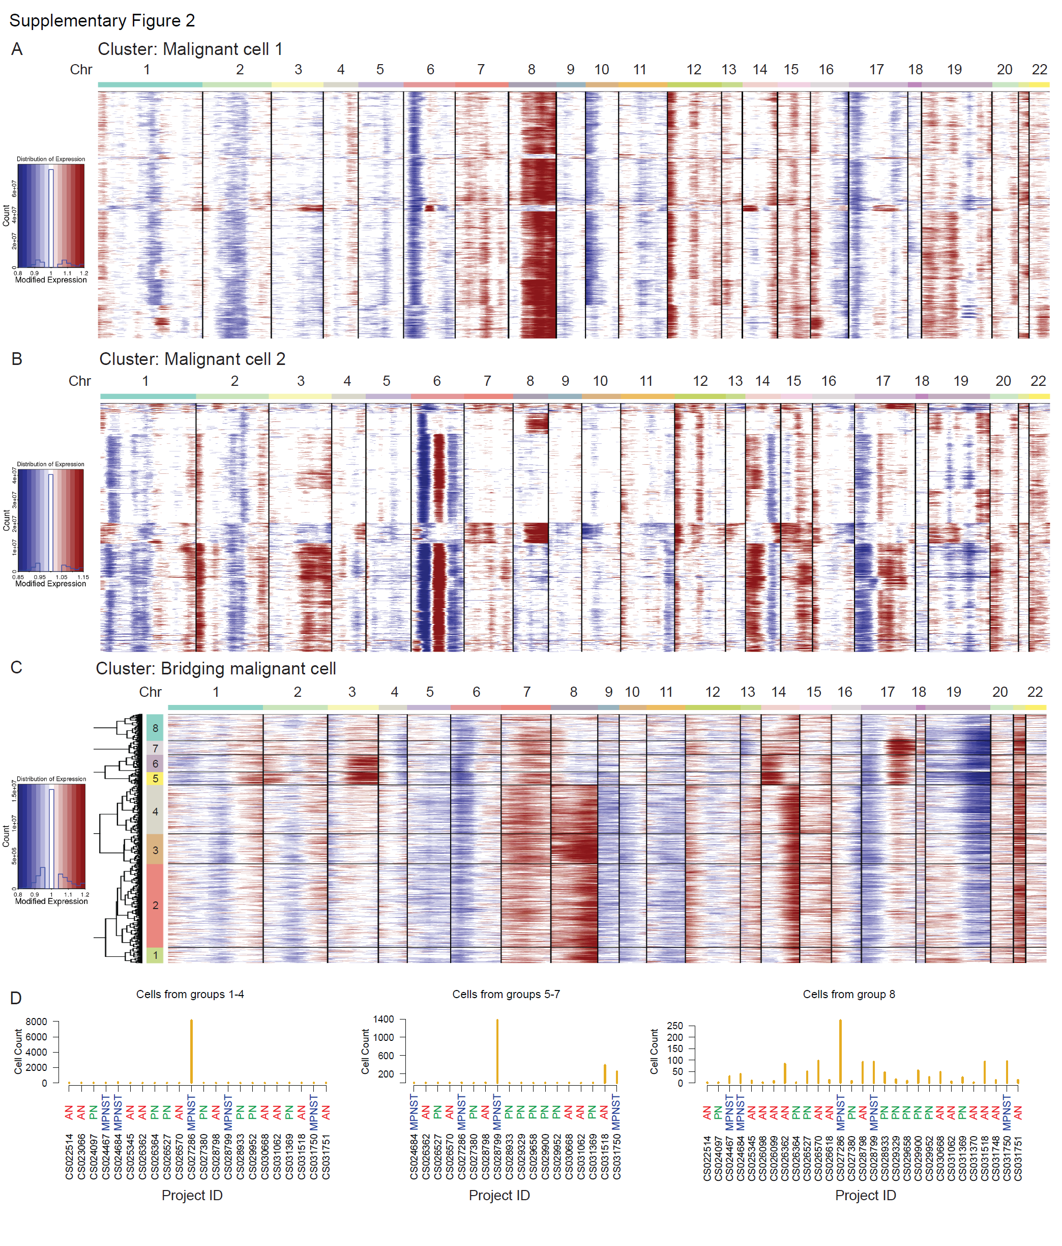
Supplementary Figure 2. Heatmap of inferCNV result comparing cells from the “Malignant cell 1” cluster (A), “Malignant cell 2” cluster (B), and “Bridging malignant cell” cluster (C). D. Distribution of individual specimen contributing cells to the “Bridging malignant cell” cluster.

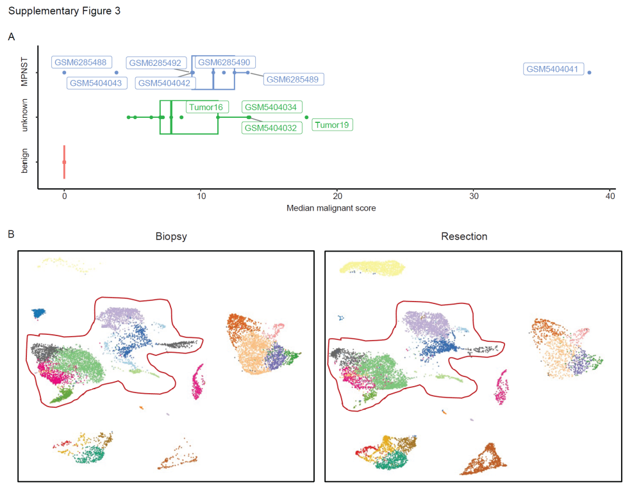
Supplementary Figure 3. A. Box plot showing the distribution of median malignant score calculated from cells of independent cohort of single-cell or single-nuclei RNAseq dataset. B. UMAP plot of single-cell RNAseq data showing similar transcriptional profiles between the core needle biopsy (left panel) and resection (right panel) of tumor19. The red line-circled cells are malignant cells.
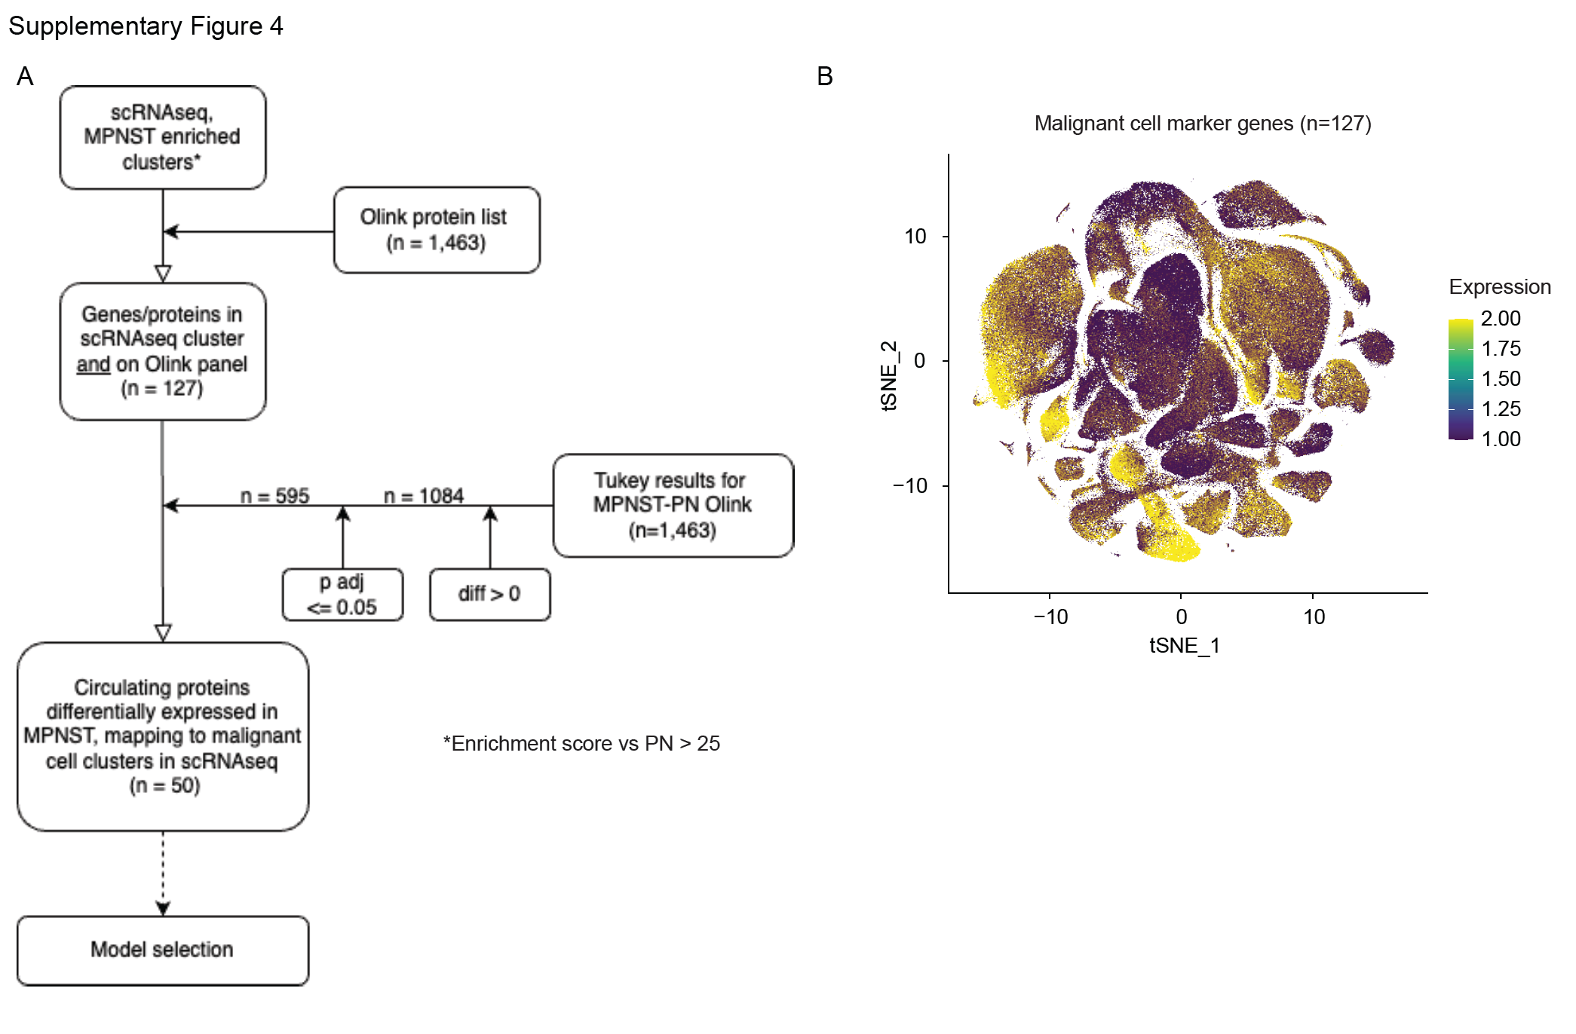
Supplementary Figure 4. A. Flow chart demonstrating the steps and criterion for plasma biomarker identification using NF1 single-cell RNAseq reference dataset. B. tSNE plot showing the expression and distribution of 127 single-cell informed gene markers in the reference dataset.
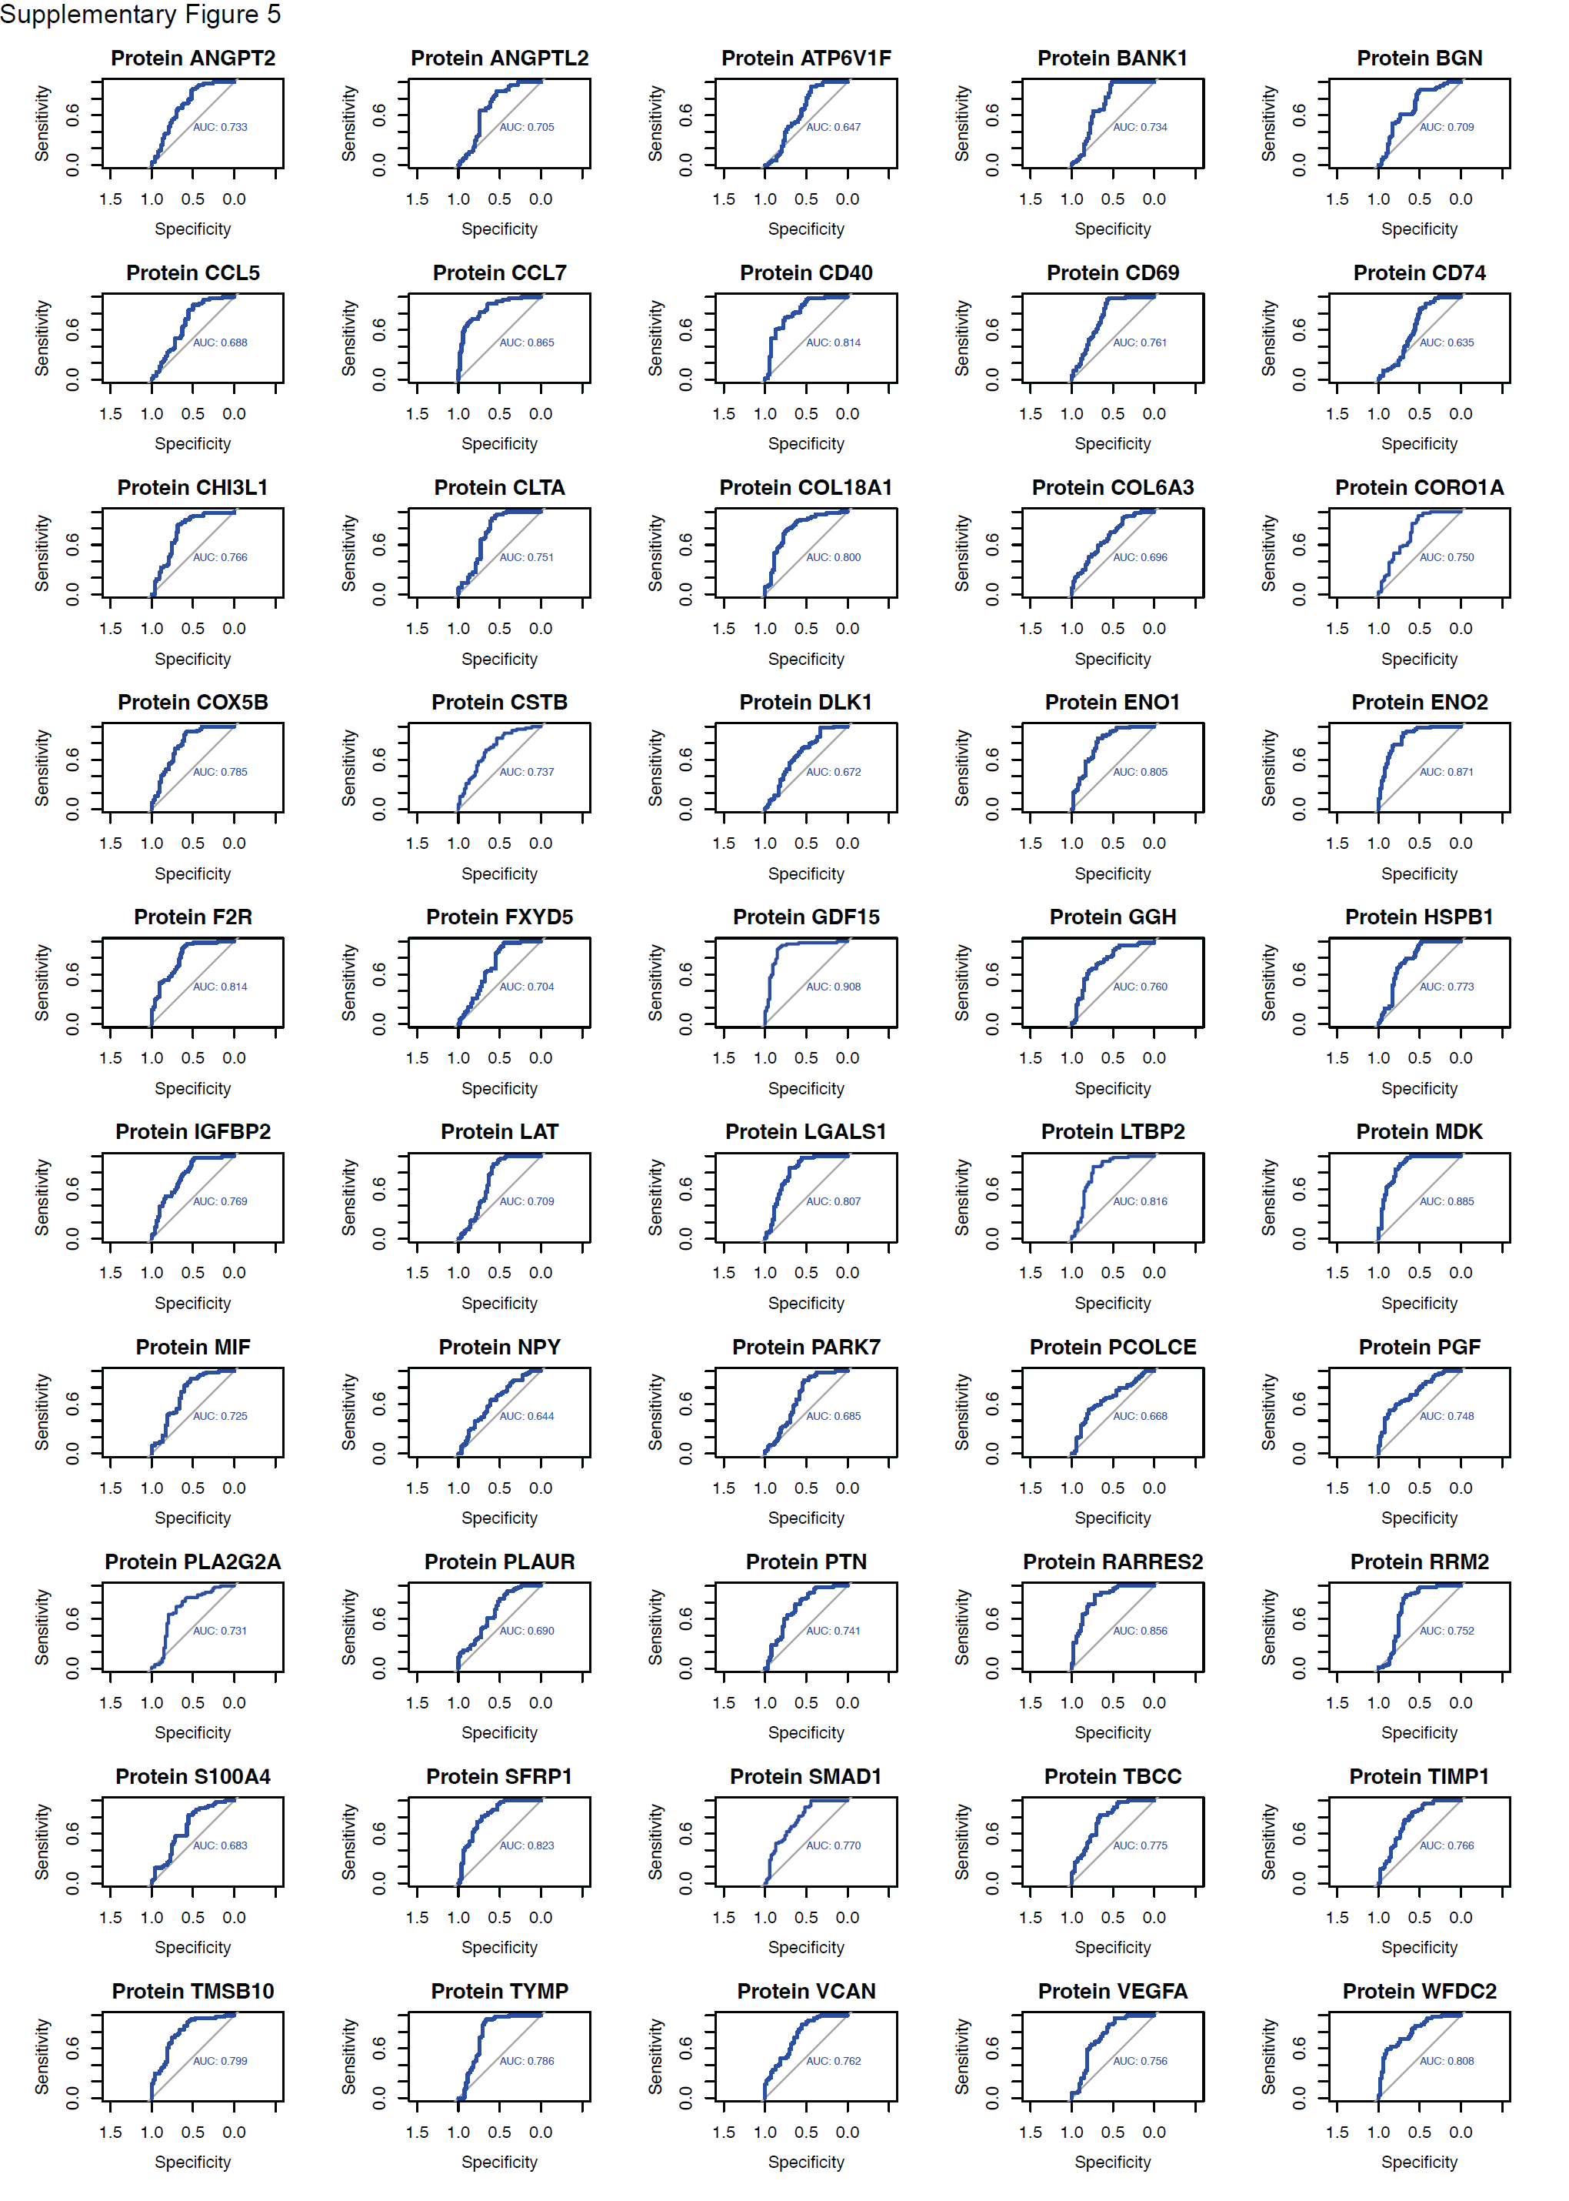
Supplementary Figure 5. Receiver operating characteristic (ROC) curve of 50 individual plasma biomarkers identified in this study.

