Appendix
Table 1
Variable Construction and Data Sources
Variable Name | Description | Source
year | Year of observation | SINIM
codigo | Commune ID code | SINIM
comuna | Commune name | SINIM
region | Region of the commune-year | SINIM
ingreso_pmb | Revenue from PMB in thousands of CLP | SINIM (RPMB10)
ingreso_pmb_per_capita_log | Log of per capita PMB revenue | Own calculation
ingreso_pmu | Revenue from PMU in thousands of CLP | SINIM (RPMU11)
ingreso_pmu_per_capita_log | Log of per capita PMU revenue | Own calculation
ingreso_fcm | Revenue from FCM in thousands of CLP | SINIM (IADM40)
ingreso_fcm_per_capita_log | Log of per capita FCM revenue | Own calculation
ipp_per_capita | Autonomous own permanent revenue per capita in thousands of CLP | SINIM (IADM74)
ipp_per_capita_log | Log of autonomous own revenue per capita | Own calculation
densidad_pob | Population density (inhabitants/km²) | SINIM (ICAR007)
pobreza | Poverty percentage | SINIM (ISOC001)
partido | Mayor’s political party | SERVEL
partido_presidente | 1 if mayor shares president’s party, 0 otherwise | Own calculation from SERVEL
margen_victoria | Victory margin in municipal election (%) | Own calculation from SERVEL
poly(year,3) | 3rd degree polynomial of year for time trends | Own calculation
Source: Own elaboration

Figure 1
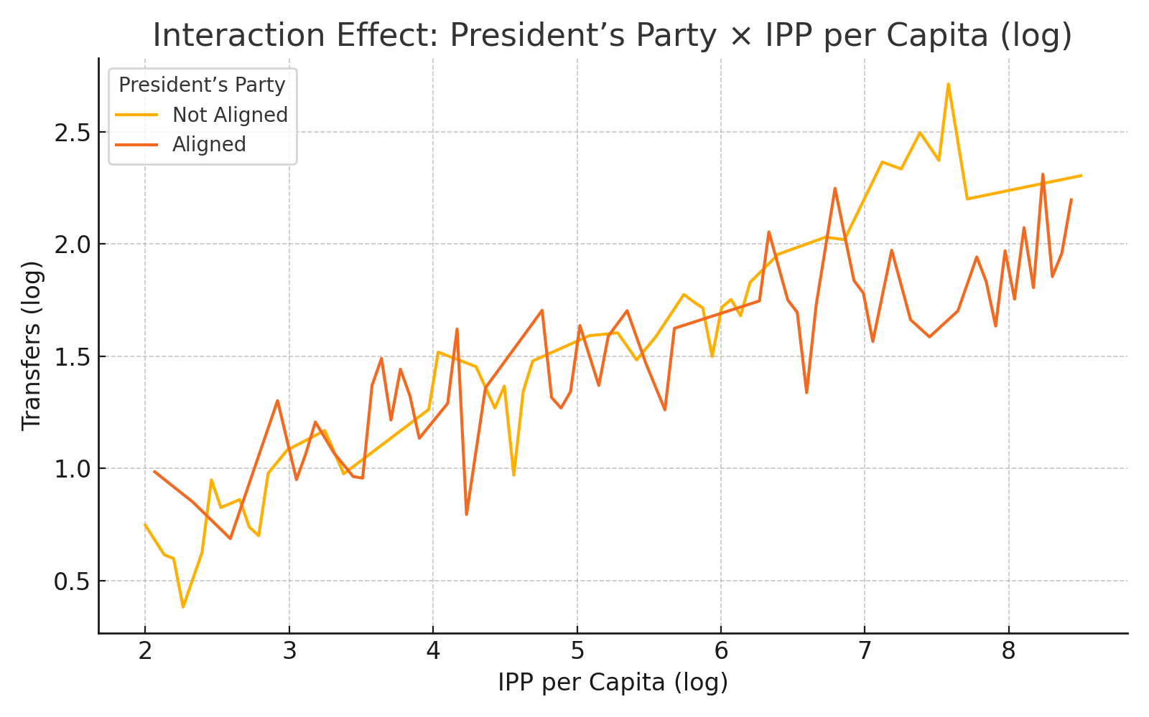
Source: Own elaboration

Figure 1 shows the interaction effect between the mayor’s alignment with the president’s party and the municipality’s autonomous permanent own income (log-transformed) on the amount of discretionary transfers received (log-transformed).

Figure 2

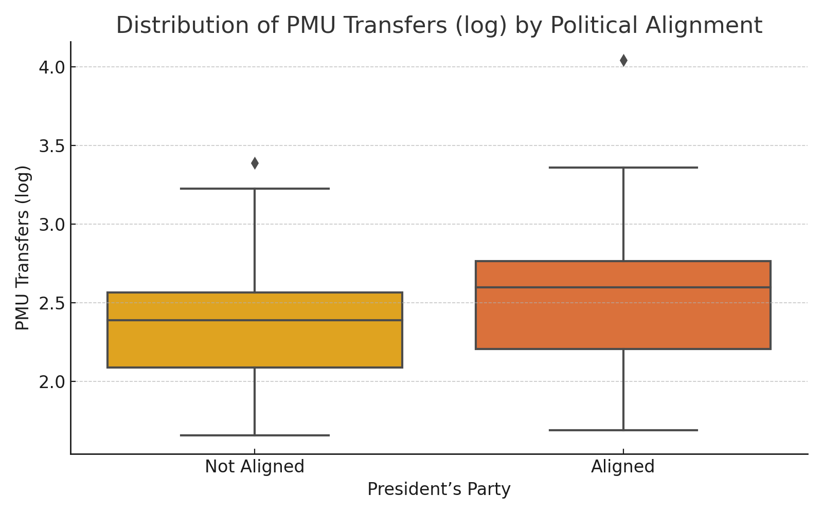
Source: Own elaboration

Figure 2 shows the distribution of PMU transfers (log-transformed) for municipalities governed by mayors aligned and not aligned with the president’s party. The distribution suggests a higher central tendency for aligned mayors.

Figure 3
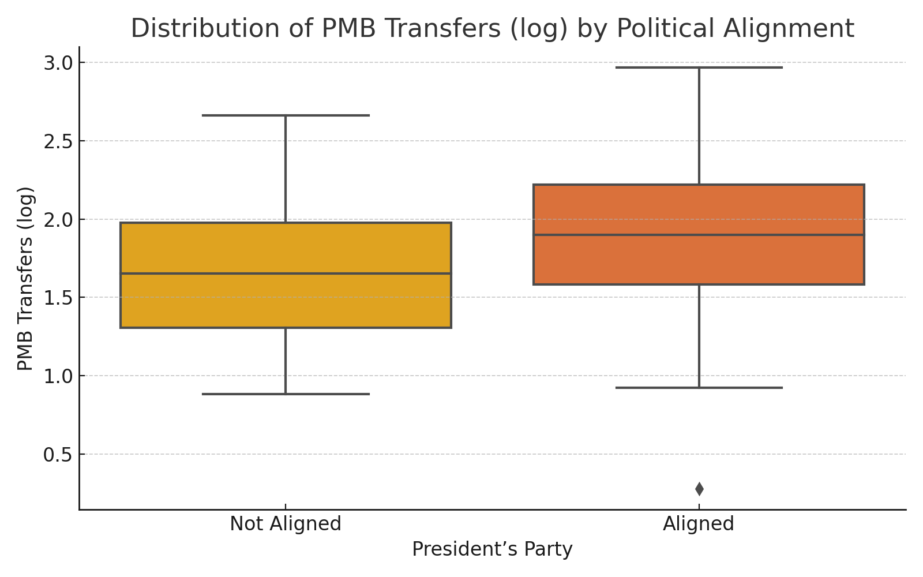
Source: Own elaboration

Figure 3 shows the distribution of PMB transfers (log-transformed) by the same political alignment criterion. Similarly, the median and spread appear higher among aligned municipalities.

