Data sets
Out of all 1652 cases, 167 images due to a history of spinal surgery or trauma, 35 images due to incomplete imaging data, 52 images with significant artifacts or unaligned splices, 8 images from patients with metabolic bone diseases, 15 images showing spinal tuberculosis, 11 images showing spinal tumors, 9 images with congenital spinal deformities, and 7 images with neuromuscular spinal deformities were excluded based on the study's inclusion and exclusion criteria.A total of 1348 whole-spine frontal/lateral DR images were finally included, which were randomly assigned as training set, validation set, and test set according to the ratio of 65%, 20%, and 15%, respectively.Specifically, the training set was used to optimize the model parameters (n = 435), the validation set to adjust the model hyperparameters (n = 101), and the test set to evaluate the performance of the trained model (n = 138).
DR Whole-Spine Imaging Equipment
- DRX-Evolution DR imaging system equipped with a wireless flat-panel detector and a full-length standing stand with a graduated scale. Examination equipment and imaging parameters were consistent across all procedures. (2) Carestream DRX-Evolution Dual Plate Functional Digital Radiography System with a standing auto-tracking camera stand and integrated lead scale. (3) Carestream DR Long Length Imaging System with image stitching software. (4) Whole-spine DR image annotation software (JPHV, Annotation 1.0.0).
Model Construction
Coordinate Encoding and Decoding
The DL model for landmark recognition required a label representation to encode landmark coordinate labels. This process facilitated the optimization of supervised learning loss during model training and enabled coordinate decoding during inference. Heatmaps were employed to encode the coordinates, similar to class label smoothing regularization[1]. This approach effectively mitigated the risk of model overfitting during training by incorporating contextual information and addressing the inherent ambiguity of target positions. The coordinate encoding process converted the landmark coordinates into heatmap representations. Formally, we denote by $g=\left(u,v\right)$ the ground-truth coordinate of a landmark. The resolution reduction was defined as:
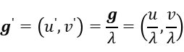 （1）
where $λ$ is the down sampling ratio. Subsequently, the heatmap centered at the accurate coordinate $g^{'}$ can be denoted as:

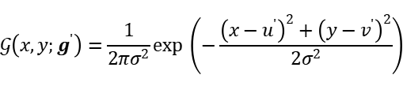 （2）
where $\left(x,y\right)$ specifies a pixel location in the heatmap, and $σ$ denotes a fixed spatial variance.Coordinate decoding refers to the process of inferring coordinates from the heatmap by identifying the maximum activation based on the distribution structure of the predicted heatmap.
DL Modeling of Whole-Spine Frontal and Lateral DR Images in AIS Patients
(1) Whole-Spine Frontal DL Model
The frontal whole-spine DL model employs the VF-Net backbone network,which consists of encoders and decoders. The encoders utilize the ResNet34 network, while each layer of the decoder is connected to its corresponding encoder layer through a skip-connection structure. The network output comprises three components: Heatmap, Center Offset, and Corner Offset, as illustrated in Figure S1.
The original images were resized to a resolution of 1024×512 pixels in the first stage.In the model training phase, data augmentation methods such as random rotation (−30° to +30°), random scaling, and horizontal flipping were applied to increase the data diversity to improve model robustness.The augmented image was then input into the network to produce the center coordinates, center point offsets, and corner point offsets for each vertebra. The loss between the three output components and the ground truth (GT) was calculated, and the network was iteratively optimized using back-propagation.For inference, the center coordinates and center point offsets were used to compute the actual coordinates of the vertebral centers. Subsequently, the corner point offsets were used to calculate the coordinates of the four corner points of each vertebra based on the vertebral center coordinates.Based on the calculation method in parameter measurement, the relevant spino-pelvic parameters were then calculated from the coordinates of the predicted landmarks, thus enabling automatic measurement.
To determine the Cobb angle, two vertebrae out of the 17 thoracic and lumbar vertebrae (12 thoracic and 5 lumbar) were randomly selected. From these vertebrae, the coordinates of the two corner points of the upper endplate of the upper vertebra were used to construct vector A, while the coordinates of the two corner points of the lower endplate of the lower vertebra were used to construct vector B. The angle between vector A and vector B was then calculated. In total, 136 combinations of any two vertebrae exist, and 136 angles were computed. The largest angle corresponds to the Cobb angle, with the two associated vertebrae identified as the upper and lower vertebrae[2]. Furthermore,the distance of the center of each vertebra from the center sacral vertical line was further calculated in this curvature range, and the largest was the apex vertebrae offset distance, and the corresponding vertebrae were the apex vertebrae. Based on the accurate identification of vertebrae, further automatic measurement of other spino-pelvic parameters in whole spine front is realized.

FIG S1.Whole spine frontal model VF-NET Network[3]
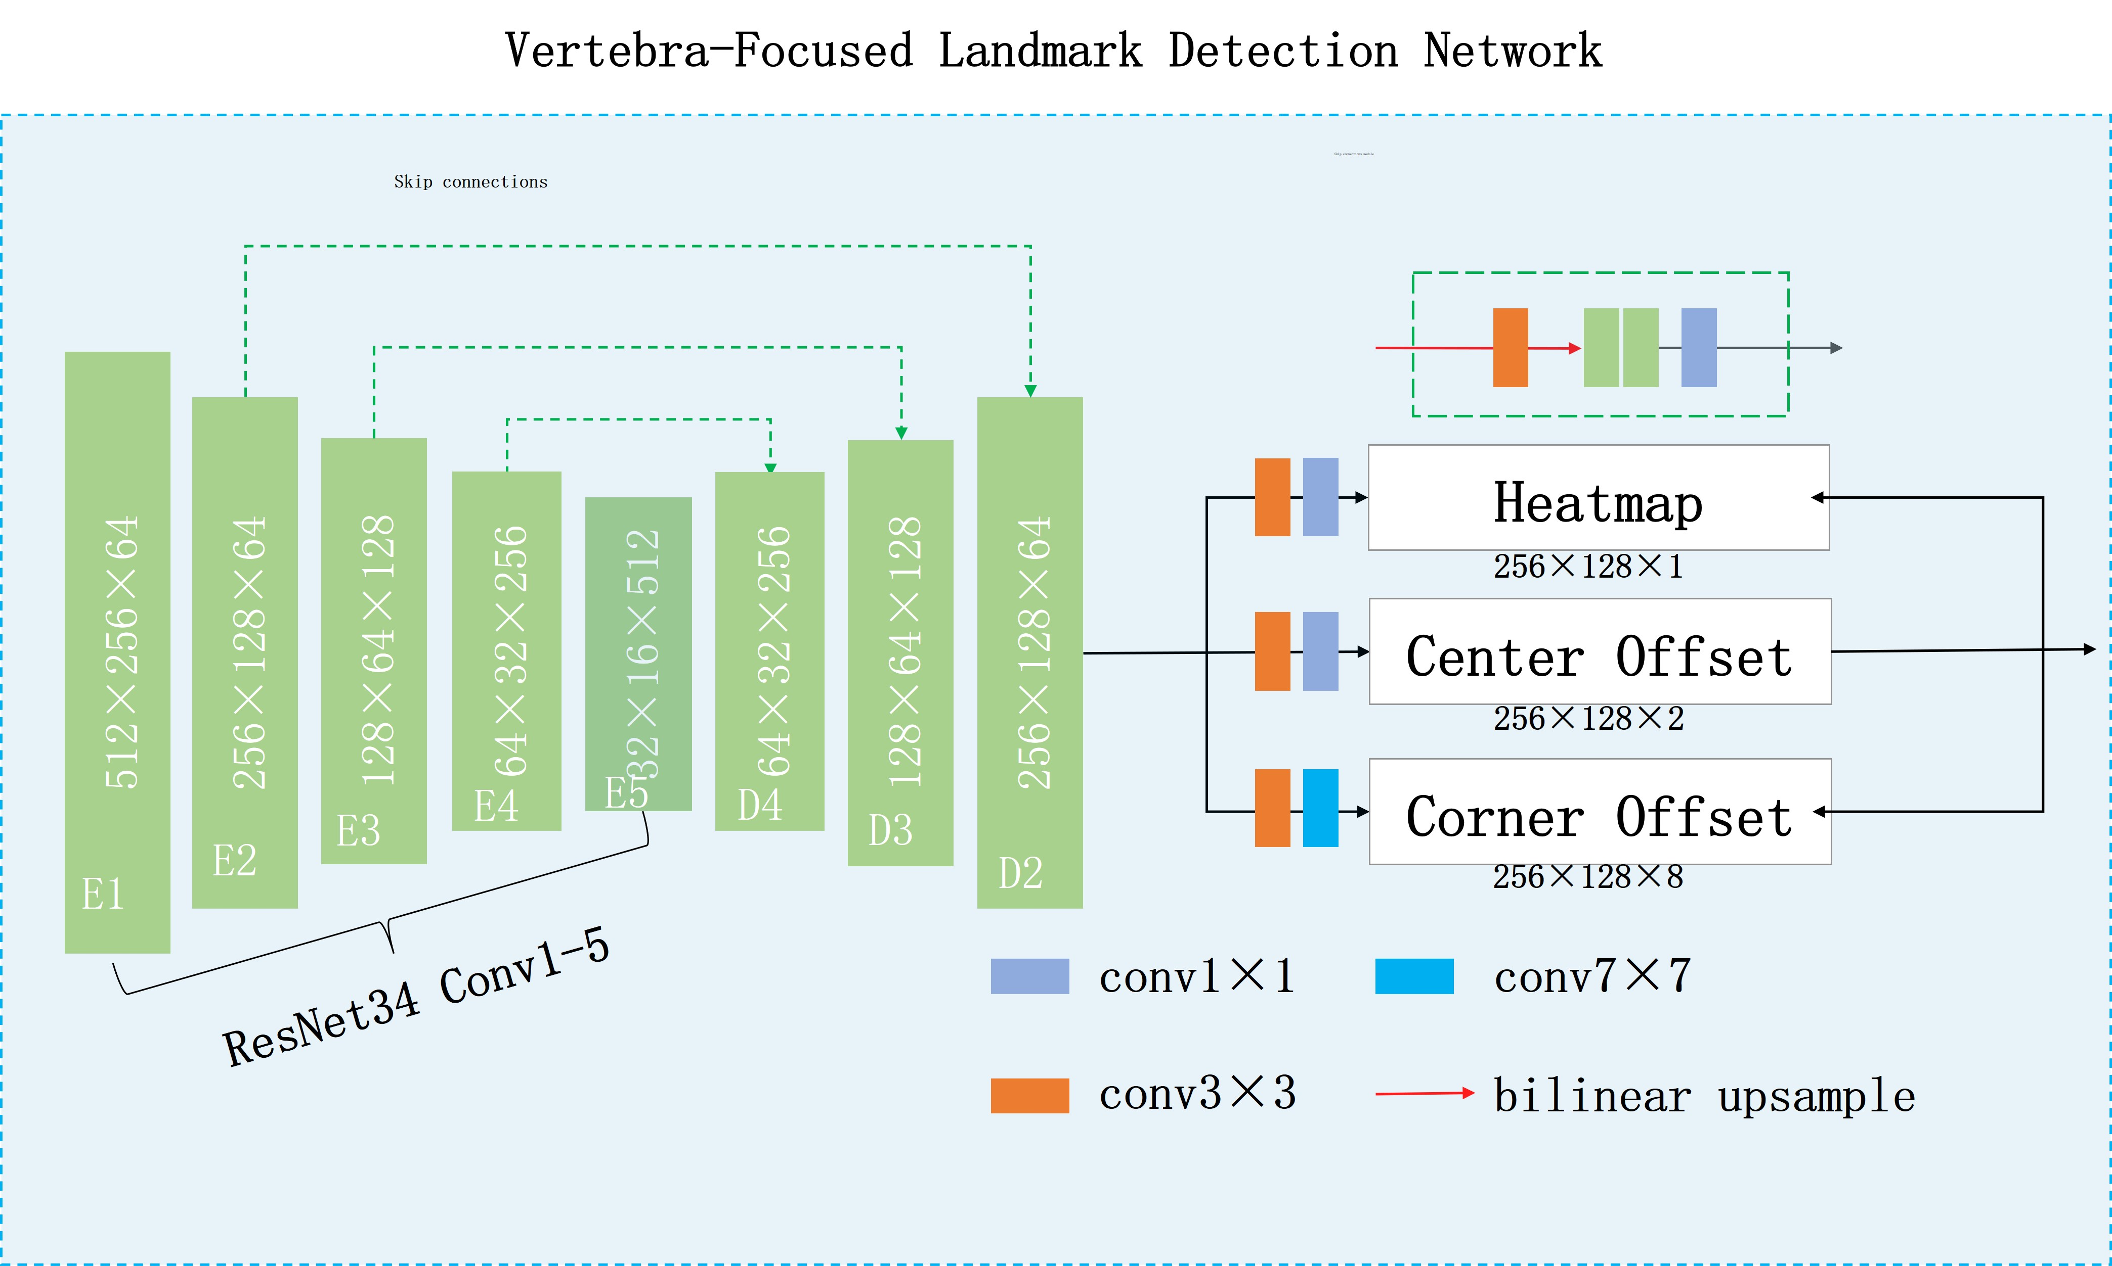

Figure S2.Visual Comparison of Model Detection Key points with Reference Standards
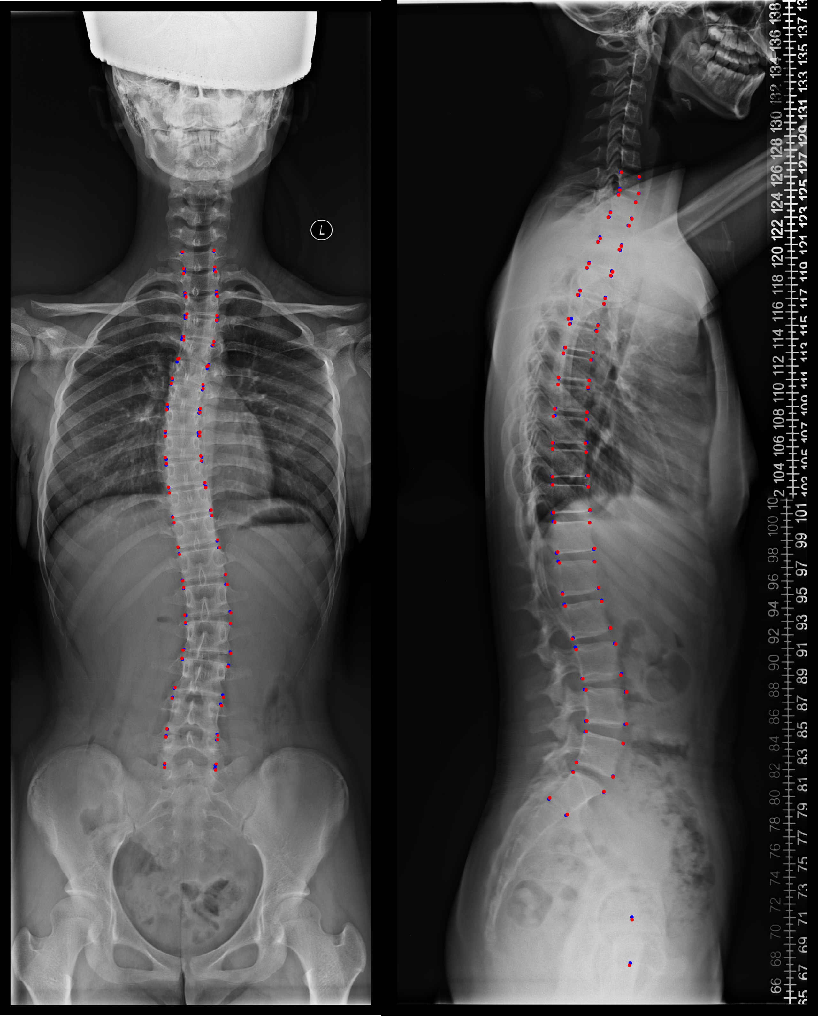

References:
1. Szegedy C, Vanhoucke V, Ioffe S, Shlens J, Wojna Z (2016) Rethinking the Inception Architecture for Computer Vision. IEEE:2818-2826
2. Sun Y, Xing YZ, Zhao ZA, Meng X, Xu G, Hai Y (2022) Comparison of manual versus automated measurement of Cobb angle in idiopathic scoliosis based on a deep learning keypoint detection technology. EUR SPINE J 31:1969-1978. 10.1007/s00586-021-07025-6*10.1007/s00586-021-07025-6
3. Yi JR, Wu PX, Huang QY, Hui Q (2020) VERTEBRA-FOCUSED LANDMARK DETECTION FOR SCOLIOSIS ASSESSMENT. In. Rutgers University, Piscataway.

