Supplementary figures
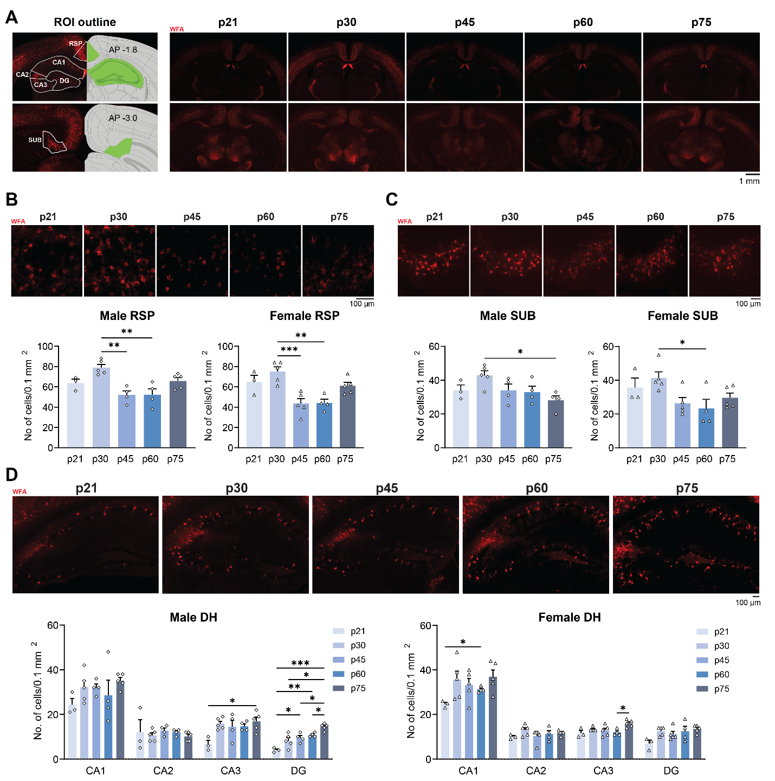
Fig. S1: PNN changes throughout adolescence by region and sex.
A Left: the outline of ROI for RSP, DH, and SUB; right: representative images of p21, p30, p45, p60, and p75 male brain sections stained with WFA. B Representative images for WFA staining in RSP (top, males) and quantification for the number of PNN⁺ cells demonstrating significant post-adolescent decreases in the number of PNN (males bottom left; p21: n = 3, p30 and p75: n = 5, p45 and p60: n = 4; one-way ANOVA: F = 8.124, p < 0.001; Tukey’s post-hoc test: p30 vs. p45: p = 0.002, p30 vs. p60: p = 0.002; females bottom right, p21: n = 3, p60: n = 4, others: n = 5; one-way ANOVA: F = 9.032, p < 0.001; Tukey’s post-hoc test: p30 vs. p45: p < 0.001, p30 vs. p60: p = 0.002) RSP. C Representative images for WFA staining in SUB (top, males) and quantification for the number of PNN⁺ cells revealing similar decreases in SUB (males bottom left; p21: n = 3, p30: n = 5, others: n = 4; one-way ANOVA: F = 3.197, p = 0.044; Tukey’s post-hoc test: p30 vs. p75: p = 0.025; females bottom right, p21: n = 3, p60: n = 4, others: n = 5; one-way ANOVA: F = 3.429, p < 0.031; Tukey’s post-hoc test: p30 vs. p60: p = 0.034) SUB. D Representative images for WFA staining in DH (top, males) and quantification for the number of PNN⁺ cells showing stable or increased numbers of PNN (males bottom left; p21: n = 3, p30 and p75: n = 5, p45 and p60: n = 4; two-way RM ANOVA: Region: F_{(1.905,30.48)} = 95.74 p < 0.001, Age: F_{(4, 16)} = 3.533 p = 0.030, Region ´ Age: F_{(12,48)} = 1.273 p = 0.265; Tukey’s post-hoc test: CA3: p21 vs. p75: p = 0.048, DG: p21 vs. p45: p = 0.035, p21 vs. p60: p = 0.003, p21 vs. p75: p < 0.001, p30 vs. p75: p = 0.036, p45 vs. p75: p = 0.048, p60 vs. p75: p = 0.020; females bottom right, p21: n = 3, p60: n = 4, others: n = 5; two-way RM ANOVA: Region: F_{(1.893,32.17)} = 149.1 p < 0.001, Age: F_{(4, 17)} = 7.984 p < 0.001, Region ´ Age: F_{(12,51)} = 0.928 p = 0.053; Tukey’s post-hoc test: CA1: p21 vs. p60: p = 0.019, CA3: p60 vs. p75: p = 0.031) CA1, CA2, CA3, and DG. Data represent mean ± s.e.m., ***p < 0.001; **p < 0.01; *p < 0.05.

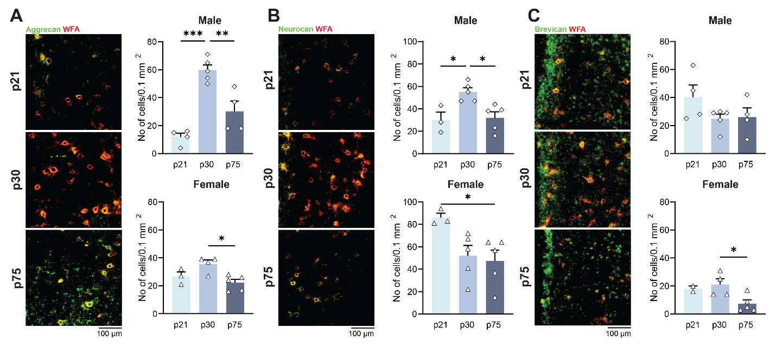
Fig. S2: Developmental changes of aggrecan, neurocan and brevican in RSP in males and females.
A Left: representative image of aggrecan (green) and WFA (red) labeling in RSP. Right: quantification of the number of WFA⁺ aggrecan+ cells in RSP showing significant decrease in males (top; p30: n = 5, others: n = 4; one-way ANOVA: F = 25.75, p < 0.001; Tukey’s post-hoc test: p21 vs. p30: p < 0.001, p30 vs p75: p = 0.004) and females (bottom; p21: n = 3, p30: n = 4, p75: n = 5; one-way ANOVA: F = 6.475, p = 0.018; Tukey’s post-hoc test: p30 vs p75: p = 0.015). B Left: representative image of neurocan (green) and WFA (red) labeling in RSP. Right: quantification for the number of WFA⁺ neurocan+ cells in RSP with reduced neurocan expression in males (top; p21: n = 3, others: n = 5; one-way ANOVA: F = 7.686, p = 0.010; Tukey’s post-hoc test: p21 vs. p30: p = 0.023, p30 vs p75: p = 0.017) and females (bottom; p21: n = 3, others: n = 5; one-way ANOVA: F = 4.319, p = 0.045; Tukey’s post-hoc test: p21 vs p75: p = 0.046). C Left: representative image of brevican (green) and WFA (red) labeling in RSP. Right: quantification of the number of WFA⁺ brevican+ cells in RSP with levels in males (top; p30: n = 5, others: n = 4; one-way ANOVA: F = 1.855, p = 0.207) and significant reduction in females (bottom; p21: n = 2, p30: n = 4, p75: n = 5; one-way ANOVA: F = 4.928, p = 0.040; Tukey’s post-hoc test: p30 vs p75: p = 0.040). Data represent mean ± s.e.m., ***p < 0.001; **p < 0.01; *p < 0.05.

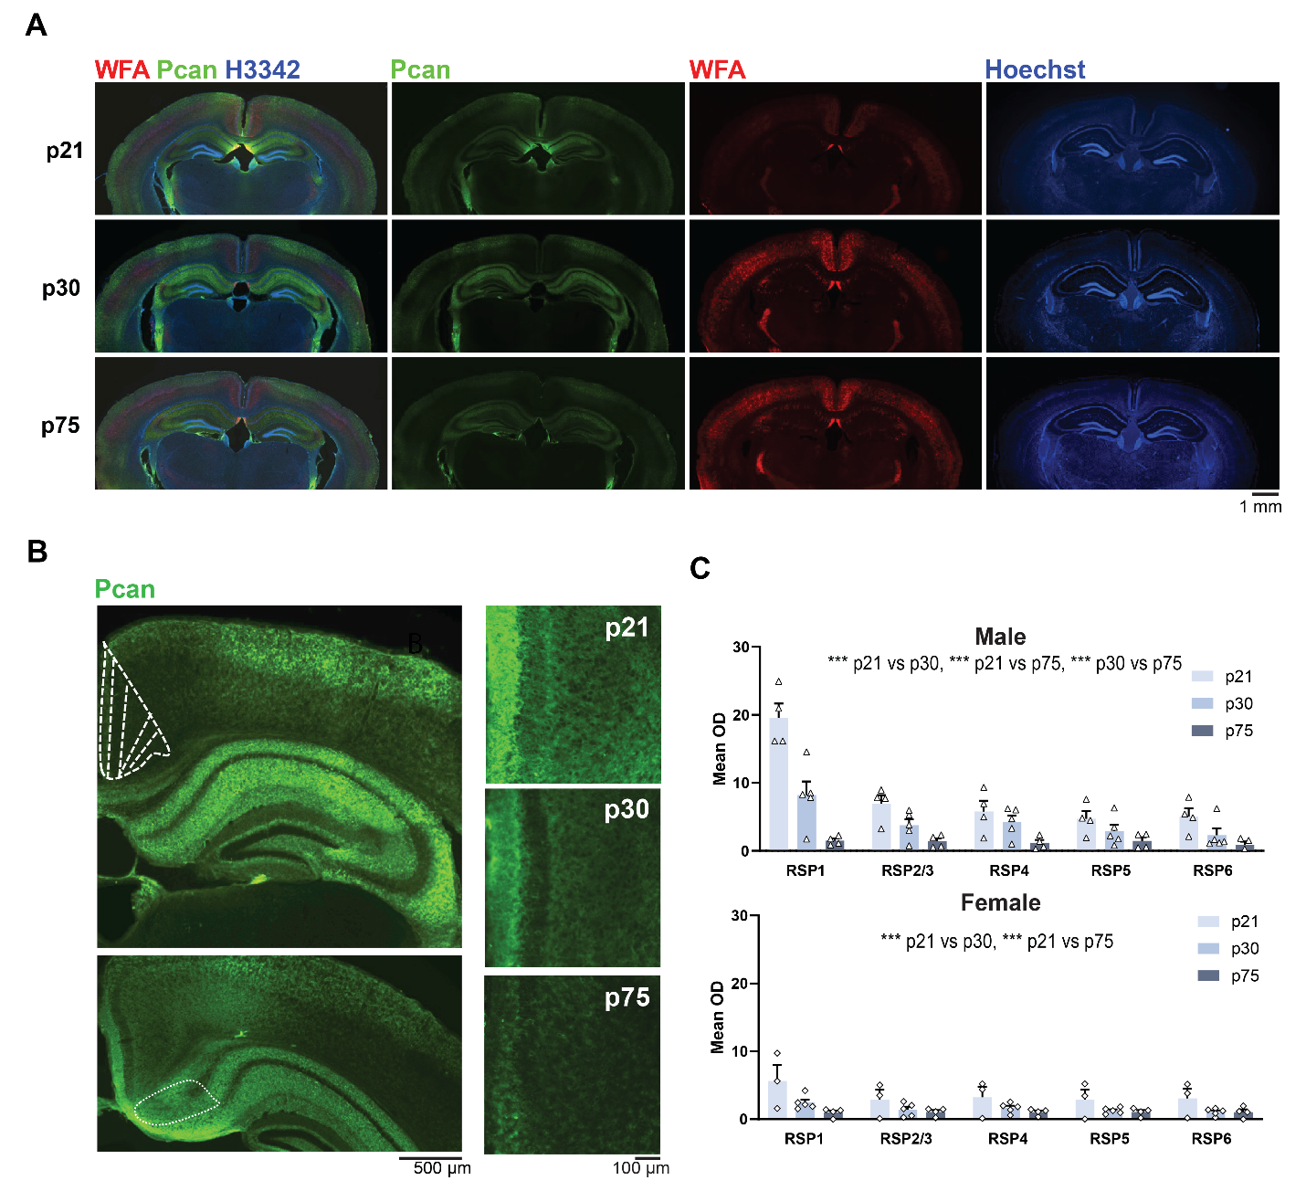
Fig. S3: Levels and developmental changes of phosphocan across RSP layers.
A Low magnification images demonstrating the cortical, hippocampal, and thalamic distribution of phosphacan and WFA at p21 (males n = 4, females n = 3), p30 (males, n = 5, females n = 5), and p75 (males n = 4, females n = 4). At p30, the highest levels are obtained in layer 1, containing the cortical axons. B High magnification images showing progressive post-adolescent down-regulation of phosphacan across layers and ECM compartments including but not restricted to PNN. C Layer-by-layer quantification of phosphocan optical density demonstrating significant effects in males (two-way ANOVA: Age: F (2, 50) = 42.32, p < 0.001, Layer: F (4, 50) = 17.70, p < 0.001, Age × Layer: F _{(8, 50)} = 6.574, p < 0.001, Tukey’s post-hoc test: p21 vs. p30: p < 0.001, p21 vs. p75: p < 0.001, p30 vs. p75: p < 0.001) and females (two-way ANOVA: Age: F_{(2,45)} = 12.36, p < 0.001, Layer: F_{(4,45)} = 1.478, p = 0.225, Age × Layer: F_{(8,45)} = 0.5702, p = 0.797, Tukey’s post-hoc test: p21 vs. p30: p < 0.001, p21 vs. p75: p < 0.001). Data represent mean ± s.e.m., ***p < 0.001; **p < 0.01; *p < 0.05.
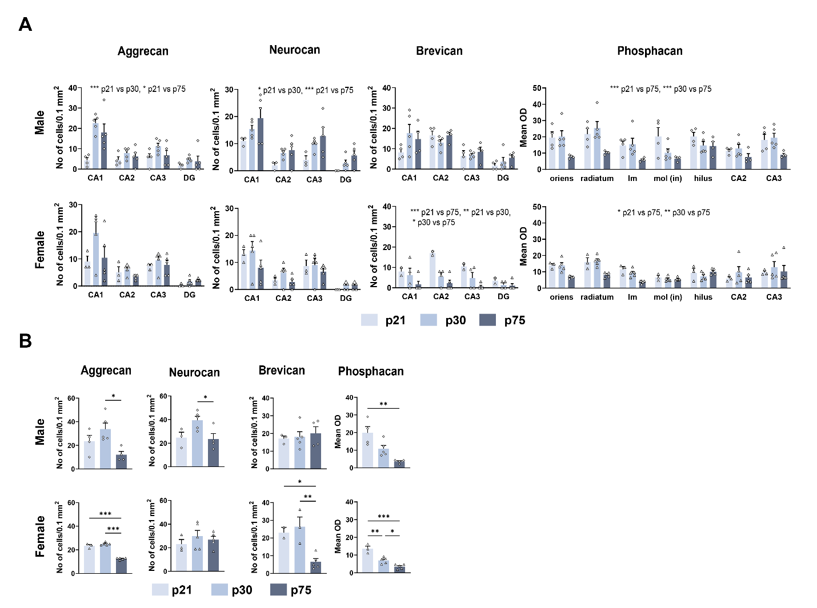
Fig. S4: Post-adolescent levels of PNN-associated lecticans in DH and SUB
A Developmental decreases of PNN composition in DH (male aggrecan: p21: n = 4, other: n = 5, two-way ANOVA: Age: F (2, 44) = 12.14, p < 0.001, Area: F (3, 44) = 15.71, p < 0.001, Age × Area: F _{(6, 44)} = 3.146, p = 0.012, Tukey’s post-hoc test: p21 vs. p30: p < 0.001, p21 vs. p75: p = 0.011; female aggrecan: p21: n = 3, other: n = 5, two-way ANOVA: Age: F (2, 40) = 3.515, p = 0.039, Area: F (3, 40) = 14.21, p < 0.001, Age × Area: F _{(6, 40)} = 1.438, p = 0.225; male neurocan: p21: n = 3, other: n = 5, two-way ANOVA: Age: F (2, 40) = 9.519, p < 0.001, Area: F (3, 40) = 17.99, p < 0.001, Age × Area: F _{(6, 40)} = 0.2076, p = 0.972, Tukey’s post-hoc test: p21 vs. p30: p = 0.027, p21 vs. p75: p < 0.001; female neurocan: p21: n = 3, other: n = 5, two-way ANOVA: Age: F (2, 40) = 2.812, p = 0.072, Area: F (3, 40) = 16.57, p < 0.001, Age × Area: F _{(6, 40)} = 0.7006, p = 0.651; male brevican: p30: n = 5, other: n = 4, two-way ANOVA: Age: F (2, 40) = 1.567, p = 0.221, Area: F (3, 40) = 15.22, p < 0.001, Age × Area: F _{(6, 40)} = 1.302, p = 0.279; female brevican: p21: n = 2, p30: n = 4, p75: n = 5, two-way ANOVA: Age: F (2, 32) = 15.37, p < 0.001, Area: F (3, 32) = 4.618, p = 0.009, Age × Area: F _{(6, 32)} = 1.735, p = 0.145, Tukey’s post-hoc test: p21 vs. p30: p = 0.006, p21 vs. p75: p < 0.001, p30 vs. p75: p = 0.038; male phosphacan: p21: n = 4, other: n = 5, two-way ANOVA: Age: F (2, 70) = 20.37, p < 0.001, Area: F (6, 70) = 3.190, p = 0.008, Age × Area: F _{(12, 70)} = 1.307, p = 0.235, Tukey’s post-hoc test: p21 vs. p75: p < 0.001, p30 vs. p75: p < 0.001; female phosphacan: p21: n = 3, other: n = 5, two-way ANOVA: Age: F (2, 70) = 7.449, p = 0.001, Area: F (6, 70) = 5.615, p < 0.001, Age × Area: F _{(12, 70)} = 1.868, p = 0.054, Tukey’s post-hoc test: p21 vs. p75: p = 0.017, p30 vs. p75: p = 0.002). B Developmental change of PNN composition in SUB (male aggrecan: p30: n = 5, other: n = 4, one-way ANOVA: F = 5.746, p = 0.022; Tukey’s post-hoc test: p30 vs. p75: p = 0.017; female aggrecan: p21: n = 3, other: n = 5, one-way ANOVA: F = 124.9, p < 0.001; Tukey’s post-hoc test: p21 vs. p75: p < 0.001, p30 vs. p75: p < 0.001; male neurocan: p21: n = 3, p30: n = 5, p75: n = 4, one-way ANOVA: F = 4.951, p = 0.036; Tukey’s post-hoc test: p30 vs. p75: p = 0.047; female neurocan: p21: n = 3 other: n = 5, one-way ANOVA: F = 0.5794, p = 0.578; male brevican: p21: n = 3, p30: n = 5, p75: n = 4, one-way ANOVA: F = 0.2091, p = 0.815; female brevican: p21: n = 2, p30: n = 3, p75: n = 5, one-way ANOVA: F = 11.40, p = 0.006, Tukey’s post-hoc test: p21 vs. p75: p = 0.036, p30 vs. p75: p = 0.008; male phosphacan: p30: n = 5, other: n = 4, one-way ANOVA: F = 11.01, p = 0.003, Tukey’s post-hoc test: p21 vs. p75: p = 0.002; female phosphacan: p21: n = 3, other: n = 5, one-way ANOVA: F = 29.62, p < 0.001, Tukey’s post-hoc test: p21 vs. p30: p = 0.001, p21 vs. p75: p < 0.001, p30 vs. p75: p = 0.027). Data represent mean ± s.e.m., ***p < 0.001; **p < 0.01; *p < 0.05.

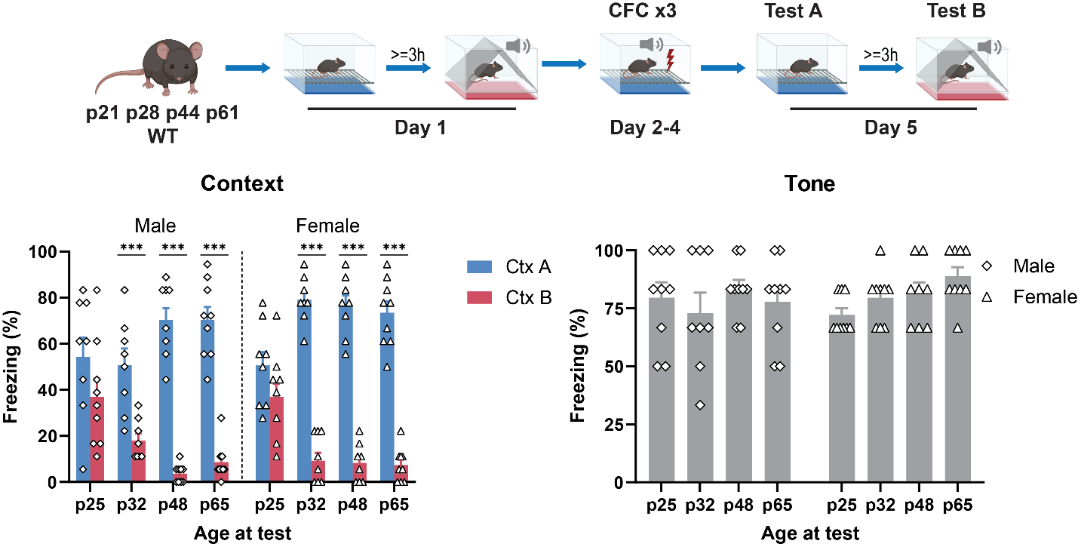
Fig. S5: Context specificity of CFC memories acquired during early adolescence (p25-p35).
Context discrimination task (top) shows that mice were able to form specific contextual fear memory after p28 (: n = 8- 9/age group and sex, bottom left, three-way RM ANOVA, Sex: F_{(1,62)} = 1.413, p = 0.239, Age: F_{(3,62)} = 0.7597, p = 0.521, Ctx: F_{(1,62)} = 588.2, p < 0.001, Age × Sex: F_{(3,62)} = 0.7293, p = 0.538, Age × Ctx: F_{(3,62)} = 34.50, p < 0.001, Sex × Ctx: F_{(1,62)} = 5.748, p = 0.020, Age × Sex × Ctx: F_{(3,62)} = 5.065, p = 0.003, Tukey’s post-hoc test: Ctx A vs. Ctx B in all groups other than p25 male and p25 female: p < 0.001). And that they show normal fear response to auditory cue since p21 (p32 male and p48 female: n = 8, other: n = 9, bottom right, two-way ANOVA: Age × Sex: F_{(3,62)} = 1.247, p = 0.300, Age: F_{(3,62)} = 1.069, p = 0.369, Sex: F_{(1,62)} = 0.3027, p = 0.584). Data represent mean ± s.e.m., ***p < 0.001.

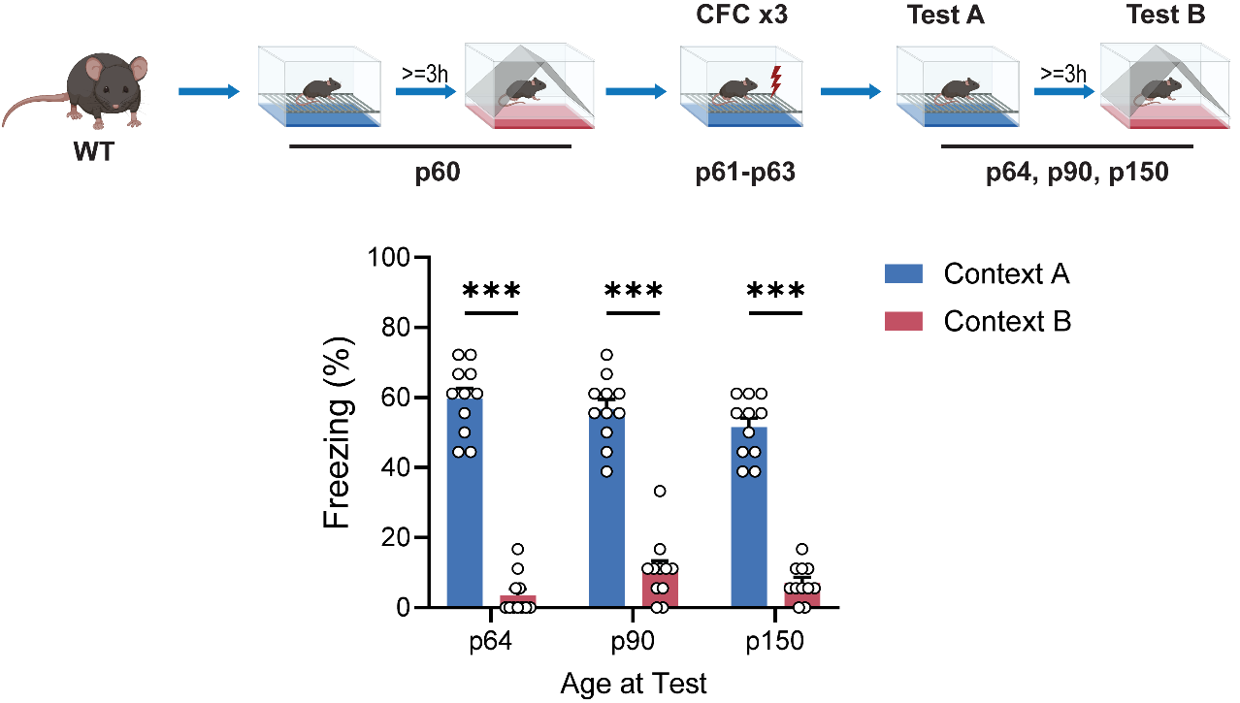
Fig. S6 Specificity of recent and remote contextual fear memory formed during late adolescence (p60-p63).
Contextual discrimination task performed on p60 mice shows a prolonged memory specificity in distinguishing dissimilar contexts (same setup used in this study for p28 mice, without tone) up to p150(two-way RM ANOVA: Age of test: F_{(1.890, 18.90)} = 2.209 p = 0.139, Context: F_{(1, 10)} = 370.2 p < 0.001, Age of test x Context: F_{(1.897, 18.97)} = 2.532 p = 0.108). Data represent mean ± s.e.m., ***p < 0.001.

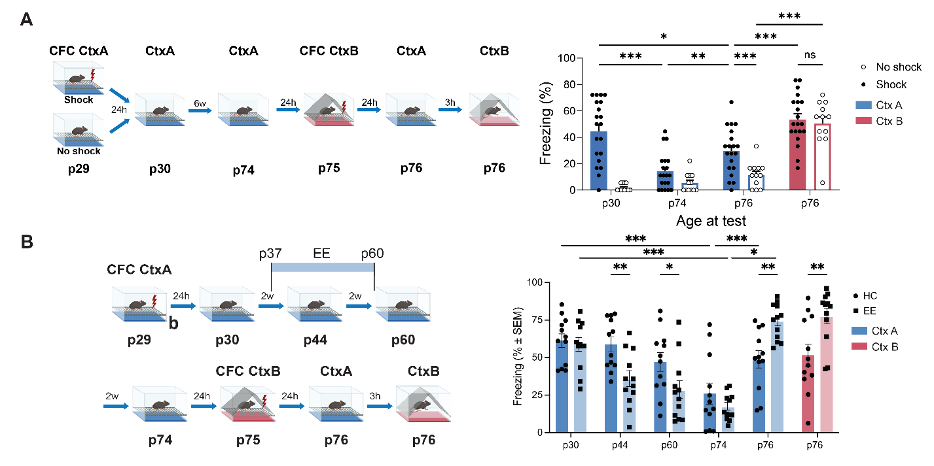
Fig. S7: Freezing behavior after shock re-exposure in a different context.
A Left, Experimental paradigm; Right, Shock in a novel context (Context B, CtxB) on p75 resulted in Context B-specific freezing, but also in increased freezing to the conditioned context (Context A, CtxA) (n = 24 for shock group, n = 12 for no shock group; two-way RM ANOVA: Test: F_{(3,102)} = 36.20 p < 0.001, Shock: F_{(1, 34)} = 25.95 p < 0.001, Test ´ Shock: F_{(3,102)} = 7.009 p < 0.001; Šídák's post-hoc test: shock group: Test1 vs. Test2 and Test3 vs. Test4: p < 0.001, no shock group: Test4 vs. all other tests: p < 0.001). B Anterograde interference with CFC by introducing a 2-week environmental enrichment (EE) exposure one week after training (p37-p60) accelerated the impairment of memory expression in the EE group (n = 12) relative to home cage (HC) controls (n= 12). Despite initial impairments, the retention of the adolescent CtxA-shock memory was significantly enhanced by EE (two-way RM ANOVA effects of Test F _{(3.477, 76.48)} = 35.04, P < 0.001; and Test x Group interaction F _{(5, 110)} = 14.28, P < 0.001, Tukey’s post-hoc test: EE vs. HC p44: p = 0.004, p60: p = 0.037, p76 CtxA: p = 0.002, p76 CtxB: p = 0.010; p30 vs. p74: HC and EE: p < 0.001, p74 vs. p76 CtxA: HC: p = 0.044, EE: p < 0.001). Data represent mean ± s.e.m. ***p < 0.001; **p < 0.01; *p < 0.05.

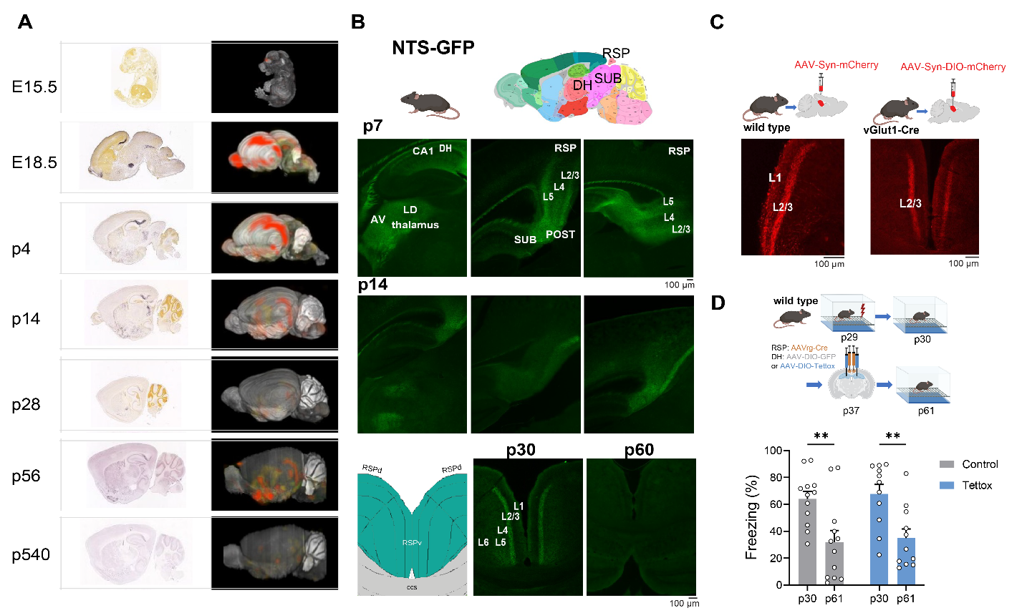
Fig. S8: Effect of inactivating DH to RSP projections during late adolescence on the retrieval of previously acquired memories.
A Left, Delineation of brain areas showing strong NTS labeling in thalamic, hippocampal, and RSP regions during early development (p7-p14) in NTS-GFP mice. Right, Representative images of NTS labeling showing two projections from SUB to RSP terminating in L2/3 and L5. B Disappearance of NTS from DH to RSP projections between p30 and p60. C Mature DH to RSP projections to RSP L1 and L2/3 (left), with excitatory projections terminating in L2/3 (middle) and lack of terminals in L% (right). D Inhibition of DH to RSP projections does not affect the impaired retrieval of adolescent memories (n = 12, two-way RM ANOVA: Tettox: F_{(1,21)} = 0.1627 p = 0.691, Age of test: F_{(1, 21)} = 30.14 p < 0.001 Infusion x Age of test: F_{(1,21)} = 0.0040 p = 0.950; Šídák's post-hoc test: Control p30 vs. p61: p = 0.002 , Tettox p30 vs. p61: p = 0.002). Data represent mean ± s.e.m., **p < 0.01.

Supplementary materials and methods

Animals
Wild-type (C57BL/6N) male and female mice were obtained from Envigo (Lafayette, IN, USA). Tgfbr2^{fl/fl} (# 012603), Vglut1-IRES2-Cre-D(#037512) and Neurotensin-IRES-tauGFP (NT-GFP; strain Nts^{tm1Mom}/MomJ, #006702) mice were obtained from Jackson Laboratory (Bar Harbor, ME, USA) and bred in the institutional animal facility. Animals were maintained under 12 h:12 h light:dark cycle with lights on at 07:00, temperature 20–22 °C, humidity 30–60% with ad libitum access to food and water. All procedures were approved by Northwestern University Animal Care and Use Committee (protocols IS00002463 and IS00003359) and Albert Einstein College of Medicine Animal Care and Use Committee (protocols 00001289 and 00001268) in compliance with US National Institutes of Health standards.

Contextual Fear Conditioning
Contextual fear conditioning (CFC) was performed in automated system (TSE Systems, Berlin, Germany or Med associate, Fairfax, VT, USA). Mice were exposed to Context A (CtxA) for 3 min, followed by a foot shock (0.7 mA, 2 s). On indicated days of test, freezing level of mice to the context were measured in CtxA or Context B (CtxB, different from Context A in shape, floor material, smell, and background noise) for 3 min. In most experiments, mice were tested once a week until p60 or p75, except for a spontaneous recovery experiment, in which mice were tested once a month until p181.

Contextual discrimination
The contextual discrimination task was performed over 4 days to explicitly determine the ability of mice to discriminate between CtxA and CtxB . On day 1, the mice were allowed to explore CtxA and Context B (CtxB, differ to Context A in shape, floor material, and smell), each for 3 min. On day 2-4, mice were exposed to CtxA for 3 min followed by a tone (30s, 75 dB SPL, 10 kHz, 200 ms pulse) and a foot shock (0.7 mA, 2 s, constant current) sequentially once each day. On the day of test, freezing levels were measured during exposure of mice to CtxA and CtxB for 3 min each. The same tone used on day 2-4 was played at the end of CtxB test for 30 s to measure the freezing level to the auditory cue. Exposures to CtxA and CtxB were always spaced 3 h apart and counterbalanced.

Memory reinstatement
Memory reinstatement was determined by measuring the effect of early adolescent CtxA CFC on late adolescence CtxB CFC. We subjected the mice to CFC mice CtxA on p29 followed by 2 tests on p30 and p74. On p75 they were exposed to CtxB for 3 min and received a shock reminder (0.7 mA, 2 s) at the end of the exposure. On p76 freezing was determined in CtxA and CtxB for 3 min each, spaced 3 h apart, and counterbalanced. Interference of prior CFC in CtxA with freezing to CtxB and generalization of freezing to CtxA after CFC in CtxB served as indices of CtxA memory retention.

Environmental enrichment
The memory reinstatement procedure was repeated in both the enriched environment (EE) and control groups, with additional CtxA tests conducted at p44 and p60 After CFC on p29, mice in EE group were placed in EE for on p37 to p60, while control group remain in standard housing. Two identical EE boxes were made of clear polycarbonate, 12 inches high, 45.5 inches long, and 21.5 inches wide, with two filtered air openings in the lid and nontransparent bottom covered with 5 cm of bedding material to prevent fear of heights. The boxes were placed on a stainless-steel rack in a climate-controlled room on a 12 h light/dark cycle. Males and females were placed in separate boxes, and each box contained 6 mice at a time, with three running wheels, three tunnels, three domes, a water and food station. The same layout was used in both boxes throughout the experiment. For behavioral test on p44, mice were briefly moved into standard housing and returned to EE after the test. After p60 mice were returned permanently into standard housing. The control mice were maintained in standard housing during this time.

Stereotaxic intracranial injection
Mice were anesthetized with isoflurane and placed on a stereotaxic instrument (Model 1900, Kopf Instruments, Tujunga, CA, USA). Viral vectors carrying AAV8-hSyn-mCherry (114472-AAV8, Addgene, gift from Karl Deisseroth), AAV8-hSyn-DIO-mCherry (50459-AAV8, Addgene, gift from Bryan Roth), AAV8/rg-hSyn-Cre-dTomato (107738-AAV8/rg, Addgene, gift from Rylan Larsen), AAVDJ-CMV- DIO-eGFP (GVVC-AAV-12, Stanford University Gene Vector and Virus Core), or AAVDJ-CMV-DIO-eGFP-2A-TeNT (Cre-Dependent Tetanus Toxin, GVVC-AAV-71, Stanford University Gene Vector and Virus Core) is delivered bilaterally into DH (1.8 mm posterior, 1.2 mm lateral, 2.25 mm ventral to bregma) and/or RSP (1.8 mm posterior, 1.2 mm lateral, 1.1 mm ventral to bregma) using a Hamilton neurosyringe connected with microinfusing pump (UMP-3, WPI, Sarasota, FL, USA). For each site 0.5 μL AAV solution (2 x 10¹² GC/mL) was delivered at 0.15 μL/min, and syringes were left in place for 5 min after the injection. Recombinant HAPLN1 (2608-HP-025, R&D Systems, Minneapolis, MN, USA, 100 ng/μL in PBS), TGFB1(763102, BioLegend, San Diego, CA, USA, 10 ng/μL in PBS) or TGFB2 (7346-B2-005, R&D Systems, 10 ng/μL in PBS) at was injected bilaterally into RSP (0.5 μL/site) as described above.

Immunohistochemistry
Mice were anesthetized with an intraperitoneal injection of 240 mg/kg Avertin and transcardially perfused with ice-cold phosphate buffer followed by 4% paraformaldehyde in phosphate buffer (pH 7.4, 50 mL each per mouse). Brains were removed and post-fixed for 24 hours in the same fixative and then cryoprotected by immersing in 20% and 30% sucrose in phosphate buffer for 24 hours each. After that the brains were frozen in OCT embedding medium and 50 µm freezing microtome sections were made for use in free-floating lectin histochemistry or immunohistochemistry. Biotinylated WFA (1:1000 B-1355-2, Vector Laboratories, Newark, CA, USA) was used to visualize PNN. For immunohistochemistry, primary antibodies against aggrecan (1:1000, ab3778, Abcam, Cambridge, UK), neurocan (1:2000, AF5800 R&D systems), brevican (1:500, 19017-1-AP, Proteintech,Rosemont, IL, USA), phosphacan (1:500, sc-33664, Santa Cruz, Dallas, TX, USA), PVALB (1:5000, pvg-213, Swant, Burgdorf, Switzerland), SST (1:1000, MAB354, Millipore, Burlington, MA, USA), VIP (1:1000, 20077-1513001, Immunostar, Hudson, WI, USA), NPY (1:1000, 22940-1628001, Immunostar), CR (1:4000, CG1, Swant), Iba1 (1:1000, ab5076, Abcam), Olig2(1:2000, ab109186, Abcam), PDGFRa (1:2000, AF1062, R&D Systems), and s100b(1:2000, 287108, Synaptic Systems, Goettingen, Germany) were used followed by corresponding secondary antibodies (1:500, Alexa Fluor conjugated, Jackson IR, West Grove, PA, USA or 1:200, Biotinylated, Vector Laboratories). When using biotinylated systems, the signals were visualized with the ABC-HRP Detection Kit (PK-6100, Vector Laboratories) and TSA Fluorophores (Akoya Biosciences, Marlborough, MA, USA).

Microscopy, image analysis and quantification
For large scale analyses, sections were scanned using Axioscan Z1 microscope (Zeiss, Oberkochen, Germany) scanner under 10x objective. Images were stitched and converted to TIFF format. RSP findings were additionally verified following confocal microscopy under 60x objective (Fluoview FV10i-LIV, Olympus, Hachioji, Tokyo, Japan). All quantifications were performed with ImageJ using two methods: the multi point plug-in and analyze particles plug-in. Intensity was calculated by measuring the gray value after thresholding to eliminate background interference. Cell counting and gray value analysis were performed in a 0.1 mm² area for each ROIs. The measurements were averaged from 2 sections per animal; each animal was treated as an independent sample for statistical analysis.
Quantitative PCR analysis
Mice subjected to fresh tissue collection were euthanized with cervical dislocation. After that, the brain was removed and DH and RSP tissue were dissected from the brain. Total RNA was extracted using RNeasy Plus Mini Kit (74136, Qiagen,). Reverse transcription was performed on 100 ng of total RNA using PrimeScript RT Reagent Kit (RR037A, Takara, Kusatsu City, Japan). Quantitative PCR analysis was performed on a QuantStudio 6 Flex instrument (Applied Biosystems, Waltham, MA, USA) using SYBR green detection system (4367659, Applied Biosystems) and primers specific for Tgfb1 (QT00145250, Qiagen) and Tgfb2 (QT00106806, Qiagen). GAPDH (F: AACTTTGGCATTGTGGAAGG; R: ACACATGGGGGTAGGAACA) was used as endogenous control. mRNA levels were calculated using the comparative CT method (2^{−ΔΔCt}).

Statistical analysis
Statistical power to detect anticipated effect sizes was determined using power analysis (calculator at http://www.stat.ubc.ca/~rollin/stats/ssize/n2.html) conducted on representative samples of previous work and pilot experiments. For all proposed experiments, minimum power is set at 0.90 to detect an α = 0.05 (two-sided test) for a difference in means from 20% to 40%, with a 15% common standard deviation. Mice are randomly assigned to groups. However, to prevent litter effects, mice from the same litter were assigned to different experimental groups. Viruses and proteins were injected by experimenters aware of the construct, but the mice were then assigned coded numbers by the laboratory technician. The code was available after quantification and before analyses. Statistical analyses were performed using GraphPad Prism. Outlier mice exhibiting abnormal behavior performance determined by Grubbs' test or with misplaced infusion were excluded. One-way ANOVA or Two-way ANOVA followed by indicated post hoc tests were used for comparisons of three or more experimental groups (only when ANOVA was significant) whereas Student’s t-test was used for comparison of two experimental groups. Homogeneity of variance was confirmed with Levene’s test for equality of variances. Repeated measures (RM) ANOVAs with Geisser Greenhouse correction were performed for within-subject designs. On indicated data, we performed correlation analyses and report Pearson’s r coefficients.
All comparisons were conducted using two-tailed tests and the P value for all cases was set to <0.05 for significant differences. Data are expressed as mean ± s.e.m. Statistically significant differences are indicated as *P < 0.05, **P < 0.01, and ***P < 0.001.

